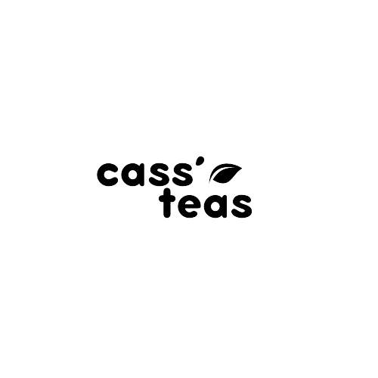

# 

Team 6

Jie L.

Shawnelle M.

Israel U.

# Planning

Purpose.

Type of Website: Marketing/e-commerce

Target Audience:

Adults, male and female, age 16+, educated, medium to high income, with interest for health, well-being and sustainable products.

# Navigation Structure

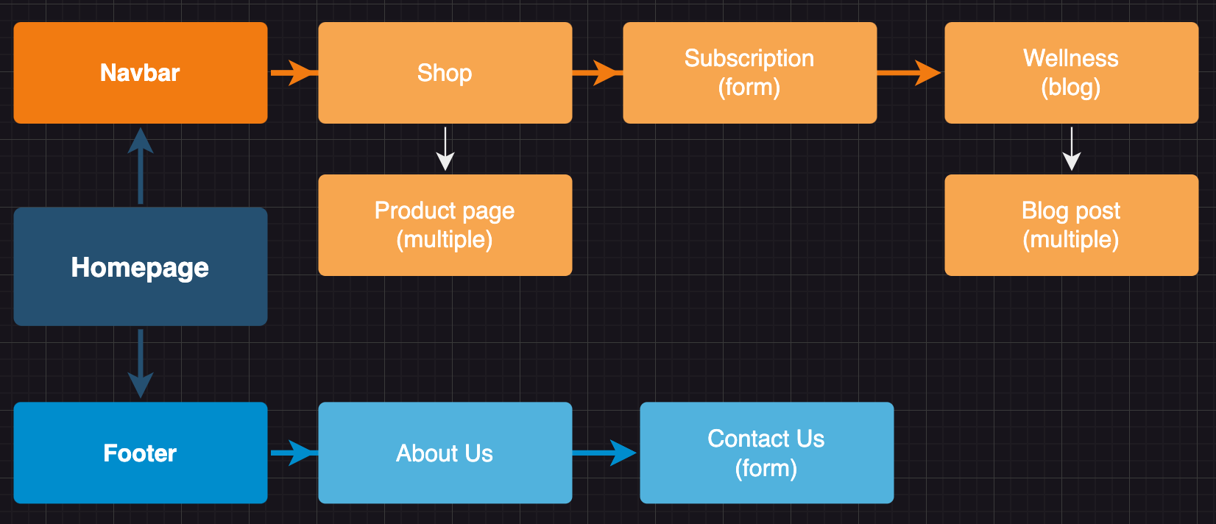

* Nav top bar

1. Homepage
2. Shop
   1. Product page
3. Subscription

Form to fill with information to begin a monthly tea subscription.

1. Wellness
   1. Blog post/article

* Nav footer

1. About us

Information about the company, the origins, goals…

1. Contact us

Form to send question and comments

# Similar websites

<https://www.blume.com>

<https://www.davidstea.com/ca_en/home/>

# Design

* 1. Color Palette

* 1. Fonts

(fonts to be used when defined)

# Content

* 1. Logo

* 1. Images

Product photo Product Label

# Layout

Wireframe

Mockups

1. Implementation:
   1. Defining website, organizing files and folders
   2. Creating the webpages
   3. Reviewing the website in a browser:
   4. Make changes and corrections