Instructions to run the model output codes
There are two methods to run the codes, the second being a failsafe method if there are issues with running the first due to lack of certain utilities
You can also find all original codes in our publicly available github:
https://github.com/Marc-Laurent-Gawa/Wide-Range-Image-Blending-COMP448-Project

IMPORTANT NOTE: These instructions are for running the models on the paired dataset using the pretrained weights acquired during traing using the External_Running_dataset jupyter notebook file running on google collab
You may check the notebook to verify the setup of the training, however to run this notebook file it will require google colab and a lot of time (the training took us multiple days to complete in full using the top GPU environment available on colab which will require subscription access)

Additionally, the second method also uses colab however will work for any free user with a google account as colab offers the T4 gpu runtime with 100 compute units

METHOD 1: Matlab script running
Test 1: Running on new dataset
Copy your codes into a dedicated folder of your choosing
Ensure your machine has the following:
- A cuda compatible GPU for hardware acceleration on your machine
- Matlab
- Python 3.7 or above
- The following libraries
  - Pytorch
  - Numpy
  - Torchvision
  - Tensorboard
  - Skimage
Go to the following google drive link to download the following additional utilities that are too big to include in the zip file submission:
https://drive.google.com/drive/folders/1JDY_-iKj66uf4Nz7ul-X14zhl88WxOlQ?usp=sharing
Open the street weights folder, download both Gen and Dis file, move them into the weights folder of your codes (these are the pretrained weights acquired after training for a period of a week)
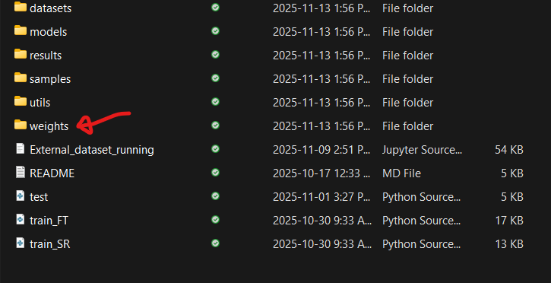

The inside of the weights folder should look like this
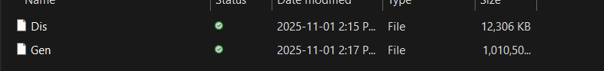

Next, Open up the drive link again and download the Street_Paired_left_right_data.zip
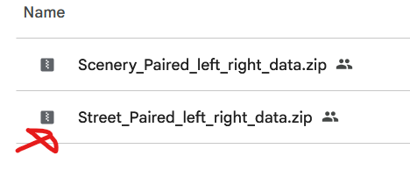
Extract the zip file, Take the two folders titled input1 and input2 and move the two folders into the samples folder of your code space
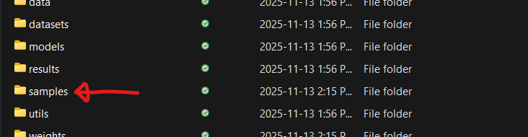
The inside of your samples folder should look like this
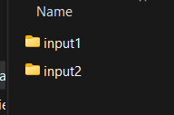
With the insides of each folder containing the images

You may now open the matlab script file titled Run_codes_1.m and click run the first section
After the image outputs are created, you can run the next section. You will be asked to enter a batch value used to view the resulting images. Every batch will be displayed, to view the next batch, press enter within the console or type stop then enter to quit out. There should be 76 images to view in total
If you wish to see the results within the folders, open the folder titled results, and open the folder results1-2 (results2-1 are results outputs with the left and right segment swapped)
If you wish to compare with the original full images, go into the drive again and download the Street_testing_data_full_images.zip inside the Full image data folder
Image sources, left and right segment and result outputs all share the same file name

Test 2: Running on new dataset using old dataset weights
Follow all the same instructions as listed in the previous section with these following differences
Download the weights from this source:
https://drive.google.com/drive/folders/1dRpBBFAYHlbOrRjpKiW6SvdU8AnTepqy
use the Rune_codes_2.m file instead

Test 3: Running on old dataset using old dataset weights
Follow the same instructions as the first section but with these following differences
Download the weights from this source:
https://drive.google.com/drive/folders/1dRpBBFAYHlbOrRjpKiW6SvdU8AnTepqy
Download Scenery_Paired_left_right_data.zip instead of the street one
use the Rune_codes_2.m file instead

IMPORTANT: Once you have run a full test, extract your resulting images from the results folder (result1-2 is sufficient but you may also keep result2-1 if you wish). Ensure also to delete all images within both results folder ALONG with the images in your input folders before setting up another a new test to avoid any overlapping.
Your extracted results folders may be used when running the evaluation scripts described later in the read me

METHOD 2: Google Colab
If you encounter any issues with the first method due to inaccessibility of certain utilities listed, use the following
Take the jupyterNotebook file titled Code_Running, open google colab and import the file. Select a GPU runtime (T4 if you are a free user) and connect
Within the notebook you will see three main sections
Test 1: Run the model on the new dataset with the new dataset weights (Main one to run)
Test 2: Run the model on the new dataset with the old dataset weights (additional test optional to the user)
Test 3: Run the model on a sample of the old dataset from the original project with the old dataset weights to view performance of the original project (additional test optional to the user)

Each of these sections have runnable code cells to execute all the preparation of getting python libraries and importing dataset along with executing the codes to run the models and visualize the results
Select a section you wish to see and execute the cells in order (a cell must finish running before starting the next one

Note: to run a cell on colab, hover your mouse over it and click the run button
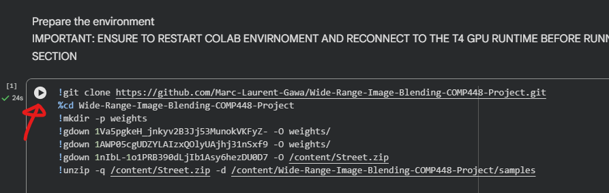

Once you have run a section, move on the view results cell and run it
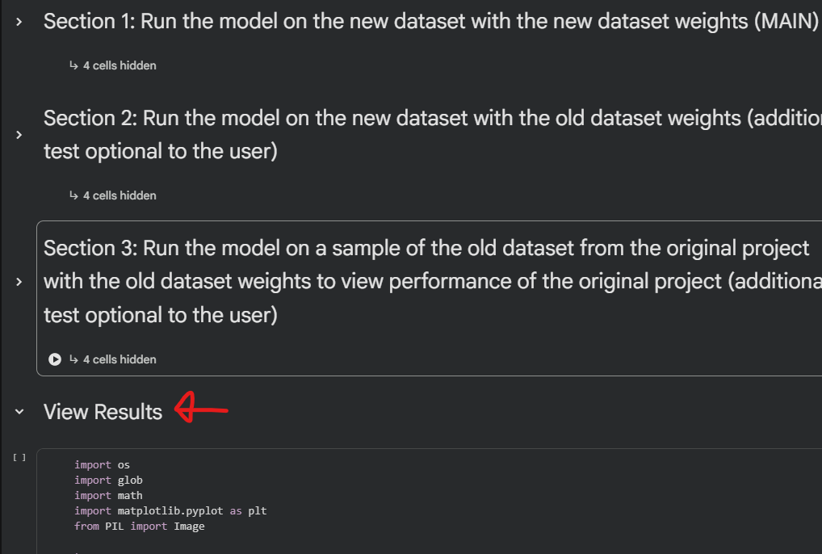

Instructions to run the output evaluation codes
WRIBQuantitativeAnalysis.m file is used to perform evaluation on the model outputs
To run this file, you must have the resulting images of the “Running on new dataset” outputs (Test 1) along with the “Old dataset using the old weight” Outputs (Test 3) .
From the root of your script file, whether it be the same as it came within the zip file or if you decide to move the script elsewhere, create a folder to and insert the two sets of result images (two new folders). Go into the script file and follow the instructions, It will ask you to update the relative path so the script may gather the result images
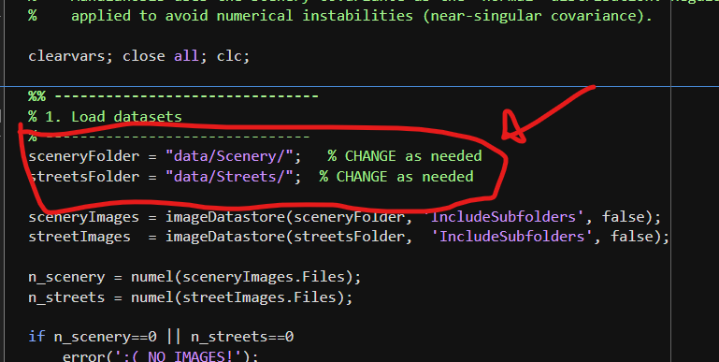

You can also directly get a zip folder of all the results within the drive link described in the previous section, you will find them in the results folder
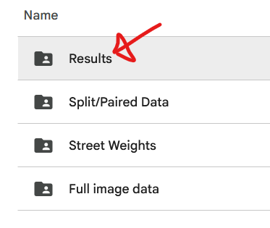
https://drive.google.com/drive/folders/1JDY_-iKj66uf4Nz7ul-X14zhl88WxOlQ?usp=sharing

Once your two data folders are setup and the appropriate relatives paths are edited into the script folder, you may execute the sections in order to view the evaluation.

Note: If you wish, you may also use the Test 2 results (Running on new dataset with old dataset weights) if you wish to see the evaluation of that test.

