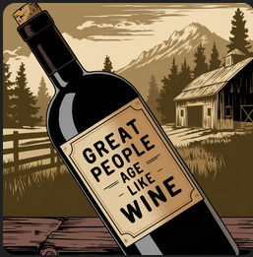

HallMarc

HallMarc

Bitcoin ages better than wine. Download:
Minitbits on Goolge Play
Macadamia on The App Store

Scan QR Code with your wallet
Happy Birthday! Here’s some sats.


Bitcoin ages better than wine.

Download:
Minibits on Goolge Play
Macadamia on The App Store
Happy Birthday! Here’s some sats.
Scan QR Code with your wallet



