**MENTOR-SHIFT: A MOBILE PLATFORM SOLUTION**

**ON PERSONALIZED TUTORING**

A Capstone Project Presented to

The Faculty of the Undergraduate Program

School of Engineering and Computer Studies

Divine Word College of Legazpi

In Partial Fulfillment

of the Requirements for the Degree

BACHELOR OF SCIENCE IN INFORMATION TECHNOLOGY

By

**JADE BUBAN RAPOSA**

**IAN JAY NICCOLO DURAN BUENO**

**MARC AUSTIN KATIGBAK BONAGUA**

October 2024

**RECOMMENDATION FOR CAPSTONE PROJECT FINAL DEFENSE**

In partial fulfillment of the requirements for the Degree of Bachelor of Science in Information Technology, this Capstone Project entitled, “**MENTOR-SHIFT: A MOBILE PLATFORM SOLUTION ON PERSONALIZED TUTORING”** prepared by **Jade Buban Raposa, Ian Jay Niccolo D. Bueno and Marc Austin K. Bonagua** are hereby submitted to the Capstone Project Committee for consideration and approval.

**DHAN DAVISH ALAMO**

Adviser

In partial fulfillment of the requirements for the Degree of Bachelor of Science in Information Technology, this Capstone Project entitled, “**MENTOR-SHIFT: A MOBILE PLATFORM SOLUTION ON PERSONALIZED TUTORING”** prepared and submitted by **Jade Buban Raposa, Ian Jay Niccolo D. Bueno, and Marc Austin K. Bonagua** are hereby considered and endorsed for Final Defense.

**RHODORA FAYE A. BROSAS, MBA, MIT**

Capstone Project Coordinator

**RESULT OF THE FINAL DEFENSE**

**Project Title:** MENTOR-SHIFT: A MOBILE PLATFORM SOLUTION ON                PERSONALIZED TUTORING

**Researcher:** Jade Buban Raposa Ian Jay Niccolo D. Bueno

    Marc Austin K. Bonagua

**Place:**SoECS Conference Room **Date:** October 14, 2024 **Time:** 11:30 AM

FINAL DEFENSE COMMITTEE       ACTION TAKEN

**JP REMAR A. SERRANO ________________**

Panel Member

**REILAN L. CADUBLA             ________________**

Panel Member

**DHAN DAVISH V.ALAMO**

Adviser

**RHODORA FAYE A. BROSAS, MBA, MIT**

Capstone Project Coordinator

**CAPSTONE PROJECT 2 COMPLETION**

**Project Title:** MENTOR-SHIFT: A MOBILE PLATFORM SOLUTION ON PERSONALIZED TUTORING

**Researcher:** Jade Buban Raposa, Ian Jay Niccolo D. Bueno

Marc Austin K. Bonagua  

**Degree Program:** Bachelor of Science in Information Technology

**Final Defense Completed on:**October 14, 2024

**CAPSTONE PROJECT COMMITTEE**

FINAL DEFENSE COMMITTESIGNATURES

**JP REMAR A. SERRANO ________________**

Panel Member

**REILAN  L. CADUBLA ________________**

Panel Member

**DHAN DAVISH V. ALAMO ________________**

Adviser

**VICTOR Q. PARILLAS JR., DIT**

Chairman

**CERTIFICATE OF APPROVAL**

This is to certify that the Capstone Project of:

**JADE BUBAN RAPOSA**

**IAN JAY NICCOLO D. BUENO**

**MARC AUSTIN K. BONAGUA**

Has been approved by the Capstone Project Committee in partial fulfillment of the Requirements of the Bachelor of Science in Information Technology School of Engineering and Computer Studies.

**DHAN DAVISH ALAMO**

Adviser

**RHODORA FAYE A. BROSAS, MBA, MIT**

Capstone Project Coordinator

**ENGR. MARBEN S. RAMOS, LPT**

OIC – Dean

**EXECUTIVE SUMMARY**

**Project Title:** MENTOR-SHIFT: A MOBILE PLATFORM SOLUTION ON PERSONALIZED TUTORING

**Researcher:** Jade Buban Raposa Ian Jay Niccolo D. Bueno

    Marc Austin K. Bonagua

**Keywords:**  Educational Technology, Mentorship, Mobile Learning, Personalized Learning

The "MENTOR-SHIFT: A Mobile Platform Solution for Personalized Tutoring" is an application designed to enhance the mentorship and tutoring experience in academic settings. This mobile platform addresses several critical gaps in the current educational support systems, including the difficulty in finding suitable mentors, the lack of personalized learning approaches, and the challenges in tracking academic progress and certification. By enabling seamless communication between students and educators and fostering flexible and structured mentorship opportunities, MENTOR-SHIFT provides a comprehensive solution that promotes effective mentorship within a mobile platform. Key features of the system include:

The platform enables users to select their roles during sign-up, providing tailored access to features based on their role as either a student or educator. Students can search for mentors, request mentorship, and access educational resources, while educators can manage mentorship requests and provide relevant materials. The streamlined mentorship request process allows educators to accept or decline requests based on their availability and expertise, ensuring personalized mentorship aligned with students' academic goals.

Educators can create and manage courses, post study materials, and assign activities such as quizzes and lessons. These resources become available to students once their mentorship request is approved, facilitating structured learning. The platform also allows educators to monitor student progress, input reports, and upload certificates for students who successfully complete their tasks. Students can download these certificates as proof of their achievements and progress.

A built-in messaging system enables real-time communication between mentors and mentees, fostering collaboration and enhancing the learning experience. This feature ensures continuous engagement and support throughout the mentoring process.

The development of MENTOR-SHIFT follows the Agile Lean approach, emphasizing iterative development, continuous improvement, and user feedback to create a user-friendly and highly adaptable platform. This ensures the app remains flexible, responsive to user needs, and capable of evolving with future educational trends. By promoting collaborative learning environments, MENTOR-SHIFT supports both mentors and mentees in achieving academic success.

**ACKNOWLEDGEMENT**

Without the assistance of the individuals behind this project, this work would not have been possible.

**RHODORA FAYE A. BROSAS, MBA, MIT ,** Capstone Project Coordinator, her guidance drove to the completion of this project.

**DHAN DAVISH ALAMO,** for his unwavering support, guidance and motivation which helped the completion of the project.

**JP REMAR A. SERRANO** and **REILAN L. CADUBLA** , panel members, for their constructive criticisms and suggestions significantly enhanced this project.

**FAMILY,** who have always been there, showing them support throughout their education.

**FRIENDS,** who have been the main source of happiness at school, offering their warmth and comfort to get through during tough times. Their understanding has helped in navigating the challenges of college life with resilience and a smile.

Each played a significant role in making this project successful and they are grateful for it.

**TABLE OF CONTENTS**

**Contents   Page No.**

Title Page .  .  .  .  .  .  .  .  .  .  .  .  .  .  .  .  .  .  .  .  .  .  .  .  .  .  .  .  .  .  .  .  .  .  .  .  .  .  i

Recommendation for Final Defense .  .  .  .  .  .  .  .  .  .  .  .  .  .  .  .  .  .  .  .  .  .  .  ii

Result of Final Defense .  .  .  .  .  .  .  .  .  .  .  .  .  .  .  .  .  .  .  .  .  .  .  .  .  .  .  .  .  .  iii

Capstone Completion .  .  .  .  .  .  .  .  .  .  .  .  .  .  .  .  .  .  .  .  .  .  .  .  .  .  .  .  .  .  .  iv

Certificate of Approval .  .  .  .  .  .  .  .  .  .  .  .  .  .  .  .  .  .  .  .  .  .  .  .  .  .  .  .  .  .  . v

Executive Summary .  .  .  .  .  .  .  .  .  .  .  .  .  .  .  .  .  .  .  .  .  .  .  .  .  .  .  .  .  .  .  .  vi

Acknowledgement .  .  .  .  .  .  .  .  .  .  .  .  .  .  .  .  .  .  .  .  .  .  .  .  .  .  .  .  .  .  .  .  .  vii

Table of Contents .  .  .  .  .  .  .  .  .  .  .  .  .  .  .  .  .  .  .  .  .  .  .  .  .  .  .  .  .  .  .  .  .  viii

List of Tables .  .  .  .  .  .  .  .  .  .  .  .  .  .  .  .  .  .  .  .  .  .  .  .  .  .  .  .  .  .  .  .  .  .  .  .  ix

List of Figures .  .  .  .  .  .  .  .  .  .  .  .  .  .  .  .  .  .  .  .  .  .  .  .  .  .  .  .  .  .  .  .  .  .  .  . x

**Chapter**

**1  PROJECT IDENTIFICATION**

Project Context .  .  .  .  .  .  .  .  .  .  .  .  .  .  .  .  .  .  .  .  .  .  .  .  . 1

Description of the Existing System .  .  .  .  .  .  .  .  .  .  .  .  .  .  8

Statement of the Problem .  .  .  .  .  .  .  .  .  .  .  .  .  .  .  .  .  .  . 9

Objectives of the Study .  .  .  .  .  .  .  .  .  .  .  .  .  .  .  .  .  .  .  .  . 10

Purpose and Description .  .  .  .  .  .  .  .  .  .  .  .  .  .  .  .  .  .  .  .  11

Scope and Delimitation .  .  .  .  .  .  .  .  .  .  .  .  .  .  .  .  .  .  .  .  .  12

Technical Terms .  .  .  .  .  .  .  .  .  .  .  .  .  .  .  .  .  .  .  .  .  .  .  .  .  13

**Chapter**

**2  METHODOLOGY**

Software Development Cycle .  .  .  .  .  .  .  .  .  .  .  .  .  .  .  .  .  .  22

Purpose, Deliverables, and Development Activities .  .  .  .  .  24

Data Gathering Techniques .  .  .  .  .  .  .  .  .  .  .  .  .  .  .  .  .  .  .  26

Sources of Data .  .  .  .  .  .  .  .  .  .  .  .  .  .  .  .  .  .  .  .  .  .  .  .  .  .  27

Survey Results .  .  .  .  .  .  .  .  .  .  .  .  .  .  .  .  .  .  .  .  .  .  .  .  .  .  28

Theoretical Framework .  .  .  .  .  .  .  .  .  .  .  .  .  .  .  .  .  .  .  .  .  40

Conceptual Framework .  .  .  .  .  .  .  .  .  .  .  .  .  .  .  .  .  .  .  .  .  42

**Chapter**

**3  REQUIREMENTS ANALYSIS AND DOCUMENTATION**

Flowchart.  .  .  .  .  .  .  .  .  .  .  .  .  .  .  .  .  .  .  .  .  .  .  .  .  .  .  .  .  45

System Architecture .  .  .  .  .  .  .  .  .  .  .  .  .  .  .  .  .  .  .  .  .  .  .  47

Software Design .  .  .  .  .  .  .  .  .  .  .  .  .  .  .  .  .  .  .  .  .  .  .  .  .  48

Database Design .  .  .  .  .  .  .  .  .  .  .  .  .  .  .  .  .  .  .  .  .  .  .  .  .  53

System Requirements .  .  .  .  .  .  .  .  .  .  .  .  .  .  .  .  .  .  .  .  .  . 56

System Tradeoffs .  .  .  .  .  .  .  .  .  .  .  .  .  .  .  .  .  .  .  .  .  .  .  .  .  60

System Design .  .  .  .  .  .  .  .  .  .  .  .  .  .  .  .  .  .  .  .  .  .  .  .  .  .  65

Project Timeline .  .  .  .  .  .  .  .  .  .  .  .  .  .  .  .  .  .  .  .  .  .  .  .  .  70

**CHAPTER**

**4  SUMMARY, FINDINGS, CONCLUSIONS, AND RECOMMENDATIONS**

Summary .  .  .  .  .  .  .  .  .  .  .  .  .  .  .  .  .  .  .  .  .  .  .  .  .  .  .  .  .

Findings .  .  .  .  .  .  .  .  .  .  .  .  .  .  .  .  .  .  .  .  .  .  .  .  .  .  .  .  .  .

Conclusions .  .  .  .  .  .  .  .  .  .  .  .  .  .  .  .  .  .  .  .  .  .  .  .  .  .  .  .

Recommendations .  .  .  .  .  .  .  .  .  .  .  .  .  .  .  .  .  .  .  .  .  .  .  .

**REFERENCES** .  .  .  .  .  .  .  .  .  .  .  .  .  .  .  .  .  .  .  .  .  .  .  .  .  .  .  .  .  .  .  .  .

**APPENDICES**

A Letter .  .  .  .  .  .  .  .  .  .  .  .  .  .  .  .  .  .  .  .  .  .  .  .  .  .  .  .  .  .  .  .

B Questionnaires .  .  .  .  .  .  .  .  .  .  .  .  .  .  .  .  .  .  .  .  .  .  .  .  .  .

C Source Code .  .  .  .  .  .  .  .  .  .  .  .  .  .  .  .  .  .  .  .  .  .  .  .  .  .  .  .

D User’s Manual .  .  .  .  .  .  .  .  .  .  .  .  .  .  .  .  .  .  .  .  .  .  .  .  .  .  .

E Gantt Chart .  .  .  .  .  .  .  .  .  .  .  .  .  .  .  .  .  .  .  .  .  .  .  .  .  .  .  .

**CURRICULUM VITAE** .  .  .  .  .  .  .  .  .  .  .  .  .  .  .  .  .  .  .  .  .  .  .  .  .  .  .  .  .

**LIST OF FIGURES**

**Figure no.                                        Title               Page No.**

2.1 Agile Lean Methodology .  .  .  .  .  .  .  .  .  .  .  .  .  .  .   .  .  .  . . . . . . 22

2.2 Community of Inquiry (CoI) .  .  .  .  .  .  .  .  .  .  .  .  .  .  .   .  . . . . . . 40

2.3 Conceptual Framework of the Proposed System .  .  .  .  .  . . . . . . 42

3.1 Flowchart of the Manual Process.  .  .  .  .  .  .  .  .  .  .  .  .  .  .  . . . . . 45

3.2 System Architecture of the Proposed System.  .  .  .   .  .  .  . . . . . . 47

3.3 Use-Case Diagram.  .  .  .  .  .  .  .  .   .  .  .  .  .  .  .  .  .  .  .  .  .  . . . . . . 48

3.4 Sequence Diagram.  .  .  .  .  .  .  .  .  .  .  .  .  .  .  .  .  .  .  .  .  .  . . . . . . 50

3.5 Class Diagram.  .  .  .  .  .  .  .  .  .  .  .  .  .  .  .  .  .  .  .  .  .   .  .  .  . . . . . . 51

**LIST OF TABLES**

**Table no.                                       Title               Page No.**

2.1 Activities of Agile Lean Methodology.  .  .  .   .  .  .  .  .  .  .  .  . . . . . 24

2.2 Reasons Why Students Shift.  .  .  .  .  .  .  .  .  .  .   .  .  .  .  .  . . . . . . 29

2.3 Students Mindset Before Shifting.  .  .  .  .  .  .  .  .  .  .  .   .  . . . . . . 30

2.4 Students Wish They Had Personalized Guidance And Support.  .  .  .  .  .  .  .  .  .  .  .   .  .  .  .  .  .  .  .  .  .  .  .  .  .   .   .   . . . . . 30

2.5 Biggest Obstacle Faced  In Seeking Academic Help  .  .  .  . . . . . . 31

2.6 Importance of Connecting with Mentors using Mobile App .   .  . . 32

2.7 Students Interested In Using The Propose App.  .  .  .  .  .  .  . . . . . 33

2.8 Features Preferred By Students.  .  .  .  .  .  .  .  .  .  .  .  .  .  .  .  . . . . . 33

2.9 Common Challenge Students Face According to Educators.  .  .  .  .  .  .  .  .  .  .  .  .  .  .  .  .  .   .  .  .  .  .  .  . .  .  .  .  . . . . 35

2.10 Ways Personalized Assistance Can Impact A Student’s

Academic Success and Learning Experience.  .  .  .  .  .  .   .  .  .  . . . 36

2.11 Important Skills For Students To Develop In Their Field.  .  .  .  .  . 37

2.12 Educators Comfortability In Using Mobile Apps For

Helping, Connecting, and Supporting Students.  .  .  .  .  .  .  .  . . . 38

2.13 Educators Belief in Apps For Improving And

Enhancing Student’s Knowledge.  .  .  .  .  .  .  .  .  .  .  .  .  . .  .  . . . . . 38

2.14 Features Preferred By Educators For The App.  .  .  .  .  .  .  .  . . . . . 39

3.1 User Table.  .  .  .  .  .  . .  .  .  .   .  .  .  .  .  .  .  .  .  .  .  .  .  .  .  .  .  .  .  .  .  .   53

3.2 Mentor Table.  .  .  .  .  .  .  .  .  .  .  .  .  .  .  .  .  .  .  .  .  .  .  .  .  .  .   .  .  . . 53

3.3 Mentee Table.  .  .  .  .  .  .  .  .  .  .  .  .  .  .  .  .  .  .  . .  .  .  .  .  .  .  .  .  .  . . 54

3.4 Mentorship Request Table.  .  .  .  .  .  .  .  .  .  .  .  .  .  .  .  .  .  .  .  .  .  .  54

3.5 Content Table.  .  .  .  .  .  .  .  .  .  .  .  .   .  .  .  .   .  . .  .  .  .  .  .  .  .  .  .  .  55

3.6 Assessment Table.  .  .  .  .  .  .  .  .  .  .  .  .   .  .  .  .   .  .  .   .  .  .   .  .  . . 55

3.7 Report Table.  .  .  .  .  .  .  .  .  .  .  .  .  .   .  .  .  .  .  .  .  .  .  .  .  .   .  .   .  .  . 56

3.8 Server Hardware Requirements.  .  .  .  .  .  .  .   .  .   .  .  .  .  .  .  .  .  .  .  57

3.9 Client Hardware Requirements.  .  .  .  .  .  .  .  .  .  .  .  .  . .  .  .   .  .  .  . 57

3.10 Recommended Software Specifications.  .  .  .  .  .  .  .  .  .  .   .  .  .  .  .  59

3.11 Technical Issue.  .  .  .  .  .  .  .  .  .  .  .  .  .  .  .  .  .  .  .  . .  .  .   .  .  .  .  .  .  60

3.12 Operational Issues.  .  .  .  .  .  .  .  .  .  .  .  .  .  .  .  .  . .  .  .  .   .  .  .  .  .  .  62

3.13 Economic Issues.  .  .  .  .  .  .  .  .  .  .  .  .  .  .  .  .  .  .  .  .  .  .  .  .  .  .  .  .  . 63

3.14 Non-Functional Requirements.  .  .  .  .  .  .  .  .  .  .   .  .  .  .  .  .  .  .  . . . 65

3.15 Functional Requirements.  .  .  .  .  .  .  .  .  .  .  . .  .   .  .  .  .  .  .  .  .  .  . . 66

3.16 Gantt Chart Using Lean Methodology.  .  .  .  .  .  .  .  .  .  .  .  .  .  .  .  . . 70

# Chapter 1

**PROJECT CONTEXT**

The initiative emerges from the dynamic connection between tutoring and mobile technology, representing a paradigm shift in educational assistance systems. The integration of mobile platforms transforms tutoring, a long-standing practice based on personalized instruction. This context demonstrates a major shift in how students access educational resources and interact with mentors. Mobile technology provides consumers with unprecedented convenience and flexibility, allowing for seamless interaction with educational content and expert support. The project emerges as a pioneering initiative at the forefront of educational innovation. By leveraging the ubiquitous nature of mobile devices and the personalized approach of tutoring, the project seeks to redefine the learning experience. It operates within a landscape shaped by digital connectivity and personalized learning pathways, where learners can access educational support anytime, anywhere. This sets the stage for the project to catalyze a shift towards more inclusive, accessible, and effective learning environments, driving progress towards educational equity and excellence.  
 This educational approach directly contributes to Goal 4: Quality Education by making learning opportunities more accessible and supporting lifelong learning. Furthermore, it contributes to Goal 8: Decent Work and Economic Growth by equipping individuals with critical skills and information, particularly through mentoring programs powered by mobile apps. This idea also aligns with Goal 10: Reduced Inequalities by reducing educational barriers and providing mentorship opportunities for marginalized groups. Finally, Goal 11: Sustainable Cities and Communities is supported using digital platforms to reduce educational gaps and promote inclusive learning environments. Overall, the combination of teaching and mobile app technology offers revolutionary potential, accelerating progress toward several SDGs and creating a more equitable and sustainable future.

Personalized learning is a crucial educational strategy that tailors instruction to individual students' needs, interests, and abilities. It aims to enhance student engagement, motivation, and academic success by accommodating individual variations. Shemshack (2020) discussed personalized learning as a natural human activity shaped by experiences, emphasizing the importance of technology integration in creating effective personalized learning models.  Khor (2023) discussed personalized learning benefits, challenges, and the role of learning analytics in leveraging and supporting personalized instruction. Zhang (2020) discussed the historical background, government policies, and interdisciplinary research on personalized learning, emphasizing the need for collaboration across disciplines. Mirasol (2023) discussed the flexibility and personalization of learning in the Open High School Program for senior high learners, emphasizing tailored learning experiences. Lagman (2017) discussed personalized learning in environments that focus on a one-size-fits-all approach, leading to challenges for students with learning difficulties. To improve learning efficiency and recommend appropriate content for individual learners, personalized e-learning platforms were developed to cater to specific learning needs and preferences by providing personalized learning paths tailored to specific requirements

The combination of these studies reinforces the idea that personalized learning is an effective educational strategy that promotes individualized instruction and enhances learning results. The integration of technology, cross-disciplinary collaboration, and individualized learning experiences all help to create effective personalized learning environments. As educational institutions explore and implement personalized learning approaches, it is critical to use research and practice insights to improve teaching and learning for all students.

E-learning and mobile learning (m-learning) are two transformative approaches to education that leverage technology to deliver learning content. E-learning encompasses

resources accessed via computers or the internet. While m-learning is a part of e-learning that utilizes mobile devices like smartphones and tablets for anytime, anywhere learning. These methods offer flexibility, accessibility, and customization, revolutionizing education in the digital age. Pimmer (2016) discusses how mobile learning in higher education is associated with positive outcomes, especially with instructionist and hybrid designs, but evidence for broad application is limited. Chen (2023) offers a systematic view of mobile device ownership and its implications for learning that aims to help institutions establish mobile strategies. The results show students' evolving beliefs about the value of mobile technology. Sebastian (2024) explores the application of the flipped learning model in online learning environments and its effectiveness in preparing students for a complex and ever-changing world. It highlights the impact of educational technology on student performance and learning outcomes, emphasizing the role of new modes of learning in enhancing learning outcomes. Mobo (2019) discusses how e-learning is seen as beneficial for students, offering flexibility, accessibility, and improved academic performance through the use of electronic tools and resources. E-learning is defined as cost-efficient, skill-developing, and flexible learning system. Bacolod (2022) shows how mobile learning is considered a flexible and innovative solution for restricted learning, especially in situations like natural disasters and pandemics, where traditional face-to-face instruction is disrupted. Fabito (2017) provides insights into the factors that contribute to the effectiveness of mobile learning. It shows the students' perceptions of mobile learning and identifies the key factors that influence their success in using mobile devices for learning purposes.

These indicate that e-learning and mobile learning (m-learning) offer flexibility, accessibility, and customization in education. Positive outcomes, such as improved academic performance and student engagement, are observed across various contexts. Effective instructional design and technological integration are essential for maximizing the benefits of these approaches. The evolving student beliefs highlight the importance of institutions establishing effective mobile strategies. Innovative models like flipped learning show promise in enhancing learning outcomes and preparing students for modern challenges. In summary, e-learning and m-learning are vital components of contemporary education, providing cost-efficient, skill-developing, and flexible learning solutions adaptable to various disruptions.

Tutorship, mentorship, and peer mentoring represent integral components of educational support systems, each contributing uniquely to personal and academic development. Arnesson (2017) highlights mentorship as a pedagogic tool bridging theory and practice in higher education, emphasizing mentors' role in students' learning and professional growth. Thakare (2019) and Farheen (2018) delve into software development for online mentoring systems, recognizing mentorship's potential for transferring knowledge and fostering positive mentor-mentee relationships. Chung (2022) explores mobile app development aimed at enhancing online peer tutoring experiences, emphasizing the importance of face-to-face and remote mentoring sessions.

Research findings underscore the effectiveness of mentoring programs across various contexts. Gutierrez (2016) identifies cultivation phases and formal mentoring programs as key contributors to mentoring effectiveness, particularly beneficial for junior faculty members. Bercasio (2016) and Balan (2015) examine the impact of peer mentoring on skill enhancement and research competency, demonstrating positive outcomes in problem-solving and research skill development. Campit (2015) and Almaden (2024) further support the efficacy of peer tutoring and mentorship in improving academic performance and entrepreneurial capacity, respectively. Combo (2023) and Calo (2020) contribute insights into mentorship systems' design and implementation, focusing on research competency development and tutorial efficiency. Salinas (2024) and Vecaldo (2021) highlight the role of peer mentoring in improving reading performance and providing comprehensive support to practice teachers, respectively. Torres (2022) addresses the need for mobile solutions for accessing tutoring services, emphasizing the importance of reliable tutor-parent connections.

These studies emphasized the significant effects of mentoring, tutoring, and peer tutoring on personal and academic development. Mentorship programs offer invaluable guidance

support, fostering positive relationships between mentors and mentees, which enhance academic performance, career development, and research competency. Similarly, tutoring systems facilitate personalized learning experiences and academic success, improving reading performance, research skills, and subject proficiency among students. Peer tutoring methods and programs have been shown to have great effects as they promote collaborative learning, mutual empowerment, and academic achievement among peers. Peer tutoring fosters a supportive learning environment where students can share knowledge, build confidence, and improve their understanding of academic concepts. In totality, these forms of support play crucial roles in empowering individuals, promoting learning outcomes, and enhancing educational experiences across diverse areas.

These various studies underscore the efficacy of personalized learning, e-learning, mobile learning, mentoring, tutoring, and peer tutoring in enhancing educational outcomes. By leveraging technology, cross-disciplinary collaboration, and individualized instruction, these approaches facilitate flexible, accessible, and customizable learning experiences that cater to diverse student needs. The Mentor-Shift mobile app stands to benefit from these insights by providing a platform where users can access personalized mentorship, educational resources, and assessments tailored to their individual learning objectives and interests. By integrating elements

**COMPANY PROFILE**

The Divine Word College of Legazpi (DWCL) is a private Catholic co-educational basic and higher education institution run by the Philippine Central Province of the Society of the Divine Word in Legazpi, Albay, Philippines. It was founded by Rev. Fr. Juan Carullo, a retired Army Chaplain in 1947. It offers basic and higher education programs and has two campuses, which are the North and South.

Five departments in Divine Word College of Legazpi (DWCL) include the School of Engineering and Computer Studies (SOECS), School of Education, Arts, and Sciences (SEAS), School of Hospitality Management (SHOM), School of Nursing (SON), and School of Business, Management and Accountancy (SBMA). The SOECS department, which consists of five course programs, would be the pioneer scope for the proposed mobile app. They include Bachelor of Science in Electrical Engineering (BSEE), Bachelor of Science in Civil Engineering (BSCE), Bachelor of Science in Computer Science (BSCS), Bachelor of Science in Information Technology (BSIT), and Bachelor of Library and Information Science (BLIS).

**DESCRIPTION OF THE EXISTING SYSTEM**

The tutoring industry has changed dramatically in modern times. Students all around the world can now easily access professional tutors through internet platforms. These services offer on-demand sessions with interactive features like screen-sharing and virtual whiteboards for improved collaboration and learning. They also enable tailored assistance across a range of subjects.

Thanks to tools like Zoom and Google Meet, live tutoring sessions may now be conducted virtually in schools. These settings resemble conventional classrooms and encourage teacher-student dialogue, arguments, and immediate feedback. Additionally, they remove the requirement for in-person attendance by enabling participation from any location with internet access, providing flexibility and inclusivity.

By giving students quick access to educational resources and individualized learning experiences on their smartphones and tablets, mobile applications have completely changed the tutoring industry. Self-directed learning is encouraged by apps such as Quizlet and Duolingo, which let users customize their learning objectives with dynamic courses, assessments, and flashcards. In addition to improving accessibility, this mobile-first strategy gives students the freedom to manage their education whenever and wherever they choose. These cutting-edge tutoring techniques herald a new era of adaptable, captivating, and inclusive education by pointing to a move toward digitalization and customized learning.

**DESCRIPTION OF THE PROPOSED SYSTEM**

The app offers a variety of study materials, tests, and activities that match the areas of expertise of the selected mentor, making it easier for users to choose mentors based on their interests and level of experience. After completing tasks provided by mentors, users receive certificates, and they have access to resources for diverse learning that are displayed like a classroom, in which you can personalize your study habit according to your preferences. Mentor approval is required to access these study materials, which promotes relationships between mentors and mentees. Students can assess their understanding and identify areas for improvement by using the performance reports from quizzes and exams that will be maintained by the mentor. The app's main goal is to help students by making mentor selection and individualized learning experiences easier. Users can look for mentors according to standards, making sure that the mentors match their academic objectives. Once the mentor is selected, they can request for mentorship approval for the mentor to decide. After the approval of the mentor, students can then have access to a variety of study materials and each their own activities for measuring how much they’ve learned, this promotes greater comprehension and helps them to successfully handle difficulties that require skill that they’re lacking.

The app also integrates a messaging system that allows seamless communication between students and their selected mentors. This system fosters a direct and supportive relationship, enabling students to ask questions, request clarification, and receive feedback from their mentors in real time. This gives bridge for the mentor to provide notifications and updates on activities, feedback, and important study material recommendations, ensuring a continuous flow of guidance and interaction. Certificates are awarded upon completion of tasks and assessments as a way to recognize the student's progress. These certificates are manually created by the mentor, personalized to the student’s achievements. Once a mentor has finalized a certificate, it is uploaded into the app, where students can easily download it.

This feature provides an official and tangible record of accomplishments, which students can use to showcase their expertise and progress in their learning journey. The program makes sure mentors have control over the learning process by highlighting how important it is to get mentor approval before accessing study materials. While mentor acceptance is necessary for mentors to examine and accept guidance requests, users can still choose mentors and see resources. By giving students quick access to educational resources and individualized learning experiences on their smartphones and tablets, mobile applications have completely changed the tutoring industry. Self-directed learning is encouraged by apps such as Quizlet and Duolingo, which let users customize their learning objectives with dynamic courses, assessments, and flashcards. In addition to improving accessibility, this mobile-first strategy gives students the freedom to manage their education whenever and wherever they choose. These cutting-edge tutoring techniques herald a new era of adaptable, captivating, and inclusive education by pointing to a move toward digitalization and customized learning.

**STATEMENT OF THE PROBLEM**

The proposed study, titled “Mentor-Shift: A Mobile Application Solution On Personalized Tutoring," seeks to address the following questions:

1. What are the challenges faced by students in the School of Engineering and Computer Studies (SOECS) in terms of:

1. Mentor Selection;
2. Learning Approach;
3. Certification and Reports?

2. What will be the features of the propose system to address the problem encountered in terms of:

1. Mentor Selection;
2. Learning Approach;
3. Certification and Reports?

3. What is the evaluation tool to be used for the propose system, considering the ISO 25010 standards, particularly in terms of:

1. Usability;
2. Reliability;
3. Maintainability; and
4. Portability?

**OBJECTIVES OF THE STUDY**

The objectives of the propose mobile application, “Mentor-Shift” is to develop a comprehensive mobile platform that is specifically designed to streamline tutoring for students in need of academic help and educators that are willing to support and assist them.

The study has the following objectives:

1. To identify and analyze the specific challenges encountered by students within the School of Engineering and Computer Studies (SOECS) related to mentor selection, learning approach, and certification, as well as reporting processes.

2. To develop a propose system with the following features such as mentor preference and selection, unconstrained learning approach through a classroom-like interface for mentees to view study materials, complete activities, and check reports to tracks their scores and progress. These elements are designed to enhance individualized learning experiences, streamline mentor-student interactions, and provide clear assessments of academic development.

3. To assess the propose Mentor-Shift system based on key criteria such as usability, reliability, maintainability, and portability. This evaluation tool will provide insights into the effectiveness and efficiency of the system in addressing the identified challenges within SOECS, ensuring its suitability and practicality for implementation in real-world educational settings.

**PURPOSE AND DESCRIPTION**

The aim of this study is to revolutionize the tutoring experience within the School of Engineering and Computer Studies (SOECS) through the development of Mentor-Shift, a mobile application tailored to facilitate personalized learning. By addressing the limitations of traditional tutoring methods, Mentor-Shift seeks to provide a versatile platform accessible to students, adaptable to their evolving needs, and conducive to academic success. The proposed application will benefit various stakeholders as follows:

**Students**. The app will empower students to take charge of their learning journey by connecting them with mentors tailored to their needs. It will offer a streamlined approach to managing tutoring sessions, tracking progress, peer-to-peer learning, and providing feedback, thereby enhancing the learning experience.

**Educators**. The platform will serve as a valuable tool by connecting them with students who are seeking their expertise. It will provide a structured environment for their interactions with students, allowing them to easily communicate and collaborate.

**SOECS Department**. The app will elevate the tutoring experience by offering personalized guidance, fostering collaboration, and enhancing course persistence. It will make academic support more accessible to everyone, resulting in a more inclusive and effective learning environment.

**Researchers**. This study aims to advance knowledge in educational technology by examining practical applications of personalized learning platforms and their impact on student outcomes.

**Future Researchers**. This study will serve as a blueprint for future research endeavors in educational technology, offering valuable lessons on the design and implementation of user-friendly applications tailored to support student success.

**SCOPE AND DELIMITATION**

The software serves as a comprehensive platform for mentorship activities, providing educators and students within the School of Engineering and Computer Studies (SOECS) department with an online mobile app. Mentees can use the app to search for mentors, request mentorship based on their preferences and areas of expertise, and access a personalized learning experience through a classroom-like interface. Within this interface, mentees can view study materials, complete activities, and monitor their progress and score-based reports. Mentors can approve mentorship requests from mentees, announcements and post URL links to educational resources or Google Meet for meetings and classes, customize their profiles, input scores from activities and communicate with mentees in real time via messaging. Designed for Android smartphones, the app ensures accessibility and user-friendly navigation, enhancing the mentor-mentee relationship and providing tailored learning experiences.

The application lacks built-in video conferencing capabilities, instead relying externally on Google Meet for virtual communication. Mentor matching does not generate automatic recommendations; instead, mentees search for mentors based on their target preferences, especially the subject/topic they want to improve on. The app does not have any designated database for multi-purpose files, so we had no choice but to lay aside the feature for uploading and downloading of different file types. The app does not use machine learning for targeted recommendations or advanced analytics. Payment transactions are handled outside of the app to allow for a more focused approach to mentoring and learning.

**TECHNICAL TERM**

The following terms were defined conceptually and operationally for clarity and common understanding.

**Certification and Reports** - the certification is a completion of the content by the mentee; the certificate is awarded as proof that standards have been met. This report will follow the review's results and offer information on whether the requirements were fulfilled. It refers to the feature of the propose system wherein the mentee can download and print the certificate after finishing the lessons or completed all the mentor’s module.

**Mentor Selection -** Effective technical mentorship hinges on selecting experts with essential skills, clear communication, and proven ability to support learners. With the use of the propose system, the mentee can search, select, and request mentorship to a mentor that fits their preferences.

**Mobile Application -** refers to a software application specifically designed to run on mobile devices such as smartphones and tablets. These applications are typically downloaded and installed from app stores or other distribution platforms and offer a wide range of functionalities,

including productivity tools, entertainment, social networking, gaming, and more. It refers to the propose system that will be available to every Android device.

**Personalized Learning Approach -** This educational approach customizes learning to match individual students' needs, interests, and abilities, with the goal of enhancing engagement and academic success. The proposed system enables students to tailor their learning experience by accessing lessons, study materials, and activities at their own pace, much like in a classroom setting.

**Real-time Messaging Interface -** the interface facilitating real-time communication between mentors and mentees within the app, enabling seamless interaction, collaboration, and support during tutoring sessions. Another feature of the propose system where messaging can be done between the mentors and mentees for communication purposes.

**Chapter 2**

**METHODOLOGY**

This chapter presents the software development, data gathering techniques, sources of data, results, theoretical framework, and conceptual framework that were used in designing the system.

**SOFTWARE DEVELOPMENT**

**Figure 2.1**

*Agile Lean Methodology*

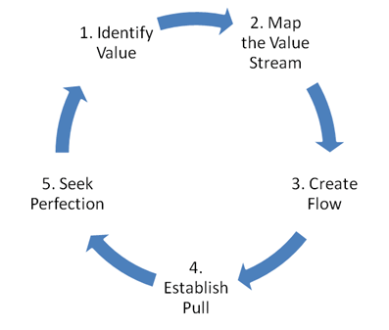

In developing the Mentor-Shift application, we adhere to Lean principles, focusing on efficiency and continuous improvement. Our approach encompasses five essential phases to streamline processes and maximize value. By following these phases, we aim to deliver a high-quality application that meets and evolves with user needs.

**Identify Value:** Recognize user demands and identify the key features that provide the most value. To obtain in-depth insights, this entails holding focus groups, questionnaires, and user interviews. Prioritizing features that directly address user pain points and improve the user experience overall is also necessary.

The developers will participate in focus groups and user interviews to gain firsthand insights into user needs and pain points. They will analyze the gathered data to determine the key features that offer the most value and prioritize them in the development backlog

**Map the Value Stream:** Create a waste-free, value-delivering process by visualizing and designing it. Make thorough process maps to help you find and eliminate operations that don't offer value. In order to guarantee a comprehensive understanding of the development process, collaborate with cross-functional teams. Then, iteratively improve these workflow maps.

The developers will collaborate with cross functional teams to create detailed process maps of the development workflow

**Create Flow:** Make sure there are few delays or bottlenecks in the development process. Use agile approaches like Scrum or Kanban to efficiently handle work-in-progress. To keep development moving at a constant pace and encourage candid communication among team members, cultivate a culture of continuous integration and continuous deployment, or CI/CD.

The developers in this phase will practice continuous integration and continuous deployment (CI/CD) to maintain a steady development pace and enhance communication

**Establish Pull:** By building features in response to user demand and feedback, you can ensure that they are both relevant and valuable. Focus groups, questionnaires, and beta testing can all be used to involve users and obtain insightful feedback. Consider these suggestions while prioritizing new development, and use data analytics to help you make wise decisions and continue to enhance your product.

The developers in this phase will build features based on user feedback obtained from focus groups, questionnaires, and beta testing

**Seek Perfection:** Strive for perfection in every facet of the project by making constant improvements. Adopt a Kaizen (continuous improvement) mindset and evaluate procedures and results frequently to find areas that could use better. After every development cycle, hold retrospectives and evaluate results using important metrics to direct efforts toward improvement and promote an innovative and learning culture.

The developers will participate in retro perspective  after each development cycle, using key metrics to guide their improvement efforts and foster a culture of innovation and learning

**Purpose, Deliverables, and Developmental Activities**

**Table 2.1**

*Activities of Agile Lean Methodology*

|  |  |  |  |
| --- | --- | --- | --- |
| **Method** | **Purpose** | **Deliverables** | **Development**  **Activities** |
| Eliminate Waste | Identify and eliminate non-value adding activities and processes to optimize resource utilization. | Waste reduction plan, Process flow diagrams | Analyze current processes for inefficiencies, Identify and prioritize waste elimination opportunities |
| Create Knowledge In | Foster a culture of continuous learning and improvement, leveraging insights to drive innovation. | Knowledge sharing platform, Innovation reports | Encourage collaboration and idea sharing, Implement feedback loops for continuous improvement |

|  |  |  |  |
| --- | --- | --- | --- |
| Build Quality In | Embed quality assurance practices into the development process to ensure a high-quality end product. | User interface prototypes or mockups, UI/UX quality standards | Implement automated testing, Conduct code reviews and inspections, Address defects promptly |
| Fast Delivery | Streamline development and deployment processes to deliver value to users quickly and efficiently. | Iterative development cycles, Functional prototypes or minimum viable product (MVP) | Prioritize features based on user feedback, Minimize handoffs and delays |
| Empower Your Team | Empower team members by providing autonomy, support, and resources to make decisions and take action. | Team communication plan detailing, Roles and responsibilities matrix | Delegate authority and decision-making, Provide training and mentorship to enhance team capabilities |
| Delay In Making Decisions | Avoid premature decisions by gathering sufficient information and considering all available options. | Decision log, Risk register | Gather relevant data and insights, Evaluate decision criteria and alternatives before making a decision |
| Optimize The Whole | Optimize the system as a whole rather than individual components, considering interdependencies. | System optimization plan, Post-project review report | Conduct system-wide analysis, Identify bottlenecks and inefficiencies, Implement holistic improvements |

**DATA GATHERING TECHNIQUES**

The study employs in-depth interviews and surveys to investigate student and educator experiences, specifically focusing on learning styles and areas conducive to personalized learning. Its primary objective is to gain comprehensive insights into these experiences:

**Interviews.** Perform in-depth interviews with instructors, students, and leaders in education to learn about their perspectives on tutoring strategies, difficulties faced by students, and possible advantages of the Mentor-Shift app.

**Questionnaire.** Use online questionnaires to get numerical data from educators and students. Responses from the students will cover expectations, difficulties, and preferences for mobile learning and individualized tutoring. The opinions of educators will shed light on the methods of tutoring that are used today and what they anticipate from the Mentor-Shift app.

**Document Analysis.** Conduct document analysis using literature reviews and research studies to gather information already in the public domain about mobile learning, personalized tutoring, and the effectiveness of related educational technology applications from the perspectives of educators and students.

**SOURCES OF DATA**

The data-gathering methods the researchers focused on were interviews and research, wherein the participants in the interviews were mixed with DWCL students, faculty members, and educational leaders. Furthermore, the researchers review the literature and research studies that will assist them in gathering relevant information about personalized tutoring, mobile learning, and educational technology.

**Interviews.** Students of the SOECS department under IT, CS, and Engineering courses are interviewed to learn about their opinions on the difficulties facing tutoring today, what they hope to get out of the Mentor-Shift program, and what they think about individualized tutoring techniques. These interviews will yield insightful information about the particular requirements and expectations of students for academic help.

In order to learn about the difficulties faced by tutors, what they hope to gain from the Mentor-Shift program, and their thoughts on individualized tutoring techniques, faculty members are also interviewed. Their backgrounds in mentoring and teaching will provide insightful information about the viability and efficacy of the suggested program.

**Questionnaires.** Students as well as educators will receive surveys in order to collect data on demographics, preferred learning styles, technological aptitude, and suggestions for

future features for the Mentor-Shift app. The application will be developed and customized to match the unique needs and preferences of the target customers based on the quantitative insights this data will offer.

**Research.** A thorough assessment of the literature and research studies are carried out to obtain information and understanding regarding mobile learning, individualized tutoring, and educational technology applications. The present evaluation aims to integrate current research and optimal methodologies to provide guidance for the development and execution of the Mentor-Shift initiative, considering the viewpoints of educators and students alike.

**SURVEY RESULTS**

In this section, we present the findings and analysis derived from the survey conducted as part of our research project. The survey aimed to gather insights from both students and educators regarding their perspectives, experiences, and expectations related to the Mentor-Shift application.

Through comprehensive data collection and analysis, we illuminate key trends, preferences, and challenges identified by participants, offering valuable insights that inform the development and implementation of Mentor-Shift.

**Table 2.2.**

*Reasons Why Students Shift*

|  |  |
| --- | --- |
| **Survey Options** | **Results** |
| The course content was too difficult. | 11 (52.4%) |
| The course was not relevant to my career goals. | 8 (38%) |
| The course was too time-consuming. | 3 (14.3%) |
| The course did not provide enough hands-on experience. | 7 (33.3%) |
| The course was not offered during my preferred times. | 5 (23.8%) |
| The course was not offered in a location that was convenient for me. | 3 (14.3%) |
| The course was not being taught by a faculty member I liked or respected. | 2 (9.5%) |
| The course did not cover the topics I was interested in. | 6 (28.6%) |
| The course was too expensive. | 2 (9.5%) |

Table 2.2 provides insights into the reasons students consider shifting courses, as indicated by survey responses. Key reasons include course difficulty, lack of relevance to career goals, time constraints, inadequate hands-on experience, scheduling conflicts, inconvenient locations, faculty preferences, and dissatisfaction with course topics. These findings underscore the multifaceted factors influencing students' decisions to explore alternative academic paths, emphasizing the need for targeted interventions to support student retention and success.

**Table 2.3**

*Students Mindset Before Shifting*

|  |  |
| --- | --- |
| **Survey Options** | **Results (%)** |
| “Fear unknown: New course, scary!” | 5 (23.8%) |
| “Sunk costs: Invested time & money, can't waste it.” | 12 (57.1%) |
| “Limited options: Can't easily switch due to restrictions.” | 7 (33.3%) |
| “Fear failure: Don't want to seem like a quitter.” | 14 (66.6%) |
| “External pressure: Others expect me to stay the course.” | 9 (42.9%) |
| “Lack of support: Feel alone in considering the change.” | 6 (28.6%) |

Table 2.3 presents key factors influencing students' decisions to shift courses, including fear of the unknown, sunk costs, limited options, fear of failure, external pressures, and

lack of support. The free-text response highlights confusion as an additional concern. These findings emphasize the nuanced considerations students weigh when contemplating course changes, underscoring the need for comprehensive support mechanisms to address diverse challenges.

**Table 2.4.**

*Students Wish They Had Personalized Guidance and Support*

|  |  |
| --- | --- |
| **Survey Options** | **Results** |
| Always | 8 (38.1%) |
| Often | 6 (28.6&) |
| Sometimes | 5 (23.8%) |
| Rarely | 2 (9.5%) |
| Never | 0 |

Table 2.4 illustrates students' preferences regarding personalized guidance and support. Results show varying degrees of frequency, with some students expressing a consistent desire for support ("Always"), while others indicate occasional needs ("Often," "Sometimes"). A smaller percentage reports infrequent requirements ("Rarely"), and some indicate no need for personalized support ("Never"). These findings highlight the diverse and evolving support needs of students, emphasizing the importance of flexible and adaptable support structures within educational environments. By understanding these varying needs, institutions can better tailor their mentorship programs to provide more targeted and effective guidance, ensuring that each student receives the appropriate level of support based on their individual requirements. This approach not only enhances student engagement but also fosters a more personalized and responsive learning experience, contributing to overall academic success and satisfaction.

**Table 2.5.**

*Biggest Obstacle Faced in Seeking Academic Help*

|  |  |
| --- | --- |
| **Survey Options** | **Results** |
| Difficulty finding mentors with relevant expertise | 4 (19%) |
| Traditional tutoring services being too expensive | 0 |
| Time constraints making scheduling sessions difficult | 2 (9.5%) |
| Feeling uncomfortable asking for help | 15 (71.4%) |

Table 2.5 outlines the main obstacles students face when seeking academic help, including difficulty finding relevant mentors, financial constraints, scheduling conflicts, and discomfort in asking for assistance. These results underscore the multifaceted challenges students encounter in accessing support services, highlighting the need for accessible and affordable resources to address diverse needs effectively.

**Table 2.6.**

*Importance of Connecting with Mentors using Mobile App*

|  |  |  |  |  |  |
| --- | --- | --- | --- | --- | --- |
|  | **Not Important At All** | **Slightly Important** | **Moderately Important** | **Very Important** | **Extremely Important** |
| **Scale** | **1** | **2** | **3** | **4** | **5** |
| **%** | 0 | 0 | 4 (19%) | 10 (47.6%) | 7 (33.3%) |

Table 2.6 illustrates the importance students attribute to connecting with mentors via a mobile app, rated on a linear scale from "Not Very Important At All" to "Very Important." These responses offer insights into students' preferences and expectations regarding the accessibility

and convenience of mobile platforms for mentorship, guiding the development of "Mentor-Shift" to meet their needs effectively.

**Table 2.7**

*Students Interested In Using The Propose App*

|  |  |
| --- | --- |
| **Survey Options** | **Results** |
| Yes, definitely | 76.2 % |
| Maybe, depending on the features | 23.8 % |
| No, I prefer traditional tutoring methods | 0 |

Table 2.7 shows students' interest in utilizing "Mentor-Shift" for personalized or academic help, offering options like "Yes, definitely," "Maybe, depending on features," and "No, preferring traditional tutoring methods." This format allows respondents to express their inclination toward the proposed app, reflecting their openness to innovative learning platforms versus traditional methods.

**Table 2.8**

*Features Preferred By Students*

|  |  |
| --- | --- |
| **Survey Options** | **Results** |
| Real-time communication tools for instant feedback | 11 (52.4%) |
| Ratings and review system for mentors | 11 (52.4%) |
| Ability to share notes and resources with mentors | 14 (66.7%) |
| Peer-to-peer tutoring options | 9 (42.9%) |
| Customizable notifications for session reminders and updates | 7 (33.3%) |
| Options for virtual office hours with mentors | 10 (47.6%) |
| Personalized Learning Paths | 10 (47.6%) |

Table 2.8 outlines students' preferred features for the "Mentor-Shift" app, including real-time communication, mentor ratings, resource sharing, peer-to-peer tutoring, customizable notifications, virtual office hours, and personalized learning paths. This data informs the development of the app to align with students' preferences for enhancing their mentoring experience digitally.

|  |  |  |  |
| --- | --- | --- | --- |
| **Participant** | **Obstacles Encountered in Academics** | **Challenges in Course Material/ Task Comprehension** | **Having Mentor Support through Academic Challenges?** |
| 1 | 20% | 30% | 50% |
| 2 | 40% | 60% | 100% |
| 3 | 20% | 20% | 60% |
| 4 | 20% | 40% | 80% |
| 5 | 20% | 40% | 100% |

|  |  |  |
| --- | --- | --- |
| **Participant** | **Having a Mentor who can help in which areas he/she can assist** | **Mentoring Impact** |
| 1 | 100% | 100% |
| 2 | 100% | 100% |
| 3 | 100% | 100% |
| 4 | 100% | 100% |

|  |  |  |
| --- | --- | --- |
| 5 | 100% | 100% |

The purpose of the student survey is to identify academic obstacles and evaluate how well mentoring addresses them. It examines a few challenges, including time management, comprehending the readings, and staying motivated. By being aware of these obstacles, teachers can modify mentorship programs to better fit the requirements of their students and improve their educational experiences. Students' opinions on how mentors may support them during difficult times and offer educational guidance are also gathered through the survey. All things considered, it is an indispensable instrument for molding fruitful mentorship programs in academic environments.

**Table 2.9**

*Common Challenge Students Face According to Educators*

|  |  |
| --- | --- |
| **Survey Options** | **Results** |
| Understanding complex concepts | 7 (43.8%) |
| Time management and workload | 6 (37.5%) |
| Lack of resources or support | 2 (12.5%) |
| Students just being lazy and relying on AI | 1 (6.3%) |

Table 2.9 outlines educators' views on common student challenges, including complex concepts, time management, resource limitations, and reliance on AI. These insights inform the development of supportive strategies in the "Mentor-Shift" platform to address student difficulties effectively.

**Table 2.10**

*Ways Personalized Assistance Can Impact A Student’s Academic Success and Learning Experience*

|  |  |
| --- | --- |
| **Survey Options** | **Results** |
| Providing tailored explanations and assistance | 4 (25%) |
| Building confidence and motivation | 5 (31.3%) |
| Fostering a supportive learning  environment | 6 (37.5%) |
| All of the above | 1 (6.3%) |

Table 2.10 summarizes educators' perspectives on the impact of personalized assistance on student success, including tailored support, confidence-building, and fostering a supportive environment. These insights guide feature development in the "Mentor-Shift" app, aligning with educators' views to enhance student learning experiences effectively.

**Table 2.11**

*Important Skills For Students To Develop In Their Field*

|  |  |
| --- | --- |
| **Survey Options** | **Results** |

|  |  |
| --- | --- |
| Technical skills | 2 (12.5%) |
| Problem-solving abilities | 3 (18.8%) |
| Critical thinking skills | 6 (37.5%) |
| All of the above | 5 (31.2%) |

Table 2.11 outlines educators' views on vital student skills, including technical expertise, problem-solving, and critical thinking. These insights inform the development of features within the "Mentor-Shift" app to bolster student proficiency in these areas, aligning platform offerings with educators' input to enhance academic and professional success.

**Table 2.12**

*Educators Comfortability In Using Mobile Apps For Helping, Connecting, and Supporting Students*

|  |  |  |  |  |  |
| --- | --- | --- | --- | --- | --- |
|  | **Not Comfortable At All** | **Slightly Comfortable** | **Moderately Comfortable** | **Very Comfortable** | **Extremely Comfortable** |
| **Scale** | **1** | **2** | **3** | **4** | **5** |
| **%** | 0 | 0 | 3 (18.8%) | 7 (43.8%) | 6 (37.5%) |

Table 2.12 gauges educators' comfort using mobile apps for mentorship on a scale from "Not Very Comfortable" to "Very Comfortable." This insight informs strategies to support mentors' adoption of the "Mentor-Shift" app, enhancing its usability and effectiveness.

**Table 2.13**

*Educators Belief in Apps For Improving And Enhancing Student’s Knowledge*

|  |  |
| --- | --- |
| **Survey Options** | **Results** |
| Yes | 12 (75%) |
| No | 0 |
| Maybe | 4 (25%) |

Table 2.13 displays survey responses from educators and mentors regarding the effectiveness of a mentoring app in enhancing students' knowledge retention and motivation, potentially reducing course shifting or dropping out. Response options include "Yes," "No," and "Maybe," offering insights into educators' perceptions of the app's utility for supporting student success. This question directly assesses the app's potential impact on addressing student needs and retention challenges, guiding app development and implementation strategies.

**Table 2.14**

*Features Preferred By Educators For The App*

|  |  |
| --- | --- |
| **Survey Options** | **Results** |
| Real-time messaging and communication | 41.7 % |
| Personalized learning plans | 41.7 % |

|  |  |
| --- | --- |
| Progress tracking and analytics | 91.7 % |

Table 2.14 presents educators' preferences for features in the "Mentor-Shift" app, including options such as technical skills, problem-solving abilities, critical thinking skills, and an option for selecting all of the above. These choices reflect educators' priorities in fostering students' proficiency in key areas essential for academic and professional success.

## THEORETICAL FRAMEWORK

**Figure 2.2**

*Community of Inquiry (CoI) Framework Garrison, Anderson & Archer (2000, 2001)*

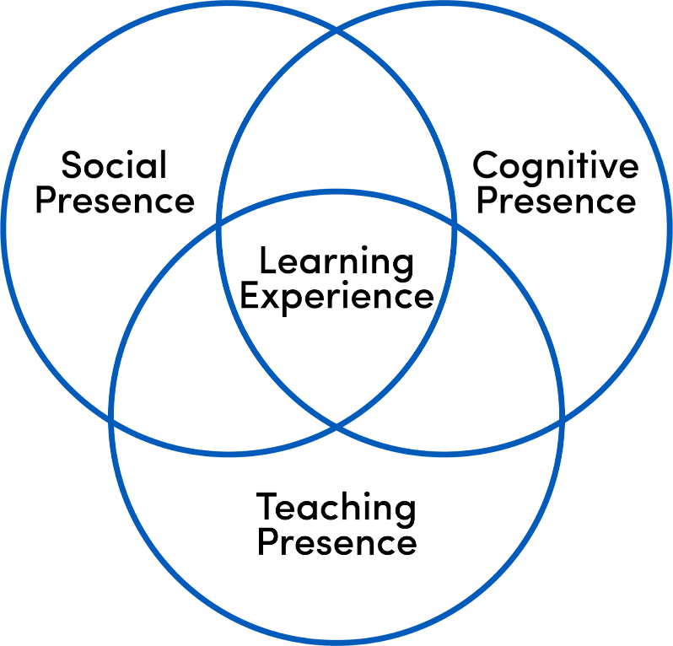

The proposed solution is based on the Community of Inquiry (CoI) framework, which focuses on three key elements: cognitive presence, social presence, and teaching presence. The Mentor-Shift app aims to foster deep learning and meaningful interactions between mentors and mentees by leveraging these elements.

Cognitive presence is enhanced through engaging learning activities and resources, while social presence is strengthened by encouraging peer collaboration and building a sense of community. Teaching presence is ensured through active guidance, feedback, and facilitation by mentors. By applying the CoI framework, the app creates a supportive online learning environment within SOECS, allowing mentors and mentees to engage in collaborative, enriching educational experiences.

**CONCEPTUAL FRAMEWORK**

**Figure 2.3**

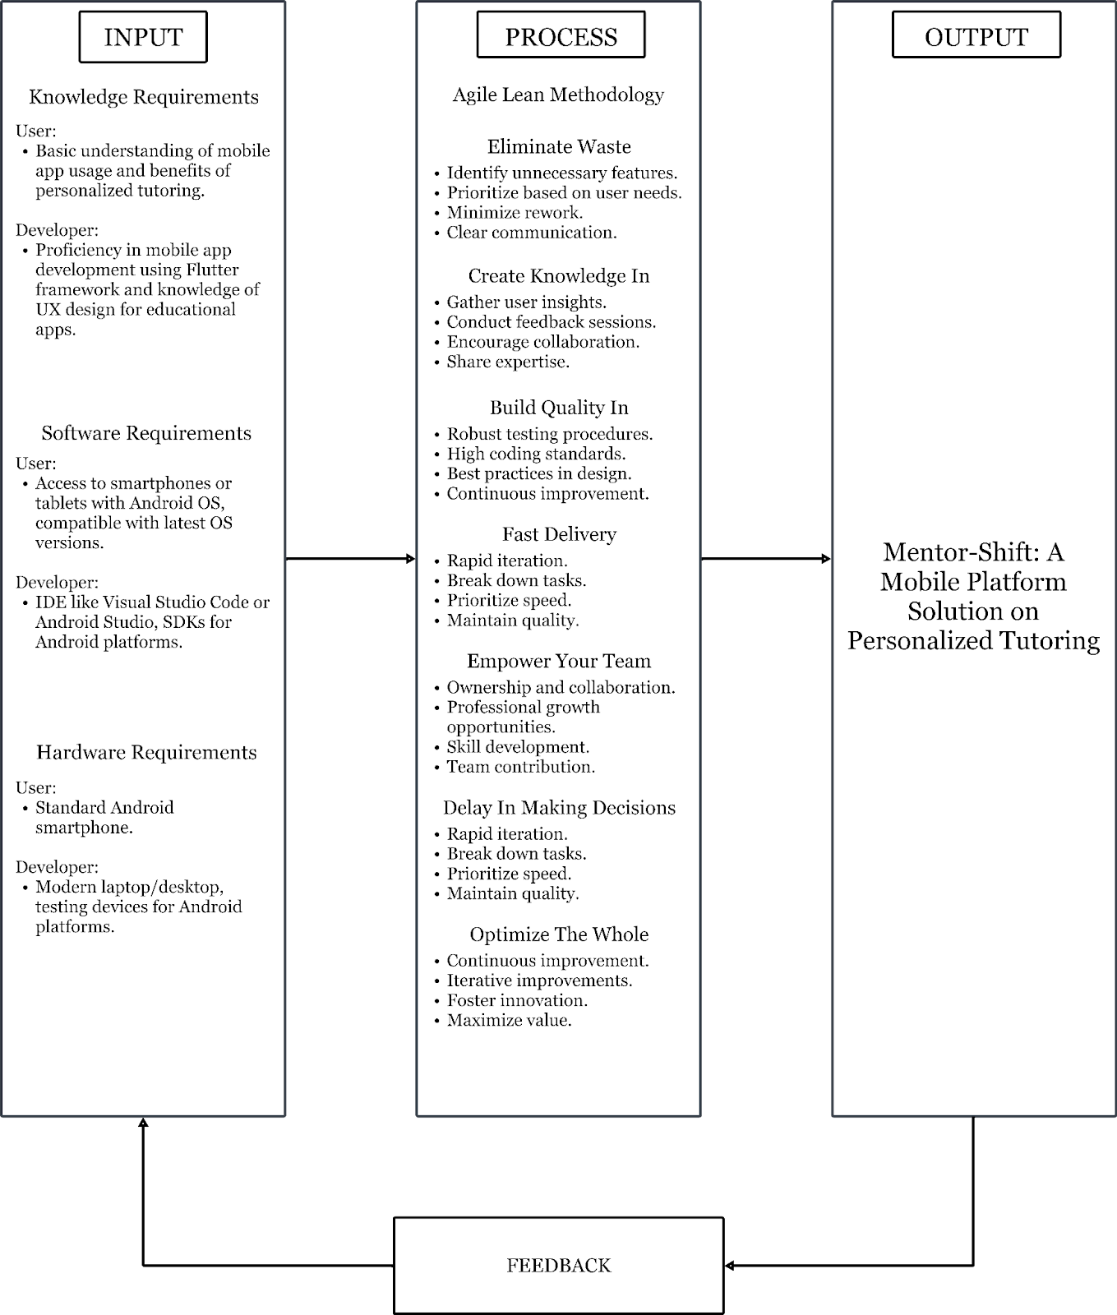*Conceptual Framework of the Proposed System*

The project's conceptual architecture outlines essential information and resources for both users and developers. Users are expected to have a basic understanding of mobile apps and the benefits of individualized teaching, while developers require a broader skill set encompassing expertise in programming languages such as Java & Kotlin, proficiency in mobile app development frameworks like Android Gradle, and knowledge of user experience design principles. Additionally, developers must possess familiarity with database management systems for secure data storage and software testing procedures for app debugging and optimization.

The process of each phase utilizes the Agile Lean methodology, which encompasses the seven phases of the Agile Lean methodology: Eliminate Waste, Create Knowledge In, Build Quality In, Fast Delivery, Empower Your Team, Delay in Making Decisions, and Optimize the Whole. Each phase is guided by specific objectives aimed at influencing the progression of the Mentor-Shift app in alignment with educational goals and user needs. From defining system requirements and designing user interfaces to app development, testing, and deployment, the process segment ensures a disciplined and systematic approach to achieving the desired mobile application outcome. Through these phases, the conceptual framework acts as a roadmap for the seamless development and deployment of the Mentor-Shift app, with the aim of revolutionizing individualized tutoring experiences for students in the School of Engineering and Computer Studies.

**Chapter 3**

**REQUIREMENTS ANALYSIS AND DOCUMENTATION**

The requirements analysis and documentation presented the figures of the flowchart, system architecture, software design, namely, the use case, class, and sequence diagrams. It also includes tables for database design, system requirements, system tradeoffs, system design, project timeline, and statistical tools.

**FLOWCHART**

**Figure 3.1**

**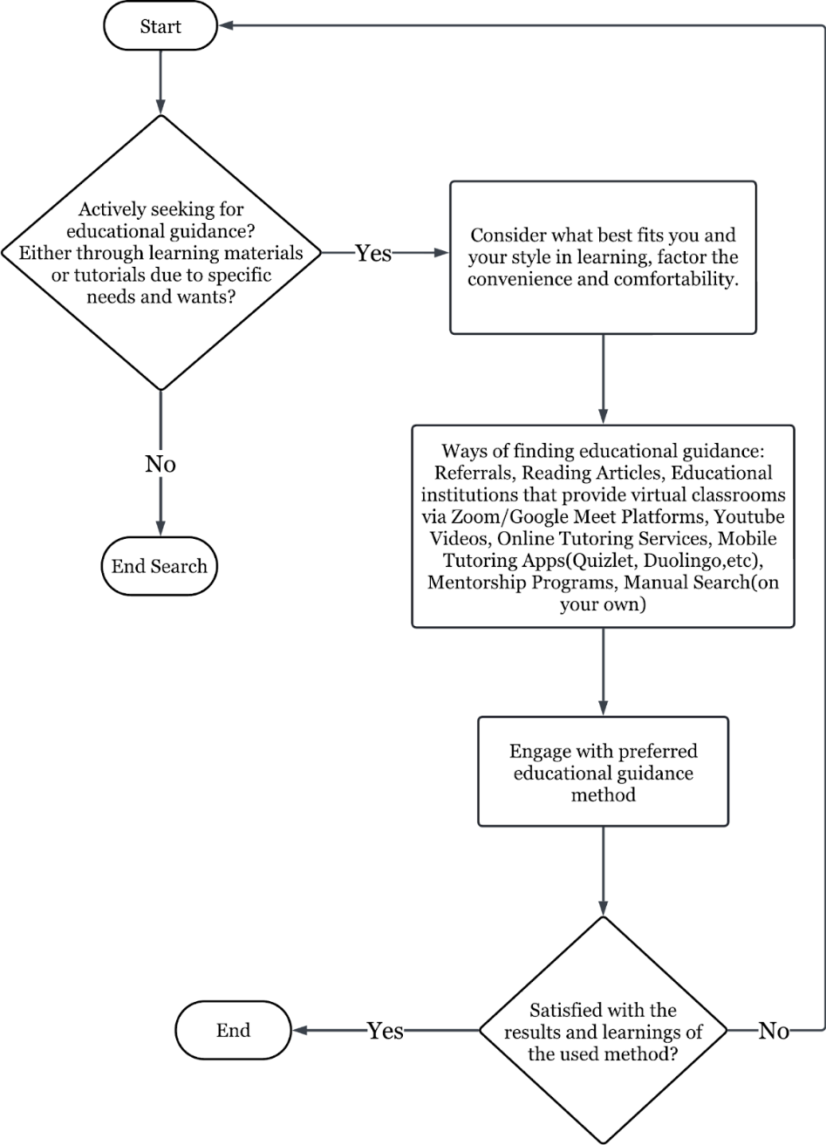***Flowchart of the Manual Process*

For individuals seeking tutoring or mentoring support, their preferred means can significantly impact their learning experience. If immediate assistance and interaction are crucial, education institutions offering virtual classrooms via platforms like Zoom and Google Meet provide real-time engagement opportunities, fostering active learning environments. Those who favor visual and multimedia learning formats can benefit from accessing YouTube tutorials, which cater to diverse academic demands through engaging video content. Online directories for tutors or mentors are ideal for those actively searching for personalized assistance in their field, providing access to a wide range of expertise through online tutoring services.

For learners who prefer studying independently on mobile devices, mobile tutoring apps such as Quizlet and Duolingo offer convenient access to educational resources tailored to individual learning styles. These platforms also often include gamified learning features, enabling users to track progress and stay motivated. Meanwhile, individuals interested in formal mentoring programs can explore dedicated mentorship platforms that provide structured guidance, pairing learners with experienced professionals in their field of interest. Additionally, some learners may prefer social learning communities where they can collaborate with peers and mentors in group settings, fostering a more collective and interactive approach.

Finally, for those who prefer a more traditional approach, manual searching for tutors and mentors in person remains a viable option, allowing for direct interactions and personalized connections within local communities. Depending on their unique preferences and needs, individuals can select the most suitable means of accessing tutoring or mentoring support to enhance their learning journey, whether through real-time virtual engagement, multimedia platforms, or personal face-to-face interactions.

**SYSTEM ARCHITECTURE**

**Figure 3.2**

*System Architecture of the Proposed System*

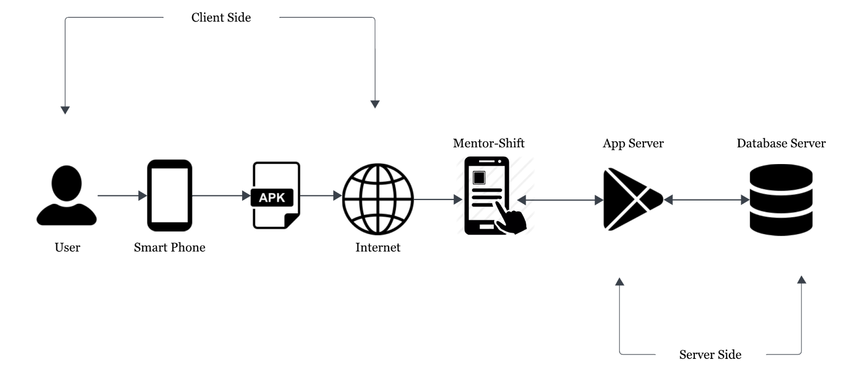

The system architecture for the app is made to meet the precise needs and goals listed in the project scope. Because of the architecture's modular and scalable design, it may be easily expanded upon and modified in the future. We hope to create seamless communication and interaction between users and the system by utilizing a client-server approach, where a mobile application acts as the client interface and a cloud-based server handles the fundamental processing and data management activities. Reliability, security, and performance are given top priority in the architecture, which includes features like load balancing, encryption protocols, and redundant server instances to guarantee high availability, data integrity, and ideal system responsiveness.

**SOFTWARE DESIGN**

The software design for the Mentor-Shift application focuses on creating a user-friendly platform for students and mentors. It encompasses architecture, components, interfaces, and data to support effective mentorship. Key considerations include scalability, security, and ease of use, ensuring the application performs reliably and efficiently as the user base grows.

**Figure 3.3**

*Use-Case Diagram*

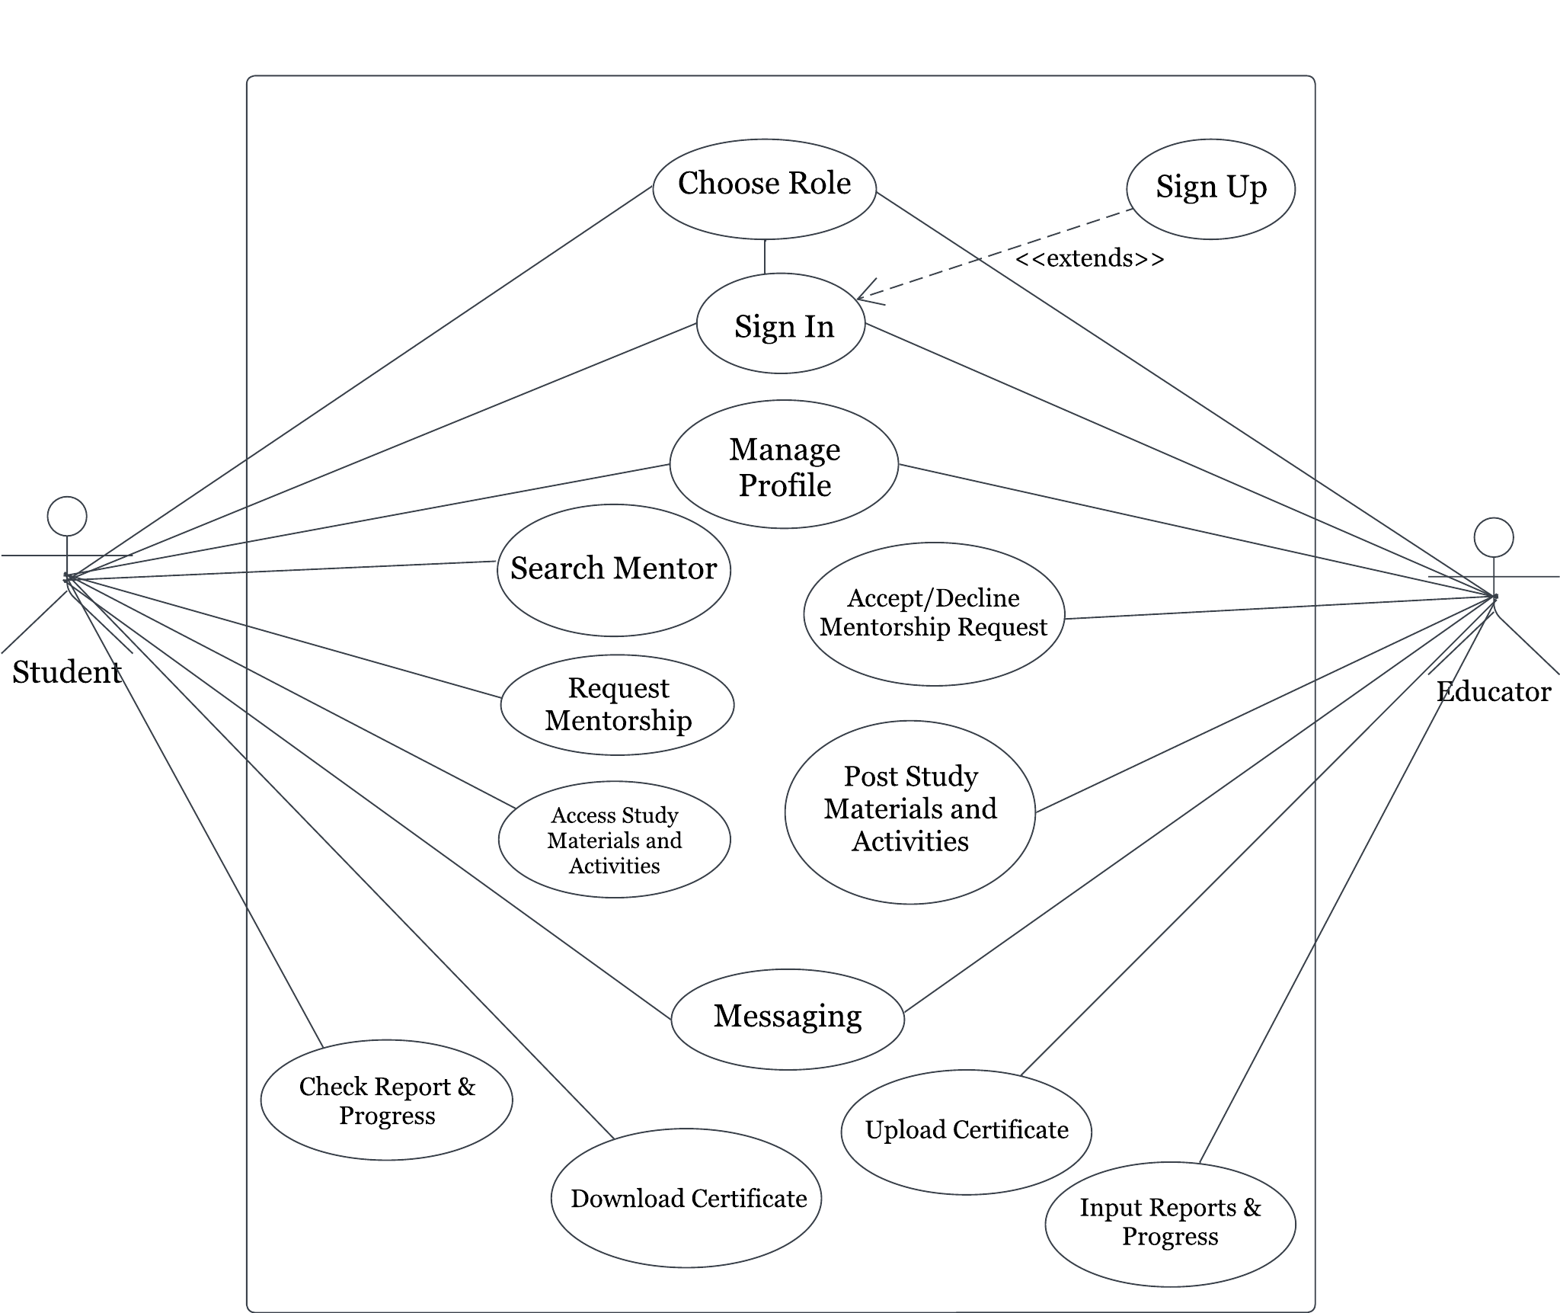

This use-case diagram illustrates a mentor app featuring two user roles: student and educator. Upon selecting their roles, users can access the sign-in screen with an option to sign up. Both roles can manage profiles and send messages for effective communication. Students can search for mentors, request mentorship, access study materials, check progress reports, and download certificates after completing tasks. Educators can accept or decline mentorship requests, post study materials and activities, upload certificates, input progress reports, and add new courses tailored to their expertise. This streamlined approach fosters engagement and collaboration, enhancing the mentorship experience for both students and educators.

**Figure 3.4**

**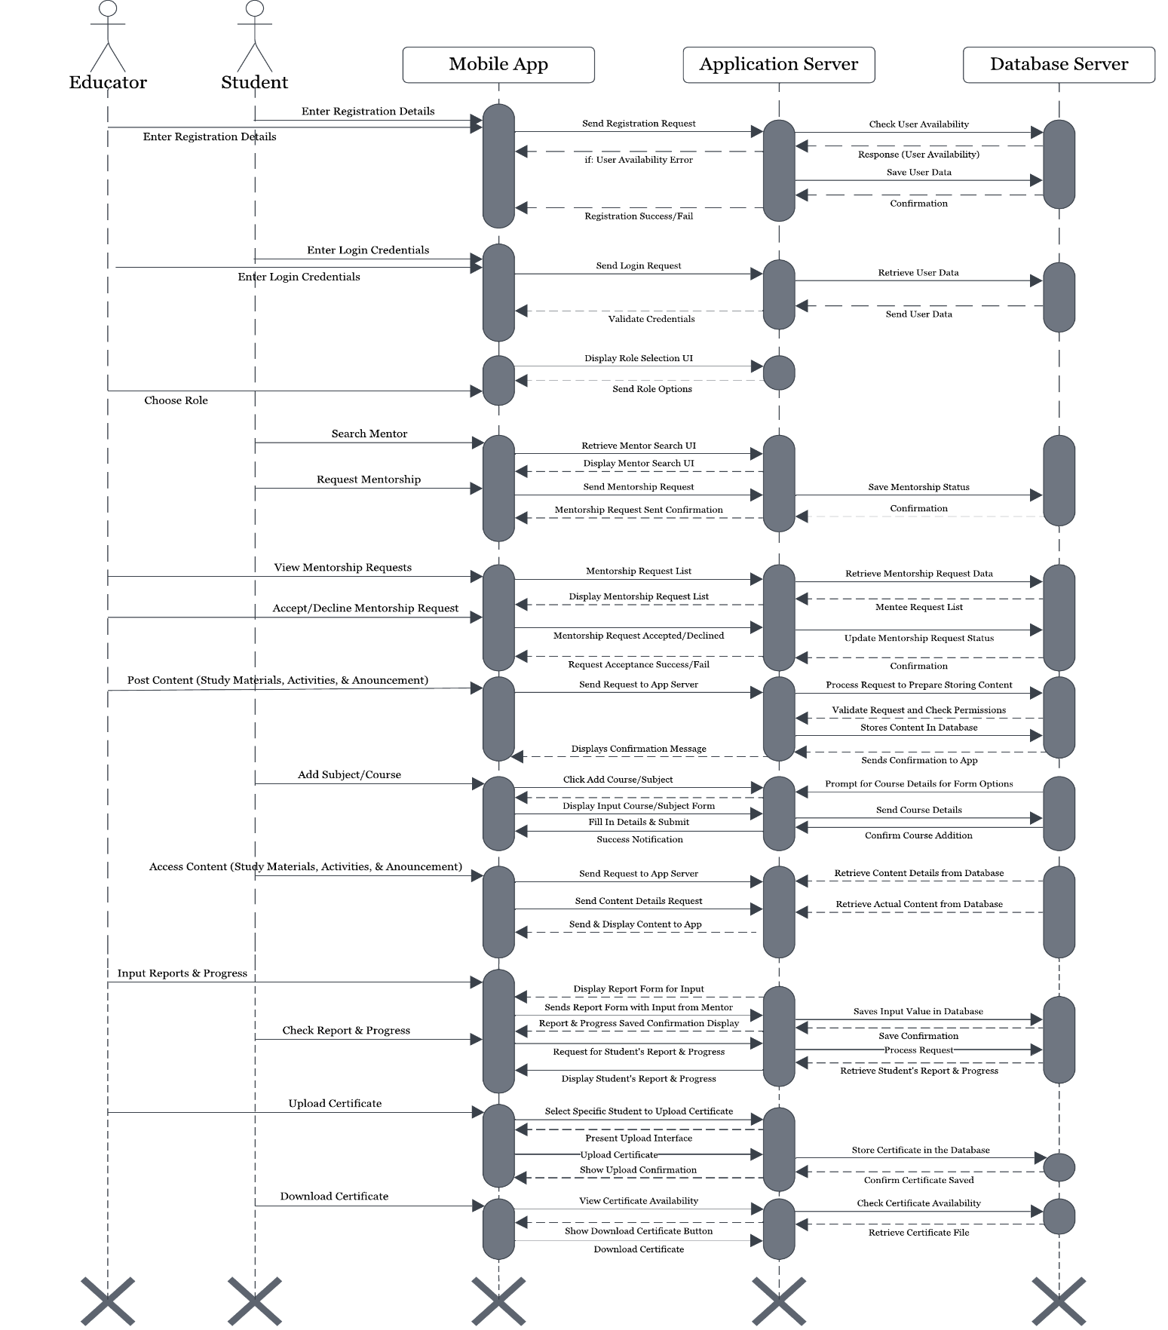***Sequence Diagram*

The sequence diagram for the "Mentor-Shift" mobile app illustrates a range of key functionalities for smooth user interaction, providing an efficient platform for both educators and students. Both educators and students can choose their respective roles upon registration or login, using their credentials based on the role they selected. Students can search for mentors by browsing profiles that match their academic needs and request mentorship from the educator of their choice. Once a request is sent, educators can review, accept, or decline these mentorship requests, enabling a personalized mentorship process.

Educators play a central role in managing the academic journey of their mentees. They can post study materials, activities, quizzes, and assignments via URL links, which are accessible to students after their mentorship request has been approved. Furthermore, educators can make important announcements to keep students updated on deadlines, new content, or upcoming events. As students engage with these resources, educators can monitor their progress, inputting reports and scores for completed activities. These reports provide valuable insights for students to track their academic development.

The app facilitates certification by allowing educators to upload certificates for specific students who have successfully completed their tasks. Once a certificate is uploaded, students can view and download it, giving them tangible proof of their achievements and milestones.

The app supports course management by enabling educators to add new courses or subjects. Educators can initiate the process by selecting the "Add Course" option in their dashboard, entering the required course details, and submitting the information. The app then verifies and stores these details in the course management system, making the new course available for student enrollment.

This sequence diagram captures the critical interactions and features that make Mentor-Shift a dynamic tool for enhancing mentorship and education through streamlined processes and real-time collaboration between students and educators.

**Figure 3.5**

*Class Diagram*

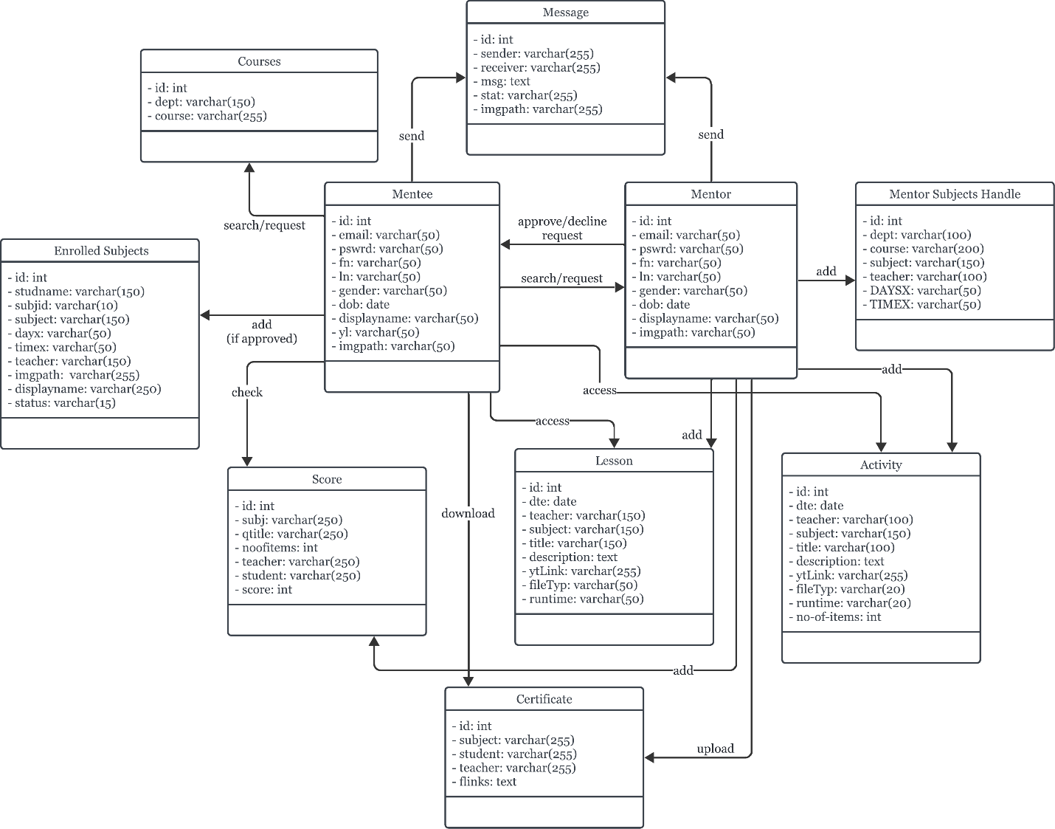

The class diagram depicts the interaction between Mentee and Mentor. Aside from selecting courses, mentees can also message mentors, look for mentors, and ask for mentorship. The chosen course is added to their enrolled subjects after it is approved, enabling them to view lessons and activities, download certificates, and check their scores. Based on their area of expertise, mentors can upload lessons, activities, and certificates, send messages, accept or reject mentorship requests, and add courses. The diagram illustrates how mentees can access courses and learning resources provided by mentors once their mentorship approval is granted.

**DATABASE DESIGN**

The tables below represent the foundational database structure for users and mentors within the Mentor-Shift application. The User table stores essential information about each user, while the Mentor table extends the user information with specific details related to mentors' expertise and availability.

**Table 3.1**

*Mentee Table*

|  |  |  |  |  |  |  |
| --- | --- | --- | --- | --- | --- | --- |
| id(PK) | email | last_name | first_name | gender | displayname | imgpath |
| birthday | password | yearlvl |  |  |  |  |

Table 3.1 outlines the Mentee Table, which stores essential information about students in the Mentor-Shift app. Each mentee is identified by a unique id (primary key) and includes fields such as email, first_name, last_name, gender, birthday, and yearlvl to track personal and academic details. The displayname and imgpath fields manage the mentee's public profile, while password ensures secure login. This table is crucial for organizing mentee profiles and facilitating personalized mentorship within the app.

**Table 3.2**

*Mentor Table*

|  |  |  |  |  |  |  |
| --- | --- | --- | --- | --- | --- | --- |
| id(PK) | email | last_name | first_name | gender | displayname | imgpath |
| birthday | password |  |  |  |  |  |

Table 3.2 details the Mentor Table, which holds key information for mentors in the Mentor-Shift app. Each mentor is uniquely identified by the id (primary key) and includes fields such as email, first_name, last_name, gender, and birthday for personal and demographic information. The displayname and imgpath fields manage the mentor's public profile, while password ensures secure access. This table is fundamental for organizing mentor profiles, enabling efficient mentor-mentee interactions within the app.

**Table 3.3**

*Mentor Subject Handle*

|  |  |  |  |  |  |  |
| --- | --- | --- | --- | --- | --- | --- |
| id(PK) | dept | course | subject | teacher | days | time |

Table 3.3 presents the Mentor Subject Handle, which manages the subjects and schedules associated with mentors in the Mentor-Shift app. Each entry is identified by a unique id (primary key) and includes fields such as dept (department), course, subject, and teacher, providing detailed information about the subjects offered by each mentor. Additionally, the days and time fields specify when the subjects are available, allowing mentees to plan their schedules effectively. This table plays a crucial role in linking mentors with their respective subjects, facilitating organized and accessible mentoring sessions.

**Table 3.4**

*Activity Table*

|  |  |  |  |  |  |  |
| --- | --- | --- | --- | --- | --- | --- |
| id(PK) | date | teacher | subject | title | description | ytlink |
| filetype | runtime | no-of-items |  |  |  |  |

Table 3.4 outlines the Activity Table, which catalogs educational activities within the Mentor-Shift app. Each activity is identified by a unique id (primary key) and includes fields such as date, teacher, and subject to provide context for the activity. The title and description fields summarize the activity's content, while the ytlink field allows for the inclusion of related YouTube videos. The filetype indicates the format of any associated materials, and runtime specifies the duration of the activity. Lastly, no-of-items represents the number of resources included. This table is crucial for managing structured learning experiences for mentees.

**Table 3.5**

*Certificate Table*

|  |  |  |  |  |
| --- | --- | --- | --- | --- |
| id(PK) | subject | student | teacher | flinks |

Table 3.5 presents the Certificate Table, which stores information related to the certificates awarded within the Mentor-Shift app. Each certificate is identified by a unique id (primary key) and includes fields such as subject and student to indicate the area of achievement and the recipient of the certificate. The teacher field denotes the mentor who issued the certificate, while flinks provides links to access the certificate files. This table is essential for tracking and managing the certification process, ensuring that mentees receive proper recognition for their accomplishments.

**Table 3.6**

*Courses Table*

|  |  |  |
| --- | --- | --- |
| id(PK) | dept | course |

Table 3.6 details the Courses Table, which organizes information about the various courses available within the Mentor-Shift app. Each course is uniquely identified by an id (primary key) and includes fields such as dept (department) and course, providing clarity on the academic structure and categorization of each course. This table is vital for facilitating the selection of courses by both mentors and mentees, ensuring that users can easily navigate the educational offerings available within the app.

**Table 3.7**

*Enrolled Subjects Table*

|  |  |  |  |  |  |  |
| --- | --- | --- | --- | --- | --- | --- |
| id(PK) | studentName | subjectId | subject | days | time | teacher |
| imgpath | displayname | status |  |  |  |  |

Table 3.7 presents the Enrolled Subjects Table, which tracks the subjects that students are enrolled in within the Mentor-Shift app. Each entry is uniquely identified by an id (primary key) and includes fields such as studentName and subjectId to link students with their respective subjects. Additional fields like subject, days, and time provide details on the scheduling of each enrolled subject, while teacher identifies the mentor associated with the subject. The imgpath and displayname fields enhance the student’s profile representation. Lastly, the status field indicates the current enrollment status of the student. This table is crucial for managing student enrollments and ensuring efficient tracking of academic participation.

**Table 3.8**

*Lessons Table*

|  |  |  |  |  |  |  |
| --- | --- | --- | --- | --- | --- | --- |
| id(PK) | date | teacher | subject | title | descriptions | ytlink |
| filetype | runtime |  |  |  |  |  |

Table 3.8 outlines the Lessons Table, which organizes the instructional lessons available within the Mentor-Shift app. Each lesson is uniquely identified by an id (primary key) and includes fields such as date, teacher, and subject to provide context about the lesson's timing and content area. The title and description fields summarize the lesson's focus, while the ytlink allows for the inclusion of related YouTube videos. The filetype field specifies the format of any associated lesson materials, and runtime indicates the expected duration of the lesson. This table is essential for managing and delivering structured lessons, enhancing the educational experience for mentees.

**Table 3.9**

*Message Table*

|  |  |  |  |  |  |
| --- | --- | --- | --- | --- | --- |
| id(PK) | sender | receiver | message | status | imgpath |

Table 3.9 presents the Message Table, which captures the communication between users within the Mentor-Shift app. Each message is uniquely identified by an id (primary key) and includes fields such as sender and receiver to indicate the participants in the conversation. The message field contains the content of the communication, while the status field tracks whether the message has been sent, delivered, or read. The imgpath field can store any associated images or attachments related to the message. This table is essential for facilitating real-time

interactions between mentors and mentees, enhancing collaboration and support throughout the learning journey.

**Table 3.10**

*Score Table*

|  |  |  |  |  |  |  |
| --- | --- | --- | --- | --- | --- | --- |
| id(PK) | subject | quiz-title | no-of-item | teacher | student | score |

Table 3.10 details the Score Table, which records the assessment results for students within the Mentor-Shift app. Each entry is uniquely identified by an id (primary key) and includes fields such as subject and quiz title to specify the relevant assessment context. The no-of-items field indicates the number of questions or tasks included in the quiz. Additionally, teacher identifies the mentor responsible for administering the quiz, while student links the score to the specific learner. The score field captures the student's performance, providing a clear record of their achievements in various assessments. This table is crucial for tracking student progress and facilitating feedback on their learning outcomes.

**SYSTEM REQUIREMENTS**

These are basic rules that define the necessary functionalities and performance standards for a software project. They serve as a guide for developers, ensuring that the final product fits user requirements and business objectives. In this article, we will look at the exact system requirements for the proposed project, concentrating on important issues like functionality, usability, and security.

**Hardware Requirements**

Hardware requirements play a crucial role in determining the infrastructure needed to support its functionality and performance. These requirements encompass the server hardware specifications necessary to host the application, as well as the client hardware specifications required for users to access the app seamlessly on their mobile devices. By identifying and complying with these hardware requirements, developers can ensure that the Mentor-Shift app operates efficiently and delivers a smooth user experience to its users.

**Table 3.10**

*Server Hardware Requirements*

**Recommended Server Hardware Specifications**

|  |  |
| --- | --- |
| **Required Hardware** | **Specifications** |
| **Server** |  |
| OS | Windows 10 or higher/Linux-based operating system (e.g., Ubuntu Server) |
| CPU | AMD Ryzen 3 or higher |
| Disk | SSD storage (100 GB minimum) |
| Transfer | Gigabit Ethernet or higher |

**Table 3.11**

*Client Hardware Requirements*

**Recommended Client Hardware Specifications**

|  |  |
| --- | --- |
| **Required Hardware** | **Specifications** |
| **Client** |  |
| Processor | Qualcomm Snapdragon series for Android devices |
| Hard Disk Drive | 64 GB of internal storage |
| Memory | 3 GB RAM |
| Internet Bandwidth | 5 mbps |
| Devices | Android |

The recommended server hardware specifications for the app include a choice of operating system between Windows 10 or higher and Linux-based systems such as Ubuntu Server. This flexibility caters to different hosting preferences and environments. In terms of CPU, an AMD Ryzen 3 or equivalent processor is recommended to ensure efficient handling of server-side operations and requests. SSD storage with a minimum capacity of 100 GB is advised to support fast data access and retrieval, enhancing overall server performance. Having a Gigabit Ethernet or higher transfer rate is recommended to help smooth communication and data exchange between the server and client devices.

On the client side, the recommended hardware specifications focus on ensuring optimal performance and user experience for mobile users. For Android devices, processors from the Qualcomm Snapdragon series are recommended, while Apple A-series processors are recommended for iOS devices. A minimum of 64 GB of internal storage allows users to store app data and multimedia files without encountering storage limitations. With 3 GB of RAM, users can expect smooth multitasking and app operation on their devices. A stable internet connection with a bandwidth of at least 5 Mbps ensures reliable data transmission between the client device and the server, supporting real-time interactions and content delivery. The Mentor-Shift app is compatible with both Android and iOS devices, offering accessibility to a wide range of users across different mobile platforms.

**Software Requirements**

Specific software requirements are essential to ensure its functionality, security, and user experience. These requirements encompass the technologies, frameworks, programming languages, and development tools needed to build and deploy the application successfully. Following these software specifications, developers can produce a stable and intuitive platform that fulfills the requirements of mentors and mentees in the academic community.

**Table 3.12**

*Recommended Software Specifications*

**Recommended Software Specifications**

|  |  |
| --- | --- |
| **Particulars** | **Specifications** |
| Language | Java & Kotlin |
| Framework | Android Gradle |
| Database | MySQL |

The recommended software specifications for the Mentor-Shift app include Java and Kotlin as the programming languages for their robust performance and compatibility with Android development. The app will be built using the Android Gradle framework, which provides efficient project management and seamless integration with Android tools. MySQL will be used as the database solution, offering reliable data storage and online hosting capabilities, ensuring scalable data management, session handling, and smooth user interactions. This combination enables secure and efficient management of user data, notifications, and real-time information within the app.

**SYSTEM TRADEOFFS**

In this section, we explore the various compromises and decisions made during the development of the Mentor-Shift app. These tradeoffs involve balancing competing priorities such as functionality, performance, cost, and time-to-market. By carefully considering these tradeoffs, we aim to optimize the app's design and implementation to meet the needs of users while staying within resource constraints and project timelines.

**Table 3.13**

*Technical Issues*

|  |  |
| --- | --- |
| **Technical Issues** | **Trade Offs** |

|  |  |
| --- | --- |
| Performances | Mobile device speed should be at least 2.05 GHz. |
| Deployment | Android phone version 11 or higher |
| Operational Characteristics | To develop in a desktop computer with Windows 11 as its OS and AMD Ryzen 3 Mobile 3200G as its processor |
| Interoperability with Other Technologies | Can be developed with Android Studio as IDE, Android Studio’s Virtual Device Manager (VDM) for testing, Java & Kotlin as programming language, Git for version control, and MySQL as the database |

To ensure smooth development for the proposed app, a few technical issues should first be addressed.

Performance requirements necessitate a mobile device with a minimum speed of 2.05 GHz to ensure smooth operation of the app. While this ensures an optimal user experience, it may limit the app's compatibility with older or less powerful devices. Deployment considerations mandate that the app is compatible with Android phone version 11 or higher, which may restrict the user base to those with different devices or operating systems. Operational characteristics dictate development on a desktop computer running Windows 11 with an AMD Ryzen 3 Mobile 3200G processor, potentially limiting the development environment options for developers. Prioritizing interoperability with other technologies facilitates development using Android Studio as the IDE, Android Studio’s Virtual Device Manager for testing, Java & Kotlin as the programming language, Git for version control, and MySQL as database. While this ensures seamless integration and collaboration among development tools and services, it may restrict developers who prefer alternative tools or platforms. Thus, these tradeoffs highlight the need for careful consideration to balance technical requirements with practical considerations and developer preferences.

**Table 3.14**

*Operational Issues*

|  |  |
| --- | --- |
| **Operational Issues** | **Trade Offs** |
| Support Tools | Git, Android Studio, MySQL, and Figma |
| User and Developer Skills | Knowledgeable in using Java & Kotlin Programming Language, Android Gradle would be used as a framework. Informed on how to use MySQL and Git. |
| Processes | Planning and designing the structure of the app, as well as its functionality and features. Using Android Studio for coding, Git for version control, and MySQL for data management and storing. Testing the app will determine if it works as intended and will be modified and fixed if there are any issues found. |
| Documentation | Guidelines for version control with Git, setup instructions for the development environment. MySQL functions, Android Gradle project structure definition, API documentation, deployment procedures, troubleshooting guides, and a maintenance plan. |

The operational issues for the app cover several key areas, each with its own trade-offs and requirements. Utilizing support tools like Git, Android Studio, MySQL, and Android Gradle is essential for efficient development and deployment. However, this necessitates a certain level of user and developer skills, particularly proficiency in Java & Kotlin programming language for Android app development, as well as familiarity with MySQL and Git. Additionally, effective processes, such as meticulous planning, coding with Android Studio, version control with Git, and data management with MySQL are crucial for successful app development. Finally, comprehensive documentation covering version control guidelines, setup instructions, project structure, API documentation, deployment procedures, troubleshooting guides, and maintenance plans is essential to facilitate collaboration and ensure the app's functionality and longevity.

**Table 3.15**

*Economic Issues*

|  |  |
| --- | --- |
| **Economic Issues** | **Trade Offs** |
| Hardware and Software Updates | This application will work best with increased processor speed, RAM, and updated Android versions. |

|  |  |  |
| --- | --- | --- |
| Development Cost | The projected development cost of the project is  Php 3,000   * Cost for application hosting is 3000 for 4 months |  |
| Operational Cost | The projected operational cost of the project is  Php 9,000   * Estimated printing costs is Php 2,000 * Estimated transportation cost is Php 3,000 * Estimated food costs is Php 4,000 |  |
| Training Cost (Developers and Users) | None |  |

The table outlines the economic considerations for the proposed Mentor-Shift application, highlighting trade-offs between hardware and software updates and associated costs. Optimal performance will require increased processor speed, RAM, and updated Android versions. The projected development cost is Php 3,000, which includes application hosting for four months. Operational expenses are estimated at Php 9,000, covering printing (Php 2,000), transportation (Php 3,000), and food (Php 4,000). Notably, no training costs are required for developers or users. These considerations emphasize the balance between ensuring smooth functionality and managing costs effectively.

**SYSTEM DESIGN**

In this section, the researchers will be able to determine the system's functional and non-functional requirements. This section will also serve as a reference for identifying potential problems that may create errors in the final output.

**Table 3.16**

*Non-Functional Requirements*

|  |  |  |
| --- | --- | --- |
| **Properties** | **Constraints** | |
| System | The system should be stable and consistently available, and it should have a fast and efficient response service. | The system is dependent on an internet connection for it to work as intended. |
| Software | The software should first be installed on a mobile device and have an internet connection to be operable so that the intended functions and features work. | Dependent on an internet connection, reliable and compatible hardware, and an OS for installation. The hardware’s performance will be equivalent to how the software performs. |
| User | Users should have a smartphone with updated versions and an operable state. Should be familiar with how to navigate it. | Should have basic knowledge of operating mobile devices, despite making the app user-friendly for convenience. |
| Service | The service should be reliable, scalable, and secure for ensuring consistent performance, accommodating growth, and protecting user data. | Infrastructure limitations, regulatory compliance requirements, and budgetary constraints will impact performance, data handling, and technology selection. |

The non-functional requirements for the Mentor-Shift app focus on ensuring stability, reliability, and efficiency across various aspects of the system. The properties outline the desired characteristics, including stability and efficiency for the system, operability and compatibility for the software, and user familiarity and accessibility for the end-users. However, several constraints must be considered, such as dependency on internet connectivity for system and software operability, hardware and OS compatibility, and user knowledge requirements. Infrastructure limitations, regulatory compliance, and budgetary constraints pose challenges that must be addressed to maintain consistent performance, data security, and operational integrity.

**Table 3.17**

*Functional Requirements*

|  |  |  |  |  |
| --- | --- | --- | --- | --- |
| **Input** | **Process** | **Output** | **Storage** | **Control** |

|  |  |  |  |  |
| --- | --- | --- | --- | --- |
| Registration | Gathers user details such as name, email, password, and role selection through the registration form. | Upon successful registration, users are directed to the login page. | MySQL | System |
| User Authentication | Validates user credentials during the login process. | Grant access to authenticated users. | MySQL | System |

|  |  |  |  |  |
| --- | --- | --- | --- | --- |
| Role Selection | Allows users to select a role (Mentee or Mentor). | Displays user dashboard based on the selected role. | MySQL | User |
| Mentor Search | Mentee inputs search criteria for selecting a mentor. | Displays a list of mentors matching the criteria. | MySQL | Mentee |
| Mentorship Request | Mentee sends mentorship request to selected mentor. | Mentor receives request for approval or rejection. | MySQL | Mentee |
| Course Selection | Mentee selects courses after mentorship approval. | Enrolled courses added to mentee’s profile. | MySQL | Mentee |
| Content Access | Mentee accesses lessons, activities, and announcements. | Lessons, activities, and announcements are displayed for interacting. | MySQL | Mentee/Mentor |
| Report Viewing | Mentee checks progress, scores, and feedback. | Displays progress reports and performance scores. | MySQL | Mentee |
| Certificate Upload | Mentor uploads certificates for mentees who complete tasks or courses. | Certificates are available for mentees to download. | MySQL | Mentor |
| Certificate Download | Mentee downloads certificates after completing a course or task. | Certificate is available for download. | MySQL | Mentee |
| Message Exchange | Mentees and Mentors exchange messages within the app. | Displays messages in real-time. | MySQL | Mentee/Mentor |
| Course Creation | Mentor creates and uploads lessons, activities, and certificates. | Courses and resources are available to mentees. | MySQL | Mentor |
| Mentorship Approval | Mentor approves or declines mentorship requests. | Mentee is notified of approval or rejection. | MySQL | Mentor |
| Report Input | Mentor inputs scores and progress for mentees. | Updated report data is displayed to the mentee. | MySQL | Mentor |

The proposed Mentor-Shift system includes an array of features designed to facilitate mentorship interactions in a classroom environment. The system effectively collects all necessary user information during the registration process, ensuring a smooth onboarding experience. User authentication provides robust access control, safeguarding interactions on the platform.

Users can select their roles as either Mentees or Mentors, with functionalities for mentor browsing and mentorship requests promoting effective communication between them. Mentees can search for mentors, request mentorship, and access courses once approved, while mentors can create and manage courses, upload lessons and activities, and approve or decline mentorship requests.

The Access Content feature allows mentees to engage with curated educational resources, enhancing their learning journey and fostering academic progress. The system

supports efficient management of scores and progress reporting, enabling mentors to provide feedback on student performance.

Data is stored securely in a MySQL database, ensuring effective scalability and management of user information, mentor profiles, mentorship requests, courses, lessons, assessments, and certificates. Control mechanisms keep users informed throughout their mentorship experience with notifications for mentorship requests and updates on request statuses.

Data is stored securely in a MySQL database, ensuring effective scalability and management of user information, mentor profiles, mentorship requests, courses, lessons, assessments, and certificates. Control mechanisms keep users informed throughout their mentorship experience with notifications for mentorship requests and updates on request statuses. Data is stored securely in a MySQL database, ensuring effective scalability and management of user information, mentor profiles, mentorship requests, courses, lessons, assessments, and certificates. Control mechanisms keep users informed throughout their mentorship experience with notifications for mentorship requests and updates on request statuses. Data is stored securely in a MySQL database, ensuring effective scalability and management of user information, mentor profiles, mentorship requests, courses, lessons, assessments, and certificates. Control mechanisms keep users informed throughout their mentorship experience with notifications for mentorship requests and updates on request statuses.

**PROJECT TIMELINE**

**Table 3.18**

*Gantt Chart Using Lean Methodology*

**Legend:**

* Finished
* Not Finished

Our project timeline, which follows the Lean methodology, spans several months and is defined by tasks critical to the app's development. Beginning with requirements planning which includes project proposal and research and ending with deployment, the timeline includes critical processes such as proposal submission, literature review, user interface design, coding, testing, and deployment.

Each activity is distributed across the months, allowing for iterative development cycles, user feedback incorporation, and debugging phases to ensure the quality and functionality of the Mentor-Shift app. This structured timeline facilitates a systematic approach to project management, ensuring timely completion and adherence to project milestones.

# Chapter 4

**FINDINGS, CONCLUSIONS, AND RECOMMENDATIONS**

This chapter presents the findings, conclusions, and recommendations of the study on “MENTOR-SHIFT: A Mobile Platform Solution on Personalized Tutoring.”

## FINDINGS

Based on the data obtained, the study presented the following findings:

1. Problems encountered by Students within the School of Engineering and Computer Studies (SOECS):
2. (problems regarding mentor selection)
3. (problems regarding learning approach)
4. (problems regarding certification and reporting)
5. Added features of the proposed system:

The proposed system, "Mentor-Shift: A Mobile Platform Solution on Personalized Tutoring" offers several added features to enhance personalized tutoring. It is an application platform designed to streamline a classroom-like interface for mentees to view study materials, complete activities, and check reports to tracks their scores and progress. Mentees can submit activities digitally within the application, making the process more efficient, while Mentor can upload eBooks, tutorials, and activities.

1. The system was evaluated using the ISO 25010 quality model.
2. Usability: The platform is designed to be easy for students to use, whether you're a mentor looking for students to teach or a mentee. With a clean and simple interface, users can easily search study materials, activities, and check reports to tracks their scores and progress.
3. Reliability: The system is built to be dependable, ensuring it runs smoothly without frequent crashes or issues. Features like regular data backups and error handling mean that even if something goes wrong, the system can quickly recover, ensuring no information is lost and the platform stays up and running when you need it.
4. Maintainability: The platform is designed to be easy to update and improve over time. Whether it's fixing bugs, adding new features, or adjusting to new needs, the system can be tweaked and improved without major overhauls, ensuring it stays relevant and functional for the long term.
5. Portability:

## CONCLUSIONS

Based on the findings, the conclusions below were derived:

## RECOMMENDATIONS

Based on the conclusions, the following recommendations were formulated.

**References**

Almaden, A., & Yu, B. (2024) - Local Study. *Assessment of the Implemented Kapatid Mentor ME Program (KMME) of the Department of Trade and Industry (DTI) in Region VII, Philippines | JPAIR Multidisciplinary Research*, Philair.  
https://philair.ph/index.php/jpair/article/view/410/1703

Arnesson, K., & Albinsson, G. (2017) - Foreign Study. *Mentorship - A Pedagogical Method for Integration of Theory and Practice in Higher Education*, Nordic Journal of Studies in Educational Policy, Vol. 3, Issue 3, Taylor and Francis Online.  
https://doi.org/10.1080/20020317.2017.1379346

Bacolod, D.B. (2022) - Local Literature. *Mobile Learning as a Solution for Restricted Learning during the COVID-19 Pandemic, Journal of Digital Educational Technology*, Vol. 2, Issue 1, Pages ep2203, DOI.

https://www.jdet.net/download/mobile-learning-as-a-solution-for-restricted-learning-during-the-covid-19-pandemic-11584.pdf

Balan, H. (2015) - Local Literature. *Using Peer Mentoring Buddy System as an Intervention Strategy to Enhance Science Research Skills*, Journal of Multidisciplinary Studies, Vol. 4, No. 1, pp. 168-185. DOI.

https://multidisciplinaryjournal.com/pdf/pee_monitoring.pdf

Bercasio, R., & Cabrillas, Z. (2017) - Local Study. *Effectiveness of Peer Mentoring in Enhancing the Mathematical Problem-Solving Skills of College Students in Bicol University*, Volume 20. DOI.

https://www.journal.bicol-u.edu.ph/assets/journal_pdf/3%20Bercasio%20Cabrillas_35-55.pdf

Calo, A.V. (2020) - Local System. *GrabTutor: A web and mobile application for tutor appointment system with GPS security feature*, Indian Journal of Science and Technology, 13, 1955-1964. ResearchGate.

https://www.researchgate.net/publication/342307714_GrabTutor_A_web_and_mobile_application_for_tutor_appointment_system_with_GPS_security_feature

Campit, J., Cayabyab, J., & Galas, E. (2015) - Local Literature. *The Effect of Peer Tutoring on Achievement of Students in Discrete Structures*, Vol. 3 No. 5, 8-12, ResearchGate.  
https://www.researchgate.net/publication/337000254_The_Effect_of_Peer_Tutoring_on_Achievement_of_Students_in_Discrete_Structures

Chen, B., Denoyelles, A., & Seilhamer, R. (2023) - Foreign Literature. *The Evolving Landscape of Students' Mobile Learning Practices in Higher Education*, Teaching and Learning. EDUCAUSE.

https://er.educause.edu/articles/2023/1/the-evolving-landscape-of-students-mobile-learning-practices-in-higher-education

Chung, S.H., & Tan, S.C. (2022) - Foreign System. *MENTOR – Intelligent Mobile Online Peer Tutoring Application for Face-to-Face and Remote Peer Tutoring*, ASCILITE Publications, Pages 386-391, ResearchGate.

https://www.researchgate.net/publication/364628885_MENTOR_-_Intelligent_Mobile_Online_Peer_Tutoring_Application_for_Face-to-Face_and_Remote_Peer_Tutoring

Combo, J.E. (2023) - Local Study. *Analyzing the Role of Teachers' Mentoring in Improving Senior High School Students' Research Competency*, Vol. 4, Pages 42-53, ResearchGate.

https://www.researchgate.net/publication/374194593_Analyzing_the_Role_of_Teachers%27_Mentoring_in_Improving_Senior_High_School_Students%27_Research_Competency

Fabito, B. (2017) - Local Literature. *Exploring Critical Success Factors of Mobile Learning as Perceived by Students of the College of Computer Studies – National University*, 2017 International Conference on Soft Computing, Intelligent System and Information Technology (ICSIIT), Pages 220-226. IEEE Xplore.  
https://ieeexplore.ieee.org/abstract/document/8262571

Farheen, J., & Dixit, S. (2018) - Foreign System. *E-Mentoring System Application*, 2018 2nd International Conference on 2018 2nd International Conference on I-SMAC (IoT in Social, Mobile, Analytics and Cloud) (I-SMAC)I-SMAC (IoT in Social, Mobile, Analytics and Cloud) (I-SMAC), IEEE Xplore.

https://ieeexplore.ieee.org/document/8653663

Gutierrez, M. (2016) - Local Study. *Effectiveness of Junior Faculty Mentoring Relationships in the Colleges of Pharmacy in Metro Manila, Philippines*, JAASP 1:367-76. JAASP Research Paper.

https://www.aaspjournal.org/uploads/155/5929_pdf.pdf

Khor, E., & Mutthulakshmi, K. (2023) - Foreign Literature. *A Systematic Review of the Role of Learning Analytics in Supporting Personalized Learning*, Education Sciences. ResearchGate.

https://doi.org/10.3390/educsci14010051

Lagman, A., Mansul, D.M. (2017) - Local Literature. *Extracting Personalized Learning Path in Adaptive E-Learning Environment Using Rule Based Assessment*, Proceedings of the 2017 International Conference on Information Technology, Association for Computing Machinery, Pages 335-340. ACM Digital Library.  
https://doi.org/10.1145/3176653.3176679

Mirasol, K., Noli, A., & Nicolas, A. (2023) - Local Study. *Flexibility and Personalization of Learning in the Senior High Open High School Program: Basis for Enhanced Alternative Delivery Mode of Teaching and Learning*, American Journal of

Multidisciplinary Research and Innovation, Vol. 2, Issue 4, Pages 13-23. E-Palli Publishers.  
https://journals.e-palli.com/home/index.php/ajmri/article/view/1758

Mobo, F., & Sabado, G. (2019) - Local Study. *An Assessment of the Effectiveness of E-Learning in AMA Olongapo Campus*, Oriental journal of computer science and technology, Vol. 12, Page 99-105. ResearchGate.

https://www.researchgate.net/publication/336277449_An_Assessment_of_the_Effectiveness_of_E-Learning_in_AMA_Olongapo_Campus

Pimmer, C., Mateescu, M., & Gröhbiel, U. (2016) - Foreign Literature. *Mobile and ubiquitous learning in higher education settings. A systematic review of empirical studies*, Computers in Human Behavior, Volume 63. SCIENCE DIRECT.

https://www.sciencedirect.com/science/article/abs/pii/S0747563216303843

Salinas, K.M. (2024) - Local Literature. *Peer Mentoring and Interactive Reading Materials Towards Student's Reading Performance*, Scribd.

https://www.scribd.com/document/633079447/Chapter-2-RRL-for-Peer-Mentoring-and-Interactive-Reading-Materials-towards-Student-s-Reading-Performance

Sebastian, A., Mukhtar Kp, J., Lirio, R., Asis, E., Acosta-Ponce, W., & Villegas-Ramirez, G. (2024) - Foreign Study. *The Educational Technology: A Technology for Education and an Education with Technology*. ResearchGate.

https://www.researchgate.net/publication/377718242_The_Educational_Technology_A_Technology_for_Education_and_an_Education_with_Technology

Shemshack, A., & Spector, J.M. (2020) - Foreign Literature. *A Systematic Literature Review of Personalized Learning Terms*, Smart Learning Environments, Vol. 7 - Issue 1. Smart Learning Environments.

<https://doi.org/10.1186/s40561-020-00140-9>

Thakare, S., Jadhav, S., Mane, I., Pawar, S., & Kulkarni, A. (2019) - Foreign System. *Online Mentoring System (An Online Mentor-Student System)*, International Journal of Engineering Trends and Technology. ResearchGate.

https://www.researchgate.net/publication/332196330_Online_Mentoring_System_An_Online_Mentor-Student_System

Torres, N., & Santos, R. (2022) - Local System. *Grab A Tutor: A Decision Support Mobile App for Student Tutoring*, The QUEST: Journal of Multidisciplinary Research and Development, Vol. 1. ResearchGate.

https://www.researchgate.net/publication/372196974_Grab_A_Tutor_A_Decision_Support_Mobile_App_for_Student_Tutoring

Vecaldo, R. (2021) - Local Literature. *Mentoring Support of Cooperating Teachers: Insights from Filipino Practice Teachers*, INTERNATIONAL JOURNAL OF EDUCATIONAL SCIENCES, Vol. 34. ResearchGate.

https://www.researchgate.net/publication/354606144_Mentoring_Support_of_Cooperating_Teachers_Insights_from_Filipino_Practice_Teachers

Zhang, L., Basham, J., & Yang, S. (2020) - Foreign Literature. *Understanding The Implementation of Personalized Learning: A Research Synthesis*, Educational Research Review, Vol. 31. ScienceDirect.

https://www.sciencedirect.com/science/article/abs/pii/S1747938X19306487

Garrison, Anderson & Archer (2000, 2001). *Community of Inquiry*, Office of Curriculum, Assessment and Teaching Transformation, University at Buffalo.  
https://www.buffalo.edu/catt/teach/develop/teach/learning-environments/community-of-inquiry.html

Srivastava, S. (2020). *How We Align Lean Principles in Our Software Development Process*, Appinventiv.

https://appinventiv.com/blog/how-we-integrate-lean-principles-in-software-development/

**Appendix A**

**LETTER**

February 5, 2024

To whom it may concern:

Dear Survey Participants,

We kindly ask for your consent to participate in our Capstone I survey titled "Mentor-Shift: A Mobile Platform Solution on Personalized Tutoring." This survey aims to identify course difficulties faced by students in the School of Engineering and Computer Sciences (SOECS) and welcomes potential mentors to provide insights into these challenges.

We plan to conduct interviews with students and mentors to gather comprehensive feedback. Rest assured, all responses will remain strictly confidential and will solely serve to enhance the learning environment at SOECS and potentially other educational settings. We earnestly request your collaboration in promoting student participation in this survey and encouraging potential mentors to share their perspectives. Your involvement is crucial to the success of this initiative and the advancement of our academic programs.

Thank you for considering our request.

Very truly yours,

(Sgd.) **JADE B. RAPOSA**

(Sgd.) **IAN JAY NICCOLO D. BUENO**

(Sgd.) **MARC AUSTIN K. BONAGUA**

Noted by:

(Sgd.) **DHAN DAVISH V. ALAMO**

Capstone Project Adviser

**Appendix B**

**QUESTIONNAIRES**

**Interview Guide for Students:**

1. Can you describe a course or aspect of your chosen field that you find particularly challenging?
2. What led you to consider changing your course of study? (List common reasons such as dissatisfaction with the course content, personal interests, career aspirations, etc.)
3. How did you handle the decision-making process and the emotional aspects of changing courses?
4. Looking back, do you feel that the decision to change your course was beneficial or detrimental to your academic and career development?
5. Have you been provided with sufficient guidance and resources to manage course difficulty? If not, what kind of support would you have liked to receive?

**Survey Questionnaire for Students:**

1. On a scale from 1 to 5, how satisfied are you with the current course you are enrolled in? (1 being very dissatisfied, 5 being very satisfied)
2. Would you recommend this course to other students? Please explain why or why not.
3. Which of the following strategies have you tried to overcome course difficulties? (Multiple choices: seeking additional resources, attending office hours, collaborating with peers, etc.)
4. Do you believe that the course content aligns with your career goals?
5. How would you rate the availability of academic support services for students facing course difficulties?

**Interview Guide for Mentors:**

1. Can you share your observations on the common challenges students face when choosing their courses?
2. What role do you play in helping students navigate their academic choices and deal with course difficulties?
3. What strategies do you suggest for students to overcome challenges in their chosen courses?
4. How do you perceive the impact of changing courses on a student's academic progress and career aspirations?
5. Are there any barriers to providing adequate support for students who are considering or currently experiencing course difficulties?

**Survey Questionnaire for Mentors:**

1. How often do you interact with students who are contemplating changing their course of study?
2. What types of challenges do you typically encounter when assisting students with course selection?
3. To what extent do you feel prepared to support students through course change decisions?
4. What additional training or resources would you like to have to better support students facing course difficulties?
5. Would you say that the current academic environment provides enough flexibility for students to change their course of study without significant negative consequences?

**Appendix C**

**PILOT TESTING TALLY**

The following are the results of the pilot testing tally conducted with IT professionals and beneficiaries, evaluating various aspects such as usability, reliability and security.

**Table C.1**

*Pilot Testing Tally (Beneficiaries)*

|  |  |  |  |  |  |  |  |
| --- | --- | --- | --- | --- | --- | --- | --- |
| Characteristics | **5** | **4** | **3** | **2** | **1** | **N** | **ADJECTIVAL DESCRIPTION** |
| 1. Functionality Suitability | 4 | 0 | 0 | 0 | 0 | 5.00 | Far More Than What is Expected |
| 3 | 1 | 0 | 0 | 0 | 4.75 | Far More Than What is Expected |
| 2 | 2 | 0 | 0 | 0 | 4.50 | More Than What is Expected |
| 4 | 0 | 0 | 0 | 0 | 5.00 | Far More Than What is Expected |
| Sub-Average (1) |  |  |  |  |  | **4.81** | Far More Than What is Expected |
| 2. Reliability | 4 | 0 | 0 | 0 | 0 | **5.00** | Far More Than What is Expected |
| 3. Usability | 3 | 1 | 0 | 0 | 0 | 4.75 | Far More Than What is Expected |
| 3 | 1 | 0 | 0 | 0 | 4.75 | Far More Than What is Expected |
| 4 | 0 | 0 | 0 | 0 | 5.00 | Far More Than What is Expected |
| 3 | 1 | 0 | 0 | 0 | 4.75 | Far More Than What is Expected |
| Sub-Average (3) |  |  |  |  |  | **4.81** | Far More Than What is Expected |
| 4. Performance Efficiency/Speed | 2 | 2 | 0 | 0 | 0 | **4.50** | More Than What is Expected |
| 5. Maintainability | 3 | 0 | 1 | 0 | 0 | **4.50** | More Than What is Expected |
| 6. Portability | 3 | 1 | 0 | 0 | 0 | **4.75** | Far More Than What is Expected |

7. Security

|  |  |  |  |  |  |  |  |
| --- | --- | --- | --- | --- | --- | --- | --- |
|  | 2 | 2 | 0 | 0 | 0 | 4.50 | More Than What is Expected |
|  | 1 | 3 | 0 | 0 | 0 | 4.25 | More Than What is Expected |
| Sub-Average (7) |  |  |  |  |  | **4.38** | Far More Than What is Expected |
| 8. Compatibility | 2 | 1 | 1 | 0 | 0 | 4.25 | More Than What is Expected |
| 3 | 1 | 0 | 0 | 0 | 4.75 | Far More Than What is Expected |
| Sub-Averag(8) |  |  |  |  |  | **4.50** | More Than What is Expected |
|  |  |  |  |  |  | **4.66** | Far More Than What is Expected |

Table C.1 shows the pilot testing results from beneficiaries, The end-user evaluation rates the system highly across all key areas, with an overall average of 4.66, described as "Far More Than What is Expected." It excels in functionality, reliability, and usability, with sub-averages of 4.81 in both functionality and usability. The system is user-friendly, secure, and performs efficiently, with notable strengths in portability and data accuracy. Security and compatibility also score well, though slightly lower, with sub-averages of 4.38 and 4.50, respectively.

**Table C.2**

*Pilot Testing Tally (IT Professionals)*

|  |  |  |  |  |  |  |  |  |  |
| --- | --- | --- | --- | --- | --- | --- | --- | --- | --- |
|  |  | **Frequency** | | | | |  | **Weighted Mean** | **Adjectival Description** |
| Characteristic | Sub-Characteristic | **5** | **4** | **3** | **2** | **1** | **Total** |  |  |
| 1. **Functional Suitability** *is the capability of the system to provide functions which meet stated and implied needs when the software is used under the specified conditions* | | | | | | | | | |

|  |  |  |  |  |  |  |  |  |  |
| --- | --- | --- | --- | --- | --- | --- | --- | --- | --- |
|  | *Completeness* | 0 | 0 | 2 | 0 | 0 | 2 | **3.00** | Presence of Expectation |
| *Correctness* | 0 | 2 | 0 | 0 | 0 | 2 | **4.00** | More than What is Expected |
| *Appropriateness* | 0 | 2 | 0 | 0 | 0 | 2 | **4.00** | More than What is Expected |
| *Suitability* | 0 | 2 | 0 | 0 | 0 | 2 | **4.00** | More than What is Expected |
| *Accurateness* | 1 | 1 | 0 | 0 | 0 | 2 | **4.50** | More than What is Expected |
| *Interoperability* | 1 | 1 | 0 | 0 | 0 | 2 | **4.50** | More than What is Expected |
|  | *Security* | 1 | 1 | 0 | 0 | 0 | 2 | **4.50** | More than What is Expected |

|  |  |  |  |
| --- | --- | --- | --- |
|  | ***Sub-Average (1)*** | **4.07** | More than What is Expected |

|  |  |  |  |  |  |  |  |  |  |
| --- | --- | --- | --- | --- | --- | --- | --- | --- | --- |
|  | | | | | | | | | |
|  |  |  |  |  |  |  |  |  |  |
|  |  |  |  |  |  |  |  |  |
|  |  |  |  |  |  |  |  |  |
|  |  | | | | | | |  |  |
|  | | | | | | | | | |
|  |  |  |  |  |  |  |  |  |  |
|  |  |  |  |  |  |  |  |  |
|  |  | | | | | | |  |  |
|  | | | | | | | | | |
|  |  |  |  |  |  |  |  |  |  |
|  |  |  |  |  |  |  |  |  |
|  |  |  |  |  |  |  |  |  |
|  |  |  |  |  |  |  |  |  |
|  |  |  |  |  |  |  |  |  |
|  |  | | | | | | |  |  |
|  | | | | | | | | | |
|  |  |  |  |  |  |  |  |  |  |
|  |  |  |  |  |  |  |  |  |
|  |  | | | | | | |  |  |
|  | | | | | | | | | |

|  |  |  |  |  |  |  |  |  |  |
| --- | --- | --- | --- | --- | --- | --- | --- | --- | --- |
|  | | | | | | | | | |
|  |  |  |  |  |  |  |  |  |  |
|  |  |  |  |  |  |  |  |  |
|  |  |  |  |  |  |  |  |  |
|  |  | | | | | | |  |  |
|  | | | | | | | | | |
|  |  |  |  |  |  |  |  |  |  |
|  |  |  |  |  |  |  |  |  |
|  |  | | | | | | |  |  |
|  | | | | | | | | | |
|  |  |  |  |  |  |  |  |  |  |
|  |  |  |  |  |  |  |  |  |
|  |  |  |  |  |  |  |  |  |
|  |  |  |  |  |  |  |  |  |
|  |  |  |  |  |  |  |  |  |
|  |  | | | | | | |  |  |
|  | | | | | | | | | |
|  |  |  |  |  |  |  |  |  |  |
|  |  |  |  |  |  |  |  |  |
|  |  | | | | | | |  |  |
|  | | | | | | | | | |

|  |  |  |  |  |  |  |  |  |  |
| --- | --- | --- | --- | --- | --- | --- | --- | --- | --- |
|  | *Confidentiality* | 1 | 0 | 1 | 0 | 0 | 2 | **4.00** | More than What is Expected |
| *Integrity* | 0 | 1 | 1 | 0 | 0 | 2 | **3.50** | Presence of The Expectation |
| *Non-repudiation* | 0 | 1 | 1 | 0 | 0 | 2 | **3.50** | Presence of The Expectation |
| *Authenticity* | 2 | 0 | 0 | 0 | 0 | 2 | **5.00** | Far More than What is Expected |
|  | ***Sub-Average (6)*** | | | | | | | **4.00** | More than What is Expected |
| 7. **Maintainability** *is the capability of the system can be modified to improve it, correct it or adapt it to changes in environment, and in requirements.* | | | | | | | | | |
|  | *Modularity* | 0 | 2 | 0 | 0 | 0 | 2 | **4.00** | More than What is Expected |
| *Reusability* | 1 | 1 | 0 | 0 | 0 | 2 | **4.50** | More than What is Expected |
| *Analyzability* | 1 | 1 | 0 | 0 | 0 | 2 | **4.50** | More than What is Expected |
| *Modifiability* | 2 | 0 | 0 | 0 | 0 | 2 | **5.00** | Far More than What is Expected |
| *Testability* | 1 | 1 | 0 | 0 | 0 | 2 | **4.50** | More than What is Expected |
|  | ***Sub-Average (7)*** | | | | | | | **4.50** | More than What is Expected |
| **8. Portability** *is the capability of the software to be transferred from one environment to another.* | | | | | | | | | |
|  | *Adaptability* | 1 | 1 | 0 | 0 | 0 | 2 | **4.50** | More than What is Expected |
| *Reusability* | 1 | 1 | 0 | 0 | 0 | 2 | **4.50** | More than What is Expected |
| *Analyzability* | 1 | 0 | 1 | 0 | 0 | 2 | **4.00** | More than What is Expected |
| *Modifiability* | 1 | 1 | 0 | 0 | 0 | 2 | **4.50** | More than What is Expected |
| *Testability* | 1 | 0 | 1 | 0 | 0 | 2 | **4.00** | More than What is Expected |
|  | ***Sub-Average (8)*** | | | | | | | **4.30** | More than What is Expected |
|  | **Over-All Average** | | | | | | | **4.20** | More than What is Expected |

Table C.1 shows the pilot testing results from IT professionals, assessing readability, security, maintainability, and usability. It shows strong performance across several key areas, with an overall average score of 4.20, described as "More than What is Expected." Functional suitability and maintainability stand out with sub-averages of 4.07 and 4.50, respectively, reflecting the system's capability to meet needs and adapt to changes. The system performs efficiently, shares compatibility, and is highly usable, with sub-averages of 4.0 and 4.5 in these categories. Although security and reliability receive slightly lower scores (around 4.0), they still meet expectations. Overall, the system is robust, with high marks for operability, modifiability, and testability.

## APPENDIX D

**USER MANUAL**

**MENTEE SIDE:**

1. Select your role, the option is **“MENTEE”**

1. Tap **“SIGN UP”** to create an account. Make sure to use your **“@dwc-legazpi.edu”** email.

1. Enter your **“EMAIL”** using the school account, and set your **“PASSWORD”.** Press **“Next.”**

1. You will enter your **“FIRST NAME”,** **“LAST NAME”, “GENDER”,** and **“BIRTHDATE.”** After that, press **“NEXT.”**

1. A screenshot of a login form

   Description automatically generatedNow, enter your preferred **“DISPLAY NAME”** and your **“YEAR LEVEL.”** After that, press **“SUBMIT.”**
2. A screenshot of a login form

   Description automatically generatedYou have now created an account. Enter your **“EMAIL”** and **“PASSWORD”** and press **“SIGN IN”** to log in.
3. A screenshot of a phone

   Description automatically generatedAfter logging in, click the 3 lines at the top left.
4. You will see options: **“HOME”, “INBOX”, “SET PROFILE PIC”, “CHANGE PASSWORD”, “BROWSE SUBJECTS”, “SUBJECT ENROLLED”,** and **“LOG OUT.”**

1. Since you are a mentee, click **“BROWSE SUBJECTS”** to enroll in the subject you need. Before enrolling, you need to wait for confirmation from the professor. They will decide if you can enroll in their subject. You can check **“SUBJECT ENROLLED”** to see if you’ve been enrolled or declined.

1. A blue background with white text

   Description automatically generatedIf you have been enrolled, there will be a blue icon on the right side. Click it, and you will see four buttons: **“LESSONS”** (where the professor will post lesson files), **“ACTIVITY”** (where quizzes will be posted), and **“REPORTS”** (where you will see your progress in the class, your scores, and test details). **“PEOPLE”**(you can see here your professor ad your classmates.)
2. After completing quizzes and finishing the subject, you can view your certificate by clicking **“VIEW CERTIFICATE.”**

12. When you are done with everything, click **“LOG OUT.”**

**MENTOR SIDE:**

1. Select your role, the option is **“MENTOR.”**

1. Tap **“SIGN UP”** to create an account. Make sure to use your **“@dwc-legazpi.edu”** email.

1. Enter your **“EMAIL”** using the school account, and set your **“PASSWORD.”** Press **“Next.”**

1. A screenshot of a login form

   Description automatically generatedEnter your **“FIRST NAME,” “LAST NAME,” “GENDER,”** and **“BIRTHDATE.”** After that, press **“NEXT.”**
2. A screenshot of a login form

   Description automatically generatedNow, enter your preferred **“DISPLAY NAME.”** After that, press **“SUBMIT.”**
3. You have now created an account. Enter your **“EMAIL”** and **“PASSWORD,”** then press **“SIGN IN”** to log in.

1. After logging in, click the 3 lines at the top left.

1. A screenshot of a phone

   Description automatically generatedYou will see the options: “**HOME**,” “**INBOX**,” “**SET PROFILE PIC**,” “**CHANGE** **PASSWORD**,” “**SUBJECTS**,” and “**LOG OUT**.”
2. Click **“SUBJECTS”** so that you can start adding the subjects you will teach.
3. After clicking **“SUBJECTS,”** click the **“ADD”** button to add the subjects you want.

1. You will have to wait for students to enroll in your class, but before they can enroll, you have the right to accept or decline their enrollment. If you accept, they will be automatically enrolled in your class.
2. **A screenshot of a phone

   Description automatically generated**In the dashboard, you’ll see the subjects you added, along with **“SUBJECT,” “NO. OF STUDENTS,”** and **“ACTIONS.”**
3. Click the blue icon under “**ACTIONS**,” which will direct you to: “**LESSONS**” (where you will post lesson files), “**ACTIVITY**” (where you will upload quizzes), “**REPORTS**” (where you will track your students' progress), and “**PEOPLE**” (where you can see and message your students).
4. You can add lessons by clicking “**VIDEO**” and “**EBOOK**.” You can choose to upload lessons as video url link from Youtube or PDF files.
5. If you want to hold a Google Meet, click the “**ACTIVITY**” button. There, you will see two options: “**Virtual meetings**” (to interact with your students online) and “**Google Form**” (this is where you will put your quizzes)
6. After quizzes or when the term ends, you can issue certificates to your students. To do this, click the “**PEOPLE**” button, find the student you wish to give the certificate to, and click the “**CERTIFICATE**” button next to the “**MESSAGE**” button.

1. When the session is done, click the **“LOG OUT”** button.

**CURRICULUM VITAE**

**JADE BUBAN RAPOSA**

San Pedro, Santo Domingo, Albay

+63 9471918324

jaduya678@gmail.com

**PERSONAL INFORMATION:**

Birthdate : February 19, 1998  
Civil Status : Single

Gender : Male

Religious Affiliation : Roman Catholic

**EDUCATIONAL ATTAINMENT:**

Tertiary : Divine Word College of Legazpi

Course: BS Information Technology

Secondary : Sto. Domingo National High School, Year Graduated: 2015

Elementary : Saint Raphael Academy, Year Graduated: 2011

**CURRICULUM VITAE**

**IAN JAY NICCOLO BUENO**

___, ________, Masbate

+63 ____

_________@gmail.com

**PERSONAL INFORMATION:**

Birthdate :   
Civil Status : Single

Gender : Male

Religious Affiliation : Roman Catholic

**EDUCATIONAL ATTAINMENT:**

Tertiary : Divine Word College of Legazpi

Course: BS Information Technology

Secondary : MOBO National High School, Year Graduated: 2021

Elementary : MOBO North Central School, Year Graduated: 2015

**CURRICULUM VITAE**

**MARC AUSTIN BONAGUA**

San Ramon, Tabaco City, Albay

+63 931-9338-480

marcaus07@gmail.com

**PERSONAL INFORMATION:**

Birthdate : August 7, 2003  
Civil Status : Single

Gender : Male

Religious Affiliation : Roman Catholic

**EDUCATIONAL ATTAINMENT:**

Tertiary : Divine Word College of Legazpi

Course: BS Information Technology

Secondary : Tabaco National High School

Year Graduated : 2021

Elementary : Tabaco South Central Elementary School Year Graduated : 2015