Rent the Runway: Mining a Dream Closet in the Clouds

Marc Bragdon

Stephanie Gardner

Vincenzo Nazzaro

# **Introduction**

Imagine a dream closet in the cloud with endless possibilities, in every color and every trend. This dream closet became a reality when Rent the Runway revolutionized the fashion industry by allowing a customer to rent designer items instead of the commitment of the traditional purchasing path. Not only did Rent the Runway create a disruptive business model, the company allowed a customer to spend less while temporarily expanding their wardrobe.

With the evolution of social media capturing and sharing every moment, there is a newfound pressure to not be seen nor tagged in the same outfit twice. According to an environmental charity, Hubbub, 41% of all 18-25-year-olds feel pressure to wear a different outfit every time they go out, increasing to 47% for young women. (Bowman, 2017). Why own when it can be rented for the sole intention of wearing once?

Rent the Runway turned credit card debt into the dream closet by building a business model that includes inventory of clothing and accessories where the customer can select their size and rent the item for a specific date and time period. After the customer wears their rented item, they return it for free and leave a review based on the fit and overall satisfaction of the item. The customer review has the option to include a photo which can help other customers visualize the item on similar body types, instead of having to use the image on a model as the only reference for fit.

With the growth of ecommerce and the ability to capture data on customer profiles and behavior, there is an opportunity to not only improve the shopping experience but also personalize the product shown and recommended. Presenting items that would entice the customer to ultimately complete the rental would not only improve customer experience, it would also positively impact sales. In a fast-paced world with constant changes and trends, can Rent the Runway help customers discover options based on the fit and occasion?

**Analysis and Models**

**About the Data**

The data file on Rent the Runway transactions was provided by Kaggle.com as a JSON file. (Clothing Fit Data for Size Prediction, 2018) Table 1 below indicates basic elements of the data set, noting the number of customers, products, and transactions.

|  |  |
| --- | --- |
| Number of Customers | 105,508 |
| Number of Products | 5,850 |
| Number of Transactions | 192,544 |

Table 1: Rent the Runway Data

A deeper examination of the dataset disclosed the basic structure and data types for each variable as seen below in Table 2.

|  |  |  |  |
| --- | --- | --- | --- |
| Variable | Type | Variable | Type |
| Fit | Integer | Body_type | Integer |
| User_id | Character | Review_summary | Character |
| Bust_size | Integer | Category | Integer |
| Weight | Double | Height | Double |
| Item_id | Character | Size | Integer |
| Rating | Character | Age | Double |
| Rented_for | Character | Review_date | Character |
| Review_text | Character |  |  |

Table 2: Data breakdown in Json file

**Data Transformation**

Many data conversions were performed including the following transformations:

* Converted fit from a character to factor
* Converted category from character to factor
* Converted body type from character to factor
* Converted size from int to numeric
* Converted rating from integer to ordinal factor (may also be used as numeric)
* Converted age to numeric
* Converted height from character to inches and make the value numeric
* Removed the lbs in weight and convert to numeric

After the variables were converted, bust size was split into two new separate variables; band size and cup size. The newly created band size variable helped provide a deeper insight into body type as a circumference measurement.

After the data transformation, the variables were explored in more detail to identify additional cleaning requirements. The variable of age was explored to identify the age range, mean, minimum and maximum. Figure 1 and Figure 2 below show the age distribution within the dataset. Figure 1 discloses ages that are well above the norm and one extreme outlier with an age of 117 which can be assumed as a false report. Additionally, customers claimed ages as low as zero which can also be assumed as a false report. The age range was adjusted to only focus on a range from 16-89, which eliminated a small set of children under the age of 16 and ages over 90. Since customers could have potentially rented for high school dances, ages 16 were counted as accurately reported.

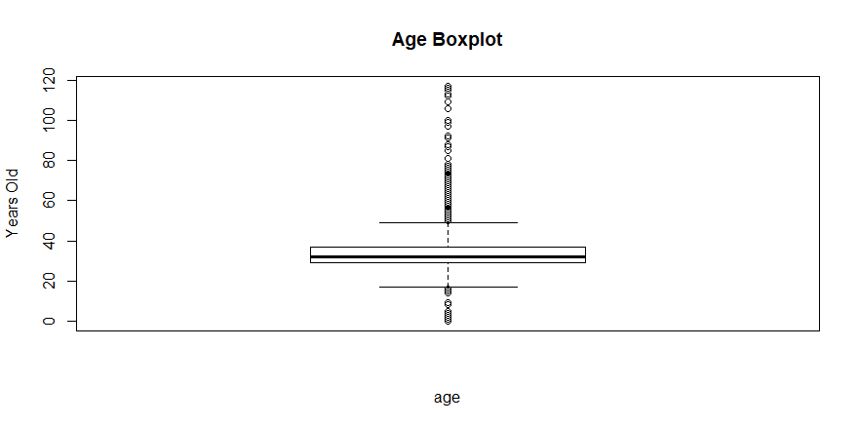

Figure : Age Boxplot

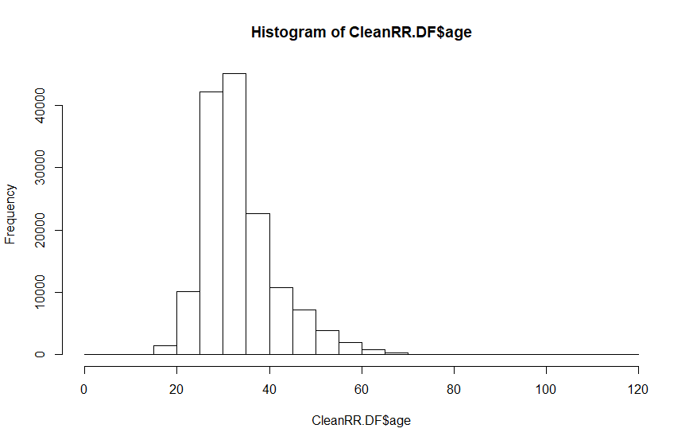

Figure : Histogram of Ages

Next, the variable weight was examined as seen below in Figure 3. Again, it can be noted that there were false reports including weights as low as 50 pounds with unusual sizes. Therefore, to maintain integrity of the data only weights greater than 75 pounds remained in the data set.

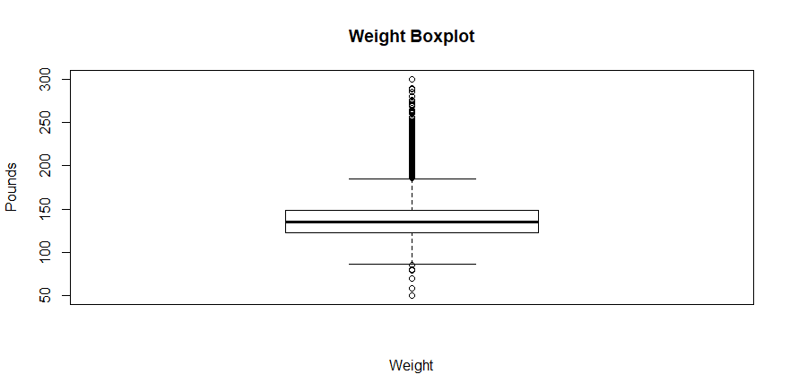

Figure : Weight Boxplot

The size variable also disclosed another anomaly as seen in Figure 4 below. Rent the Runway supports larger sizes; however, the maximum size is 22. Therefore, any size greater than 22 were eliminated as well.

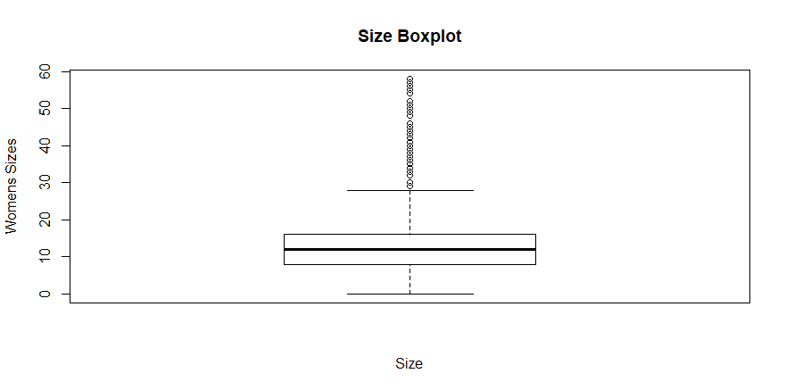

Figure : Size Boxplot

Finally, an examination of height did not disclose any irregularities as seen below in Figure 5.

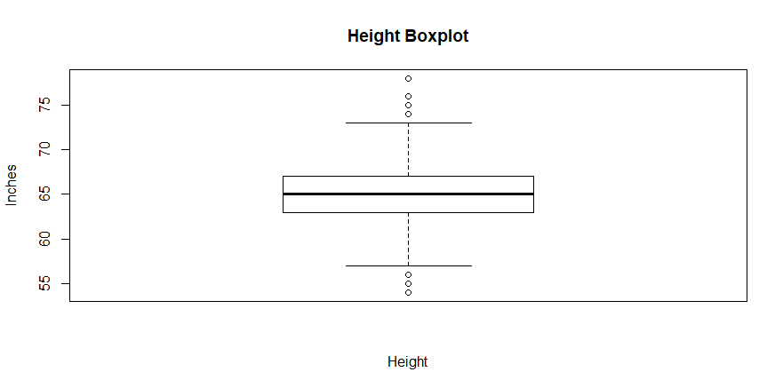

Figure Height Boxplot

An examination of the data frame disclosed empty fields 164,843 and Table 3 reflects the NAs by variable.

|  |  |  |  |
| --- | --- | --- | --- |
| **Variable** | **NAs** | **Variable** | **NAs** |
| Fit | 0 | Body_type | 14637 |
| User_id | 0 | Review_summary | 0 |
| Bust_size | 18411 | Category | 0 |
| Weight | 29982 | Height | 677 |
| Item_id | 0 | Size | 0 |
| Rating | 82 | Age | 960 |
| Rented_for | 10 | Review_date | 0 |
| Review_text | 0 |  |  |

Table : Data Frame NAs

Data cleaning continued only focusing on complete cases with a total of 147,489 transactions. Even though many records were removed from the data set, there was not a significant impact to the data thus allowing a balanced view on all variables with consistent data.

The variables underwent reexamination at the conclusion of data cleaning to ensure no additional cleansing is necessary. Customer characteristics can also be noted in the key variables in the data set below. The core customer has an average age of 33.8 with the highest users in the 28-33 age range as seen in Figure 6 below.

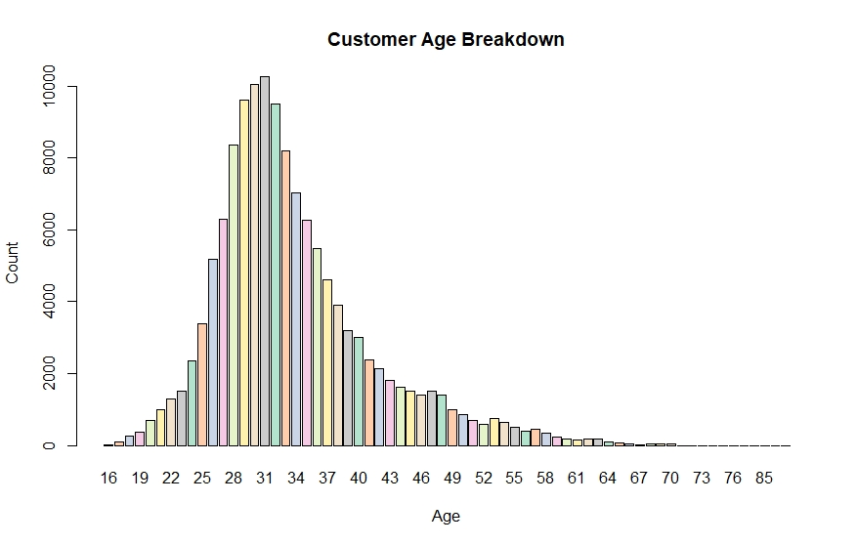

Figure Customer Age

Figure 7 displays the breakout of sizes, disclosing the most common sizes rented include sizes 8, 4, and 12 in ascending order. It is interesting to note that size 6, which is a very common size, is uncharacteristically low in the data set.

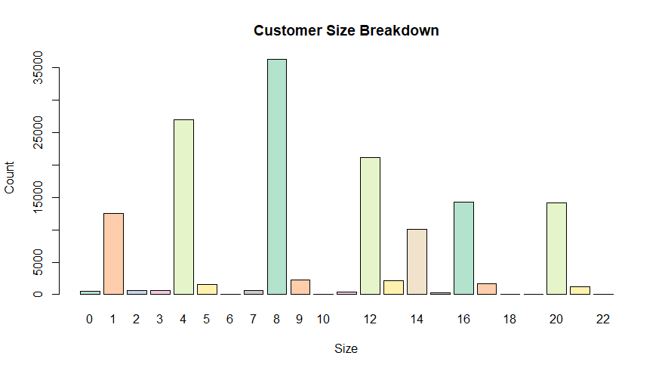

Figure Customer Size

However, based on the sample data set provided it aligns with the most common body types which are hourglass and athletic as seen below in Figure 8.

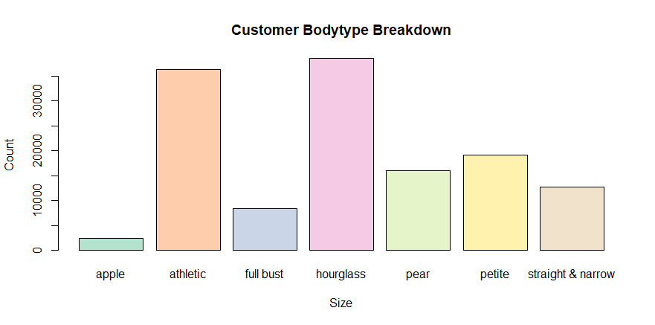

Figure Body Type

Exploring the most common occasion that the customer rented for, it is not surprising to see that wedding is the most common occasion as this was the initial foundation and concept of the business model. Formal affairs and party are also very common which can be associated with special occasions as well as seen below in Figure 9.

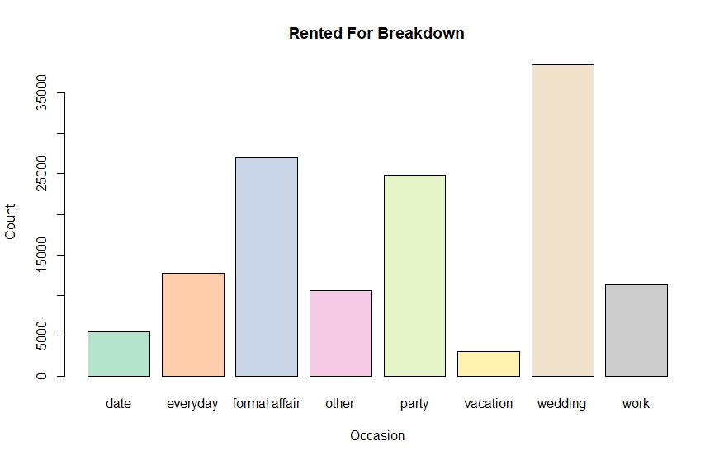

Figure Occasion Rented For

Overall, there is high satisfaction with most of the ratings being very high at 10 and 8 as observed in Figure 10 below.

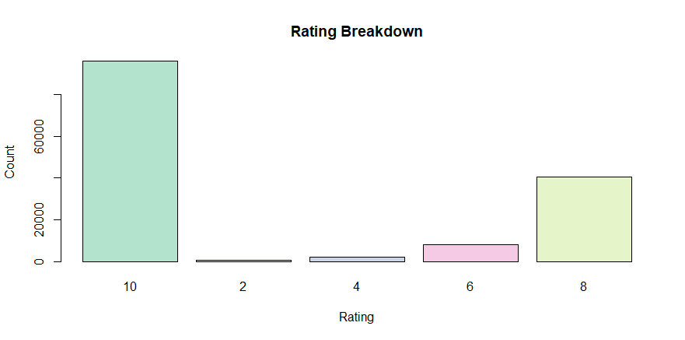

Figure Rating

Exploring the fit of the items, the items in the data set appear to fit well with only a small amount of styles fitting too large or too small as seen below in Figure 11.

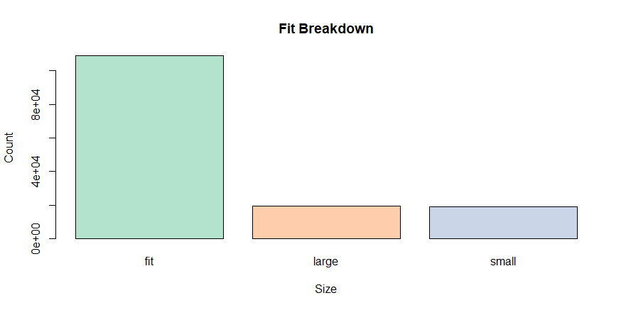

Figure Fit

Continued exploration with the data will be performed. Each subsequent discovered may require additional data manipulation throughout the model analysis.

**Model 1: Association Rule Mining**

In preparation for association rule mining, the data required additional modification. Using the ddplyr package, the variables user id and review date were combined into a single transaction. Results in the following structure were produced:

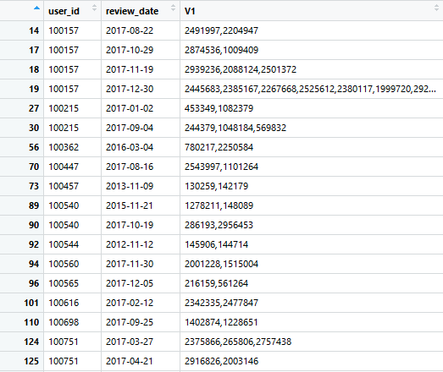

Table

The data frame displayed the following variables: use id, review data and the items reviewed on a single day. This assumed all items reviewed on the same day reflects a single rental transaction. For example, as shown in row 18 in Table 4, customer 100157 wrote a review for three items; the assumption dictates this is a single transaction. As noted in the results, there were no association rules. A transaction log required the removal of both the user id and review date to generate a single transaction.

The 20 most frequently rented items were calculated as seen below in Figures 12 and 13. Figure 12 reflects the total times an item was rented, while Figure 13 reflects the percentage to total transactions. As previously noted, there are only 5,000 products in the data set but 192,000 transactions. Assuming an even distribution, each item would have been rented 38 times. As with fashion trends, this is not the case. The top five items have been rented over 1,000 times.

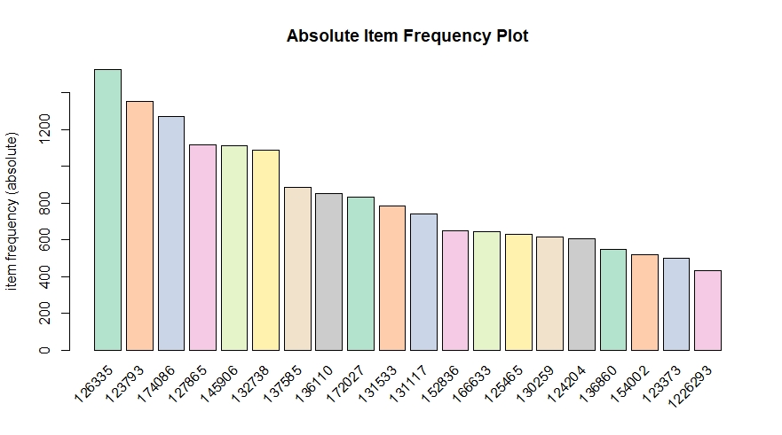

Figure Item Frequency

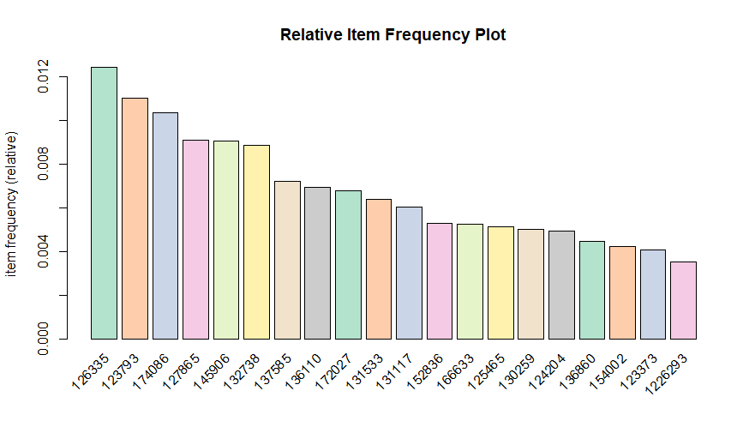

Figure Relative Item Frequency

Of note, there were no rule generated with this transaction data.

A second data set was created focusing only on transactions with more than one item within the basket. Again, no association rules were generated. This also demonstrated that items are not related to each other, indicating items are not rented together.

A third feature set was created using only fit, bust size, rented for and body type. The variables were converted into factors. The market basket format generated the following results as seen below in Table 6. The two most items used with the data set were identified as fit and hourglass.

|  |
| --- |
| transactions as itemMatrix in sparse format with  146382 rows (elements/itemsets/transactions) and  146504 columns (items) and a density of 3.412871e-05  most frequent items:  fit hourglass wedding athletic formal affair (Other)  107734 43982 42622 37518 30496 469557  element (itemset/transaction) length distribution:  sizes  4 5  1 146381  Min. 1st Qu. Median Mean 3rd Qu. Max.  4 5 5 5 5 5  includes extended item information - examples:  labels  1 1  2 10  3 100 |

Table : Term Document Matrix for Fit variables

**Model 2: Clustering kmeans**

A clustering model was explored next, creating a feature subset of clean data which focused on height, weight, bust size, body type and age. Height, weight, and age required transformation to numeric variables. Bust size and body type also required transformation into factor variables. The H2O package trained the model to report the body type based on the remaining variables height, weight, bust size and age. As seen below in Figure 14, the model used the centroids for the top 5 items, for fit, chest size, height and size.

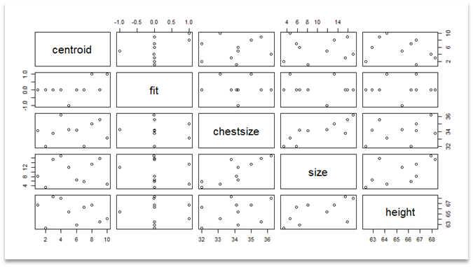

Figure Top Items

**Model 3: Decision Trees & Random Forest**

**Decisions Trees**

After a cursory review of the data to ensure all variables are formatted correctly and using some of the rules identified during association rules mining and k means, a new data frame was created with body type, age, bust size, weight, height and size to create the decision tree. The data was split into a test and training data frame using a partition of 90% of the data for training.

Additional data transformation was required including converting size, weight, and height into numeric variables. Body type and bust size were also confirmed as factor variables to ensure success of the model.

For the initial training of the decision tree model for body type, all variables within the training set are included. The training parameters were set to cross validation with a fold value of 10. The model produced an accuracy of 38% and Figure 15 below shows that accuracy decreases as the complexity increases.

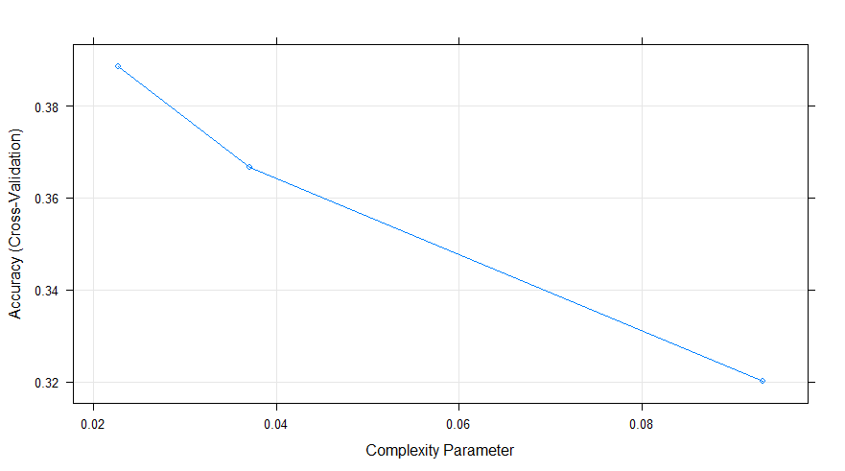

Figure

Additionally, as Figure 16 shows the decision tree did not contain many branches since the total number of variables used was relatively.

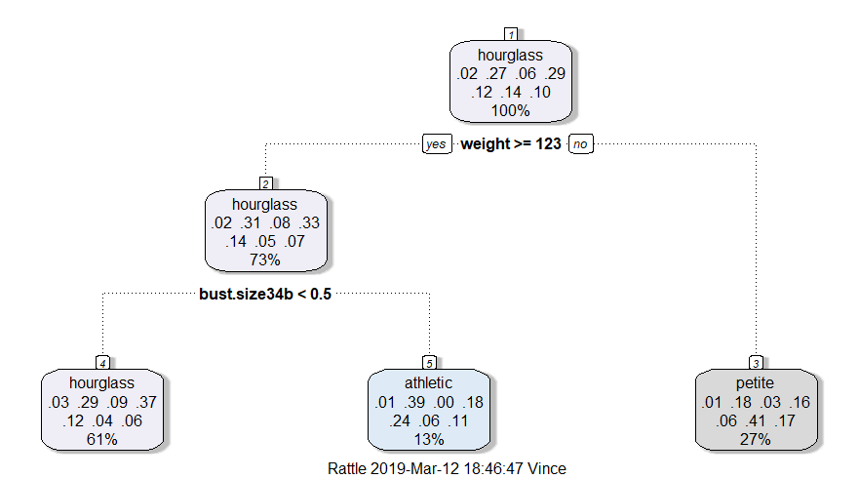

Figure Decision Tree

Using the “rpart” package, a very different model and decision trees was generated. Additionally, a host of other issues arises. The first issue is the duration of time it takes to run the entire data. Using a very small segment of the dataset, 0.1% (which is too small for accurate prediction) generates a decision tree (Figure 17). Using a much larger data set and the same parameters in the caret model led to inclusive results since the model never concluded training. It ran for over 12 hours and eventually crashed the system. Tuning and additional modifications did not alter the results the model was abandoned.

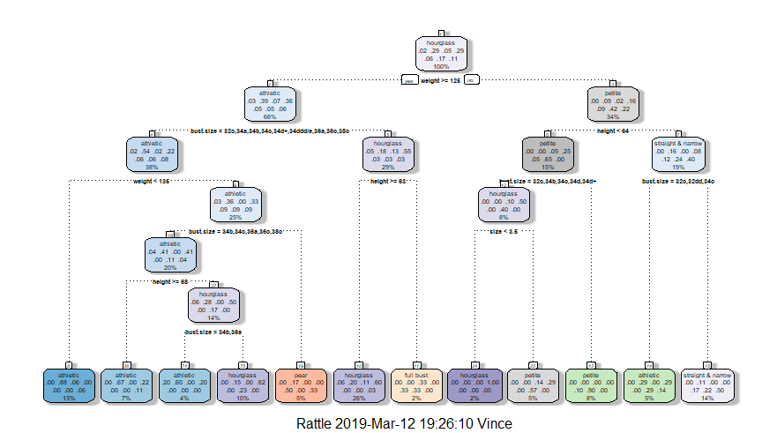

Figure Decision Tree

**Random Forest**

One of the unique and most beneficial parts of a random forest is that it provides an output on variable importance, allowing for a reconsideration of factors. In the initial attempt at implementation, body type, size, weight and height were used. These are dimensions of the customer provided by the data and were run with rating being the dependent variable and a surrogate for satisfaction.

Body type proved to be a poor choice for prediction of satisfaction based on the numerical rating and was removed leaving height, weight, size, and age. Age was added because it, along with the others, is something the customer would know before even using the site. Age proved to be a powerful indicator towards a higher satisfaction rating.

Another random forest model was also run to predict rating using the variables of height, weight, size and age. Ten trees were used with a 5-fold cross-validation. This model generated an accuracy of 67% as seen below in Figure 18.

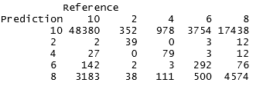

Figure Random Forest for Rating

**Model 4: naive Bayes**

The naïve Bayes model was initially attempted to predict what the item was rented for based on age and item id. Age and item id were transformed to factors as it is a requirement for the naïve Bayes model. To train and test the model, a sample split of 90% was used on the data. The model was run with low accuracy results at only 36% accuracy as seen below in Figure 19.

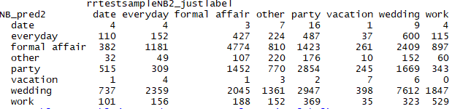

Figure naive Bayes Model for Rented For with Item Id

Due to the low accuracy of the first model, exploration was continued with additional variables. The second model on naïve Bayes substituted item id for category. Age remained in the model and both age and category were again transformed to factors. The same sample split of 90% was used on the model. The second model had higher accuracy than model 1 achieving 42% accuracy but remained low as results are seen below in Figure 20.

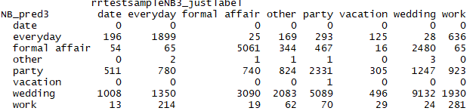

Figure naive Bayes Model for Rented For with Category

A third attempt on the model was performed but changed the predicting variable to fit. The model used the variables of size, weight, height, body type and item id. As like the prior models, the variables were transformed into factors and the same sample split of 90% was used. This model saw a significant increase of accuracy achieving a 63% accuracy as seen below in Figure 21.

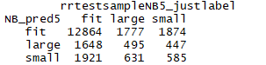

Figure naive Bayes Model for Fit

**Model 5:  SVM**

The next model explored was Support Vector Machine, known as SVM. The model was performed on the review text of the customer provided review. Additional data transformation was required including tokenizing the text, changing the words to lowercase, and removing stop words. The document term matrix was fed into the SVM to attempt to classify words against the numerical rating. Rating could be predicted based on the review text with a 46% accuracy rate.

Another SVM model was also explored to predict rating. A new data frame was created using the variables of rating, height, weight, size and age. This model generated an accuracy of 65%.

**Model 6: Text Mining**

Exploration of the customer reviews were continued with text mining. A new data frame was created to only include rating and review summary. Transformation was required including converting all words to lowercase, removing all stop words, removing punctuation, and tokenizing the reviews.

The data was sorted in descending order to achieve to the goal of word frequency. SVM was used in text mining sentimental analysis based on frequency of words and rating was a surrogate for customer satisfaction. Seeing the most frequent words used can identify patterns in reviews and more favorable items.

**Model 7: kNN**

K nearest neighbor, known as kNN, was performed to predict fit. The variables identified for the model were item id, weight, height, and size. Size and item id were converted to a numeric variable while fit was converted to a character variable. As there were many challenges with determining k using algorithms, the model ran without determining k and assumed the generated k number. The model ran with a 66% accuracy rate in predicting fit as seen below in Figure 21.

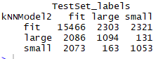

Figure kNN model for Fit

The model was adjusted and tested to see if body type could be predicted using the same variables of item id, weight, height, and size. Body type was transformed to a character variable and size and item id were transformed again to numeric variables. Figure 23 shows the results and the model only produced a 28% accuracy rate.

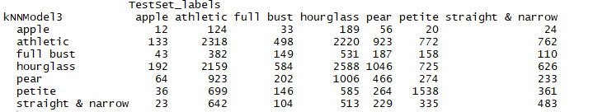

Figure : kNN model for Body Type

**Results**

**Model 1: Association Rules Mining**

The associate rules mining model ran the transaction data using support = 0.0001, conf = 0.8 and a minlen = 2 and maxlen = 5000 resulted in 10 rules with a confidence exceeding 0.8. The rules can be seen below in Table 6.

|  |
| --- |
| lhs rhs support confidence lift count  [1] {34dd,formal affair} => {fit} 0.0018 0.80 1.1 237  [2] {32a,formal affair,straight & narrow} => {fit} 0.0016 0.82 1.1 216  [3] {32a,athletic,formal affair} => {fit} 0.0012 0.80 1.1 164  [4] {34a,formal affair,straight & narrow} => {fit} 0.0017 0.81 1.1 228  [5] {34a,athletic,formal affair} => {fit} 0.0029 0.82 1.1 390  [6] {32b,athletic,other} => {fit} 0.0011 0.81 1.1 146  [7] {32b,formal affair,hourglass} => {fit} 0.0017 0.80 1.1 221  [8] {32d,athletic,formal affair} => {fit} 0.0025 0.82 1.1 335  [9] {34d,athletic,formal affair} => {fit} 0.0037 0.81 1.1 489  [10] {34b,formal affair,pear} => {fit} 0.0052 0.82 1.1 697 |

Table : Association Rules Mining for Fit

Based on the number of records within the transaction data, there is very little support for these rules. However, the confidence is high, and lift is greater than 1.

Examining the rules for when the left-hand side of is set to small and large fit resulted in two very small rules sets. Firstly, it can be noted that the level of support and confidence is very low, however the count of each item is high. It does reflect what factors are associated with a small fit.

|  |
| --- |
| lhs rhs support confidence lift count  [1] {small} => {wedding} 0.041 0.32 1.11 5521  [2] {small} => {hourglass} 0.037 0.28 0.98 4873  [3] {small} => {athletic} 0.036 0.28 1.02 4823  [4] {small} => {party} 0.026 0.20 1.10 3534  [5] {small} => {formal affair} 0.023 0.18 0.87 3045  [6] {small} => {34b} 0.022 0.17 0.98 2975  [7] {small} => {34c} 0.020 0.15 1.04 2647  [8] {small} => {petite} 0.018 0.14 0.98 2437  [9] {small} => {pear} 0.015 0.11 0.96 1987  [10] {small} => {34d} 0.015 0.11 1.04 1961 |

Table : Association Rules Mining table for Small

Since a small fit did not disclose any interesting relationships, an examination of large fit was explored. The top rule discovered within this model consisted of customers who self-identified as hourglass reported their clothing as large, but as the remain rules are examined other self-reported body type also report a large fit with rented items.

|  |
| --- |
| lhs rhs support confidence lift count  [1] {large} => {hourglass} 0.039 0.30 1.02 5206  [2] {large} => {athletic} 0.033 0.25 0.92 4402  [3] {large} => {wedding} 0.032 0.24 0.83 4243  [4] {large} => {party} 0.024 0.18 0.99 3240  [5] {large} => {formal affair} 0.023 0.17 0.85 3036  [6] {large} => {34b} 0.022 0.17 0.95 2961  [7] {large} => {everyday} 0.020 0.15 1.61 2699  [8] {large} => {34c} 0.020 0.15 1.03 2673  [9] {large} => {petite} 0.019 0.14 0.99 2512  [10] {large} => {pear} 0.018 0.13 1.12 2354 |

Table : Association Rules Mining Large Fit

Using the entire data set and maintaining support at 0.0001, lowering confidence level to 0.5 and minlength of 2 combines the result into Graph 2. Most of the rules fall within the fit category with the those few rules associated with Hourglass and petite filling in the rest.

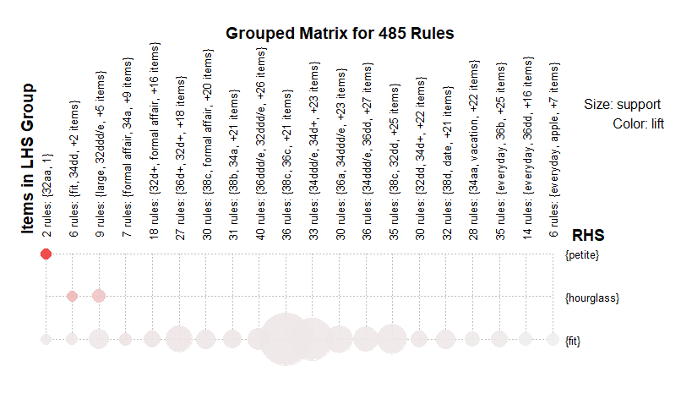

Graph : Fit rules by Lift

**Model 2: Clustering Kmeans**

Looking at the most popular items, Figure 24 concludes that popular items consistently fit well and fit across a range of sizes. The variables used included height, chest size which is the band. Fit was converted to -1, 0, 1 where -1 = small, 0 = fit and 1 = large.



Figure Clustering of Top Items

Analyzing the positions of the centroids projects y = chest size, z = height and x = fit on a three-dimensional plot shows the relationship between all three of the critical where fit is the variable tag by Rent the Runway as seen below in Graph 3.

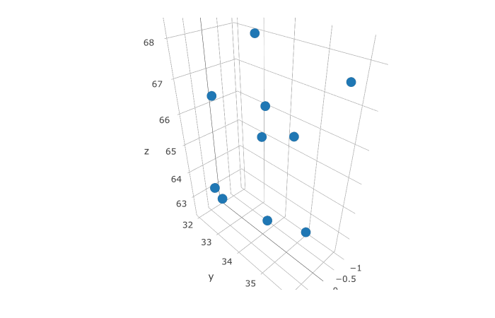

Graph : kMeans centroids based on height, band size and fit

Exploring the data for fit (x) to size(z) and band size (y) also confirms most good fits fall in the sizes 4 and 8 as presented in Graph 4.

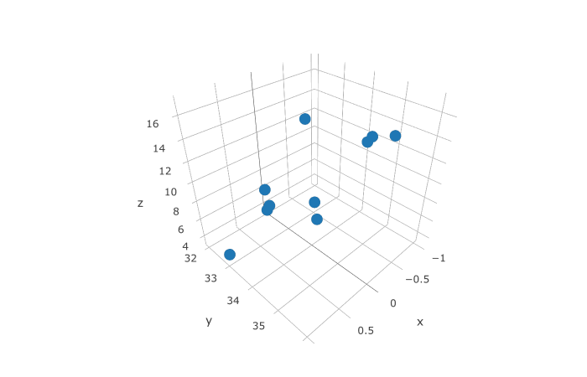

Graph : kMeans size, chest size, fit

**Model 3: Decision Tree and Random Forest**

**Decision Tree**

Executing the known test data within the model generated a confusion matrix as seen below in Table 10 with an accuracy of approximately 38%.

|  |  |  |  |  |  |  |  |
| --- | --- | --- | --- | --- | --- | --- | --- |
|  | Apple | athletic | full bust | Hourglass | Pear | Petite | Straight&  narrow |
| apple | 0 | 0 | 0 | 0 | 0 | 0 | 0 |
| athletic | 26 | 671 | 0 | 342 | 395 | 107 | 181 |
| full bust | 0 | 0 | 0 | 0 | 0 | 0 | 0 |
| hourglass | 180 | 2278 | 713 | 2967 | 1023 | 356 | 520 |
| pear | 0 | 0 | 0 | 0 | 0 | 0 | 0 |
| petite | 16 | 648 | 110 | 633 | 179 | 1456 | 542 |
| straight&  narrow | 0 | 0 | 0 | 0 | 0 | 0 | 0 |

Table Decision Tree for Body Type

A final effort was explored to create a more reliable decision tree using H2O. Once again, the same parameters were incorporated into the model. In this case a cross fold of 10 levels generated no visible tree. However, the H2O model’s confusion matrix as seen below in Table 11 had a 54% accuracy.

|  |  |  |  |  |  |  |  |
| --- | --- | --- | --- | --- | --- | --- | --- |
|  | apple | athletic | full bust | Hourglass | Pear | Petite | Straight&  narrow |
| apple | 295 | 170 | 42 | 248 | 68 | 57 | 23 |
| athletic | 64 | 7358 | 349 | 2977 | 849 | 1005 | 713 |
| full bust | 28 | 592 | 1202 | 785 | 217 | 173 | 103 |
| hourglass | 103 | 2927 | 435 | 8164 | 1014 | 1022 | 547 |
| pear | 48 | 1427 | 191 | 1563 | 2107 | 410 | 213 |
| petite | 18 | 560 | 122 | 709 | 264 | 5071 | 172 |
| straight&  narrow | 7 | 1038 | 89 | 620 | 196 | 306 | 2520 |

Table Decision Tree on Body Type

Body type continues to be a challenge in predicting due to nature of the variable.

**Random Forest**

The random forest model had an accuracy rate of 62%. As seen below in Table 11, the most accurate body type variable predicted was petite. Again, this body type is very specific due to height. Apple, pear, and full bust were the most challenging body types to predict. As there are similarities between these body types, this causes the potential for misidentification as other body measurements are needed.

|  |  |
| --- | --- |
| Body Type | Error Rate |
| Petite | 23% |
| Hourglass | 29% |
| Athletic | 35% |
| Full Bust | 43% |
| Pear | 43% |
| Apple | 53% |

Table : Body type error

The second random forest model in predicting rating had a 67% accuracy. The model could predict the highest rating of 10 with a 68% accuracy as well as predicting the lowest rating of 2 with 70% accuracy. Overall customers are satisfied with the rented item; however, there appear to be more factors that impact an average rating.

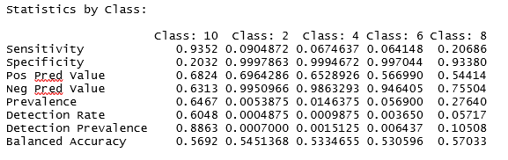

Figure Random Forest for Rating

**Model 4: Naïve Bayes**

The first naïve Bayes model which attempted to predict the occasion the item was rented for had very low accuracy at 36%. As seen below in Figures 26 and 27, wedding and formal affair could be predicted with a 40% accuracy, however as these are the core of the business model. The everyday occasion was the most difficult occasion to predict with only a 7% accuracy. It is very challenging to predict the occasion based on the item id and age of the customer.

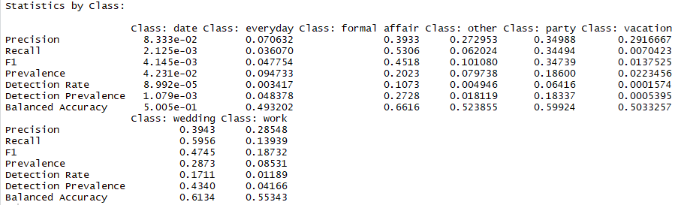

Figure naive Bayes for Rented For

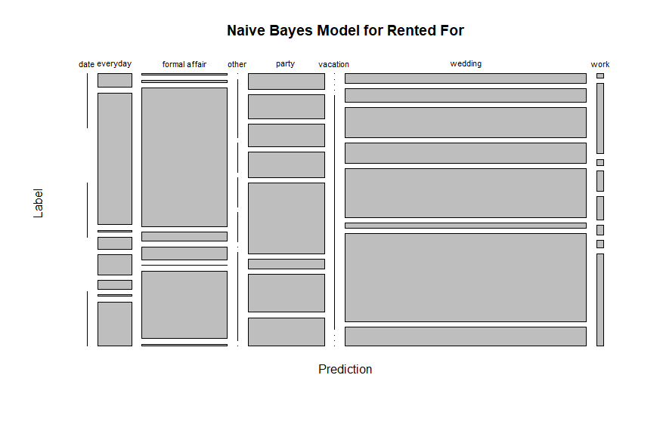

Figure naive Bayes for Rented For Plot

The second model of naïve Bayes that replaced item id with category proved to have a better accuracy rate in predicting the rented occasion with a 42% accuracy rate. As seen below in Figures 28 and 29, formal affair increased to a 59% accuracy, but wedding fell to 38% accuracy. Date did not have any results most likely due to the sample split. The everyday occasion increased significantly based on the category variable.

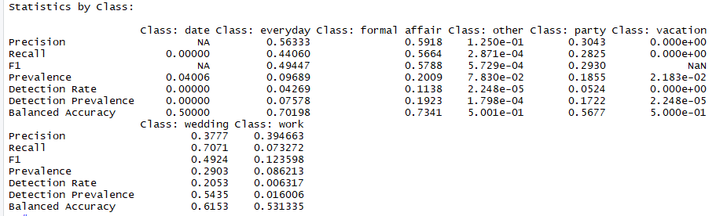

Figure naive Bayes for Rented For by Category

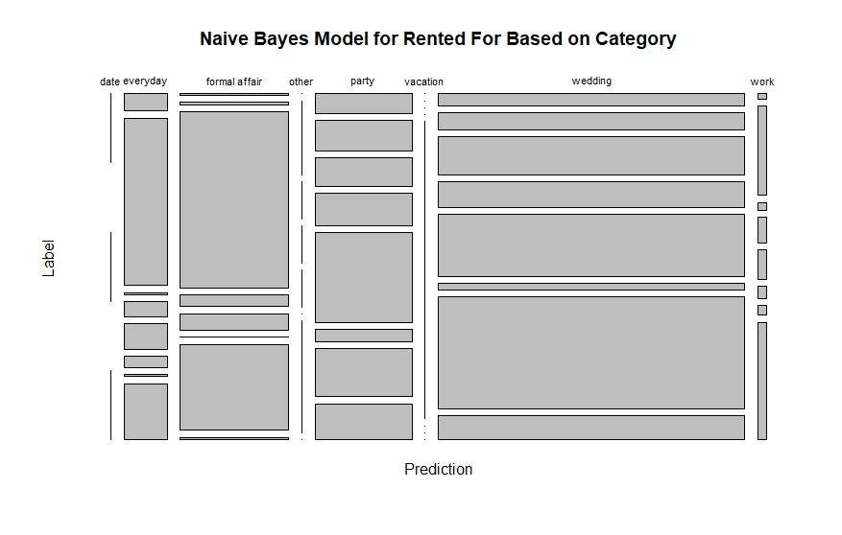

Figure naive Bayes for Rented For by Category Plot

The final naïve Bayes model which predicted fit proved to be the most accurate model with a 63% accuracy rate. An item with a good fit could be predicted with a 78% accuracy while large and small fit could only be predicted with less than 20% accuracy as seen below in Figures 30 and 31. While k was explored and manipulated, it was noted that as k increased, while the accuracy of predicting fit increased, the accuracy of a large fit and small fit decreased. Thus, the k remained at the assumed value of the model to have higher accuracy rates for large and small fit.

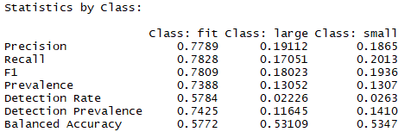

Figure naive Bayes for Fit

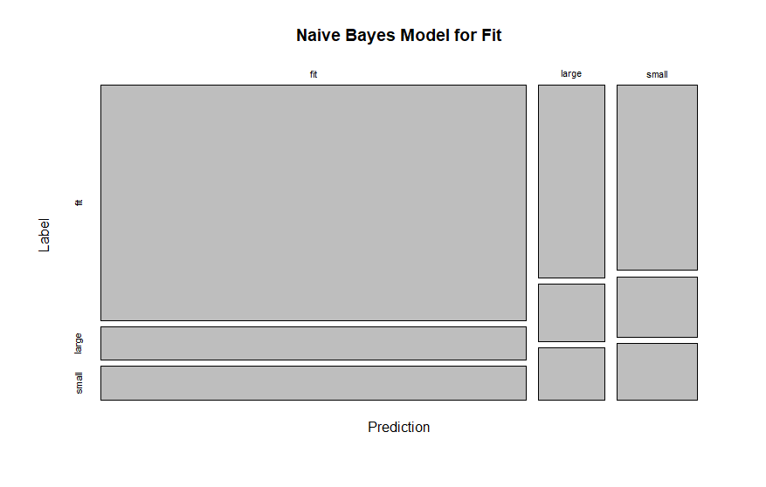

Figure naive Bayes for Fit Plot

**Model 5: SVM**

The SVM model had an accuracy of 46%. The rating could be predicted based on the review text, however there is still much improvement needed. Since certain common words could be used both positively and negatively, this proved to be a challenge with classification. The SVM model also was leveraged in the text mining model with the continued exploration of the customer reviews.

The second SVM model that attempted to predict rating was more challenging. The overall accuracy of the model was 65%. However, as the model appear to be successful, when looking at each rating, as seen below in Figures 32 and 33, the model only predicted the highest rating of 10, while ignored the other ratings.

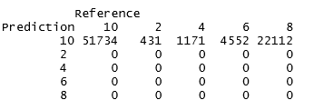

Figure SVM for Rating

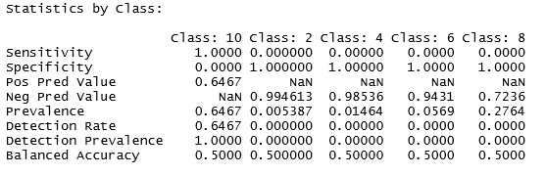

Figure SVM for Rating

**Model 6: Text Mining**

Exploring the text frequency in the customer reviews, dress can be noted as the most frequently used word. This result aligns with the top customer rental for weddings. Other words of significance include perfect, compliments, comfortable, and loved. Wedding is a high frequency word as seen below in Figure 34.

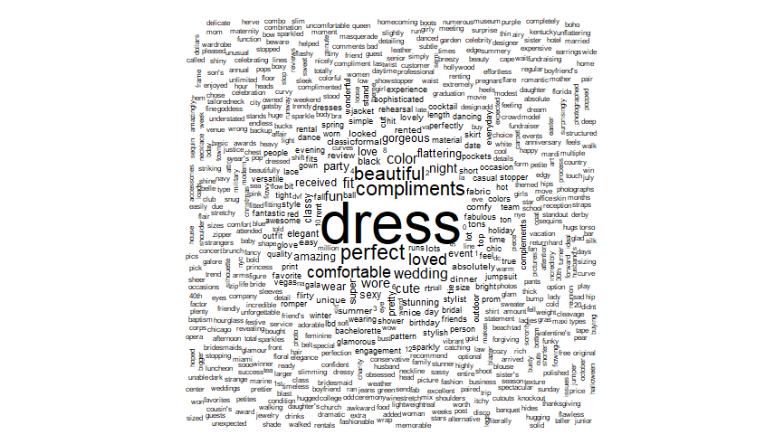

Figure Text Mining Word Cloud

Table 12 identifies the top ten most frequently used words. It can be noted that all words are very positive. This aligns with the high satisfaction and high customer ratings.

|  |  |
| --- | --- |
| Word | Frequency |
| dress | 79,905 |
| perfect | 21,462 |
| compliments | 19,897 |
| beautiful | 18,997 |
| comfortable | 14,293 |
| loved | 14,193 |
| fit | 12,007 |
| color | 11,698 |
| fun | 10,074 |

Table Word Frequency in Reviews

**Model 7: kNN**

Even though body type was initially thought to be a significant, this variable is not significant as it cannot accurately be predicted based on item id, weight, height, and size which are key metrics in body type. As seen below in Figures 35 and 36, the most common body types of hourglass and athletic can only be accurately predicted 33% and 30% respectively. Petite is the body type with the most accurate predictions at 42% which is not surprising given that this body type is very specific due to height. The apple body type is the most challenging with only 2% accuracy. This is also not surprising as more body measurements are needed to determine this body type.

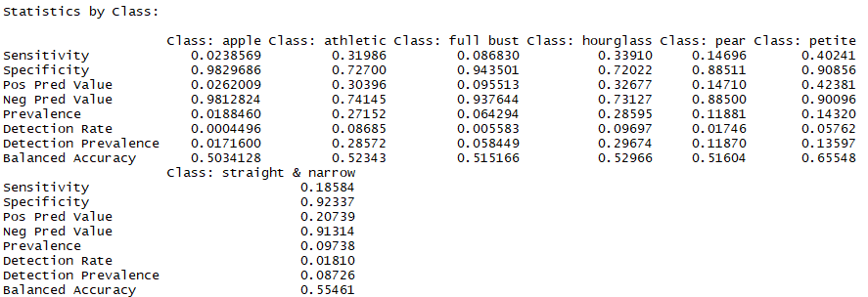

Figure kNN for Body Type

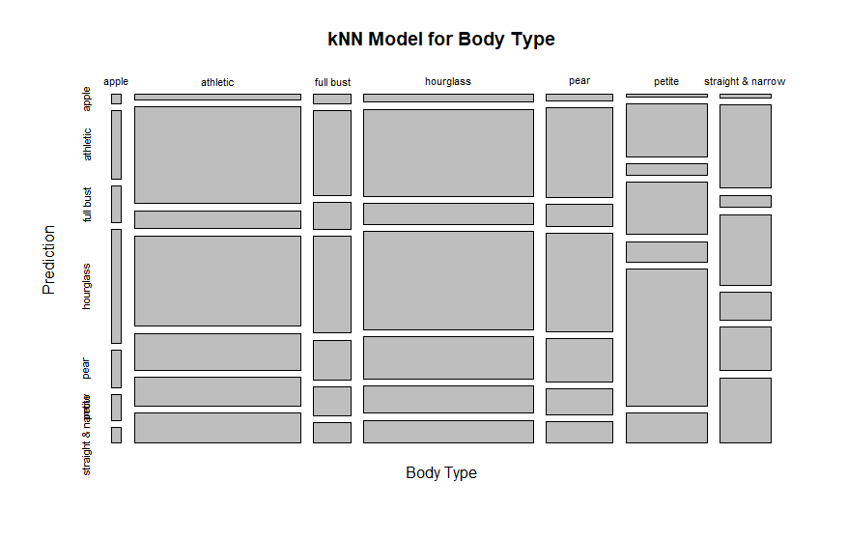

Figure knn for Body Type Plot

Predicting fit proved to be more accurate with the overall accuracy at 66%. As seen below in Figures 37 and 38 items can be identified as fitting with a 77% accuracy. However, both large and small fits can only be accurately predicted at a 33% and 32% accuracy rate respectively. The model was tuned with different k values at 3 and 5, but as the fit accuracy increased, the accuracy on large and small fits decreased.

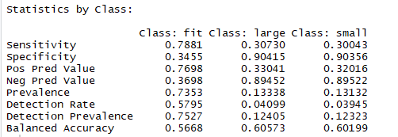

Figure knn for Fit

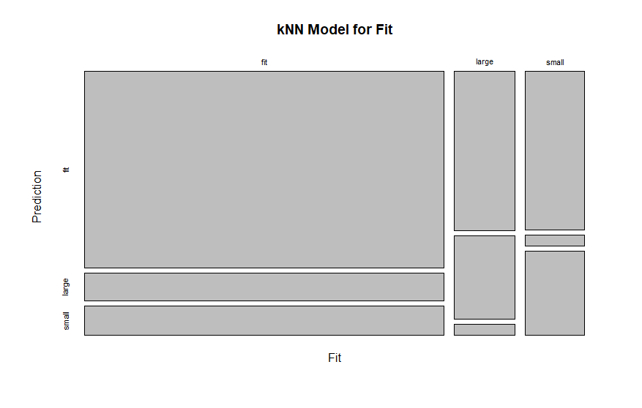

Figure kNN for Fit Plot

**Overall Results**

There are challenges in perceptual variables, like body type. Initially it was assumed that body type would be a significant variable in predictions. However, it never seemed to rise to a level of importance with the challenge of subjectivity. Surprisingly, age turned out to be an important variable in predicting fit. Customer satisfaction can be predicted but unfortunately it cannot be tied to a specific item.

Many variables that were assumed to be important to the models, turned out not to be. Association rules mining provides some insight into the variables which might be used in later models. As those models evolved in many cases, they all reverted to using all or combinations of age, weight, height, bust size, and fit. Surprisingly age turned out to be one of the best variables for predicting fit in most of the models.

There are many additional variables needed in order to provide a more accurate recommendation model. Ideally, other customer characteristics to be captured and provided would include waist measurement, hip measurement, and the price of the rental as there is a wide range of prices to help better understand the customer. Having data on the designer that the customers rented provides an insight into suggestions for future rentals.

Also, many of these variables are self-reported which also assumes a standardized metric in perception for body type as well as assuming accuracy of size metrics including weight, height and size.

**Conclusions**

The dream closet in the cloud will continue to evolve and change shapes. Even with the evolution, the foundation of the company will remain solid as special occasions and the role of social media will continue to impact customer needs and behavior. As the world of fashion constantly is changing, Rent the Runway has opportunities to be ahead of the curve beyond trends.

There is also an opportunity to identify styles to add to the inventory that fit a more expansive size range of customers. As popular items maintain a longer lifetime profitability, creating more popular items with size inclusivity in mind is an important factor as Rent the Runway continues to expand the customer base and business model. As size inclusivity continues to be a hot topic in the fashion industry, it is important to be a leader embracing inclusivity and diversity.

Product size recommendations and fit predictions are critical in order to improve the shopping experiences and to reduce low ratings and poor reviews. However, modeling customers’ fit feedback is challenging due to its subtle semantics, arising from the subjective evaluation of products and imbalanced label distribution.

As personalization continues to grow in the fashion industry, there are many obstacles. Not showing the customer the ideal items could lead to poor perception and lower confidence in Rent the Runway. Customer satisfaction is key to the business model as it can impact sales in a style which can lead to long term effects in profitability.

As the dream closet is just a click away, the possibilities are endless, with something new to wear every day. As Rent the Runway continues to empower their customer and evolve their business model, revolutionizing recommendations will be their latest conquest.

# References

Bowman, L. (2017, November 15). One in six young people won’t wear an outfit again if it’s been seen on social media. *Metro*.

*Clothing Fit Data for Size Prediction*. (2018). Retrieved from Kaggle: https://www.kaggle.com/rmisra/clothing-fit-dataset-for-size-recommendation

Misra, R. (n.d.). *Clothing Fit Dataset for Size Recommendation*. Retrieved from Kaggle: https://www.kaggle.com/rmisra/clothing-fit-dataset-for-size-recommendation

www.renttherunway.com