Marc Carter RMD

Marc Carter

11/16/2019

## Heat Map to show Correlation

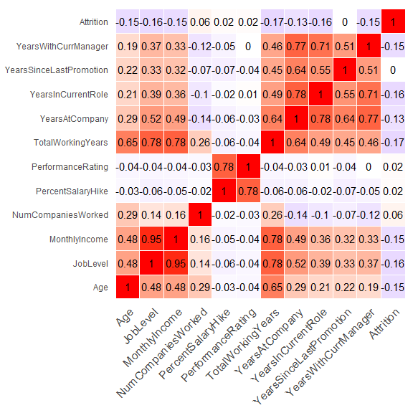

## EDA Plots

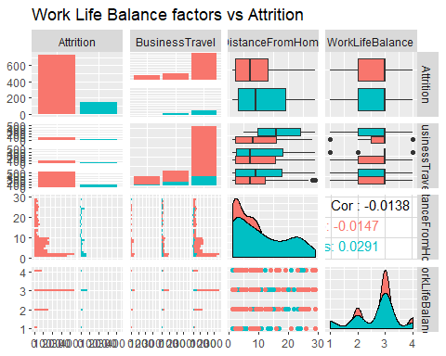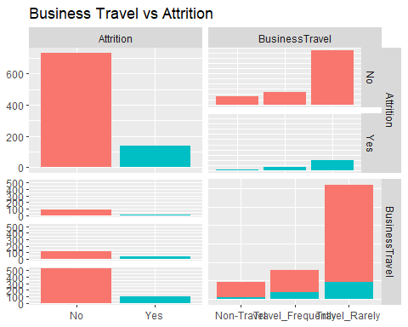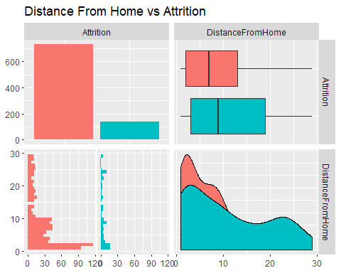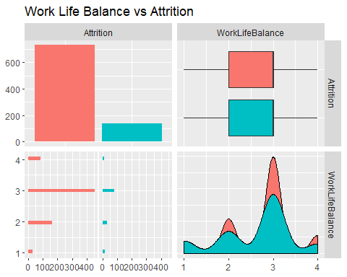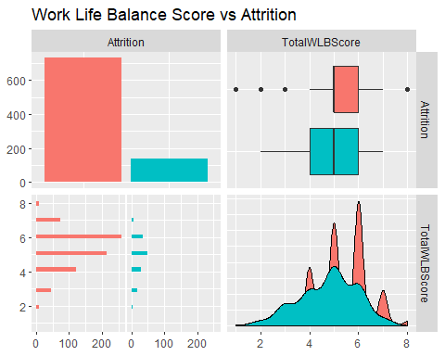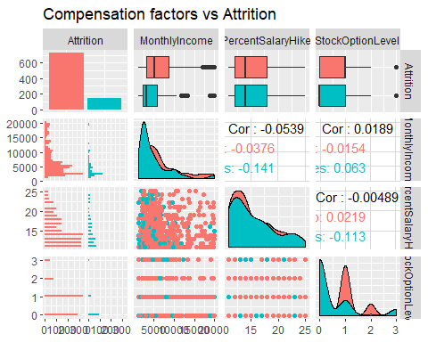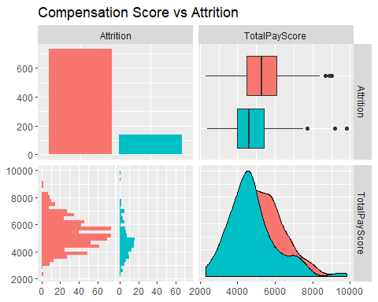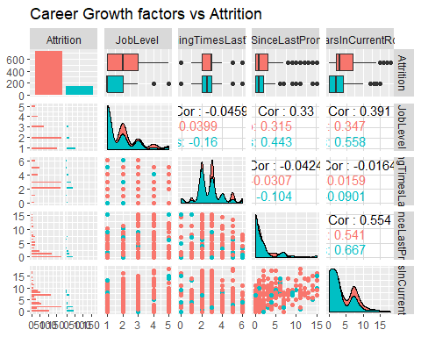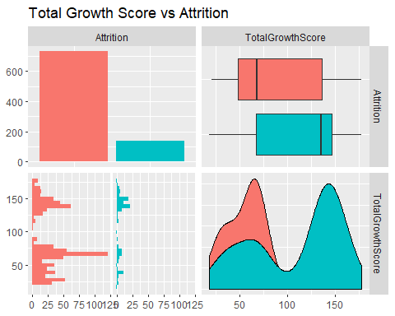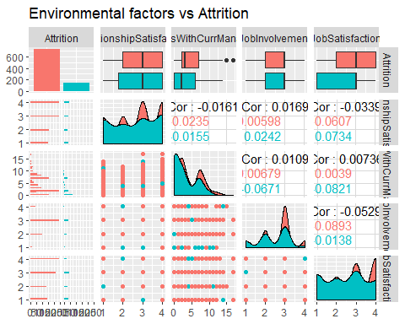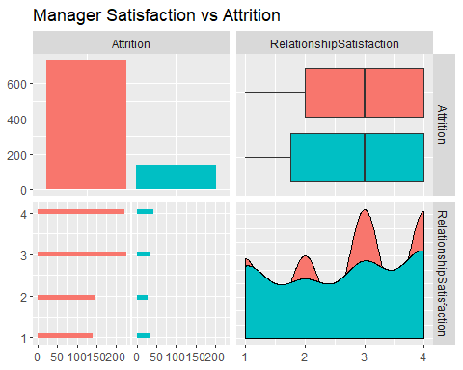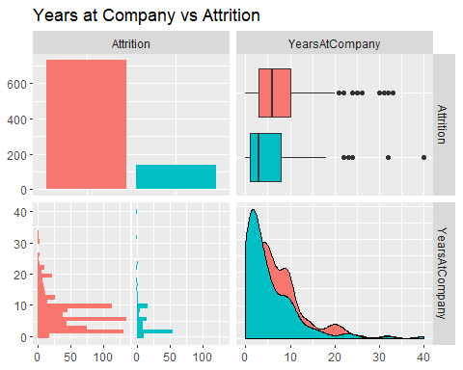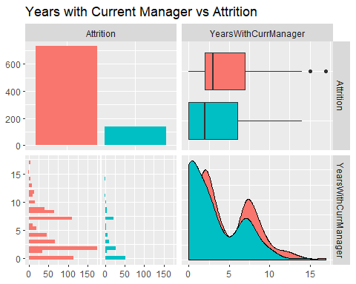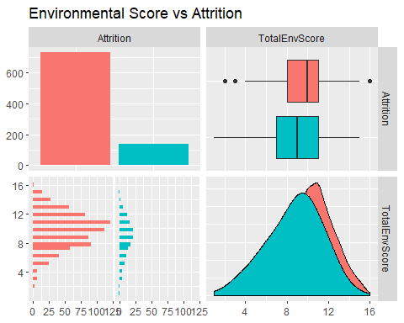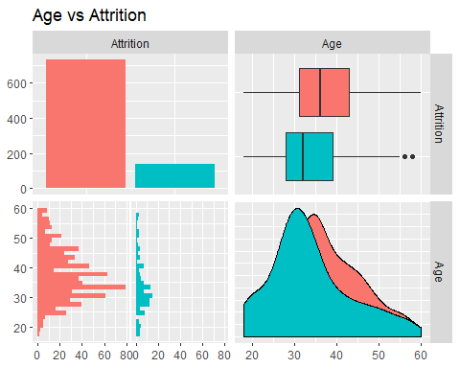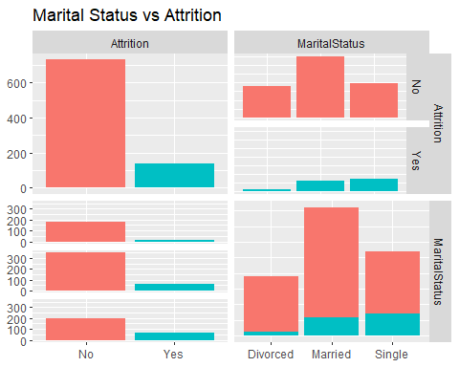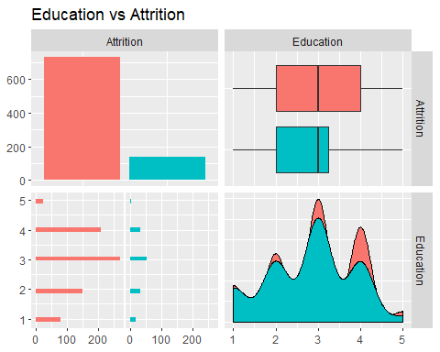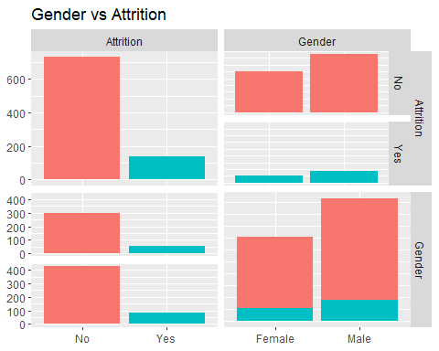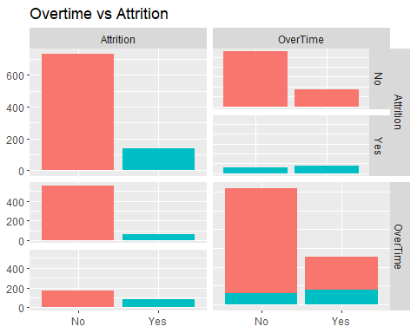

## KNN Model

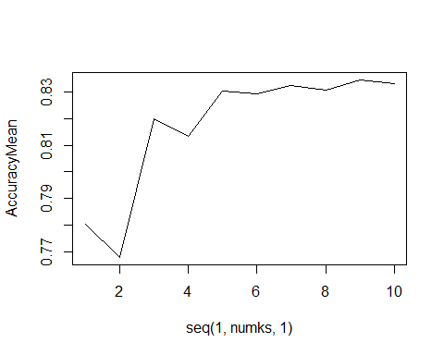

## [1] 9

## [1] 0.8345594

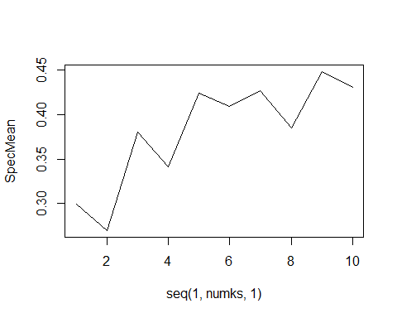

## [1] 9

## [1] 0.4483581

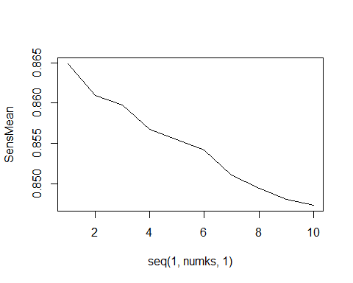

## [1] 1

## [1] 0.8648779

## Niave Bayes Model

## [1] 0.8479693

## [1] 0.7110025

## [1] 0.8510936

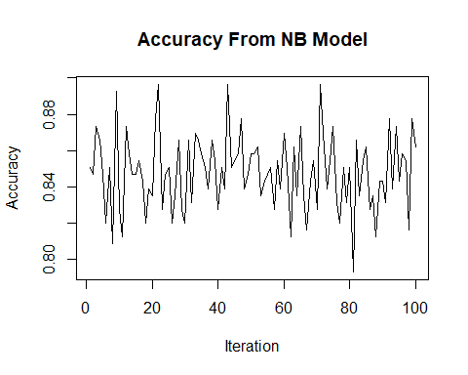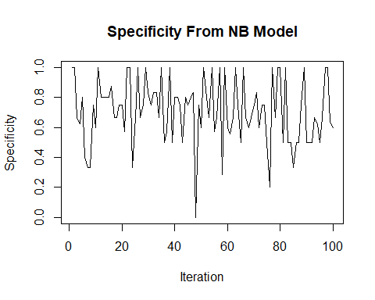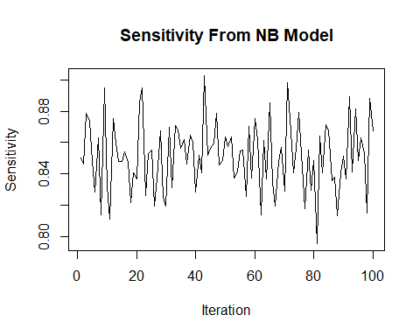

## Linear Model

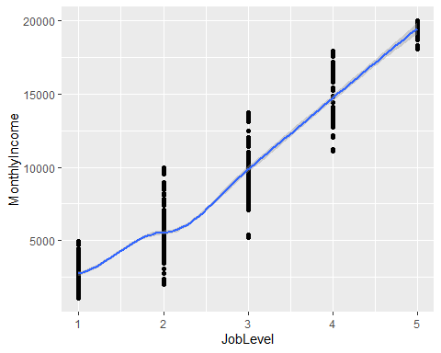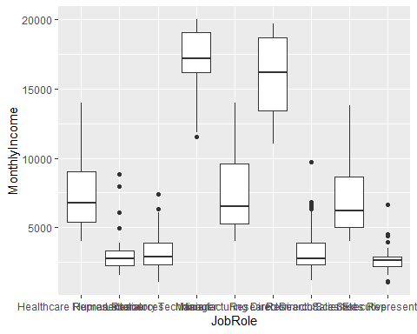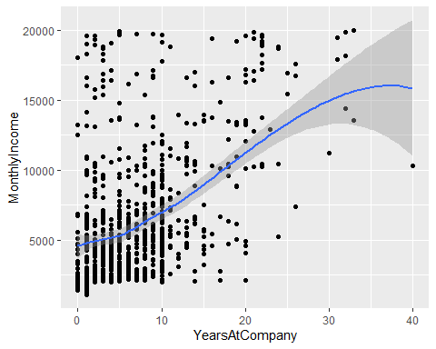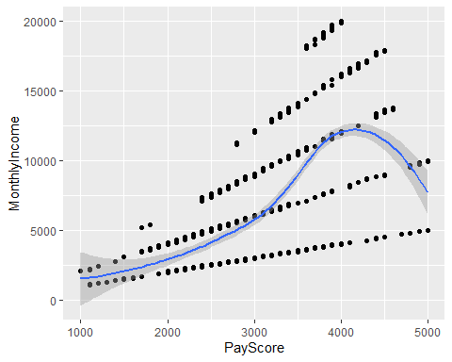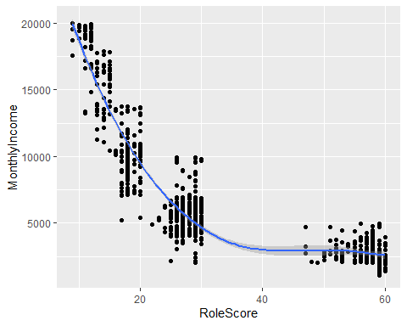

## [1] 440.3302

##   
## Call:  
## lm(formula = MonthlyIncome ~ JobLevel + JobRole + YearsAtCompany +   
## PayScore + RoleScore, data = ds_train)  
##   
## Residuals:  
## Min 1Q Median 3Q Max   
## -1766.20 -247.36 36.03 270.83 1198.02   
##   
## Coefficients:  
## Estimate Std. Error t value Pr(>|t|)   
## (Intercept) -6.865e+03 1.752e+02 -39.179 < 2e-16 ***  
## JobLevel 3.559e+03 4.168e+01 85.386 < 2e-16 ***  
## JobRoleHuman Resources -1.999e+02 1.056e+02 -1.894 0.05853 .   
## JobRoleLaboratory Technician -2.633e+02 7.336e+01 -3.589 0.00035 ***  
## JobRoleManager 1.913e+03 9.890e+01 19.348 < 2e-16 ***  
## JobRoleManufacturing Director 7.596e+01 6.602e+01 1.151 0.25025   
## JobRoleResearch Director 1.896e+03 9.125e+01 20.781 < 2e-16 ***  
## JobRoleResearch Scientist -2.293e+02 7.442e+01 -3.081 0.00213 **   
## JobRoleSales Executive 4.894e+00 5.682e+01 0.086 0.93138   
## JobRoleSales Representative -1.244e+02 9.303e+01 -1.337 0.18151   
## YearsAtCompany 8.844e+00 2.954e+00 2.994 0.00284 **   
## PayScore 1.537e+00 2.317e-02 66.356 < 2e-16 ***  
## RoleScore 3.534e+01 2.657e+00 13.301 < 2e-16 ***  
## ---  
## Signif. codes: 0 '***' 0.001 '**' 0.01 '*' 0.05 '.' 0.1 ' ' 1  
##   
## Residual standard error: 420.1 on 856 degrees of freedom  
## Multiple R-squared: 0.9917, Adjusted R-squared: 0.9916   
## F-statistic: 8547 on 12 and 856 DF, p-value: < 2.2e-16

## 2.5 % 97.5 %  
## (Intercept) -7208.653968 -6520.858651  
## JobLevel 3477.359720 3640.986727  
## JobRoleHuman Resources -407.110542 7.231053  
## JobRoleLaboratory Technician -407.287968 -119.323166  
## JobRoleManager 1719.357743 2107.579958  
## JobRoleManufacturing Director -53.620104 205.530451  
## JobRoleResearch Director 1717.198148 2075.408075  
## JobRoleResearch Scientist -375.327599 -83.192966  
## JobRoleSales Executive -106.620104 116.408011  
## JobRoleSales Representative -306.998447 58.195426  
## YearsAtCompany 3.045446 14.642521  
## PayScore 1.491998 1.582951  
## RoleScore 30.124711 40.554757

