JCS J8 DDC4
Architecture & Integration Division

Joint Fire Support
Tier I Joint Mission Thread

AV-1 Overview and Summary Information



JAN 2012

JCS J8 DD C4 Architecture & Integration Division
Joint Fire Support Joint Mission Thread
CRN: W91C9G-07-D-0004
Joint Fire Support Tier I Joint Mission Thread AV-1
Submitted by:

_______________________________ ________________________
CHARLES A. CHIVIS Date
Lead Architect
Science Applications International Corporation
JCS J8 DDC4 AID
Reviewed by:

_______________________________ ________________________
MICHAEL J. SPITZ Date
Senior Systems Analyst
Science Applications International Corporation
JCS J8 DDC4 AID
Approved by:

_______________________________ ________________________
MARSHA MULLINS Date Joint Fires Government Lead
Deputy, Architecture Driven Analysis Branch
JCS J8 DDC4 AID

_______________________________ ________________________
CHRISTOPHER BEHRE Date
Chief, Architecture Driven Analysis Branch
JCS J8 DDC4 AID
TABLE OF CONTENTS

1 Architecture Identification 1
1.1 Architecture Name 1
1.2 Architecture Version Number 1
1.3 Architecture Description 1
1.4 Mission Statement 2
1.5 Security Classification 2
1.6 Last Modified Date 2
1.7 Granularity Level 2
1.8 Methodologies Used 2
1.9 Assumptions and Constraints 2

2 Tool and File Formats Used 3
2.1 Tools Used 3
2.2 File Formats Used 3

3 Architecture Views/Products 4
3.1 Architecture Views 4
3.2 Other Products 4
3.3 Temporal Scope 5
3.4 Time Frame Start Date 5
3.5 Time Frame End Date 5
3.6 Organizations Involved 5
3.7 Supporting Forums 5
3.8 Scope 5
3.9 Creator Last Name 7
3.10 Creator First Name 7
3.11 Creator Email 7
3.12 Publisher Organization 7
3.13 Approval Authority 7

4 Purpose and Viewpoint 8
4.1 Purpose 8
4.2 Viewpoint 8

5 Context 9
5.1 Mission Name 9
5.2 Guidance References 9
5.2.1 Doctrine 9
5.2.2 Goals 9
5.2.3 Vision 9
5.3 Mission Description 9

6 Tasking for Architecture Project and Linkages to Other Architectures 11
6.1 Tasking for Architecture Project 11
6.2 Plan of Action and Milestones 11

LIST OF FIGURES AND TABLES

Figure 1: Joint Mission Thread Construct 1
Figure 2: Tier I Information Preliminary to Measures 4
Figure 3: Joint Operational Functions & Tasks 6
Figure 4: Joint Fire Support Viewpoint 8
Table 1: Joint Fires Related Terms and Definitions 10
Table 2: Tier 1 Architecture Developmental Products/Views 11

Architecture Identification

Architecture Name
Joint Fire Support (JFS) Joint Mission Thread (JMT)

Architecture Version Number
Version 3.00

Architecture Description
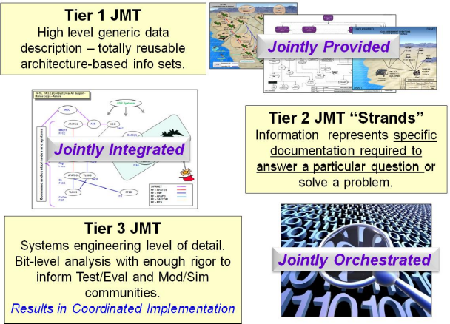
This architecture describes the Joint Fire Support (JFS) Tier I Joint Mission Thread (JMT). Its development is in response to Joint Requirements Oversight Council Memorandum (JROCM) XXX-XX, Capability Gap Assessment, and is in compliance with the Chairman of the Joint Chiefs of Staff Instruction (CJCSI) 6212.01E requirement for JMTs to be established and used to document and characterize information and data exchange for interoperability assessments of joint capabilities. It is linked to a single tactical Universal Joint Task (UJT) (UJT TA 3.2.1: Conduct Joint Fires) and several operational fires related UJTs. The Architecture Driven Analysis (ADA) Branch JMT Development Team will follow guidance from the JMT Development and Reuse Concept of Operations (CONOPS) and will rely primarily on Joint Publication (JP) 3-09, Joint Fire Support, as an authoritative source to identify performers, systems, activities, and information exchange requirements. The architecture will be developed within the Tier I construct (Figure 1); meaning it is generic, neither Service nor scenario specific, and therefore, totally reusable.
Figure 1: Joint Mission Thread Construct
Effective joint fire support depends on planning for the successful performance of the following four basic fire support tasks: support forces in contact, support the CONOPS, synchronize joint fire support, and sustain joint fire support operations. The Architecture Driven Analysis (ADA) Branch, Architecture & Integration Division (AID), Deputy Director for C4 (DDC4), Force Structure, Resources, and Assessment Directorate (J8), Joint Chiefs of Staff (JCS) will support Joint Fires Support Executive Steering Committee (JFS ESC) initiation, development, and revision of architecture products decomposing the high level tasks across the breadth of the Joint Fires thread to include the Plan, Prepare, Execute, and Assess phases of operation.

Mission Statement
The Joint Force Commander (JFC) and Component Commanders (CC), with the assistance of their staffs, integrate and synchronize joint fire support in time, space, and purpose to increase the effectiveness of the joint force.

Security Classification
Unclassified

Last Modified Date
21 June 2011

Granularity Level
Operational/Tactical

Methodologies Used
JMT Methodology; see “Concept of Operations (CONOPS) for Joint Mission Thread Development and Reuse” for more information.

Assumptions and Constraints
- The authoritative publication used to govern the development of the Joint Fire Support mission thread will be JP 3-09, Joint Fire Support, dated 30 June 2010.
- The sponsor, the JFS ESC, will support validation of the Joint Fire Support JMT.
- The sponsor will accept responsibility for providing the JMT Development Team with an approved Joint Fire Support Operational View-1 (OV-1).
- The sponsor will work with the JMT Development Team to identify relevant stakeholders.
- The JMT Development Team has sufficient expertise, tools, and manpower to complete the development of the Joint Fire Support JMT.
- The sponsor will make subject matter experts (SMEs) available for data collection.
- Section 6 outlines all Department of Defense Architecture Framework (DoDAF) architecture products included in the Joint Fire Support Tier 1 JMT Integrated Architecture Development.
- DoDAF architecture requirements do not preclude development of other unique products, e.g., the Integrated View, when necessary.

Tool and File Formats Used

Tools Used
The JMT Development Team will utilize SPARX Enterprise Architect (EA) tools for static/dynamic architecture development. Additionally, a SPARX-based Tier I repository solution has been developed for use with this project. The JMT Development Team will also use the SPARX Business Process Modeling Notation (BPMN) tool for executable architecture development, as required. An executable architecture will also be developed using IBM’s WebSphere Business Modeler (WBM). Executing in WBM exposes process workflow bottlenecks through its visual simulation engine platform.

File Formats Used
Generally, architecture products can be accessed using Microsoft Word, Excel, or Visio, as JPEG files. Other import/export formats are available, including Extensible Markup Language (XML), but examination of compatibility with specific tools must occur before utilizing other formats for data sharing.

Architecture Views/Products

Architecture Views
The baseline Joint Fire Support Tier I JMT Package consists of an All View-1 (AV-1) Overview and Summary Information, AV-2 Integrated Dictionary, OV-1 High Level Operational Concept Graphic, OV-2 Operational Resource Flow Description, OV-4 Organizational Relationships Chart, OV-5b Operational Activity Model, Systems View-1 (SV-1) (initial) Systems Interface Description, and Business Process Model, across the breadth of the thread. The sponsor then begins the validation/approval process of these artifacts with appropriate SMEs. This will enable the team to federate the views for reuse and analysis by other architects, either within the same JMT or across several JMTs. The Joint Mission Thread Architecture and Test Working Group (JMTAT WG) will assemble the multiple JMT perspectives in order to exploit their commonality.

Other Products
In order to drive ‘jointness’ throughout JMTs into Tier II architectures and Tier II Studies (See Figure 1), Information Preliminary to Measures (Figure 2) is developed by mapping the phases of operation (Plan, Prepare, Execute, and Assess) to objectives. Objectives are clearly defined, decisive, and attainable goals toward which every operation is directed. The mission objectives are then mapped to desired effects. Effects contribute to setting the conditions necessary to achieve an associated objective. The attributes and joint conditions are then mapped to the desired effects.

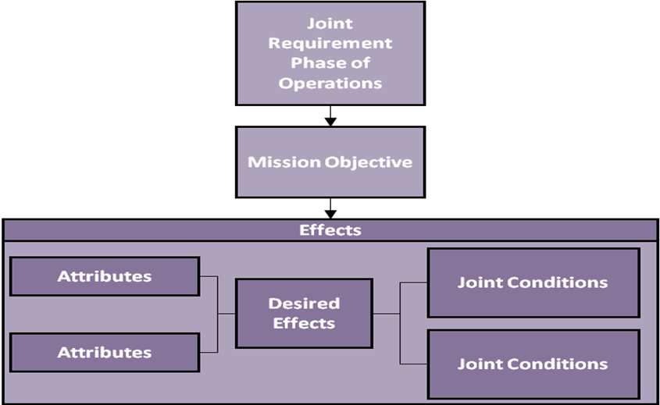

Figure 2: Tier I Information Preliminary to Measures
This type of mapping assists in driving jointness into each mission space by providing focus areas for future analysis teams. The associated attributes and joint conditions scope the mission space and provide a clear depiction of what is required to complete a particular mission.

Temporal Scope
As Is

Time Frame Start Date
3 January 2011

Time Frame End Date
1st Quarter Fiscal Year (FY) 2012

Organizations Involved
- JCS J8 DDC4, AID, ADA Branch
- JCS J8 DDC4, Joint Fires Division
- JCS J8 DDC4, Joint Deployable Analysis Team (JDAT)

Supporting Forums
- JFS ESC
- JMTAT WG

Scope
Joint fires are defined as fires produced during the employment of forces from two or more components in coordinated action to produce desired effects in support of a common objective (JP 1-02). Synchronized joint fire support requires the coordinated interaction of all elements of the fire support system, thorough and continuous planning, aggressive coordination, and vigorous execution. The fire support system includes the target acquisition, command and control, and attack/delivery systems that must function collectively to ensure effective fires are delivered where and when the commander requires them.

Operational firepower is by its nature, primarily a joint/multinational task. Firepower refers to the delivery of all types of ordnance to include bombs, rockets, missiles, and artillery as well as other nonlethal means against the enemy. The architecture products developed will address joint fires in the context of Plan, Prepare, Execute, and Assess.

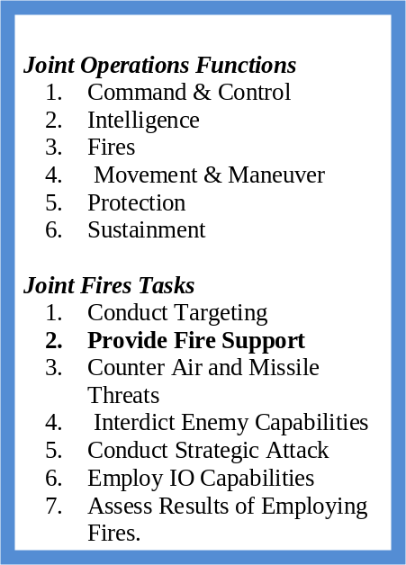
This JMT is limited to Joint Fire Support, one of seven tasks within Joint Fires, which in turn is one of six functions in Joint Operations, as defined in JP 3-0, Joint Operations (Figure 3). Additional scoping factors include the following:
Figure 3: Joint Operational Functions & Tasks
- Basic fire support tasks include support forces in contact, support the CONOPS, synchronize joint fire support, and sustain joint fire support operations.
- Supported commanders include Land, Air, Special Operations Forces (SOF) and maritime component commanders within the Areas of Operations (AOs) designated by the JFC.
- Lethal force capabilities include fixed-wing aircraft, attack helicopters, unmanned aerial systems (UAS), missiles, rockets, canon artillery, and Naval Surface Fire Support.
- Non-lethal force capabilities include electronic attack, Information Operations (IO), and computer network attacks (CYBER).
- Fire Supporting Operational UJTs include:
  - OP 1.2.5 Conduct Offensive Operations in the Joint Operations Area
  - OP 1.2.6 Conduct Defensive Operations in the Joint Operations Area
  - OP 2.2.5 Collect Target Information
  - OP 3 Employ Operational Firepower
  - OP 3.1 Conduct Joint Force Targeting
  - OP 3.1.1 Establish Joint Force Targeting Guidance
  - OP 3.1.6.1 Assess Battle Damage on Operational Targets
  - OP 3.1.6.2 Assess Munitions Effects on Operational Targets
  - OP 3.1.7 Employ Fire Support Coordination Measures
  - OP 3.1.8 Coordinate Immediate Targets for Two or More Components
  - OP 3.2 Attack Operational Targets
  - OP 3.2.1 Provide Close Air Support Integration for Surface Forces
  - OP 3.2.2 Conduct Attack on Operational Targets using Nonlethal Means
  - OP 3.2.3 Attack Aircraft and Missiles (Offensive Counterair (OCA))
  - OP 3.2.4 Suppress Enemy Air Defenses
  - OP 3.2.5 Interdict Operational Forces/Targets
  - OP 3.2.6 Provide Firepower in Support of Operational Maneuver
  - OP 3.2.7 Synchronize Operational Firepower
  - OP 5.6.1 Integrate Operational Information Operations
- Tactical UJTs include:
  - TA 1.2.3 Conduct Amphibious Assault Operations
  - TA 1.2.3.1 Conduct Raids
  - TA 3.2.1 Conduct Joint Fires
  - TA 3.2.1.1 Engage Time Sensitive Targets
  - TA 3.2.2 Conduct Close Air Support (CAS)
  - TA 3.2.3 Conduct Interdiction Operations
  - TA 3.2.4 Conduct Joint Suppression of Enemy Air Defenses (JSEAD)
  - TA 3.2.6 Conduct Attacks Using Nonlethal Means
  - TA 3.2.7 Conduct Air and Missile Defense Operations
  - TA 3.2.8.1 Conduct Offensive Counterair Operations

Creator Last Name
Chivis

Creator First Name
Charles

Creator Email
charles.chivis.ctr@js.mil

Publisher Organization
JCS J8 DDC4 AID

Approval Authority
The JFS ESC is a flag/general officer level Joint Requirements Oversight Council (JROC) approved body established to analyze and resolve joint fires issues. They will provide operational certification of the Joint Fires Integrated Architecture.

Purpose and Viewpoint

Purpose
The primary focus of the architecture development is to support interoperability assessments of joint capabilities. In addition, the provision of a standardized and reusable architecture supports experimentation, training, testing, and certification within the Service, Joint, and Coalition communities.

Viewpoint
The developed architecture is based on the joint operational and tactical viewpoint of the joint force components and supporting organizations in the integration and synchronization of fires to support the JFC's objectives. The developed architecture will be defined from the brigade and above joint fire support viewpoint. (Figure 4)

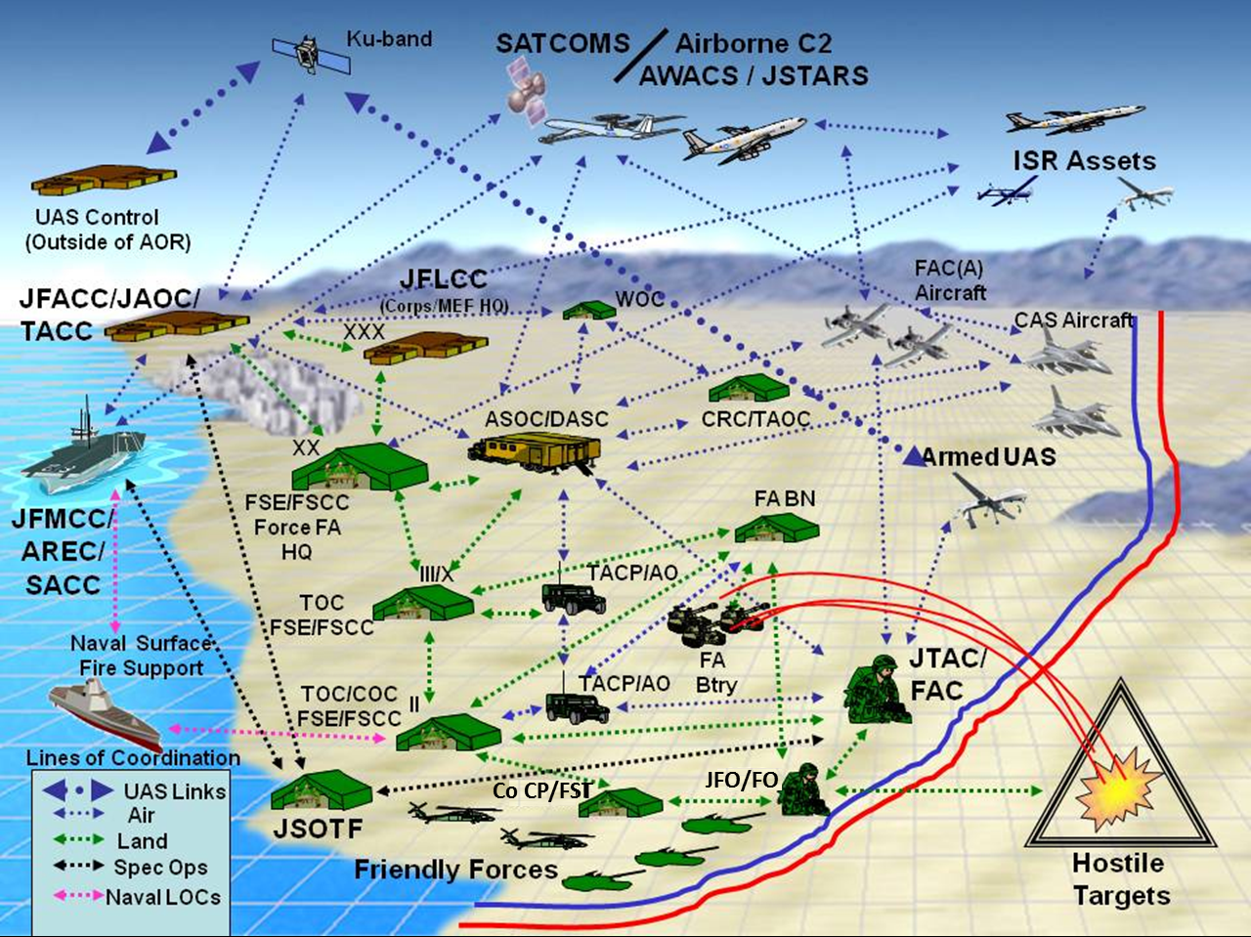
Figure 4: Joint Fire Support Viewpoint

Context

Mission Name
Joint Fire Support

Guidance References

Doctrine
- Joint Publication 3-0, Joint Operations
- Joint Publication 3-09, Joint Fire Support
- Joint Publication 3-09.3, Close Air Support
- Joint Publication 3-60, Joint Targeting
- Joint Fires and Targeting Handbook
- Joint Mission Thread Development Guide (Draft)
- Joint Mission Thread Tier I Development User’s Guide (Draft)
- Publications recommended by the JMTAT WG
- Publications recommended by members of the JMT Development Team
- Publications recommended by the Joint Fire Support mission thread sponsor

Goals
The primary focus of the architecture development will be on identifying the high-level activities, nodes, systems, and information elements that encompass the Joint Fire Support task.

Vision
Through the development of the architectures, the JFS ESC (in coordination with the Services, combatant commands, and the interagency community) is creating an overall view of the Joint Fire Support mission space. The vision will provide a foundation for further investigation of Joint Fire Support practices and goals for the Department of Defense (DoD) and could lead to expansion for coalition and partner nations.

Mission Description
The foundations of Joint Fire Support are based on the elements of combat power, the principles of joint operations, and joint functions. The elements of combat power are combined to provide the basis for the generation of overwhelming firepower. The fire support system has its roots in the firepower element of combat power. JP 3-09, Joint Fire Support, provides three definitions listed in Table 1, that supply the context for Joint Fire Support.

Table 1: Joint Fires Related Terms and Definitions
Term | Definition
Fires | The use of weapon systems to create specific lethal or nonlethal effect on a target.
Joint Fires | Fires delivered during the employment of forces from two or more components in coordinated action to produce desired effects in support of a common objective.
Joint Fire Support | Joint fire that assist air, land, maritime, and special operations forces to move, maneuver, and control territory, populations, airspace, and key waters.

Tasking for Architecture Project and Linkages to Other Architectures

Tasking for Architecture Project
JROCM XXX-XX, Capability Gap Assessment, tasked that JCS J8 DDC4 develop a Joint Fire Support JMT to support the CJCSI 6212.01E mandate to develop joint mission threads.

Plan of Action and Milestones
The architecture products supporting the Joint Fire Support Integrated Architecture follow the process guidance set forth in the Tier 1 JMT User’s Guide and the JMT CONOPS. The plan of action and milestones report (POAM) support the development of all required products. Development of other views may be necessary to support the project to provide the level of detail required for both operational and systems analyses using the Doctrine, Organization, Training, Materiel, Leadership and education, Personnel, and Facilities (DOTMLPF) construct.
Table 2 reflects the Tier 1 architecture developmental products/views in support of the Joint Fire Support Integrated Architecture project with the associated plan of action and milestones. Requirements may be added, deleted, or adjusted to ensure the products developed support the sponsor’s overall objectives and remain within the scoped parameters of the project.
Table 2: Tier 1 Architecture Developmental Products/Views
View | Name | Completion Date
AV-1 | Overview and Summary Information | Jan 2012
AV-2 | Integrated Dictionary | Jan 2012
OV-1 | High-Level Operational Concept Graphic | Jan 2012
OV-2 | Operational Resource Flow Description | Jan 2012
OV-4 | Organizational Relationships Chart | Jan 2012
OV-5b | Operational Activity Model | Jan 2012
SV-1 (initial) | Systems Interface Description | Jan 2012
BPM | Business Process Modeling | Jan 2012
Information Preliminary to Measures |  | Jan 2012

