Chemical Analysis of Personal Environmental Exposures

MyExposome, Inc.



# Introduction and Summary

**This test was done for: MyExposome Wristband Project**

**Thank You** for taking part in the MyExposome demonstration project funded by the National Institute of Health (NIH). We are analyzing your wristband to report any detectable level of each of **1,592** compounds.

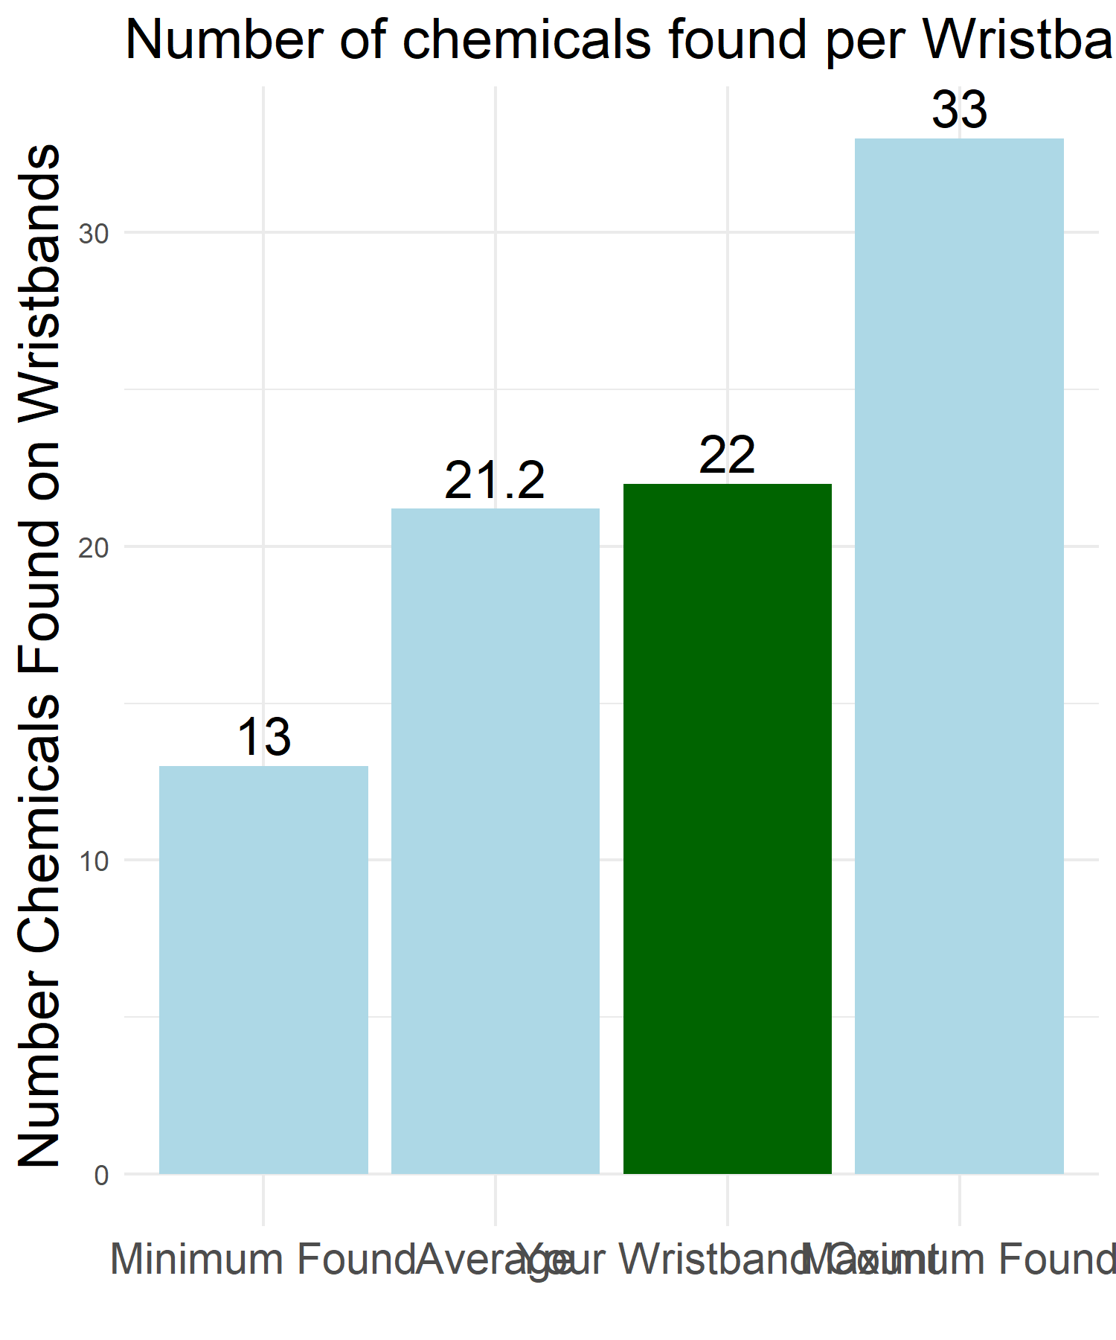

The total number of chemicals found in your wristband was **22**. The average number of chemicals found across all tested wristbands in this project was **21.2**. The maximum number of chemicals found on any one wristband was **33**. The minimum number of chemicals found on any one wristband was **13**.

The total number of distinct chemicals found across all the wristbands in this study was **72**.

This project provides a broad screen to identify compounds across many chemical groups with a focus on Pesticides, Chemicals in Commerce, Polychlorinated Biphenyls (PCBs), Flame Retardants and other chemicals of interest.

You were one of **30** participants in this demonstration project. The analysis was done with unique identifiers assigned to each wristband so your personal information is protected. Your unique subject name for the purposes of this analysis is: **SK4003WB**.

In addition to your silicone wristband results discussed below, we also asked you to wear a bracelet and a necklace containing silicone wristbands. One of the objectives of the study was to compare the results of the wristband with the chemical readings from the other devices. We have included a high-level summary of the device comparison which will be provided in the “additional information” section at the end of the report.

The rest of this report provides information and results based on the wristband since this is the most accurate and tested method of providing results of environmental exposure.

## List of Key Observations

Chemicals make up the material backbone of products in commerce—from couches and carpets to clothes and cleaning products. While chemicals serve an important role in our economy, they also end up in our environment— in our water, land, and air—and our bodies. Some of these chemicals are hazardous and exposure to them—whether through environmental releases, workplace exposures, or use of products—can lead to health problems such as asthma, learning disabilities, and cancer. Unfortunately, we have insufficient information about exactly which chemicals individuals are exposed to and in what amounts. Without this information it is challenging for individuals to determine how best to reduce their exposure to harmful chemicals, or for government agencies, companies, health professionals, and others to develop effective policies and interventions to protect public health from harmful chemicals. Wristbands are intended to address this information void.

**IMPORTANT NOTE:** We have listed, where data was available, information regarding some known health implications of exposures to some of the compounds found in the wristbands. **PLEASE NOTE** that we are NOT saying there is anything you need to be concerned about because we are **NOT** comparing the **LEVEL** of compound found in the wristbands to the level necessary to create any health concerns. This project is designed to measure individual exposures to certain chemicals in your environment. It is not attempting to explain the relationship between an exposure and a health outcome. The measurement of an environmental chemical in a person’s wristband does not mean, by itself, that the chemical causes harm or disease. Advances in analytical methods allow us to measure low levels of environmental chemicals, but separate studies of varying exposure levels and health effects are needed to determine whether levels result in disease.

This project is explicitly **NOT** medical research and you should not use the results in that way. Having said that, there are indeed some compounds that are interesting to know about. Some people decide to limit their exposures through altered purchases and behaviors although, in our society, that is sometimes not easy. **One of the great challenges is that many chemical compounds are not studied for real world exposure and so for most compounds there are really no clear guidelines.**

The rest of this document provides more details and context for the below summary. See the section “List of Chemicals found, showing Classifications” to understand how any of the compounds listed below are commonly used and classified.

* **INDIVIDUAL RESULTS**
* 4 of your detected chemicals are listed in the **EPA IRIS** dataset.
* 4 of your detected chemicals are listed in the **California Prop 65** toxicity dataset.
* 5 of your detected chemicals are listed in the **IARC** Cancer Report.
* 2,6-Diethylnaphthalene was detected only on your wristband.
* Butylated hydroxyanisole was detected only on your wristband.
* **GROUP RESULTS**
* 22 of the chemicals in this study group are listed in the **EPA IRIS** dataset.
* 8 of the chemicals in this study group are listed in the **California Prop 65** dataset.
* 18 of the chemicals in this study group are listed in the **IARC** Cancer Report.
* Benzophenone was detected on every wristband.
* 93% of all wristbands had at least one Flame Retardant.
* 100% of all wristbands had at least one Pesticide.
* 90% of all wristbands had at least one Polycyclic Aromatic Hydrocarbon (PAH).
* 97% of all wristbands had at least one Volatile Organic Compound (VOC).
* 80% of all wristbands had at least one Pharmacological compound.
* 100% of all wristbands had at least one Personal Care compound.
* 100% of all wristbands had at least one chemical commonly found in Commerce.
* 97% of all wristbands had at least one chemical commonly found in Consumer Products.
* 3% of all wristbands had at least one chemical classified as a Dioxin or Furan.

## Compound Classification

Our Chemical Analysis of Personal Environmental Exposures process tests for **1,592** chemicals. We have classified these chemicals into a few categories to make these results easier to understand.

Every chemical in the testing is classified into one **or more** of the following categories:

| Classification | Classification Description |
| --- | --- |
| Chemicals in Commerce | Chemicals found in consumer, industrial, or commercial products or product streams |
| Consumer Products | Chemicals found in foodstuffs or other consumable goods such as cigarettes, coffee, and spices or other products intended for household or personal use |
| Dioxins and Furans | Most dioxins and furans are not man-made or produced intentionally but are created when other chemicals or products (such as herbicides, pulp, paper) are made. In addition, they can be produced when products are burned. |
| Flame Retardant | Flame retardants used in consumer and commercial products such as polybrominated diphenyl ethers (PBDEs), polybrominated biphenyls (PBBs), and organic phosphate flame retardants (OPFRs) and others |
| Polycyclic Aromatic Hydrocarbons (PAHs) | Polycyclic Aromatic Hydrocarbon (PAHs/OPAHs/NPAHs): found in petroleum, fuels and combustion of organic matter |
| Personal Care | Found in many personal care products (shampoos, perfumes, other cosmetics…) |
| Pesticides | Herbicides, fungicides, insecticides, rodenticides, etc. or degradation products of pesticides |
| Pharmacological | Used in making or as components of manufactured drugs |
| Polychlorinated Biphenyl | Manufactured chlorinated chemicals that are found in electrical, lighting, gas and construction industries |
| Volatile Organic Compounds (VOCs) | VOCs are a large chemical classification made up of alkanes, benzenes, and other volatile (i.e. easily airborne) compounds that are found in burning fuels and released from many consumer products like solvents, paints, adhesives, preservatives, cleaners and building materials. |

# Individual Results

The following list of chemicals, along with their classifications, were found in your wristband:

## List of Chemicals found, showing Classifications

Classification Report on your Wristband

| Chemical Name | CAS Number | Classification(s) |
| --- | --- | --- |
| 1-Methylnaphthalene | 90-12-0 | Polycyclic Aromatic Hydrocarbons (PAHs), Volatile Organic Compounds (VOCs), Chemicals in Commerce |
| 2,4-Di-tert-butylphenol | 96-76-4 | Chemicals in Commerce |
| 2,6-Diethylnaphthalene | 59919-41-4 | Polycyclic Aromatic Hydrocarbons (PAHs) |
| 2,6-Dimethylnaphthalene | 581-42-0 | Polycyclic Aromatic Hydrocarbons (PAHs) |
| Benzophenone | 119-61-9 | Personal Care, Chemicals in Commerce |
| Benzothiazole | 95-16-9 | Chemicals in Commerce |
| Benzyl benzoate | 120-51-4 | Pesticides |
| Benzyl salicylate | 118-58-1 | Personal Care |
| Bis(2-ethylhexyl)phthalate | 117-81-7 | Chemicals in Commerce, Pesticides |
| Butyl benzyl phthalate | 85-68-7 | Chemicals in Commerce |
| Butylated hydroxyanisole | 121-00-6 | Personal Care, Consumer Products |
| Caffeine | 58-08-2 | Pharmacological, Consumer Products |
| DEET | 134-62-3 | Pesticides |
| Di-n-nonyl phthalate | 84-76-4 | Chemicals in Commerce |
| Diethyl phthalate | 84-66-2 | Chemicals in Commerce, Pesticides |
| Diisobutyl phthalate | 84-69-5 | Chemicals in Commerce |
| Galaxolide | 1222-05-5 | Personal Care, Chemicals in Commerce |
| Lilial | 80-54-6 | Personal Care |
| Naphthalene | 91-20-3 | Polycyclic Aromatic Hydrocarbons (PAHs), Volatile Organic Compounds (VOCs) |
| P-Cymene | 99-87-6 | Volatile Organic Compounds (VOCs) |
| TPP | 115-86-6 | Flame Retardant, Chemicals in Commerce |
| Tris(2-chloroisopropyl)phosphate | 13674-84-5 | Flame Retardant |

## List of Classifications found, showing Chemicals

While the above table shows all the chemicals, and every classification for each chemical, this information can sometimes more easily be understood by seeing that same data organized by classification. This allows you to see all the chemicals of a particular “type” grouped together (remembering that some chemical compounds are repeated in multiple categories). The following list of classifications, along with their chemicals, were found in your wristband:

Classification Report on your Wristband

| Classification | Chemical Name(s) |
| --- | --- |
| Chemicals in Commerce | TPP, Butyl benzyl phthalate, Bis(2-ethylhexyl)phthalate, Benzophenone, Diisobutyl phthalate, Di-n-nonyl phthalate, Galaxolide, 2,4-Di-tert-butylphenol, Benzothiazole, Diethyl phthalate, 1-Methylnaphthalene |
| Consumer Products | Butylated hydroxyanisole, Caffeine |
| Flame Retardant | Tris(2-chloroisopropyl)phosphate, TPP |
| Personal Care | Butylated hydroxyanisole, Benzophenone, Galaxolide, Benzyl salicylate, Lilial |
| Pesticides | Bis(2-ethylhexyl)phthalate, DEET, Benzyl benzoate, Diethyl phthalate |
| Pharmacological | Caffeine |
| Polycyclic Aromatic Hydrocarbons (PAHs) | 2,6-Dimethylnaphthalene, 2,6-Diethylnaphthalene, Naphthalene, 1-Methylnaphthalene |
| Volatile Organic Compounds (VOCs) | Naphthalene, 1-Methylnaphthalene, P-Cymene |

## Chemical Classifications Compared to Averages

If we look at this same data, broken down by chemical classification, and remembering that some chemical compounds are repeated in multiple categories, we see the following. The first numeric column is your wristband results and the second is the average of all the wristbands in this project.

| classification | Subject | Average |
| --- | --- | --- |
| Chemicals in Commerce | 11 | 10.1 |
| Consumer Products | 2 | 2.7 |
| Dioxins and Furans | 0 | 1 |
| Flame Retardant | 2 | 1.8 |
| Personal Care | 5 | 6.4 |
| Pesticides | 4 | 5.6 |
| Pharmacological | 1 | 1 |
| Polycyclic Aromatic Hydrocarbons (PAHs) | 4 | 2.6 |
| Volatile Organic Compounds (VOCs) | 3 | 2.3 |

## EPA IRIS Dataset Report

Some of the chemicals found on your wristband have evaluations available from the United States Environmental Protection Agency (EPA). The EPA’s Integrated Risk Information System (IRIS) is a human health assessment program that evaluates information on health effects that may result from exposure to environmental contaminants. Through the IRIS Program, EPA provides science-based human health assessments to support the Agency’s regulatory activities. The IRIS database [(http://www.epa.gov/iris/)](http://www.epa.gov/iris/) is web accessible and contains information on more than 550 chemical substances. We have looked up all the chemicals found on your wristband and provided links to the data on the EPA IRIS web site in those cases where the data is available.

Observed Chemical List showing EPA IRIS URLs

| Chemical Name | IRIS Summary Web Link |
| --- | --- |
| Bis(2-ethylhexyl)phthalate | <https://cfpub.epa.gov/ncea/iris2/chemicalLanding.cfm?substance_nmbr=14> |
| Butyl benzyl phthalate | <https://cfpub.epa.gov/ncea/iris2/chemicalLanding.cfm?substance_nmbr=293> |
| Diethyl phthalate | <https://cfpub.epa.gov/ncea/iris2/chemicalLanding.cfm?substance_nmbr=226> |
| Naphthalene | <https://cfpub.epa.gov/ncea/iris2/chemicalLanding.cfm?substance_nmbr=436> |

## California Proposition 65 Dataset Report

Some of the chemicals found on your wristband are classified per California Proposition 65 [(http://www.oehha.ca.gov/prop65.html)](http://www.oehha.ca.gov/prop65.html) which categorizes many different chemicals with respect to toxicity (potential hazard) Of the chemicals found on your wristband, here are the ones that are listed as having some type of toxicity per California Proposition 65. We have summarized some of the listed risks in the table below but please refer to the official California website listing specific risks for each chemical for up-to-date and accurate information: [(https://www.p65warnings.ca.gov/fact-sheets)](https://www.p65warnings.ca.gov/fact-sheets)

Observed Chemical List showing California Prop 65

| Chemical Name | Risk Type Per California Prop 65 |
| --- | --- |
| Benzophenone | cancer |
| Bis(2-ethylhexyl)phthalate | developmental, male & cancer |
| Butyl benzyl phthalate | developmental |
| Naphthalene | cancer |

## International Agency for Research on Cancer Data Report

The chemicals found on the wristband are classified by the International Agency for the Research on Cancer [(https://monographs.iarc.who.int/agents-classified-by-the-iarc/))](https://monographs.iarc.who.int/agents-classified-by-the-iarc/)) which categorizes many different chemicals with respect to types of cancer risks. Of the chemicals found on your wristband, here are the ones that are listed as having some type of rating per IARC.

Observed Chemical List showing IRAC classification

| Chemical Name | Risk Type Per IARC |
| --- | --- |
| Benzophenone | Possibly carcinogenic to humans |
| Bis(2-ethylhexyl)phthalate | Possibly carcinogenic to humans |
| Butyl benzyl phthalate | Not classifiable as to its carcinogenicity to humans |
| Caffeine | Not classifiable as to its carcinogenicity to humans |
| Naphthalene | Possibly carcinogenic to humans |

## Individual Percentage Exposure vs Maximum within Sample Set

Another way to look at this is to wonder what percentage of a chemical a particular individual had compared to the maximum found for that chemical in any wristband in this project. In other words, if wristband-A had 100 nano-grams per gram of wristband, and the maximum found in any individual was 1,000 nano-grams per gram wristband, then wristband-A had 10% of the maximum value found. The chart below shows the percentage of maximum found for this subject for each chemical.

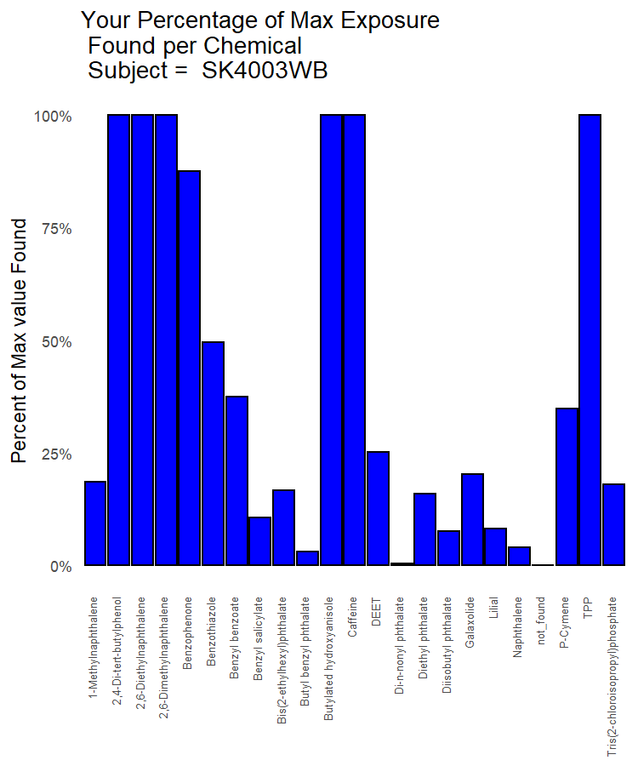

# Group Comparison Results

As previously stated, the average number of chemicals found was **21.2**. All wristbands were tested for **1,592** chemicals. In this section, we will go over many of the same categories as the section above but show you wristband results from the entire group instead of just your wristband.

## List of Chemicals found on ANY Wristband

The following list of chemicals, along with their classification(s), were found on at least one of the wristbands in this study.

Classification Report Across all WB in Study

| Chemical Name | CAS Number | Classification(s) |
| --- | --- | --- |
| (+/-)-Cis-Permethrin | 61949-76-6 | Pesticides |
| 1-Methyl phenanthrene | 832-69-9 | Polycyclic Aromatic Hydrocarbons (PAHs) |
| 1-Methylnaphthalene | 90-12-0 | Polycyclic Aromatic Hydrocarbons (PAHs), Volatile Organic Compounds (VOCs), Chemicals in Commerce |
| 1,2,4-Trimethylbenzene | 95-63-6 | Volatile Organic Compounds (VOCs) |
| 1,6-Dimethylnaphthalene | 575-43-9 | Polycyclic Aromatic Hydrocarbons (PAHs) |
| 2-Methylnaphthalene | 91-57-6 | Polycyclic Aromatic Hydrocarbons (PAHs), Volatile Organic Compounds (VOCs), Chemicals in Commerce |
| 2,4-Bis(alpha,alpha-dimethylbenzyl)phenol | 2772-45-4 | Chemicals in Commerce |
| 2,4-Di-tert-butylphenol | 96-76-4 | Chemicals in Commerce |
| 2,6-Diethylnaphthalene | 59919-41-4 | Polycyclic Aromatic Hydrocarbons (PAHs) |
| 2,6-Dimethylnaphthalene | 581-42-0 | Polycyclic Aromatic Hydrocarbons (PAHs) |
| 4-Chloro-3,5-dimethylphenol | 88-04-0 | Chemicals in Commerce |
| A-Ionone | 127-41-3 | Personal Care |
| Acenaphthene | 83-32-9 | Polycyclic Aromatic Hydrocarbons (PAHs) |
| Acenaphthylene | 208-96-8 | Polycyclic Aromatic Hydrocarbons (PAHs) |
| Amyl cinnamal | 122-40-7 | Personal Care |
| Anthracene | 120-12-7 | Polycyclic Aromatic Hydrocarbons (PAHs) |
| B-Ionone | 79-77-6 | Personal Care |
| Benzophenone | 119-61-9 | Personal Care, Chemicals in Commerce |
| Benzothiazole | 95-16-9 | Chemicals in Commerce |
| Benzotriazole | 95-14-7 | Chemicals in Commerce |
| Benzyl benzoate | 120-51-4 | Pesticides |
| Benzyl salicylate | 118-58-1 | Personal Care |
| Bifenthrin | 82657-04-3 | Pesticides |
| Biphenyl | 92-52-4 | Chemicals in Commerce, Pesticides |
| Bis(2-ethylhexyl)phthalate | 117-81-7 | Chemicals in Commerce, Pesticides |
| Butyl benzyl phthalate | 85-68-7 | Chemicals in Commerce |
| Butylated hydroxyanisole | 121-00-6 | Personal Care, Consumer Products |
| Butylated hydroxytoluene | 128-37-0 | Chemicals in Commerce, Consumer Products |
| Caffeine | 58-08-2 | Pharmacological, Consumer Products |
| Carvone | 99-49-0 | Personal Care, Consumer Products, Pesticides |
| Cinnamal | 104-55-2 | Personal Care, Chemicals in Commerce, Consumer Products, Pesticides |
| Citral | 141-27-5 | Personal Care, Consumer Products |
| Coumarin | 91-64-5 | Personal Care, Consumer Products |
| Cyhalothrin I (lambda) | 68085-85-8 | Pesticides |
| D-Citronellol | 1117-61-9 | Personal Care |
| DEET | 134-62-3 | Pesticides |
| Di-n-butyl phthalate | 84-74-2 | Personal Care, Chemicals in Commerce, Pesticides |
| Di-n-hexyl phthalate | 84-75-3 | Chemicals in Commerce |
| Di-n-nonyl phthalate | 84-76-4 | Chemicals in Commerce |
| Dibenzofuran | 132-64-9 | Dioxins and Furans |
| Diethyl phthalate | 84-66-2 | Chemicals in Commerce, Pesticides |
| Diisobutyl phthalate | 84-69-5 | Chemicals in Commerce |
| Dimethyl phthalate | 131-11-3 | Chemicals in Commerce, Pesticides |
| Ethofenprox | 80844-07-1 | Pesticides |
| Ethylene brassylate | 105-95-3 | Personal Care |
| Fipronil | 120068-37-3 | Pesticides, Pharmacological |
| Fluoranthene | 206-44-0 | Polycyclic Aromatic Hydrocarbons (PAHs) |
| Fluorene | 86-73-7 | Polycyclic Aromatic Hydrocarbons (PAHs) |
| Galaxolide | 1222-05-5 | Personal Care, Chemicals in Commerce |
| Geraniol | 106-24-1 | Personal Care, Consumer Products |
| Lilial | 80-54-6 | Personal Care |
| Linalool | 78-70-6 | Personal Care, Pesticides |
| Methoprene I | 40596-69-8 | Pesticides |
| Naphthalene | 91-20-3 | Polycyclic Aromatic Hydrocarbons (PAHs), Volatile Organic Compounds (VOCs) |
| P-Cymene | 99-87-6 | Volatile Organic Compounds (VOCs) |
| P-Dichlorobenzene | 106-46-7 | Volatile Organic Compounds (VOCs), Chemicals in Commerce, Pesticides |
| P-Xylene | 106-42-3 | Volatile Organic Compounds (VOCs) |
| PBDE 49 | 243982-82-3 | Flame Retardant |
| PBDE 99 | 60348-60-9 | Flame Retardant |
| Pentadecan-15-olide | 106-02-5 | Personal Care |
| Permethrin | 52645-53-1 | Pesticides |
| Phenanthrene | 85-01-8 | Polycyclic Aromatic Hydrocarbons (PAHs) |
| Piperonyl butoxide | 51-03-6 | Pesticides |
| Pyrene | 129-00-0 | Polycyclic Aromatic Hydrocarbons (PAHs), Chemicals in Commerce |
| Retene | 483-65-8 | Polycyclic Aromatic Hydrocarbons (PAHs) |
| Thymol | 89-83-8 | Pharmacological |
| Toluene | 108-88-3 | Volatile Organic Compounds (VOCs) |
| Tonalide | 21145-77-7 | Personal Care, Consumer Products |
| TPP | 115-86-6 | Flame Retardant, Chemicals in Commerce |
| Trichloroethylene | 79-01-6 | Volatile Organic Compounds (VOCs) |
| Triethyl phosphate | 78-40-0 | Flame Retardant, Chemicals in Commerce, Pesticides |
| Tris(2-chloroisopropyl)phosphate | 13674-84-5 | Flame Retardant |

## List of Classifications found on ANY Wristband

While the above table shows all the chemicals, and all classifications for each chemical, this information can sometimes more easily be understood by seeing that same data organized by classification. This allows you to see all the chemicals of a particular “type” grouped together (remembering that some chemical compounds are repeated in multiple categories).

Classification Report across all Wristbands

| Classification | Chemical Name(s) |
| --- | --- |
| Chemicals in Commerce | TPP, Biphenyl, 2-Methylnaphthalene, Butyl benzyl phthalate, Bis(2-ethylhexyl)phthalate, Benzophenone, Triethyl phosphate, Diisobutyl phthalate, Di-n-hexyl phthalate, Di-n-nonyl phthalate, Galaxolide, Cinnamal, Butylated hydroxytoluene, Benzotriazole, 2,4-Bis(alpha,alpha-dimethylbenzyl)phenol, 2,4-Di-tert-butylphenol, 4-Chloro-3,5-dimethylphenol, Benzothiazole, Di-n-butyl phthalate, Diethyl phthalate, P-Dichlorobenzene, Pyrene, 1-Methylnaphthalene, Dimethyl phthalate |
| Consumer Products | Tonalide, Citral, Butylated hydroxyanisole, Carvone, Caffeine, Coumarin, Geraniol, Cinnamal, Butylated hydroxytoluene |
| Dioxins and Furans | Dibenzofuran |
| Flame Retardant | Tris(2-chloroisopropyl)phosphate, TPP, PBDE 49, PBDE 99, Triethyl phosphate |
| Personal Care | Tonalide, D-Citronellol, Citral, Butylated hydroxyanisole, Benzophenone, Carvone, Pentadecan-15-olide, Galaxolide, Ethylene brassylate, Linalool, Coumarin, Amyl cinnamal, B-Ionone, A-Ionone, Geraniol, Benzyl salicylate, Cinnamal, Lilial, Di-n-butyl phthalate |
| Pesticides | Biphenyl, Bis(2-ethylhexyl)phthalate, Bifenthrin, DEET, Methoprene I, Piperonyl butoxide, Cyhalothrin I (lambda), Triethyl phosphate, Carvone, Benzyl benzoate, Fipronil, Ethofenprox, Linalool, Cinnamal, (+/-)-Cis-Permethrin, Di-n-butyl phthalate, Diethyl phthalate, P-Dichlorobenzene, Dimethyl phthalate, Permethrin |
| Pharmacological | Thymol, Caffeine, Fipronil |
| Polycyclic Aromatic Hydrocarbons (PAHs) | 2,6-Dimethylnaphthalene, 2-Methylnaphthalene, Acenaphthene, Acenaphthylene, Anthracene, 1,6-Dimethylnaphthalene, Retene, 2,6-Diethylnaphthalene, Fluoranthene, Fluorene, Naphthalene, Phenanthrene, Pyrene, 1-Methylnaphthalene, 1-Methyl phenanthrene |
| Volatile Organic Compounds (VOCs) | Trichloroethylene, P-Xylene, 2-Methylnaphthalene, 1,2,4-Trimethylbenzene, P-Dichlorobenzene, Naphthalene, 1-Methylnaphthalene, Toluene, P-Cymene |

## EPA IRIS Dataset Report: All Wristbands

Some of the chemicals found on some of the wristbands in this group have evaluations available from the United States Environmental Protection Agency (EPA). The EPA’s Integrated Risk Information System (IRIS) is a human health assessment program that evaluates information on health effects that may result from exposure to environmental contaminants. Through the IRIS Program, EPA provides science-based human health assessments to support the Agency’s regulatory activities. The IRIS database [(http://www.epa.gov/iris/)](http://www.epa.gov/iris/) is web accessible and contains information on more than 550 chemical substances. We have looked up all the chemicals found on any wristband and provided links to the data on the EPA IRIS web site in those cases where the data is available.

Observed Chemical List showing EPA IRIS URLs

| Chemical Name | IRIS Summary Web Link |
| --- | --- |
| Biphenyl | <https://cfpub.epa.gov/ncea/iris2/chemicalLanding.cfm?substance_nmbr=13> |
| 2-Methylnaphthalene | <https://cfpub.epa.gov/ncea/iris2/chemicalLanding.cfm?substance_nmbr=1006> |
| Acenaphthene | <https://cfpub.epa.gov/ncea/iris2/chemicalLanding.cfm?substance_nmbr=442> |
| Acenaphthylene | <https://cfpub.epa.gov/ncea/iris2/chemicalLanding.cfm?substance_nmbr=443> |
| Anthracene | <https://cfpub.epa.gov/ncea/iris2/chemicalLanding.cfm?substance_nmbr=434> |
| Butyl benzyl phthalate | <https://cfpub.epa.gov/ncea/iris2/chemicalLanding.cfm?substance_nmbr=293> |
| Bis(2-ethylhexyl)phthalate | <https://cfpub.epa.gov/ncea/iris2/chemicalLanding.cfm?substance_nmbr=14> |
| Bifenthrin | <https://cfpub.epa.gov/ncea/iris2/chemicalLanding.cfm?substance_nmbr=333> |
| PBDE 99 | <https://cfpub.epa.gov/ncea/iris2/chemicalLanding.cfm?substance_nmbr=1008> |
| 1,2,4-Trimethylbenzene | <https://cfpub.epa.gov/ncea/iris2/chemicalLanding.cfm?substance_nmbr=1037> |
| Di-n-butyl phthalate | <https://cfpub.epa.gov/ncea/iris2/chemicalLanding.cfm?substance_nmbr=38> |
| Dibenzofuran | <https://cfpub.epa.gov/ncea/iris2/chemicalLanding.cfm?substance_nmbr=429> |
| Diethyl phthalate | <https://cfpub.epa.gov/ncea/iris2/chemicalLanding.cfm?substance_nmbr=226> |
| Fluoranthene | <https://cfpub.epa.gov/ncea/iris2/chemicalLanding.cfm?substance_nmbr=444> |
| Fluorene | <https://cfpub.epa.gov/ncea/iris2/chemicalLanding.cfm?substance_nmbr=435> |
| P-Dichlorobenzene | <https://cfpub.epa.gov/ncea/iris2/chemicalLanding.cfm?substance_nmbr=552> |
| Naphthalene | <https://cfpub.epa.gov/ncea/iris2/chemicalLanding.cfm?substance_nmbr=436> |
| Phenanthrene | <https://cfpub.epa.gov/ncea/iris2/chemicalLanding.cfm?substance_nmbr=459> |
| Pyrene | <https://cfpub.epa.gov/ncea/iris2/chemicalLanding.cfm?substance_nmbr=445> |
| Toluene | <https://cfpub.epa.gov/ncea/iris2/chemicalLanding.cfm?substance_nmbr=118> |
| Dimethyl phthalate | <https://cfpub.epa.gov/ncea/iris2/chemicalLanding.cfm?substance_nmbr=353> |
| Permethrin | <https://cfpub.epa.gov/ncea/iris2/chemicalLanding.cfm?substance_nmbr=185> |

## California Proposition 65 Dataset Report: All Wristbands

Some of the chemicals found on wristbands in the group are classified per California Proposition 65 [(http://www.oehha.ca.gov/prop65.html)](http://www.oehha.ca.gov/prop65.html)which categorizes many different chemicals with respect to toxicity (potential hazard).Of the chemicals found on your wristband, here are the ones that are listed as having some type of toxicity per California Proposition 65.We have summarized some of the listed risks in the table below but please refer to the official California website listing specific risks for each chemical for up-to-date and accurate information:[(https://www.p65warnings.ca.gov/fact-sheets)](https://www.p65warnings.ca.gov/fact-sheets)

Observed Chemical List showing California Prop 65

| Chemical Name | Risk Type Per California Prop 65 |
| --- | --- |
| Butyl benzyl phthalate | developmental |
| Bis(2-ethylhexyl)phthalate | developmental, male & cancer |
| Benzophenone | cancer |
| Di-n-hexyl phthalate | female, male |
| Di-n-butyl phthalate | developmental, female, male |
| P-Dichlorobenzene | cancer |
| Naphthalene | cancer |
| Toluene | female & developmental |

## International Agency for Research on Cancer Data Report: All Wristbands

The chemicals found on the wristbands are classified by the International Agency for the Research on Cancer [(https://monographs.iarc.who.int/agents-classified-by-the-iarc/)](https://monographs.iarc.who.int/agents-classified-by-the-iarc/) which categorizes many different chemicals with respect to types of cancer risks. Of the chemicals found on your wristband here are the ones that are listed as having some type of rating per IARC.

Observed Chemical List showing IRAC classification

| Chemical Name | Risk Type Per IARC |
| --- | --- |
| Acenaphthene | Not classifiable as to its carcinogenicity to humans |
| Anthracene | Not classifiable as to its carcinogenicity to humans |
| Butyl benzyl phthalate | Not classifiable as to its carcinogenicity to humans |
| Bis(2-ethylhexyl)phthalate | Possibly carcinogenic to humans |
| Benzophenone | Possibly carcinogenic to humans |
| Piperonyl butoxide | Not classifiable as to its carcinogenicity to humans |
| Caffeine | Not classifiable as to its carcinogenicity to humans |
| Coumarin | Not classifiable as to its carcinogenicity to humans |
| Butylated hydroxytoluene | Not classifiable as to its carcinogenicity to humans |
| Fluoranthene | Not classifiable as to its carcinogenicity to humans |
| Fluorene | Not classifiable as to its carcinogenicity to humans |
| P-Dichlorobenzene | Possibly carcinogenic to humans |
| Naphthalene | Possibly carcinogenic to humans |
| Phenanthrene | Not classifiable as to its carcinogenicity to humans |
| Pyrene | Not classifiable as to its carcinogenicity to humans |
| 1-Methyl phenanthrene | Not classifiable as to its carcinogenicity to humans |
| Toluene | Not classifiable as to its carcinogenicity to humans |
| Permethrin | Not classifiable as to its carcinogenicity to humans |

## Display Statistics on Chemicals Found

One important way to look at the data is, for each chemical, what was the minimum/maximum/mean/median value found, how many wristbands was it found on, and the standard deviation of all the values found.

The data is the raw nanograms found in each gram of wristband normalized to time-adjust the values as though the wristband were worn for exactly one week. In other words, the raw data was adjusted by the time worn and the size of the wristbands between participants to make data as comparable as possible before general statistics were performed on each chemical.

Values below the limit of detection, or values that could not be quantified, are not included in the statistical analyses and are listed as zeros.

That information is displayed below:

Statistical Report on all Chemicals on just SK4003WB wristband

| Chemical Name | SK4003WB Result | MinResult | MaxResult | MeanResult | MedianResult | Count | Standard Deviation |
| --- | --- | --- | --- | --- | --- | --- | --- |
| 1-Methylnaphthalene | 26.7 | 5.04 | 143 | 31.4 | 20.5 | 12 | 37.4 |
| 2,4-Di-tert-butylphenol | 328 | 10.7 | 328 | 145 | 129 | 19 | 98 |
| 2,6-Diethylnaphthalene | 38.9 | 38.9 | 38.9 | 38.9 | 38.9 | 1 | NA |
| 2,6-Dimethylnaphthalene | 45 | 26.8 | 45 | 36 | 36.05 | 4 | 8.34 |
| Benzophenone | 1,340 | 147 | 1,530 | 589 | 477 | 30 | 399 |
| Benzothiazole | 486 | 112 | 980 | 491 | 486 | 25 | 226 |
| Benzyl benzoate | 12,200 | 250 | 32,500 | 3,420 | 1,205 | 26 | 6570 |
| Benzyl salicylate | 2,430 | 153 | 23,000 | 3,210 | 1,550 | 25 | 4750 |
| Bis(2-ethylhexyl)phthalate | 40,100 | 6,340 | 239,000 | 55,700 | 48,400 | 27 | 46500 |
| Butyl benzyl phthalate | 377 | 67.6 | 12,400 | 2,070 | 1,105 | 26 | 2890 |
| Butylated hydroxyanisole | 365 | 365 | 365 | 365 | 365 | 1 | NA |
| Caffeine | 15,800 | 423 | 15,800 | 5,150 | 3,090 | 23 | 4750 |
| DEET | 5,350 | 75.3 | 21,200 | 3,420 | 1,074 | 24 | 5510 |
| Di-n-nonyl phthalate | 42.5 | 42.5 | 8,800 | 1,480 | 818 | 17 | 2080 |
| Diethyl phthalate | 2,800 | 362 | 17,600 | 2,650 | 1,530 | 27 | 3670 |
| Diisobutyl phthalate | 1,960 | 453 | 25,800 | 5,310 | 2,710 | 28 | 5870 |
| Galaxolide | 1,340 | 168 | 6,590 | 1,660 | 927 | 25 | 1850 |
| Lilial | 292 | 150 | 3,590 | 1,300 | 710 | 14 | 1290 |
| Naphthalene | 94.8 | 0.83 | 2,300 | 134 | 49.5 | 25 | 453 |
| P-Cymene | 267 | 55.5 | 765 | 244 | 186 | 23 | 193 |
| TPP | 2,670 | 104 | 2,670 | 491 | 225.5 | 18 | 647 |
| Tris(2-chloroisopropyl)phosphate | 608 | 41.5 | 3,380 | 855 | 478.5 | 26 | 909 |
| (+/-)-Cis-Permethrin | 0 | 117 | 1,790 | 614 | 274 | 4 | 794 |
| 1-Methyl phenanthrene | 0 | 59.3 | 59.3 | 59.3 | 59.3 | 1 | NA |
| 1,2,4-Trimethylbenzene | 0 | 112 | 191 | 152 | 151.5 | 2 | 55.9 |
| 1,6-Dimethylnaphthalene | 0 | 16.3 | 70.5 | 41.9 | 40.4 | 4 | 23.7 |
| 2-Methylnaphthalene | 0 | 3.46 | 5.78 | 4.62 | 4.62 | 2 | 1.64 |
| 2,4-Bis(alpha,alpha-dimethylbenzyl)phenol | 0 | 51.9 | 81 | 68.8 | 66.5 | 5 | 11.6 |
| 4-Chloro-3,5-dimethylphenol | 0 | 381 | 5,290 | 2,530 | 1,910 | 3 | 2510 |
| A-Ionone | 0 | 132 | 1,410 | 561 | 141 | 3 | 735 |
| Acenaphthene | 0 | 490 | 490 | 490 | 490 | 1 | NA |
| Acenaphthylene | 0 | 47.3 | 80.2 | 63.8 | 63.75 | 2 | 23.3 |
| Amyl cinnamal | 0 | 82.6 | 478 | 278 | 324 | 5 | 181 |
| Anthracene | 0 | 21.4 | 153 | 63.4 | 60 | 11 | 37.4 |
| B-Ionone | 0 | 635 | 717 | 676 | 676 | 2 | 58 |
| Benzotriazole | 0 | 73.5 | 353 | 213 | 213.2 | 2 | 198 |
| Bifenthrin | 0 | 320 | 320 | 320 | 320 | 1 | NA |
| Biphenyl | 0 | 89.7 | 89.7 | 89.7 | 89.7 | 1 | NA |
| Butylated hydroxytoluene | 0 | 38.7 | 486 | 154 | 96.7 | 10 | 146 |
| Carvone | 0 | 176 | 3,650 | 1,540 | 784 | 3 | 1860 |
| Cinnamal | 0 | 42.4 | 1,980 | 384 | 215 | 13 | 505 |
| Citral | 0 | 266 | 606 | 435 | 432 | 3 | 170 |
| Coumarin | 0 | 95.2 | 2,690 | 1,130 | 766 | 5 | 1140 |
| Cyhalothrin I (lambda) | 0 | 322 | 322 | 322 | 322 | 1 | NA |
| D-Citronellol | 0 | 83 | 1,530 | 819 | 829 | 8 | 496 |
| Di-n-butyl phthalate | 0 | 43,500 | 43,500 | 43,500 | 43,500 | 1 | NA |
| Di-n-hexyl phthalate | 0 | 381 | 416 | 398 | 398.5 | 2 | 24.7 |
| Dibenzofuran | 0 | 921 | 921 | 921 | 921 | 1 | NA |
| Dimethyl phthalate | 0 | 87.1 | 285 | 202 | 219 | 5 | 88.6 |
| Ethofenprox | 0 | 116 | 1,090 | 603 | 603 | 2 | 689 |
| Ethylene brassylate | 0 | 1,350 | 35,000 | 8,060 | 2,700 | 6 | 13300 |
| Fipronil | 0 | 1,040 | 1,040 | 1,040 | 1,040 | 1 | NA |
| Fluoranthene | 0 | 57.4 | 63.2 | 60.3 | 60.3 | 2 | 4.1 |
| Fluorene | 0 | 191 | 191 | 191 | 191 | 1 | NA |
| Geraniol | 0 | 1,070 | 3,070 | 2,070 | 2,070 | 2 | 1410 |
| Linalool | 0 | 92.4 | 1,660 | 627 | 531 | 13 | 463 |
| Methoprene I | 0 | 4,240 | 4,240 | 4,240 | 4,240 | 1 | NA |
| P-Dichlorobenzene | 0 | 441 | 441 | 441 | 441 | 1 | NA |
| P-Xylene | 0 | 162 | 162 | 162 | 162 | 1 | NA |
| PBDE 49 | 0 | 160 | 160 | 160 | 160 | 1 | NA |
| PBDE 99 | 0 | 267 | 267 | 267 | 267 | 1 | NA |
| Pentadecan-15-olide | 0 | 1,610 | 41,600 | 13,800 | 10,500 | 13 | 11900 |
| Permethrin | 0 | 41.3 | 3,680 | 942 | 333 | 12 | 1310 |
| Phenanthrene | 0 | 17.6 | 693 | 355 | 355.3 | 2 | 478 |
| Piperonyl butoxide | 0 | 321 | 321 | 321 | 321 | 1 | NA |
| Pyrene | 0 | 63.2 | 63.2 | 63.2 | 63.2 | 1 | NA |
| Retene | 0 | 28.1 | 28.1 | 28.1 | 28.1 | 1 | NA |
| Thymol | 0 | 80.3 | 80.3 | 80.3 | 80.3 | 1 | NA |
| Toluene | 0 | 916 | 916 | 916 | 916 | 1 | NA |
| Tonalide | 0 | 8.85 | 1,660 | 372 | 83.2 | 19 | 487 |
| Trichloroethylene | 0 | 147 | 147 | 147 | 147 | 1 | NA |
| Triethyl phosphate | 0 | 48.3 | 971 | 321 | 133 | 4 | 435 |

## Display Chemicals Found as Percentage of Participants

Here are all the chemicals found on any wristband. If every participants wristband contained a given chemical that chemical will show height as 100%. If only one person had a chemical it will be the shortest possible bar. The dashed red line is drawn at 50% to more easily discern chemicals that were found in most of the samples.

If the chemical was found on your wristband then that bar is colored blue. If the chemical was found on at least one other participant, but not on your wristband, the bar is colored grey. For example, if you see a high percentage of blue bars up near 100% then your sample has a high overlap with the rest of the study group. If most of the blue bars are down below 50% then your sample does not overlap as much with the rest of the group.

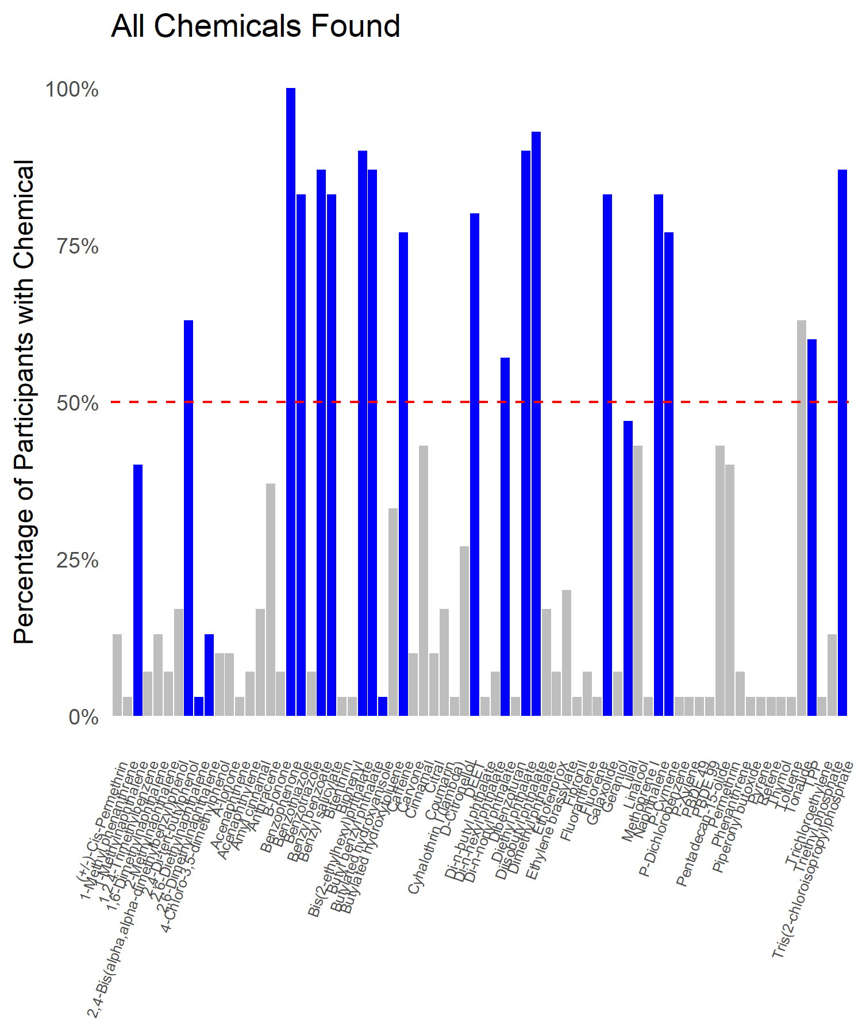

## Wristbands with At Least One of a Classification

A related question is how many study participants had at least one of any given classification (e.g. how many participants had at least one “Flame Retardant”).

Tested Wristbands with **at least one** of a given classification

| Classification | Wristbands with This Classification | Percentage with this Classification |
| --- | --- | --- |
| Chemicals in Commerce | 30 | 100% |
| Consumer Products | 29 | 97% |
| Dioxins and Furans | 1 | 3% |
| Flame Retardant | 28 | 93% |
| Personal Care | 30 | 100% |
| Pesticides | 30 | 100% |
| Pharmacological | 24 | 80% |
| Polycyclic Aromatic Hydrocarbons (PAHs) | 27 | 90% |
| Volatile Organic Compounds (VOCs) | 29 | 97% |

## Chemical Classification on every Wristband

The count of how many chemicals, broken down by classification, was found in every tested wristband, is as follows:

Classification of Chemicals in Every Tested Wristband

| classification | SK4000WB | SK4002WB | SK4003WB | SK4004WB | SK4005WB | SK4006WB | SK4007WB | SK4008WB | SK4009WB | SK4010WB | SK4011WB | SK4014WB | SK4016WB | SK4017WB | SK4018WB | SK4019WB | SK4020WB | SK4021WB | SK4022WB | SK4023WB | SK4024WB | SK4025WB | SK4026WB | SK4027WB | SK4028WB | SK4029WB | SK4030WB | SK4031WB | SK4033WB | SK4034WB |
| --- | --- | --- | --- | --- | --- | --- | --- | --- | --- | --- | --- | --- | --- | --- | --- | --- | --- | --- | --- | --- | --- | --- | --- | --- | --- | --- | --- | --- | --- | --- |
| Chemicals in Commerce | 12 | 13 | 11 | 15 | 10 | 7 | 11 | 9 | 12 | 9 | 11 | 8 | 7 | 9 | 9 | 8 | 9 | 8 | 10 | 11 | 10 | 11 | 9 | 13 | 10 | 11 | 10 | 9 | 9 | 13 |
| Consumer Products | 5 | 3 | 2 | 4 | 4 | 1 | 3 | 2 | 2 | 5 | 4 | 3 | 1 | 0 | 2 | 2 | 2 | 2 | 3 | 3 | 5 | 3 | 2 | 4 | 1 | 2 | 2 | 2 | 2 | 3 |
| Dioxins and Furans | 0 | 0 | 0 | 0 | 0 | 0 | 0 | 0 | 0 | 0 | 0 | 0 | 0 | 0 | 0 | 0 | 0 | 0 | 0 | 0 | 0 | 1 | 0 | 0 | 0 | 0 | 0 | 0 | 0 | 0 |
| Flame Retardant | 4 | 2 | 2 | 3 | 1 | 2 | 2 | 2 | 2 | 1 | 1 | 1 | 1 | 3 | 2 | 1 | 0 | 1 | 1 | 1 | 2 | 2 | 1 | 2 | 2 | 1 | 0 | 2 | 2 | 3 |
| Personal Care | 8 | 5 | 5 | 9 | 10 | 3 | 13 | 5 | 4 | 11 | 8 | 6 | 5 | 2 | 6 | 5 | 5 | 3 | 5 | 9 | 11 | 9 | 6 | 9 | 3 | 5 | 5 | 5 | 2 | 9 |
| Pesticides | 8 | 6 | 4 | 7 | 7 | 5 | 8 | 5 | 4 | 6 | 6 | 5 | 4 | 4 | 4 | 4 | 5 | 7 | 6 | 6 | 4 | 7 | 7 | 8 | 6 | 8 | 3 | 2 | 5 | 7 |
| Pharmacological | 1 | 1 | 1 | 1 | 1 | 1 | 1 | 0 | 1 | 1 | 1 | 1 | 0 | 0 | 1 | 0 | 1 | 1 | 0 | 1 | 1 | 1 | 1 | 1 | 1 | 2 | 0 | 1 | 1 | 1 |
| Polycyclic Aromatic Hydrocarbons (PAHs) | 1 | 4 | 4 | 2 | 2 | 2 | 2 | 1 | 3 | 2 | 2 | 3 | 0 | 0 | 2 | 2 | 2 | 1 | 2 | 5 | 3 | 8 | 2 | 2 | 2 | 3 | 0 | 1 | 3 | 4 |
| Volatile Organic Compounds (VOCs) | 1 | 3 | 3 | 3 | 5 | 2 | 2 | 3 | 0 | 2 | 2 | 3 | 1 | 2 | 2 | 2 | 4 | 3 | 1 | 3 | 1 | 3 | 2 | 2 | 1 | 3 | 1 | 2 | 3 | 3 |

## Chart of All Tested-for Chemicals

As a more detailed breakdown, we can get an overview of the test for all the chemicals found in every tested wristband. The chart below has a horizontal line for every tested chemical. The blank space shows that most of the chemicals don’t show up in any of the tested wristbands but, once a chemical is found in one of the wristbands it is typically found in others as well. This can be seen below by observing how frequently the horizontal light-blue lines are aligned. The diagram after this one provides more details about the specific chemicals found, the purpose of this diagram is to show an overview.

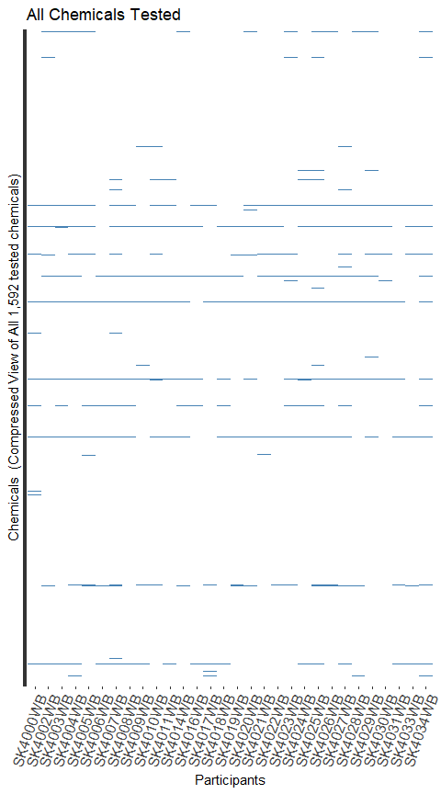

## Chart of all Found Chemicals

To allow us to look more carefully at the blue lines, we’ll eliminate from the chart all those lines which represent chemicals found in none of the wristbands in this sample set. We’ll also eliminate any of the wristbands that didn’t have ANY chemicals found. The chart below has a horizontal line for every tested chemical that was seen in at least one wristband.

Your wristband is differentiated by color.

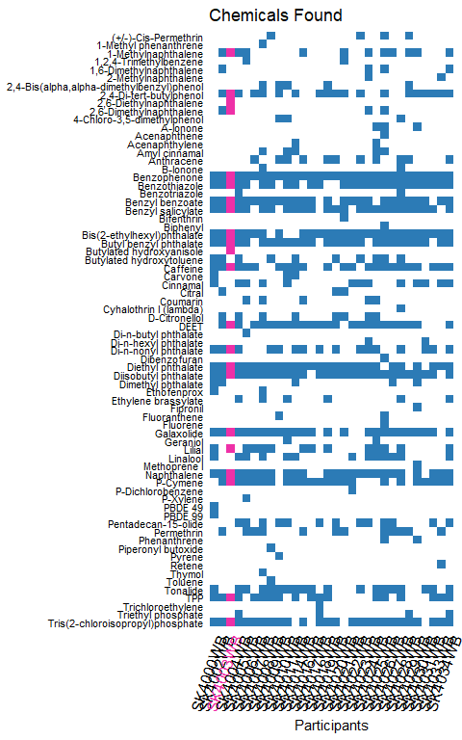

## Heat Map: “relatively how much” of each chemical

The following chart shows how your wristband compares to other wristbands in this group in terms of how many, and how much, of each chemical was found. We eliminate from the chart all those lines which represent chemicals found in none of the wristbands in this sample set showing only chemicals that at least one person did show in his/her wristband.

Your wristband name is highlighted in green on the bottom row of the chart.

NOTE: It is important to understand this chart properly. A more highly saturated red color means MORE of the chemical compound was found while a lighter color means relatively less was found. A white, or blank, means that none of that compound was detected in your wristband. Having said that, please do not try to compare BETWEEN ROWS. Mathematically speaking the colors have no meaning when compared between rows due to different rates of uptake of each chemical into a wristband. In other words, just compare the colors across a given row, not between rows.

To create this chart, we normalized within each row based on the maximum value for that chemical in any wristband. We then separate the values into 5 groups and color coding all items within each group. It is useful to remember that the groups are relative to each row separately and independently. The five groups are:

* Top 25%
* 3rd 25%
* 2nd 25%
* Bottom 25%
* None Found

In the image below the black squares highlight which wristband had the maximum value for each chemical. The green dots indicate your wristband.

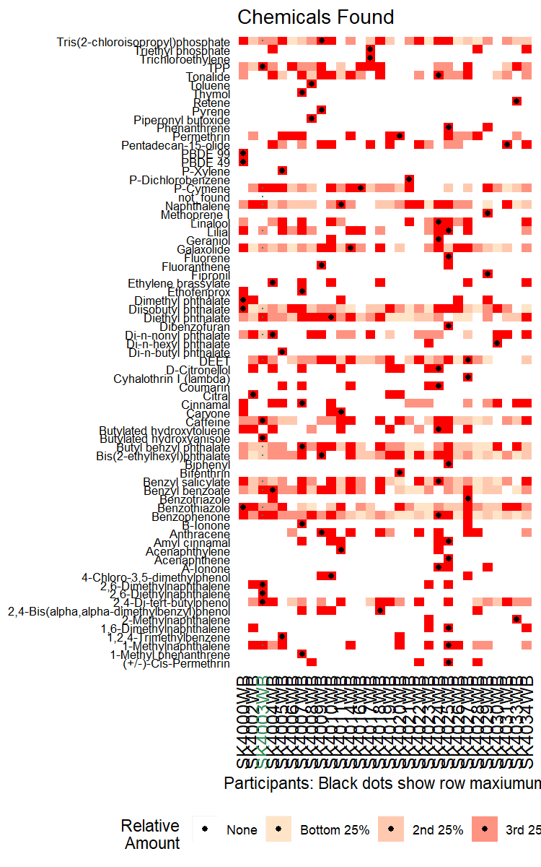

## Total Nanograms found of any Chemicals

Each tested wristband picked up different amounts of different chemicals. One simple question is “how much total chemical compound, of any type, did each wristband, or each nanogram-of-wristband, pick up? In other words, if we tested for a list of chemicals, and Wristband-A picked up 10 nanograms of Chemical 1, and 10 nanograms of chemical 2 and none of the other chemicals, then Wristband-A picked up a total of 20 nanograms of chemicals. The exact number is not as interesting as is the SIZE OF THE NUMBER relative to other people who wore the wristband and were tested for the same chemical.

The numbers were normalized relative to both the size of the wristband and the length of time the wristband was worn and hence can be relatively reliably compared.

Your wristband is in GREEN.

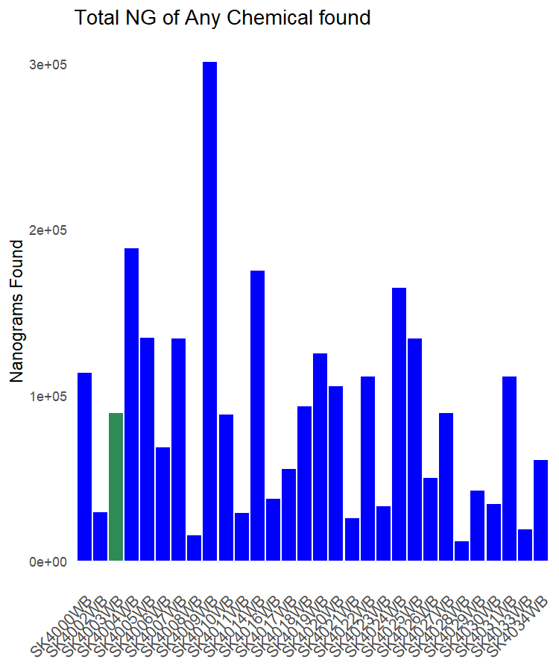

<–

## Numerical Matrixes of all Data

We now provide a few numerical matrixes so you can see the actual numbers that were used as the basis to create the charts above.

–>

<– ### Matrix showing Quartiles

The matrix below shows the result of normalizing the values found, based on the maximum value found, and then breaking up the values into 4 quartiles while leaving those with no-value-found at zero. In other words, we process each row so that it has only the values 0, 1, 2, 3, and 4.

–>

# Additional Information

## Summary report on Wristband vs Other devices:

* This project was a significant success. We exceeded our expectations regarding scientific outcomes with high levels of predictability regarding our key questions.
  + Wristbands resulted in significantly more data and remain the preferred approach among the three devices.
  + The comparison of the three sets of device results allows us to predict which compounds are coming from the air, which from the skin, and which are a mix of routes of exposure.
    - With this relatively small data set we were able to achieve between 65% and 85% accuracy in predictions. We anticipate this will improve as we add more people to this project!
    - MyExposome intends to pursue an additional grant which will significantly improve the ability of all scientists using wristbands to predict source of exposure.
  + In terms of the number of compounds detected and quantity of each compound detected , it is apparent that wristbands resulted in significantly more data overall.
    - For VOLATILE compounds (compounds which evaporate at room temperature) there are no dramatic differences between wristband vs necklace vs bracelet results although wristbands remain most robust.
    - For Semi-VOLATILE compounds (compounds with higher boiling points) there is a dramatic improvement in detection by the wristband versus the alternatives, suggesting that the wristbands capture from more routes of exposure than air alone.

## Other information about this report

All analyses were performed using R (ver. 4.2.0)[R Core Team, 2013] and knitr (ver ) [Xie, 2013] for reproducible research.   Report run on 04/28/22.

This information is made available to you by MyExposome, Inc. Refer to www.MyExposome.com for our standard terms and conditions. We do not provide medical advice. The Information provided is for research, informational, entertainment and educational use only as a result of the current research-based state of our approach. The Services are not intended to be used by the customer for any diagnostic purpose and are not a substitute for medical advice.

Report contents, structure, and results copyright(c) MyExposome, Inc. All rights reserved.