# *Ecological Archives* Exxxxx

# Fuhr M. *et al* Long-term stem inventory data from mountain forest plots in France. *Ecology* xxxx

## INTRODUCTION

TODO (Zianis, Muukkonen, Mäkipää, and Mencuccini, 2005).

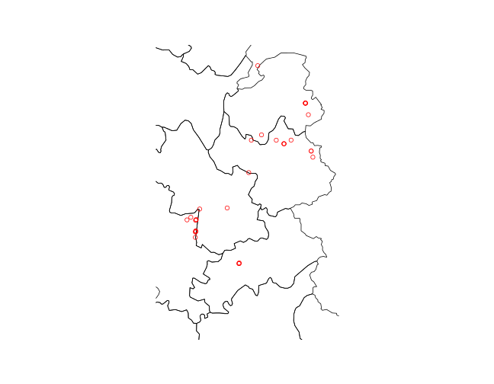 **Figure 1** Plots distribution in France.

[github](https://github.com/dfalster/baad/).

## METHODS

## METADATA CLASS I. DATA SET DESCRIPTORS

### A. DATA SET IDENTITY

Long-term stem inventory data from mountain forest plots in France.

### B. DATA SET IDENTIFICATION CODE:

### C. DATA SET DESCRIPTORS:

**1. Originators**: The study was initiated by TODO.

**2. Abstract**: We present repeated stem measurement data from 0 plots in mountain forests in France.

### D. Key words

France; mortality; permanent plot; mountain forest; recruitment; stem growth; stem height; canopy radius and height; forest management

## METADATA CLASS II. RESEARCH ORIGIN DESCRIPTORS

### A. "OVERALL" PROJECT DESCRIPTION

**1. Identity**:

**2. Originators**:

**3. Period of study**: From 1994 to 2015.

**4. Objectives**:

**5. Abstract**:

**6. Sources of funding**:

### B. SPECIFIC SUBPROJECT DESCRIPTION

#### II.B.1. Census of stems ≥7.5 cm DBH

**1. Sites description**: TODO site type, geography, Habitat, Geology Landform, Site history, Climate

**2. Experimental or sampling design**: TODO

**3. Research methods**: TODO Field, Taxonomy, Permit history, Legal

## CLASS III. DATA SET STATUS AND ACCESSIBILITY

### A. Status

**Latest update**: The dataset made available through this publication was processed on TODO. Newer updates may be retrieved from the following website TODO [github.com/kunstler](https://github.com/kunstler).

**Metadata status**: Metadata are complete to last update and are stored with data.

**Data verification**: TODO

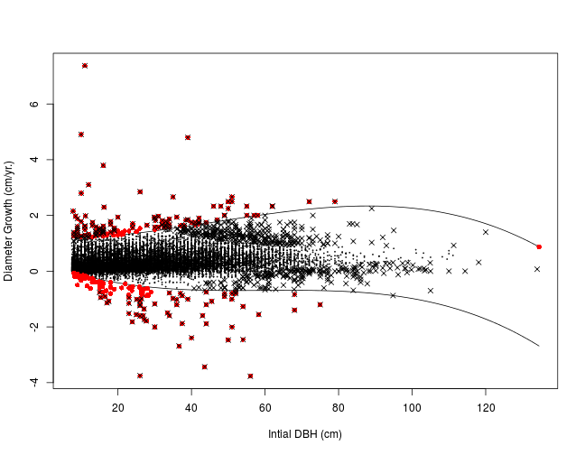 **Figure 2** Growth in function of iniotial dbh. and outlier identification.

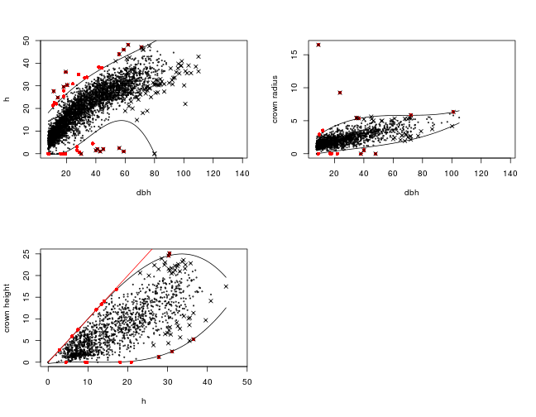 **Figure 3** Tree allometry and outlier identification.

### B. Accessibility

**1. Storage location and medium**: The data published on Ecological Archives is the first release stored at [github.com/kunstler](https://github.com/kunstler).

If you notice any problems with the dataset, please list an issue at [github.com/kunstler](https://github.com/kunstler).

**Contact persons**: TODO.

**Copyright restrictions**: The dataset is released under the the [Creative Commons Zero](https://creativecommons.org/publicdomain/zero/1.0/) ??.

**Costs**: None.

## CLASS IV. DATA STRUCTURAL DESCRIPTORS

### A. Data Set Files

The following files are provided:

* data_c.csv: Tree coordinates file
* data_m.csv: Tree measurements file
* data_p.csv: Plots description file
* metadata_data_c.csv: Metatdata for tree coordinates file
* metadata_data_m.csv: Metatdata for tree measurements file
* metadata_data_p.csv: Metatdata for plots description file

### B. Variable definitions for data.csv

|  |  |  |  |  |
| --- | --- | --- | --- | --- |
| X | variables | type | unit | definition |
| map_year | map_year | integer | NA | NA |
| plot_id | plot_id | character | NA | NA |
| stem_id | stem_id | character | NA | NA |
| quadrat_id | quadrat_id | integer | NA | NA |
| code_species | code_species | character | NA | NA |
| x | x | numeric | NA | NA |
| y | y | numeric | NA | NA |
| z | z | numeric | NA | NA |
| year_birth | year_birth | integer | NA | NA |

|  |  |  |  |  |
| --- | --- | --- | --- | --- |
| X | variables | type | unit | definition |
| measure_id | measure_id | character | NA | NA |
| plot_id | plot_id | character | NA | NA |
| year | year | numeric | NA | NA |
| stem_id | stem_id | character | NA | NA |
| code_status | code_status | character | NA | NA |
| code_diam | code_diam | integer | NA | NA |
| dbh | dbh | numeric | NA | NA |
| h_tot | h_tot | numeric | NA | NA |
| crown_h1 | crown_h1 | numeric | NA | NA |
| crown_h2 | crown_h2 | numeric | NA | NA |
| crown_h3 | crown_h3 | numeric | NA | NA |
| crown_h4 | crown_h4 | numeric | NA | NA |
| crown_r1 | crown_r1 | numeric | NA | NA |
| crown_r2 | crown_r2 | numeric | NA | NA |
| crown_r3 | crown_r3 | numeric | NA | NA |
| crown_r4 | crown_r4 | numeric | NA | NA |
| base_crown_h | base_crown_h | logical | NA | NA |
| strate | strate | integer | NA | NA |

|  |  |  |  |  |
| --- | --- | --- | --- | --- |
| X | variables | type | unit | definition |
| plot_id | plot_id | character | NA | NA |
| owner_id | owner_id | character | NA | NA |
| year_first_mes | year_first_mes | integer | NA | NA |
| N_census | N_census | integer | NA | NA |
| area | area | numeric | NA | NA |
| x_min | x_min | integer | NA | NA |
| x_max | x_max | numeric | NA | NA |
| y_min | y_min | integer | NA | NA |
| y_max | y_max | integer | NA | NA |
| aspect | aspect | character | NA | NA |
| elevation | elevation | integer | NA | NA |
| GPS_loc | GPS_loc | character | NA | NA |
| long | long | numeric | NA | NA |
| lat | lat | numeric | NA | NA |
| x_lamb2_et | x_lamb2_et | numeric | NA | NA |
| y_lamb2_et | y_lamb2_et | numeric | NA | NA |

**Number of observations by files**

|  |  |
| --- | --- |
| file | Nobs |
| data_c | 21982 |
| data_m | 46628 |
| data_p | 71 |

## ACKNOWLEDGMENTS

**Compilers:** TODO.

## REFERENCES