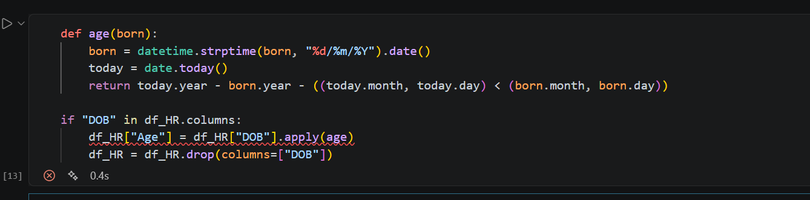
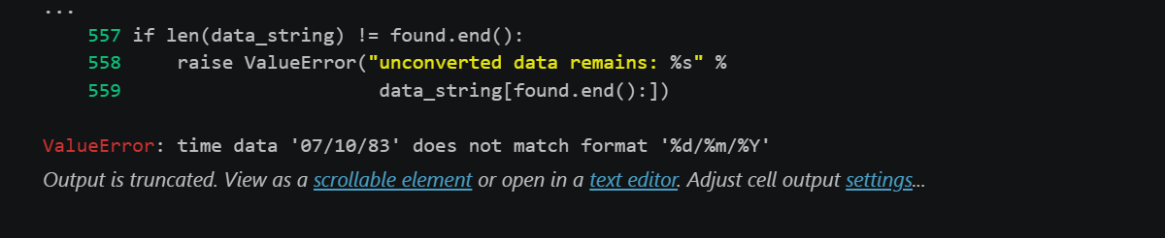
Error Log Date: 9th August 2026
The age() function that used strptime initially expected a 4-digit year, but the database stored the DOB’s as 2-digit years. To fix this, I changes the format string from %Y to %y, which instead parses the 2-digit years as it uses Pythons century-inference rule instead.
This introduced another smaller error that was a quick fix, being that there was a mix dd/mm/yy and mm/dd/yy formats within this column, which is an inconsistency at fault of the database, but to fix this, I added a simple try/except fallback to handle both patterns so they both could be used.
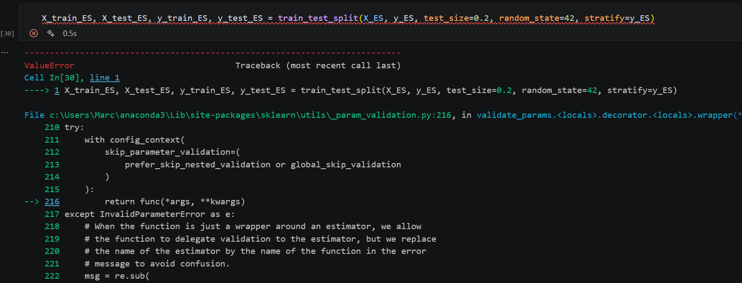
Error Log Date: 11th August 2026
The cause of the error today was that X_ES and y_ES still contained null values when attempting the splitting. This traced back to 788 fully blank trailing rows in the employee satisfaction dataset. These were just simply fixed by introducing a step earlier into the code that drops all the fully null rows, reducing the dataset size to about 14999 proper records. Rerunning the split after this reduction worked well.

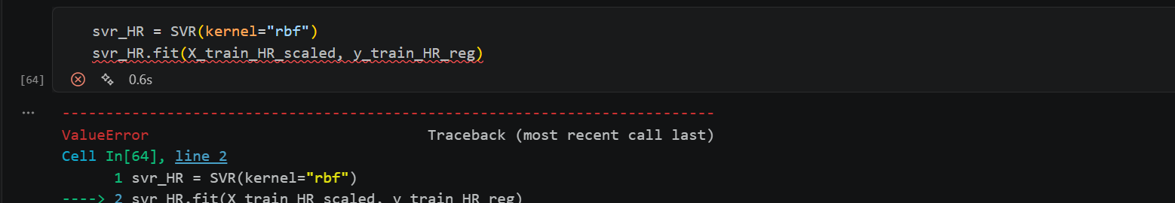
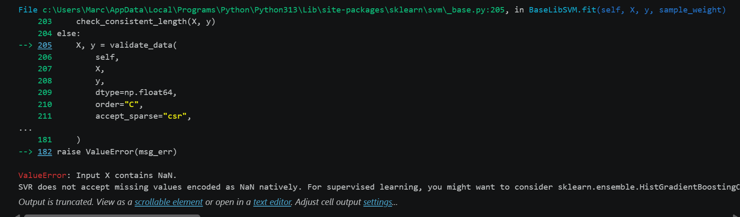
Error Log Date: 12th August 2026
I believe this error to be caused by the ManagerID having missing values. And because SVR cannot accept any missing values this has to be fixed perfectly.
This was fixed by adding an imputation step before the scaling of the data. I filled the missing numeric columns with median imputation and missing qualitative columns with modal imputation. This method worked well to solve this problem and didn’t take too long.

End Log.

