Name:Esteban, Marc Gavriele M. BSIT305

This is the Wind type character of the game we are creating. The succession of the game resembles a clone of super Mario bros game that was made in September 13, 1985. The game is a pretending side looking over classification where you need to complete the game by sparing the princess. The game is generally similar to a clone however you should simply to achieve the game with adversaries without letting your lives cleaned. The symbol has 3 lives and 3 powerups. The proverb of the game is "Do your best util the end never surrender."

Character:

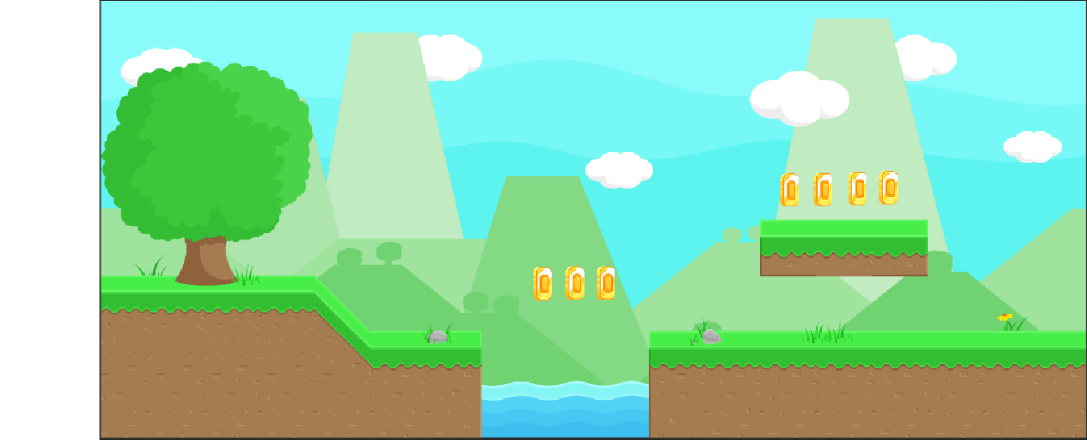Backgroud: