DRM 2010 Workshop Organization
General Chair: | Ehab Al-Shaer (University of North Carolina at Charlotte, USA)
Program Chairs: | Hongxia Jin (IBM Research, USA)  Marc Joye (Technicolor, France)
Steering Committee: | Aggelos Kiayias (University of Athens, Greece)  Rei Safavi-Naini (University of Calgary, Canada)  Moti Yung (Google & Columbia University, USA)
Program Committee: | Alapan Arnab (T-Systems, South Africa)  Ingemar Cox (University College London , UK)  Jean-Bernard Fischer (Nagravision, Switzerland)  Gregory Heileman (University of New Mexico, USA)  Bill Horne (Hewlett-Packard, USA)  Aggelos Kiayias (University of Athens, Greece)  Brian LaMacchia (Microsoft, USA)  Fernando Pérez-González (Universidad de Vigo, Spain)  Milan Petkovic (Philips Research Laboratories, The Nederlands)  Rei Safavi-Naini (University of Calgary, Canada)  Xin Wang (Huawei Technologies & University of Southern California, USA)  Bin Zhu (Microsoft Research Asia, China)
Additional reviewers: | Muhammad Asim  Jean-Phlippe Aumasson  Pramod Jamkhedkar  Alexandre Karlov  Sye Loong Keoh  Maria Khater | Koji Nuida  Luis Perez-Freire  Juan Ramón Troncoso-Pastoriza  Nicholas Sheppard  Brecht Wyseur
Sponsor: | 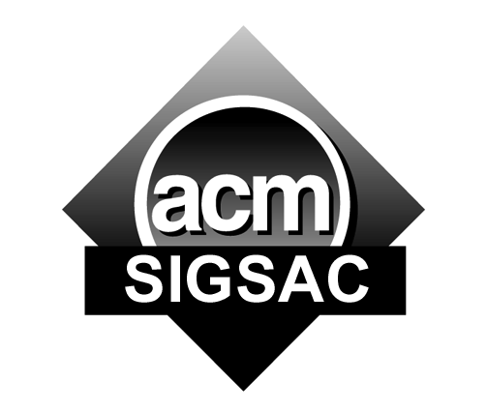
Supporters: |  | 
 | 

