Note that there are three main parts to this lab/homework. The first has us work with R code and the second asks us to evaluate different types of plots. The last is just a short part where I ask you to think about what you learned etc.

Section 1: Visual data in R

**Purpose:**

1. **Learn how to use ggplot to make different types of plots**
2. **Understand how to change different aspects and features of a plot**

**Tasks:**

1. **Read and follow along with the R code**
2. **Copy and past your R code into the space in this document and then post to AsULearn**

# Making plots with ggplot package

To do this part of the homework you can copy and past the code in the ‘code blocks’ into R and run it. Then when you figure out how to answer the questions just copy and paste your code from R into this document!

Rather than a normal handout/lab this one tells a story and has you learning ggplot while you do so. Be sure to check out the reading here: <https://r4ds.had.co.nz/data-visualisation.html> before doing this project.

If you need more background on how ggplot works check out chpt 3 of <https://socviz.co/makeplot.html#makeplot> “Data Visualization”

You might not know how to do the things being asked for right away. That is fine and expected. What i want you to learn is how to *find the answers* rather than what the answer is. In other words, I am more concerned with the process than the result. But if you are getting frustrated reach out and I’m always happy to help

## Story time

You are working on your Ph.D with a professor of anthropology at Fancypants University. She has just learned about a new species of monkey that she wants you to collect data on. So you are off to the island of Naboombu, where you will be given the task of watching these primates.

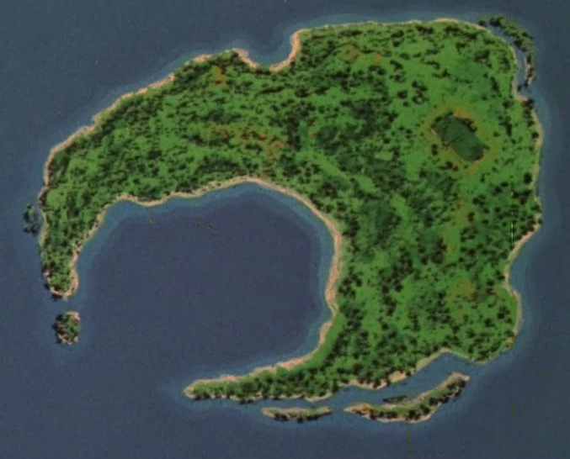

## Collecting your data, part 1

When you arrive on the western part of the island you notice that there are a whole lot of monkeys here and you need to find a way to get an idea of what they look like. So you and your team decide to start by measuring their tails (they aren’t apes!). You manage to measure 500 of these fellas (ok, this is a bit of a reach but lets say that you are *really* quick at measuring and the monkeys like having their tails measured….)

below is a very quick reminder of how R works

#first we make an object and assign something to it...  
  
the_numbers <- c(4, 8, 15, 16, 23, 42)  
#once we have an object we can do things to that object.  
  
mean(the_numbers)

sum(the_numbers)

sd(the_numbers)

We are going to be simulating the data you collected rather than writing 500 entries..

Run the following R code in a new session to get the first monkey data! **Be sure to run the first line of code that loads in the tidyverse library.** I made some comments so you can follow along with what the code is doing:

library(tidyverse)  
set.seed(2020) #this sets the randomizer in R  
tail_length <-rnorm(500,57,2) # create a set of 500 random numbers with a mean of 57 and a standard deviation of 2   
sample_number <-1:500 # create a vector of numbers from 1 to 500  
monkey_pop <- rep(letters[1], 500) # this makes a vector of 500 'a's  
monkey_data_1 <- tibble(sample_number, tail_length, monkey_pop) #create a data table (a tibble is a function that makes nice data tables with a modern flair...)  
  
monkey_data_1 %>% ggplot(aes(tail_length)) + geom_histogram(binwidth = 10) # this takes the monkey data and plots a histogram of the tail length

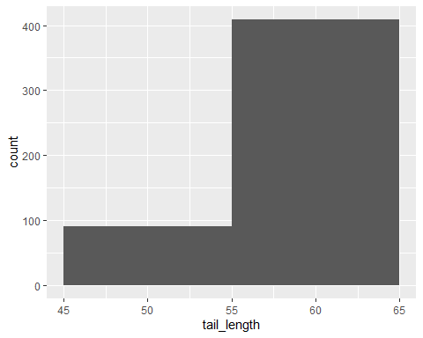

### 

### Question 1: Changing the bin length:

You note that the plot you made with the code above doesn’t look very nice. After thinking for a bit you realize the bin length is too large and you can’t see enough of the data. What code would you use to change the binwidth to be 1. Copy the code from above and change it in R so the figure looks better. Then copy that code into the box below:

### 

#copy your answer to question 1 here:

monkey_data_1 %>% ggplot(aes(tail_length)) + geom_histogram(binwidth = 1)

### Question 2: Ok, but you know your professor wants the histogram to be blue. How can you change the code below to make the fill of the histogram be blue?

#### (n.b. for help see section **3.5 “Mapping aesthetics vs setting them” of** [**https://socviz.co/makeplot.html#makeplot**](https://socviz.co/makeplot.html#makeplot)**)**

#copy your answer to question 2 here:

monkey_data_2 %>% ggplot(aes(tail_length)) + geom_histogram(binwidth = 1, color = "blue", fill = "blue")

You send this lovely blue histogram off to your professor and go and take a nap (measuring 500 tails *plus* data entry is serious work!)

## Collecting your data, part 2

The next day you are talking to some local people and hear about another group of monkeys on a different part of the island. **First run the code below to get that data and make a histogram!**

tail_length <-rnorm(500,52,2)  
sample_number <-501:1000  
monkey_pop <- rep(letters[2], 500)  
monkey_data_2 <- tibble(sample_number, tail_length, monkey_pop)  
  
monkey_data_2 %>% ggplot(aes(tail_length)) + geom_histogram(binwidth = 1)

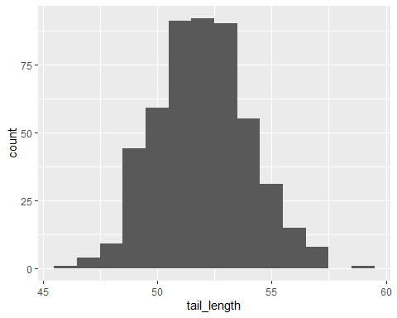

Now you want to look at both of the populations at the same time! Thankfully you have taken this class and have some R code ready to do this. Run the code below in your R session to make a histogram of both datasets

all_data <- bind_rows(monkey_data_1, monkey_data_2) # here we are using the function bindrows to add the two datasets together!  
  
all_data %>% ggplot(aes(tail_length )) + geom_histogram(color="#e9ecef", alpha=0.6, position = 'identity')

## `stat_bin()` using `bins = 30`. Pick better value with `binwidth`.

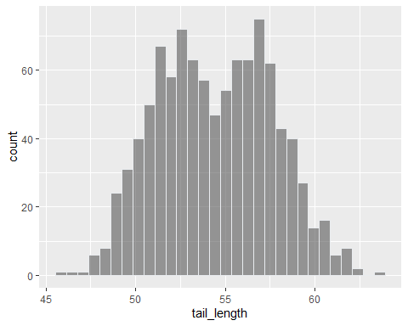

Hmmm…that doesn’t look right since you can’t tell the different groups apart. But you think back to your stats class in college and remember that we need to set an aes(...) argument. The aesthetic specifies that a variable will be expressed by one of the available visual elements, such as size and **color**. You sorta did this above when we made the histogram blue but this is a bit trickier…

### Question 3: How can you change the code below to make the different monkey populations have different colors (note: you just need to add one argument to the aes() part. i put “*************” to show where to put this

#Question 3: edit the below code to color by the variable monkey_pop  
  
all_data %>% ggplot(aes(tail_length, fill=monkey_pop )) + geom_histogram(color="#e9ecef", alpha=0.6, position = 'identity')

So you look at this and think to yourself “Hey, they overlap a bit but there are difference at the tails….😀. I am going to send this to my adviser and she will be soooooo happy!”

A few hours later you get an email with these requests. Your adviser wants you to do all of the following to the figure you have made

### Question 4: updates to the plot

Here is what she wants you to do:

* Put the legend on the bottom rather than on the right
* Label the x axis “tail length (cm)”
* Label the y axis “number of observations”
* Give it a title that is meaningful
* Put a credit somewhere that says who made the figure
* Change the legend so that it says “Monkey groups”
* Change the labels from “a” and “b” to “Group one” and “Group 2”

Lets take this step by step. Copy the below R code and use each step to build the new graph. If you need help use the class readings or ask on Discord! Then copy the code you used below. For example, to get the first part of this we would update the code like this

#old code  
all_data %>% ggplot(aes(tail_length, fill=monkey_pop )) + geom_histogram(color="#e9ecef", alpha=0.6, position = 'identity', binwidth = 1)

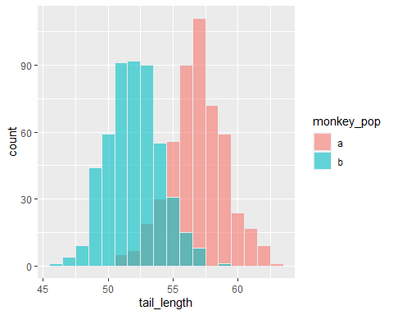

# new code

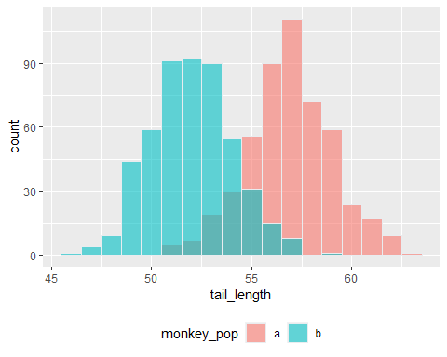

To figure out how to do this we are going to need to check online. One good source is <https://rstudio.com/wp-content/uploads/2015/03/ggplot2-cheatsheet.pdf>. For example if you look at the right hand column of page 2 you will see a box that talks about how to change the labels…another good source is this site: <https://ggplot2.tidyverse.org/reference/> which i use quite a bit to rejigger figures.

### 

#copy your answer to question 4 here:  
  
  
#plot a. here is my version to the professors first request.   
  
all_data %>% ggplot(aes(tail_length, fill=monkey_pop )) + geom_histogram(color="#e9ecef", alpha=0.6, position = 'identity', binwidth = 1) + theme(legend.position = "bottom")  
  
#plot b  
all_data %>% ggplot(aes(tail_length, fill=monkey_pop )) + geom_histogram(color="#e9ecef", alpha=0.6, position = 'identity', binwidth = 1) + theme(legend.position="bottom") + labs(x="tail length (cm) ")  
  
  
#plot c  
all_data %>% ggplot(aes(tail_length, fill=monkey_pop )) + geom_histogram(color="#e9ecef", alpha=0.6, position = 'identity', binwidth = 1) + theme(legend.position="bottom") + labs(x="tail length (cm) ", y= "number of observations")  
  
  
#plot d  
all_data %>% ggplot(aes(tail_length, fill=monkey_pop )) + geom_histogram(color="#e9ecef", alpha=0.6, position = 'identity', binwidth = 1) + theme(legend.position="bottom") + labs(title= "Naboombu Monkey Tail Lengths", x="tail length (cm) ", y= "number of observations")  
  
  
#plot e  
all_data %>% ggplot(aes(tail_length, fill=monkey_pop )) + geom_histogram(color="#e9ecef", alpha=0.6, position = 'identity', binwidth = 1) + theme(legend.position="bottom") + labs(title= "Naboombu Monkey Tail Lengths", x="tail length (cm) ", y= "number of observations", caption="Made by Kendra Casse")  
  
#plot f

all_data %>% ggplot(aes(tail_length, fill=monkey_pop )) + geom_histogram(color="#e9ecef", alpha=0.6, position = 'identity', binwidth = 1) + theme(legend.position="bottom") + labs(title= "Naboombu Monkey Tail Lengths", x="tail length (cm) ", y= "number of observations", caption="Made by Kendra Casse", fill="Monkey Groups")  
  
  
#plot g

all_data %>% ggplot(aes(tail_length, fill=monkey_pop )) + geom_histogram(color="#e9ecef", alpha=0.6, position = 'identity', binwidth = 1) + theme(legend.position="bottom") + labs(title= "Naboombu Monkey Tail Lengths", x="tail length (cm) ", y= "number of observations", caption="Made by Kendra Casse", fill="Monkey Groups") + scale_fill_discrete(labels=c("Group 1", "Group 2"))

## 

## Bonus

Now that you have played around with options on ggplot and read the sections about this function play around in a ‘sandbox’ and change whatever you want (background color, text type, etc)

#copy your answer to bonus question here:  
all_data %>% ggplot(aes(tail_length, fill=monkey_pop )) + geom_histogram(color="#e9ecef", alpha=0.6, position = 'identity', binwidth = 1, linetype="dashed") + theme(legend.position="bottom",panel.background= element_rect(fill="black", color="black")) + labs(title= "Naboombu Monkey Tail Lengths", x="tail length (cm) ", y= "number of observations", caption="Made by Kendra Casse", fill="Monkey Groups") + scale_fill_discrete(labels=c("Group 1", "Group 2"))

## Part 3: New visualizations with new data

## 

You and your professor submit your data paper to a journal. After a few months you get your peer review back and the reviewers say “wow, this is cool! But ya know what, we think you need more measurements before we can conclude these are 2 different populations. Can you go and measure ear length?”

copy and Run the following code to get the new_data

ear1 <- rnorm(500, 4.4, .22)  
ear2 <- rnorm(500, 6.3, .31)  
  
ear1 <-tibble(ear =rnorm(500, 4.4, .22), monkey_pop = rep(letters[1], 500), sample_number = 1:500)  
  
  
ear2 <-tibble(ear =rnorm(500, 6.3, .31), monkey_pop = rep(letters[2], 500), sample_number = 501:1000)  
  
ear_all <- bind_rows(ear1, ear2)  
  
new_data <- all_data %>% left_join(ear_all, by= c("monkey_pop", "sample_number"))

Since you know have two measurements on each monkey you need a new way to visualize these data. Remembering what you learned at AppState you go and make a scatterplot of these data. Copy the below code into R and see what happens!

new_data %>% ggplot(aes(tail_length, ear)) + geom_point() # this makes the scatterplot geom

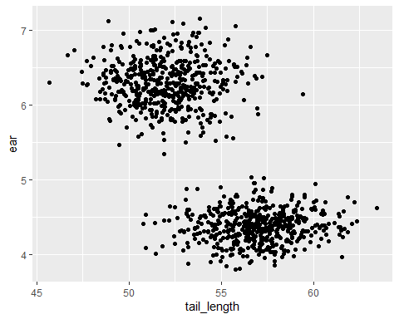

new_data %>% ggplot(aes(tail_length, ear, color = monkey_pop)) + geom_point()

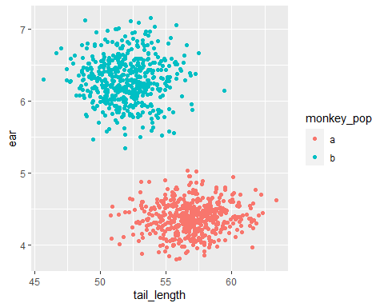

You are thrilled and send it off to your adviser.

She comes back and asks for the following updates:

### Question 5: updating the scatteplot

* Get rid of the legend
* Add a regression line for each group
* Add a transparency or a jittter to deal with over plotting
* Make the 2 groups have a different shape
* Add an ellipse to the groups ( *see “stat_ellipse()” for a hint*)

#write you answers to question 4 here  
  
  
#plot a  
new_data %>% ggplot(aes(tail_length, ear, color = monkey_pop)) + geom_point() + theme(legend.position= "none")  
  
#plot b  
new_data %>% ggplot(aes(tail_length, ear, color = monkey_pop)) + geom_point() + theme(legend.position= "none") + geom_smooth(method="auto", se=TRUE, fullrange=TRUE, level=.95)  
  
  
#plot c  
new_data %>% ggplot(aes(tail_length, ear, color = monkey_pop)) + geom_point() + theme(legend.position= "none") + geom_smooth(method="auto", se=TRUE, fullrange=TRUE, level=.95) + geom_jitter()  
  
# plot d

new_data %>% ggplot(aes(tail_length, ear, color = monkey_pop, shape=monkey_pop)) + geom_point() + theme(legend.position= "none") + geom_smooth(method="auto", se=TRUE, fullrange=TRUE, level=.95) + geom_jitter()

#plot e

new_data %>% ggplot(aes(tail_length, ear, color = monkey_pop, shape=monkey_pop)) + geom_point() + theme(legend.position= "none") + geom_smooth(method="auto", se=TRUE, fullrange=TRUE, level=.95) + geom_jitter() + stat_ellipse()

### 

### Question 6: taking it further

Your adviser now asks if you can make the plots with the new data for the following different geoms.

* make a violin plot
* make a boxplot
* make a ridgeline plot (n.b. to do this one we need to install a new package called “ggridges” (<https://www.r-graph-gallery.com/294-basic-ridgeline-plot.html>)

# write you answers to question 6 here. i put the first one here to help you out  
  
#plot a  
new_data %>% ggplot(aes( monkey_pop, tail_length, fill = monkey_pop)) + geom_violin()

#plot b

new_data %>% ggplot(aes( monkey_pop, tail_length, fill = monkey_pop)) + geom_boxplot()

#plot c

new_data %>% ggplot(aes( monkey_pop, tail_length, fill = monkey_pop)) + geom_density_ridges()

## export the data

she wants the whole dataset sent to her so she can take a look at it herself. You know that you can use write_csv to do a basic export but she has some specific requests:

### Question 7

* change the name of the csv file so it is called “new_primate_data” rather than “my_monkeydata.csv”
* change the format of the exported file to an Excel sheet (this is hard)

#write you answers to question 7 here. as a tip look at this code: write_csv(new_data, "my_monkeydata.csv")  
  
  
#part a  
  
write_csv(new_data, "New_Primate_Data.csv")  
  
  
  
#part b

write.xlsx((read.csv("/Users/kendracasse/Quant_Stats_HW_KendraCasse/New_Primate_Data.csv")), sub('.csv', '.xlsx',"New_Primate_Data.csv",fixed=TRUE))

### 

# Once more, for the folks who like to dial it up to 11 (optional)

## 

Your paper has been accepted(!!!) but the editors want it selected for a special feature that requires an interactive component. To do this we need to use a few new packages: *plotly* and *glue*. Plotly lets us make interactive graphs fairly easily (it is one of my secrets that once you get the hang of it the code isn’t too hard to use and it makes fancy slides!). Glue lets us take different parts of a dataframe and paste (or glue) them together

install.packages("plotly")  
library(plotly)  
  
p <- new_data %>% ggplot(aes(tail_length, ear, color = monkey_pop)) + geom_point() # this is the basic plot we made before. I am just saving it to an object called p  
  
ggplotly(p) # just this simple function does so much!

add sample number to the hover:

p <- new_data %>% ggplot(aes(tail_length, ear, color = monkey_pop, label= sample_number)) + geom_point() #here, we are adding the label argument to the aes function so that the ‘sample number’ variable shows up on when we put the mouse over the point.   
  
ggplotly(p)

make the tooltip look pretty

install.packages("glue")  
library(glue)  
  
  
  
p <- new_data %>% ggplot(aes(tail_length, ear, color = monkey_pop, text = glue('sample is: {sample_number}'))) + geom_point() # here we use glue to add the "sample is:" text in front of the *sample number* variable.

ggplotly(p)

# What else can you do with R visualizations

Now that you have learned a lot about how to work with visualization data i want you to take a moment and think about how to approach another dataset

The palmerpenguins package contains two datasets. to install it copy the following code into R

install.library("palmerpenguins")

One is called penguins, and is a simplified version of the raw data; see [?penguins](https://allisonhorst.github.io/palmerpenguins/reference/penguins.html) for more info

The second dataset is penguins_raw, and contains all the variables and original names as downloaded; see [?penguins_raw](https://allisonhorst.github.io/palmerpenguins/reference/penguins_raw.html) for more info.

Both datasets contain data for 344 penguins. There are 3 different species of penguins in this dataset, collected from 3 islands in the Palmer Archipelago, Antarctica. The culmen is the upper ridge of a bird’s bill. In the simplified penguins data, culmen length and depth are renamed as variables bill_length_mm and bill_depth_mm to be more intuitive.

think about what the below code is doing. Once again we are using the pipe (%>%) to take the dataset and apply a function to it (in this case, the count function)

library(palmerpenguins)

glimpse(penguins)

penguins %>%  
 count(species)

## # A tibble: 3 x 2  
## species n  
## <fct> <int>  
## 1 Adelie 152  
## 2 Chinstrap 68  
## 3 Gentoo 124

penguins %>%  
 group_by(species) %>%  
 summarize(across(where(is.numeric), mean, na.rm = TRUE))

Take a look at these data. what sort of figures might you want to make? Think about how you could tell a story about these penguins via an image. Then write some code that will let you do this. When you are done, take a moment to explain in prose why you made this figure and how you used R to do it

Section 2: comparing plots

**Purpose:**

1. **Understand what makes a plot good and how to ‘fix’ bad plots**

**Tasks:**

1. **For each figure, note 1) what is the figure trying to say and 2) what makes it problematic/how someone might fix it for it to be better**

**Figure A**

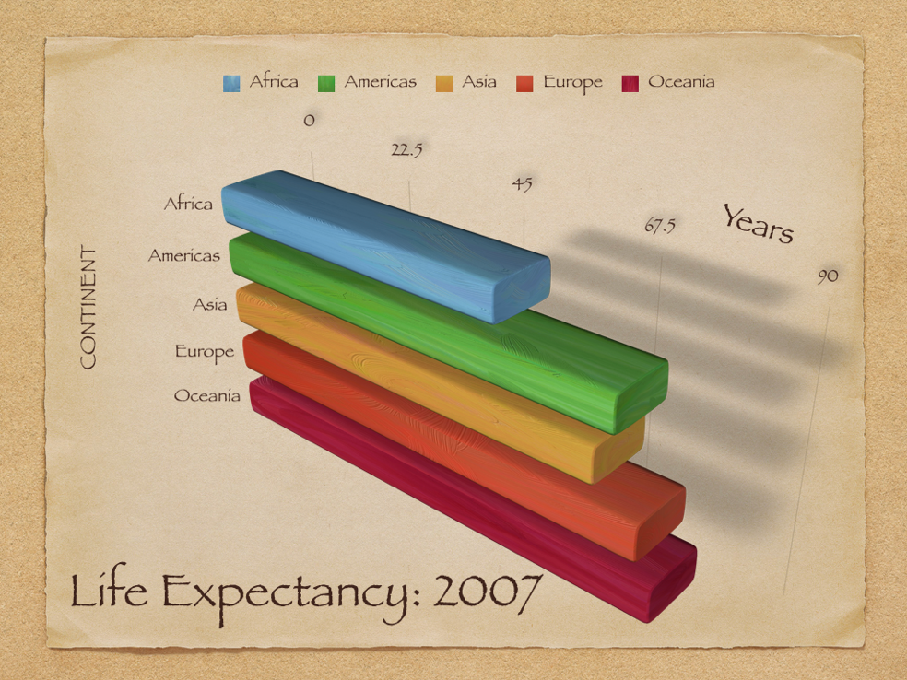

What is this figure trying to say?

This figure is showing the average life expectancy in 2007 in different continents.

What is problematic?

The perspective makes it hard to see what the data is actually saying. Also, the increments/scales of the X axis don’t make much sense and make the data even harder to conceptualize.

How might someone redo this better?

You could redo this better by making the scale of the X axis go up by ten each time, and change it to a 2D bar graph so the perception is very clear and easy to read.

**Figure B**

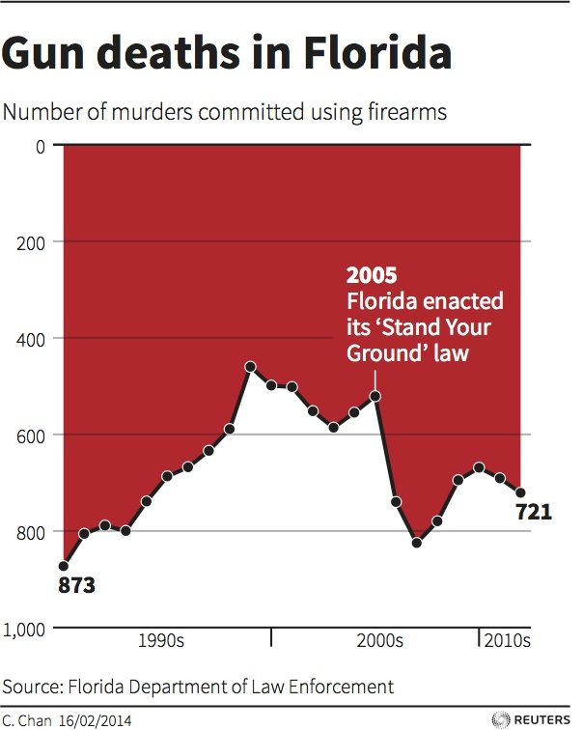

What is this figure trying to say?

This figure is trying to show the number of murders committed using firearms in Florida from the 1980’s to the 2010’s.

What is problematic?

The Y axis is upside down basically because the highest point is 0 and the lowest point is 1,000, which is extremely confusing. Also, the scale of the X axis is unclear what exact year you are looking at. The graph is extremely misleading and makes it look like that after Florida passes its “Stand Your Ground” law that murders decreased significantly, but they actually increased significantly.

How might someone redo this better?

This graph needs to be thrown away. The scale of the Y axis should start at zero and increase, making it clear to see how many murders there were that year. The X axis should clearly show each year from which the data was retrieved. It should also clearly show that after the 2005 Stand Your Ground law was enacted, firearm murders in Florida increased dramatically.

Figure C.

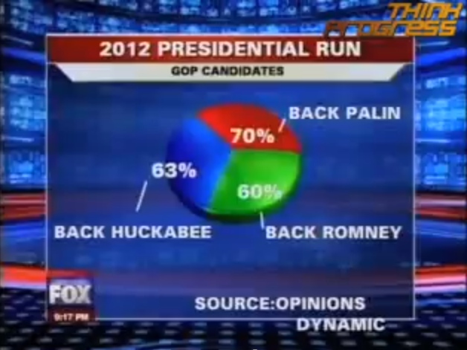

What is this figure trying to say?

I think the figure is trying to show what percentage of people are backing the republican candidates for the 2012 election.

What is problematic?

Everything!! First, the percentages add up to be 193%. The visualization just looks aesthetically bad, the source name is off of the graph. The title needs to be more clear for what the data is actually showing. Because the pie chart adds up to be well over 100%, you are unable to visualize how large the pieces of the pie are in relation to each other. The 60% slice looks the biggest even though it is the smallest one.

How might someone redo this better?

The data needs to be corrected, because there can’t be 193% of people polled. Then, there should be some other type of graph that isn’t a pie chart. The title should be clear and tell exactly what the data is showing.

Figure D.

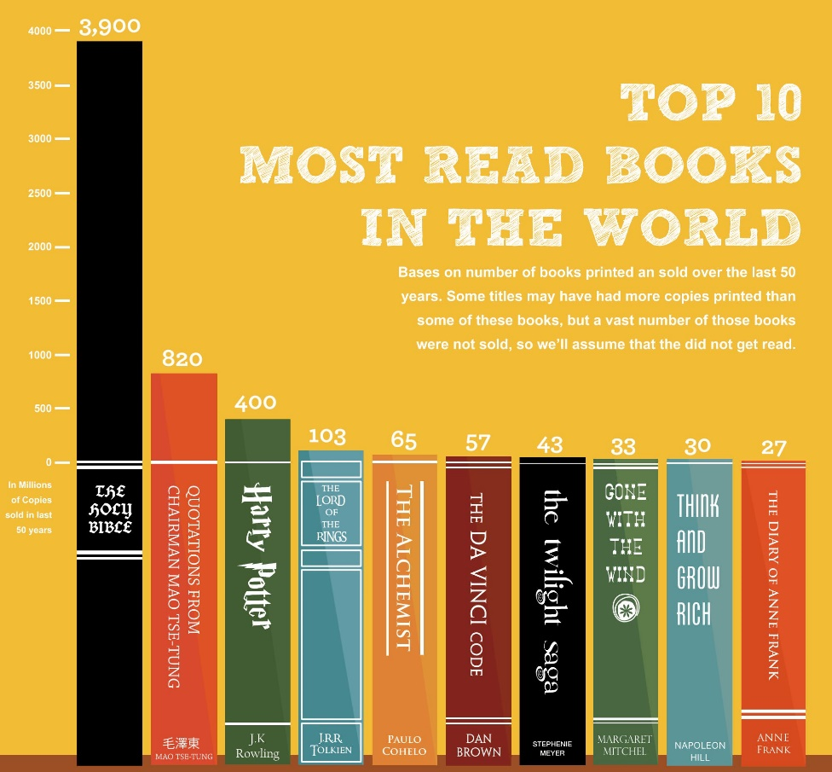

What is this figure trying to say?

The figure is showing the most read books in the world by millions of copies sold in the last 50 years.

What is problematic?

It is hard to see where the bars actually start, it looks like the entire books are the bars. Also, the scale on the Y axis is extremely small and really hard to read along with the little blurb about how the graph shows copies sold by millions in the last 50 years.

How might someone redo this better?

The scale of the Y axis needs to be a lot bigger and more legible so that you can tell where the bar graph starts. The blurb on the side needs to be way bigger so you can actually read it and be able to tell what the numbers on the graph are saying.

Figure E.

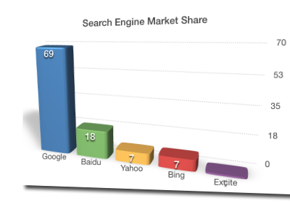

What is this figure trying to say?

The figure is showing what percentage of the industry uses a specific search engine.

What is problematic?

This is problematic because it is 3D, so the perspective makes it really hard to see the graph clearly. For the excite bar, there isn’t even a number on it so you can’t tell what the percentage is. The number are rounded because they rounded the scale of the Y axis from 17.5 to 18. There is no date on the graph that tells when this data was from so it could be 2005, 2015, who knows. There is no source either to show where these figures are from.

How might someone redo this better?

The image should be a 2D graph with clearly labeled bars so you can see what the exact percentages are. There should be a source to show where the data came from and there should be a date to show when this data was taken.

Figure F.

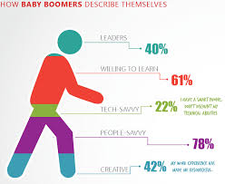

What is this figure trying to say?

I think that the figure is trying to show how people from the baby boomer generation would describe themselves in words?

What is problematic?

So much about this is problematic. The little figure of the running man makes it impossible to tell how big the sections are. Also, the data adds up to be 243% which makes no sense at all. Again, this figure has no date of when the data was taken and no source to show where the data came from.

How might someone redo this better?

This data needs to be shown in a different type of graph such as a bar graph. The data should add up to be 100% or explain why the number do not add up to be 100%. There should be a source and date for the data.

Figure G

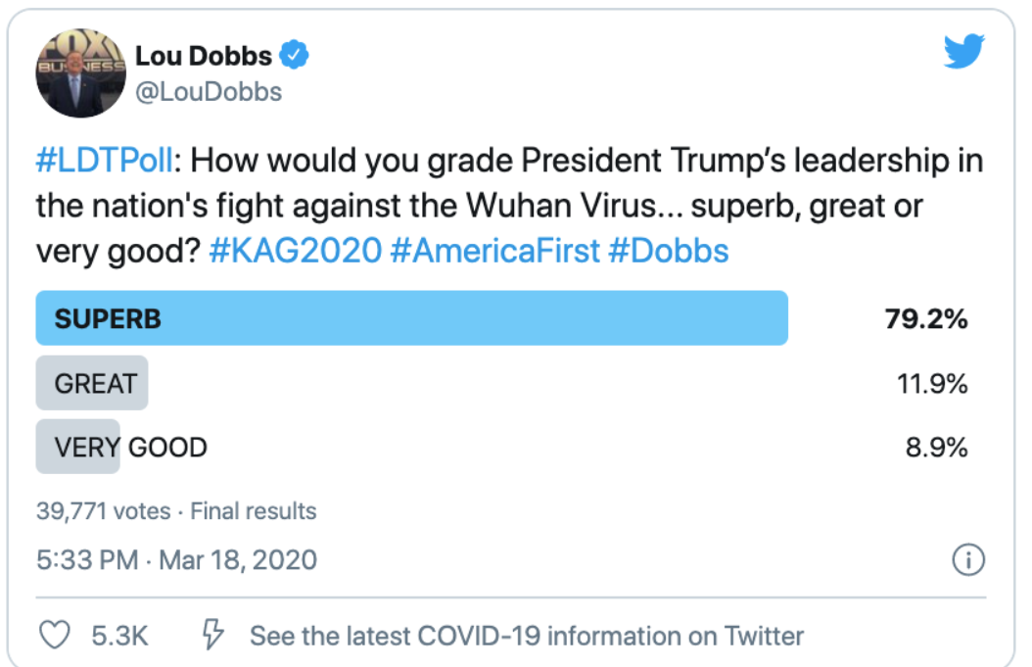

What is this figure trying to say?

This figure is trying to make the point that they think Donald Trump is great, that’s all.

What is problematic?

This figure is problematic because all of the answer choices are different words for the exact same thing. Also, the question being asked is not accurate and does not even say the correct name of the virus it is talking about..

How might someone redo this better?

You would need to have more options for answer choices that don’t all mean the same thing. The question should be clear and accurate on what this poll is about.

**And finally…..the best pie chart:**

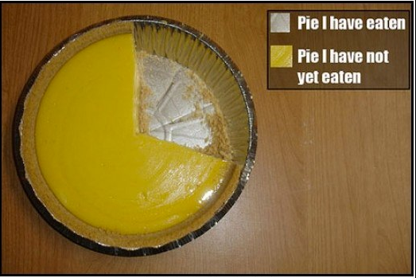

Section 3: Thinking about R

This is not easy stuff. Most folks don’t put much thought into what makes a good visualization nor do they take the time to keep these ideas in mind when creating them. This is true both in the media and in academia. I hope you have learned something from this project!

1. After thinking about these topics, what would you say makes a good data visualization stand out from a bad one?

A good visualization is one that is clear, concise and easy to read. You should be able to clearly see everything that is being shown in a way where it doesn’t take much brain power to understand it. There should be a clear title to show what the data is about and there should be sources and dates showing where the data was from and when it was retrieved.

2. ggplot is one of the most used packages in R (I saw a reference that it has been used to make over a million plots!). The ‘language’ is a bit hard to parse at first. Do you think you are getting a handle on how to make plots?

I think that I am understanding it a little better, however, I still need clear directions to be able to do it well. I am not at the point where I can make plots without having directions on how to do it.

3. Now that you know something about data visualizations, what sorts of visualization might you make for your data analysis project?

I would probably want to make bar graphs for each individual genre to show perhaps the top ten (maybe more) most popular songs and what their scores in each factor are (i.e. loudness, danceability etc.), then see what the correlation across those factors are to get an average of what makes a popular song in each Genre, then compare that between genres. This way to get a visualization of what each genre of music the public finds most attractive to make a song go viral/popular.

4. for the project where we look at how stats are seen in the media, did the story you chose have a figure in it? If so, do you think it is a good one?

No