JFileSysLib – Quick start (Eclipse)

1) Download the library from https://github.com/MarcMil/JFileSysLib/ plus the demo code projects
2) Run Eclipse
3) Select File/Import...
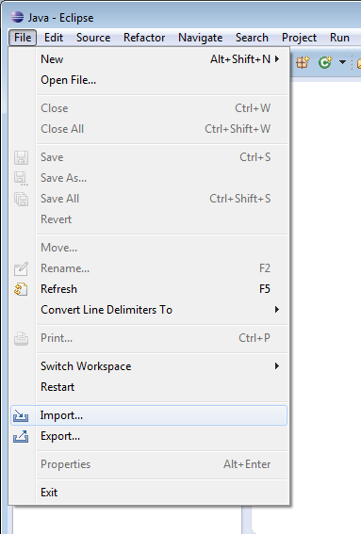

4) Select General/Existing Projects into Workspace and press Next

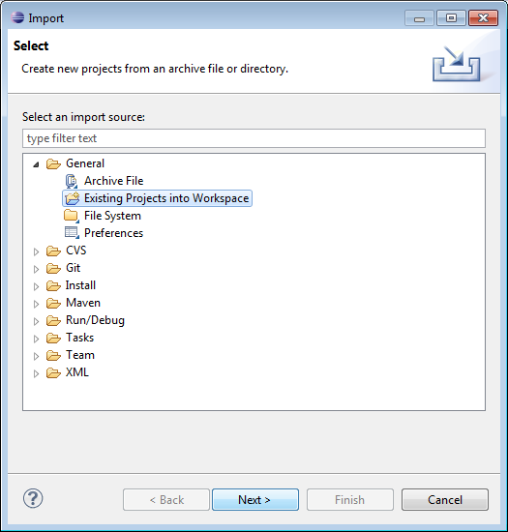

5) Select the download path as Root directory and click Finish.
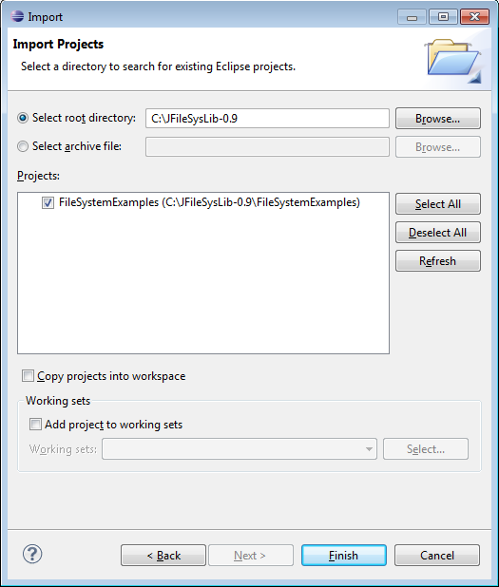
Disable suspend on uncaught exceptions
1) Select Window/Preferences

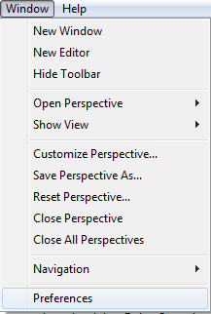

2) Select the the Java/Debug node. Uncheck the „Suspend execution on uncaught exceptions“ check box and press OK.
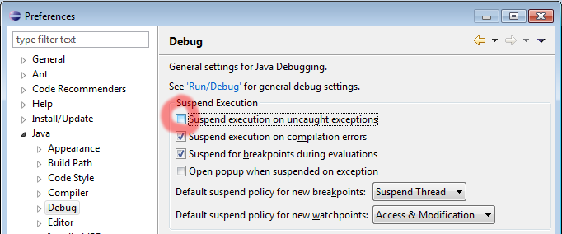
Don't worry: This is due to JFileSys (JDokan)'s inner Java/native architecture binding. It will not have any effects on your final product.
Running the example file system

1) Select the project in the Package Explorer and press F11.
In the upcoming window, select „Java Application“ and click on OK.

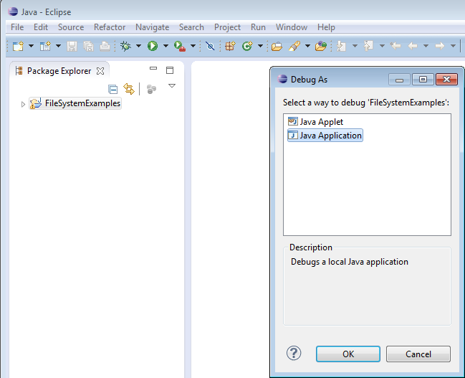

2) Clickon „Program“ and afterwards on OK.
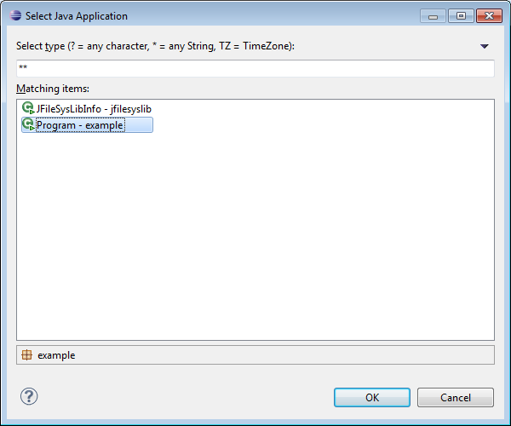
9) The demo file system should appear.

