12

Force-Directed Drawing Algorithms

Introduction. . . . . . . . . . . . . . . . . . . . . . . . . . . . . . . . . . . . . . . . . . . . . . . . .

Spring Systems and Electrical Forces . . . . . . . . . . . . . . . . . . .

The Barycentric Method . . . . . . . . . . . . . . . . . . . . . . . . . . . . . . . . . .

Graph Theoretic Distances Approach . . . . . . . . . . . . . . . . . . .

Further Spring Refinements. . . . . . . . . . . . . . . . . . . . . . . . . . . . . . .

Large Graphs . . . . . . . . . . . . . . . . . . . . . . . . . . . . . . . . . . . . . . . . . . . . . . .

Stress Majorization . . . . . . . . . . . . . . . . . . . . . . . . . . . . . . . . . . . . . . . .

Non-Euclidean Approaches . . . . . . . . . . . . . . . . . . . . . . . . . . . . . . .

Lombardi Spring Embedders . . . . . . . . . . . . . . . . . . . . . . . . . . . . .

Dynamic Graph Drawing . . . . . . . . . . . . . . . . . . . . . . . . . . . . . . . . .

Conclusion . . . . . . . . . . . . . . . . . . . . . . . . . . . . . . . . . . . . . . . . . . . . . . . . . .

12.1

12.2

12.3

12.4

12.5

12.6

12.7

12.8

12.9

12.10

12.11

383

385

386

388

389

391

396

397

400

401

403

404

Stephen G. Kobourov

*University of Arizona*

References . . . . . . . . . . . . . . . . . . . . . . . . . . . . . . . . . . . . . . . . . . . . . . . . . . . . . . . . . .

12.1

Introduction

Some of the most flexible algorithms for calculating layouts of simple undirected graphs

belong to a class known as force-directed algorithms. Also known as spring embedders, such algorithms calculate the layout of a graph using only information contained within the structure of the graph itself, rather than relying on domain-specific knowledge. Graphs drawn with these algorithms tend to be aesthetically pleasing, exhibit symmetries, and tend to produce crossing-free layouts for planar graphs. In this chapter we will assume that the input graphs are simple, connected, undirected graphs and their layouts are straight-line drawings. Excellent surveys of this topic can be found in Di Battista *et al.* [DETT99] Chapter 10 and Brandes [Bra01].

Going back to 1963, the graph drawing algorithm of Tutte [Tut63] is one of the first *force- directed* graph drawing methods based on *barycentric representations*. More traditionally, the spring layout method of Eades [Ead84] and the algorithm of Fruchterman and Rein- gold [FR91] both rely on spring forces, similar to those in Hooke’s law. In these methods, there are repulsive forces between all nodes, but also attractive forces between nodes that are adjacent.

Alternatively, forces between the nodes can be computed based on their graph theoretic distances, determined by the lengths of shortest paths between them. The algorithm of Kamada and Kawai [KK89] uses spring forces proportional to the graph theoretic distances. In general, force-directed methods define an objective function which maps each graph layout into a number in R+ representing the energy of the layout. This function is defined in such a way that low energies correspond to layouts in which adjacent nodes are near some pre-specified distance from each other, and in which non-adjacent nodes are well-spaced. A

383

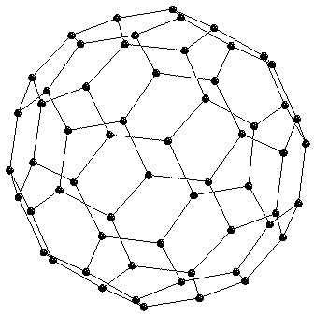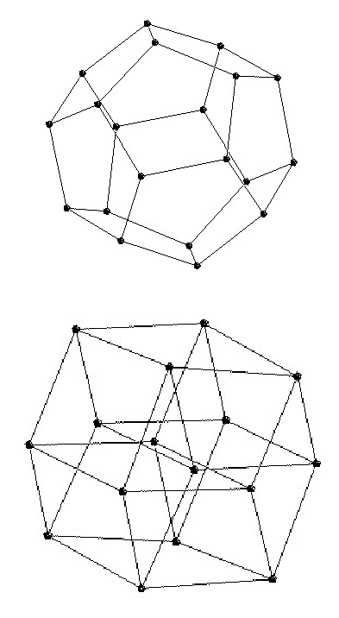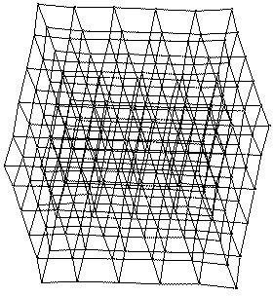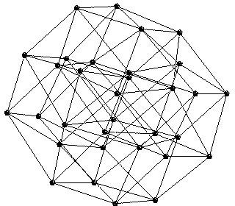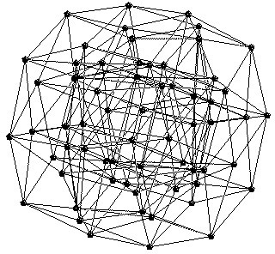

384

*CHAPTER 12.*

*FORCE-DIRECTED DRAWING ALGORITHMS*

Figure 12.1

Examples of drawings obtained with force-directed algorithms. First row:

small graphs: dodecahedron (20 vertices), C60 bucky ball (60 vertices), 3D cube mesh (216

vertices). Second row: Cubes in 4D, 5D and 6D [GK02].

layout for a graph is then calculated by finding a (often local) minimum of this objective

function; see Figure 12.1.

The utility of the basic force-directed approach is limited to small graphs and results are poor for graphs with more than a few hundred vertices. There are multiple reasons why traditional force-directed algorithms do not perform well for large graphs. One of the main obstacles to the scalability of these approaches is the fact that the physical model typically has many local minima. Even with the help of sophisticated mechanisms for avoiding local minima the basic force-directed algorithms are not able to consistently produce good layouts for large graphs. Barycentric methods also do not perform well for large graphs mainly due to resolution problems: for large graphs the minimum vertex separation tends to be very small, leading to unreadable drawings.

The late 1990s saw the emergence of several techniques extending the functionality of force-directed methods to graphs with tens of thousands and even hundreds of thousands of vertices. One common thread in these approaches is the multi-level layout technique, where the graph is represented by a series of progressively simpler structures and laid out in reverse order: from the simplest to the most complex. These structures can be coarser graphs (as in the approach of Hadany and Harel [HH01], Harel and Koren [HK02], and Walshaw [Wal03], or vertex filtrations as in the approach of Gajer, Goodrich, and Kobourov [GGK04].

The classical force-directed algorithms are restricted to calculating a graph layout in Euclidean geometry, typically R2, R3, and, more recently, R*n* for larger values of *n*. There are, however, cases where Euclidean geometry may not be the best option: Certain graphs may be known to have a structure which would be best realized in a different geometry,

*12.2. SPRING SYSTEMS AND ELECTRICAL FORCES*

385

such as on the surface of a sphere or on a torus. In particular, 3D mesh data can be

parameterized on the sphere for texture mapping or graphs of genus one can be embedded on a torus without crossings. Furthermore, it has also been noted that certain non- Euclidean geometries, specifically hyperbolic geometry, have properties that are particularly well suited to the layout and visualization of large classes of graphs [LRP95, Mun97]. With this in mind, Kobourov and Wampler describe extensions of the force-directed algorithms to Riemannian spaces [KW05].

12.2

Spring Systems and Electrical Forces

The 1984 algorithm of Eades [Ead84] targets graphs with up to 30 vertices and uses a

mechanical model to produce “aesthetically pleasing” 2D layouts for plotters and

screens. The algorithm is succinctly summarized as follows:

CRT

*To embed a graph, we replace the vertices by steel rings and replace each edge with a spring to form a mechanical system. The vertices are placed in some initial layout and let go so that the spring forces on the rings move the system to a minimal energy state. Two practical adjustments are made to this idea: firstly, logarithmic strength springs are used; that is, the force exerted by a spring is:*

*c*1 ∗ log(*d/c*2)*,*

*where d is the length of the spring, and c*1 *and c*2 *are constants. Experience*

*shows that Hookes Law (linear) springs are too strong when the vertices are far apart; the logarithmic force solves this problem. Note that the springs exert no force when d* = *c*2*. Secondly, we make nonadjacent vertices repel each other. An inverse square law force,*

*c*3*/d*2*,*

*where c*3 *is constant and d is the distance between the vertices, is suitable. The mechanical system is simulated by the following algorithm.*

*algorithm SPRING(G:graph);*

*place vertices of G in random locations; repeat M times*

*calculate the force on each vertex; move the vertex c*4 ∗ (*force on vertex*)

*draw graph on CRT or plotter.*

*The values c*1 = 2*, c*2 = 1*, c*3 = 1*, c*4 = 0*.*1*, are appropriate for most graphs.*

*Almost all graphs achieve a minimal energy state after the simulation step is run 100 times, that is, M* = 100*.*

This excellent description encapsulates the essence of spring algorithms and their natural

simplicity, elegance, and conceptual intuitiveness. The goals behind “aesthetically pleasing” layouts were initially captured by the two criteria: “all the edge lengths ought to be the same, and the layout should display as much symmetry as possible.”

The 1991 algorithm of Fruchterman and Reingold added “even vertex distribution” to the earlier two criteria and treats vertices in the graph as “atomic particles or celestial bodies,

386

*CHAPTER 12. FORCE-DIRECTED DRAWING ALGORITHMS*

exerting attractive and repulsive forces from one another.” The attractive and repulsive

forces are redefined to

*fa*(*d*) = *d*2*/k,*

*fr*(*d*) = −*k*2*/d,*

in terms of the distance *d* between two vertices and the optimal distance between vertices

*k* defined as

*area*

*k* = *C*

*.*

*number of vertices*

This algorithm is similar to that of Eades in that both algorithms compute attractive

forces between adjacent vertices and repulsive forces between all pairs of vertices. The algorithm of Fruchterman and Reingold adds the notion of “temperature” which could be used as follows: “the temperature could start at an initial value (say one tenth the width of the frame) and decay to 0 in an inverse linear fashion.” The temperature controls the displacement of vertices so that as the layout becomes better, the adjustments become smaller. The use of temperature here is a special case of a general technique called *simulated annealing* , whose use in force-directed algorithms is discussed later in this chapter. The pseudo-code for the algorithm by Fruchterman and Reingold, shown in Figure 12.2 provides further insight into the workings of a spring-embedder.

Each iteration the basic algorithm computes *O*(|*E*|) attractive forces and *O*(|*V* |2) repul-

sive forces. To reduce the quadratic complexity of the repulsive forces, Fruchterman and Reingold suggest using a grid variant of their basic algorithm, where the repulsive forces be- tween distant vertices are ignored. For sparse graphs, and with uniform distribution of the vertices, this method allows a *O*(|*V* |) time approximation to the repulsive forces calculation. This approach can be thought of as a special case of the multi-pole technique introduced in *n*-body simulations [Gre88] whose use in force-directed algorithms will be further discussed later in this chapter.

As in the paper by Eades [Ead84] the graphs considered by Fruchterman and Reingold are small graphs with less than 40 vertices. The number of iterations of the main loop is also similar at 50.

12.3

The Barycentric Method

Historically, Tutte’s 1963 barycentric method [Tut63] is the first “force-directed” algorithm

for obtaining a straight-line, crossings free drawing for a given 3-connected planar graph. Unlike almost all other force-directed methods, Tutte’s guarantees that the resulting draw- ing is crossings-free; moreover, all faces of the drawing are convex.

The idea behind Tutte’s algorithm, shown in Figure 12.3, is that if a face of the planar graph is fixed in the plane, then suitable positions for the remaining vertices can be found by solving a system of linear equations, where each vertex position is represented as a convex combination of the positions of its neighbors. This algorithm be considered a force-directed method as summarized in Di Battista *et al.* [DETT99].

In this model the force due to an edge (*u, v*) is proportional to the distance between vertices *u* and *v* and the springs have ideal length of zero; there are no explicit repulsive forces. Thus the force at a vertex *v* is described by

*F* (*v*) =

(*pu* − *pv*)*,*

(*u,v*)*∈E*

where *pu* and *pv* are the positions of vertices *u* and *v*. As this function has a trivial minimum

with all vertices placed in the same location, the vertex set is partitioned into fixed and free

*12.3. THE BARYCENTRIC METHOD*

387

area:= *W* ∗ *L*; {*W* and *L* are the width and length of the frame}

*G* :=J(*V, E*); {the vertices are assigned random initial positions}

*k* := *area/*|*V* |;

function *fa*(*x*) := begin return *x*2*/k* end; function *fr*(*x*) := begin return *k*2*/x* end; for *i* := 1 to *iterations* do begin

{calculate repulsive forces}

for *v* in *V* do begin

{each vertex has two vectors: *.pos* and *.disp v.disp* := 0;

for *u* in *V* do

if (*u* /= *v*) then begin

{*δ* is the difference vector between the positions of the two vertices}

*δ* := *v.pos* − *u.pos*;

*v.disp* := *v.disp* + (*δ/*|*δ*|) ∗ *fr*(|*δ*|)

end

end

{calculate attractive forces}

for *e* in *E* do begin

{each edges is an ordered pair of vertices *.vand.u*} *δ* := *e.v.pos* − *e.u.pos*;

*e.v.disp* := *e.v.disp* − (*δ/*|*δ*|) ∗ *fa*(|*δ*|);

*e.u.disp* := *e.u.disp* + (*δ/*|*δ*|) ∗ *fa*(|*δ*|)

end

{limit max displacement to temperature *t* and prevent from displacement outside frame}

for *v* in *V* do begin

*v.pos* := *v.pos* + (*v.disp/*|*v.disp*|) ∗ min(*v.disp, t*); *v.pos.x* := min(*W/*2*,* max(−*W/*2*, v.pos.x*));

*v.pos.y* := min(*L/*2*,* max(−*L/*2*, v.pos.y*))

end

{reduce the temperature as the layout approaches a better configuration}

*t* := *cool*(*t*)

end

Figure 12.2 Pseudo-code for the algorithm by Fruchterman and Reingold [FR91].

vertices. Setting the partial derivatives of the force function to zero results in independent

systems of linear equations for the *x*-coordinate and for the *y*-coordinate.

The equations in the for-loop are linear and the number of equations is equal to the number of the unknowns, which in turn is equal to the number of free vertices. Solving these equations results in placing each free vertex at the barycenter of its neighbors. The system of equations can be solved using the Newton-Raphson method. Moreover, the resulting solution is unique.

One significant drawback of this approach is the resulting drawing often has poor vertex resolution. In fact, for every *n >* 1, there exists a graph, such that the barycenter method computes a drawing with exponential area [EG95].

388

*CHAPTER 12. FORCE-DIRECTED DRAWING ALGORITHMS*

Barycenter-Draw

*Input: G* = (*V, E*); a partition *V* = *V*0 ∪ *V*1 of *V* into a set *V*0 of at least three *fixed* vertices and a set *V*1 of *free* vertices; a strictly convex polygon *P* with |*V*0| vertices

*Output:* a position *pv* for each vertex of *V* , such that the fixed vertices form a convex polygon *P* .

1. Place each fixed vertex *u* ∈ *V*0 at a vertex of *P* , and each free vertex at the

origin.

1. repeat

foreach free vertex *v* ∈ *V*1 do

1

*xv* = *deg*(*v*)

*xu*

(*u,v*)*∈E*

1

*yv* = *deg*(*v*)

*yu*

(*u,v*)*∈E*

until *xv* and *yv* converge for all free vertices *v*.

Figure 12.3 Tutte’s barycentric method [Tut63]. Pseudo-code from [DETT99].

12.4

Graph Theoretic Distances Approach

The 1989 algorithm of Kamada and Kawai [KK89] introduced a different way of thinking

about “good” graph layouts. Whereas the algorithms of Eades and Fruchterman-Reingold aim to keep adjacent vertices close to each other while ensuring that vertices are not too close to each other, Kamada and Kawai take graph theoretic approach:

*We regard the desirable geometric (Euclidean) distance between two vertices in*

*the drawing as the graph theoretic distance between them in the corresponding graph.*

In this model, the “perfect” drawing of a graph would be one in which the pair-wise geo-

metric distances between the drawn vertices match the graph theoretic pairwise distances, as computed by an All-Pairs-Shortest-Path computation. As this goal cannot always be achieved for arbitrary graphs in 2D or 3D Euclidean spaces, the approach relies on setting up a spring system in such a way that minimizing the energy of the system corresponds to minimizing the difference between the geometric and graph distances. In this model there are no separate attractive and repulsive forces between pairs of vertices, but instead if a pair of vertices is (geometrically) closer/farther than their corresponding graph distance the vertices repel/attract each other. Let *di,j* denote the shortest path distance between vertex *i* and vertex *j* in the graph. Then *li,j* = *L* × *di,j* is the ideal length of a spring between vertices *i* and *j*, where *L* is the desirable length of a single edge in the display. Kamada

*12.5. FURTHER SPRING REFINEMENTS*

389

and Kawai suggest that *L* = *L*0*/* max*i<j di,j*, where *L*0 is the length of a side of the display

area and

max*i<j di,j*

is the diameter of the graph, i.e., the distance between the farthest

pair of vertices. The strength of the spring between vertices *i* and *j* is defined as

*ki,j* = *K/d*2 *,*

*i,j*

where *K* is a constant. Treating the drawing problem as localizing |*V* | = *n* particles

*p*1*, p*2*, . . . , pn* in 2D Euclidean space, leads to the following overall energy function:

*n −*1 *n*

1

2

*ki,j*(|*pi* − *pj*| − *li,j*)2*.*

*E* =

*i*=1 *j*=*i*+1

The coordinates of a particle *pi* in the 2D Euclidean plane are given by *xi* and *yi* which

allows us to rewrite the energy function as follows:

*n −*1 *n*

1

2

(*xi* − *xj*)2 + (*yi* − *yj*)2 + *l*2 − 2*li,j* (*xi* − *xj*)2 + (*yi* − *yj*)2 *.*

*E* =

*ki,j*

*i,j*

*i*=1 *j*=*i*+1

The goal of the algorithm is to find values for the variables that minimize the energy

function *E*(*x*1*, x*2*, . . . , xn, y*1*, y*2*, . . . , yn*). In particular, at a local minimum all the partial derivatives are equal to zero, and which corresponds to solving 2*n* simultaneous non-linear equations. Therefore, Kamada and Kawai compute a stable position one particle *pm* at a time. Viewing *E* as a function of only *xm* and *ym* a minimum of *E* can be computed using the Newton-Raphson method. At each step of the algorithm the particle *pm* with the largest value of ∆*m* is chosen, where

2

2

*∂E*

*∂E*

∆*m* =

+

*.*

*∂x*

*∂y*

*m*

*m*

Pseudo-code for the algorithm by Kamada and Kawai is shown in Figure 12.4.

The algorithm of Kamada and Kawai is computationally expensive, requiring an All-Pair- Shortest-Path computation which can be done in *O*(|*V* |3)time using the Floyd-Warshall al- gorithm or in *O*(|*V* |2 log |*V* |+|*E*||*V* |) using Johnson’s algorithm; see the All-Pairs-Shortest- Path chapter in an algorithms textbook such as [CLRS90]. Furthermore, the algorithm requires *O*(|*V* |2) storage for the pairwise vertex distances. Despite the higher time and space complexity, the algorithm contributes a simple and intuitive definition of a “good” graph layout: A graph layout is good if the geometric distances between vertices closely correspond to the underlying graph distances.

12.5

Further Spring Refinements

Even before the 1984 algorithm of Eades, force-directed techniques were used in the context

of VLSI layouts in the 1960s and 1970s [FCW67, QB79]. Yet, renewed interest in force- directed graph layout algorithms brought forth many new ideas in the 1990s. Frick, Ludwig, and Mehldau [FLM95] add new heuristics to the Fruchterman-Reingold approach. In par- ticular, oscillation and rotations are detected and dealt with using local instead of global temperature. The following year Bruß and Frick [BF96] extended the approach to layouts directly in 3D Euclidean space. The algorithm of Cohen [Coh97] introduced the notion of an incremental layout, a precursor of the multi-scale methods described in Section 12.6.

390

*CHAPTER 12. FORCE-DIRECTED DRAWING ALGORITHMS*

compute *di,j* for 1 ≤ *i* /= *j* ≤ *n*;

compute *li,j* for 1 ≤ *i* /= *j* ≤ *n*; compute *ki,j* for 1 ≤ *i* /= *j* ≤ *n*; initialize *p*1*, p*2*, . . . , pn*;

while (*maxi*∆*i > ǫ*)

let *pm* be the particle satisfying ∆*m* = *maxi*∆*i*;

while (∆*m > ǫ*)

compute *δx* and *δy* by solving the following system of equations:

*∂*2*E*

*∂*2*E*

*∂E*

(*t*) (*t*)

(*t*) (*t*)

(*t*) (*t*)

(*xm , ym* )*δx* + *∂x*

(*xm , ym* )*δy* = − *∂x* (*xm , ym* );

*∂x*2

*∂y*

*m m*

*m*

*m*

*∂*2*E*

*∂*2*E*

*∂E*

(*t*) (*t*)

(*t*) (*t*)

(*t*) (*t*)

(*x , y* )*δx* + (*xm , ym* )*δy* = − *∂y* (*xm , ym* )

*m m*

2

*∂y ∂x*

*∂y*

*m m*

*m*

*m*

*xm* := *xm* + *δx*;

*ym* := *ym* + *δy*;

Figure 12.4 Pseudo-code for the algorithm by Kamada and Kawai [KK89].

The 1997 algorithm of Davidson and Harel [DH96] adds additional constraints to the

traditional force-directed approach in explicitly aiming to minimize the number of edge- crossings and keeping vertices from getting too close to non-adjacent edges. The algo- rithm uses the simulated annealing technique developed for large combinatorial optimiza- tion [KGV83]. Simulated annealing is motivated by the physical process of cooling molten materials. When molten steel is cooled too quickly it cracks and forms bubbles making it brittle. For better results, the steel must be cooled slowly and evenly and this process is known as annealing in metallurgy. With regard to force-directed algorithms, this process is simulated to find local minima of the energy function. Cruz and Twarog [CT96] extended the method by Davidson and Harel to three-dimensional drawings.

Genetic algorithms for force-directed placement have also been considered. Genetic al- gorithms are a commonly used search technique for finding approximate solutions to opti- mization and search problems. The technique is inspired by evolutionary biology in general and by inheritance, mutation, natural selection, and recombination (or crossover), in par- ticular; see the survey by Vose [Vos99]. In the context of force-directed techniques for graph drawing, the genetic algorithms approach was introduced in 1991 by Kosak, Marks and Shieber [KMS91]. Other notable approaches in the direction include that of Branke, Bucher, and Schmeck [BBS97].

In the context of graph clustering, the *LinLog* model introduces an alternative energy model [Noa07]. Traditional energy models enforce small and uniform edge lengths, which often prevent the separation of nodes in different clusters. As a side effect, they tend to group nodes with large degree in the center of the layout, where their distance to the remaining nodes is relatively small. The node-repulsion LinLog and edge- repulsion LinLog models group nodes according to two well-known clustering criteria: the density of the cut [LR88] and the normalized cut [SM00].

*12.6. LARGE GRAPHS*

391

12.6

Large Graphs

The first force-directed algorithms to produce good layouts for graphs with more than 1000

vertices is the 1999 algorithm of Hadany and Harel [HH01]. They introduced the multi- scale technique as a way to deal with large graphs and in the following year four related but independent force-directed algorithms for large graphs were presented at the Annual Symposium on Graph Drawing. We begin with Hadany and Harel’s description on the *multi-scale method* :

*A natural strategy for drawing a graph nicely is to first consider an abstraction,*

*disregarding some of the graph’s fine details. This abstraction is then drawn, yielding a “rough” layout in which only the general structure is revealed. Then the details are added and the layout is corrected. To employ such a strategy it is crucial that the abstraction retains essential features of the graph. Thus, one has to define the notion of coarse-scale representations of a graph, in which the combinatorial structure is significantly simplified but features important for visualization are well preserved. The drawing process will then “travel” between these representations, and introduce multi-scale corrections. Assuming we have already defined the multiple levels of coarsening, the general structure of our strategy is as follows:*

1. *Perform* fine-scale *relocations of vertices that yield a locally organized con- figuration.*
2. *Perform* coarse-scale *relocations (through local relocations in the coarse rep- resentations), correcting global disorders not found in stage 1.*
3. *Perform* fine-scale *relocations that correct local disorders introduced by stage 2.*

Hadany and Harel suggest computing the sequence of graphs by using edge contractions

so as to preserve certain properties of the graph. In particular, the goal is to preserve three topological properties: cluster size, vertex degrees, and homotopy. For the coarse-scale relocations, the energy function for each graph in the sequence is that of Kamada and Kawai (the pairwise graph distances are compared to the geometric distances in the current layout). For the fine-scale relocations, the authors suggest using force-directed calculations as those of Eades [Ead84], Fruchterman-Reingold [FR91], or Kamada-Kawai [KK89]. While the asymptotic complexity of this algorithm is similar to that of the Kamada-Kawai algorithm, the multi-scale approach leads to good layouts for much larger graphs in reasonable time.

The algorithm of Harel and Koren [HK02] took force-directed algorithms to graphs with 15,000 vertices. This algorithm is similar to the algorithm of Hadany and Harel, yet uses a simpler coarsening process based on a *k*-centers approximation, and a faster fine-scale beautification. Given a graph *G* = (*V, E*), the *k*-centers problem asks to find a subset of the vertex set *V ′* ⊆ *V* of size *k*, so as to minimize the maximum distance from a vertex to

*V ′*: min *u* ∈ *V* max*u∈V,v∈V* ′ *dist*(*u, v*). While *k*-centers is an NP-hard problem, Harel and

Koren use a straightforward and efficient 2-approximation algorithm that relies on Breadth- First Search [Hoc96]. The fine-scale vertex relocations are done using the Kamada-Kawai approach. The Harel and Koren algorithm is summarized in Figure 12.5.

392

*CHAPTER 12. FORCE-DIRECTED DRAWING ALGORITHMS*

Layout(*G*(*V, E*))

% Goal: Find *L*, a nice layout of *G*

% Constants:

% Rad[= 7] – determines radius of local neighborhoods

% Iterations[= 4] – determines number of iterations in local beautification

% Ratio[= 3] – ratio between number of vertices in two consecutive levels

% MinSize[= 10] – size of the coarsest graph

Compute the all-pairs shortest path length:

Set up a random layout *L k* ← *MinSize*

while *k* ≤ |*V* | do

*centers* ←K-Centers(*G*(*V, E*)*, k*)

*dV V*

*radius* = max*v∈centers* min*u∈centers*{*dvu*} ∗ *Rad*

LocalLayout(*dcenters×centers, L*(*centers*)*, radius, Iterations*)

for every *v* ∈ *V* do

*L*(*v*) ∈ *L*(*center*(*v*)) + *rand k* ← *kRatio*

return *L*

K-Centers(*G*(*V, E*)*, k*)

% Goal: Find a set *S* ⊆ *V* of size *k*, such that max*v∈V* min*s∈S*{*dsv*} minimized.

*S* ← {*v*} for some arbitrary *v* ∈ *V*

for *i* = 2 to *k* do

1. Find the vertex u farthest away from *S*

(i.e., such that min*s∈S*{*dus*} ≥ min*s∈S*{*dws*}*,* ∀*w* ∈ *V* )

2. *S* ← *S* ∪ {*u*}

return *S*

is

LocalLayout(*dV ×V , L, k, Iterations*)

% Goal: Find a locally nice layout *L* by beautifying *k*-neighborhoods

% *dV ×V*

: all-pairs shortest path length

% *L*: initialized layout

% *k*: radius of neighborhoods

for *i* = 1 to *Iterations* ∗ |*V* | do

1. Choose the vertex *v* with the maximal ∆*k*

*v*

2. Compute *δk* as in Kamada-Kawai

*v*

3. *L*(*v*) ← *L*(*v*) + (*δk*(*x*)*, δk*(*y*))

*v v*

end

Figure 12.5 Pseudo-code for the algorithm by Harel and Koren [HK02].

*12.6. LARGE GRAPHS*

393

Main Algorithm

create a filtration V : *V*0 ⊃ *V*1 ⊃ *. . .* ⊃ *Vk* ⊃ ∅

for *i* = *k* to 0 do

for each *v* ∈ *Vi* − *Vi*+1 do

find vertex neighborhood *Ni*(*v*)*, Ni−*1(*v*)*, . . . , N*0(*v*) find initial position *pos*[*v*] of *v*

repeat *rounds* times

for each *v* ∈ *Vi* do

compute local temperature *heat*[*v*]

−→

*disp*[*v*] ← *heat*[*v*] · *FNi* (*v*)

for each *v* ∈ *Vi* do

*pos*[*v*] ← *pos*[*v*] + *disp*[*v*] add all edges *e* ∈ *E*

Figure 12.6 Pseudo-code for the algorithm by Gajer *et al.* [GGK04].

The 2000 algorithm of Gajer *et al.* [GGK04], shown in Figure 12.6, is also a multi-

scale force-directed algorithm but introduces several ideas to the realm of multi-scale force- directed algorithms for large graphs. Most importantly, this approach avoids the quadratic space and time complexity of previous force-directed approaches with the help of a simpler coarsening strategy. Instead of computing a series of coarser graphs from the given large

graph *G* = (*V, E*), Gajer *et al.* produce a *vertex filtration* V :

*V*0 ⊃ *V*1 ⊃ *. . .* ⊃ *Vk* ⊃ ∅,

where *V*0 = *V* (*G*) is the original vertex set of the given graph *G*. By restricting the number

of vertices considered in relocating any particular vertex in the filtration and ensuring that the filtration has *O*(log |*V* |) levels an overall running time of *O*(|*V* | log2 |*V* |) is achieved. Filtrations based on graph centers (as in Harel and Koren [HK02]) and maximal independent sets are considered. *V* = *V*0 ⊃ *V*1 ⊃ *. . .* ⊃ *Vk* ⊃ ∅, is a maximal independent set filtration of *G* if *Vi* is a maximal subset of *Vi−*1 for which the graph distance between any pair of its elements is greater than or equal to 2*i*.

In the GRIP system [GK02], Gajer *et al.* add to the filtration and neighborhood cal- culations of [GGK04]: they introduce the idea of realizing the graph in high-dimensional Euclidean space and obtaining 2D or 3D projections at the end. The algorithm also relies on intelligent initial placement of vertices based on graph theoretic distances, rather than on random initial placement. Finally, the notion of cooling is re-introduced in the context of multi-scale force-directed algorithms. The GRIP system produces high-quality layouts, as illustrated in Figure 12.7.

Another multilevel algorithm is that of Walshaw [Wal03]. Instead of relying on the Kamada-Kawai type force interactions, this algorithm extends the grid variant of Fruchterman- Reingold to a multilevel algorithm. The coarsening step is based on repeatedly collaps- ing maximally independent sets of edges, and the fine-scale refinements are based on Fruchterman-Reingold force calculations. This *O*(|*V* |2) algorithm is summarized in Fig- ure 12.8.

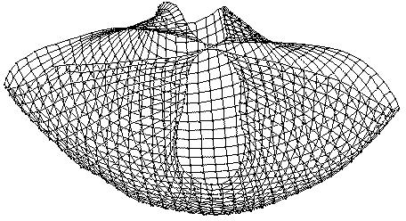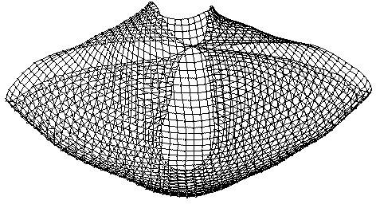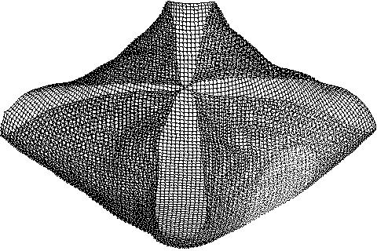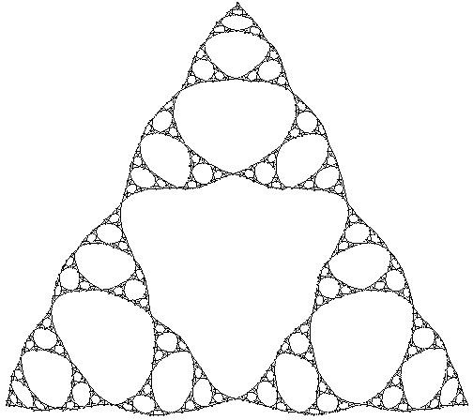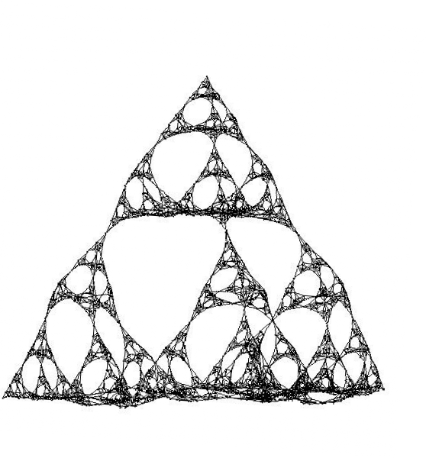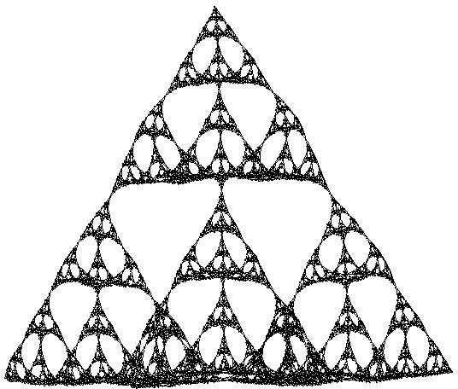

394

*CHAPTER 12. FORCE-DIRECTED DRAWING ALGORITHMS*

The fourth 2000 multilevel force-directed algorithm is due to Quigley and Eades [QE00].

This algorithm relies on the Barnes-Hut *n*-body simulation method [BH86] and reduces repulsive force calculations to *O*(|*V* | log |*V* |) time instead of the usual *O*(|*V* |2). Similarly, the algorithm of Hu [Hu05] combines the multilevel approach with the *n*-bosy simulation method, and is implemented in the sfdp drawing engine of GraphViz [EGK+01].

One possible drawback to this approach is that the running time depends on the distribu- tion of the vertices. Hachul and Ju¨nger [HJ04] address this problem in their 2004 multilevel algorithm.

Figure 12.7

Drawings from GRIP. First row: knotted meshes of 1600, 2500, and 10000

vertices. Second row: Sierpinski graphs of order 7 (1,095 vertices), order 6 (2,050 vertices),

3D Sierpinski of order 7 (8,194 vertices) [GK02].

*12.6. LARGE GRAPHS*

395

function *fg*(*x, w*):=begin return −*Cwk*2*/x* end

function *fl*(*x, d, w*):=begin return {(*x* − *k*)*/d*} − *fg*(*x, w*) end

*t* := *t*0;

*Posn* := *NewPosn*;

while (*converged* /= 1) begin

converged :=1;

for *v* ∈ *V* begin

*OldPosn*[*v*] = *NewPosn*[*v*]

end

for *v* ∈ *V* begin

{initialize *D*, the vector of displacements of *v*} *D* := 0;

{calculate global (repulsive) forces}

for *u* ∈ *V, u* /= *v* begin

∆ := *Posn*[*u*] − *Posn*[*v*];

*D* := *D* + (∆*/*|*Delta*|) ∗ *fg*(|∆|*,* |*u*|);

end

{calculate local (spring) forces }

for *u* ∈ Γ(*v*) begin

∆ := *Posn*[*u*] − *Posn*[*v*];

*D* := *D* + (∆*/*|*Delta*|) ∗ *fl*(|∆|*,* |Γ(*v*)|*,* |*u*|);

end

{reposition *v*}

*NewPosn*[*v*] = *NewPosn*[*v*] + (*D/*|*D*|) ∗ min(*t,* |*D*|);

∆ := *NewPosn*[*v*] − *OldPosn*[*v*];

if (|∆| *> k* × *tol*)*converged* := 0;

end

{reduce the temperature to reduce the maximum movement}

*t* := *cool*(*t*);

end

Figure 12.8 Pseudo-code for the algorithm by Walshaw [Wal03].

396

*CHAPTER 12. FORCE-DIRECTED DRAWING ALGORITHMS*

12.7

Stress Majorization

Methods that exploit fast algebraic operations offer another practical way to deal with

large graphs. *Stress minimization* has been proposed and implemented in the more general setting of multidimensional scaling (MDS) [Kru64]. The function describing the stress is similar to the layout energy function of Kamada-Kawai from Section 12.4:

*n −*1 *n*

1

2

*ki,j*(|*pi* − *pj*| − *li,j*)2*,*

*E* =

*i*=1 *j*=*i*+1

but here *ki,j*=1 and = is simply the graph theoretic distance. In their paper on

graph drawing by stress minimization Gansner *et al.* [GKN04] point out that this particular

*li,j di,j*

formulation of the energy of the layout, or *stress function* has been already used to draw

graphs as early as in 1980 [KS80]. What makes this particular stress function relevant to drawing large graphs is that it can be optimized better than with the local Newton-Raphson method or with gradient descent. Specifically, this stress function can be globally minimized via *majorization*. That is, unlike the energy function of Kamada-Kawai, the classical MDS stress function can be optimized via majorization which is guaranteed to converge.

The *strain* model, or classical scaling, is related to the stress model. In this setting a solution can be obtained via an eigen-decomposition of the adjacency matrix. Solving the full stress or strain model still requires computing all pairs shortest paths. Significant savings can be gained if we instead compute a good approximation. In PivotMDS Brandes and Pich [BP06] show that replacing the all-pairs-shortest path computation with a distance calculations from a few vertices in the graph is often sufficient, especially if combined with a solution to a sparse stress model.

When not all nodes are free to move, *constrained stress majorization* can be used to support additional constraints by, and treating the majorizing functions as a quadratic program [DKM09]. Planar graphs are of particular interest in graph drawing, and often force-directed graph drawing algorithms are used to draw them. While in theory any planar graph has a straight-line crossings-free drawing in the plane, force-directed algorithms do not guarantee such drawings.

Modifications to the basic force-directed functionality, with the aim of improving the lay- out quality for planar graphs, have also been considered. Harel and Sardas [HS98] improve an earlier simulated annealing drawing algorithm by Davidson and Harel [DH96]. The main idea is to obtain an initial plane embedding and then apply simulated annealing while not introducing any crossings. Overall their method significantly improved the aesthetic quality of the initial planar layouts, but at the expense of a significant increase in running time of *O*(*n*3), making it practical only for small graphs.

PrEd [Ber00] and ImPrEd [PSA11] are force-directed algorithms that improve already created drawings of a graph. PrEd [Ber00] extends the method of Fruchterman and Rein- gold [FR91] and can be used as a post-processing crossings-preserving optimization. In particular, PrEd takes some straight-line drawing as input and guarantees that no new edge crossings will be created (while preserving existing crossings, if any are present in the input drawing). Then the algorithm can be used to optimize a planar layout, while preserv- ing its planarity and its embedding, or to improve a graph that has a meaningful initial set of edge crossings. To achieve this result, PrEd adds a phase where the maximal movement of each node is computed, and adds a repulsive force between (node, edge) pairs. The main aims of ImPrEd [PSA11] are to significantly reduce the running time of PrEd, achieve high aesthetics even for large and sparse graphs, and make the algorithm more stable and reliable

*12.8. NON-EUCLIDEAN APPROACHES*

397

with respect to the input parameters. This is achieved via improved spacing of the graph

elements and an accelerated convergence of the drawing to its final configuration.

An alternative approach for modifying force-directed functionality is to use a prepro- cessing step rather than a random layout to initialize the algorithm. Experimental results indicate that combining a linear-time planar embedding step with a standard force-directed algorithm such as a Fruchterman-Reingold can lead to improved qualitative and quantitative results [FK12].

12.8

Non-Euclidean Approaches

Much of the work on non-Euclidean graph drawing has been done in hyperbolic space which

offers certain advantages over Euclidean space; see Munzner [Mun97, MB96]. For example, in hyperbolic space it is possible to compute a layout for a complete tree with both uniform edge lengths and uniform distribution of nodes. Furthermore, some of the embeddings of hyperbolic space into Euclidean space naturally provide a fish-eye view of the space, which is useful for “focus+context” visualization, as shown by Lamping *et al.* [LRP95]. From a visualization point of view, spherical space offers a way to present a graph in a center- free and periphery-free fashion. That is, in traditional drawings in R2 there is an implicit assumption that nodes in the center are important, while nodes on the periphery are less important. This can be avoided in space, where any part of the graph can become the center of the layout. The early approaches for calculating the layouts of graphs in hyperbolic space, however, are either restricted by their nature to the layout of trees and tree-like graphs, or to layouts on a lattice.

The hyperbolic tree layout algorithms function on the principle of hyperbolic sphere packing, and operate by making each node of a tree, starting with the root, the center of a sphere in hyperbolic space. The children of this node are then given positions on the surface of this sphere and the process recurses on these children. By carefully computing the radii of these spheres it is possible to create aesthetically pleasing layouts for the given tree.

Although some applications calculate the layout of a general graph using this method, the layout is calculated using a spanning tree of the graph and the extra edges are then added in without altering the layout [Mun98]. This method works well for tree-like and quasi- hierarchical graphs, or for graphs where domain-specific knowledge provides a way to create a meaningful spanning tree. However, for general graphs (e.g., bipartite or densely connected graphs) and without relying on domain specific knowledge, the tree-based approach may result in poor layouts.

Methods for generalizing Euclidean geometric algorithms to hyperbolic space, although not directly related to graph drawing, have also been studied. Recently, van Wijk and Nuij [vWN04] proposed a Poincar´e’s half-plane projection to define a model for 2D viewing and navigation. Eppstein [Epp03] shows that many algorithms that operate in Euclidean space can be extended to hyperbolic space by exploiting the properties of a Euclidean model of the space, such as the Beltrami-Klein or Poincar´e.

Hyperbolic and spherical space have also been used to display self-organizing maps in the context of data visualization. Ontrup and Ritter [OR01] and Ritter [Rit99] extend the traditional use of a regular (Euclidean) grid, on which the self-organizing map is created, with a tessellation in spherical or hyperbolic space. An iterative process is then used to adjust which elements in the data-set are represented by the intersections. Although the hyperbolic space method seems to be a promising way to display high-dimensional data-sets, the restriction to a lattice is often undesirable for graph visualization.

S2

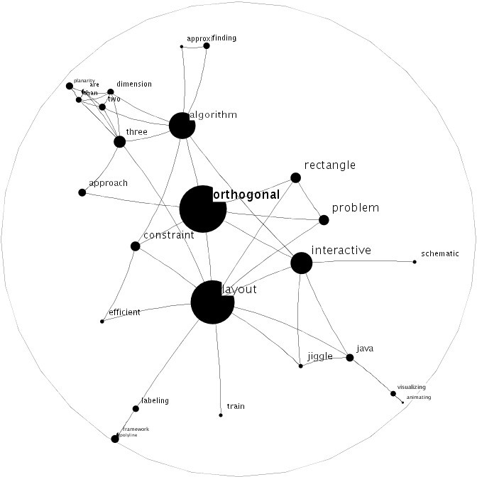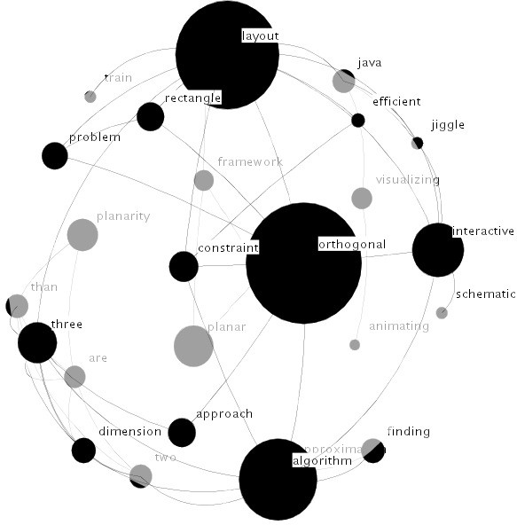

398

*CHAPTER 12. FORCE-DIRECTED DRAWING ALGORITHMS*

Figure 12.9 Layouts of a graph obtained from research papers’ titles in hyperbolic space

H2 and in spherical space S2 [KW05].

Ostry [Ost96] considers constraining force-directed algorithms to the surface of three-

dimensional objects. This work is based on a differential equation formulation of the motion of the nodes in the graph, and is flexible in that it allows a layout on almost any object, even multiple objects. Since the force calculations are made in Euclidean space, however, this method is inapplicable to certain geometries (e.g., hyperbolic geometry).

Another example of graph embedding within a non-Euclidean geometry is described in the context of generating spherical parameterizations of 3D meshes. Gotsman *et al.* [GGS03] describe a method for producing such an embedding using a generalization to spherical space of planar methods for expressing convex combinations of points. The implementation of the procedure is similar to the method described in this paper, but it may not lend itself to geometries other than spherical.

Kobourov and Wampler [KW05] describe a conceptually simple approach to generalizing force-directed methods for graph layout from Euclidean geometry to Riemannian geome- tries. Unlike previous work on non-Euclidean force-directed methods, this approach is not limited to special classes of graphs but can be applied to arbitrary graphs; see Fig- ure 12.9. The method relies on extending the Euclidean notions of distance, angle, and force-interactions to smooth non-Euclidean geometries via projections to and from appro- priately chosen tangent spaces. Formal description of the calculations needed to extend such algorithms to hyperbolic and spherical geometries are also detailed.

In 1894 Riemann described a generalization of the geometry of surfaces, which had been studied earlier by Gauss, Bolyai, and Lobachevsky. Two well-known special cases of Rie- mannian geometries are the two standard non-Euclidean types, spherical geometry and hyperbolic geometry. This generalization led to the modern concept of a Riemannian man- ifold. Riemannian geometries have less convenient structure than Euclidean geometry, but they do retain many of the characteristics which are useful for force-directed graph layouts. A Riemannian manifold *M* has the property that for every point *x* ∈ *M* , the tangent space *TxM* is an inner product space. This means that for every point on the manifold, it is possible to define local notions of length and angle.

*12.8. NON-EUCLIDEAN APPROACHES*

399

Using the local notions of length we can define the length of a continuous curve *γ* : [*a, b*] →

*M* by

-

*b*

*length*(*γ*) = ||*γ′*(*t*)||*dt.*

*a*

This leads to a natural generalization of the concept of a straight line to that of a *geodesic*, where the geodesic between two points *u, v* ∈ *M* is defined as a continuously differentiable curve of minimal length between them. These geodesics in Euclidean geometry are straight

lines, and in spherical geometry they are arcs of great circles.

We can similarly define the distance between two points, *d*(*x, y*) as the length of a geodesic between them. In Euclidean space the relationship between a pair of nodes is defined along lines: the distance between the two nodes is the length of the line segment between them and forces between the two nodes act along the line through them. These notions of distance and forces can be extended to a Riemannian geometry by having these same relationships be defined in terms of the geodesics of the geometry, rather than in terms of Euclidean lines. As Riemannian manifolds have a well-structured tangent space at every point, these tan- gent spaces can be used to generalize spring embedders to arbitrary Riemannian geometries. In particular, the tangent space is useful in dealing with the interaction between one point and several other points in non-Euclidean geometries. Consider three points *x*, *y*, and *z* in a Riemannian manifold *M* where there is an attractive force from *x* to *y* and *z*. As can be easily seen in the Euclidean case (but also true in general) the net force on *x* is not necessarily in the direction of *y* or *z*, and thus the natural motion of *x* is along neither the geodesic toward *y*, nor that toward *z*. Determining the direction in which *x* should move

requires the notion of angle.

Since the tangent space at *x*, being an inner product space, has enough structure to define lengths and angles, we do the computations for calculating the forces on *x* in *TxM* . In order to do this, we define two functions for every point *x* ∈ *M* as follows:

*τx* : *M* → *TxM*

*τ−*1 : *TxM* → *M*

*x*

These two functions map points in *M* to and from the tangent space of *M* at *x*, respec-

tively. We require that *τx* and *τ−*1 satisfy the following constraints:

*x*

1. *τ−*1(*τx*(*y*)) = *y* for all *y* ∈ *M*

*x*

2. ||*τx*(*y*)|| = *d*(*x, y*)

3. *τx* preserves angles about the origin

Using these functions it is now easy to define the way in which the nodes of a given

graph *G* = (*V, E*) interact with each other through forces. In the general framework for this algorithm each node is considered individually, and its new position is calculated based on the relative locations of the other nodes in the graph (repulsive forces) and on its adjacent edges (attractive forces). Then we obtain pseudo-code for a traditional Euclidean spring embedder and its corresponding non-Euclidean counterpart, as shown in Figure 12.10.

400

*CHAPTER 12. FORCE-DIRECTED DRAWING ALGORITHMS*

generic algorithm(*G*)

while not done do foreach *n* ∈ *G* do

position[*n*] := force directed placement(*n*, *G*)

end

non Euclidean algorithm(*G*)

while not done do foreach *n* ∈ *G* do

*x* := position[*n*]

*G′* := *τx*(*G*)

*x′* := force directed placement(*n*, *G′*)

position[*n*] := *τ−*1(*x′*)

*x*

end end

Figure 12.10 Pseudo-code for a traditional Euclidean spring embedder and its corre- sponding non-Euclidean counterpart.

12.9

Lombardi Spring Embedders

Inspired by American graphic artist Mark Lombardi, Duncan *et al.* [DEG+10a, DEG+10b] introduce the concept of a *Lombardi drawing* , which is a drawing that uses circular arcs for edges and achieves the maximum (i.e., *perfect*) amount of angular resolution possible at each vertex.

There are several force-directed graph drawing methods that use circular-arc edges or curvilinear poly-edges. Brandes and Wagner [BW00] describe a force-directed method for drawing train connections, where the vertex positions are fixed but transitive edges are drawn as B´ezier curves. Finkel and Tamassia [FT05], on the other hand, describe a force- directed method for drawing graphs using curvilinear edges where vertex positions are free to move. Their method is based on adding dummy vertices that serve as control points for B´ezier curve.

Chernobelskyi *et al.* [CCG+11] describe two force-directed algorithms for *Lombardi-style* (or *near-Lombardi* ) drawings of graphs, where edges are drawn using circular arcs with the goal of maximizing the angular resolution at each vertex. The first approach calculates lateral and rotational forces based on the two tangents defining a circular arc between two vertices. In contrast, the second approach uses dummy vertices on each edge with repulsive forces to “push out” the circular arcs representing edges, so as to provide an aesthetic “balance”. Another distinction between the two approaches is that the first one lays out the vertex positions along with the circular edges, while the second one works on graphs that are already laid out, only modifying the edges. It can be argued that Lombardi or near-Lombardi graph drawings have a certain aesthetic appeal as has been shown in recent empirical experiments [PHNK12]; see Fig. 12.11. However, another recent experimental paper on curve-based drawings [XRP+12] seems to suggest that straight-line drawings have better readability.

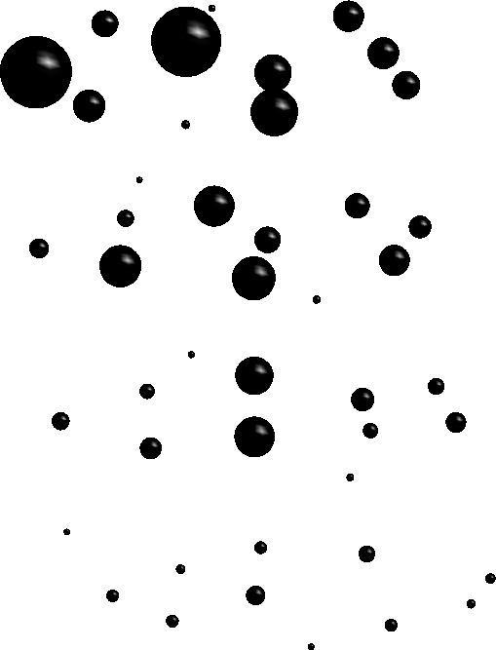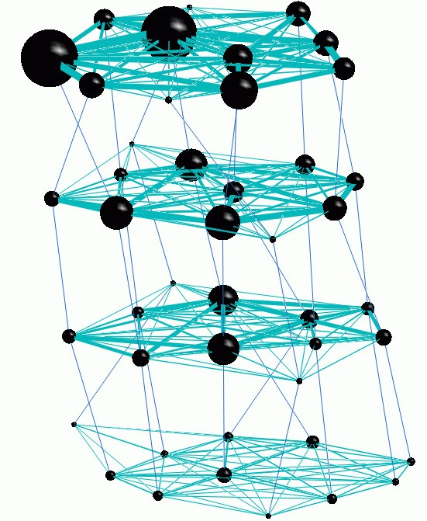

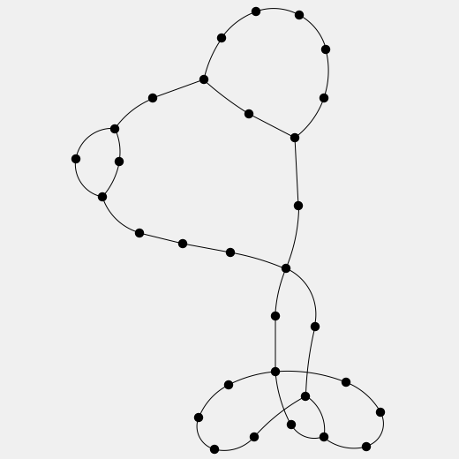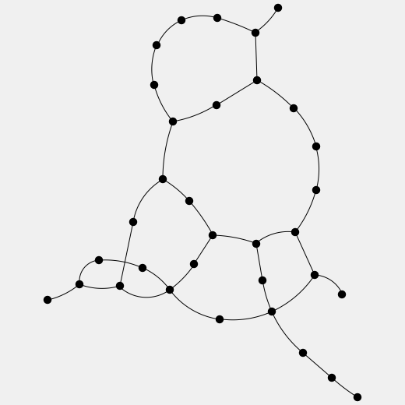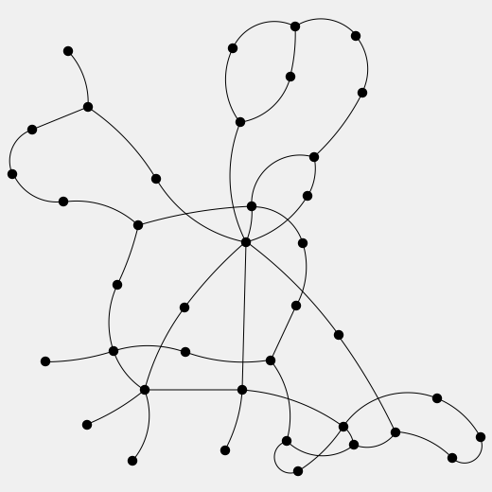

*12.10. DYNAMIC GRAPH DRAWING*

401

Figure 12.11 Examples of force-directed Lombardi drawings: note that every edge is a circular arc and every vertex has perfect angular resolution [CCG+11].

12.10

Dynamic Graph Drawing

While static graphs arise in many applications, dynamic processes give rise to graphs that

evolve through time. Such dynamic processes can be found in software engineering, telecom- munications traffic, computational biology, and social networks, among others.

Thus, dynamic graph drawing deals with the problem of effectively presenting relation- ships as they change over time. A related problem is that of visualizing multiple relationships on the same dataset. Traditionally, dynamic relational data is visualized with the help of graphs, in which vertices and edges fade in and out as needed, or as a time-series of graphs; see Figure 12.12.

Figure 12.12 A dynamic graph can be interpreted as a larger graph made of connecting graphs in adjacent timeslices [EHK+04].

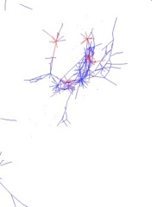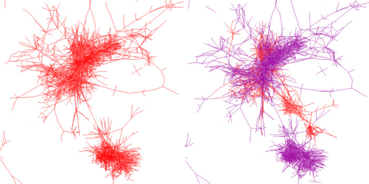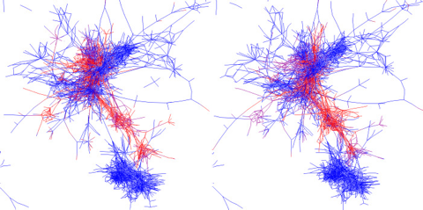

402

*CHAPTER 12. FORCE-DIRECTED DRAWING ALGORITHMS*

The input to this problem is a series of graphs defined on the same underlying set

of vertices. As a consequence, nearly all existing approaches to visualization of evolv- ing and dynamic graphs are based on the force-directed method. Early work can be dated back to North’s DynaDAG [Nor96], where the graph is not given all at once, but incrementally. Brandes and Wagner adapt the force-directed model to dynamic graphs using a Bayesian framework [Brandes and Wagner 1998]. Diehl and G¨org [DG02] con- sider graphs in a sequence to create smoother transitions. Special classes of graphs such as trees, series-parallel graphs and st-graphs have also been studied in dynamic mod- els [CDTT95, CBT+92, Moe90]. Most of these early approaches, however, are limited to special classes of graphs and usually do not scale to graphs over a few hundred vertices.

TGRIP was one of the first practical tools that could handle the larger graphs that appear in the real-world. It was developed as part of a system that keeps track of the evolution of software by extracting information about the program stored within a CVS version control system [CKN+03]. Such tools allow programmers to understand the evolution of a legacy program: Why is the program structured the way it is? Which programmers were responsi- ble for which parts of the program during which time periods? Which parts of the program appear unstable over long periods of time? TGRIP was used to visualize inheritance graphs, program call-graphs, and control-flow graphs, as they evolve over time; see Fig. 12.13.

For layout of evolving and dynamic graphs, there are two important criteria to con- sider:

1. *readability* of the individual layouts, which depends on aesthetic criteria such as

display of symmetries, uniform edge lengths, and minimal number of crossings; and

1. *mental map preservation* in the series of layouts, which can be achieved by en- suring that vertices and edges that appear in consecutive graphs in the series, remain in the same location.

These two criteria are often contradictory. If we obtain individual layouts for each graph,

without regard to other graphs in the series, we may optimize readability at the expense of mental map preservation. Conversely, if we fix the common vertices and edges in all graphs once and for all, we are optimizing the mental map preservation yet the individual layouts may be far from readable. Thus, we can measure the effectiveness of various approaches for visualization of evolving and dynamic graphs by measuring the readability of the individual layouts, and the overall mental map preservation.

Figure 12.13

Snapshots of the call-graph of a program as it evolves through time,

extracted from CVS logs. Vertices start out red. As time passes and a vertex does not

change it turns purple and finally blue. When another change is affected, the vertex again becomes red. Note the number of changes between the two large clusters and the break in the build on the last image [CKN+03].

*12.11. CONCLUSION*

403

Dynamic graphs can be visualized with *aggregated views*, where all the graphs are dis-

played at once, *merged views*, where all the graphs are stacked above each other, and with *animations*, where only one graph is shown at a time, and morphing is used when chang- ing between graphs (fading in/out vertices and edges that appear/disappear). When using the animation/morphing approach, it is possible to change the balance between readabil- ity of individual graphs and the overall mental map preservation, as in the system for Graph Animations with Evolving Layouts, GraphAEL [EHK+03, FKN+04]. Applications of this framework include visualizing software evolution [CKN+03], social networks analy- sis [MB09], and the behavior of dynamically modifiable code [DID+05].

12.11

Conclusion

Force-directed algorithms for drawing graphs have a long history and new variants are still

introduced every year. Their intuitive simplicity appeals to researchers from many different fields, and this accounts for dozens of available implementations. As new relational data sets continue to be generated in many applications, force-directed algorithms will likely continue to be the method of choice. The latest scalable algorithms and algorithms that can handle large dynamic and streaming graphs are arguably of greatest utility today.

404

*CHAPTER 12. FORCE-DIRECTED DRAWING ALGORITHMS*

References

[BBS97]

Ju¨rgen Branke, Frank Bucher, and Hartmut Schmeck. A genetic algorithm

for drawing undirected graphs. In *Proceedings of the 3rd Nordic Workshop on Genetic Algorithms and Their Applications*, pages 193–206, 1997.

Francois Bertault. A Force-Directed Algorithm that Preserves Edge Cross- ing Properties. *Information Processing Letters*, 74(1-2):7–13, 2000.

I. Bruß and A. Frick. Fast interactive 3-D graph visualization. In F. J. Brandenburg, editor, *Proceedings of the 3rd Symposium on Graph Drawing (GD)*, volume 1027 of *Lecture Notes Computer Science*, pages 99–110. Springer-Verlag, 1996.

Josh Barnes and Piet Hut. A hierarchical O(N log N) force calculation algorithm. *Nature*, 324:446–449, December 1986.

U. Brandes and C. Pich. Eigensolver methods for progressive multidi- mensional scaling of large data. In *Proceedings 14th Symposium on Graph Drawing (GD)*, pages 42–53, 2006.

Ulrik Brandes. Drawing on physical analogies. In Michael Kaufmann and Dorothea Wagner, editors, *Drawing Graphs*, volume 2025 of *Lecture Notes in Computer Science*, pages 71–86. Springer-Verlag, 2001.

Ulrik Brandes and Dorothea Wagner. Using Graph Layout to Visualize Train Interconnection Data. *J. Graph Algorithms Appl.*, 4(3):135–155, 2000.

R. F. Cohen, G. Di Battista, R. Tamassia, I. G. Tollis, and P. Bertolazzi. A framework for dynamic graph drawing. In *Proceedings of the 8th Annual Symposium on Computational Geometry (SCG ’92)*, pages 261–270, 1992.

R. Chernobelskiy, K. Cunningham, M. T. Goodrich, S. G. Kobourov, and

L. Trott. Force-directed lombardi-style graph drawing. In *Proceedings 19th Symposium on Graph Drawing (GD)*, pages 78–90, 2011.

R. F. Cohen, G. Di Battista, R. Tamassia, and I. G. Tollis. Dynamic graph drawings: Trees, series-parallel digraphs, and planar *ST* -digraphs. *SIAM J. Comput.*, 24(5):970–1001, 1995.

C. Collberg, S. G. Kobourov, J. Nagra, J. Pitts, and K. Wampler. A system for graph-based visualization of the evolution of software. In *ACM Symposium on Software Visualization (SoftVis)*, pages 77–86, 2003.

T. H. Cormen, C. E. Leiserson, R. L. Rivest, and C. Stein. *Introduction to Algorithms*. MIT Press, Cambridge, MA, 1990.

Jonathan D. Cohen. Drawing graphs to convey proximity: An incremental arrangement method. *ACM Transactions on Computer-Human Interac- tion*, 4(3):197–229, September 1997.

I. F. Cruz and J. P. Twarog. 3D graph drawing with simulated annealing. In F. J. Brandenburg, editor, *Proceedings of the 3rd Symposium on Graph Drawing (GD)*, volume 1027 of *Lecture Notes Computer Science*, pages 162–165. Springer-Verlag, 1996.

Christian A. Duncan, David Eppstein, Michael T. Goodrich, Stephen G. Kobourov, and Martin No¨llenburg. Drawing trees with perfect angular resolution and polynomial area. In *Graph Drawing*, pages 183–194, 2010.

[Ber00]

[BF96]

[BH86]

[BP06]

[Bra01]

[BW00]

[CBT+92]

[CCG+11]

[CDTT95]

[CKN+03]

[CLRS90]

[Coh97]

[CT96]

[DEG+10a]

*REFERENCES*

405

[DEG+10b]

Christian A. Duncan, David Eppstein, Michael T. Goodrich, Stephen G.

Kobourov, and Martin No¨llenburg. Lombardi drawings of graphs. In

*Graph Drawing*, pages 195–207, 2010.

Giuseppe Di Battista, Peter Eades, Roberto Tamassia, and Ioannis G. Tol- lis. *Graph Drawing: Algorithms for the Visualization of Graphs*. Prentice Hall, Englewood Cliffs, NJ, 1999.

Stephan Diehl and Carsten G¨org. Graphs, they are changing. In *Pro- ceedings of the 10th Symposium on Graph Drawing (GD)*, pages 23–30, 2002.

Ron Davidson and David Harel. Drawing graphs nicely using simulated annealing. *ACM Transactions on Graphics*, 15(4):301–331, 1996.

Brad Dux, Anand Iyer, Saumya Debray, David Forrester, and Stephen G. Kobourov. Visualizing the behaviour of dynamically modifiable code. In *13th IEEE Workshop on Porgram Comprehension*, pages 337–340, 2005.

Tim Dwyer, Yehuda Koren, and Kim Marriott. Constrained graph layout by stress majorization and gradient projection. *Discrete Mathematics*, 309(7):1895–1908, 2009.

Peter Eades. A heuristic for graph drawing. *Congressus Numerantium*, 42:149–160, 1984.

Peter Eades and Patrick Garvan. Drawing stressed planar graphs in three dimensions. In *Proceedings of the 3rd Symposium on Graph Drawing*, pages 212–223, 1995.

John Ellson, Emden R. Gansner, Eleftherios Koutsofios, Stephen C. North, and Gordon Woodhull. Graphviz—open source graph drawing tools. In *Graph Drawing*, pages 483–484, 2001.

C. Erten, P. J. Harding, S. G. Kobourov, K. Wampler, and G. Yee. GraphAEL: Graph animations with evolving layouts. In *11th Symposium on Graph Drawing*, pages 98–110, 2003.

C. Erten, P. J. Harding, S. Kobourov, K. Wampler, and G. Yee. Ex- ploring the computing literature using temporal graph visualization. In *Visualization and Data Analysis*, pages 45–56, 2004.

D. Eppstein. Hyperbolic geometry, M¨obius transformations, and geomet- ric optimization. In *MSRI Introductory Workshop on Discrete and Com- putational Geometry*, 2003.

C. Fisk, D. Caskey, and L. West. Accel: Automated circuit card etching layout. *Proceedings of the IEEE*, 55(11):1971–1982, 1967.

Joe Fowler and Stephen G. Kobourov. Planar preprocessing for spring embedders. In *Graph Drawing*, 2012.

D. Forrester, S. G. Kobourov, A. Navabi, K. Wampler, and G. Yee. graphael: A system for generalized force-directed layouts. In *12th Sympo- sium on Graph Drawing (GD)*, 2004.

A. Frick, A. Ludwig, and H. Mehldau. A fast adaptive layout algorithm for undirected graphs. In R. Tamassia and I. G. Tollis, editors, *Proceedings of the 2nd Symposium on Graph Drawing (GD)*, volume 894 of *Lecture Notes in Computer Science*, pages 388–403. Springer-Verlag, 1995.

T. Fruchterman and E. Reingold. Graph drawing by force-directed place- ment. *Softw. – Pract. Exp.*, 21(11):1129–1164, 1991.

[DETT99]

[DG02]

[DH96]

[DID+05]

[DKM09]

[Ead84]

[EG95]

[EGK+01]

[EHK+03]

[EHK+04]

[Epp03]

[FCW67]

[FK12]

[FKN+04]

[FLM95]

[FR91]

406

*CHAPTER 12. FORCE-DIRECTED DRAWING ALGORITHMS*

[FT05]

Benjamin Finkel and Roberto Tamassia. Curvilinear Graph Drawing Us-

ing the Force-Directed Method. In *Proc. 12th Int. Symp. on Graph Draw- ing (GD 2004)*, pages 448–453, 2005.

P. Gajer, M. T. Goodrich, and S. G. Kobourov. A fast multi-dimensional algorithm for drawing large graphs. *Computational Geometry: Theory and Applications*, 29(1):3–18, 2004.

C. Gotsman, X. Gu, and A. Sheffer. Fundamentals of spherical parame- terization for 3D meshes. In *ACM Transactions on Graphics, 22*, pages 358–363, 2003.

Pawel Gajer and Stephen G. Kobourov. GRIP: Graph dRawing with Intelligent Placement. *Journal of Graph Algorithms and Applications*, 6(3):203–224, 2002.

E. Gansner, Y. Koren, and S. North. Graph drawing by stress mini- mization. In *Proceedings 12th Symposium on Graph Drawing (GD)*, pages 239–250, 2004.

Leslie Greengard. *The Rapid Evolution of Potential Fields in Particle Systems*. MIT. Press, Cambridge, MA, 1988.

R. Hadany and D. Harel. A multi-scale algorithm for drawing graphs nicely. *Discrete Applied Mathematics*, 113(1):3–21, 2001.

S. Hachul and M. Ju¨nger. Drawing large graphs woth a potential-field- based multilevel algorithm. In *Proceedings of the 12th Symposium on Graph Drawing (GD)*, volume 3383 of *Lecture Notes in Computer Science*, pages 285–295. Springer-Verlag, 2004.

David Harel and Yehuda Koren. A fast multi-scale method for drawing large graphs. *Journal of Graph Algorithms and Applications*, 6(3):179– 2002, 2002.

D. S. Hochbaum. *Approximation Algorithms for NP-Hard Problems*. PWS Publishing, 1996.

David Harel and Meir Sardas. An algorithm for straight-line drawing of planar graphs. *Algorithmica*, 20(2):119–135, 1998.

Yifan Hu. Efficient and high quality force-directed graph drawing. *The Mathematica Journal*, 10:37–71, 2005.

S. Kirkpatrick, C. D. Gelatt, and M. P. Vecchi. Optimization by simulated annealing. *Science*, 220(4598):671–680, 1983.

T. Kamada and S. Kawai. An algorithm for drawing general undirected graphs. *Inform. Process. Lett.*, 31:7–15, 1989.

Corey Kosak, Joe Marks, and Stuart Shieber. A parallel genetic algo- rithm for network-diagram layout. In *Proceedings of the 4th International Conference on Genetic Algorithms*, pages 458–465, 1991.

J. B. Kruskal. Multidimensional scaling by optimizing goodness of fit to a nonmetric hypothesis. *Psychometrika*, 29:1–27, 1964.

J. Kruskal and J. Seery. Designing network diagrams. In *Proceedings 1st General Conference on Social Graphics*, pages 22–50, 1980.

S. G. Kobourov and K. Wampler. Non-Euclidean spring embedders. *IEEE Transactions on Visualization and Computer Graphics*, 11(6):757–767, 2005.

[GGK04]

[GGS03]

[GK02]

[GKN04]

[Gre88]

[HH01]

[HJ04]

[HK02]

[Hoc96]

[HS98]

[Hu05]

[KGV83]

[KK89]

[KMS91]

[Kru64]

[KS80]

[KW05]

*REFERENCES*

407

[LR88]

T. Leighton and S. Rao. An approximate max-flow min-cut theorem for

uniform multicommodity flow problems with applications to approxima- tion algorithms. In *Proceedings of the 29th Annual Symposium on Foun- dations of Computer Science (FOCS)*, pages 422–431, 1988.

John Lamping, Ramana Rao, and Peter Pirolli. A focus+context tech- nique based on hyperbolic geometry for visualizing large hierarchies. In *Proceedings of Computer Human Interaction*, pages 401–408. ACM, 1995.

T. Munzner and P. Burchard. Visualizing the structure of the World Wide Web in 3D hyperbolic space. In David R. Nadeau and John L. More- land, editors, *1995 Symposium on the Virtual Reality Modeling Language, VRML ’95*, pages 33–38, 1996.

M. Jacomy M. Bastian, S. Heymann. Gephi: an open source software for exploring and manipulating networks. *International AAAI Conference on Weblogs and Social Media*, 2009.

Sven Moen. Drawing dynamic trees. *IEEE Software*, 7(4):21–28, July 1990.

Tamara Munzner. H3: Laying out large directed graphs in 3D hyper- bolic space. In L. Lavagno and W. Reisig, editors, *Proceedings of IEEE Symposium on Information Visualization*, pages 2–10, 1997.

T. Munzner. Drawing large graphs with H3Viewer and Site Manager. In *Proceedings of the 6th Symposium on Graph Drawing*, pages 384–393, 1998.

Andreas Noack. Energy models for graph clustering. *J. Graph Algorithms Appl.*, 11(2):453–480, 2007.

S. C. North. Incremental layout in DynaDAG. In *Proceedings of the 4th Symposium on Graph Drawing (GD)*, pages 409–418, 1996.

J. Ontrup and H. Ritter. Hyperbolic self-organizing maps for semantic navigation. In *Advances in Neural Information Processing Systems 14*, pages 1417–1424, 2001.

Diethelm Ironi Ostry. Some three-dimensional graph drawing algorithms. Master’s thesis, University of Newcastle, Australia, 1996.

Helen Purchase, John Hamer, Martin No¨llenburg, and Stephen G. Kobourov. On the usability of Lombardi graph drawings. In *Graph Draw- ing*, 2012.

Daniel Archambault Paolo Simonetto and David Auber. ImPrEd: An im- proved force-directed algorithm that prevents nodes from crossing edges. *Computer Graphics Forum (EuroVis)*, 30(3):1071–1080, 2011.

N. Quinn and M. Breur. A force directed component placement procedure for printed circuit boards. *IEEE Transactions on Circuits and Systems*, CAS-26(6):377–388, 1979.

Aaron Quigley and Peter Eades. FADE: graph drawing, clustering, and visual abstraction. In *Proceedings of the 8th Symposium on Graph Drawing (GD)*, volume 1984 of *Lecture Notes in Computer Science*, pages 197–210. Springer-Verlag, 2000.

H. Ritter. Self-organizing maps on non-euclidean spaces. In Erkki Oja and Samuel Kaski, editors, *Kohonen Maps*, pages 97–110. Elsevier, Ams- terdam, 1999.

[LRP95]

[MB96]

[MB09]

[Moe90]

[Mun97]

[Mun98]

[Noa07]

[Nor96]

[OR01]

[Ost96]

[PHNK12]

[PSA11]

[QB79]

[QE00]

[Rit99]

408

*CHAPTER 12. FORCE-DIRECTED DRAWING ALGORITHMS*

[SM00]

J. Shi and J. Malik. Normalized cuts and image segmentation. *IEEE*

*Transaction on Pattern Analysis and Machine Intelligence*, 22(8):888–905, 2000.

William T. Tutte. How to draw a graph. *Proc. London Math. Society*, 13(52):743–768, 1963.

Michael D. Vose. *The Simple Genetic Algorithm: Foundations and Theory*. MIT Press, 1999.

J. J. van Wijk and W. A. A. Nuij. A model for smooth viewing and naviga- tion of large 2D information spaces. *IEEE Transactions on Visualization and Computer Graphics*, 10(4):447– 458, 2004.

C. Walshaw. A multilevel algorithm for force-directed graph drawing.

*Journal of Graph Algorithms and Applications*, 7(3):253–285, 2003.

K. Xu, C. Rooney, P. Passmore, D. H. Ham, and P. Nguyen. A user study on curved edges in graph visualization. In *IEEE InfoVis*, 2012.

[Tut63]

[Vos99]

[vWN04]

[Wal03]

[XRP+12]