Data quality report
Phase 1 · Data audit and assembly
Source: PostgreSQL database, schemas raw, dq and clean · data to 30 Sep 2026 · generated by notebooks/01_data_quality.ipynb

1. Summary
63 | 25 | 10 | 11 | 4
checks run | issues found | fixed in the clean layer | accepted or handled in KPIs | still open

We checked every one of the 13 raw tables for broken keys, missing values, inconsistent labels, impossible ranges, date order and duplicates. 38 checks passed. The 25 issues found are listed in the data quality log (data_quality_log.xlsx) with the rows affected, the fix, the dashboard visual each would distort and the count after cleaning.
- Keys and dates are sound. Every primary key is unique and every foreign key resolves; no lead closes before it opens and no viewing precedes its lead.
- Labels were fixed with mapping tables. 8,789 leads used one of 28 spellings of 14 channels, and 29,989 customers one of 26 labels for 12 countries. Both are now standard.
- Budget typos were corrected (£k entries, extra zeros, stray leading 1, annual rents): 236 values, each logged with its rule in clean.budget_fixes.
- Duplicates were merged. 102,000 records became 100,573 customers; their leads, sessions, responses and deals were re-pointed to the surviving ID.
- Missing budgets are the main open item: 38% of buyers and 38% of renters give none. Phase 2 estimates them from the prices each customer viewed.
Recommendation: accept the cleaned database for Phase 2 once the project lead confirms the 95% gate (STEP 12 of 3_cleaning_and_baselines.sql); every High issue is fixed or handled.

2. How the audit was done
Each check is one SQL query on the raw tables (file 2_data_quality_audit.sql). The raw tables are never edited: every fix lives in a mapping table or in the clean layer (file 3_cleaning_and_baselines.sql), so it can be audited and re-run monthly. After cleaning, the same problems were re-counted on the clean tables.
Table 1. Checks by type
Check type | checks | issues_found | rows_affected
Dates | 8 | 1 | 7,621
Duplicates | 3 | 3 | 4,658
Keys | 30 | 0 | 0
Labels | 3 | 3 | 62,202
Nulls | 12 | 11 | 646,359
Range | 7 | 7 | 5,163

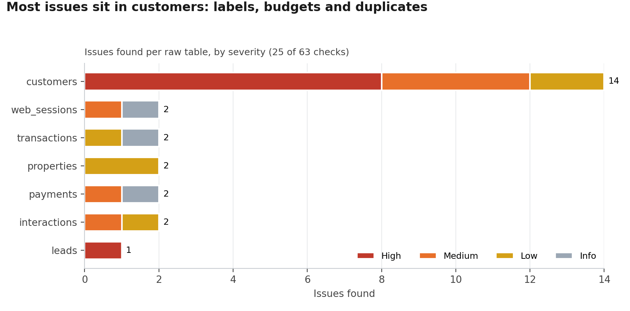
Figure 1. Issues found per raw table, by severity

3. Issues found and how each was handled
Table 2. Every issue found (full detail in data_quality_log.xlsx)
ID | Table | Issue | Rows | Severity | After cleaning | Status
DQ-31 | customers | Buyer with no purchase budget | 30,796 | High | 30,138 | Open: imputed in Phase 2 from prices viewed (notebook 04)
DQ-32 | customers | Renter with no rent budget | 8,129 | High | 8,009 | Open: imputed in Phase 2 from rents viewed (notebook 04)
DQ-33 | customers | age_band missing | 28,096 | Medium | 27,287 | Accepted: kept as 'Unknown' (filled from duplicates where possible)
DQ-34 | customers | occupation_sector missing | 27,378 | Medium | 27,000 | Accepted: kept as 'Unknown' (filled from duplicates where possible)
DQ-35 | customers | gender blank AND a separate Not stated value | 11,156 | Low | 0 | Fixed in clean layer
DQ-37 | customers | No phone (limits duplicate matching) | 28,918 | Low | 28,440 | Accepted: match on email and profile instead
DQ-38 | interactions | Inbound contact with no reply time | 5,830 | Medium | 5,830 | Handled in KPIs: 'Unknown' reply band, excluded from medians
DQ-39 | properties | size_sqm missing | 671 | Low | 671 | Accepted: not used by the dashboard KPIs
DQ-40 | properties | epc_rating missing | 1,193 | Low | 1,193 | Accepted: kept as 'Unknown'
DQ-41 | transactions | Tenancy with no finance_type | 3,327 | Low | 0 | Fixed in clean layer (set to 'Renting')
DQ-42 | web_sessions | Anonymous session (expected) | 500,865 | Info | 500,865 | Expected: used for traffic totals only
DQ-43 | leads | Non-standard lead-source spelling (14 variants) | 8,789 | High | 0 | Fixed in clean layer (CASE mapping, 14 channels)
DQ-44 | customers | Non-standard country label (UK, U.K., England, HK, UAE, KSA...) | 29,989 | High | 0 | Fixed in clean layer (CASE mapping, 12 countries + ISO)
DQ-45 | web_sessions | UK resident browsing from a non-UK IP (VPN noise) | 23,424 | Medium | 23,424 | Rule: overseas = residence, never IP address
DQ-46 | customers | Purchase budget under 5,000 (typed in thousands) | 66 | High | 0 | Fixed in clean layer (x1000)
DQ-47 | customers | Purchase budget 6x+ the prices the customer viewed (extra zero) | 77 | High | 0 | Fixed in clean layer (/10)
DQ-48 | customers | Budget 3-6x viewed prices starting with a stray 1 | 46 | Medium | 0 | Fixed in clean layer (first digit dropped)
DQ-49 | customers | Rent budget 10,000+ a month (annual figure or extra zero) | 47 | High | 0 | Fixed in clean layer (/12 or /10)
DQ-50 | payments | Negative payment amount | 4 | Medium | 4 | Open: confirm with finance; excluded from payments-due totals
DQ-51 | transactions | Sold above asking (negative discount, plausible) | 3,426 | Info | 3,426 | Expected: kept (competitive bids)
DQ-52 | interactions | Reply time capped at 4,320 min (3 days) | 1,497 | Low | 1,497 | Handled in KPIs: reply bands and medians, never means
DQ-60 | payments | Payment due after 30 Sep 2026 (future schedule, expected) | 7,621 | Info | 7,621 | Expected: excluded from the late-payment share
DQ-61 | customers | Records sharing an email hash with another record | 2,206 | High | 0 | Fixed in clean layer (merged to the oldest record)
DQ-62 | customers | Records sharing a phone hash with another record | 1,452 | High | 0 | Fixed in clean layer (merged to the oldest record)
DQ-63 | customers | Profile look-alike pairs (no shared hash) queued for manual review | 1,000 | Medium | 1,000 | Open: manual review (top 100 first)

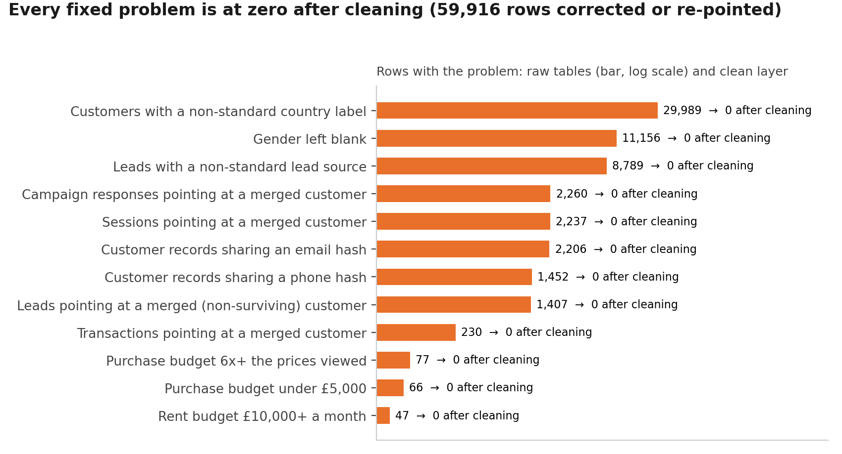
Figure 2. Problems fixed in the clean layer: raw count against the count after cleaning
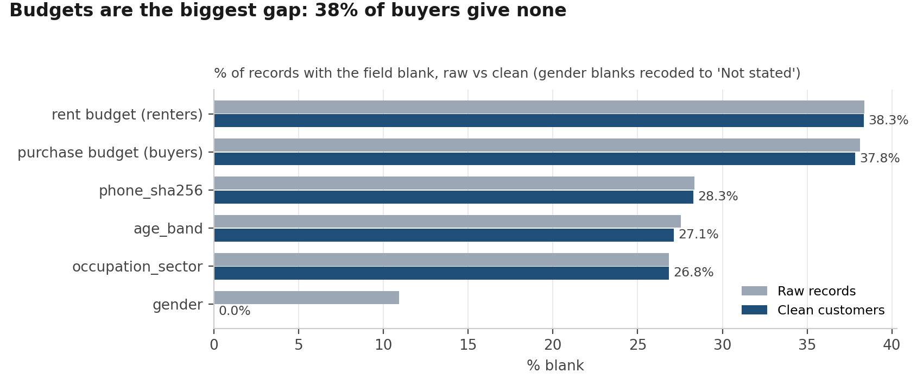
Figure 3. Missing values in the customer table, raw records vs clean customers

4. Duplicate customers
Two records are treated as the same person when they share an email hash or a phone hash; the oldest record survives and the newer one is merged into it (904 on email, 523 on phone). About 45% of real duplicates share neither hash, so a second method scores profile look-alikes (same type, intent, country and region; agreement on budget, age, occupation and buyer position, weighted by how rare each value is). The 1,000 strongest pairs are in clean.dedupe_review_queue for manual review; they are not merged until a reviewer accepts them.
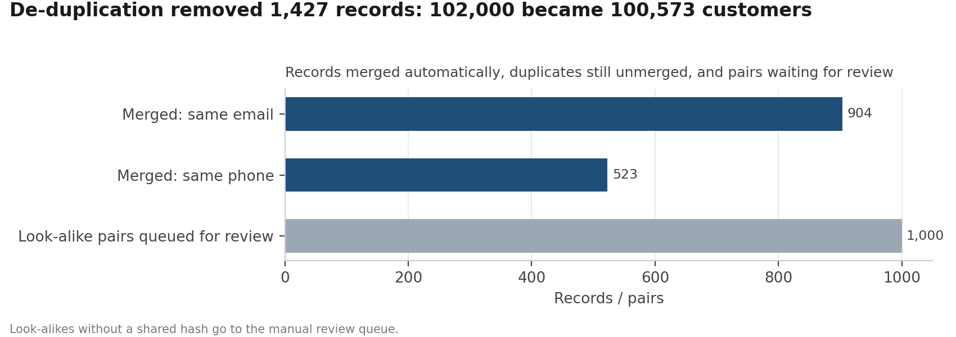
Figure 4. Customer records before and after merging

5. Open items and how the dashboard handles them
Table 3. Open items
ID | Issue | Rows | Next step | Dashboard visual
DQ-31 | Buyer with no purchase budget | 30,138 | Open: imputed in Phase 2 from prices viewed (notebook 04) | Segment: median price level
DQ-32 | Renter with no rent budget | 8,009 | Open: imputed in Phase 2 from rents viewed (notebook 04) | Segment: median rent
DQ-50 | Negative payment amount | 4 | Open: confirm with finance; excluded from payments-due totals | Payments: payments due
DQ-63 | Profile look-alike pairs (no shared hash) queued for manual review | 1,000 | Open: manual review (top 100 first) | Overview: customers card

- Reply times: blank and capped values are kept out of medians and shown as an 'Unknown' band.
- Overseas share: always from country of residence, never IP address (VPNs and travel make IP unreliable).
- Late payments: payments not yet due are excluded; the latest month is flagged as still maturing.
- Medians, not means, for budgets, prices and reply times, so the few extreme values cannot move a card.

6. What the Power BI Data check page shows
The dashboard has a Data check page so anyone can see the cleaning worked before trusting the other four pages:
- Row counts per table, raw against the generation log (all 13 match).
- Issues by table and severity (the chart in section 2), from dq.dq_log.
- Raw lead-source spellings against the 14 clean channels, from dq.raw_lead_source_chart.
- A reconciliation table: every Overview card next to the same number computed in SQL (clean.powerbi_check).

Appendix · Data quality log (all checks)
ID | Type | Table | Column | Check | Rows | Result
DQ-01 | Keys | locations | location_id | Primary key duplicated or null | 0 | Pass
DQ-02 | Keys | agents | agent_id | Primary key duplicated or null | 0 | Pass
DQ-03 | Keys | customers | customer_id | Primary key duplicated or null | 0 | Pass
DQ-04 | Keys | campaigns | campaign_id | Primary key duplicated or null | 0 | Pass
DQ-05 | Keys | leads | lead_id | Primary key duplicated or null | 0 | Pass
DQ-06 | Keys | interactions | interaction_id | Primary key duplicated or null | 0 | Pass
DQ-07 | Keys | properties | property_id | Primary key duplicated or null | 0 | Pass
DQ-08 | Keys | site_visits | visit_id | Primary key duplicated or null | 0 | Pass
DQ-09 | Keys | transactions | transaction_id | Primary key duplicated or null | 0 | Pass
DQ-10 | Keys | payments | payment_id | Primary key duplicated or null | 0 | Pass
DQ-11 | Keys | campaign_responses | response_id | Primary key duplicated or null | 0 | Pass
DQ-12 | Keys | web_sessions | session_id | Primary key duplicated or null | 0 | Pass
DQ-13 | Keys | property_views | view_id | Primary key duplicated or null | 0 | Pass
DQ-14 | Keys | properties | location_id | Orphan: location_id not found in locations | 0 | Pass
DQ-15 | Keys | leads | customer_id | Orphan: customer_id not found in customers | 0 | Pass
DQ-16 | Keys | leads | agent_id | Orphan: agent_id not found in agents | 0 | Pass
DQ-17 | Keys | leads | campaign_id | Orphan: campaign_id not found in campaigns | 0 | Pass
DQ-18 | Keys | interactions | lead_id | Orphan: lead_id not found in leads | 0 | Pass
DQ-19 | Keys | interactions | agent_id | Orphan: agent_id not found in agents | 0 | Pass
DQ-20 | Keys | site_visits | lead_id | Orphan: lead_id not found in leads | 0 | Pass
DQ-21 | Keys | site_visits | property_id | Orphan: property_id not found in properties | 0 | Pass
DQ-22 | Keys | transactions | lead_id | Orphan: lead_id not found in leads | 0 | Pass
DQ-23 | Keys | transactions | customer_id | Orphan: customer_id not found in customers | 0 | Pass
DQ-24 | Keys | transactions | property_id | Orphan: property_id not found in properties | 0 | Pass
DQ-25 | Keys | payments | transaction_id | Orphan: transaction_id not found in transactions | 0 | Pass
DQ-26 | Keys | campaign_responses | campaign_id | Orphan: campaign_id not found in campaigns | 0 | Pass
DQ-27 | Keys | campaign_responses | customer_id | Orphan: customer_id not found in customers | 0 | Pass
DQ-28 | Keys | web_sessions | customer_id | Orphan: customer_id not found in customers | 0 | Pass
DQ-29 | Keys | property_views | session_id | Orphan: session_id not found in web_sessions | 0 | Pass
DQ-30 | Keys | property_views | property_id | Orphan: property_id not found in properties | 0 | Pass
DQ-31 | Nulls | customers | stated_budget_gbp | Buyer with no purchase budget | 30,796 | High
DQ-32 | Nulls | customers | stated_rent_budget_pcm_gbp | Renter with no rent budget | 8,129 | High
DQ-33 | Nulls | customers | age_band | age_band missing | 28,096 | Medium
DQ-34 | Nulls | customers | occupation_sector | occupation_sector missing | 27,378 | Medium
DQ-35 | Nulls | customers | gender | gender blank AND a separate Not stated value | 11,156 | Low
DQ-36 | Nulls | customers | uk_region_of_residence | UK resident with no region | 0 | Pass
DQ-37 | Nulls | customers | phone_sha256 | No phone (limits duplicate matching) | 28,918 | Low
DQ-38 | Nulls | interactions | response_time_min | Inbound contact with no reply time | 5,830 | Medium
DQ-39 | Nulls | properties | size_sqm | size_sqm missing | 671 | Low
DQ-40 | Nulls | properties | epc_rating | epc_rating missing | 1,193 | Low
DQ-41 | Nulls | transactions | finance_type | Tenancy with no finance_type | 3,327 | Low
DQ-42 | Nulls | web_sessions | customer_id | Anonymous session (expected) | 500,865 | Info
DQ-43 | Labels | leads | lead_source | Non-standard lead-source spelling (14 variants) | 8,789 | High
DQ-44 | Labels | customers | country_of_residence | Non-standard country label (UK, U.K., England, HK, UAE, KSA...) | 29,989 | High
DQ-45 | Labels | web_sessions | ip_country | UK resident browsing from a non-UK IP (VPN noise) | 23,424 | Medium
DQ-46 | Range | customers | stated_budget_gbp | Purchase budget under 5,000 (typed in thousands) | 66 | High
DQ-47 | Range | customers | stated_budget_gbp | Purchase budget 6x+ the prices the customer viewed (extra zero) | 77 | High
DQ-48 | Range | customers | stated_budget_gbp | Budget 3-6x viewed prices starting with a stray 1 | 46 | Medium
DQ-49 | Range | customers | stated_rent_budget_pcm_gbp | Rent budget 10,000+ a month (annual figure or extra zero) | 47 | High
DQ-50 | Range | payments | amount_gbp | Negative payment amount | 4 | Medium
DQ-51 | Range | transactions | discount_pct | Sold above asking (negative discount, plausible) | 3,426 | Info
DQ-52 | Range | interactions | response_time_min | Reply time capped at 4,320 min (3 days) | 1,497 | Low
DQ-53 | Dates | leads | closed_date | Lead closed before it was created | 0 | Pass
DQ-54 | Dates | leads | converted | converted flag disagrees with stage Won | 0 | Pass
DQ-55 | Dates | leads | created_date | Lead before the customer first contact | 0 | Pass
DQ-56 | Dates | leads | agent_id | Lead handled before the agent was hired | 0 | Pass
DQ-57 | Dates | site_visits | visit_date | Viewing before the lead was created | 0 | Pass
DQ-58 | Dates | transactions | contract_date | Contract before the lead was created | 0 | Pass
DQ-59 | Dates | transactions | lead_id | Transaction on a lead that is not Won | 0 | Pass
DQ-60 | Dates | payments | due_date | Payment due after 30 Sep 2026 (future schedule, expected) | 7,621 | Info
DQ-61 | Duplicates | customers | email_sha256 | Records sharing an email hash with another record | 2,206 | High
DQ-62 | Duplicates | customers | phone_sha256 | Records sharing a phone hash with another record | 1,452 | High
DQ-63 | Duplicates | customers | (profile) | Profile look-alike pairs (no shared hash) queued for manual review | 1,000 | Medium

