EDA summary
Phase 1 · Exploratory data analysis
13 charts · cleaned PostgreSQL data to 30 Sep 2026 · generated by notebooks/02_eda_summary.ipynb

Key findings
31% | 16% | 2.2x | 36%
conversion when answered < 1 h | of leads answered < 1 h | sale completions, Mar vs Feb 2025 | of London new-build value from overseas

- Demand grows each year: leads from January to September rose from 14.2k (2023) to 18.8k (2024) and 22.2k (2025), and stand at 22.3k in 2026. The spike before the dashed line is the March 2025 stamp duty rush; completions spike with it and then fall back.
- Reply speed is the strongest lever in the data. Leads answered within 1 hour convert at 31.5%, against 7.5% when left over 24 hours (4.2x). Yet only 15.9% of leads get a reply within the hour. Routing priority leads to agents who can answer fast is the quickest win.
- The stamp duty change pulled demand forward. In March 2025 buy leads were +44% on February and sale completions 2.2x February's, then fell 70% in April. Any year-on-year comparison that includes Q1-Q2 2025 needs this caveat, and the next policy change should trigger an early campaign and a model refresh.
- Overseas customers punch above their weight: 9.4% of customers, 11.1% of sale value and 36% of London new-build sale value. Hong Kong (1,837), United Arab Emirates (1,620) and United States (1,204) are the top countries. A dedicated international desk is worth it.
- Channels convert very differently (average 18.2%). Relocation partner converts 38.8% and Branch walk-in 24.9%; WeChat (13.8%) and Overseas agent partner (15.0%) convert least. Rightmove brings the most leads (24,093 closed) at 18.1%. Spend should be judged on cost per won deal, not on lead volume.
What this means for the segmentation: reply speed, channel, residence (UK or overseas), browsing hours, device and virtual-tour use all separate customers strongly, so they belong in the feature set (Phase 2). Seasonality and the stamp duty spike are timing effects: they shape when to act, not who the segments are.

12-month baselines (Oct 2025 - Sep 2026)
These are the 'before' numbers the project will be measured against.
KPI | Value | Definition
Lead-to-sale conversion (buy leads), % | 15.69 | Won / (Won + Lost), buy leads closed in the 12 months
Lead-to-deal conversion (all leads), % | 17.77 | Won / (Won + Lost), all leads closed in the 12 months
Median first reply, hours | 4.08 | Reply time on the first inbound contact, leads created in the 12 months
Leads answered within 1 hour, % | 15.6 | Share of leads with a first reply under 60 minutes
Median days to close (won leads) | 41 | Lead created to lead closed, won leads
Cost per campaign lead, £ | 64.59 | Spend of campaigns starting in the 12 months / leads with a campaign_id
Campaign spend, £ | 618,342 | Campaigns starting in the 12 months
Campaign-attributed leads | 9,574 | Leads created in the 12 months with a campaign_id

1. Monthly leads, sales and lettings
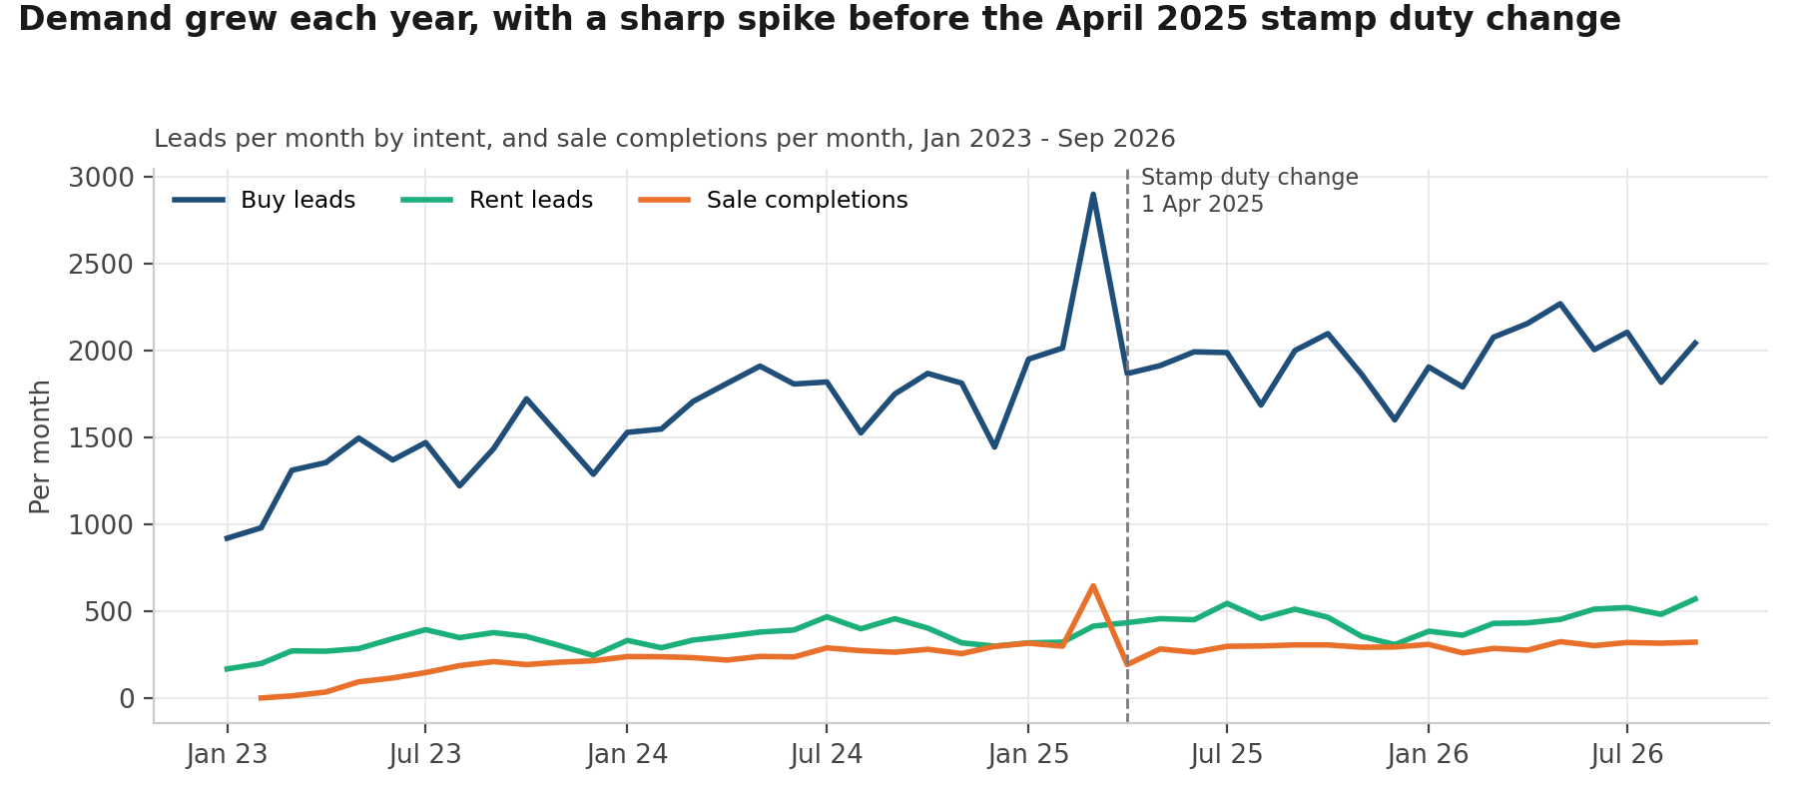
Figure 1. Monthly leads, sales and lettings
Demand grows each year: leads from January to September rose from 14.2k (2023) to 18.8k (2024) and 22.2k (2025), and stand at 22.3k in 2026. The spike before the dashed line is the March 2025 stamp duty rush; completions spike with it and then fall back.

2. Seasonality
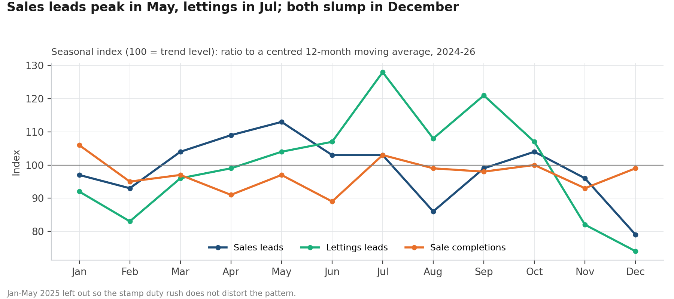
Figure 2. Seasonality
Sales and lettings have different seasons. Sales leads peak in May (index 113) and are lowest in Dec (79); lettings leads peak in Jul (128). Marketing budgets and agent rotas should follow these curves rather than a flat monthly plan.

3. Stamp duty spike
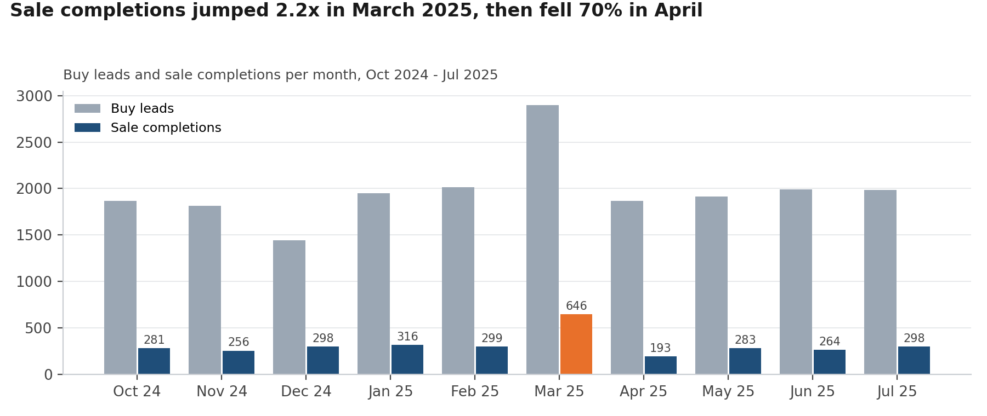
Figure 3. Stamp duty spike
The stamp duty change pulled demand forward. In March 2025 buy leads were +44% on February and sale completions 2.2x February's, then fell 70% in April. Any year-on-year comparison that includes Q1-Q2 2025 needs this caveat, and the next policy change should trigger an early campaign and a model refresh.

4. Conversion by channel
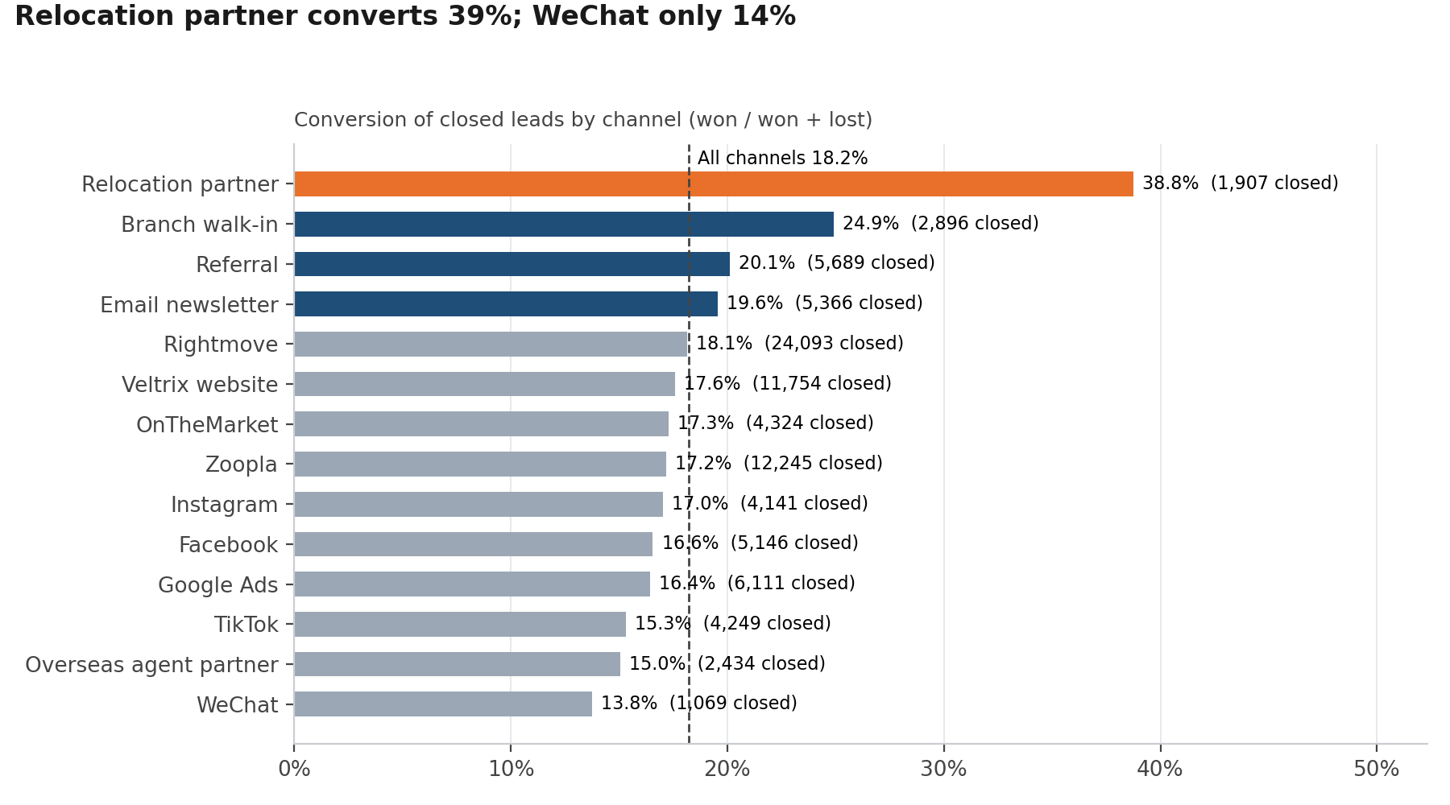
Figure 4. Conversion by channel
Channels convert very differently (average 18.2%). Relocation partner converts 38.8% and Branch walk-in 24.9%; WeChat (13.8%) and Overseas agent partner (15.0%) convert least. Rightmove brings the most leads (24,093 closed) at 18.1%. Spend should be judged on cost per won deal, not on lead volume.

5. Raw lead-source spellings
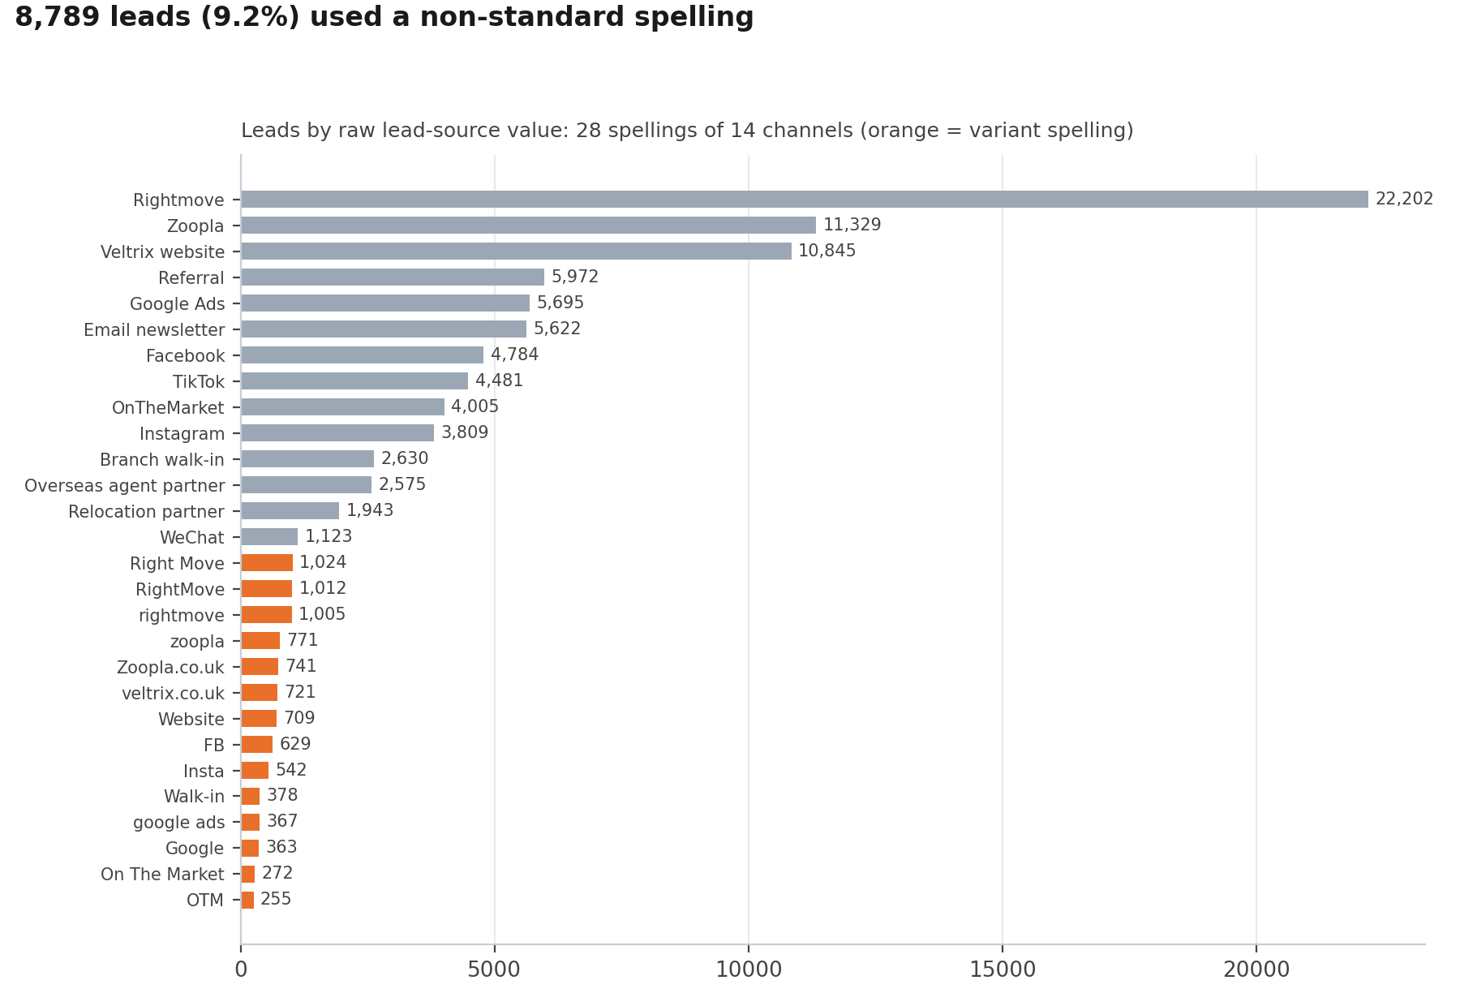
Figure 5. Raw lead-source spellings
This is why the cleaning mattered: 8,789 leads (9.2%) used one of 14 variant spellings. Without the mapping table, Rightmove, Zoopla, OnTheMarket and others would be split across several smaller bars and under-counted.

6. Reply speed
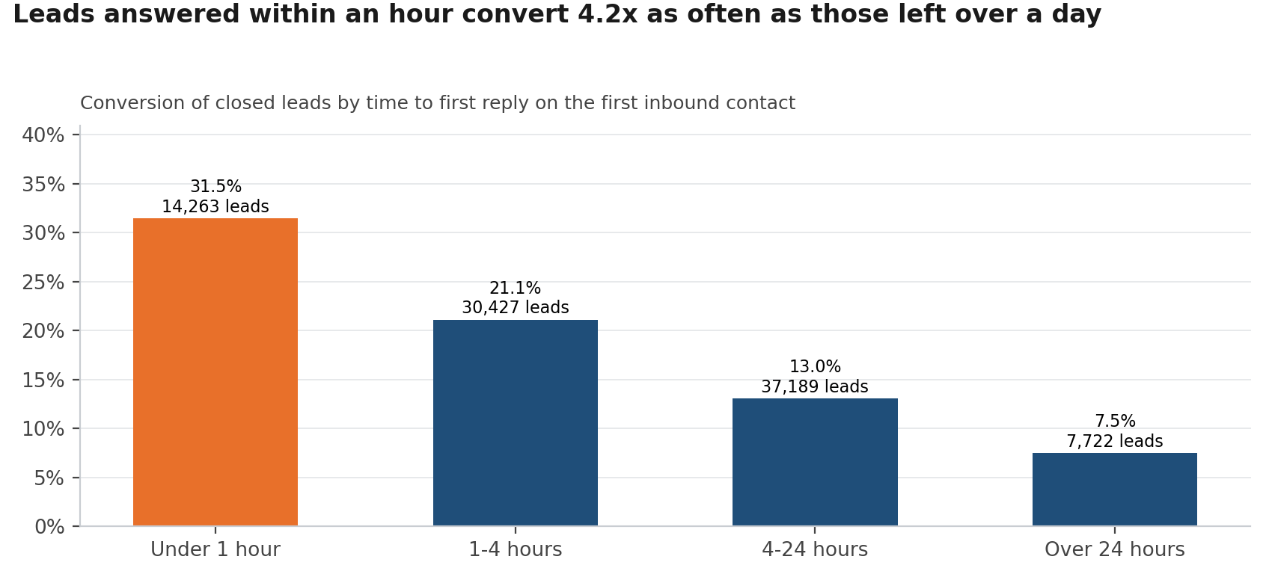
Figure 6. Reply speed
Reply speed is the strongest lever in the data. Leads answered within 1 hour convert at 31.5%, against 7.5% when left over 24 hours (4.2x). Yet only 15.9% of leads get a reply within the hour. Routing priority leads to agents who can answer fast is the quickest win.

7. Agent seniority
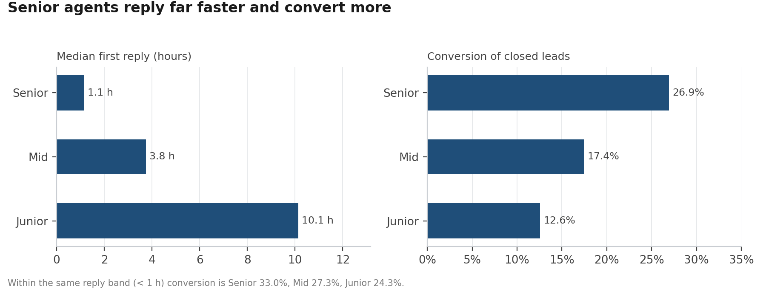
Figure 7. Agent seniority
Senior agents reply faster (median 1.1 h, against 3.8 h for mid-level and 10.1 h for juniors) and convert more (26.9% vs 17.4% vs 12.6%). When every agent replies within an hour the gap narrows (33.0% vs 24.3%), so much of the seniority advantage is speed, which juniors can be coached on.

8. Overseas share
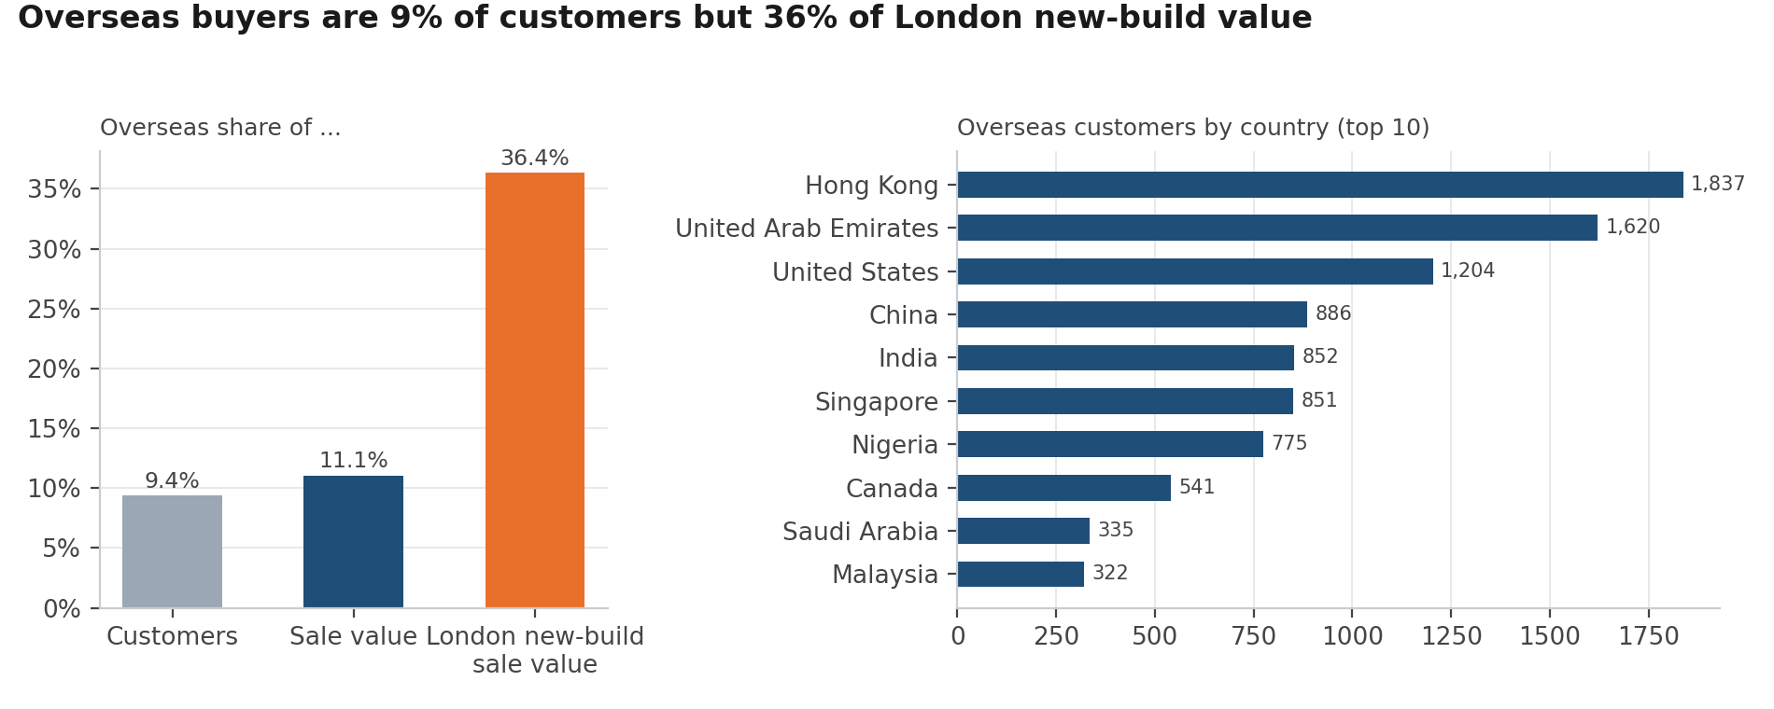
Figure 8. Overseas share
Overseas customers punch above their weight: 9.4% of customers, 11.1% of sale value and 36% of London new-build sale value. Hong Kong (1,837), United Arab Emirates (1,620) and United States (1,204) are the top countries. A dedicated international desk is worth it.

9. Night-time browsing
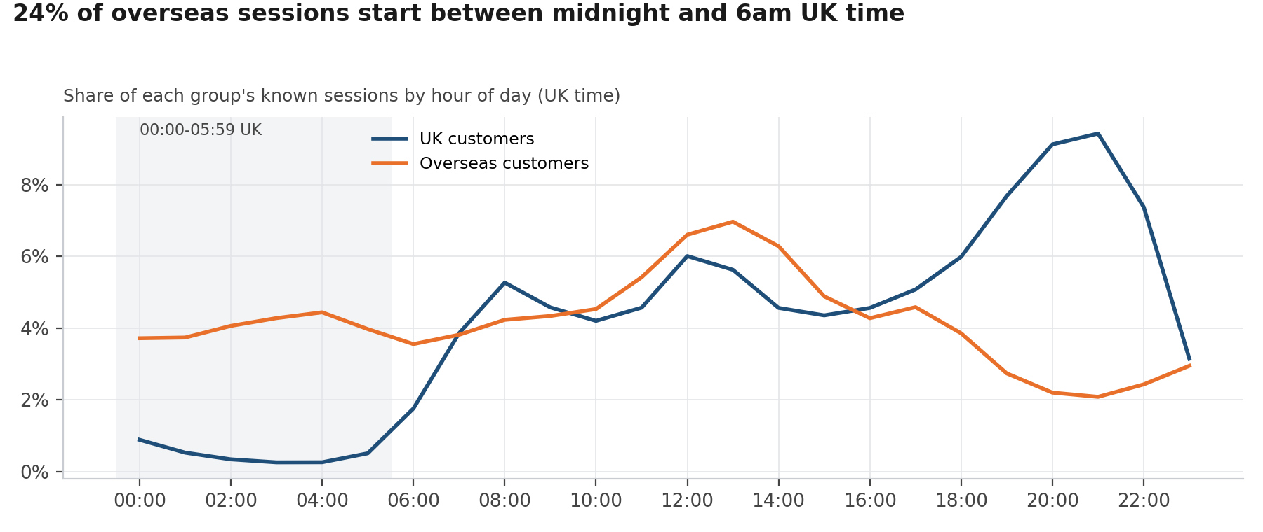
Figure 9. Night-time browsing
Overseas customers browse while the UK sleeps: 24% of their sessions start between midnight and 6am, against 3% for UK customers, and their busiest hour is 13:00 UK time. Overnight auto-replies, next-morning call-backs and campaigns timed for Asian and Gulf daytime would serve them better.

10. Devices and virtual tours
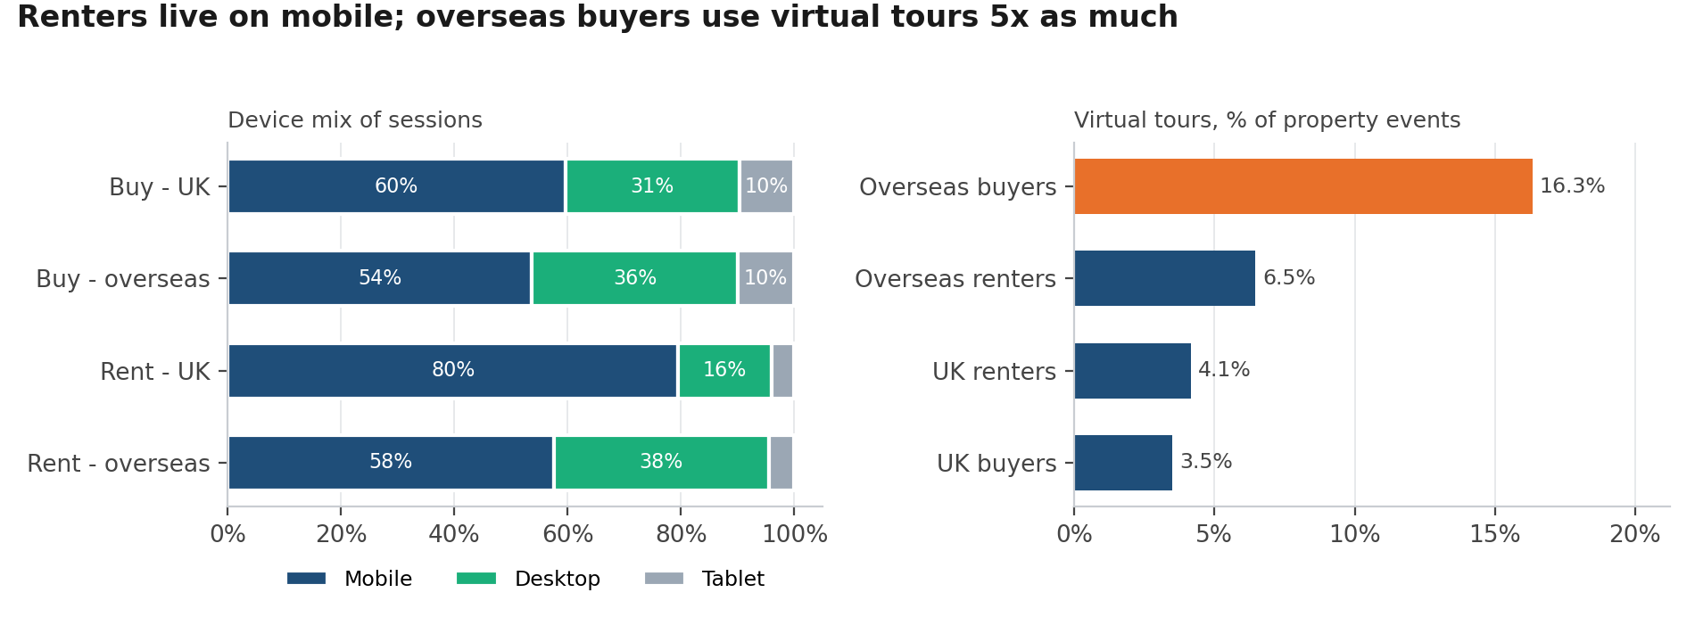
Figure 10. Devices and virtual tours
Renters live on mobile: 80% of UK renters' sessions are on mobile against 60% for UK buyers. Overseas buyers rely on virtual tours (16.3% of their property events, against 3.5% for UK buyers). Mobile-first pages for lettings and a virtual tour on every new-build and London listing follow directly.

11. Late payment
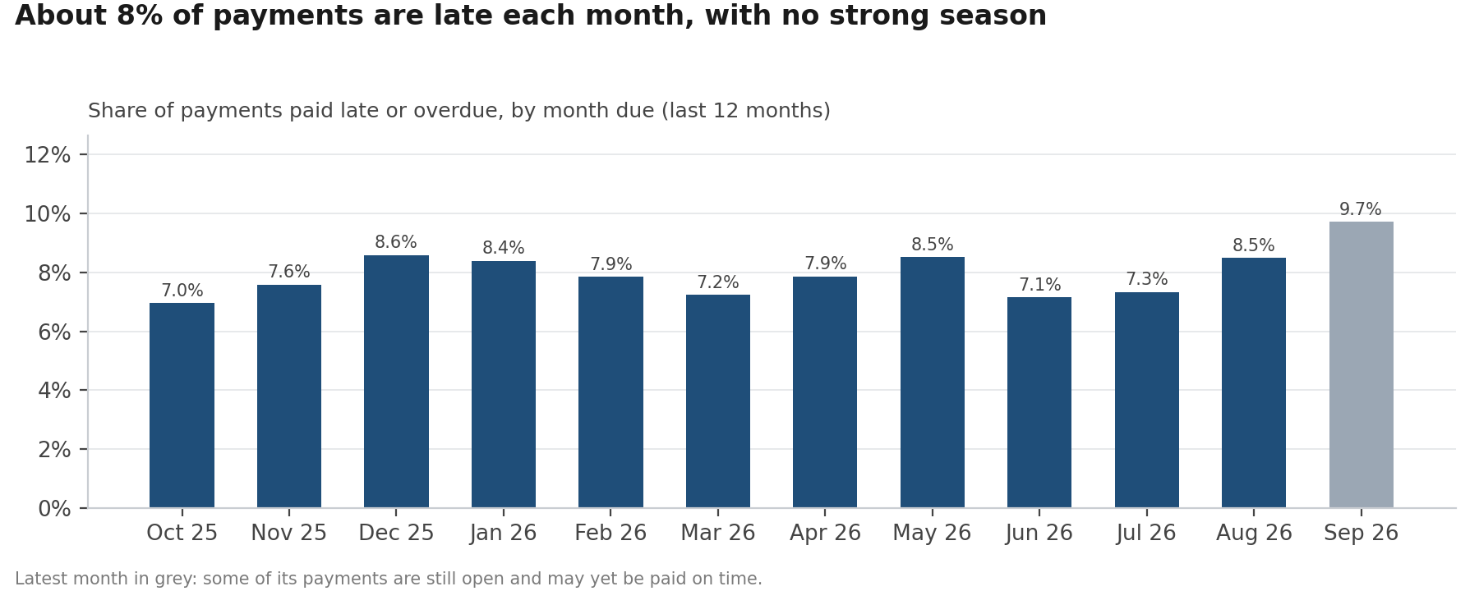
Figure 11. Late payment
Late payment is steady at about 7%-10% a month. The latest month is not final. Monthly rent is paid late 9.9% of the time against 3.6% for other payments, so the late-payment problem is mainly a lettings problem (Week 3 shows which tenancy types drive it).

12. Deal value by type
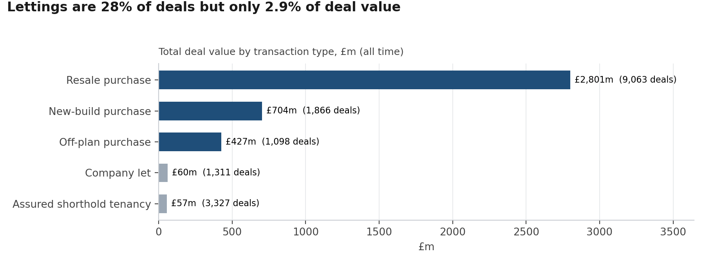
Figure 12. Deal value by type
Lettings bring volume, not value: 28% of deals but 2.9% of deal value (£117.2m of £4.05bn). Resale purchase dominates value at £2.80bn (9,063 deals).

13. Timing by segment
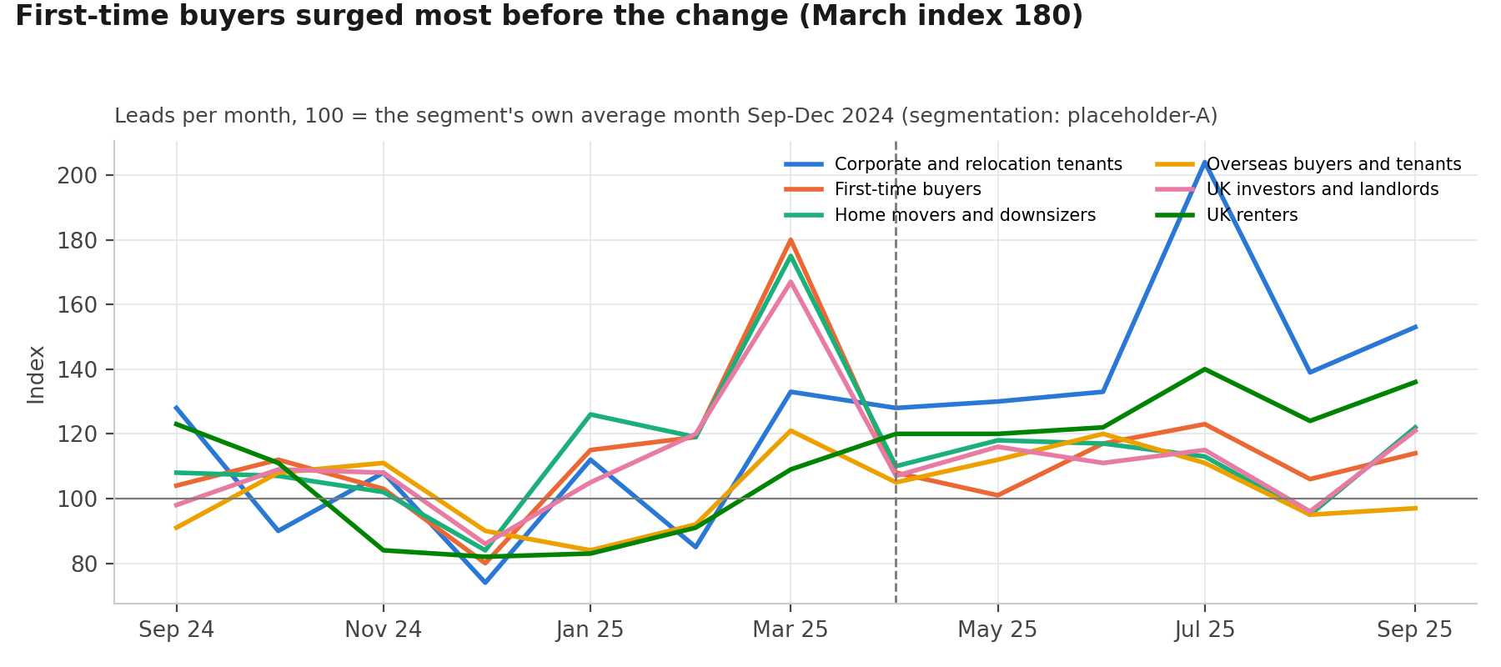
Figure 13. Timing by segment
Segments did not rush equally. In March 2025 First-time buyers ran at 180 (100 = a normal month) and Home movers and downsizers at 175, while UK renters stayed near 109. Before the next tax change, these are the segments to contact early.

