Feature documentation
Phase 2 · Feature engineering
feat.customer_features_model · features/customer_features.parquet · generated by notebooks/04_feature_engineering.ipynb

Summary
100,573 | 10 | 8 | 5
customers, one row each | numeric features | categorical features | dropped (|r| > 0.8)

- One row per customer (100,573) with behaviour only. Outcomes (conversion, deal value, late payment) are kept in feat.customer_outcomes and used only to check the segments afterwards, so the model cannot learn them.
- Budgets are complete. Typos were fixed in SQL; blanks were filled from the median price (or rent) the customer viewed, then from a group median. For buyers who state a budget, the median price they viewed is 0.96x their budget, so the stand-in is fair.
- Money is log-transformed and every numeric feature is scaled to mean 0 and standard deviation 1, so no feature dominates because of its units.
- Correlated features were removed: properties_viewed (r = 0.92 with sessions_total); off_plan_share (r = 0.83 with new_build_share); saves_total (r = 0.89 with sessions_total); property_events_total (r = 0.95 with sessions_total); inbound_contacts_total (r = 0.88 with enquiries_total).

Feature list
Feature | Type | Definition | % blank before | Transform | In model
budget_gbp | numeric | Purchase budget, £. Stated (typos fixed) or imputed; buyers only | 50.7 | log(1+x), then z-score | yes
rent_budget_pcm_gbp | numeric | Monthly rent budget, £. Stated (fixed) or imputed; renters only | 87.2 | log(1+x), then z-score | yes
sessions_total | numeric | Known (logged-in) web sessions | 0 | z-score | yes
night_session_share | numeric | Share of sessions starting 00:00-05:59 UK time | 0 | z-score | yes
properties_viewed | numeric | Distinct listings the customer interacted with | 0 | - | no (r = 0.92 with sessions_total)
virtual_tour_share | numeric | Virtual tours / all property events | 0 | z-score | yes
enquiries_total | numeric | Leads (enquiries) raised | 0 | z-score | yes
days_since_last_activity | numeric | Days from last session, lead or contact to 30 Sep 2026 | 0 | z-score | yes
mobile_share | numeric | Share of sessions on mobile | 0 | z-score | yes
new_build_share | numeric | Share of property events on new-build listings | 0 | z-score | yes
london_share | numeric | Share of property events on London listings | 0 | z-score | yes
off_plan_share | numeric | Share of property events on off-plan listings | 0 | - | no (r = 0.83 with new_build_share)
saves_total | numeric | Listings saved | 0 | - | no (r = 0.89 with sessions_total)
property_events_total | numeric | All property events (views, saves, tours, shares, floorplans) | 0 | - | no (r = 0.95 with sessions_total)
inbound_contacts_total | numeric | Inbound contacts across all leads | 0 | - | no (r = 0.88 with enquiries_total)
preferred_region | categorical | Region viewed most (else home region) | 0 | category (matched / not matched) | yes
preferred_property_type | categorical | Property type viewed most | 0 | category (matched / not matched) | yes
lead_source_primary | categorical | Channel of most of the customer's leads; 'No lead' if none | 0 | category (matched / not matched) | yes
finance_type | categorical | Mortgage, cash, buy-to-let, shared ownership, renting, company let ... | 0 | category (matched / not matched) | yes
customer_type | categorical | Individual, Limited company (SPV), Corporate | 0 | category (matched / not matched) | yes
is_overseas | categorical | Lives outside the UK (residence, never IP) | 0 | category (matched / not matched) | yes
buyer_position | categorical | Self-declared position: first-time buyer, home mover, landlord, downsizer, renter ... or Not stated | 0 | category (matched / not matched) | yes
age_band | categorical | Age band; 'Unknown' when blank (kept as its own category) | 0 | category (matched / not matched) | yes

Sources and summary values
Feature | Built from | Summary
budget_gbp | clean_customers + feat.customer_viewed_prices | median 315,000; p95 745,000
rent_budget_pcm_gbp | clean_customers + feat.customer_viewed_prices | median 1,500; p95 3,500
sessions_total | clean_web_sessions | median 9; p95 49
night_session_share | clean_web_sessions | median 0.00; p95 0.27
properties_viewed | clean_property_views | median 54; p95 361
virtual_tour_share | clean_property_views | median 0.03; p95 0.19
enquiries_total | clean_leads | median 1; p95 3
days_since_last_activity | sessions, leads, interactions | median 421; p95 1,145
mobile_share | clean_web_sessions | median 0.60; p95 1.00
new_build_share | clean_property_views + properties | median 0.24; p95 0.84
london_share | clean_property_views + locations | median 0.02; p95 0.86
off_plan_share | clean_property_views + properties | median 0.05; p95 0.48
saves_total | clean_property_views | median 4; p95 46
property_events_total | clean_property_views | median 61; p95 503
inbound_contacts_total | clean_interactions | median 2; p95 10
preferred_region | property views + locations | 12 values; top: London
preferred_property_type | property views + properties | 7 values; top: Flat
lead_source_primary | clean_leads | 15 values; top: No lead
finance_type | clean_customers | 9 values; top: Mortgage
customer_type | clean_customers | 3 values; top: Individual
is_overseas | clean_customers | 2 values; top: False
buyer_position | clean_customers | 8 values; top: First-time buyer
age_band | clean_customers | 7 values; top: Unknown

Budget imputation
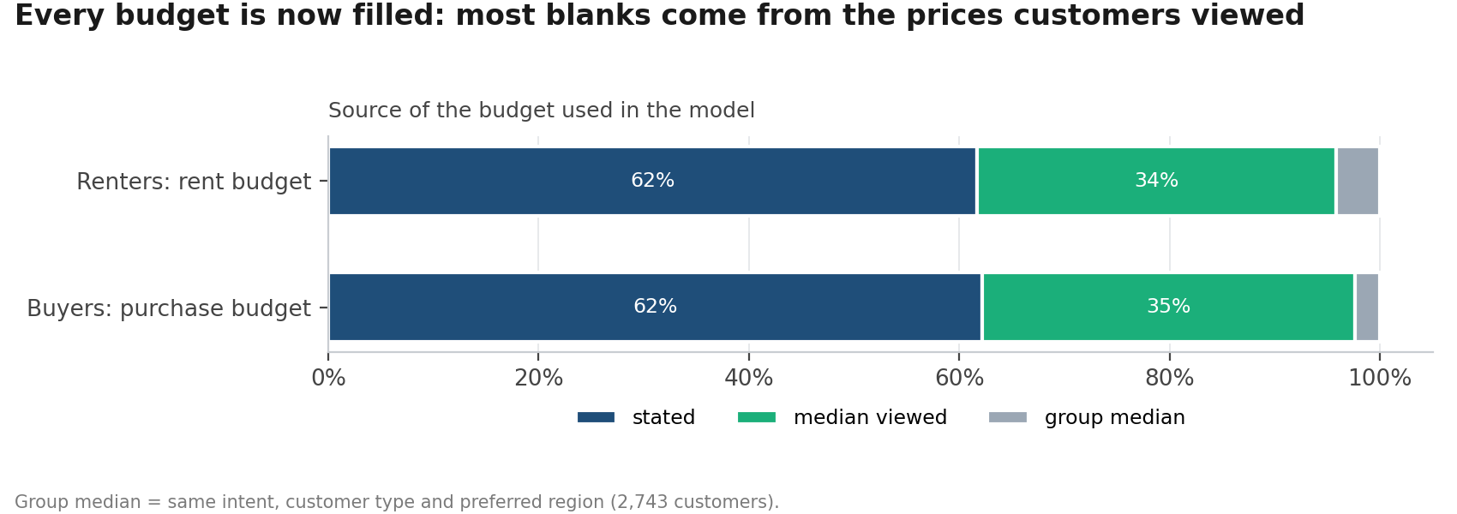
Figure 1. Where each budget used in the model comes from
Budget source | Buyers: purchase budget | Renters: rent budget
stated | 49,550 | 12,876
median viewed | 28,273 | 7,131
group median | 1,865 | 878

Transformations
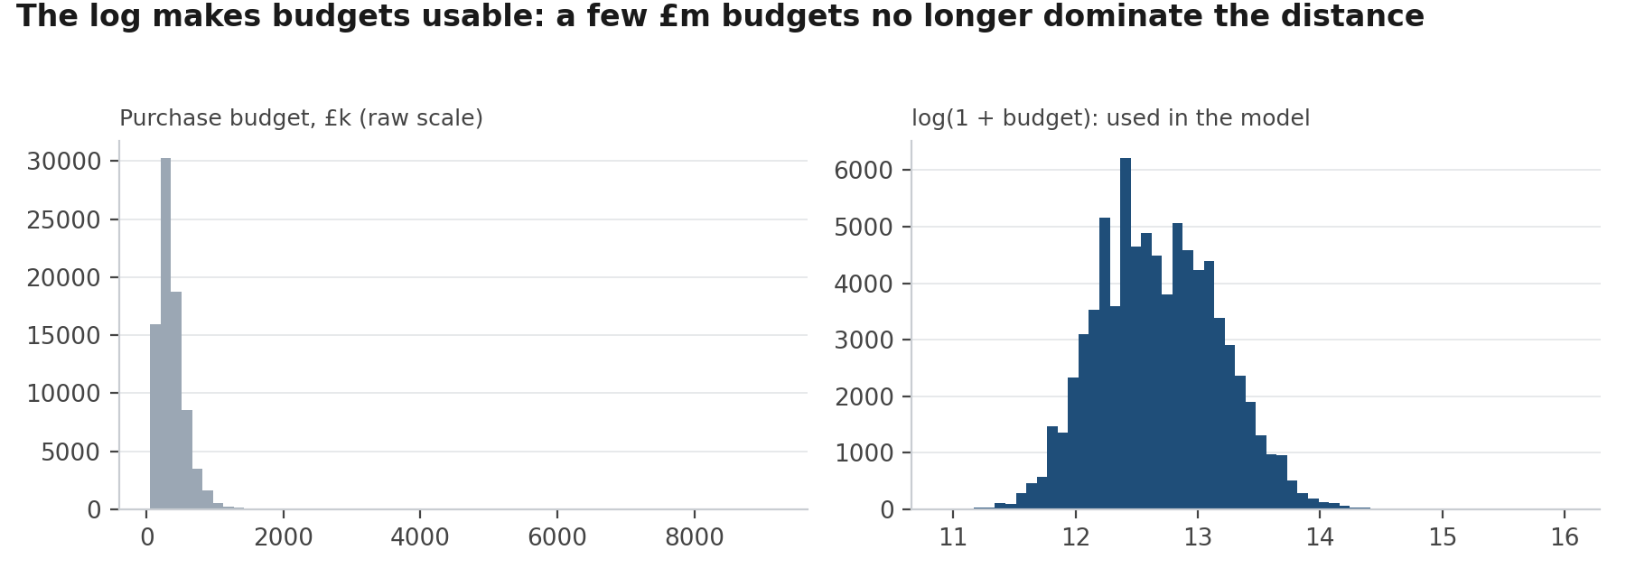
Figure 2. Purchase budget before and after the log transform
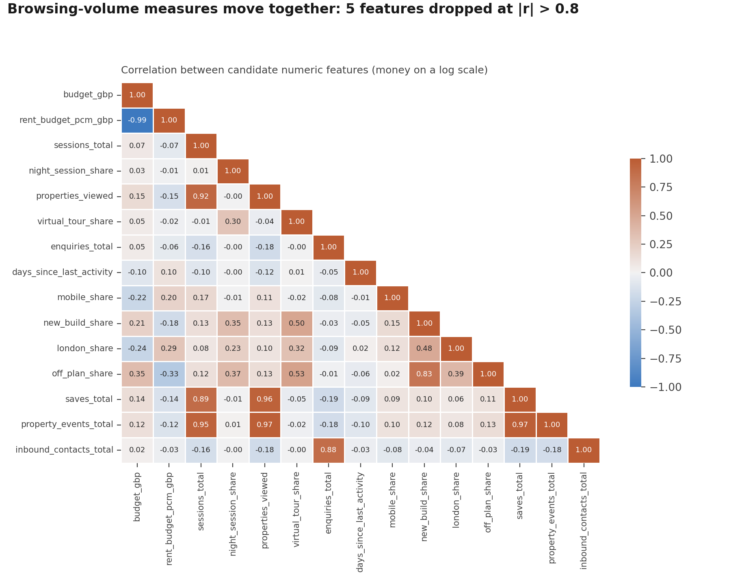
Figure 3. Correlation between candidate numeric features

Where the features live
Object | Kind | Holds
feat.customer_features_ds | Materialized view (SQL file 5, STEP 6) | Features with the plan's names, before imputation
feat.customer_features | Table (SQL file 6) | DA feature table used by the dashboard
feat.customer_outcomes | Table (SQL file 6) | Outcomes, kept out of the model
feat.customer_features_model | Table (this notebook) | Imputed features, flags and scaled z_ inputs
features/customer_features.parquet | File (this notebook) | Input for the DS model code (DuckDB / pandas)
reports/04_features/feature_spec.json | File (this notebook) | Feature lists and scaler, reused for monthly scoring

Gate: business analyst review
Each feature must mean something a salesperson or marketer recognises. Reviewers tick each line or add a comment.
Feature | Meaningful? (Y/N) | Comment
budget_gbp
rent_budget_pcm_gbp
sessions_total
night_session_share
virtual_tour_share
enquiries_total
days_since_last_activity
mobile_share
new_build_share
london_share
preferred_region
preferred_property_type
lead_source_primary
finance_type
customer_type
is_overseas
buyer_position
age_band

Role | Name | Date signed
Business analyst
Data scientist
Data analyst

