Validation report
Phase 3 · Modelling and validation · segmentation seg-v1.0
k-prototypes on feat.customer_features_model · generated by notebooks/05_model_and_validation.ipynb

Summary
6 | 0.197 | 0.66
segments chosen | silhouette (Gower) | bootstrap ARI (20 refits)

- Model: k-prototypes (numeric and categorical features together), Cao initialisation, categorical weight gamma = 1.0; k-means on the numeric features as the baseline; hierarchical clustering on Gower distance as a cross-check.
- Choice of k: candidates 6, 5, 9 were the best-separated solutions with 5-9 segments. k = 6 has the best silhouette among the stable ones and gives segments the business can name and act on.
- Stable: 20 bootstrap refits reproduce the segmentation with a mean adjusted Rand index of 0.66.
- Useful: the segments differ on outcomes the model never saw: conversion from 7.1% to 27.3%, late payment from 2.3% to 9.2%, and Buy-to-let investors alone brings 44% of deal value.

1. Data and features
100,573 customers; 10 numeric features (money log-transformed, all scaled) and 8 categorical features, from notebook 04 (feature documentation). Outcomes were kept out. k-prototypes was fitted on random samples of 8,000 (k search) and 20,000 customers (final model), then every customer was assigned to the nearest segment.
Numeric | Categorical
budget_gbp | preferred_region
rent_budget_pcm_gbp | preferred_property_type
sessions_total | lead_source_primary
night_session_share | finance_type
virtual_tour_share | customer_type
enquiries_total | is_overseas
days_since_last_activity | buyer_position
mobile_share | age_band
new_build_share
london_share

2. Choosing the number of segments
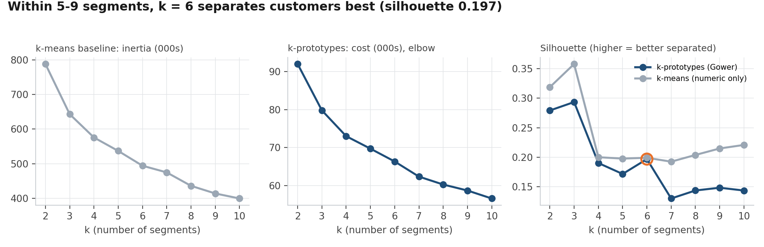
Figure 1. Elbow (cost) and silhouette for k-means and k-prototypes, k = 2 to 10
Table 1. k-prototypes for k = 2 to 10
k | Cost | Silhouette (Gower) | Smallest segment % | ARI vs hierarchical
2 | 92,005 | 0.279 | 21.0
3 | 79,781 | 0.294 | 7.0
4 | 72,991 | 0.190 | 6.9
5 | 69,700 | 0.172 | 6.8 | 0.335
6 | 66,319 | 0.197 | 6.8 | 0.397
7 | 62,333 | 0.130 | 5.8 | 0.387
8 | 60,249 | 0.144 | 5.5 | 0.395
9 | 58,670 | 0.148 | 4.8 | 0.381
10 | 56,573 | 0.144 | 1.8

The cost falls steadily with no sharp elbow, which is normal for customer data; the silhouette therefore decides between readable solutions. Two or three segments separate even more cleanly, but are too coarse to route leads or target campaigns, so the search is limited to 5-9 segments (the plan targets 6-8). Hierarchical clustering on the same Gower distances gives a partly different grouping (ARI shown), as expected from a different algorithm; the k-prototypes solution is preferred because it can assign new customers monthly.

3. Candidates and stability
Table 2. The candidate solutions presented to the team
k | Silhouette | Bootstrap ARI (mean) | Bootstrap ARI (10th pct) | Smallest segment %
6 | 0.197 | 0.658 | 0.616 | 6.8
5 | 0.172 | 0.541 | 0.493 | 6.8
9 | 0.148 | 0.629 | 0.509 | 4.8

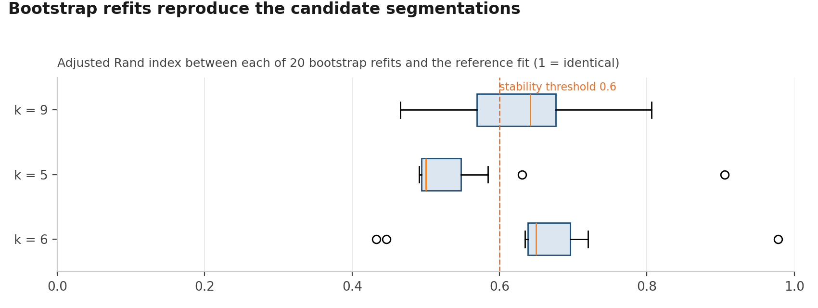
Figure 2. Bootstrap stability of each candidate
Chosen segmentation: k = 6, model version seg-v1.0. Rule: best silhouette among candidates with a mean bootstrap ARI of at least 0.6.

4. The segments
Table 3. Size and held-out outcomes per segment
Segment | Customers | % customers | Conversion % | % deal value | Late payment %
First-time buyers | 27,206 | 27.1 | 12.6 | 21.5 | 3.5
Home movers | 23,919 | 23.8 | 17.1 | 21 | 3.4
Renters | 20,263 | 20.1 | 27.3 | 2.8 | 9.2
Buy-to-let investors | 15,563 | 15.5 | 19.2 | 44 | 3.1
Overseas investors | 7,418 | 7.4 | 14.1 | 9.9 | 5.5
Window shoppers | 6,204 | 6.2 | 7.1 | 0.8 | 2.3

Table 4. What defines each segment (used to name it)
Segment | % renters | % overseas | % no enquiry | Median budget £ | Median rent £ | % night sessions | % tours | % mobile
First-time buyers | 0 | 1 | 40 | 255,000 |  | 3 | 3 | 79
Home movers | 0 | 2 | 53 | 425,000 |  | 3 | 4 | 37
Renters | 100 | 7 | 43 |  | 1,500 | 4 | 4 | 69
Buy-to-let investors | 0 | 5 | 1 | 220,000 | 1,800 | 3 | 4 | 27
Overseas investors | 4 | 88 | 38 | 580,000 | 3,000 | 25 | 21 | 54
Window shoppers | 5 | 3 | 81 | 340,000 | 1,325 | 3 | 3 | 63

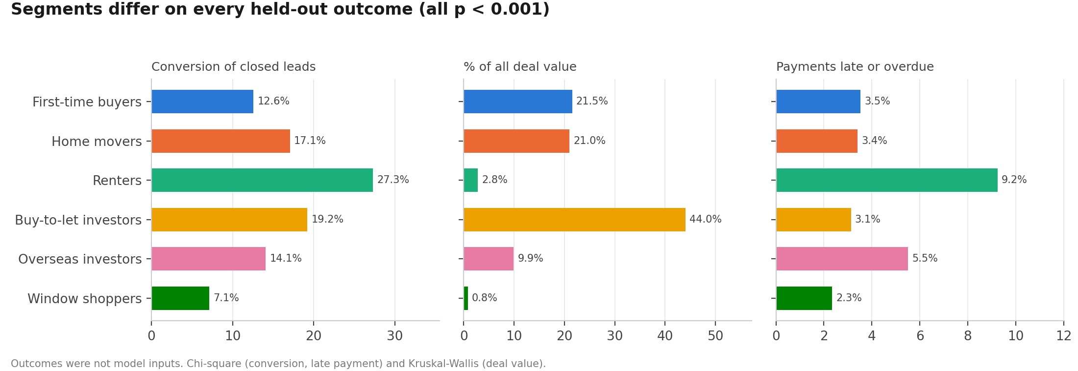
Figure 3. Held-out outcomes by segment
Table 5. Statistical tests on held-out outcomes
Outcome | Test | Statistic | p-value
Conversion (won / closed leads) | chi-square | 1,605 | < 0.001
Late payment (late / payments due) | chi-square | 966 | < 0.001
Deal value per customer | Kruskal-Wallis | 6,867 | < 0.001

6. Limitations and next steps
- k-prototypes depends on the categorical weight (gamma) and on the random start; both are fixed and logged so the result is reproducible.
- Fitting on samples keeps the run short; assigning all customers with the fitted centroids is also how new customers are scored monthly (Phase 7).
- Retrain fully every six months, or sooner if a segment's size shifts by more than 20% or a policy change (such as stamp duty) moves demand.
- The segment names are drafts from the numbers; agree final wording with sales, lettings and marketing in Phase 4.

