Segment profile report
Phase 4 · Profiling and personas · segmentation placeholder-A
Week 3 views (segment_profile, segment_index, segment_channels, segment_demand) · generated by notebooks/06_personas.ipynb

Summary
6 | 100,573 | 79% | 42%
segments | customers | of deal value in P1 segments | from Home movers and downsizers

This report profiles the 6 segments of placeholder-A: who they are, how they arrive, what they look for and buy, how they pay, what they ask agents about, and what Veltrix should do with each. Every number is computed in SQL and appears on the dashboard's Segment deep dive page. Index values compare a segment with the average customer (100).
Table 1. The segments at a glance
Segment | Tier | Customers | % customers | % deal value | Conversion % | Late % | Routed to
Home movers and downsizers | P1 | 38,011 | 37.8 | 42.5 | 17.2 | 2.9 | Regional sales desks
First-time buyers | P2 | 21,871 | 21.7 | 18.3 | 12.3 | 3.7 | Regional sales desks
UK renters | P3 | 16,818 | 16.7 | 1.4 | 24.9 | 12.3 | Regional lettings desks
UK investors and landlords | P1 | 11,902 | 11.8 | 25.6 | 19.5 | 3 | Investor desk
Overseas buyers and tenants | P1 | 9,462 | 9.4 | 11.2 | 16.8 | 3.9 | International desk
Corporate and relocation tenants | P3 | 2,509 | 2.5 | 1 | 38.9 | 1.5 | Corporate lettings

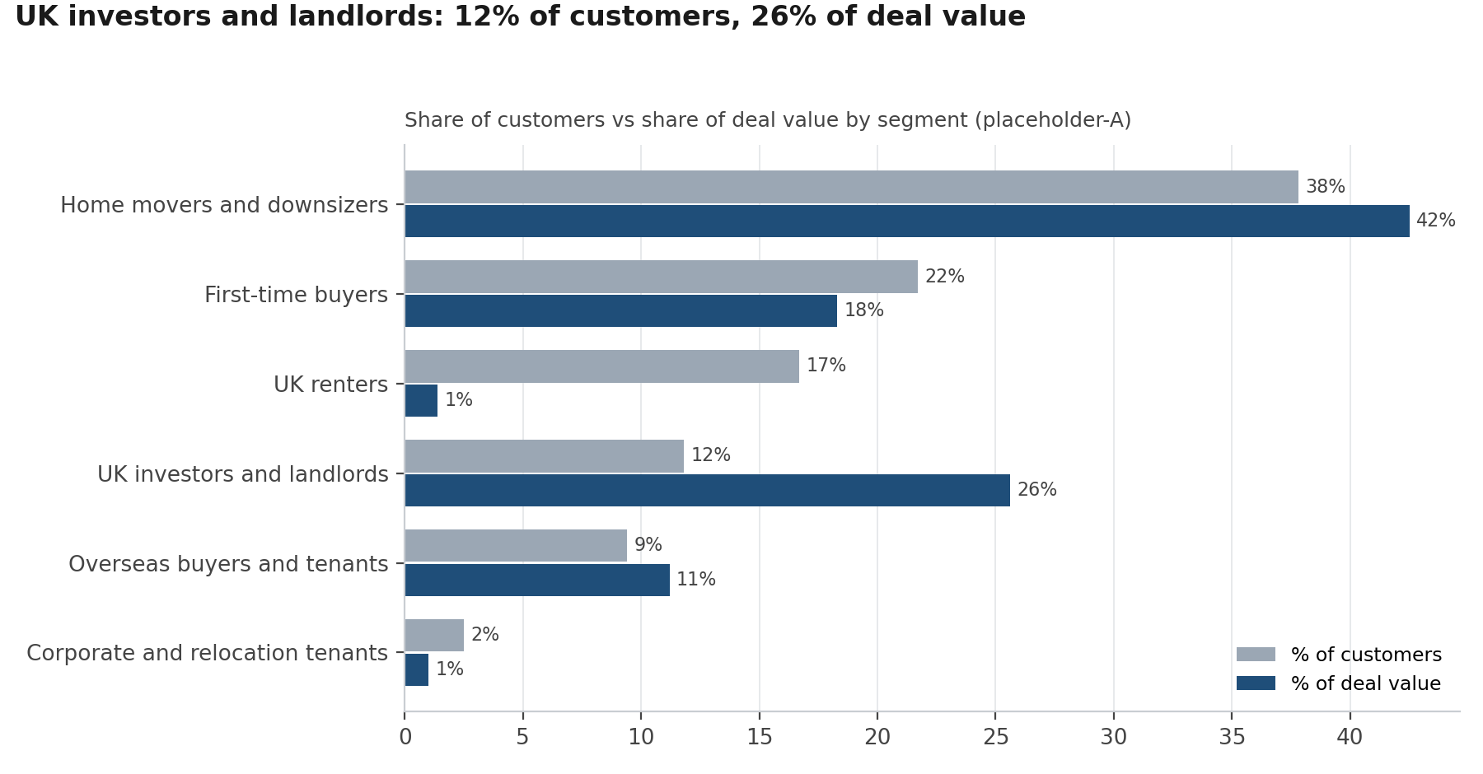
Figure 1. Share of customers and of deal value
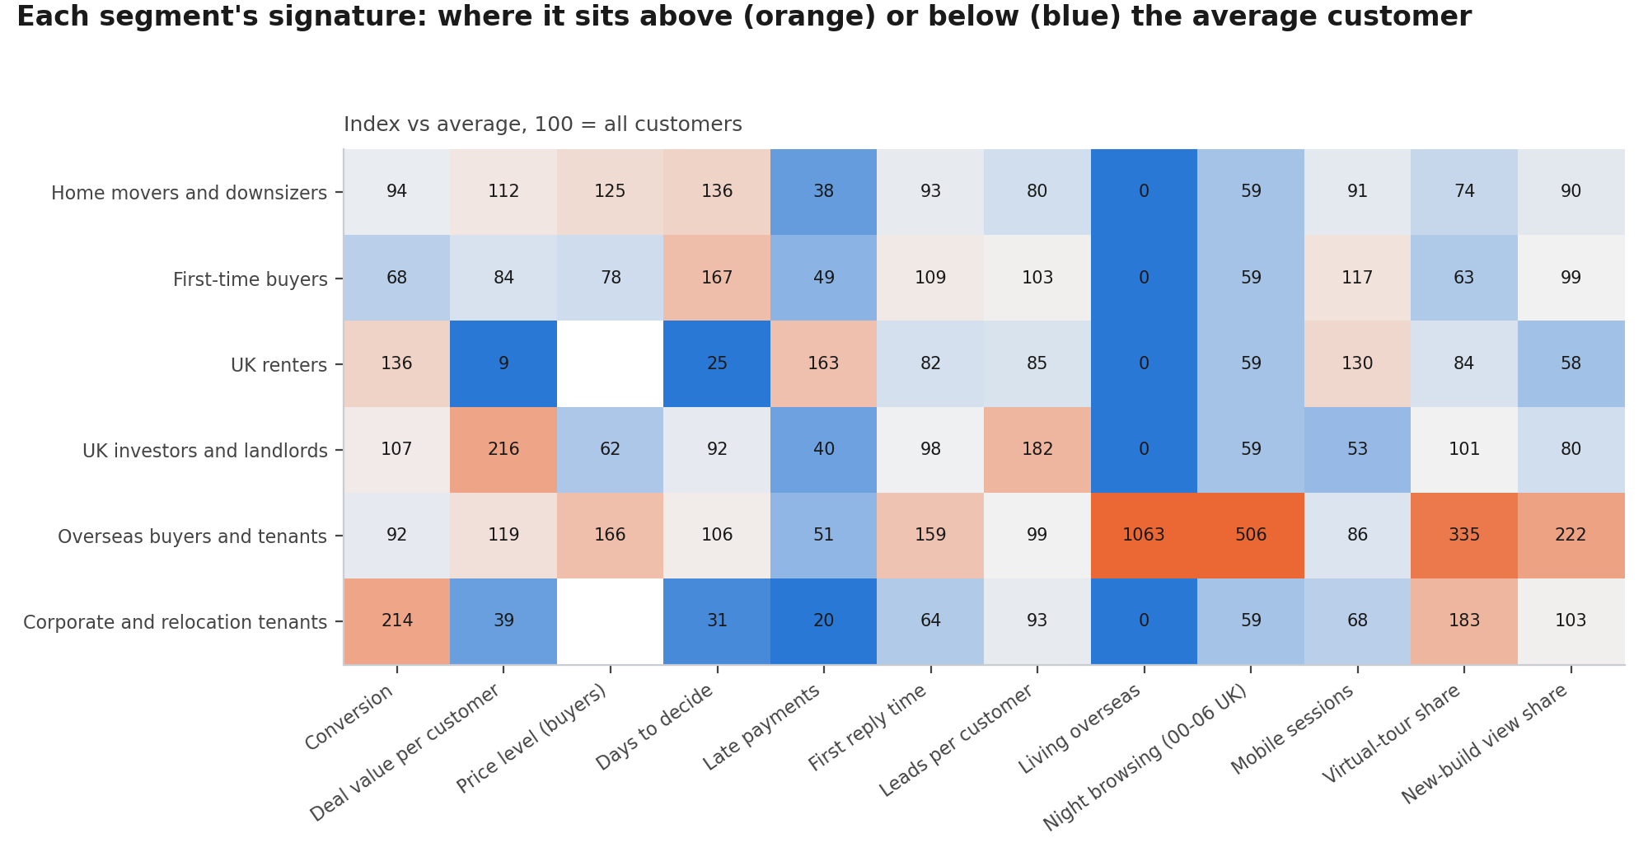
Figure 2. Index vs average on 12 measures
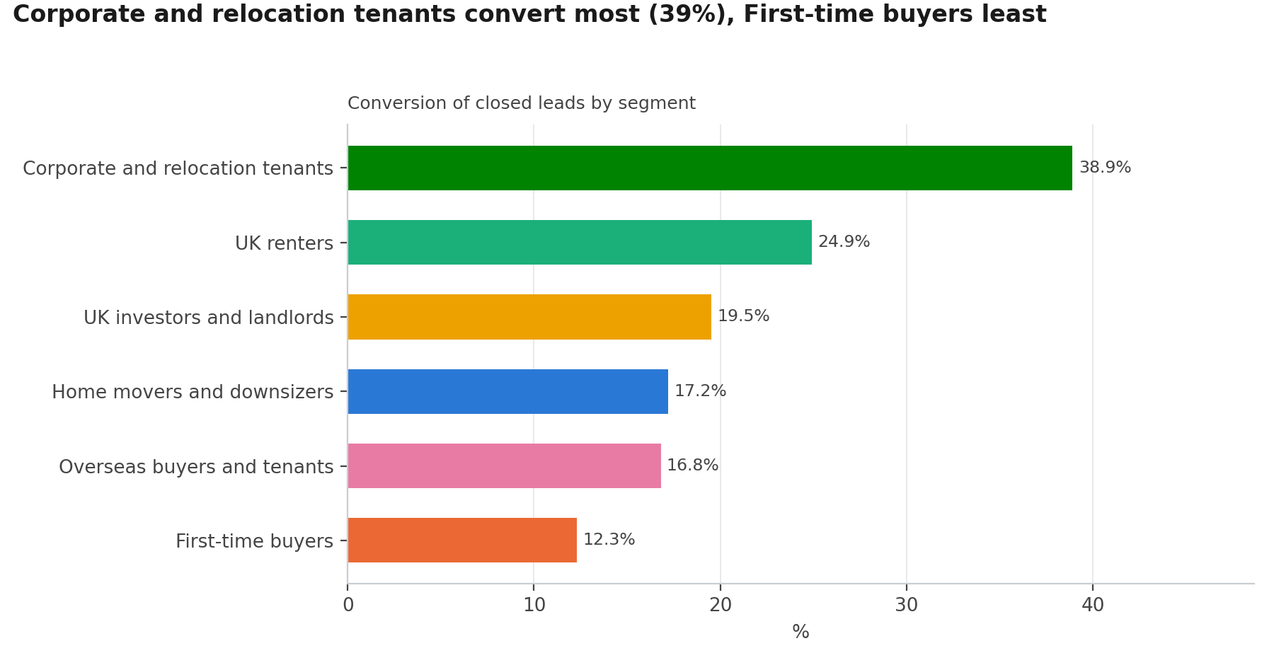
Figure 3. Conversion by segment
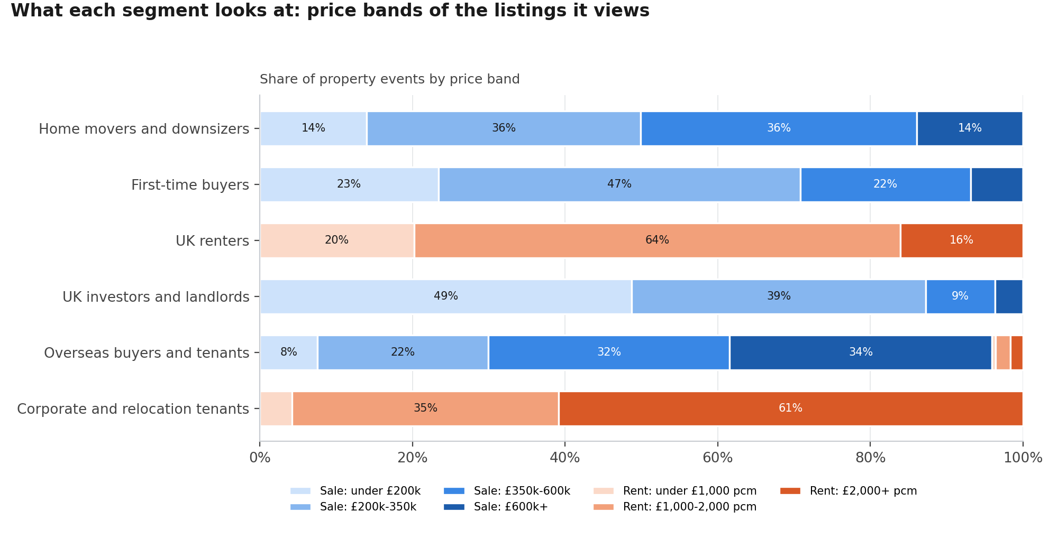
Figure 4. Price bands looked at

Home movers and downsizers · P1
38% of customers, 42% of deal value; budget around £395k; look most at flats in South East.
38,011 | 42% | 17% | 2.9%
customers | of deal value | conversion | payments late

Fact | Value
Median days to decide | 49
Median budget / rent | £395k
Living overseas | 0%
Main device | Mobile
Sessions 00:00-06:00 UK | 3%
Median first reply today | 3.8 h
March 2025 leads index (stamp duty) | 175
Window shoppers (no enquiry yet) | 15,044

How they arrive
- Rightmove: 32% of the segment's leads, converting 17%
- Zoopla: 15% of the segment's leads, converting 16%
- Veltrix website: 12% of the segment's leads, converting 17%

What they look for and buy
- Regions: South East (18%), London (16%), North West (11%)
- Property types: Flat (39%), Semi-detached (26%), Terraced (14%)
- Price bands: Sale: £350k-600k (36%), Sale: £200k-350k (36%), Sale: under £200k (14%)
- How they pay (deals): Mortgage (55%), Cash (42%), Buy-to-let mortgage (4%)

What they ask about (needs)
- School catchment (asked 3.2x as often as the average customer)
- Retirement living (asked 3.2x as often as the average customer)
- Chain and timescales (asked 2.8x as often as the average customer)

Stands out on
- Days to decide: index 136
- Price level (buyers): index 125
- Deal value per customer: index 112
- Lowest: Late payments (index 38)
- Lowest: Living overseas (index 0)
Recommended action: P1: route to Regional sales desks (Senior agent first); first contact by Branch visit; First reply within 1 hour, 7 days a week.

First-time buyers · P2
22% of customers, 18% of deal value; budget around £245k; look most at flats in North West.
21,871 | 18% | 12% | 3.7%
customers | of deal value | conversion | payments late

Fact | Value
Median days to decide | 60
Median budget / rent | £245k
Living overseas | 0%
Main device | Mobile
Sessions 00:00-06:00 UK | 3%
Median first reply today | 4.4 h
March 2025 leads index (stamp duty) | 180
Window shoppers (no enquiry yet) | 7,616

How they arrive
- Rightmove: 28% of the segment's leads, converting 13%
- Zoopla: 14% of the segment's leads, converting 12%
- Veltrix website: 12% of the segment's leads, converting 12%

What they look for and buy
- Regions: North West (16%), London (12%), Yorkshire and the Humber (11%)
- Property types: Flat (53%), Terraced (18%), Semi-detached (14%)
- Price bands: Sale: £200k-350k (47%), Sale: under £200k (23%), Sale: £350k-600k (22%)
- How they pay (deals): Mortgage (97%), Cash (3%), Buy-to-let mortgage (0%)

What they ask about (needs)
- Shared ownership (asked 3.9x as often as the average customer)
- Mortgage and finance (asked 2.3x as often as the average customer)
- Stamp duty (asked 1.5x as often as the average customer)

Stands out on
- Days to decide: index 167
- Mobile sessions: index 117
- First reply time: index 109
- Lowest: Late payments (index 49)
- Lowest: Living overseas (index 0)
Recommended action: P2: route to Regional sales desks (Mid or senior agent); first contact by Branch visit; First reply within 4 hours (working hours).

UK renters · P3
17% of customers, 1% of deal value; rent around £1,400 pcm; look most at flats in London.
16,818 | 1% | 25% | 12.3%
customers | of deal value | conversion | payments late

Fact | Value
Median days to decide | 9
Median budget / rent | £1,400 pcm
Living overseas | 0%
Main device | Mobile
Sessions 00:00-06:00 UK | 3%
Median first reply today | 3.3 h
March 2025 leads index (stamp duty) | 109
Window shoppers (no enquiry yet) | 6,517

How they arrive
- Rightmove: 30% of the segment's leads, converting 26%
- Zoopla: 20% of the segment's leads, converting 23%
- Veltrix website: 11% of the segment's leads, converting 24%

What they look for and buy
- Regions: London (30%), North West (15%), West Midlands (10%)
- Property types: Flat (76%), Terraced (11%), Maisonette (8%)
- Price bands: Rent: £1,000-2,000 pcm (64%), Rent: under £1,000 pcm (20%), Rent: £2,000+ pcm (16%)
- How they pay (deals): Renting (98%), Company let (2%)

What they ask about (needs)
- Referencing (asked 5.1x as often as the average customer)
- Tenancy terms (asked 4.5x as often as the average customer)
- Viewing arrangements (asked 1.9x as often as the average customer)
- Monthly rent paid late 14% of the time

Stands out on
- Late payments: index 163
- Conversion: index 136
- Mobile sessions: index 130
- Lowest: Deal value per customer (index 9)
- Lowest: Living overseas (index 0)
Recommended action: P3: route to Regional lettings desks (Any agent or automated nurture); first contact by Email; Same day; automated reply immediately.

UK investors and landlords · P1
12% of customers, 26% of deal value; budget around £195k; look most at flats in North West.
11,902 | 26% | 20% | 3.0%
customers | of deal value | conversion | payments late

Fact | Value
Median days to decide | 33
Median budget / rent | £195k
Living overseas | 0%
Main device | Desktop
Sessions 00:00-06:00 UK | 3%
Median first reply today | 4.0 h
March 2025 leads index (stamp duty) | 167
Window shoppers (no enquiry yet) | 1,664

How they arrive
- Rightmove: 22% of the segment's leads, converting 20%
- Veltrix website: 16% of the segment's leads, converting 19%
- Referral: 14% of the segment's leads, converting 20%

What they look for and buy
- Regions: North West (23%), Yorkshire and the Humber (16%), North East (12%)
- Property types: Flat (64%), Terraced (19%), Semi-detached (7%)
- Price bands: Sale: under £200k (49%), Sale: £200k-350k (39%), Sale: £350k-600k (9%)
- How they pay (deals): Buy-to-let mortgage (63%), Cash (35%), Mortgage (2%)

What they ask about (needs)
- Rental yield (asked 3.6x as often as the average customer)
- Offer and negotiation (asked 2.0x as often as the average customer)
- Stamp duty (asked 1.2x as often as the average customer)

Stands out on
- Deal value per customer: index 216
- Leads per customer: index 182
- Conversion: index 107
- Lowest: Late payments (index 40)
- Lowest: Living overseas (index 0)
Recommended action: P1: route to Investor desk (Senior agent first); first contact by Video call; First reply within 1 hour, 7 days a week.

Overseas buyers and tenants · P1
9% of customers, 11% of deal value; budget around £523k; look most at flats in London.
9,462 | 11% | 17% | 3.9%
customers | of deal value | conversion | payments late

Fact | Value
Median days to decide | 38
Median budget / rent | £523k
Living overseas | 100%
Main device | Mobile
Sessions 00:00-06:00 UK | 24%
Median first reply today | 6.4 h
March 2025 leads index (stamp duty) | 121
Window shoppers (no enquiry yet) | 3,046

How they arrive
- Overseas agent partner: 20% of the segment's leads, converting 13%
- Veltrix website: 15% of the segment's leads, converting 16%
- WeChat: 12% of the segment's leads, converting 14%

What they look for and buy
- Regions: London (51%), North West (11%), West Midlands (8%)
- Property types: Flat (80%), Semi-detached (6%), Detached (6%)
- Price bands: Sale: £600k+ (34%), Sale: £350k-600k (32%), Sale: £200k-350k (22%)
- How they pay (deals): Cash (37%), Company let (30%), Mortgage (21%)

What they ask about (needs)
- Currency and transfers (asked 10.0x as often as the average customer)
- Off-plan payment schedule (asked 8.2x as often as the average customer)
- Visa and relocation (asked 3.6x as often as the average customer)
- Monthly rent paid late 2% of the time

Stands out on
- Living overseas: index 1063
- Night browsing (00-06 UK): index 506
- Virtual-tour share: index 335
- Lowest: Mobile sessions (index 86)
- Lowest: Late payments (index 51)
Recommended action: P1: route to International desk (Senior agent first); first contact by Phone; First reply within 1 hour, 7 days a week.

Corporate and relocation tenants · P3
2% of customers, 1% of deal value; rent around £2,800 pcm; look most at flats in London.
2,509 | 1% | 39% | 1.5%
customers | of deal value | conversion | payments late

Fact | Value
Median days to decide | 11
Median budget / rent | £2,800 pcm
Living overseas | 0%
Main device | Desktop
Sessions 00:00-06:00 UK | 3%
Median first reply today | 2.6 h
March 2025 leads index (stamp duty) | 133
Window shoppers (no enquiry yet) | 469

How they arrive
- Relocation partner: 55% of the segment's leads, converting 39%
- Veltrix website: 11% of the segment's leads, converting 41%
- Rightmove: 10% of the segment's leads, converting 37%

What they look for and buy
- Regions: London (44%), South East (11%), North West (10%)
- Property types: Flat (59%), Semi-detached (14%), Detached (13%)
- Price bands: Rent: £2,000+ pcm (61%), Rent: £1,000-2,000 pcm (35%), Rent: under £1,000 pcm (4%)
- How they pay (deals): Company let (98%), Renting (2%)

What they ask about (needs)
- Visa and relocation (asked 23.1x as often as the average customer)
- Tenancy terms (asked 7.7x as often as the average customer)
- Referencing (asked 2.5x as often as the average customer)
- Monthly rent paid late 1% of the time

Stands out on
- Conversion: index 214
- Virtual-tour share: index 183
- New-build view share: index 103
- Lowest: Late payments (index 20)
- Lowest: Living overseas (index 0)
Recommended action: P3: route to Corporate lettings (Any agent or automated nurture); first contact by Phone; Same day; automated reply immediately.

Sign-off
Gate for Phase 5: the persona cards are approved by the heads of sales, lettings and marketing.
Role | Name | Approved / changes | Date
Head of sales
Head of lettings
Head of marketing

