Activation and test report
Phase 5 · Activation and testing · segmentation placeholder-A
CRM fields, routing rules, audiences, campaign plan, campaign test · generated by notebooks/07_activation_and_testing.ipynb on 2026-11-06

Summary
100,573 | 7 | 243,442 | 6
customers with segment + tier | routing rules | audience records, 5 channels | campaigns with a target segment

- Every lead carries a segment and a priority tier (95,804 of 95,804 leads), via its customer.
- Routing: window shoppers go to automated nurture before any agent sees them; enquiries are routed by segment to a desk and seniority with the tier's reply target.
- Today only 28% of the 2,778 open P1 leads sit with senior agents: re-assigning them is the first job after go-live.
- 34,356 window shoppers (34% of customers) move to automated nurture, freeing agent time for serious buyers and tenants.
- Campaign test: A/A check passed: the two groups do not differ (p = 0.53), so the split and the monitoring query work.

1. CRM fields
Fields the CRM team adds or updates. The customer file is crm_segments_<date>.csv; routing rules are in the workbook.
CRM field | Values | Level | Meaning | Source in PostgreSQL | Updated
segment_name | Text | Customer | Segment from the model in use | crm_export.segment_name | Monthly (scoring) / on model change
priority_tier | P1 / P2 / P3 | Customer | Value per lead tier: P1 >= 115, P2 60-114, P3 < 60 (100 = average lead) | segment_tiers.priority_tier | With segment_name
model_version | Text | Customer | Which segmentation produced the label (e.g. seg-v1.0) | crm_export.model_version | With segment_name
engagement_status | Has enquired / Window shopper / Low engagement | Customer | Window shopper = 3+ sessions and no enquiry | customer_engagement | Weekly
nurture_track | Active weekly / Dormant monthly | Customer | E-mail track for window shoppers | customer_engagement | Weekly
routed_desk | Text | Lead (via segment) | Desk that should own the lead | routing_rules.route_to_desk | On lead creation
agent_level | Text | Lead (via segment) | Senior first / Mid or senior / Any agent | routing_rules.agent_level | On lead creation
first_reply_target_min | Minutes | Lead (via segment) | 60 (P1), 240 (P2), 480 (P3) | routing_rules.first_reply_target_min | On lead creation
target_segment | Text | Campaign | The segment a campaign is aimed at | campaign_plan.target_segment | Each new campaign
test_group | Test / Control | Lead | Campaign test arm (fixed hash of lead_id) | test_assignment.test_group | On lead creation, during the test

2. Routing rules
Rules are checked in order; the first match wins.
# | Applies to | Tier | Desk | Agent level | Reply target (min) | Action
1 | Window shopper (no enquiry yet) |  | Automated nurture (no agent) | None |  | E-mail nurture track; create a lead and re-route on first enquiry
2 | Home movers and downsizers | P1 | Regional sales desks | Senior agent first | 60 | First contact by Branch visit; First reply within 1 hour, 7 days a week
3 | Overseas buyers and tenants | P1 | International desk | Senior agent first | 60 | First contact by Phone; First reply within 1 hour, 7 days a week
4 | UK investors and landlords | P1 | Investor desk | Senior agent first | 60 | First contact by Video call; First reply within 1 hour, 7 days a week
5 | First-time buyers | P2 | Regional sales desks | Mid or senior agent | 240 | First contact by Branch visit; First reply within 4 hours (working hours)
6 | Corporate and relocation tenants | P3 | Corporate lettings | Any agent or automated nurture | 480 | First contact by Phone; Same day; automated reply immediately
7 | UK renters | P3 | Regional lettings desks | Any agent or automated nurture | 480 | First contact by Email; Same day; automated reply immediately

Table 1. Why each segment has its tier (100 = average lead)
Segment | Tier | Value per lead index | £ per closed lead | Conversion % | Desk
Home movers and downsizers | P1 | 142 | 62,724 | 17.2 | Regional sales desks
Overseas buyers and tenants | P1 | 121 | 53,367 | 16.8 | International desk
UK investors and landlords | P1 | 118 | 52,041 | 19.5 | Investor desk
First-time buyers | P2 | 84 | 37,074 | 12.3 | Regional sales desks
Corporate and relocation tenants | P3 | 40 | 17,895 | 38.9 | Corporate lettings
UK renters | P3 | 10 | 4,379 | 24.9 | Regional lettings desks

Table 2. Open pipeline today by tier
Tier | Open leads | With a senior agent | % with senior
P1 | 2,778 | 769 | 27.7
P2 | 1,382 | 317 | 22.9
P3 | 220 | 54 | 24.5

3. Audiences per segment
Only customers who consented to marketing. Ad platforms receive SHA-256 hashes, never raw e-mail or phone; WeChat covers residents of China, Hong Kong, Singapore and Malaysia. Confirm each platform's hash format before the first upload.
Table 3. Reachable customers per segment and channel
Segment | E-mail | Meta | Google Ads | TikTok | WeChat | Customers
Home movers and downsizers | 23,087 | 23,087 | 23,087 | 23,087 | 0 | 38,011
First-time buyers | 13,411 | 13,411 | 13,411 | 13,411 | 0 | 21,871
UK renters | 10,707 | 10,707 | 10,707 | 10,707 | 0 | 16,818
UK investors and landlords | 6,962 | 6,962 | 6,962 | 6,962 | 0 | 11,902
Overseas buyers and tenants | 5,155 | 5,155 | 5,155 | 5,155 | 2,082 | 9,462
Corporate and relocation tenants | 1,018 | 1,018 | 1,018 | 1,018 | 0 | 2,509

Table 4. Automated nurture list
Nurture track | Consenting window shoppers
Active: weekly new-listings e-mail | 5,583
Dormant: monthly digest | 16,070

4. Campaign plan
Next month's campaigns, each with a target_segment: the segment that has brought the most deal value through that channel. Marketing can change any target; the column must not be left empty.
Table 5. Campaign plan (first 25 of 6; all in Veltrix_campaign_plan.xlsx)
Campaign | Channel | Theme | Target segment | Tier | Spend £
CMP-202610-PORTAL | Portal featured | Autumn movers | Home movers and downsizers | P1 | 20,192
CMP-202610-GOOG | Google Ads | Autumn movers | Home movers and downsizers | P1 | 16,727
CMP-202610-META | Meta | Autumn movers | Home movers and downsizers | P1 | 14,025
CMP-202610-TIKTOK | TikTok | Autumn movers | First-time buyers | P2 | 4,984
CMP-202610-WECHAT | WeChat | Autumn movers | Overseas buyers and tenants | P1 | 4,929
CMP-202610-EMAIL | Email | Autumn movers | UK investors and landlords | P1 | 1,121

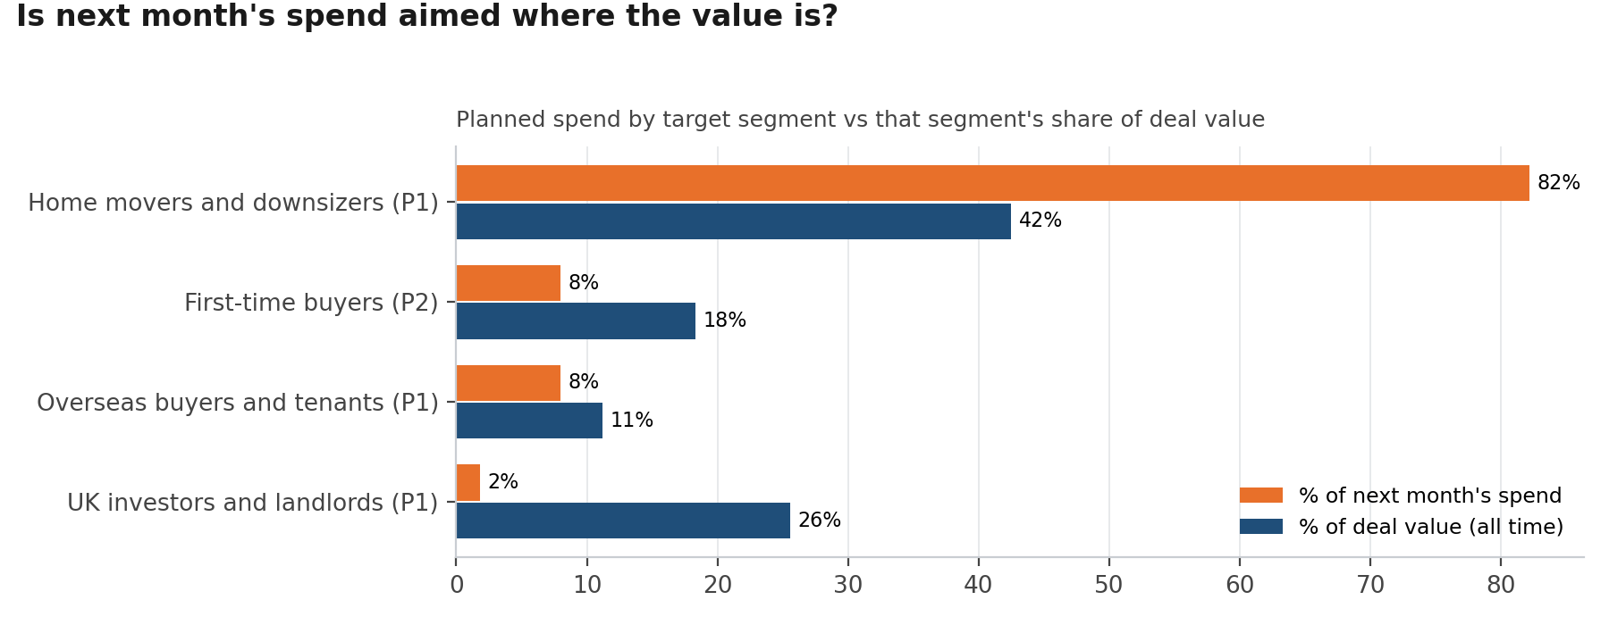
Figure 1. Planned spend vs deal value by target segment

5. The campaign test

Design
Item | Setting
Test | Senior 1-hour reply for P1 home movers (A/A check)
Target segment | Home movers and downsizers
Dates | 2026-08-03 to 2026-09-13 (6 weeks)
Treatment | Senior agent, first reply within 1 hour, 7 days a week
Control | Standard handling
Assignment | 50/50 by a fixed hash of lead_id (a lead never changes group)
Primary KPI | Viewing booked within 14 days of enquiry
Guardrail | Answered within 1 hour must rise in Test, or the treatment did not happen
Win | Test beats Control by at least 9 points, p < 0.05
Monitoring | clean.test_kpi_weekly, refreshed every Monday (Pipeline and agents page)

Results to date (A/A check on past data)
 | Test | Control
Leads with 14 days of follow-up | 464 | 465
Viewing within 14 days | 51.9% | 49.9%
Answered within 1 hour (guardrail) | 14.5% | 18.8%

Difference +2.0 points (95% CI -4.4 to +8.5), p = 0.53. With this many leads the test can detect an uplift of about 9 points (80% power, 5% significance).
A/A check passed: the two groups do not differ (p = 0.53), so the split and the monitoring query work.

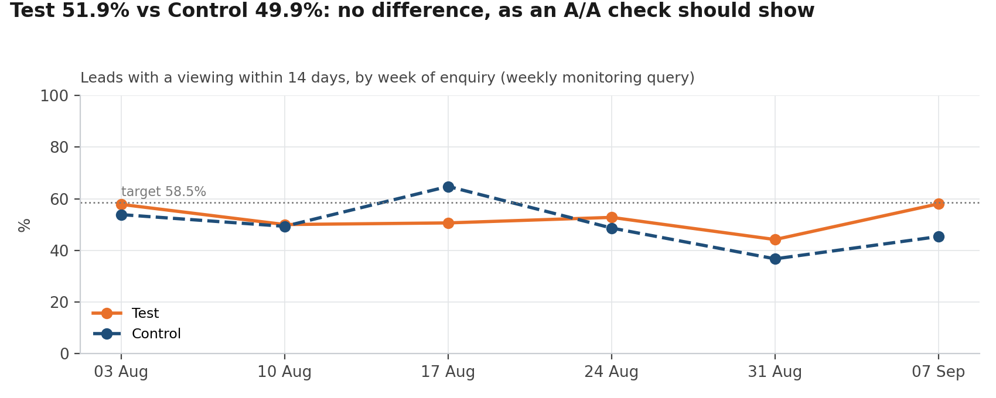
Figure 2. Weekly monitoring query: Test vs Control
The real test starts when its dates are set in clean.test_settings (see the note in file 13, STEP 4). Re-run this notebook after six weeks to produce the final test results.

Approval (gate: test design approved before launch)
Role | Name | Date approved
Business analyst lead
Head of sales
Data scientist

6. Dashboard and monitoring
The 4-page Power BI dashboard (Overview, Segment deep dive, Pipeline and agents, Payments and lettings, plus the Data check page) reads the views above. After each refresh, every number is checked against its SQL source with Veltrix_dashboard_reconciliation.xlsx.
Dashboard page / visual | SQL source to reconcile with
Overview: KPI cards | clean.powerbi_check
Overview: segments vs value | clean.segment_comparison (model in use)
Segment deep dive: cards, index, channels, action | clean.segment_profile / segment_index / segment_channels / segment_actions
Pipeline and agents: tiers by desk | clean.open_leads_by_tier
Pipeline and agents: test KPI | clean.test_kpi_summary / test_kpi_weekly
Payments and lettings: late share | clean.clean_payments (is_late_or_overdue)
Data check page | dq.dq_log, clean.powerbi_check, clean.crm_export_counts
Monitoring | clean.monitoring_latest

Latest monitoring run: 16 checks, 0 alert(s). Segment sizes are compared with the handover baseline; a shift above 20% raises an alert and triggers a model review.

