Institute for Computational Systems Biology
University of Hamburg

Lecture: Foundations of Systems Biology, WS 2025-26
Group:
Student names:

Exercise sheet 03 - Biostatistics I

1. “Know your Data” - Load, inspect and familiarize with a given data set (3 points)

Download data “phenoData.csv” from a study on human myocardial disease from here: https://github.com/mpmorley/MAGNet?tab=readme-ov-file

File can also be found in the moodle course.

For more information on the patient cohort, feel free to visit https://www.med.upenn.edu/magnet/

- Use a (non)-coding tool of your choice, e.g., Excel, R (studio) or python, to load and inspect the data. What is the dimension of the given data table? (0.5 points)

366 rows x 20 columns

- Types of data: Inspect the data in each column with respect to data types. What are quantitative data, i.e., discrete or continuous data? What are qualitative (categorial) data, i.e., binary, nominal or ordinal data? Fill in Table 1 or provide a screenshoot of the filled table. (1 points)

- Missingness: Determine the missingness, i.e., absolute and relative numbers of missing values “NA”, of the dataset: (1) entire data set, (2) number of rows with at least one NA value, (3) number of NA values per columns (fill Table 1 or provide screenshoot of table). (0.5 points)

- Regarding the data in column “Diabetes” and “RIN”. What would be your suggestion to deal with either of the missing values? (0.5 points)

Do one test for existing values and another test for missing values.

- Data filtering: Remove all rows that contain NAs. What is the dimension of the data frame after removal of NAs? From now on: continue working with the NA-filtered data table. (0.5 points)
113 rows x 20 columns

Table 1: Overview of variables in the given data table including unique variable names, data type, and missingness (excluding columns: sample_name, Library.Pool, minexpr, disease_race).
Column header | Abbreviations | Name unique entries for categorical data | Data type | ‘NA’ (abs) | ‘NA’ (rel)
tissue_source | NF - non-failing | {'Cardiectomy'}  {'NF'} | Categorical, nominal | 0 | 0
etiology | DCM - Dilated Cardiomyopathy  HCM - hypertrophic cardiomyopathy  NF - non-failing  PPCM - Peripartum Cardiomyopathy | {“DCM”, “HCM”, “PPCM”, “NF”} | Categorical, nominal | 0 | 0
gender | - | {“Male”, “Female”} | Categorical, nominal | 0 | 0
race | AA - afro-american | {“Caucasian”, “AA”} | Categorical, nominal | 0 | 0
age | - | Numbers, integers | Quantitative, discrete | 0 | 0
weight | - | Decimal numbers | Quantitative, continuous | 0 | 0
height | - | Decimal numbers | Quantitative, continuous | 1 | 0,0027
hw | Heart weight | Numbers, integers | Quantitative, discrete | 7 | 0,02
lv_mass | Left ventricle | Numbers, integers | Quantitative, discrete | 207 | 0,57
afib | Atrial fibrillation | {“No”, “Yes”} | binary | 5 | 0,014
VTVF | Pulseless ventricular tachycardia (VT) and Ventricular fibrillation (VF) | {“No”, “Yes”} | binary | 2 | 0,0055
Diabetes | - | {“No”, “Yes”} | binary | 2 | 0,0055
Hypertension | - | {“No”, “Yes”} | binary | 1 | 0,0055
LVEF | Left ventricle ejection fraction | Decimal numbers | Quantitative, continuous | 80 | 0,22
RIN | RNA integrity value | Decimal numbers | Quantitative, continuous | 6 | 0,016
TIN.median | Median transcript integrity number | Decimal numbers | Quantitative, continuous | 0 | 0

2. Describe your data - Use the NA-filtered data table (Task 1e). (2 points)
- Determine min, max, median, mean, mode, variance, standard deviation, first and third quartile, IQR for columns age, weight, height and RIN (fill Table 2 or provide a screenshot of the filled table). (0.5 points)
 | age | weight | height | RIN
min | 21 | 46 | 55 | 5,9
max | 76 | 267 | 196 | 9,9
mean | 53 | 87,46 | 166,7 | 8,7
median | 54 | 84 | 170 | 8,56
mode | 56 | 63 | 163 | 8,7
variance | 107.05 | 686,3 | 540,1 | 0,443
std | 10.35 | 26,2 | 23,2 | 0,666
Q(0.25) | 49 | 69 | 162 | 8,2
Q(0.75) | 59.25 | 101 | 180 | 8,9
IQR | 10.25 | 32 | 18 | 0,7

- Plot histograms of age and height, describe and compare the histograms using the statistical metrics in Table 2, e.g. what is the range, variability, etc. of the data? Are there any unexpected instances and/or outliers in the data? (1 points)

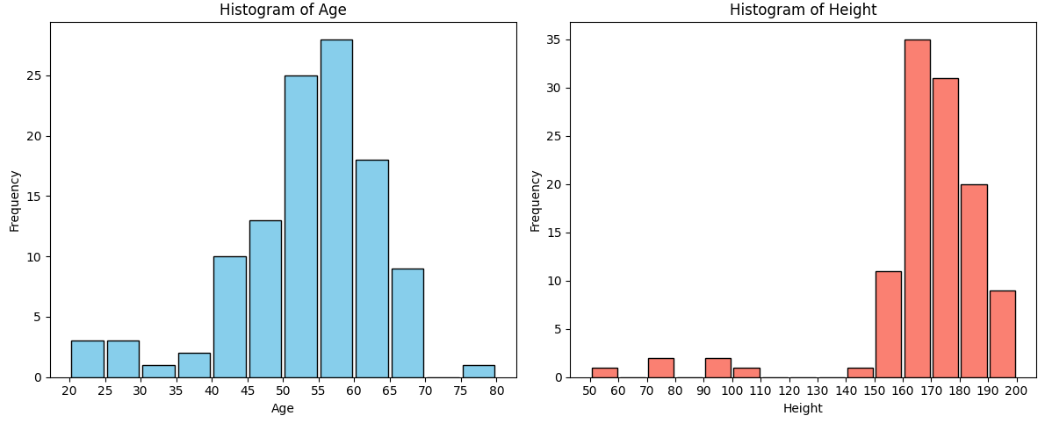
The age histograms shows a distribution that is not very uniform, deviating from the normal distribution. Generally most ages are clustered around the 50-60 yo range, with a std of 10. There are very few participants older than 70 or younger than 40, although the portion of 20-30 yo is higher than expected if the distribution would be bell-shaped. The sample is shifted to older adults compared to the general population. The values are completely plausible
The height histogram shows a bell-shaped distribution around the median of 170 with a plausible IQR of 162-180. Howver, there are several outliers clearly separated from the main distribution at 50-110cm. These are very unlikely to be actual heights and are probably errors in the data gathering.

- The integrity of RNA is crucial for gene expression studies. A RIN value of 1 indicates the presence of very small RNA pieces, i.e., most of the RNA is highly degraded. Usually a RIN between 7 and 10 denotes “good” integrity. How would you describe the RNA integrity of the present study using the descriptive values in Table 2? (0.5 points)

The mean at 8.7 with a std of 0.7 suggest that the average quality of the RNA is quite high and also relatively constant between samples. The min values lies at 5.9 so even the worst sample has acceptable quality. Only 6 values are “NA”, so the overall quality of the data is good.

3. Quantitative values: boxplots - Use the NA-filtered data table (Task 1e). (2 points)
- Create a figure with four boxplots on the same axes using the data for age, weight, height and TIN.median. Describe the datasets accordingly (“five-number summary”, Table 3 or screenshot) and include explanations on the boxes, whiskers and outliers. (1.5 points)
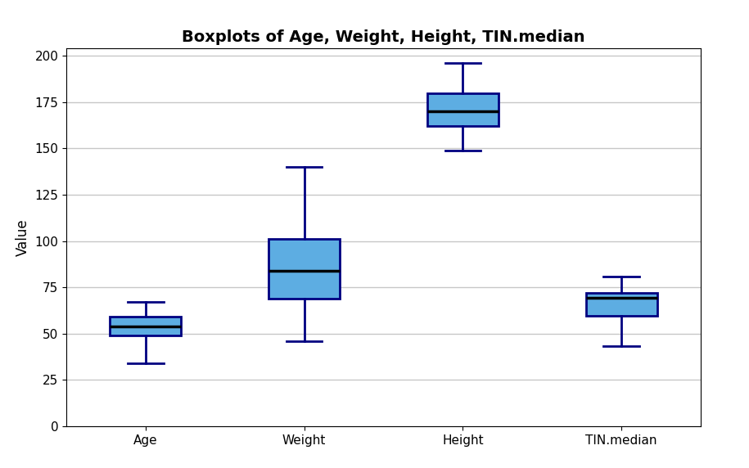
Boxplot explanations:
- The box shows the interquartile range (IQR), from Q1 (25th percentile) to Q3 (75th percentile).
- The line inside the box is the median (Q2, 50th percentile).
- The whiskers extend to the most extreme data points not considered outliers (IQR from the box).
- Outliers are not shown

Table 3: “Five-number summary” of boxplots.
 | age | weight | height | TIN.median
Lower whisker | 34 | 46 | 149 | 43,5
Upper whisker | 67 | 140 | 196 | 80,8
Median | 54 | 84 | 170 | 69,4
Q(0.25) | 49 | 69 | 162 | 59,8
Q(0.75) | 59.25 | 101 | 180 | 72,1
Number of Outliers | 7 | 1 | 6 | 20

- Is the figure from 3a), with the four data sets, an example of a good or bad data visualization? Explain why. (0.5 points)

No, because completely disparate data is plotted on the same axis. The units are different and erroneously treated as unitless integers.

4. Categorical values: frequency tables, pie charts, stacked bar charts - Use the NA-filtered data table (Task 1e). (1.5 points)
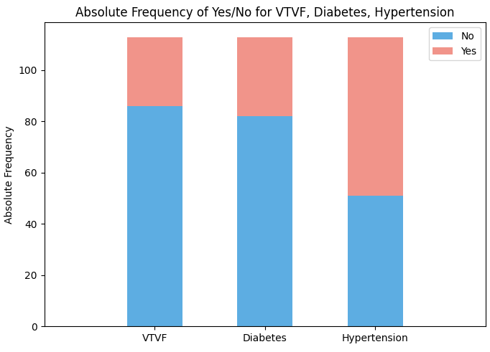
- Create a stacked bar chart for the data of VTFV, Diabetes and Hypertension, with “VTFV”, “Diabetes” and “Hypertension” on the x-axis and absolute frequency of “Yes” and “No” as stacked bar on the y-axis. (0.5 points)

- For gender, race and etiology, create both frequency tables as well as pie charts.
(1 points)

Table 4: Frequency table for gender, race and etiology.
Gender
Male | 59
Female | 54
Race
AA | 37
Caucasian | 76
Etiology
DCM | 46
NF | 54
HCM | 13

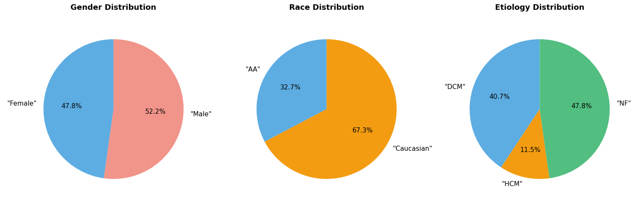

5. Study and data interpretation (1.5 points)
- Is the study data representative of a population? (0.5 points)

No, because data was collected with the explicit goal of understanding human myocardial disease, meaning patients of this disease were selected.
Furthermore, the uneven distribution of age differs starkly with overall demographics. Only two ethnicities were selected, which doesn’t align with general population, were more ethnicities are expected for 366 persons.

- What other measurements of the study cohort would you like to acquire to draw insightful conclusions from the data with respect to elucidating myocardial disease? (0.5 points)

The gathered RNA data was not actually analyzed in this assignment, which would take up a large part of the actual study.
Further, family data could lead to new insights to better separate genetic causes from other causes

- What could be biases in the data? (0.5 points)
Selection bias: People had to be HMD patients to qualify for the study meaning they cannot be directly compared to other cohorts
Volunteer bias (self-explanatory)
Detection bias: esp. for older patients other cardiovascular problems could delay the HMD diagnosis

