DAISY’s WordToEPUB plugin for Microsoft Word is a free tool that allows you to convert any Word document into an accessible ePub. It is available as a free plugin from [DAISY](https://daisy.org/) for the Microsoft Word desktop application on **Windows only.**

ePubs are an open-source eBook format with standardized accessibility features. You can read about the [ePub standard](https://www.w3.org/publishing/epub3/epub-spec.html) at the w3c. ePubs are widely used by the blind and low vision community as they work particularly well with screen readers, are easily navigable with assistive technologies and allow text to be customized to various needs (i.e. resizable, contrast).

# **Download** and **install** WordToEPUB Plugin.

* 1. Minimum requirements are Windows 7 and Microsoft Word 2010 or newer.
  2. You can follow these [instructions](https://daisy.org/activities/software/wordtoepub/installing-wordtoepub/) to help you install.
  3. [Download](https://dl.daisy.org/tools/WordToEPUB/setupWordToEPUB.exe) the WordToEpub installer and follow the prompts.

# Launch **Word** and **confirm** WordToEpub is installed.

* 1. Open or restart Microsoft Word.
  2. Open the home tab and look for WordToEPUB in the ribbon

The microsoft word ribbon toolbar with WordToEpub selected

Figure 1 The Microsoft Word Ribbon menu showing the WordToEPUB button

* 1. If you can see the WordToEPUB button, it is installed successfully.

# Prepare your **word document** for conversion to ePub.

* 1. Follow the [Accessible Microsoft Word](https://www.accessibledigitallearning.org/resource/accessibility-toolkit/) Guide included in this toolkit.
  2. You can also use DAISY’s guide for [creating Accessible Word Documents.](https://daisy.org/info-help/guidance-training/daisy-tools/creating-accessible-word-documents/)

# ePub specific **recommendations.**

* 1. Add **title** and **author** in the Word Document Properties.
     1. Click on **File** in the Ribbon
     2. Click on **Info** in the left-hand menu.
     3. Edit the **Title** field

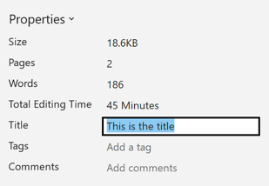

Figure 2 The Microsoft Word document properties view with Title edit.

* + 1. The **Author** field will be filled with your name as an owner of the document.
  1. Use the **built-in** word functionality to ensure WordToEPUB will recognize your formatting and structure
     1. Use built-in **styles** for headings
     2. When using blockquotes, use the built-in styles for **Block Text.**
     3. Use built-in **bullets** and **numbered lists**
     4. Use built-in **tables**
     5. Use built-in **references / insert endnote** feature in Word for footnotes and endnotes.
  2. Make sure to provide alt-text for non-decorative images that are not described in the surrounding text.

# Export your Word as an **EPUB**

* 1. Press WordToEpub button in the home ribbon.
  2. Enter the name of your file.

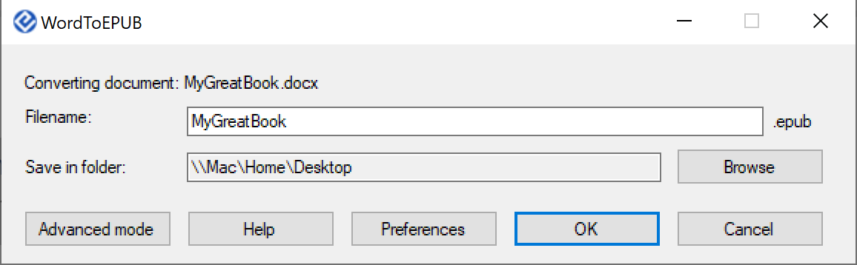

Figure 3 The WordToEPUB dialog box.

* 1. Choose a destination.
  2. Press OK!
  3. You have successfully exported your ePub!

# Advanced features

* 1. WordToEPUB comes with many additional features you can use to:
     1. Edit the **Metadata** of the file
     2. Add **Cover image**
     3. Choose the **Language**
     4. Insert Math as **MathML**
     5. Manage **Page Numbers** and more.

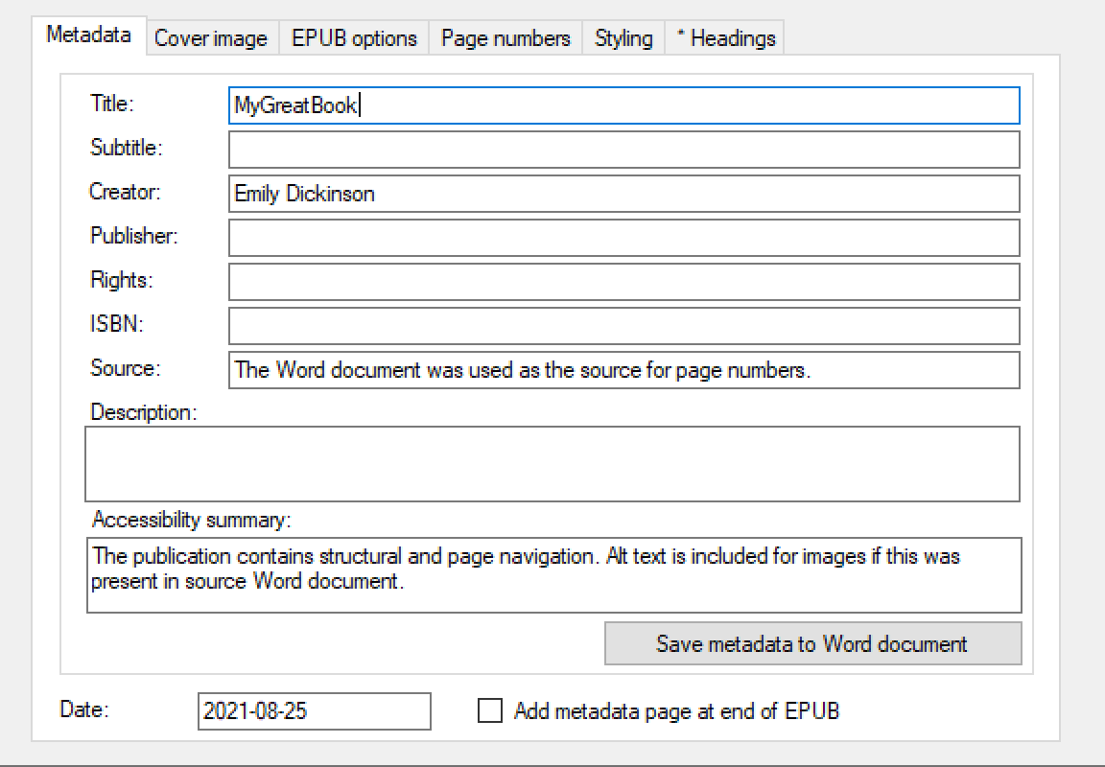

Figure 4 The WordToEPUB advanced options box

* 1. You can learn more about the advanced features from [DAISY’s Advanced Guide to WordToEPUB.](https://daisy.org/info-help/guidance-training/daisy-tools/advanced-guide-to-wordtoepub/)

# **Test** the ePub using an **ePub Reader**

* 1. It is essential you test that your ePub opens and displays as you intended with a widely used ePub reader.
  2. [**Thorium**](https://www.thorium.com/)is a popular and free ePub reader with many accessibility features.
     1. You can [download](https://www.edrlab.org/) Thorium for Mac and Windows.

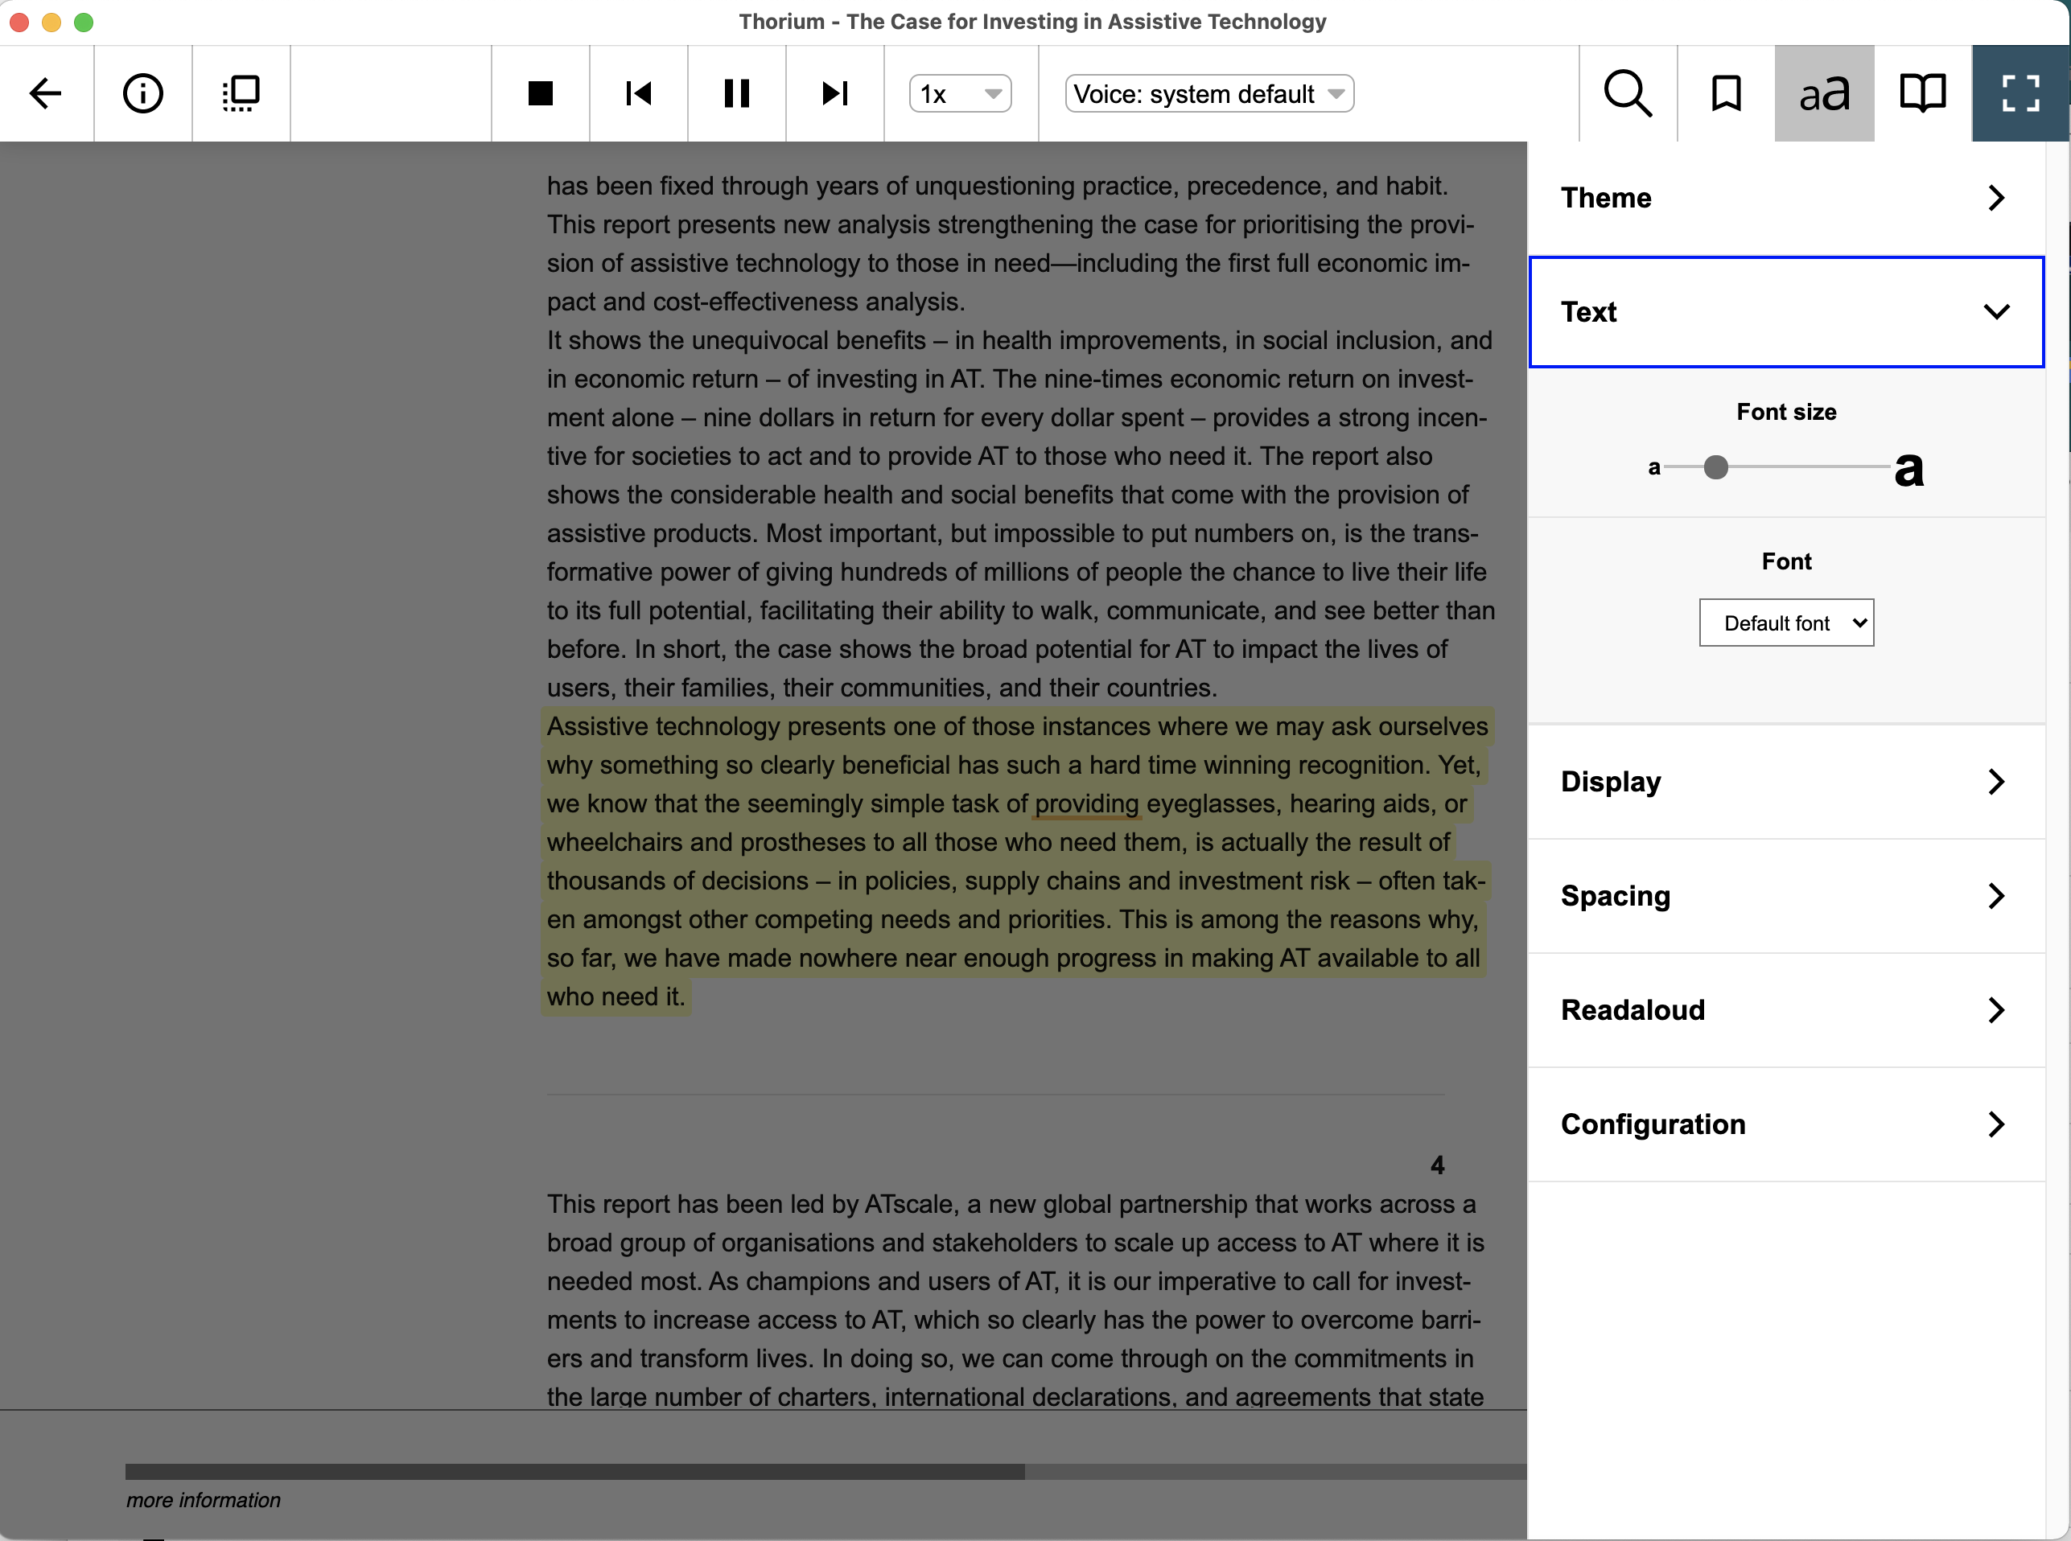

Figure 5 The Thorium ePub reader

# Check your **ePub**

* 1. It is essential you test that your ePub opens and displays as you intend with a widely used reader.
  2. [**Thorium**](https://www.edrlab.org/software/thorium-reader/)is a popular and free ePub reader developed by EDRLab.
     1. You can [download](https://www.edrlab.org/software/thorium-reader/) thorium for Mac and Windows.

## Optional Steps

# Try **read aloud** functionality in **Thorium**.

* 1. **Read aloud** can be a useful **learning tool** for users who prefer to **listen**
  2. In Thorium, the words will be **highlighted** as you listen.
  3. You can also change the **speed**, **voice type** and **pause** or **skip** during playback.
  4. Open an ePub and press the **sound icon** which will change to the **play bar.**

The read aloud button and the playbar for controlling speed and skipping

Figure 6 The Read aloud button and playback options from Thorium.

# **Edit** your ePub

* 1. You can edit your ePub using the freely available software [Calibre](https://calibre-ebook.com/).
  2. Editing your ePub allows you to make custom modifications to the **style, content, structure** and embed **media** and advanced features.
  3. An understanding of web technologies, ePub packages and html / css is necessary.

# **Validate** your ePub

* 1. If you make changes to your ePub, you must validate your ePub will open without any errors.
  2. You can use [ePubCheck](https://www.w3.org/publishing/epubcheck/) to test your ePub package.

**Additional Links**

<https://www.w3.org/publishing/epub3/epub-spec.html>

<https://daisy.org/activities/software/wordtoepub/>

<https://www.edrlab.org/software/thorium-reader/>

<http://diagramcenter.org/54-9-tips-for-creating-accessible-epub-3-files.html>

Casos especiales

Redirección de una página a otra: rust playground: [enlace](https://play.rust-lang.org/)

Redirección de una página a otra -falta de login-: [enlace](https://school.moodledemo.net/admin)