HOW TO FLASH MICROPYTHON FIRMWARE INTO THE ESP8266 USING THONNY

BY ANDRE KURIA

first you need to install thonny

if you are a Linux user copy and run this command into your terminal

bash <(wget -O - https://thonny.org/installer-for-linux)

For Windows and Mac users go to the website and get the download files

https://thonny.org

Now that you need the micropython firmware , head on to the micropython page and download the firmware

https://micropython.org/download/esp8266/

Once the firmware is downloaded you can open the thonny application .

Go to Tools then select manage plugin then search for esptool and install

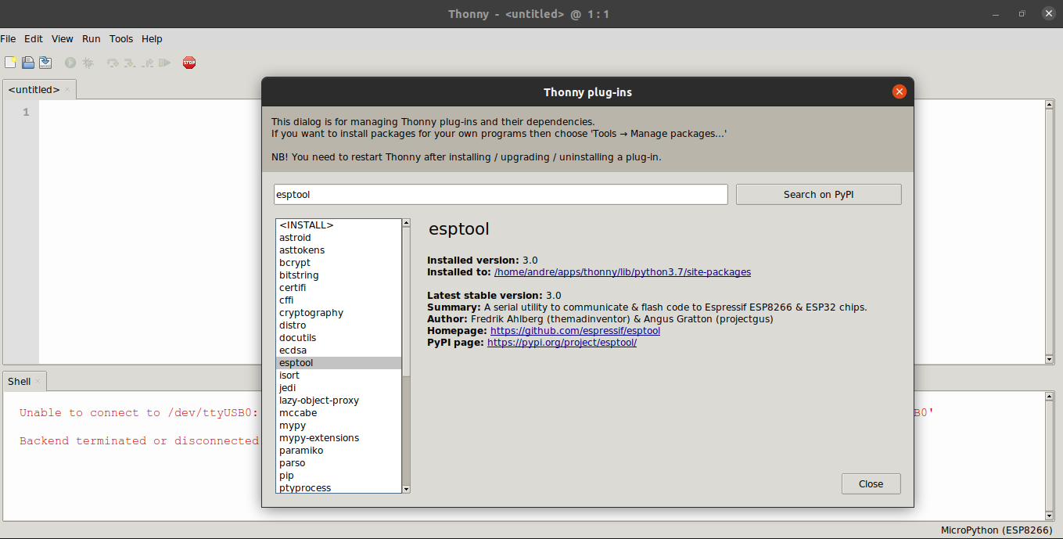

You can now plug in the esp8266 on the computer using a USB cable.

Once our esp8266 is plugged in we now set the thonny interpreter to MicroPython (ESP8266)

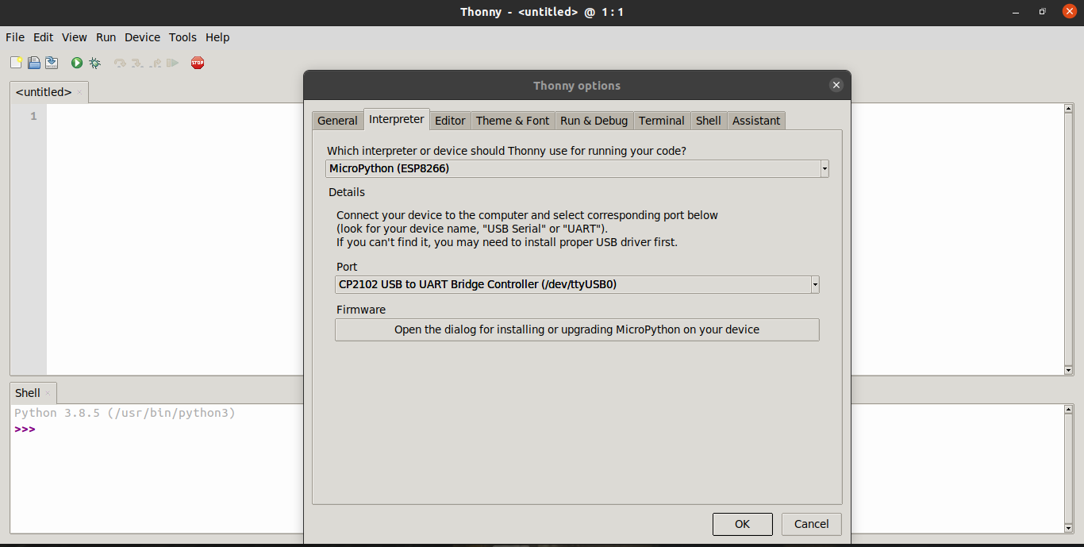

Next step is setting the USB port of the ESP8266 , the port should be noticed automatically. If not please try closing the thonny application and rerun it or ensure that the USB cable is UART compatible.

Having selected the port , you now open the MicroPython installation dialogue then:

- Select the same port
- Browse to the micropython firmware previously downloaded

Please ensure that the Erase flash before installing is checked

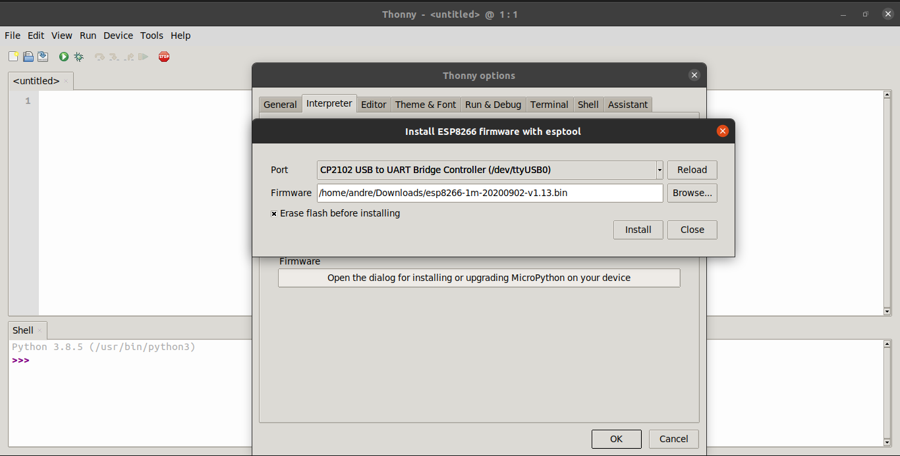
You can install now

After the installation is complete you should see the micropython repl on the shell .

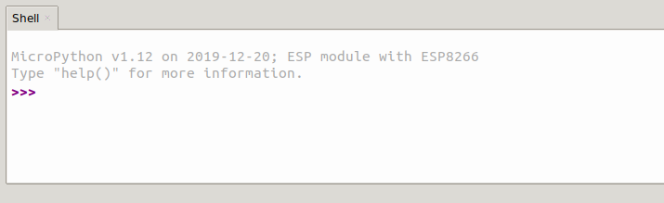

Copy the following code into the micropython repl

import esp
esp.check_fw()

This should return True and booting the micropython firmware was a success

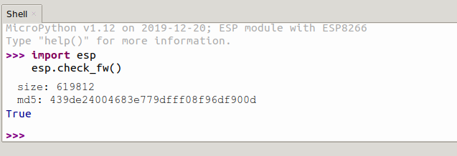

Since the micropython is ready . We can have a further test with actual micropython code that light up the on board of the ESP8266.
Copy the following board to the micropython repl

from machine import Pin

led1 = Pin(2, Pin.OUT)
led1.off()

This should light up the led on the board.

