LED Torch Project.

To complete this project successfully and to a high enough standard that is acceptable of any good craftsman, you must be wise with your time.

You will only have 6 x 1 hour lessons in school, so therefore you are trusted to complete this project in your own time at lunch, at home or both.

Use the table below to write yourself a plan of action so you will get your work completed and handed in on time.

|  |  |  |  |  |  |  |  |  |  |  |  |  |  |
| --- | --- | --- | --- | --- | --- | --- | --- | --- | --- | --- | --- | --- | --- |
|  | Clean the PCB | Drill the PCB | Solder the PCB | Put the case together around the PCB | Clean the edges of the finished Torch | Complete Stage 1 of the work sheet | Complete Stage 2 of the work sheet | Complete the portfolio | Create the circuit on circuit wizard | Create the PCB on circuit wizard | Draw the torch on 2D Design | Proof read and ‘green pen’ your work | Hand in both Practical and Theory work, to you teacher. End of unit test |
| Lesson 1 |  |  |  |  |  |  |  |  |  |  |  |  |  |
| Lesson 2 |  |  |  |  |  |  |  |  |  |  |  |  |  |
| Lesson 3 |  |  |  |  |  |  |  |  |  |  |  |  |  |
| Lesson 4 |  |  |  |  |  |  |  |  |  |  |  |  |  |
| Lesson 5 |  |  |  |  |  |  |  |  |  |  |  |  |  |
|  |  |  |  |  |  |  |  |  |  |  |  |  |  |
| Lunch 1 |  |  |  |  |  |  |  |  |  |  |  |  |  |
| Lunch 2 |  |  |  |  |  |  |  |  |  |  |  |  |  |
| Lunch 3 |  |  |  |  |  |  |  |  |  |  |  |  |  |
| Lunch 4 |  |  |  |  |  |  |  |  |  |  |  |  |  |
| Lunch 5 |  |  |  |  |  |  |  |  |  |  |  |  |  |
|  |  |  |  |  |  |  |  |  |  |  |  |  |  |
| Home 1 |  |  |  |  |  |  |  |  |  |  |  |  |  |
| Home 2 |  |  |  |  |  |  |  |  |  |  |  |  |  |
|  |  |  |  |  |  |  |  |  |  |  |  |  |  |
| Home 3 |  |  |  |  |  |  |  |  |  |  |  |  |  |
|  |  |  |  |  |  |  |  |  |  |  |  |  |  |
| Lesson 6 |  |  | Last lesson of the week commencing 14/10/2013 | | | | | | | | |  | X |

**USE YOUR TIME WISELY**

|  |  |
| --- | --- |
| LED Torch Stage 1 | Electronics |

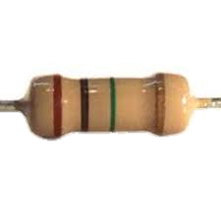

**Resistors**

When reading a resistor, hold it so the three colour bands that are close together are on you left, you now read the bands from left to right.

Example:

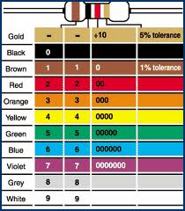

So therefore this resistor value is 560 ohms + or – 28 (5%)

This equals a value between 532 ohms and 588 ohms

5%+ -

6

0

5

Now fill in the table below the first one is done for you.

Use the chart on your left to help you

|  |  |  |  |  |  |  |
| --- | --- | --- | --- | --- | --- | --- |
| Resistor | Band 1 | Band 2 | Band 3 | OHMS | - | + |
|  | Green 5 | Blue 6 | Brown 0 | 560 | 532 | 588 |
|  |  |  |  |  |  |  |
|  |  | Violet |  |  |  |  |
|  |  |  |  |  |  |  |
|  |  | Grey |  |  |  |  |
|  |  |  |  |  |  |  |

Explain in detail below why we use resistors in a circuit.

In the box on the right draw or paste from the Internet a circuit symbol for a resistor

**LEDs**

What does LED stand for?

Fill in the labels of the LED below.

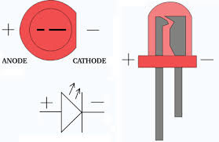

In the box below draw or paste from the Internet a circuit symbol for a LED

**Stage 2 Plastics and Fixings**

There are two categories of plastics. Research the Internet to find out what these are called and find some examples. Then fill in the table below. The name of one category and plastic is already given to you.

|  |  |  |
| --- | --- | --- |
|  | Thermo plastic |  |
|  |  |  |
| 1 |  | Epoxy resin |
| 2 |  |  |
| 3 |  |  |

What is the name of the plastic you have used in your project?

You are using machine screws to fix your torch together, how do we refer to these screws to describe the right length and diameter?

M

|  |  |  |
| --- | --- | --- |
| Name | Symbol | Picture |
| 2 x 3 volt cells (battery) |  |  |
|  |  |  |
|  |  |  |
| Resistor (use the correct band colours) |  |  |

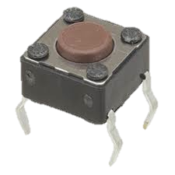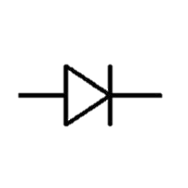

On the following pages produce a portfolio of how you have created your torch and what you have learnt.

Use the keywords, pictures, screen shots, labels and explanations to create a step-by-step guide.

Fill in the table below, naming all the components you have used in your torch project

**Components**

Research and write down an alternative method of assembling your torch, using the correct terminology.

Key words

LED, Resistor, PTM switch, Acrylic, M3X12, PCB, Drill, 2D design, Hand drawn picture, Final photo, Batteries, Lead,

Circuit wizard - circuit diagram, Circuit wizard – PCB, Countersunk, Screwdriver, Laser cutter, Oxidization, Wire wool, Solder, Copper track, 1mm twist drill bit, chuck, precision drill, delete tool, artwork, real world, component side, track side, dry joint, toggle tool, drawing tool, gallery, input, output, process, passive, current, polish, flat file, wet and dry paper, de-solder.

Name

LED Torch Portfolio

Step 1. Cleaning

When I was given my Printed Circuit board (PCB) I cleaned the copper tracks with fine grade wire wool to remove the dirt (oxidization). This was so that when I soldered my components to it they would stick first time without the track lifting, as I have learnt that solder does not stick to a dirty track.

A labelled picture of the PCB goes here.

Now carry on in the same format as step 1, but delete this text box first

Name

LED Torch Portfolio

Name

LED Torch Portfolio