Marc Scott

WHOAMI
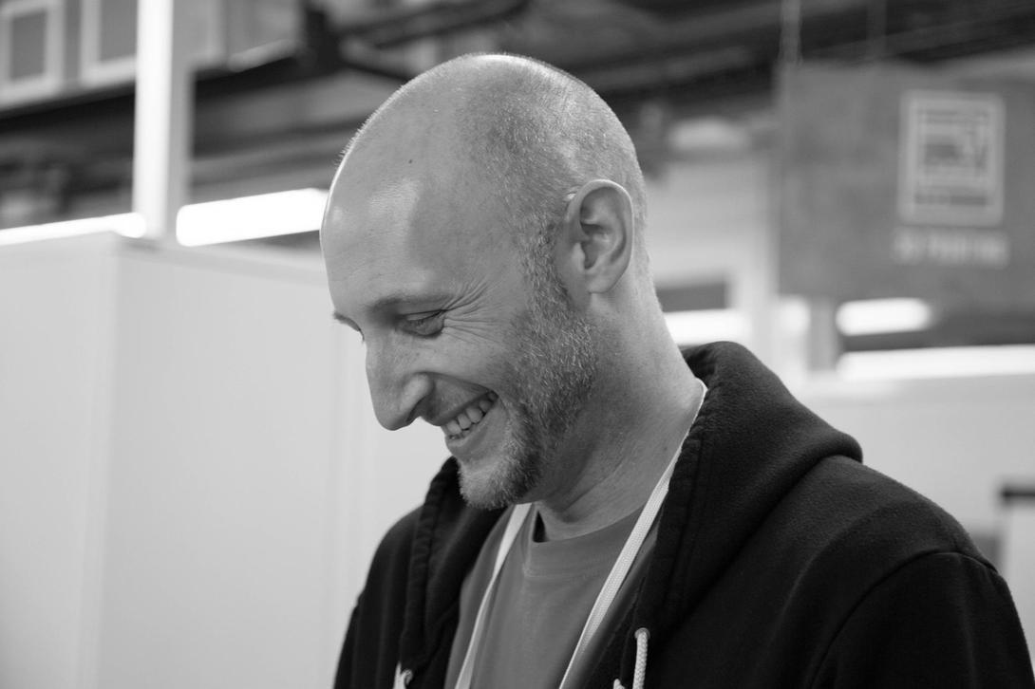
- www.coding2learn.org
- @coding2learn
Teacher of Science, Computer Science and Systems & Control 15 yrs Now work for Raspberry Pi Foundation as Content and Curriculum Manager Blog and twitter handle

Raspberry Pi Trading
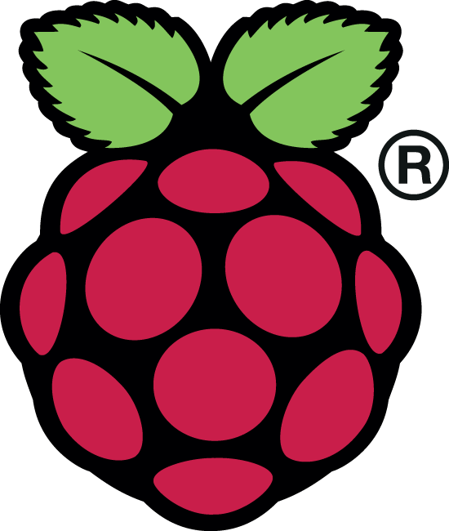
Raspberry Pi Trading design and arrange manufacture of the hardware, as well as owning the MagPi Magazine

Pi 3
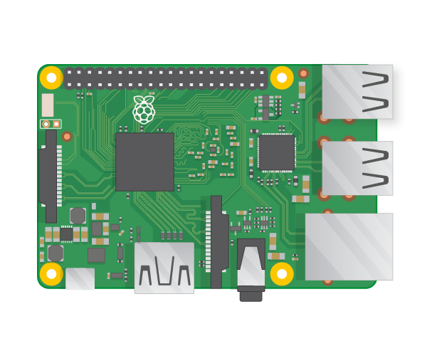

Zero
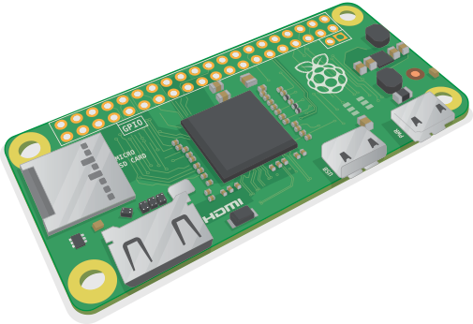

SenseHAT
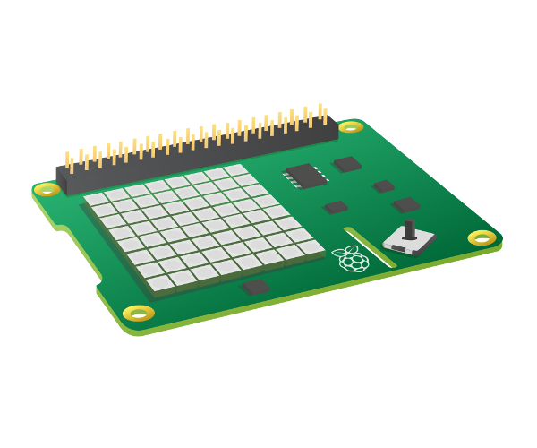

Camera
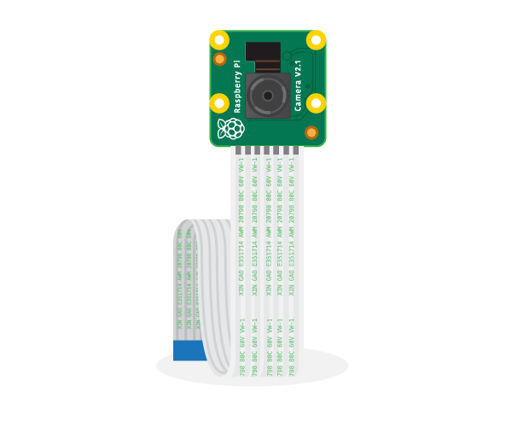

MagPi
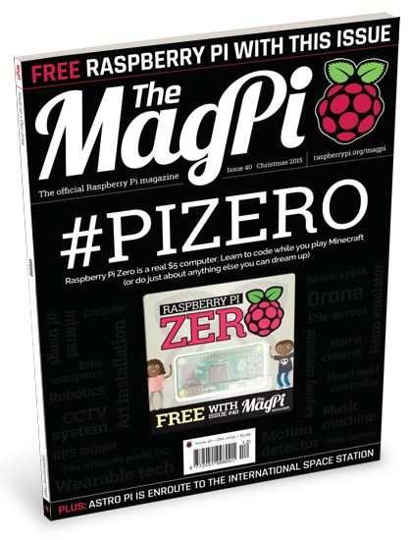

Raspberry Pi Trading
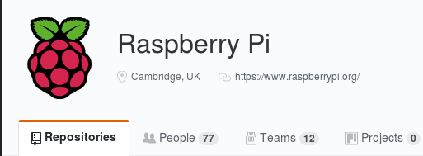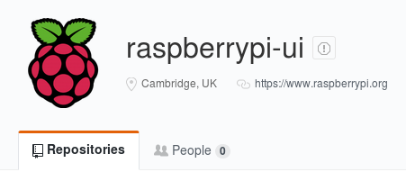
If you're interested in kernel development or OS UI design then check out the repos here

The Raspberry Pi Foundation
- An educational charity
- Founded in 2009
- Putting the power of digital making into the hands of people all over the world.
- One way we do this is by making low-cost computers and out first went on sale in February 2012
- As of March this year, we've sold 12.5 million.
- Charity that is financed by the sale of the Raspberry Pi
- Education and outreach

What we do with all that money

Resources
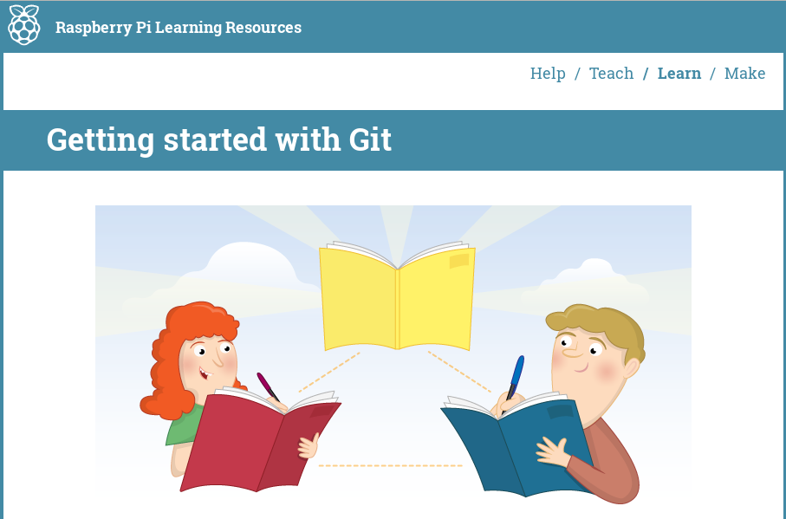
More on this later

Teacher Training
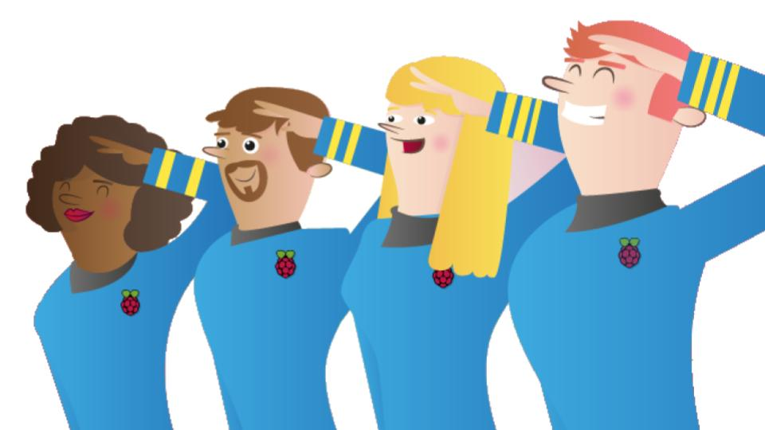
Face to face training - over 1100 educators world wide Online training with continued course creation

Outreach
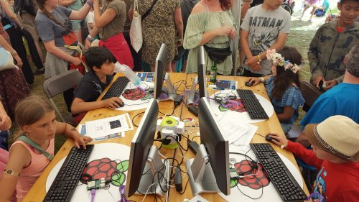

Jam support
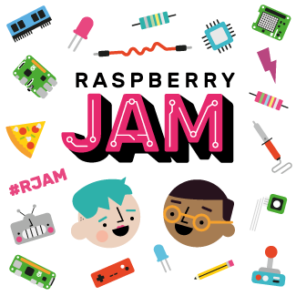

Projects
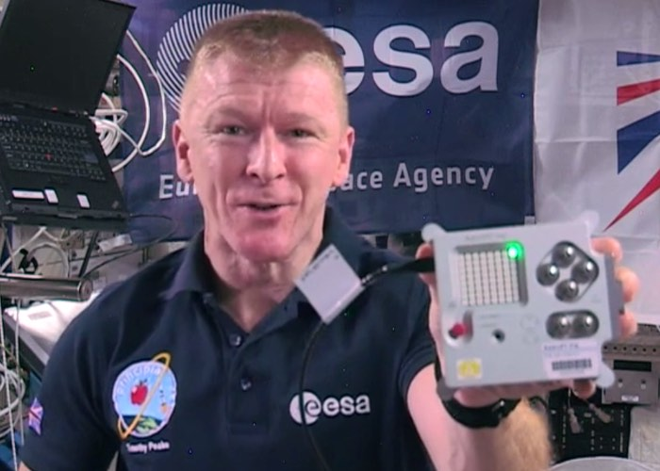
UK comp - Tim Peake European comp - Thomas Pesquet

Open Source Software

We love FOSS
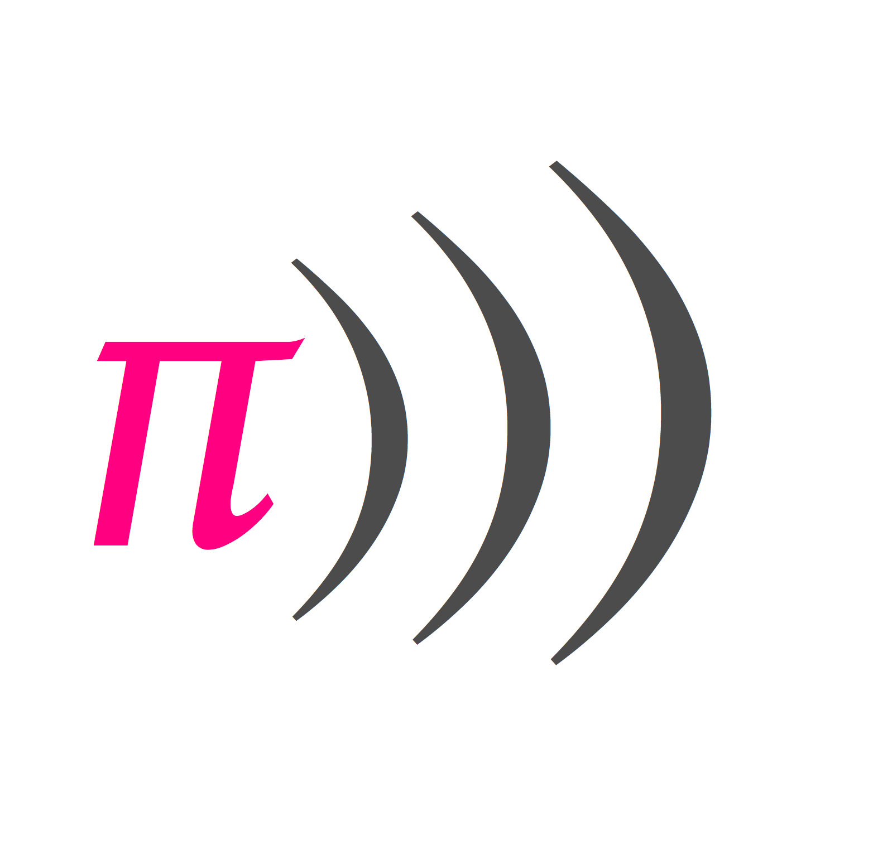
Funded initial development of Sonic Pi All resources and training uses and promotes FOSS Software

Open Educational Resources
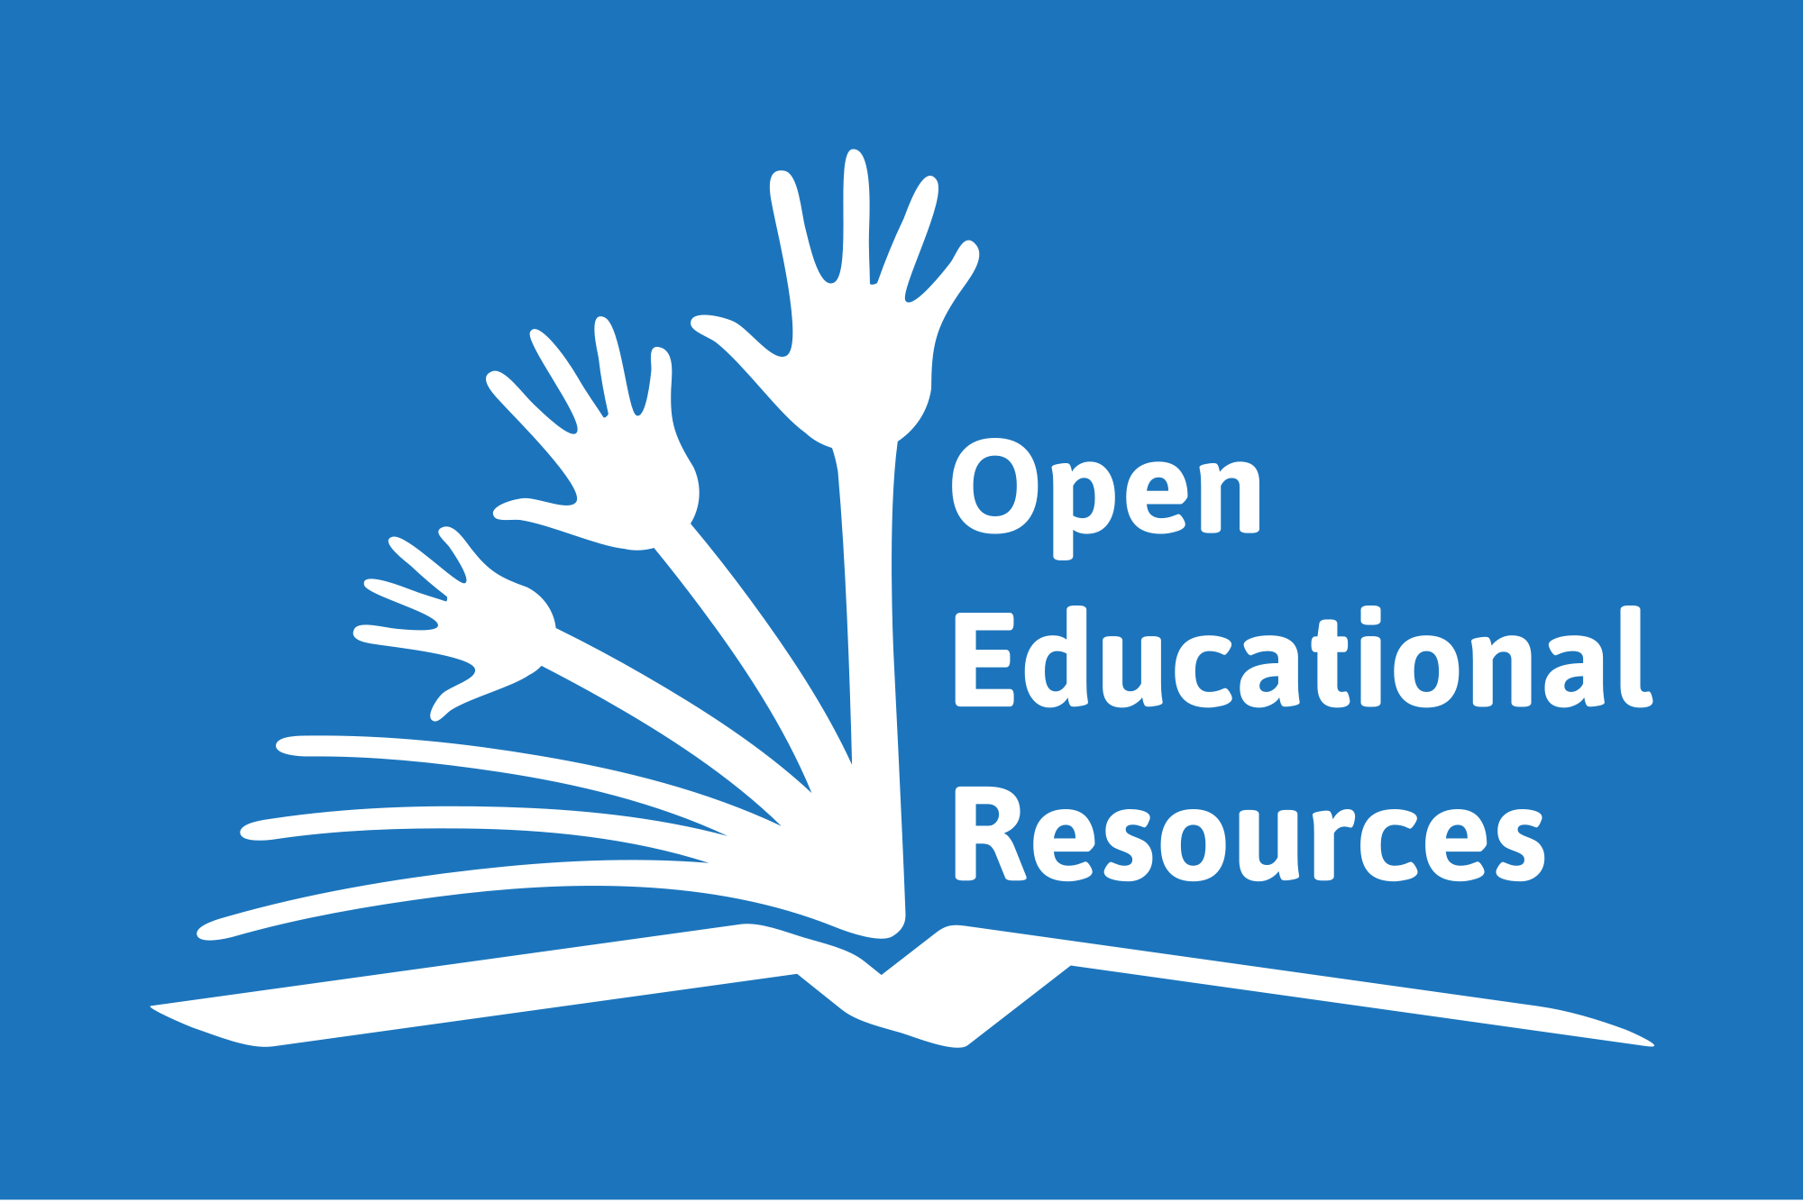
- OER started in around 2002 by United Nations Educational, Scientific and Cultural Organisation
- Producing resources that are licensed so as to allow free use and re-purposing
- How teachers usually create resources:
  - Individually
  - Not shared or just shared within a department
  - Often shared using formats such as PDF to prevent modification
- Better way - using open platforms and nor proprietary formats.
- Raspberry Pi Foundation uses markdown and GitHub to produce and distribute resources

Generating resources

Start a project
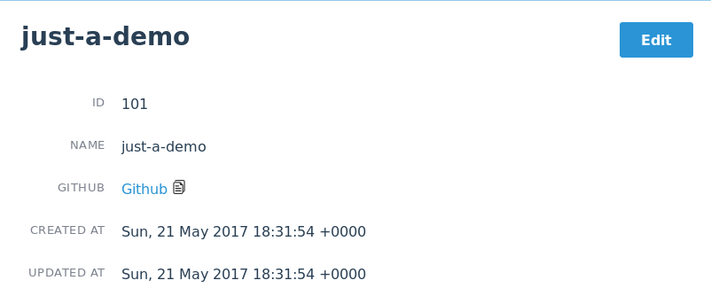

Create a repo
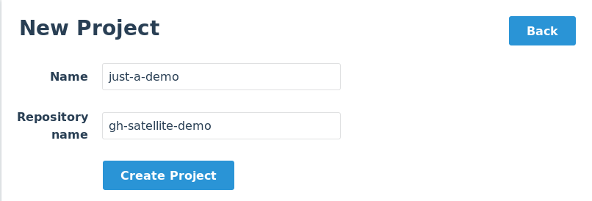

Clone
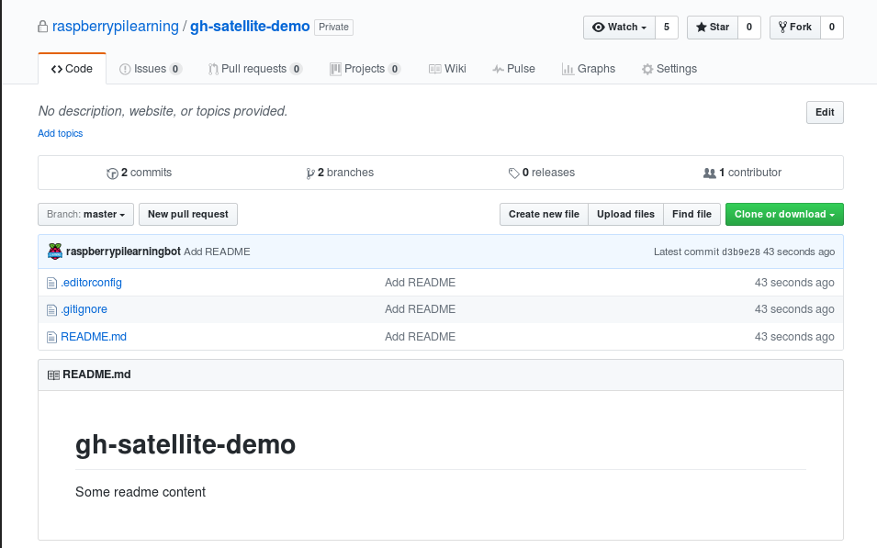
- Back end involves a bot that creates a repo with master and draft branches ready for educators to use

How we make content

Markdown
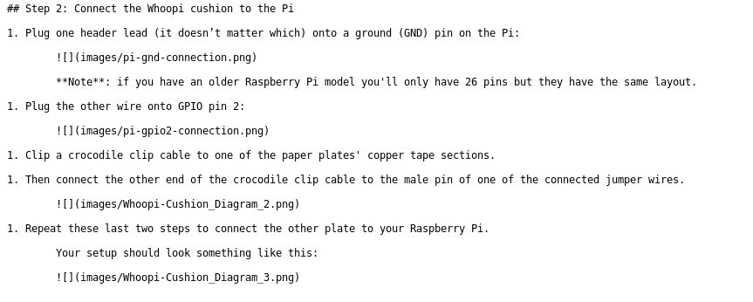

How it looks
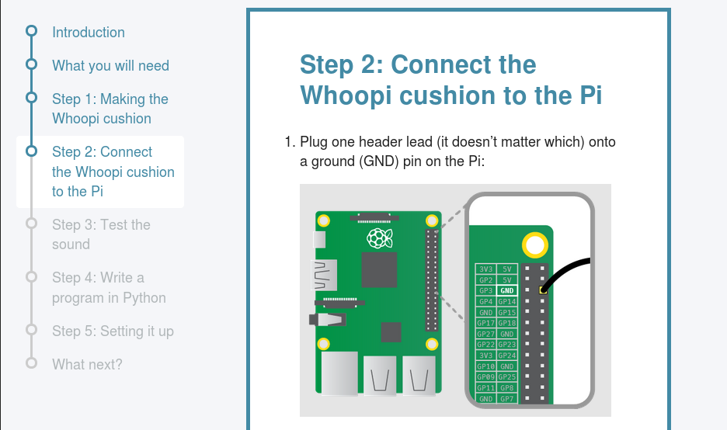
- We write in markdown
- Pushing to draft branches triggers a webhook to pull the content to our staging server
- Pushing to master triggers a webhook to pull to live

How our community engages with us and how you can to

Issues
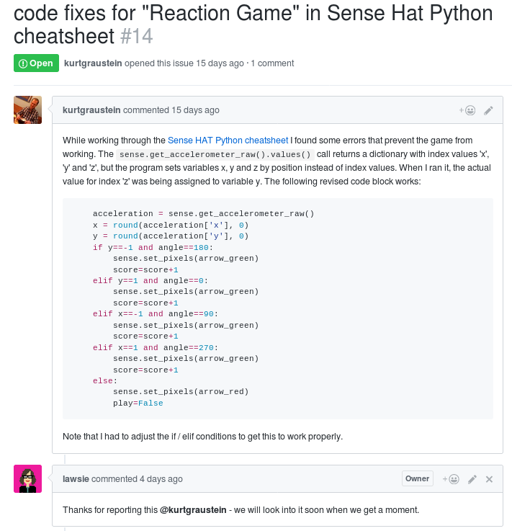

Pull requests
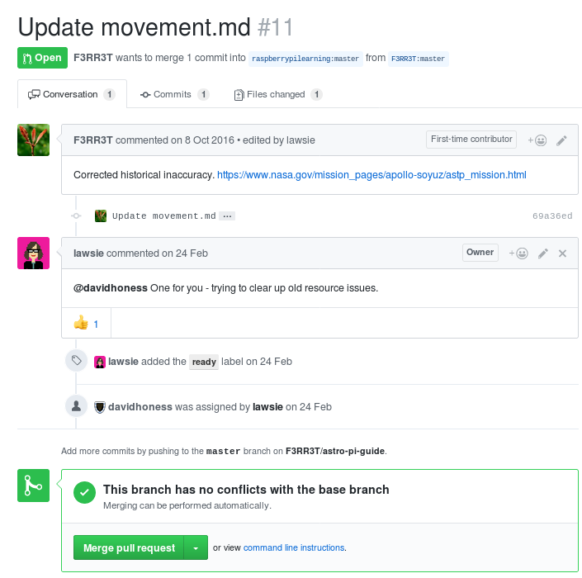

Contributions
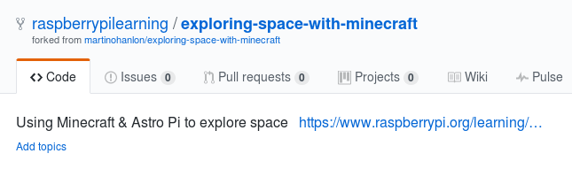

Why do we do this?
IMAGE HERE OF KIDS CODING

The state of digital making

The Good - The Kids
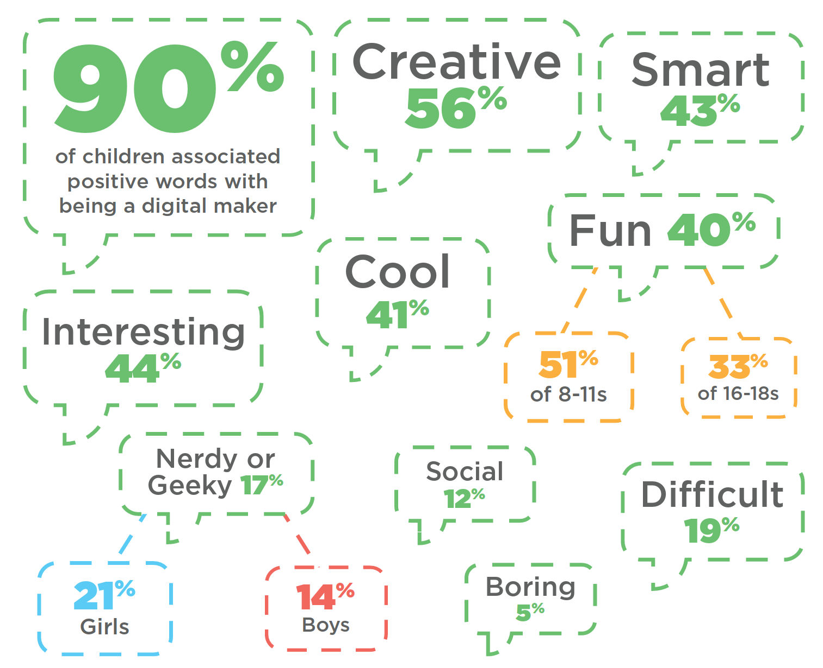

The Okay - The Parents
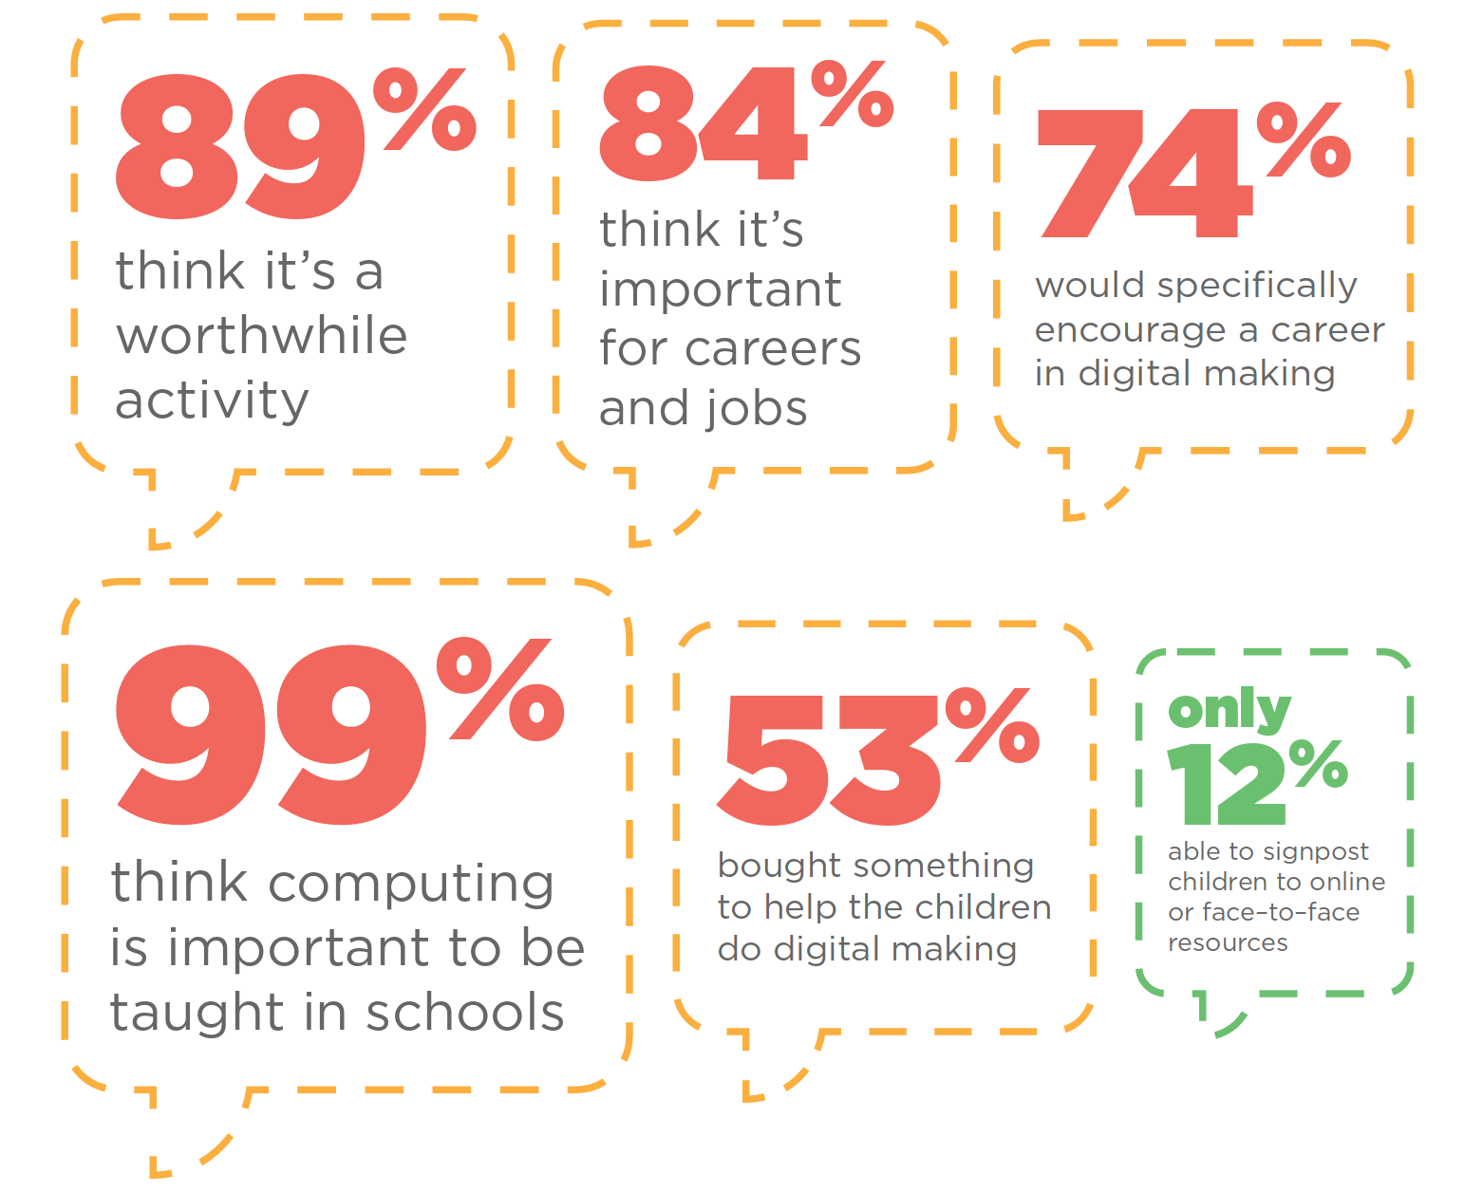

The Bad - The Teachers
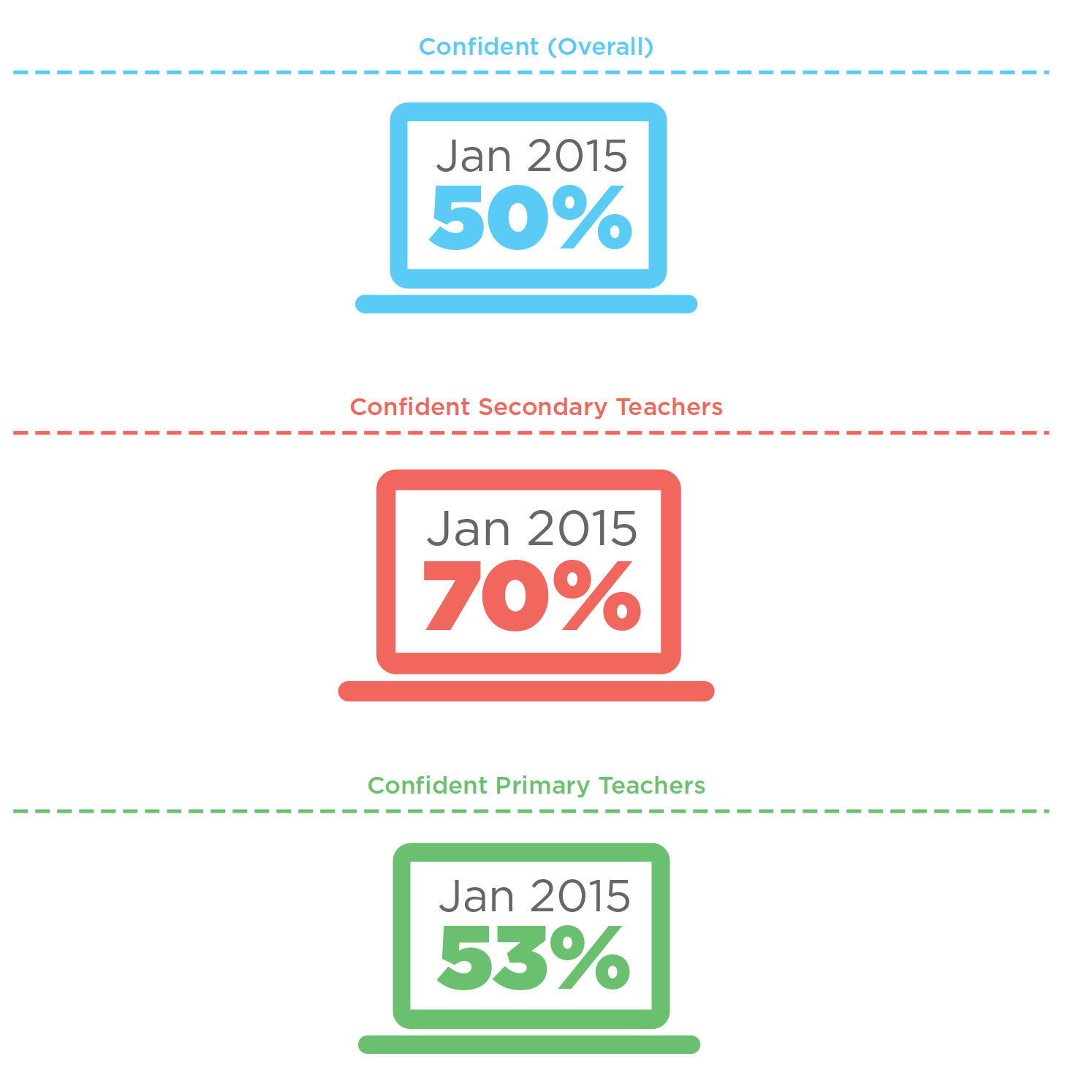

The Problem
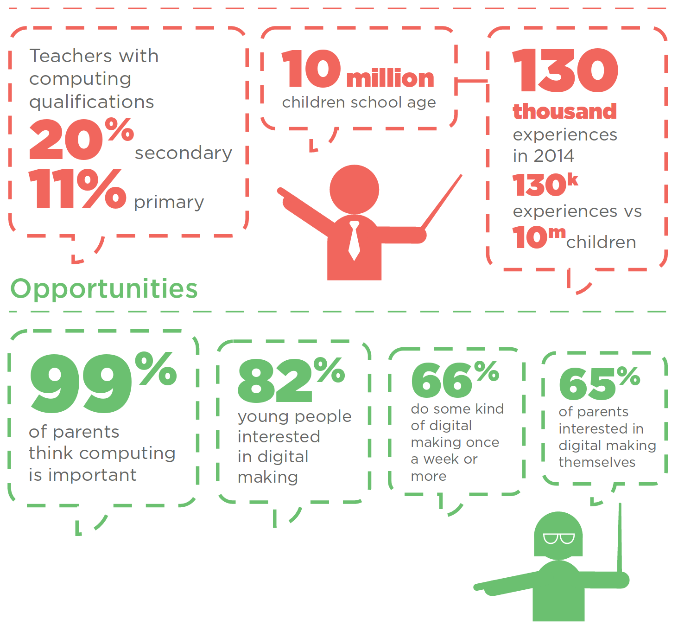

More can be done

Volunteers can help


Code Club - What?
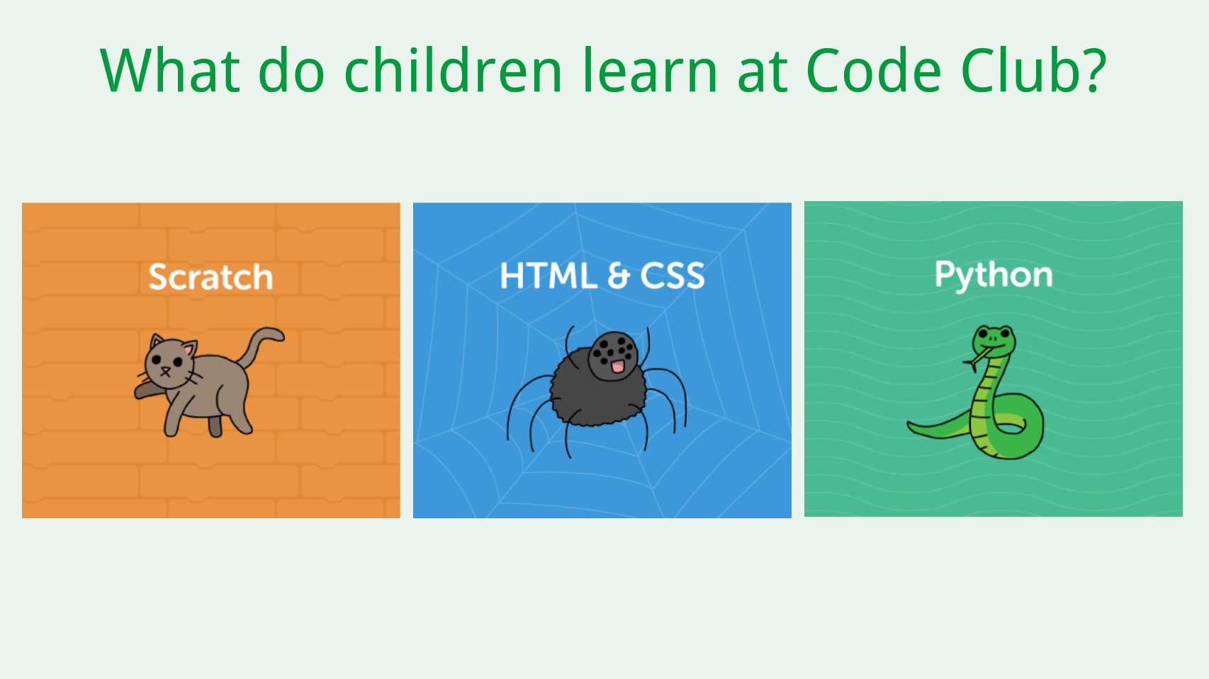

Code Club - Where?
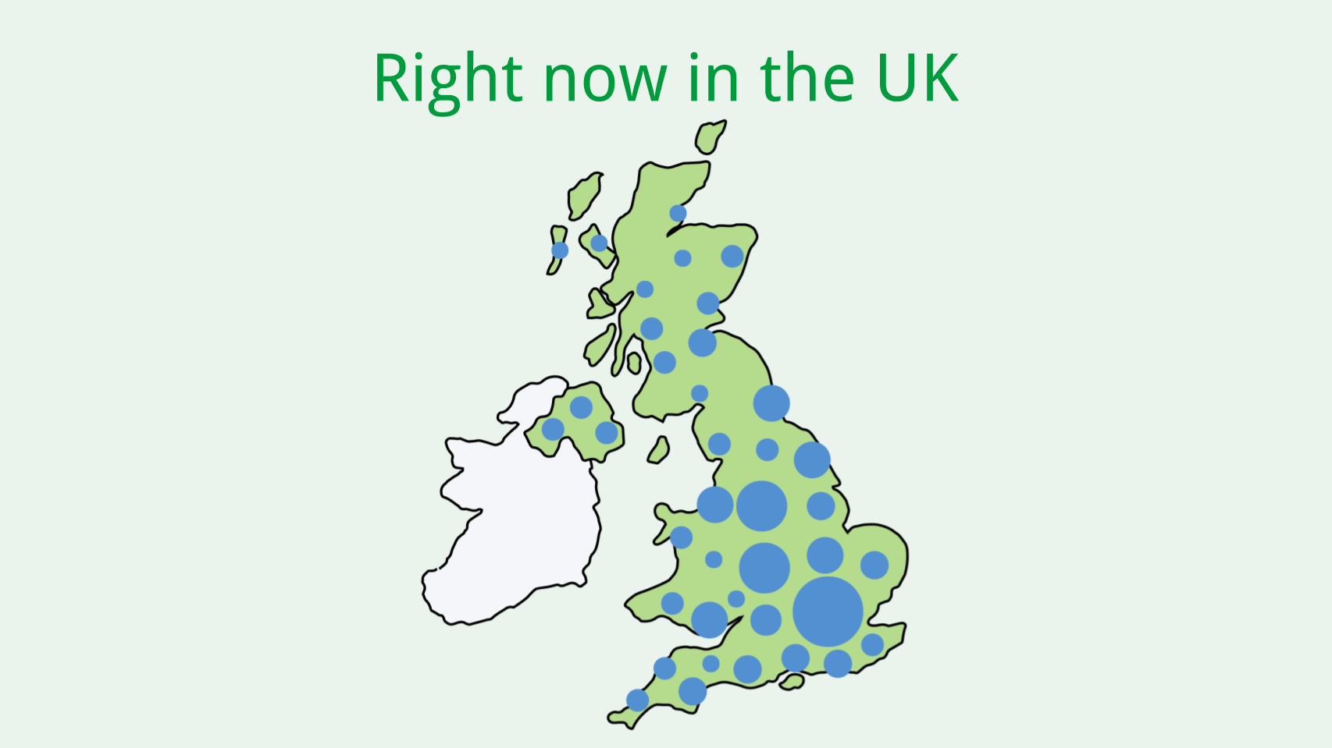

Code Club - How?
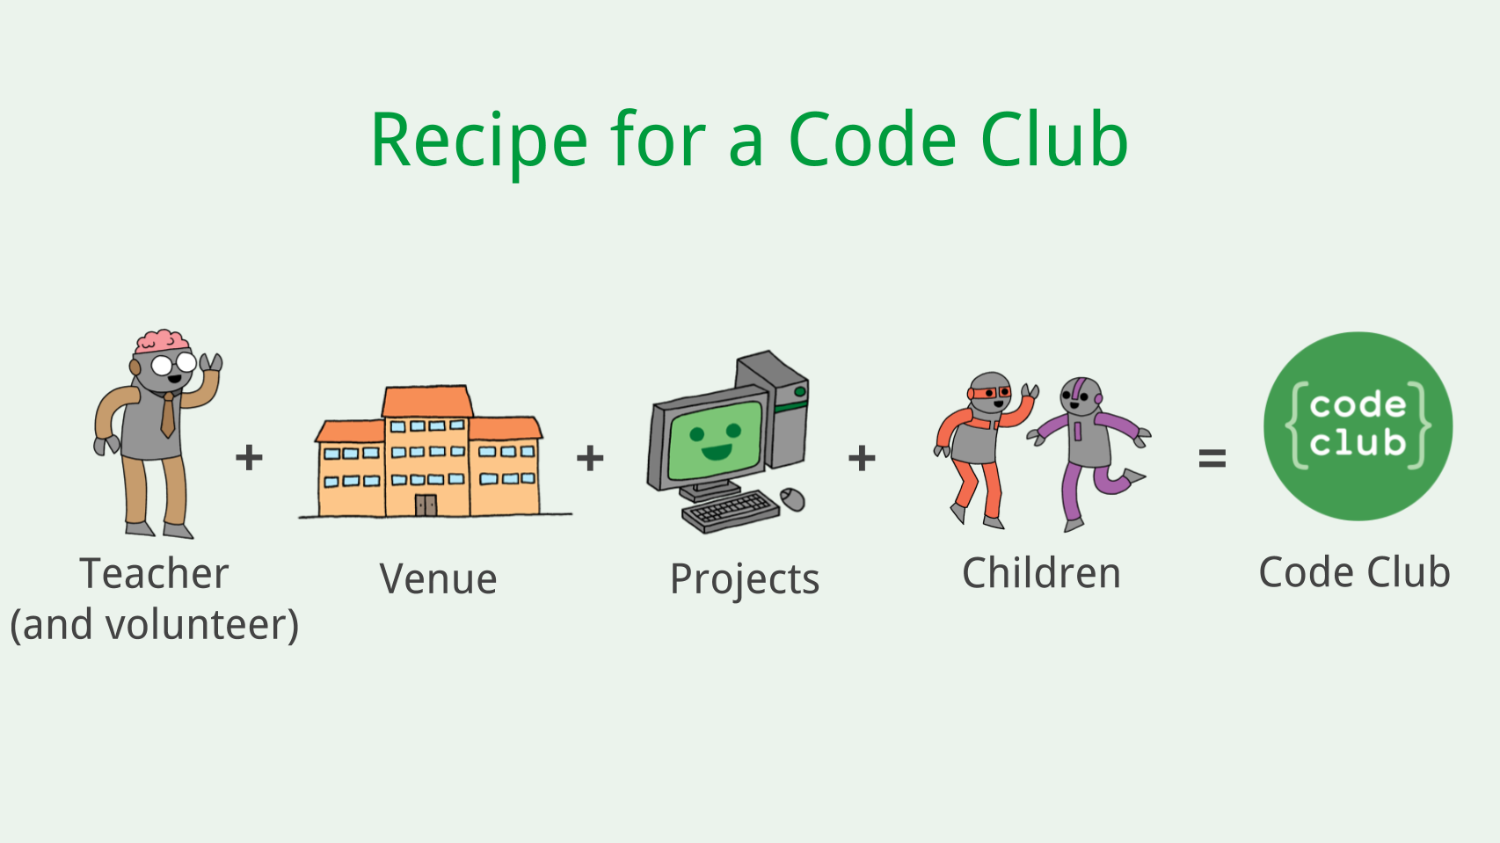

Pioneers
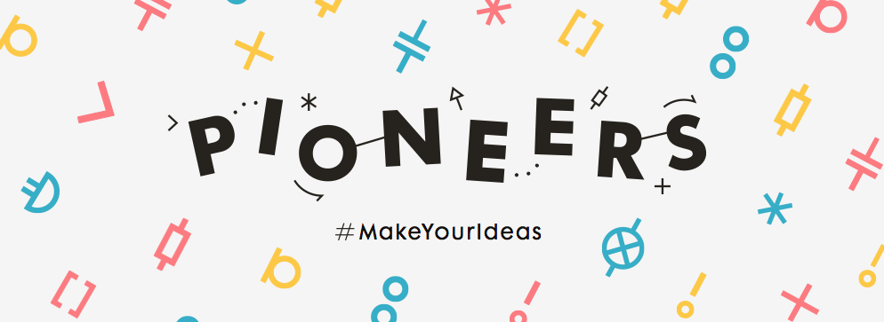

The Process
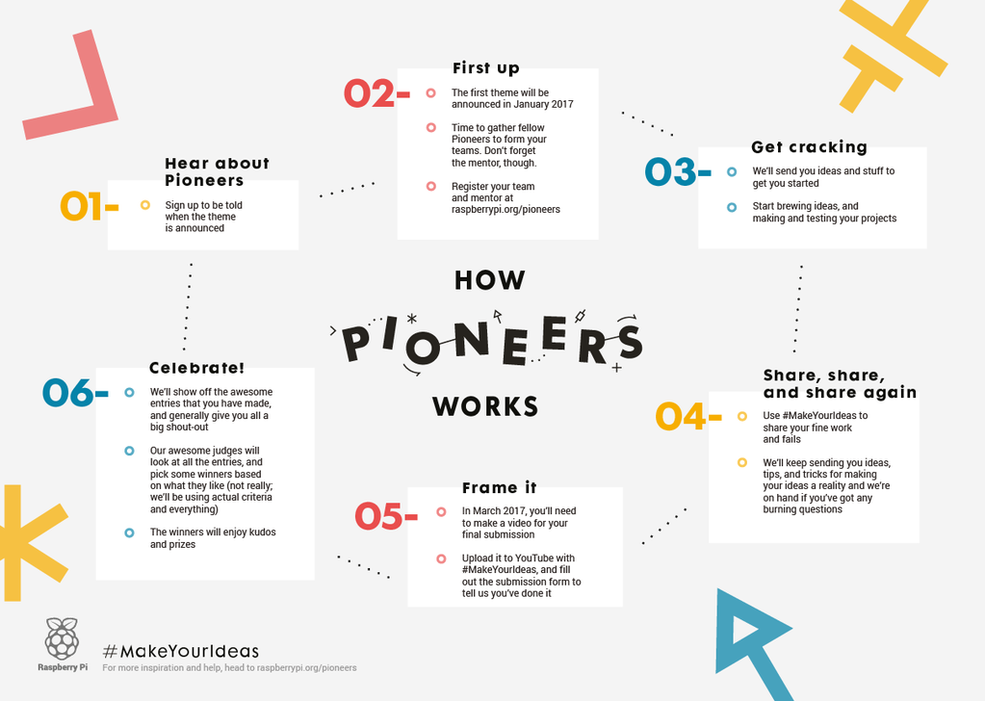

Let him explain

