7-SC-Box

Delete this and add your name

Delete this and add your form

% Delete this and add the date

# Research

## Boxes

* I need to find a box that would be suitable to store my project work for this year.
* Here are the boxes that I found online that could be suitable:

### 1st Box

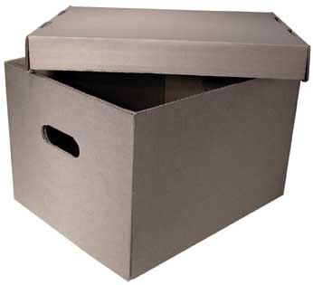

Image of First Box

* Advantages  
   1. 2. 3.
* Disadvantages  
   1. 2. 3.

### 2nd Box



Image of First Box

* Advantages  
   1. 2. 3.
* Disadvantages  
   1. 2. 3.

### 3rd Box



Image of First Box

* Advantages  
   1. 2. 3.
* Disadvantages  
   1. 2. 3.