**TMA01**

**Q1**

1. The real world entities that correspond to the classes in *competitionadmincore* would be the *Member* and *Photo* classes.
   1. The line between the member4 rectangle and photo12 rectangle shows collaboration between the software objects. The same could be said for the photo12 and category 3 rectangles too. The facts about the real world shows the ownership and categorisation of the objects to the member.
   2. 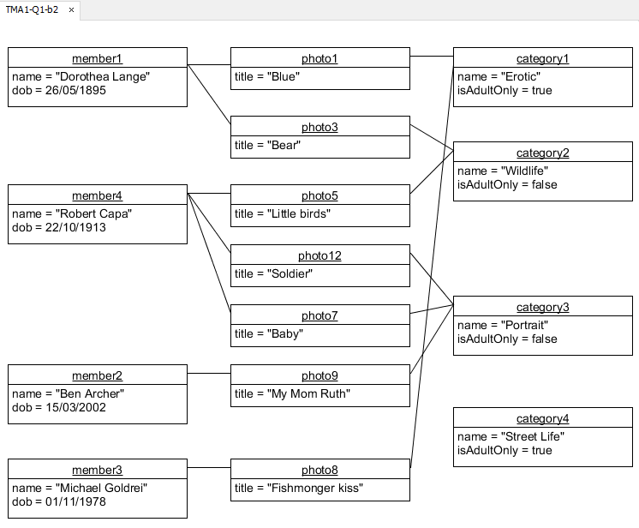
   3. When trying to insert a record for Ben Archer in an adult only category the following outcome is presented:   
      You are a junior and this is an adult only category.

Your entry has not been recorded

* 1. The sequential diagram shows the process of an entry being submitted. Upon submission it first checks to see if member2 already has hit the cap for entries into category3 which is pulled from the photo with getCategory() and false is returned which means the entry is recorded.

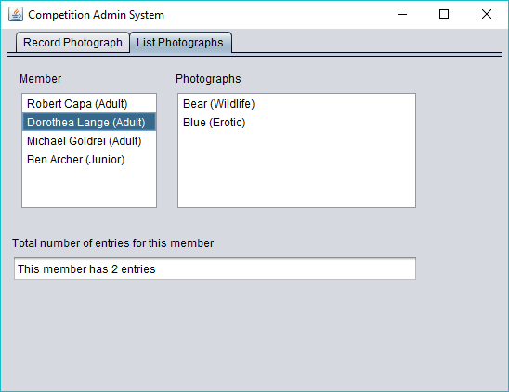

* 1. .
  2. .

NOTE: I am struggling to get my head around the different diagrams and as such couldn’t complete the last of the questions in time.