CHAPTER 2:

1. PLANNING
- In order to plan out our project system this deliverables are necessary and must be completed so that most of our work will be easier and everything will be in order. These plans can help organize our objectives and will develop our goals for the client (Create or Upgrade their current system).
Deliverables:
- Brainstorming on possible clients
- Finalization of project plan
- Drafting of WBS, Gant Chart, & Pert Chart
- Create request letters to the company
- Letter Approval
- Meeting the client for the approval
- Disscussion on different parts of Project paper
- Finalization the Work Breakdown Structure (WBS)
- Finalization of the Gantt Chart
- Finalization of the PERT Chart
- Drafting and Revisions of the interview questions
- Finalization of Questionnaires
- Conduct Final Interview

2. ANALYSIS
- After gathering necessary data from interviews, observation etc. the analyzed data would then assist us on our goal so that it will show as a clearer view on our objectives.

Deliverables:
- Narrative description of As-Is process
- Analyze the data gathered from the interview
- DFD of As-Is process
- Narrative Flowchart of As-Is process
- Create a flowchart of As-Is process
- Identity and list down the problems encountered in the existing processes
- Create Ishikawa Diagram
- Create Cost Benefit Analysis
- Analyze and understand the data gathered from the interview

3. DESIGN
- Designing the plan of the analyzed data, this will show the detail of our proposed system for the client. We will design the analyzed data using diagrams and flowcharts so that we would understand our system.
Deliverables:
- Identify the features of the proposed system
- Create use-case diagram
- Swimlane activity diagram
- Sequence Diagram
- UI design

4. IMPLEMENTATION
- We will then implement our proposed system to our client, this would show the solution to their business process (If there’s a problem) or this would show a better system for our client.
Deliverables:
- Narrative description for each feature of the proposed system
- Use-case diagram
- Swimlane activity diagram
- Sequence diagram
- Cost Benefit Analysis

The Gantt chart:
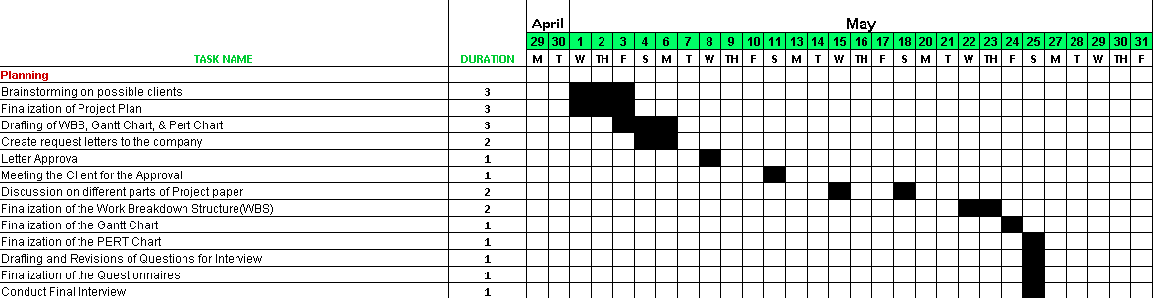
Planning:

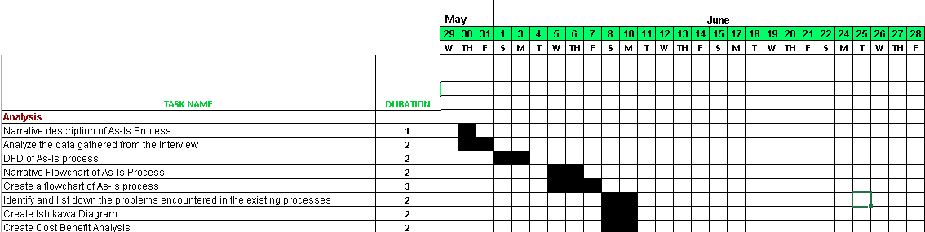
Analysis:

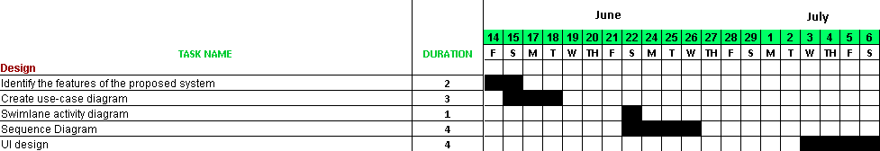
Design:

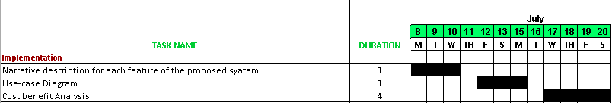
Implementation:

The PERT Charts:

