**TITLE :**

**The Preference of IT Students against Apple and Windows Operating System**

**AUTHORS :**

Diaz , Ceazar

Remiendo , Jerameel

Patacsil , Marc

CITCS - 1C

CC12

University of the Cordilleras

**I.Identifying the Variables**

* **Ease of Use**
* **Stability**
* **Programming Applicability**
* **Grades and Performance**
* **Grade Last Term**

**II. Summations and Averages**

1. **Calculated Means , Minimum and Max Values**

* **Ease of Use : Apple**

Mean : 3.12

Minimum Value : 1

Maximum Value : 5

* **Ease of Use : Windows**

Mean : 4.36

Minimum Value : 2.4

Maximum Value : 5

* **Stability : Apple**

Mean : 2.95

Minimum Value : 1

Maximum Value : 4.8

* **Stability : Windows**

Mean : 3.92

Minimum Value : 2.8

Maximum Value : 5

* **Programming Applicability : Apple**

Mean : 2.89

Minimum Value : 1

Maximum Value : 5

* **Programming Applicability : Windows**

Mean : 4.40

Minimum Value : 2

Maximum Value : 5

* **Grade Performance : Apple**

Mean : 2.86

Minimum Value : 1

Maximum Value : 5

* **Grade Performance : Windows**

Mean : 4.39

Minimum Value : 3

Maximum Value : 5

**2. Calculated Standard Deviation, Variance and Sum of Differences**

* **Standard Deviation :**

26.02575647

* **Variance :**

677.34

* **Sum of Differences :**

6096.08

**III. Tables and Cross Tabulations**

|  |  |  |  |  |  |  |  |  |
| --- | --- | --- | --- | --- | --- | --- | --- | --- |
|  | Frequency | | | | | | | |
| Response | AppleEase | WinEase | AppleStable | WinStable | AppleProg | WinProg | AppleGAP | WinGAP |
| 1 | 45 | 45 | 61 | 47 | 77 | 3 | 86 | 1 |
| 2 | 90 | 90 | 93 | 20 | 91 | 12 | 77 | 9 |
| 3 | 113 | 113 | 98 | 47 | 108 | 21 | 113 | 50 |
| 4 | 79 | 79 | 105 | 96 | 56 | 150 | 63 | 119 |
| 5 | 72 | 72 | 43 | 190 | 68 | 214 | 61 | 221 |
|  | 1 | 1 | 0 | 0 | 0 | 0 | 0 | 0 |
|  |  |  |  |  |  |  |  |  |
|  | Normal Distribution Formula | | | | | | | |
| Response | AppleEase | WinEase | AppleStable | WinStable | AppleProg | WinProg | AppleGAP | WinGAP |
| 1 | 0.07825408858 | 0.009723102157 | 0.09369857528 | 0.02931448099 | 0.1108294997 | 0.00004370510078 | 0.1136195136 | 0.00007167920993 |
| 2 | 0.21255528 | 0.05654700429 | 0.2404472213 | 0.108570067 | 0.2389212679 | 0.004803101571 | 0.242086764 | 0.006094866703 |
| 3 | 0.3117512155 | 0.1775766069 | 0.3216787814 | 0.2338961954 | 0.2959206022 | 0.1042574146 | 0.2958465756 | 0.1115369495 |
| 4 | 0.2468969989 | 0.3011156322 | 0.224357682 | 0.2931037432 | 0.2105797215 | 0.446979563 | 0.2073668975 | 0.4392956084 |
| 5 | 0.1055832107 | 0.2757098291 | 0.08157843153 | 0.2136509006 | 0.08609518134 | 0.3784982864 | 0.08336614043 | 0.3723732792 |
|  |  |  |  |  |  |  |  |  |
|  | Normal Distribution | | | | | | | |
| Response | AppleEase | WinEase | AppleStable | WinStable | AppleProg | WinProg | AppleGAP | WinGAP |
| 1 | 391.2704429 | 48.61551078 | 468.4928764 | 146.572405 | 554.1474984 | 0.2185255039 | 568.0975681 | 0.3583960496 |
| 2 | 1062.7764 | 282.7350215 | 1202.236106 | 542.8503348 | 1194.606339 | 24.01550785 | 1210.43382 | 30.47433352 |
| 3 | 1558.756078 | 887.8830344 | 1608.393907 | 1169.480977 | 1479.603011 | 521.2870729 | 1479.232878 | 557.6847475 |
| 4 | 1234.484995 | 1505.578161 | 1121.78841 | 1465.518716 | 1052.898607 | 2234.897815 | 1036.834488 | 2196.478042 |
| 5 | 527.9160536 | 1378.549145 | 407.8921576 | 1068.254503 | 430.4759067 | 1892.491432 | 416.8307021 | 1861.866396 |

**IV. Applicable Graphs and Interpretations**

* **Bar Graphs**

**Ease of Use Apple vs. Windows**

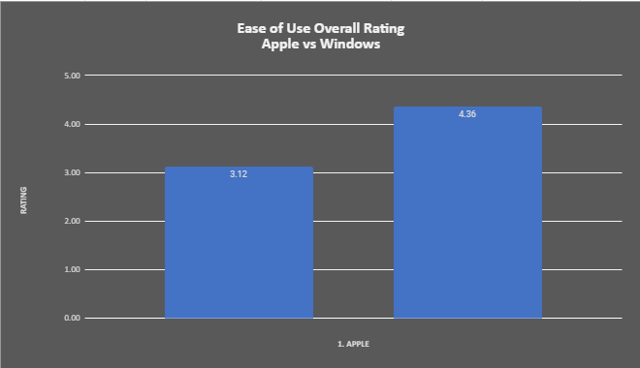

**Stability Apple vs. Windows**

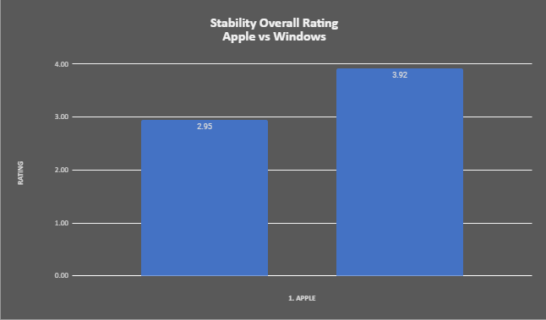

**Programming Applicability Apple Vs. Windows**

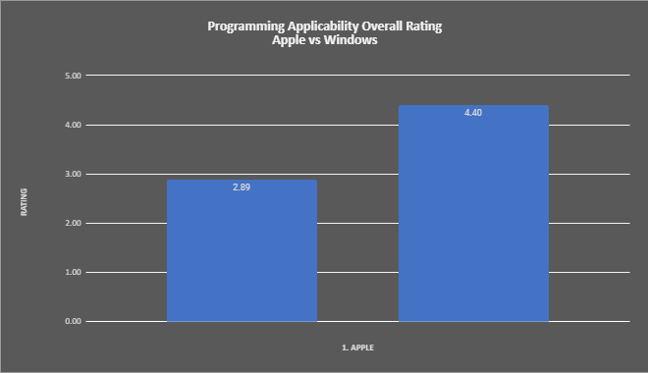

**Grade and Performance Apple vs. Windows**

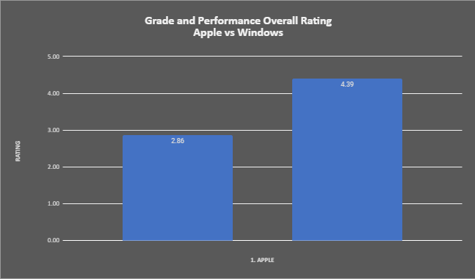

* **Pie Charts**

**Ease of Use Apple vs. Windows**

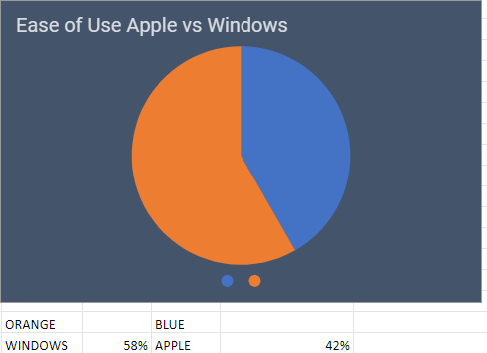

**Stability Apple Vs. Windows**

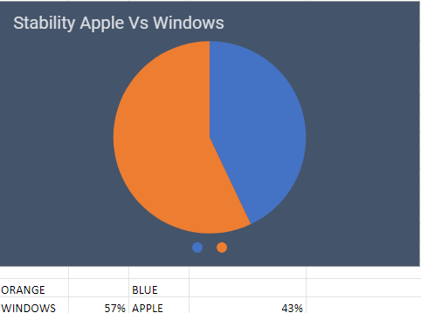

**Programming Applicability Apple Vs. Windows**

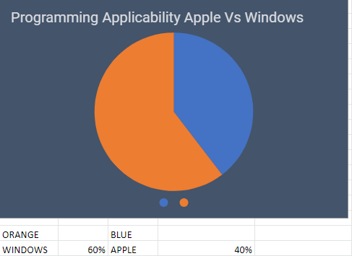

**Grade and Performance Apple Vs. Windows**

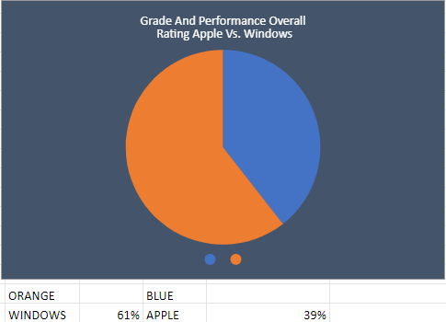

* **Histograms**

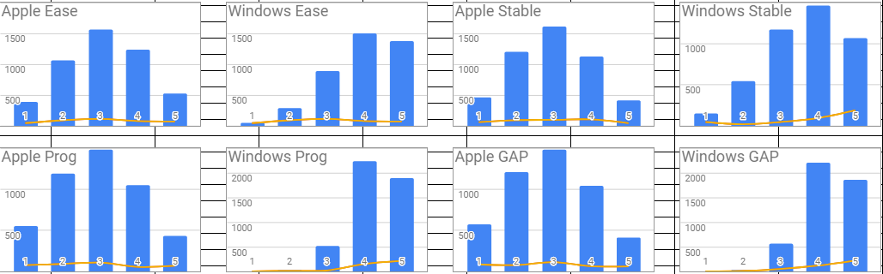

* **Scatter Plots**

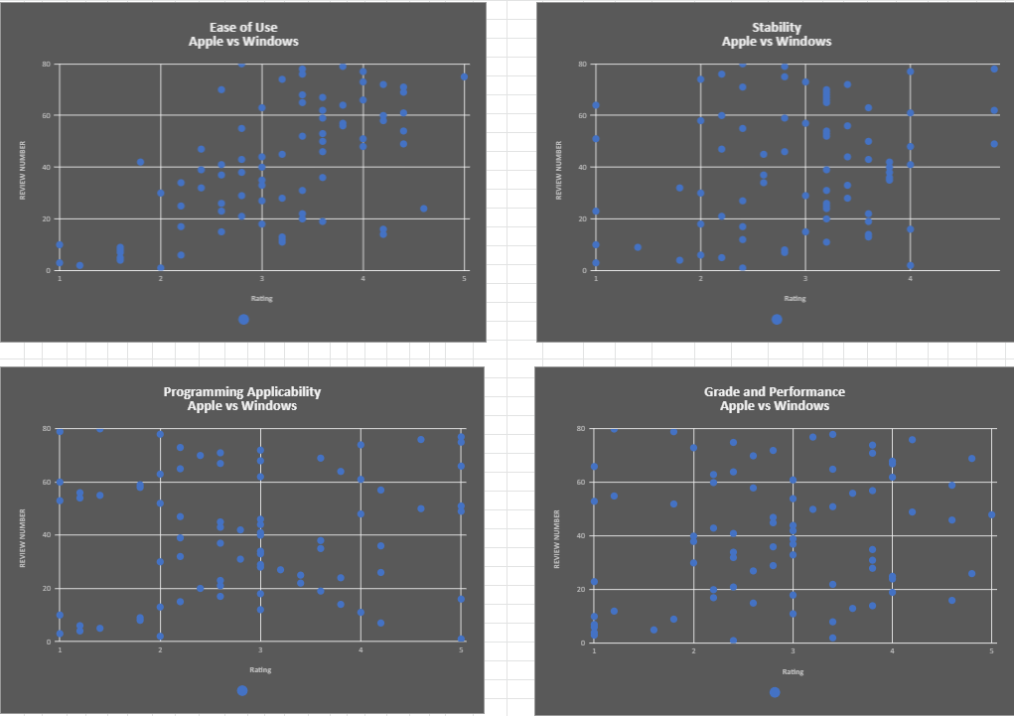

* **Correlations**

**Ease of Use Apple vs. Windows**

**R = -0.3414**

**Pearson : Low Negative**

**Interpretation :** The two variables has low correlation they may affect each other. According to the plot, most of the respondents said that windows is easier to use.

**Stability Apple vs. Windows**

**R = -0.342**

**Pearson = Low Negative**

**Interpretation :** The two variables has low correlation they may affect each other. According to the plot, most of the respondents said that windows is more stable and that it doesn’t encounter much errors than apple.

**Programming Applicability Apple vs. Windows**

**R = -0.1139**

**Pearson = Negative Negligible**

**Interpretation :** The two variables has negligible correlation and they are not related to each other. According to the plot, most of the respondents said that windows is best to use in programming.

**Grade Performance Apple vs. Windows**

**R = -0.137**

**Pearson = Negative Negligible**

**Interpretation :** The two variables has negligible correlation and they are not related to each other. According to the plot, most of the respondents they earned a better grade when they use windows than using apple.