Reference System outputting BENCHMARK:

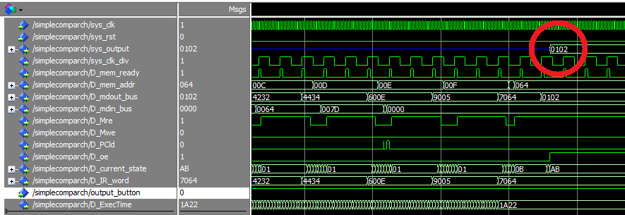

Figure 7.1. Showing the first number output (red circle) from the reference system.

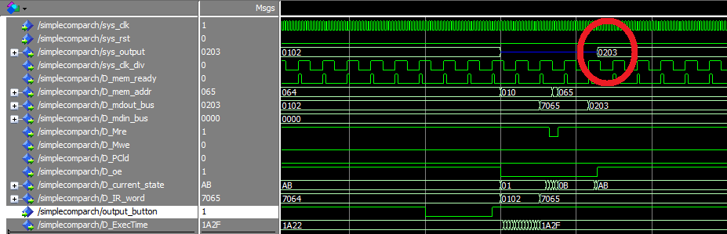

Figure 7.2. Showing the second number output (red circle) from the reference system.

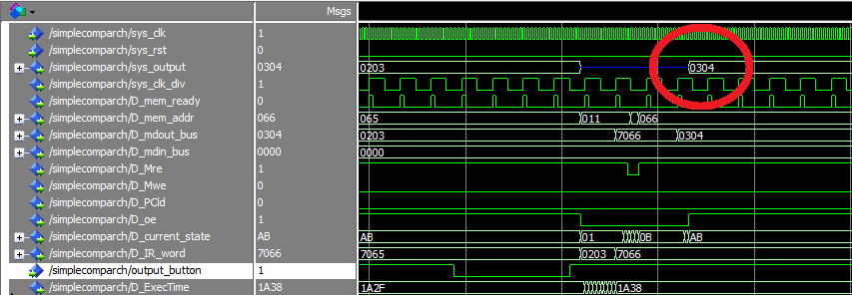

Figure 7.3. Showing the third number output (red circle) from the reference system.

Enhanced cache system outputting BENCHMARK:

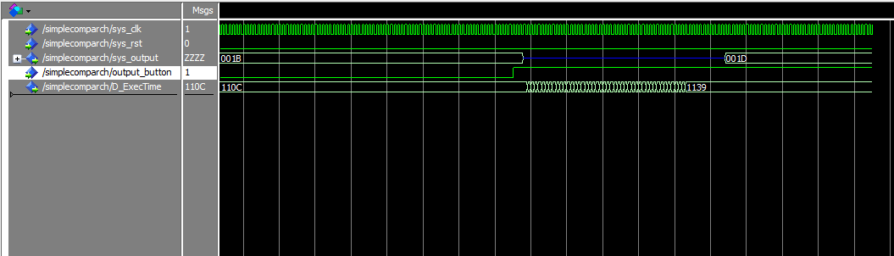

Figure 8.1. Showing the first number output (red circle - left) and second number (red circle – right) from the reference system.

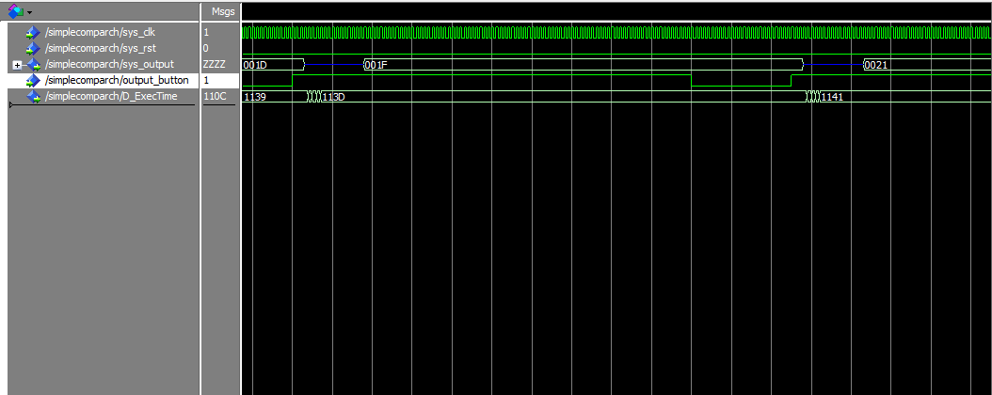

Figure 8.2. Showing the second number output (red circle - left) and second number (red circle – right) from the reference system.