**Investigation of Spanish restaurant scene**

**Comparison of New York & Toronto**

Marcel Gerhards

Octubre 6, 2019

**Content**

**1. Introduction and Business Problem** 3

**1.1 Background** 3

**1.2 Problem** 3

**1.3 Interest** 3

**2. Data section** 4

**2.1 Data sources** 4

**2.1.1 New York and Manhattan Neighborhood dataframe** 4

**2.1.2 Toronto Neighborhood dataframe** 4

**2.1.3 Data on restaurants in New York and Toronto** 4

**2.2 Data cleaning** 5

**2.2.1 New York Neighborhoods dataframe** 5

**2.2.2 Toronto Neighborhoods dataframe** 5

**2.3 Feature selection** 5

**2.4 Datasets** 6

**2.4.1 Spanish Restaurants in New York** 6

**2.4.2 Tapas Restaurants in New York** 7

**2.4.3 Spanish Restaurants in Manhattan** 7

**2.4.4 Tapas Restaurants in Manhattan** 8

**2.4.5 Tapas & Spanish Restaurants in Toronto** 8

**3 Methodology** 10

**3.1 New York and Manhattan Methodology** 10

**3. 2 Toronto Methodology** 10

**4 Results** 11

**4.1 New York** 11

**4.2 Manhattan** 12

**4.3 Toronto** 13

**5 Discussion** 14

**6. Conclusion** 14

# **1. Introduction and Business Problem**

## **1.1 Background**

Spanish food has become a new trend all over Europe and an increasing number of restaurants serving “tapas”, the typical small Spanish dishes are becoming extremely popular all over Europe. Major restaurant chains are opening all over Europe, following the franchise system. As these companies are having a great success, they are thinking to expand to the US to expand their market. As all these restaurant companies are Europe based, and have little experience in expanding to North America and additionally knowledge of the North American food industry is lacking a deep analysis is urgently needed. As Toronto and New York are trending cities with pioneering food industries, these two cities have been elected to perform an analysis of the current situation.

## **1.2 Problem**

Data that might contribute to the analysis of the problem are: Are there any restaurants that are already serving Spanish food? If yes, in which neighborhoods are they located? How many restaurants are there

## **1.3 Interest**

Obviously, the current Spanish restaurant industry would be very interested to know about a potential market and business opportunities overseas. Additionally this might even be a business opportunity for Spanish people who want to move abroad and open a small Spanish restaurant by themselves.

# **2. Data section**

## **2.1 Data sources**

### **2.1.1 New York and Manhattan Neighborhood dataframe**

The dataset about the New York Neighborhoods existed free on the web and was downloaded from the following link:

<https://geo.nyu.edu/catalog/nyu_2451_34572>

### **2.1.2 Toronto Neighborhood dataframe**

The dataset about the Toronto Neighborhoods was obtained from the following Wikipedia page:

<https://en.wikipedia.org/wiki/List_of_postal_codes_of_Canada:_M>

To obtain the dataset the information was obtained by scraping the website using the BeautifulSoup package.

The geographical coordinates of the neighborhoods was obtained using the Geocoder package and downloaded from the following link:

<https://cocl.us/Geospatial_data>

### **2.1.3 Data on restaurants in New York and Toronto**

Data about the restaurants where received by calling the Foursquare API to obtain venues in the concerned areas.

## **2.2 Data cleaning**

### **2.2.1 New York Neighborhoods dataframe**

From the New York dataset only the columns of interest were selected: 'Borough', 'Neighborhood', 'Latitude', 'Longitude'. No further cleaning of the data was necessary.

### **2.2.2 Toronto Neighborhoods dataframe**

From the Toronto dataset the rows with “Not assigned” value in the Borough column were dropped. Rows with the same Postal Code and Borough were joined. Not assigned Neighborhoods were replaced by the concerning Boroughs. Then the dataset was sorted by Postal Code.

## **2.3 Feature selection**

After obtaining the venues through Foursquare API, the dataset was categorized with onehot encoding to create a new dataset with all categories and the applying category with a value as 1. Therefore, it was easy to select the rows and corresponding venues that applied to a specific category.

Two new datasets were created with Tapas restaurant and Spanish restaurants, listing all restaurants of this type in the different cities.

## **2.4 Datasets**

### **2.4.1 Spanish Restaurants in New York**

(only a part)

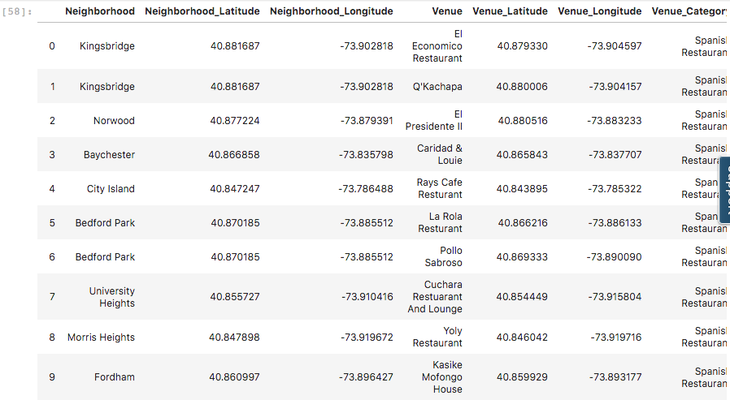

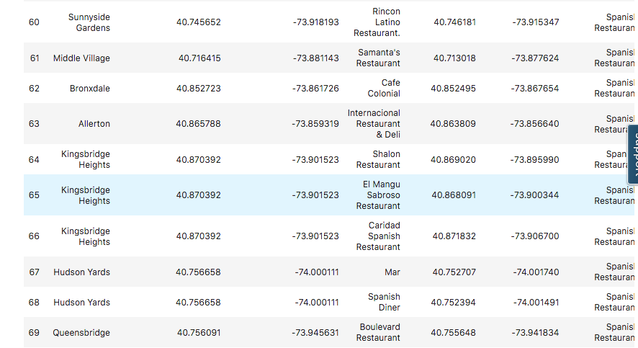

### **2.4.2 Tapas Restaurants in New York**

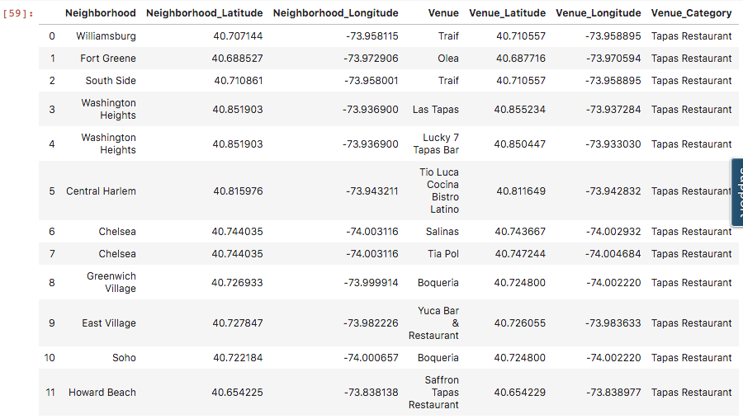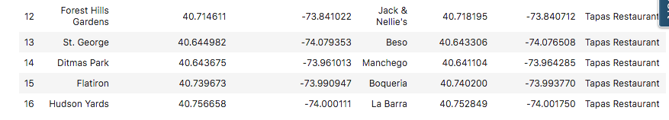

### **2.4.3 Spanish Restaurants in Manhattan**

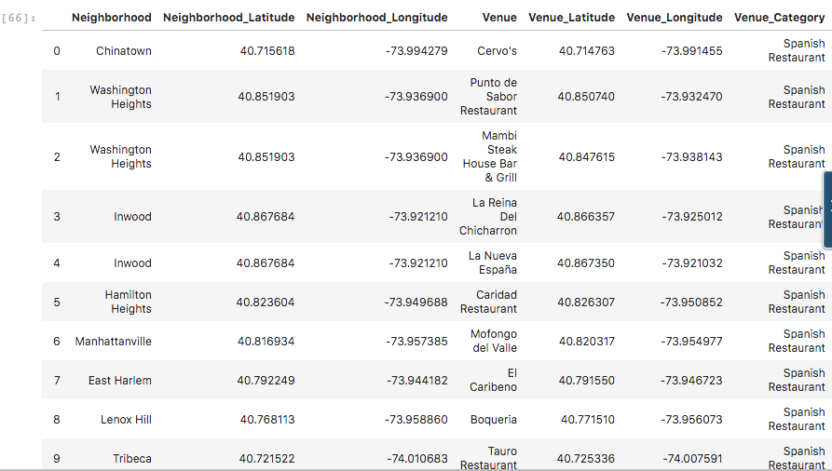

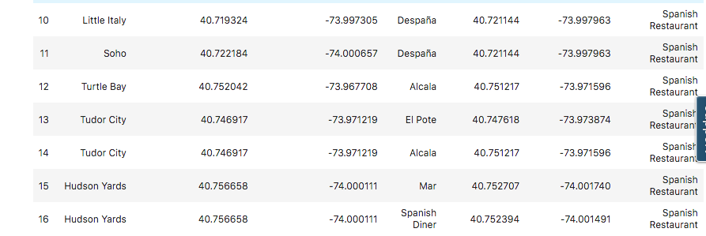

### **2.4.4 Tapas Restaurants in Manhattan**

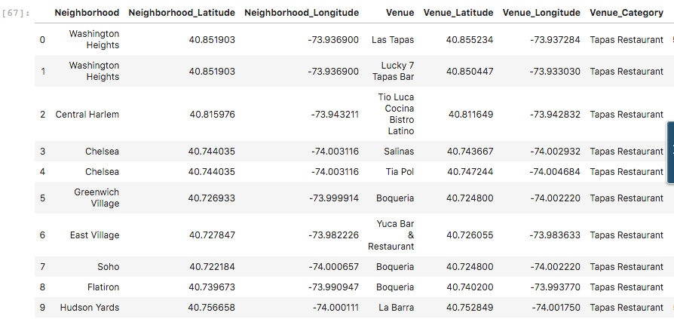

### **2.4.5 Tapas & Spanish Restaurants in Toronto**

There was no Spanish restaurant and only one Tapas restaurant in Toronto!!

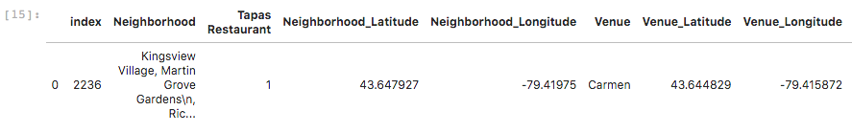

## **3 Methodology**

As the results and seize of datasets were extremely different for the two cities, New York and Toronto, a different approach for the two has been chosen.

## **3.1 New York and Manhattan Methodology**

The different cities New York and Toronto have been analyzed using the Foursquare API and screened for Spanish and Tapas restaurants. The location, name, category and venue ID have been obtained for further processing.

An analysis of the distribution was performed for New York, as there have been many restaurants. In depth analysis was performed for Manhattan.

To visualize the data, a New York and Manhattan map were created. Red spots represented Spanish restaurants and yellow spots represented Tapas restaurants.

## **3. 2 Toronto Methodology**

As there was only 1 Tapas restaurant in whole Toronto, this was analyzed for its rating and comments.

# **4 Results**

## **4.1 New York**

New York showed an extremely high number of Spanish restaurants (70 restaurants - red), and additionally 17 Tapas restaurants (yellow)! To visualize the vast amount please view the map below. You can see it is quite easy to see that quite a high number is located in the city center of Manhattan. Therefore see the next section for in depth analysis of Manhattan restaurant scene!

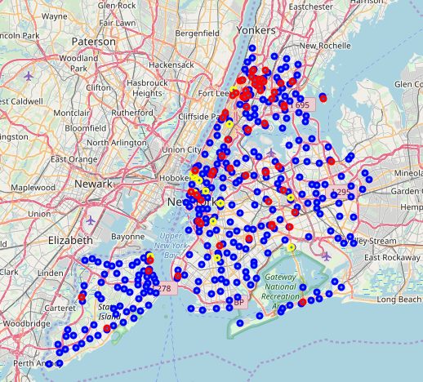

## **4.2 Manhattan**

Manhattan has 17 Spanish restaurants (24,2 % of all New York!) and 10 Tapas restaurants

(59 % of all New York!). You can see it below in the map. Many of them are centered in the city center in the south, making them apparently a quite trendy category in the busy center!

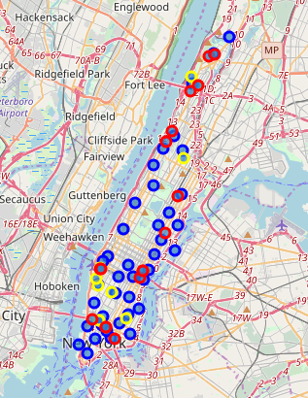

## **4.3 Toronto**

Toronto showed quite surprisingly only 1 Tapas restaurant in the whole city!!! Which is quite astonishing for such an international city as Toronto. See map below for location, which is pretty central near the city center. This restaurant has a rating of “7.9” and is listed as “Expensive”, both two strong indicators, that this is a really trending restaurant! On top of that the first comment is: “Lots of people like this place”. So apparently the owner of this restaurant is successful with his business!

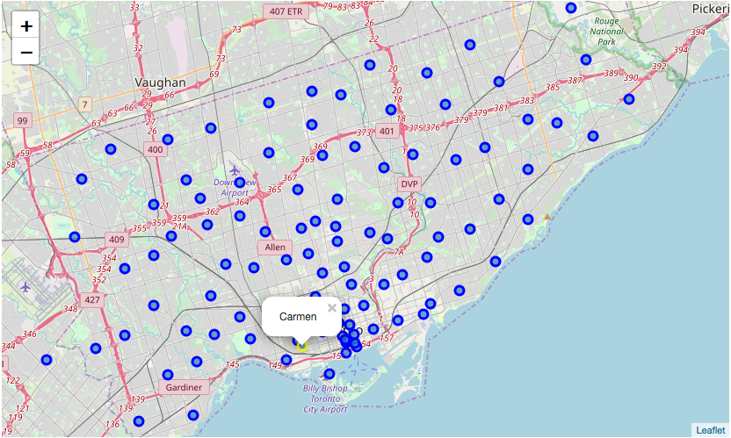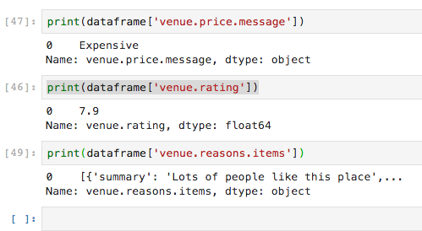

# **5 Discussion**

It is quite striking to see the vast amount of Spanish and Tapas restaurant in New York and especially in Manhattan! This city is definitely witnessing the trend that is happening in Europe at the moment as well. The restaurant scene has taken up the trend and is developing well.

On the other extreme Toronto has only 1 (!!!) Tapas restaurant in the whole city! And on top of that it is rated very good, has amazing comments and expensive prices! The trend is definitely just at the beginning to come to Toronto and maybe even Canada!

# **6. Conclusion**

It is clearly interesting for a Spanish restaurant enterprise to see this extreme difference in the two cities! When expanding to North America, they can expect to have a vast number of competitors in New York, but going to Toronto they would have the city for themselves and can be sure to hit an interesting spot.

This analysis might help the executives of the companies to make a well thought decision when expanding overseas!