How to start
Assuming that you already have some crypto coins in your 'real life' portfolio, we start with adding these coins to the Coin Library. This because we only can work with the coins that are known in the library. So, click on 'Coin Library' in the navigation menu on the left side and start adding coins using the 'Add a coin to the Library' button.
The next thing to do is providing the app with the location(s) of where your crypto is stored. Do you keep them on a Ledger or at an exchange like Bybit or Bitvavo, or at multiple locations which is what I call 'GCCP' meaning 'Good Crypto Custody Practice'. These locations are called Accounts in this app. So, click on Accounts' in the navigation menu and add the accounts that you need using the 'Add a new Account' button.

Tips
Label a coin
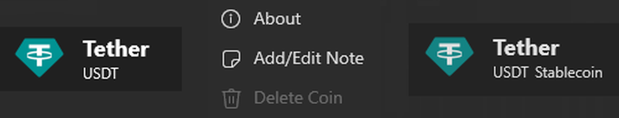
Add a note to a coin for extra information. With this you can easily identify a coin as a ‘Crypto Parel’, for example. The note can be added in the Coin Library.
Click on Asset
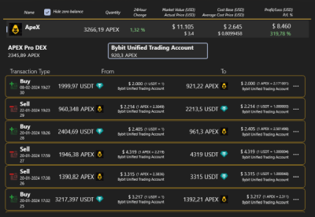
Click on an asset in the Assets overview to get detailed information on accounts holding that asset and transactions made for that asset in the selected account. Click again on the asset to get back to the overall Assets view.
Click on Account
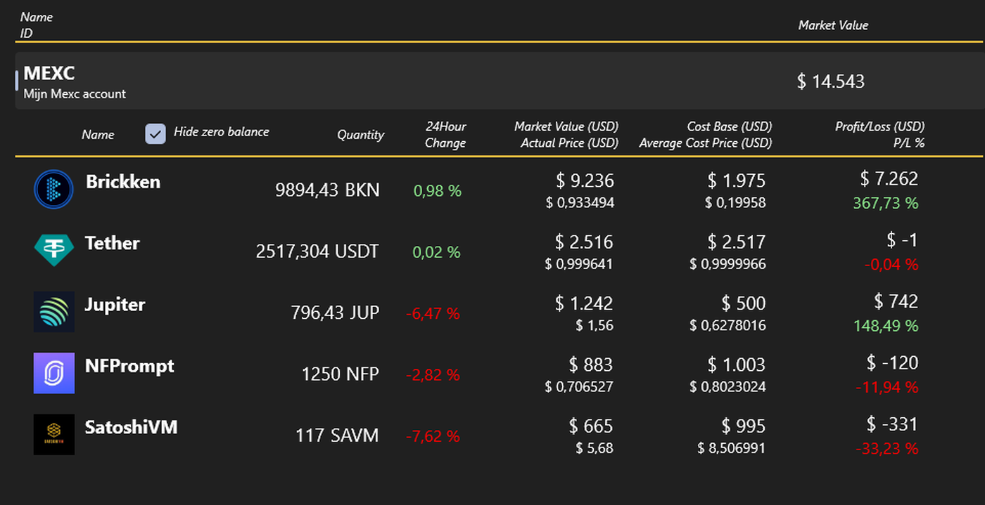
Click on an account in the Accounts overview to get detailed information on assets being hold in that account. Click again on the account to get back to the overall Accounts view.
Combine a ‘Convert’, ‘Buy’ or ‘Sell’ with a transfer
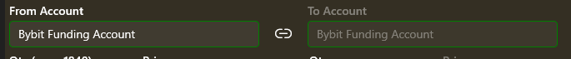
When creating a transaction, by default the ‘link-accounts’ option is enabled. Meaning that ‘From’ and ‘To’ are similar. Are you going to move the obtained currency to another account then the transaction can include a ‘Transfer’ as well. To do so, disable the ‘link-accounts’ button between both account fields. This enables the selection of the ‘To Account’

Add a Fee to the transaction separately, or ignore it.
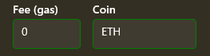
For ‘transfer’, ‘Convert’, ‘Buy’ and ‘Sell’ transactions it is possible to add also the Fee involved with it. You can also take care of it by entering the numbers for Qty included with the fee and ignore the Fee fields. It’s up to you.

Choose your preferred Number Format
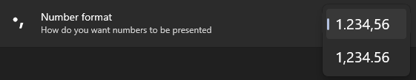
At ‘Settings’ you can choose how you want numbers being displayed. A period (.) for decimals or a comma (,)

Miscellaneous
Loading a coin takes a while
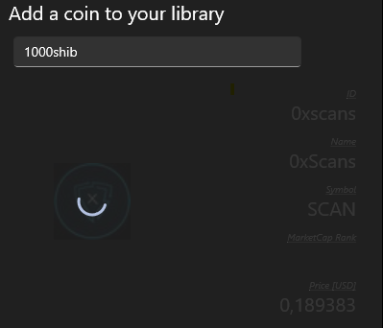
Coin data is retrieved from CoinGecko using their public API. If you do a couple of coin requests after another it can happen that "Too Many' requests is returned. CoinGecko has limited the amount of requests to their public API. The CryptoPortfolioTracker software is automatically retrying a couple of times, with a 30 second delay in between. So be patient if you see the progress ring.

Coin search based on Api-ID
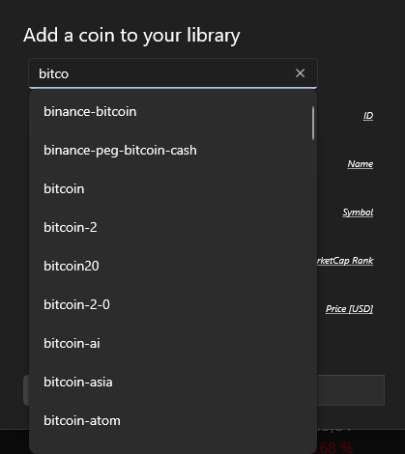
To search a coin, you have to enter the name of it instead of the symbol. The list presented are API-ID's which are unique. The name of a coin is not always unique. For example searching for bitcoin needs to be done by typing 'bitcoin' instead of 'BTC'

