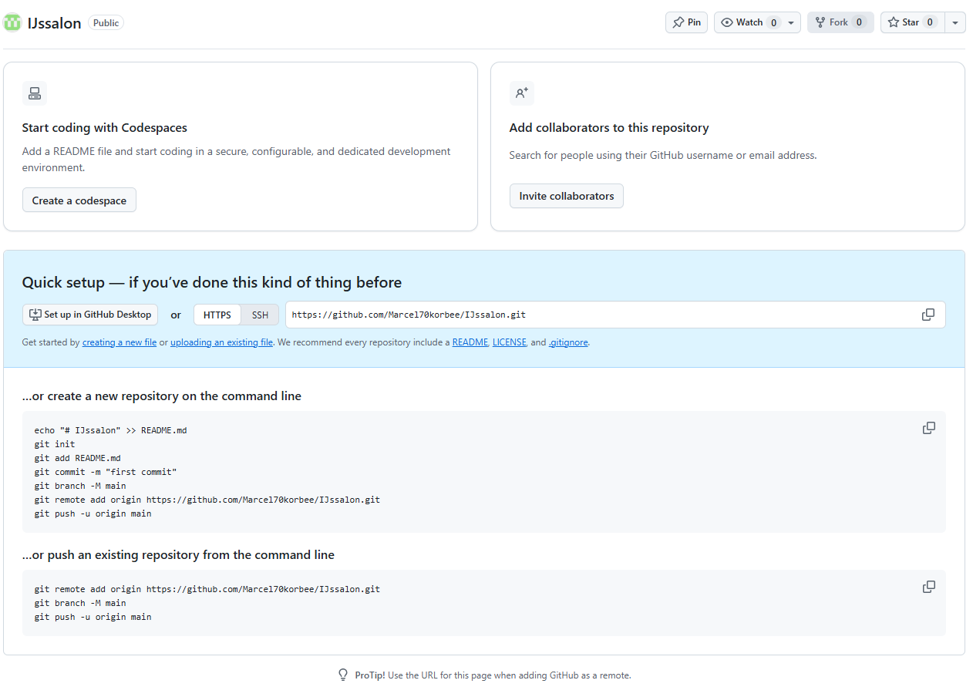
https://github.com/Marcel70korbee/IJssalon

