Visualization report by

Mazi Essoloani Aleza

June 6, 2022

In this report I have summarized the visualization I did in this project.

After gathering, cleaning and visualizing the data, I found that golden_retriever is the most popular dog followed by Pembroke and Labrador_retriever is at the third position.

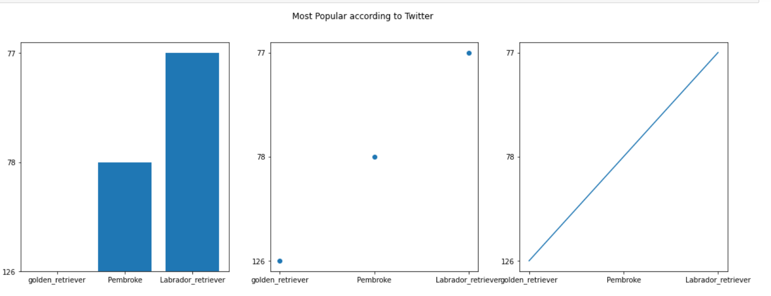

The golden retriever and the Labrador dogs have a lot of similarities except that the golden retriever has a longer fur that is in golden color, both dogs have the same personality and same physical appearance.

The Pembroke is also popular dog on Twitter, originated in Pembrokeshire, Wales, Pembroke looks very cute, I am sure that is the reason Pembroke is very popular on Twitter. Pembroke is also very popular in the medias.

The least frequently occurring dogs are Appenzeller, Clumber, Groenendael, Silky terrier, these dogs do not have popularity such as the golden retriever

The least popular dog is Afghan hound, Afghanistan is not a well know country like France or China that might be the reason why the Afghan hound originated form Afghanistan is least popular.

The three least popular names for dogs are Abby, Acro and Adele. The most popular names used for dogs are pupper, doggo, puppo. Cooper, Charlie and Bo are the three most popular names for dog. The tweeter audience of WeRateDogs is mainly from England, Canada, United states of America and some few English speaking countries, that is the reason behing having popular dogs names as English names.

Pupper, doggo and puppo are the most frequent slangs used for dog. Puppo that simply mean puppy and doggo is an adult dog that act like a puppy. Pupper is a small dog that act like a puppy.