Angle Calculation

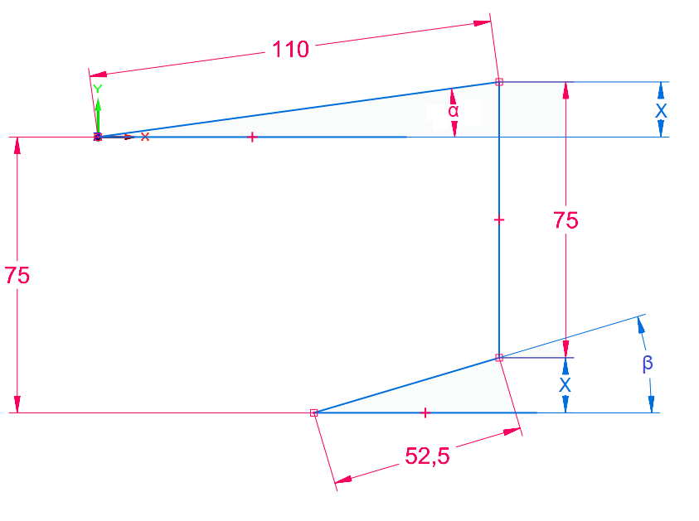

Target angle: $α$

$x=\sin\left(β\right)∙52.5=\sin\left(α\right)∙110$

$β= \sin^{-1}\left(\frac{110}{52.5} ∙sin⁡(α) \right)$

$i∙EncoderValue= \sin^{-1}\left(\frac{110}{52.5}∙sin⁡(α) \right)$ where i = transmission ratio