**James Gosling the Father of Java**

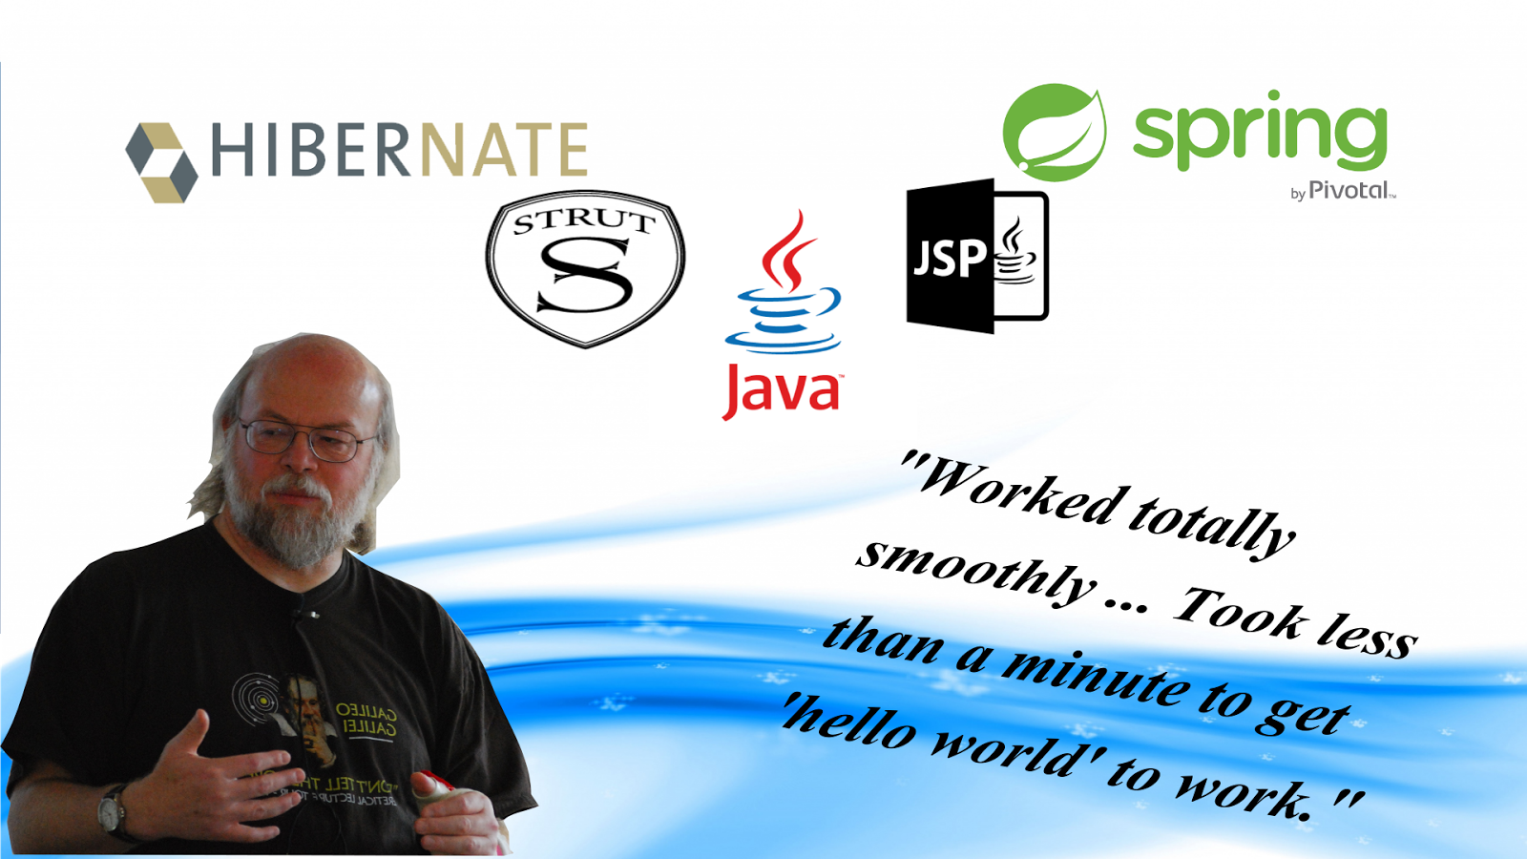

**By Marcel Kowalik (20076466)**

**Applied Computing**

Index Page

1. **Introduction of James Gosling**
2. **James Gosling’s Early life in Canada and Education**
3. **Contributions**
   1. **Java programming language**
   2. **“Gosling Emacs” a discontinued Emacs implementation.**
   3. **Windowing system NeWS.**
4. **Career Honours and Awards**
5. **Books**
   1. **“The Java Programming Language” series of books**
   2. **“The Java Language Specification” editions**
   3. **“The Real-Time Specification for Java”**
   4. **“The NeWS Book: An Introduction to the Network/Extensible Window System”**
6. **Later Life**
7. **Conclusion**
8. James Gosling is the true geek of IT people in history. Unlike some other famous IT people like Bill Gates and Steve Jobs, neither of whom finished college, Gosling completed a PhD in computer science. He also contributed to software innovation at a technical level. Gosling was born in 1955 near Calgary, Canada and he is best known as the father of the Java programming language, the first programme language designed with internet in mind. That meant it could adapt to highly distributed applications. He has built satellite data acquisition systems, a multiprocessor version of Unix, several compliers, mail systems and window managers. He has also created a WYSIWYG text editor, a constraint based drawing editor and a text editor called ‘Emacs’ for Unix systems.
9. James Gosling was born on the 19th of May in 1955 near Calgary, Alberta, Canada. That is where his education with Computers began. Gosling received a BSc in Computer Science from the University of Calgary, Canada in 1977 and few years later he received a PhD in Computer Science from Carnegie-Mellon University in 1983 (Nighthacks 2017). For his doctorate thesis was titled "The Algebraic Manipulation of Constraints” and while working towards his doctorate, he wrote a version of emacs (gosmacs) (Computer History 2017). Before Gosling joined Sun Microsystems he also built a multi-processor version of Unix while he was at the Carnegie Mellon University, as well as other several compilers and mail system (Nighthacks 2017). Between 1984 and 2010, Gosling was with Sun Microsystems which was a company that built computer hardware and software (Webopedia 2017). He became known as the father of the Java programming language. On April 2, 2010, Gosling left Sun Microsystems which has recently been acquired by the Oracle Corporation (Edubilla 2017). “Regarding why he left, Gosling cited reductions in pay, status, decision-making ability, change of role and ethical challenges.” (Edubilla 2017).
10. “Java which was started by his major contribution and idea, scaled unbelievable heights and did expanded up to cellular and more, Java proved to be a boon for open source programmers, the credit for all this stuff goes to none other than James Gosling.” (Freefeast of info 2012), There is no doubt that Gosling has many contributions in his computer science career. He is not without a reason called “the Father of Java” by many in the computer science world. Although Java programming language is not his only contribution in the computer world.
    1. James Gosling is popular for his notable creation of java language in 1944. That is where the name “The father of the Java programming language” came from. Java was primarily designed by interactive television and it proved to be very advanced language (M.S Kumar 2012). The syntax of the language java is much like C and C++ with simpler object model and fewer low-level facilities.
    2. Gosling Emacs is a discontinued Emacs implementation written in 1981 by Gosling in C language. It had its extension language called Mocklisp which did not have lists or any structured datatypes. Gosling initially allowed Gosling Emacs to be redistributed with no formal restrictions. He later sold Gosling Emacs rights to UniPress (EmacsWiki 2017).
    3. NeWs (Network extensible Window System) is a discontinued windowing system developed by Sun Microsystems in mid 1980s. The primary authors were James Gosling and David S. H. Rosenthal (James Gosling 1990). It was Originally known as “SunDew”. The NeWs interpreter was based on PostScript, extending it to allow interaction and multiple “contexts” to support windows operating system (Hopkins 2008). NeWs was used as a complete programming language, its unique feature was that it could have been used to make complete interactive programs with muse support and a GUI.
11. James Gosling received many awards and Honours in his computing career, for his great inventions and many contributions. His was fist awarded in 2002 and received The Economist Innovation Award. It is an award given by a Weekly newspaper “The Economist” which is an English-language magazine-format newspaper owned by the Economist Group. His award was given obviously for Computing but specifically for the invention of Java programming language and he was chosen from the selection of all other famous people in the computing world. In 2002 Gosling also received “The Flame Award” USENIX Lifetime Achievement Award. It’s an award given by USENIX, Association in the Advanced Computing Systems Association. “Awarded for his contributions to the UNIX and advanced systems communities, starting with early work on the Pascal P-System; the first UNIX EMACS developed at CMU on the pre-Internet Arpanet with a worldwide cast of collaborators who anticipated some of the open-source development methods that were to emerge later; his contributions to the X Window System by means of the CMU wm window manager and its network architecture that drove the development of the X Protocol; the NeWS window system developed at Sun Microsystems, and the architecture and development of the Java programming language and operating environment.” (USENIX 2002). Few years later in 2007 he was made an Officer of the Order of Canada. The Order is Canada’s second highest civilian honour and Officers are the second highest grade within the Order (CBC news 2007). In 2013 Gosling also became a fellow of the Association for Computing Machinery. It is a not-for-profit professional membership group focusing scientific and educational computing society. His latest reward was IEEE John von Neumann Medal in 2015. The IEEE John von Neumann Medal was established by the IEEE Board of Directors in 1990 and may be presented annually "for outstanding achievements in computer-related science and technology." (IEEE 2015). It is clear that James Gosling has been rewarded many times for his amazing achievements in Computer Science and it seems like he will continue receiving them for another good while.
12. James Gosling has written many books about Java and computing in his career. Most of them are Java programming language related but some are related to different areas of computing. It is obvious that his books are a great source of information about Java programming language as he has the best knowledge about it as the creator.
    1. “The Java Programming Language” series of books contain in-depth and progressively advanced coverage of classes and objects, interfaces, exception-handling, threads and multitasking, and packages. This series of books are written by James Gosling and by Ken Arnold. The first book was originally published in January 1996.
    2. “The Java Language Specification” editions are for experienced developers. It’s a complete reference package that includes both Hello World(s). The authors of this editions are: James Gosling, Bill Joy, Guy L. Steele Jr. and Gilad Bracha.
    3. “The Real-Time Specification for Java” is a book about Real-Time Java specification as its name suggests. It gives developers all the information and insight they need to start building powerful, Java-based software. The book is the definitive reference to the semantics, extensions, and modifications to the Java programming language that enable the Java platform to meet the requirements and constraints of real-time development. The authors are: James Gosling, Greg Bollella, Peter Dibble, Steve Furr and Mark Turnbull.
    4. “The NeWS Book: An Introduction to the Network/Extensible Window System” is an introduction to NeWs: the Networked, Extensible, Window System from Sun Microsystems. It is oriented towards people who have a basic knowledge of programming and window systems who would like to understand more about window systems in general and NeWS in particular. Authors are: James Gosling, David S.H. Rosenthal and Michelle J. Arden.
13. James is living a happily married life and is blessed with 2 daughters Kate and Kelsey in San Francisco Bay Area, California, U.S. After he left Sun Microsystems and google he started working for a small company specializing in ocean-based robotics (Gosling 2017). There is not a lot more information about his personal life as he does not like to share it to the public.
14. James Gosling is without a doubt an inventor that made a change in the computer history. His invention has made huge evolutions in the software systems. He is known for his love of proving “the unknown”. He is the author of Gosling Emacs, and also invented the windowing system NeWS which has unfortunately lost to X window because Sun did not give it an open source license. His influence in computing is huge and he will be remembered for a long time in the history of Computer Science. In my opinion he is one of the greatest computer scientists alive.

References

* James Gosling. 2017. James Gosling. [ONLINE] Available at: <http://nighthacks.com/jag/bio/>. [Accessed 10 April 2017].
* James Gosling - Computing History. 2017. James Gosling - Computing History. [ONLINE] Available at: http://www.computinghistory.org.uk/det/1793/james-gosling/. [Accessed 8 April 2017].
* What is Sun Microsystems? Webopedia Definition. 2017. What is Sun Microsystems? Webopedia Definition. [ONLINE] Available at: http://www.webopedia.com/TERM/S/Sun_Microsystems.html. [Accessed 12 April 2017].
* Edubilla.com. 2017. James Gosling biography, list of James Gosling inventions | edubilla.com. [ONLINE] Available at: http://www.edubilla.com/inventor/james-gosling/. [Accessed 12 April 2017].
* FreeFeast.info: Interview Questions, Awesome Gadgets, Personality Motivation Guide, Famous IT personalities. 2017. History of James Gosling | Father of Java | Java Creator: [ONLINE] Available at: http://freefeast.info/personality-motivation/famous_it_personalities/history-of-james-gosling-father-of-java-java-creator/. [Accessed 12 April 2017].
* Mousumi Saha Kumar. 2012. James Gosling: The Father of Java Programming Language. [ONLINE] Available at: http://brainprick.com/james-gosling-the-father-of-java-programming-language/. [Accessed 22 April 2017].
* EmacsWiki: Emacs History. 2017. EmacsWiki: Emacs History. [ONLINE] Available at: https://www.emacswiki.org/emacs/EmacsHistory. [Accessed 22 April 2017].
* TextEditors Wiki: GoslingEmacs. 2017. [ONLINE] Available at: http://texteditors.org/cgi-bin/wiki.pl?GoslingEmacs. [Accessed 18 April 2017].
* YouTube. 2017. NeWS: A Networked and Extensible Window System, lecture by James Gosling - YouTube. [ONLINE] Available at: https://www.youtube.com/watch?v=4zG0uecYSMA. [Accessed 19 April 2017].
* Don Hopkins 2008 - Network extensible Window System. [ONLINE] Available at: http://www.art.net/studios/Hackers/Hopkins/Don/lang/NeWS.html. [Accessed 20 April 2017].
* Flame Award | USENIX. 2017. Flame Award | USENIX. [ONLINE] Available at: https://www.usenix.org/about/awards/flame. [Accessed 20 April 2017].
* www.cbc.ca. 2017. Java creator named to Order of Canada - Technology & Science - CBC News. [ONLINE] Available at: http://www.cbc.ca/news/technology/java-creator-named-to-order-of-canada-1.660588. [Accessed 21 April 2017].
* IEEE - IEEE John von Neumann Medal. 2017. IEEE - IEEE John von Neumann Medal. [ONLINE] Available at: http://www.ieee.org/about/awards/medals/vonneumann.html. [Accessed 21 April 2017].
* Linkedin – James Gosling. 2017. [ONLINE] Available at: <https://www.linkedin.com/in/jamesgosling>. [Accessed 22 April 2017].

**Antiplagiarism Declaration**

**Critical Thinking Essay**

**Semester II**

**Declaration**

I certify that this essay is all my own work and contains no plagiarism. By Submitting this assignment, I agree to the following terms:

Any text, diagrams, summaries or other material copied from other sources (including, but not limited to, books, journals and the internet) have been clearly acknowledged and referenced. This essay will note these materials in the text by the use of ‘quotation marks’ (or indented Italics for longer quotations) followed by the author’s name and date [e.g. (Byrne, 2008)] either in the text or in a footnote/endnote. These details are then confirmed by a fuller reference in the bibliography.

I have read the sections on referencing and plagiarism in the handbook or in the WIT Plagiarism policy and I understand that only assignments which are free of plagiarism will be awarded marks. I further understand that WIT has a plagiarism policy which can lead to the suspension or permanent expulsion of students in serious cases (WIT, 2008).

Date: 24/03/2017

Student signature:

Student email: Marcelus98@poczta.fm

Student Number: 20076466

Course: Applied Computing