# ECEN 240 Lab 1 – Analog vs Digital

# Name: Marcel Pratikto

# __________________________________________________________________________________

# Purposes:

* Become familiar with lab equipment such as digital multimeters and power supplies.
* Learn how to breadboard schematic diagrams.
* Make comparisons between analog and digital circuits.

# Procedure:

Part 1. Build an analog voltage output generator with a potentiometer and observe the output variation. This circuit will be compared with the circuit of part 2.

* Insert a potentiometer in a breadboard
* Connect the outer pins to 5V and GND
* Connect the middle pin to an output wire
* Connect a 5V power supply to the breadboard (use bottom 2 rows)
* Connect a voltmeter to the output wire and the GND
* Observe the voltage output variation as you turn the knob.

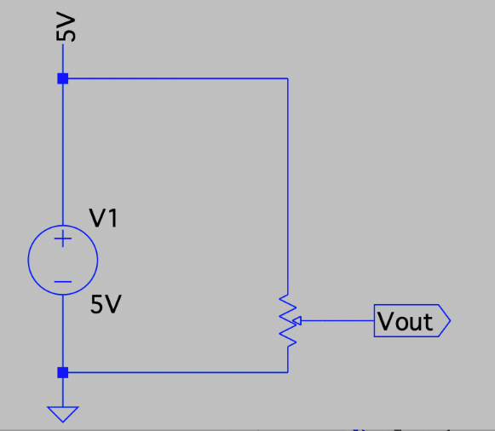

Analog Voltage Generator Schematic

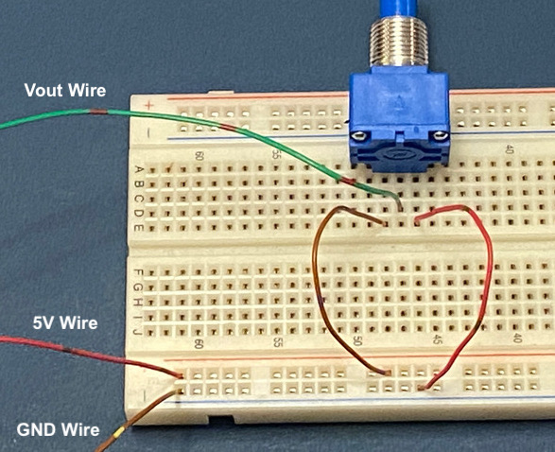

Breadboarding the analog voltage generator

Part 2. Build a simple 4-bit Digital to Analog Converter (DAC) and measure the output voltage

Step 1: Using the resistor color band chart, identify the following resistor color bands:

|  |  |  |  |  |  |
| --- | --- | --- | --- | --- | --- |
| Resistor | Band1 | Band2 | Band3 | Multiplier | Tolerance |
| R1 = 4.99K | Yellow | White | White | Brown | Brown |
| R2 = 10K | Brown | Black | Black | Red | Brown |
| R3 = 20K | Red | Black | Black | Orange | Brown |
| R4 = 40.2K | Yellow | Black | Red | Red | Brown |
| R5 = 40.2K | Yellow | Black | Red | Red | Brown |

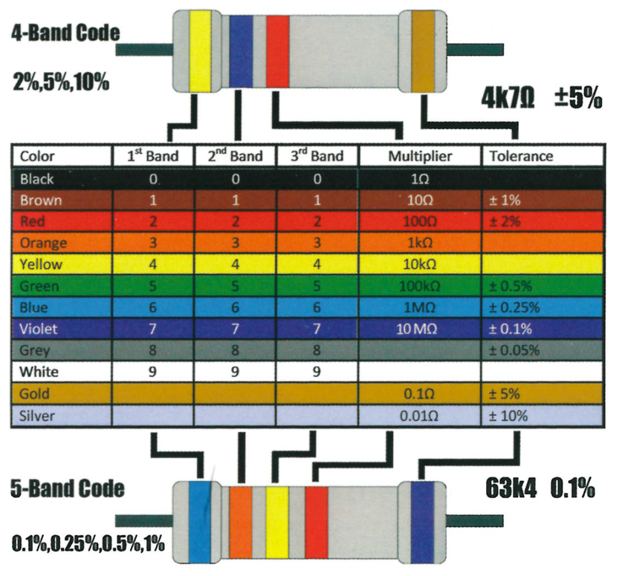

Resistor Color Band Chart

Step 2: Build the simple 4-bit DAC as shown in the schematic diagram. You may need to cut and strip wires in order to complete the project.

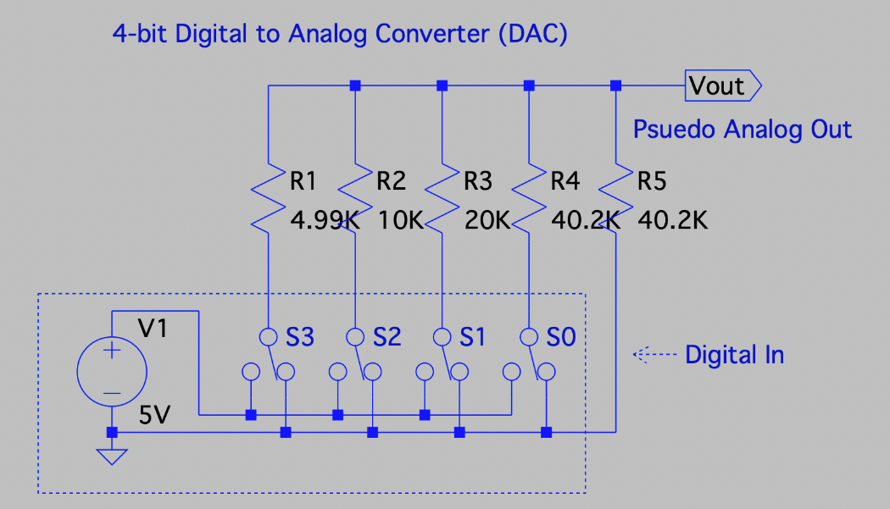

Schematic of a simple 4-bit DAC

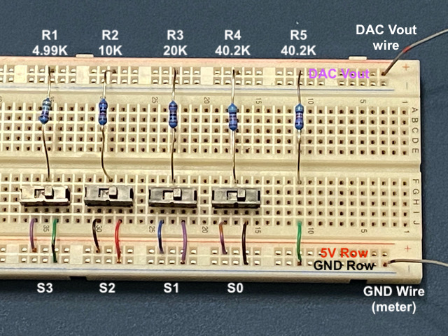

Step 3: Connect a 5V power supply to the breadboard (use bottom 2 rows)

Step 4: Connect a voltmeter to the DAC out wire with respect to GND.

Step 5: Observe the voltage fluctuations as you flip the switches. Fill out the DAC Vout table for each possible input code.

|  |  |  |  |  |  |  |
| --- | --- | --- | --- | --- | --- | --- |
| **S3** | **S2** | **S1** | **S0** |  | **DAC Vout** | **Step Size** |
| 0 | 0 | 0 | 0 |  | 0 | ------------ |
| 0 | 0 | 0 | 1 |  | 0.314 | 0.314 |
| 0 | 0 | 1 | 0 |  | 0.631 | 0.317 |
| 0 | 0 | 1 | 1 |  | 0.946 | 0.315 |
| 0 | 1 | 0 | 0 |  | 1.260 | 0.314 |
| 0 | 1 | 0 | 1 |  | 1.574 | 0.314 |
| 0 | 1 | 1 | 0 |  | 1.892 | 0.318 |
| 0 | 1 | 1 | 1 |  | 2.206 | 0.314 |
| 1 | 0 | 0 | 0 |  | 2.530 | 0.324 |
| 1 | 0 | 0 | 1 |  | 2.845 | 0.315 |
| 1 | 0 | 1 | 0 |  | 3.162 | 0.317 |
| 1 | 0 | 1 | 1 |  | 3.477 | 0.315 |
| 1 | 1 | 0 | 0 |  | 3.791 | 0.314 |
| 1 | 1 | 0 | 1 |  | 4.105 | 0.314 |
| 1 | 1 | 1 | 0 |  | 4.422 | 0.317 |
| 1 | 1 | 1 | 1 |  | 4.737 | 0.315 |

DAC Vout Table (40 Points)

Part 3. Conclusions statement.

Write a brief conclusions statement that discusses all of the original purposes of the lab. Please use complete sentences and correct grammar to express your thoughts on how you fulfilled the purposes of the lab:

# Purposes (repeated):

* Become familiar with lab equipment such as digital multimeters and power supplies.
* Learn how to breadboard schematic diagrams.
* Make comparisons between analog and digital circuits.

You might have something to say about the first two bullets, but the 3rd bullet deserves the most attention. Specifically, make sure to address these questions:

1. Is the output of a potentiometer truly an analog output?
2. Is the output of a DAC truly an analog output, or is it more of a pseudo analog output? Why or why not?
3. What is the average voltage step size of the DAC? Can you see how this can be calculated?
4. If you wanted a DAC with a step size 4-times smaller than this DAC, what must you do? To answer this question, you need to understand that the new DAC would need to produce 64 different levels instead of only 16, so how many digital bits would be required?

(The conclusions box will expand as you write)

|  |
| --- |
| Conclusions:The output of the potentiometer is analog. The output of the DAC is binary. The reason why is because the output of the potentiometer is depend on the position of the knob, and it varies. When you turn the DAC on/off, it changes the bits by around 0.314V. The result is repeatable for the DAC, making 0.314V its voltage step size. We calculated the voltage step size by subtracting the next bits by the previous. To make a DAC that is 4 times smaller, we would need to add more bits (switches) but keep the voltage the same. Each bits would then represent a smaller value. |

## Conclusion Statement (40 Points)

## Congratulations, you have completed Lab!

## You may now submit this document.