NOTE: Use of internet is not permitted, calculators are permitted and your answers must include worked solutions. If you require extra sheet(s) please write your name and student number at the top of each additional sheet.

**Objective**

Complete exam questions d, e, and f below

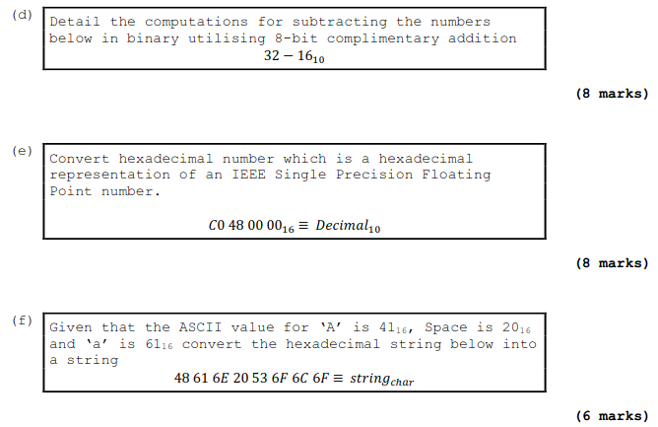

48 61 6E 20 53 6F 6C 6F = Han Solo

Hand up this practical report at the end of session and ensure it has been checked

|  |  |  |  |
| --- | --- | --- | --- |
| **Student Name** | **Marcel Zama** | **Student Number** | **C00260146** |
| **Date** | **10/11/11** | **Checked** |  |
| **Group** | **A / B** |  |  |

E) 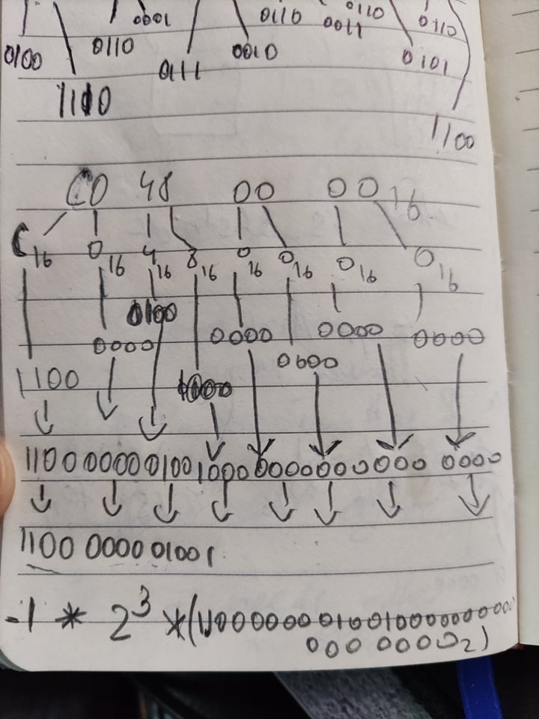

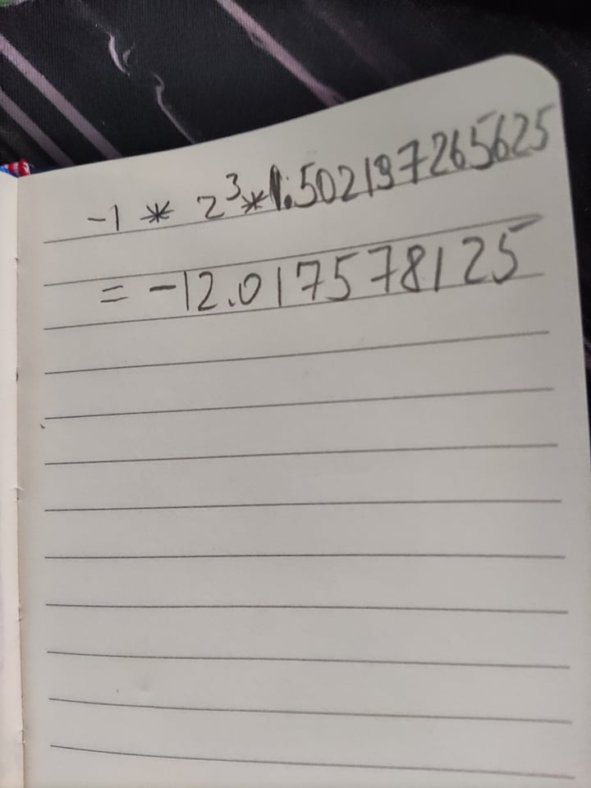

D)

32=100000 ; 16=10000 ; 100000

-10000

- -----------

10000