

School of Computer Science & Software Engineering
Bachelor of Computer Science
CSIT321 - Final Year Project

LIMOS

TECHNICAL DESIGN MANUAL

Date | 1/09/2026
Group | 34
Student 1 | Low Kai Jie | 9890658 | kjlow002@mymail.sim.edu.sg
Student 2 | Luo Anrong Augustin | 8942766 | aaluo001@mymail.sim.edu.sg
Student 3 | Marcela Fioneta | 9097272 | mfioneta001@mymail.sim.edu.sg
Student 4 | Lin Shiming | 8576658| slin048@mymail.sim.edu.sg
Supervisor | Tian Sion Hui
Assessor | Terence Chew

Table of Contents
Table of Contents 2
1. Introduction 4
1.1 Purpose 4
1.2 Scope 4
1.3 System Overview 4
Technology stack 4
2. Functional Hierarchy Diagram 5
3. Data Flow Diagrams 6
3.1 Context Diagram (Level 0) 6
3.2 Level 1 Data Flow Diagram 6
4. Entity Relationship Diagram 8
5. Sequence Diagrams 9
5.1 Register a new account 9
5.2 Sign-in & session-aware route guard 9
5.3 Log a meal (with nutrition auto-fill) 10
5.4 Scan food (mocked recognition) 11
5.5 Discover & favourite a recipe 12
5.6 Log weight & view progress 12
5.7 Business partner registration 13
5.8 Admin reviews a partner request 14
5.9 Self-service account deletion 15
6. Database Design 17
6.1 Collection Schemas 17
users — one document per account, id = Firebase Auth uid 17
profiles — id = {uid}_profile 17
partnerProfiles — id = uid 17
recipes — shared catalog, auto-generated id 17
favorites — id = {uid}_{recipeId} 18
userRecipes — user-authored recipes, auto-generated id 18
mealLogs — auto-generated id 18
weightLogs / waterLogs — auto-generated id 18
reminders — auto-generated id 18
foodRecognitions — auto-generated id 19
6.2 Composite Indexes 19
6.3 Security Rules Summary 19
7. User Interface Wireframes 20
7.1 Role Selection, Sign In, Register 20
7.2 Partner Registration & Account Status 20
7.3 Onboarding Wizard 21
7.4 Home Dashboard 22
7.5 Log Meal & Meal History 23
7.6 Recipe Catalog, Detail & Add Recipe 25
7.7 Discover (Spoonacular) & Scan Food 26
7.8 Progress 27
7.9 Profile, Edit Profile, Settings & Reminders 29
7.10 Business Partner Dashboard & Profile 30
7.11 Admin Dashboard & Partner Requests 31
7.12 Review User & Partner Accounts 33
8. Non-Functional Design Considerations 35
8.1 Medical Data Encryption 35
8.2 Role-Based Access Control 35
8.3 Third-Party Integration — Spoonacular 35
8.4 Known Limitations 35
Appendix A — Route Map 36

1. Introduction

1.1 Purpose
This document is the technical design manual for LIMOS, a cross-platform nutrition and health-tracking application built with Flutter and Firebase. It records the system's functional decomposition, data flow, entity-relationship model, interaction sequences, database schema and user-interface wireframes as implemented in the current codebase, so that the design can be understood, maintained, and extended independently of the source code.

1.2 Scope
LIMOS serves three distinct account roles from a single Flutter codebase and a single Firebase project:
- Regular User — tracks meals, water, weight, and progress; browses and logs recipes; receives diet/allergy/medical-aware recommendations.
- Business Partner — registers a business profile that is queued for admin approval before the partner dashboard becomes accessible.
- Administrator — reviews and actions partner applications, and suspends or restores user and partner accounts.
The document covers the mobile/web client application, its Firebase backend (Authentication and Cloud Firestore), and its one external integration (the Spoonacular recipe/nutrition API). It does not cover infrastructure provisioning or CI/CD, which are outside the current project's scope.

1.3 System Overview
LIMOS is a client-heavy architecture: the Flutter application talks directly to Firebase Authentication and Cloud Firestore for all account, profile and activity data, and directly to the third-party Spoonacular API for recipe search and nutrition estimation. There is no custom application server — business logic (BMI/BMR/TDEE calculation, dietary/allergy/medical-condition matching, role-based routing) lives in the client's controller layer, and access control is enforced twice: once by Firestore Security Rules server-side, and once by the app's own router guard for a responsive UI experience.

Technology stack
Layer | Technology | Notes
Client framework | Flutter (Dart) | Single codebase targeting Android, iOS and Web
Navigation | go_router 17.x | Declarative routing with a global redirect guard
Authentication | Firebase Authentication | Email/password sign-in
Database | Cloud Firestore | NoSQL document store, 11 collections
External API | Spoonacular | Recipe search/detail and nutrition-guess endpoints, called directly from the client
Field-level security | AES-256-GCM (PointyCastle) | Encrypts medical-history profile fields at rest
Backend-as-a-service | Firebase project “fypprojecthealth” | Hosting, Firestore rules & indexes, Auth

2. Functional Hierarchy Diagram

1.4 System Architecture
LIMOS follows a layered client-heavy architecture. The Flutter presentation layer communicates with controllers, which coordinate repositories and services. Firebase Authentication and Cloud Firestore provide authentication and persistent application data, while Spoonacular provides recipe and nutrition data. Firestore Security Rules provide the authoritative server-side access-control boundary; client-side route guards provide navigation and user-interface protection.
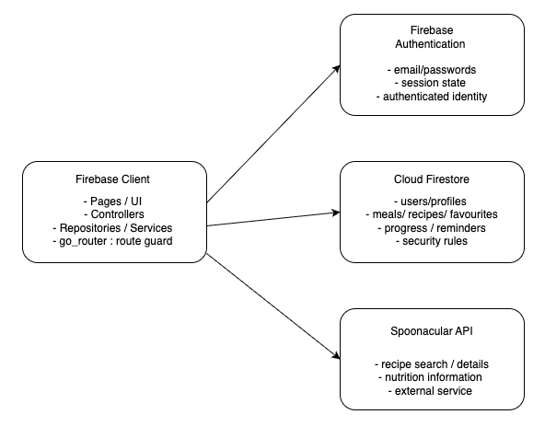
System Architecture

The functional hierarchy decomposes LIMOS into five top-level functional areas, each corresponding to a cohesive set of routes and controllers in the codebase. Account & Access Management and the shared platform services underpin every other branch.
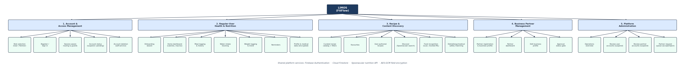
Functional Hierarchy Diagram
Diet, allergy, and medical-condition safety matching (branch 3) is a pure business-logic function, implemented in meal_recommendation.dart — that cross-references a recipe's dietType/allergen/cautionTag fields against a user's profile before it is surfaced as a recommendation; it has no dedicated screen of its own.

3. Data Flow Diagrams

3.1 Context Diagram (Level 0)
The context diagram treats LIMOS as a single process and shows every external entity it exchanges data with: the three human roles, and the two systems it depends on (Firebase and Spoonacular).
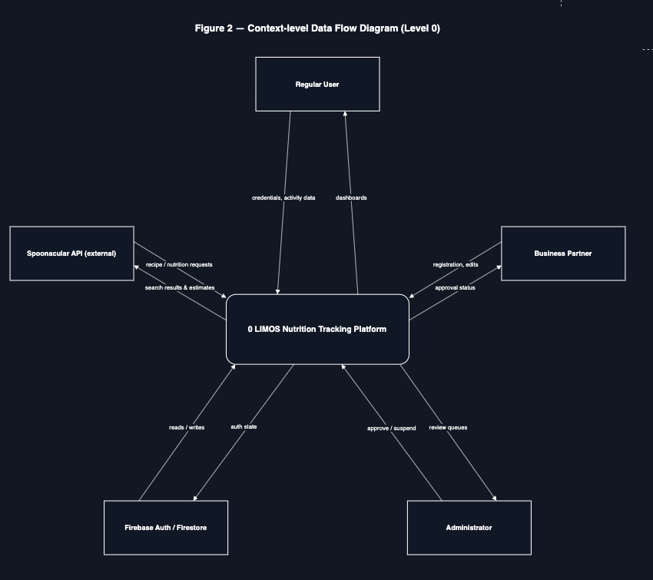
%3CmxGraphModel%3E%3Croot%3E%3CmxCell%20id%3D%220%22%2F%3E%3CmxCell%20id%3D%221%22%20parent%3D%220%22%2F%3E%3CmxCell%20id%3D%222%22%20parent%3D%221%22%20style%3D%22rounded%3D0%3BwhiteSpace%3Dwrap%3Bhtml%3D1%3BfillColor%3D%23111827%3BstrokeColor%3Dnone%3B%22%20value%3D%22%22%20vertex%3D%221%22%3E%3CmxGeometry%20height%3D%221079%22%20width%3D%221203%22%20x%3D%22148%22%20y%3D%22-80%22%20as%3D%22geometry%22%2F%3E%3C%2FmxCell%3E%3C%2Froot%3E%3C%2FmxGraphModel%3E
Context-level Data Flow Diagram

3.2 Level 1 Data Flow Diagram
Decomposing process 0 into its eight major processes exposes the data stores (Firestore collections) each process reads from or writes to. Processes 1–6 serve the regular-user experience; processes 7–8 serve business-partner and administrator workflows respectively.
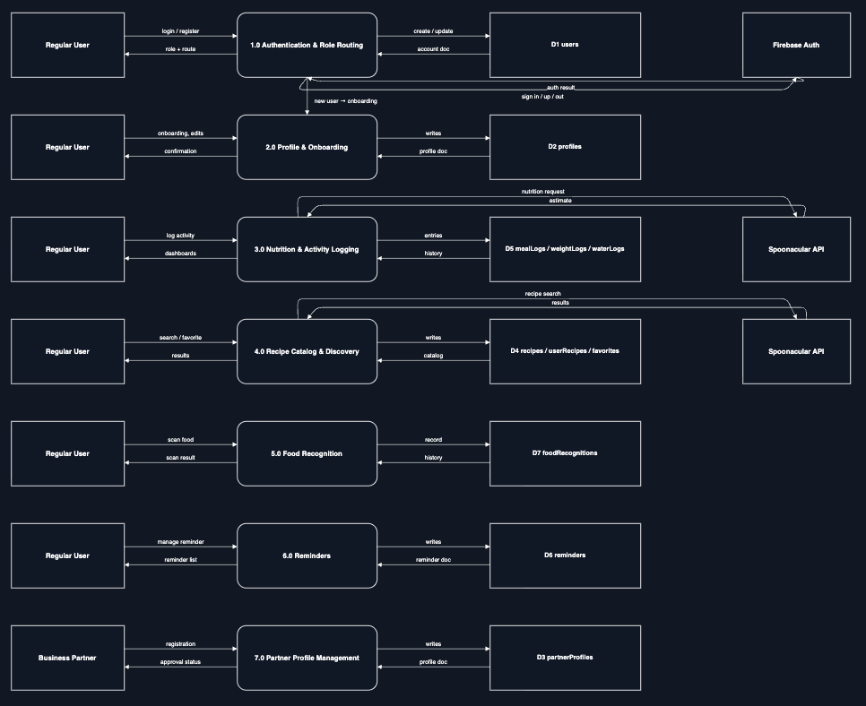
Level 1 Data Flow Diagram

4. Entity Relationship Diagram
LIMOS persists data in Cloud Firestore, a document database, so the diagram below expresses “entities” as Firestore collections and “relationships” as the userId (and, for favorites, recipeId) foreign-key fields the client uses to filter queries — there is no server-enforced referential integrity, only Security-Rules-enforced ownership.
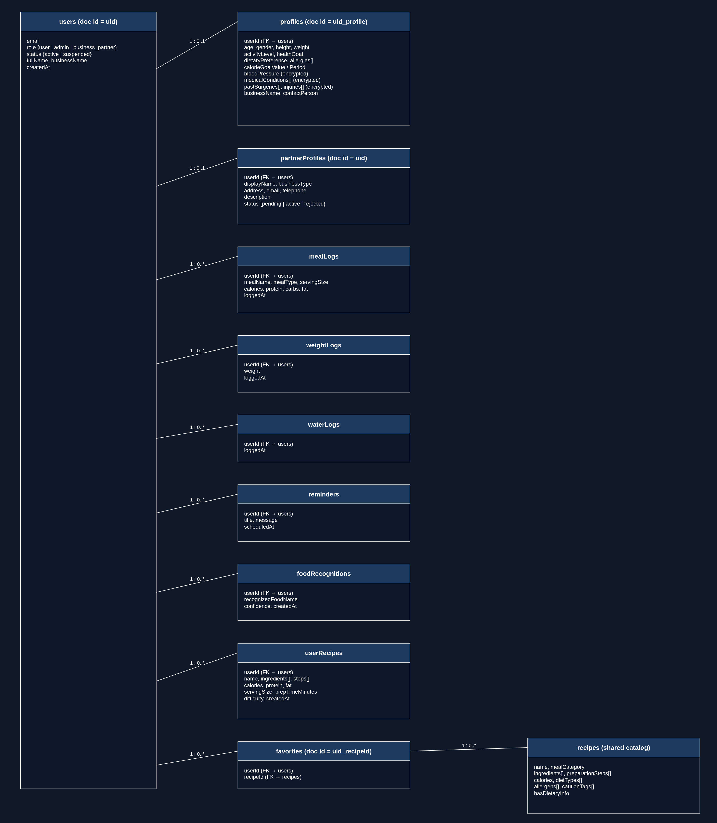
Entity Relationship Diagram
Two documents intentionally use composite, human-readable IDs instead of auto-generated ones: profiles/{uid}_profile (a 1:1 extension of a user's account) and favorites/{uid}_{recipeId} (a many-to-many join that also guarantees a user can only favorite a given recipe once, since writing the same ID twice overwrites rather than duplicates).
Relationship cardinalities: one user has one profile; one user can have many mealLogs, weightLogs, waterLogs, reminders, foodRecognitions, and userRecipes; favourites form a many-to-many relationship between users and recipes through the favorites collection. These relationships are represented by userId and recipeId fields rather than database-enforced foreign keys.

5. Sequence Diagrams
The sequence diagrams below trace the actual Page → Controller → Repository/Service call chain used in the codebase. Each lifeline is stereotyped using the Boundary/Control/Entity (BCE) convention. Boundary for UI pages, Control for controllers/services that orchestrate logic, Entity for repositories and external systems, with the initiating human role shown as a UML actor. Genuine branch points in the underlying code (a try/catch, an if/else, a status check) are drawn as UML alt combined-fragment frames rather than flattened into a single linear path.

5.1 Register a new account
A new account writes users/{uid} and profiles/{uid}_profile in one Firestore batch; a business partner additionally gets a partnerProfiles/{uid} document seeded with status ‘pending’. The alt frame reflects RegisterPage's try/catch around AuthController.register().
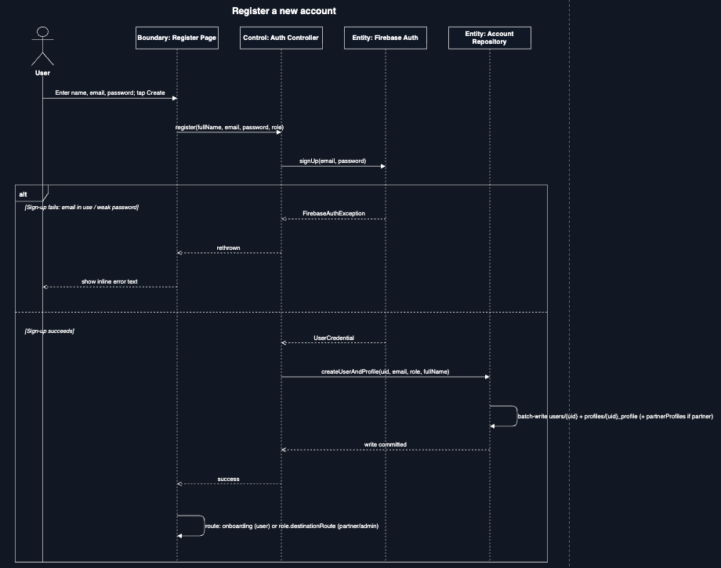
Register a new account

5.2 Sign-in & session-aware route guard
go_router's global redirect callback re-evaluates the signed-in account's role and status on every navigation, not just at login — this is what enforces suspension and partner-approval gating throughout a session. The nested alt frames mirror router.dart's actual nested conditionals (signed-in state, then account/partner status, then role-route matching).
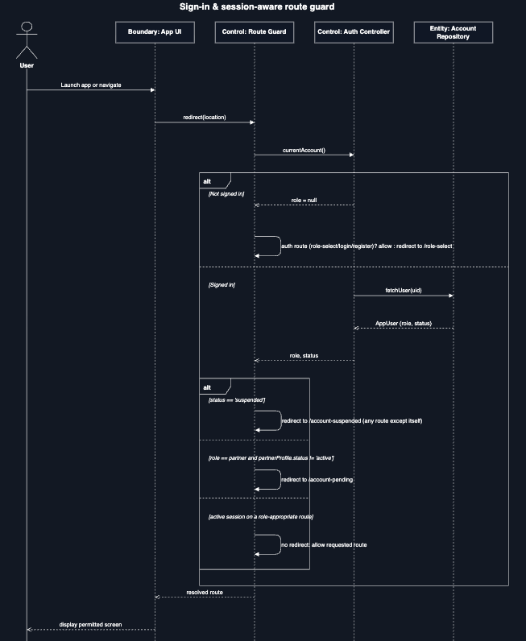
Sign-in & session-aware route guard

5.3 Log a meal (with nutrition auto-fill)
Typing a food name triggers a live Spoonacular nutrition guess that pre-fills the calorie/macro fields, which the user can still edit before saving; the alt frame covers NutritionLookupService.lookup() returning null when Spoonacular has no estimate.
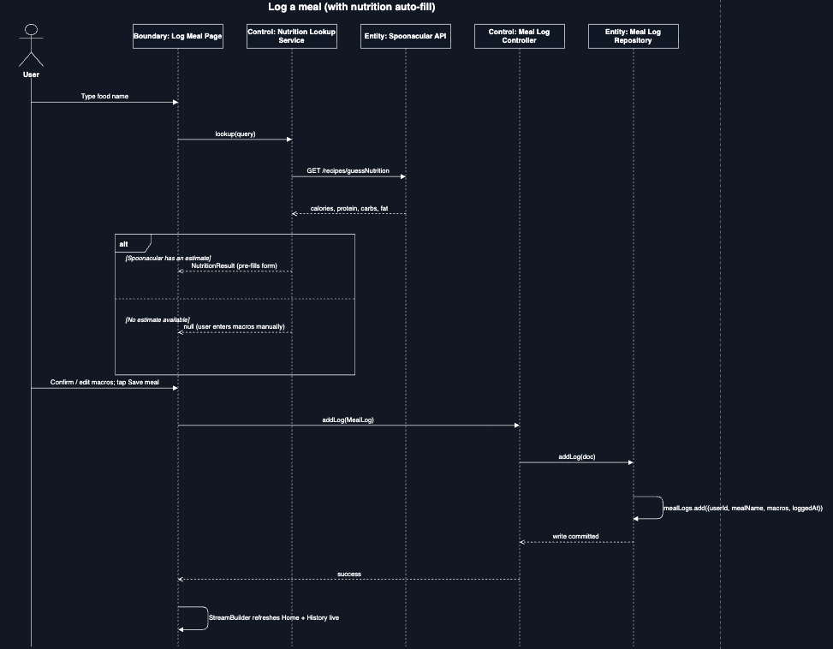
Log a meal

5.4 Scan food (mocked recognition)
No camera or ML package is integrated; the scan screen returns a fixed mocked result (‘Salad bowl’, 92% confidence) but persists it through the same real repository path as any other logged data.
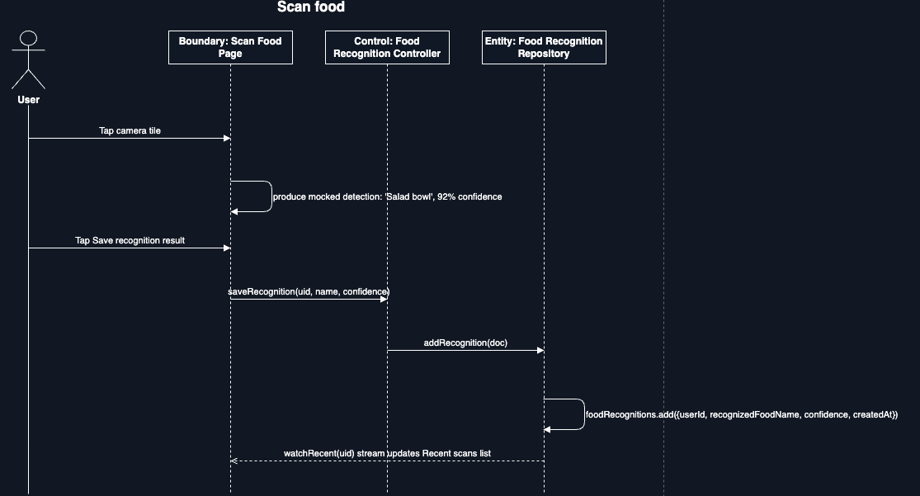
Scan food

5.5 Discover & favourite a recipe
Discover recipes are fetched live from Spoonacular and are distinct from the app's own seeded/admin recipe catalog. The alt frame covers RecipeRepository.toggleFavorite()'s create-vs-delete branch on the favorites/{uid}_{recipeId} document.
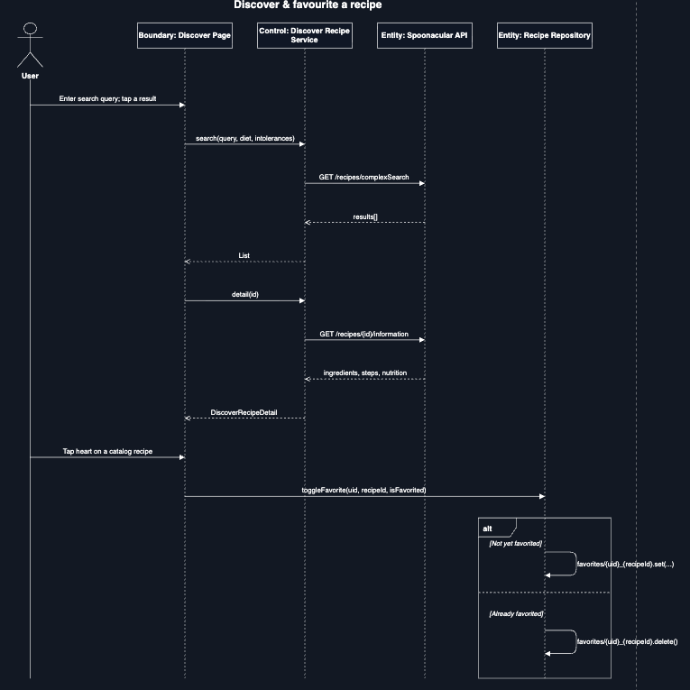
Discover & favourite a recipe

5.6 Log weight & view progress
BMI/BMR/TDEE and calorie/macro/water targets are computed client-side in HealthMetrics from the user's profile fields, not stored pre-computed; the alt frame covers the fallback HealthMetrics.forCalorieGoal(2100) path used when a profile is too incomplete for a full BMR/TDEE calculation.
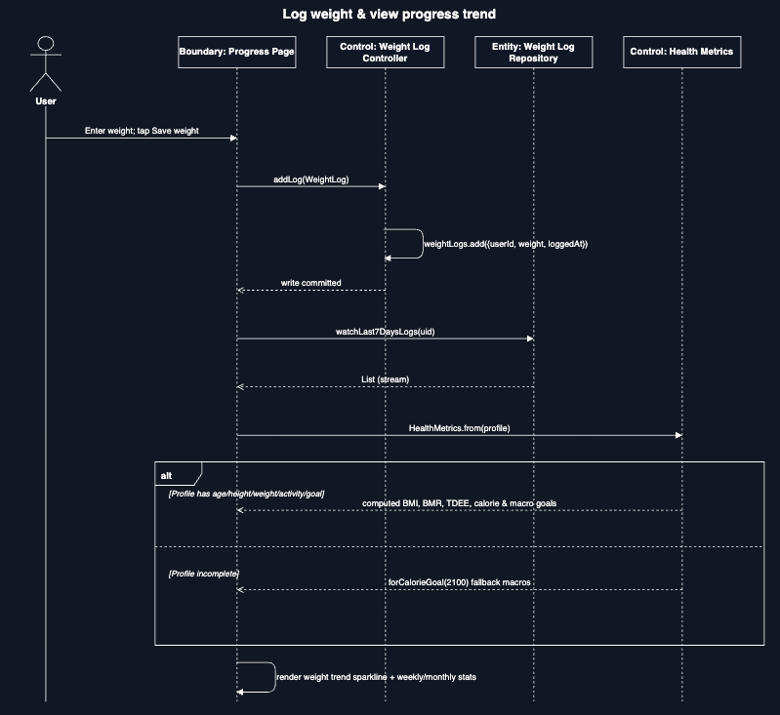
Log weight & view progress

5.7 Business partner registration
A partner's Firebase Authentication account is created as an active account so the partner can sign in, but the partner application remains pending in partnerProfiles. While partnerProfiles.status = 'pending', the router redirects the partner to /account-pending. Partner functionality becomes accessible only after an administrator changes the application status to 'active'.
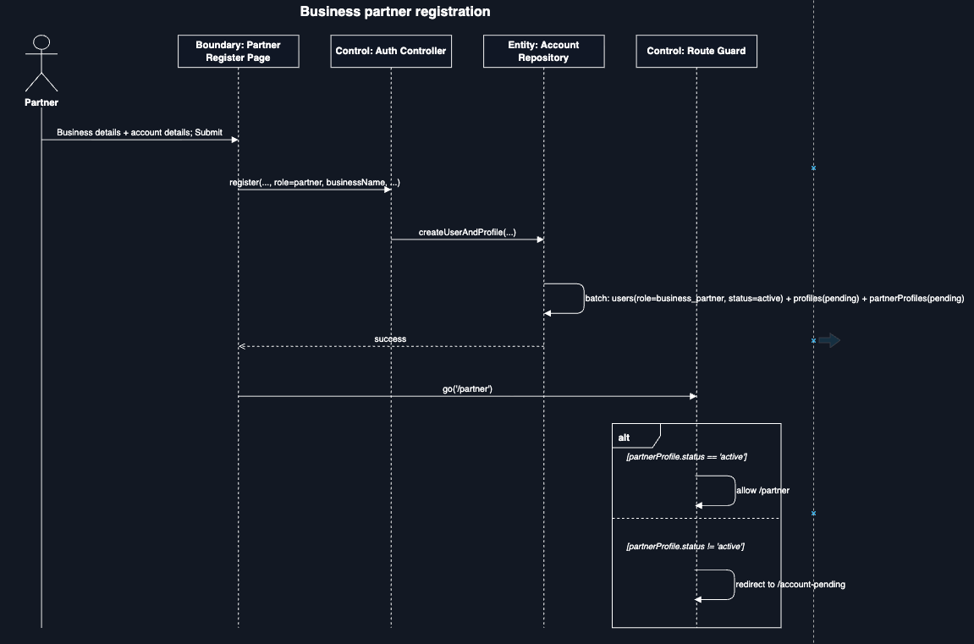
Business partner registration

5.8 Admin reviews a partner request
The Partner requests queue streams only status == ‘pending’ documents; the alt frame is the admin's actual Accept/Reject choice, each branch a single field update that the partner's own router guard picks up on their next navigation.
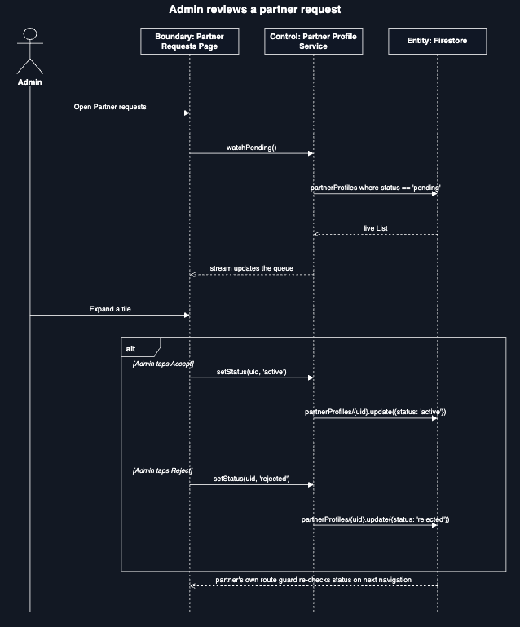
Admin reviews a partner request

5.9 Self-service account deletion
Deletion requires a fresh re-authentication (Firebase's requires-recent-login safeguard) before anything is deleted; the alt frame covers that reauthentication succeeding versus failing on an incorrect password.
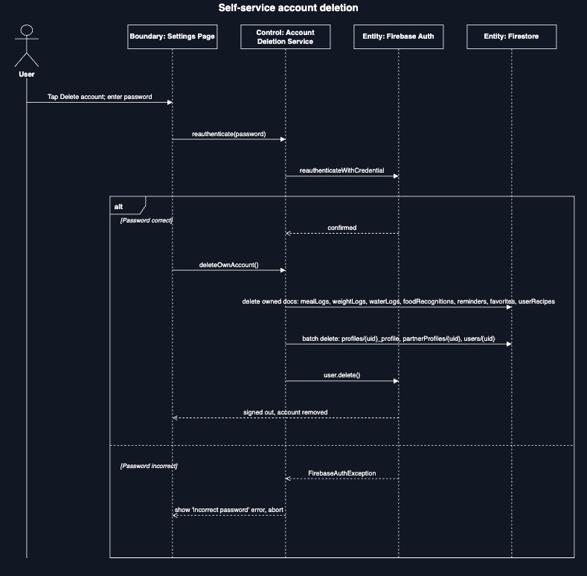
Self-service account deletion

6. Database Design
LIMOS uses Cloud Firestore, a schemaless NoSQL document database organised into flat top-level collections (no sub-collections are used). Field types below are the Dart-level types the client reads/writes; Firestore itself stores them as string, number, boolean, array, map, or timestamp values. Fields marked “(encrypted)” are stored as an AES-256-GCM ciphertext string, not as plaintext — see section 8.1.

6.1 Collection Schemas

Users: one document per account, id = Firebase Auth uid
Field | Type | Description
email | string | Account email address
role | string enum | ‘user’ | ‘admin’ | ‘business_partner’
status | string enum | ‘active’ | ‘suspended’ — admin-controlled
fullName | string? | Registering user's or partner representative's name
businessName | string? | Set only when role = business_partner
createdAt | timestamp? | Server write time

Profiles: id = {uid}_profile
Field | Type | Description
userId | string | FK → users.uid
fullName, age, gender | string?/int?/string? | Basic demographic fields (regular user)
height, weight | num? | Centimetres / kilograms
activityLevel, healthGoal | string? | From onboarding wizard's fixed option lists
dietaryPreference | string? | Omnivore | Vegetarian | Vegan | Pescatarian | Keto
allergies | array<string>? | From a fixed vocabulary shared with recipe tagging
targetWeight | num? | User's goal weight
address, phone | string? | Regular-user contact details
bloodPressure | string? (encrypted) | Normal | Elevated | High | Low
medicalConditions | array<string>? (encrypted) | Fixed vocabulary; drives caution-tag filtering
pastSurgeries, injuries | array<string>? (encrypted) | Free-text lines, encrypted per entry
calorieGoalValue, calorieGoalPeriod | num?/string? | User-set override of the computed calorie goal
businessName, contactPerson, category, status | string? | Business-partner profile shape (same collection, different field set)

partnerProfiles: id = uid
Field | Type | Description
userId | string | FK → users.uid
displayName, businessType | string | Public business identity
address, email, telephone | string | Public contact details
description | string | Free-text business description
status | string enum | ‘pending’ | ‘active’ | ‘rejected’ — admin-controlled

Recipes: shared catalog, auto-generated id
Field | Type | Description
name, mealCategory | string | Display name and category
ingredients, preparationSteps | array<string> | Ordered lists
calories | int | Per serving
dietTypes | array<string> | Diets this recipe satisfies (excludes ‘Omnivore’)
allergens | array<string> | Tracked allergens the recipe contains
cautionTags | array<string> | e.g. ‘High Sodium’ — drives medical-condition filtering
hasDietaryInfo | bool | Whether the tags above were ever reviewed (false = unknown, not ‘safe’)

Favorites: id = {uid}_{recipeId}
Field | Type | Description
userId | string | FK → users.uid
recipeId | string | FK → recipes.id

userRecipes : user-authored recipes, auto-generated id
Field | Type | Description
userId | string | FK → users.uid
name, ingredients, preparationSteps | string/array<string> | As entered on Add Recipe
calories, protein, fat | int | Per serving
servingSize | string | Free text, e.g. ‘1 bowl’
prepTimeMinutes | int | Minutes
difficulty | string | e.g. ‘easy’
createdAt | timestamp | Client write time

mealLogs : auto-generated id
Field | Type | Description
userId | string | FK → users.uid
mealName, mealType, servingSize | string | mealType e.g. Breakfast/Lunch/Dinner/Snack
calories, protein, carbohydrates, fat | int | Per logged entry
loggedAt | timestamp | When the meal was eaten/logged

weightLogs / waterLogs : auto-generated id
Field | Type | Description
userId | string | FK → users.uid
weight | num (weightLogs only) | Kilograms
loggedAt | timestamp | waterLogs has one document per glass logged

reminders : auto-generated id
Field | Type | Description
userId | string | FK → users.uid
title, message | string | Reminder content
scheduledAt | timestamp | When the reminder is due

foodRecognitions : auto-generated id
Field | Type | Description
userId | string | FK → users.uid
recognizedFoodName | string | Mocked detection result (see 5.4)
confidence | double | 0–1 confidence score
createdAt | timestamp | Scan time

6.2 Composite Indexes
Firestore requires an explicit composite index for any query that filters on one field and orders by another. firestore.indexes.json declares the following, all scoped per-user (userId ascending) and ordered by their timestamp field:
Collection | Fields (in order)
mealLogs | userId ↑, loggedAt ↑
weightLogs | userId ↑, loggedAt ↑
waterLogs | userId ↑, loggedAt ↑
reminders | userId ↑, scheduledAt ↑
foodRecognitions | userId ↑, createdAt ↓
userRecipes | userId ↑, createdAt ↓

6.3 Security Rules Summary
Access control is enforced server-side by Firestore Security Rules (firestore.rules), independent of the client's own route guards. The general pattern is strict per-user ownership, with narrow admin overrides:
Collection | Read | Create | Update | Delete
users | Owner or admin | Owner only; role must be ‘user’ or ‘business_partner’ (never ‘admin’) | Admin (any field), or owner (fullName/businessName/email only) | Owner only (self-service)
profiles | Owner or admin | Owner only | Owner or admin | Owner only
partnerProfiles | Any signed-in user | Owner only, status must start ‘pending’ | Admin (any field), or owner (public fields only, not status) | Owner only
recipes | Any signed-in user | Denied — seeded server-side via Admin SDK | Denied | Denied
mealLogs / weightLogs / waterLogs / reminders / foodRecognitions / favorites / userRecipes | Owner only | Owner only | Owner only (n/a for favorites/foodRecognitions/waterLogs) | Owner only
Note: admins can promote/suspend accounts and moderate partner applications, but cannot delete another user's Firestore documents or Firebase Auth identity, account deletion is deliberately self-service only (AccountDeletionService), matching the rule set above.

7. User Interface Wireframes
The wireframes below are low-fidelity structural mockups of every screen in the current build, grouped by the role that reaches them. Labels reproduce the actual field names, button text and section headings from the Flutter source (lib/pages/*.dart) rather than placeholder “Lorem ipsum” text, so each wireframe can be cross-referenced directly against its screen's code.

7.1 Role Selection, Sign In, Register
Shared entry flow. Role selection determines whether Register routes to the plain regular-user form or the two-step partner form.
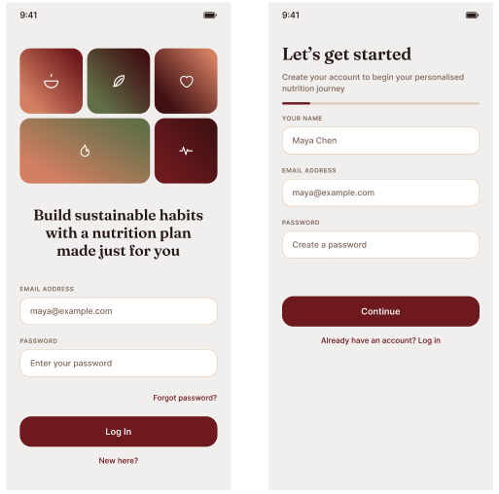
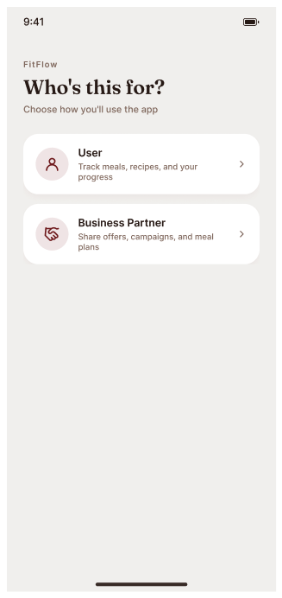
Role Selection, Sign In, Register

7.2 Partner Registration & Account Status
The partner registration wizard (business details, then account details) and the registration submitted screen is shown when they have successfully fill in the form.
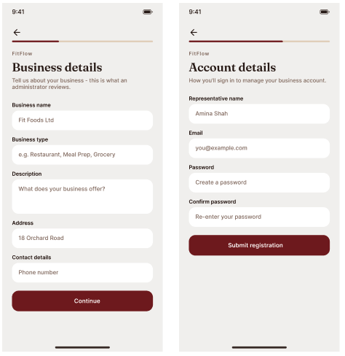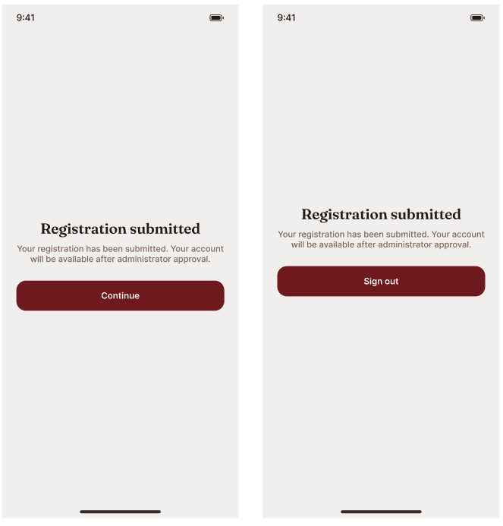
Partner Registration & Account Status

7.3 Onboarding Wizard
Shown once, immediately after a regular user's first registration, before the Home dashboard becomes reachable.

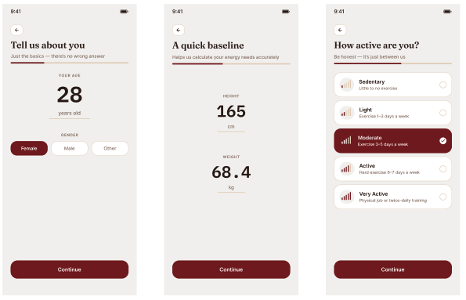
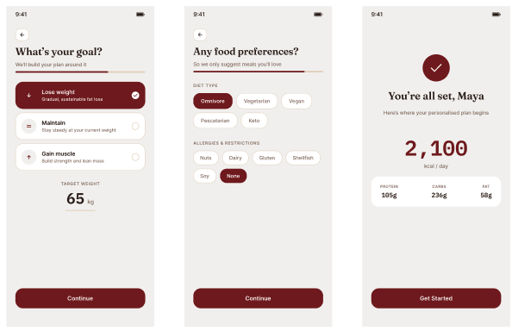

Onboarding Wizard

7.4 Home Dashboard
The regular user's default landing screen (bottom-nav index 0): calorie ring, macro progress, water intake, weight trend, and a weekly calories chart, all live Firestore streams.
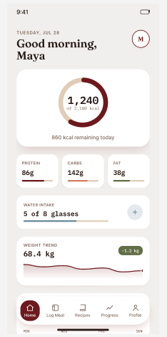

Home Dashboard

7.5 Log Meal & Meal History
Log Meal auto-fills nutrition via Spoonacular; History lists the last 30 days grouped by day.
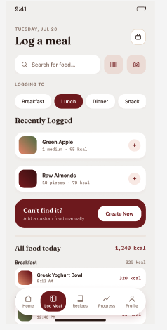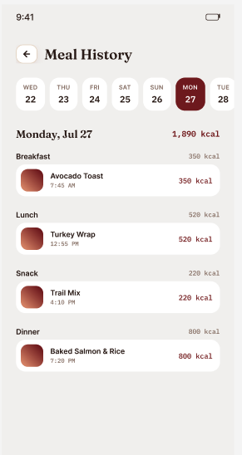
Log Meal & Meal History

7.6 Recipe Catalog, Detail & Add Recipe
Recipes (bottom-nav index 2) filters the shared catalog and the user's own recipes together; Recipe Detail and Add Recipe are reached from it.
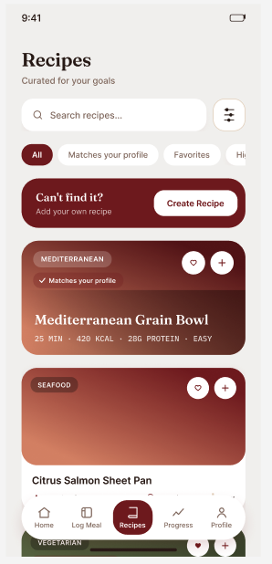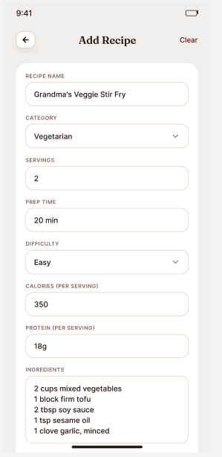
Recipe Catalog, Detail & Add Recipe

7.7 Discover (Spoonacular) & Scan Food
Discover is a separate, search-first source from the curated catalog; Scan Food persists a mocked recognition result (see 5.4).
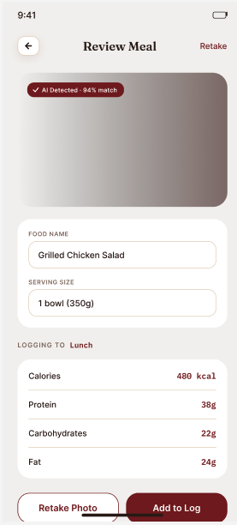
Discover (Spoonacular) & Scan Food

7.8 Progress
Progress (bottom-nav index 3): weight logging, weekly/monthly toggle, and streak/average statistics.
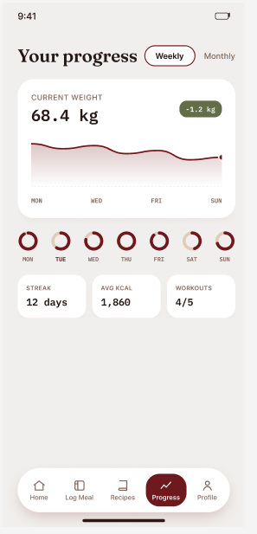
Progress

7.9 Profile, Edit Profile, Settings & Reminders
Profile (bottom-nav index 4) surfaces computed BMI/BMR/TDEE alongside stored fields; Edit Profile includes the encrypted medical-history fields.
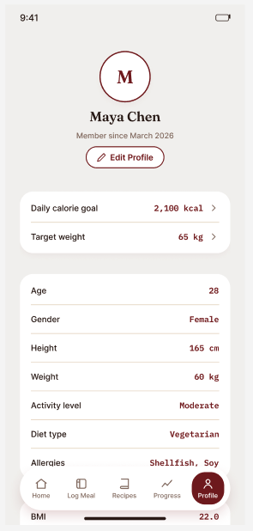
Profile, Edit Profile, Settings & Reminders

7.10 Business Partner Dashboard & Profile
The partner's own two-item bottom nav (Home, Profile), reachable only once partnerProfiles.status = ‘active’.
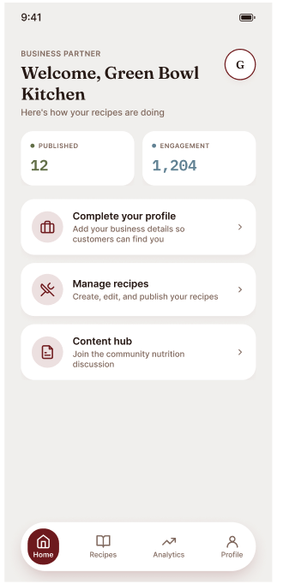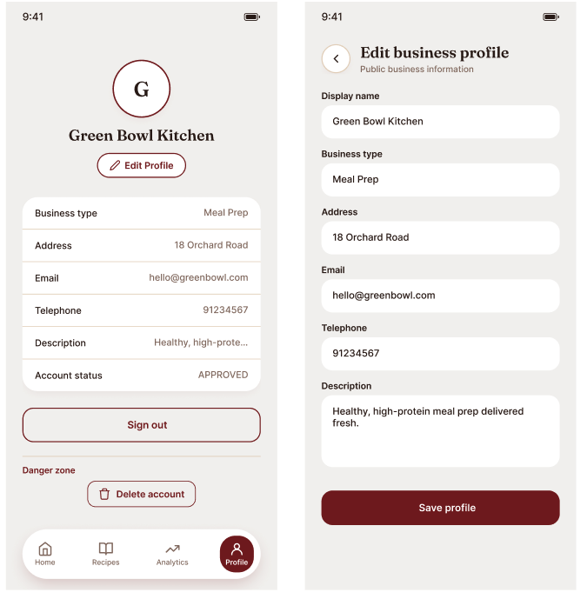
Business Partner Dashboard & Profile

7.11 Admin Dashboard & Partner Requests
The administrator's operations overview and the pending-applications review queue.
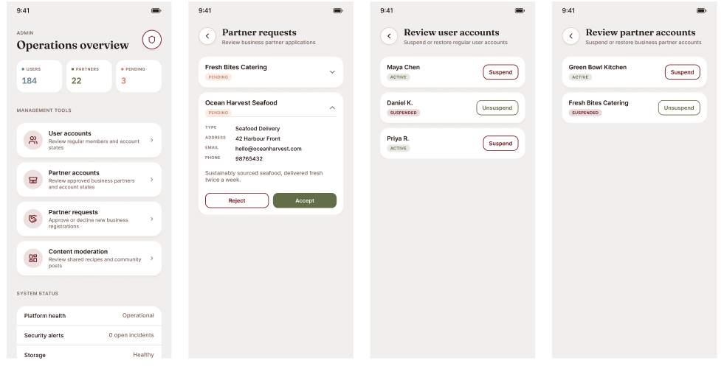
Admin Dashboard & Partner Requests

7.12 Review User & Partner Accounts
Split suspend/unsuspend queues, kept separate per role so an admin never manages both account types in one mixed list.
Review User & Partner Accounts

8. Non-Functional Design Considerations

8.1 Medical Data Encryption
The four confidential medical-history fields on a profile — bloodPressure, medicalConditions, pastSurgeries, and injuries — are encrypted at the field level before being written to Firestore, using AES-256-GCM (via PointyCastle). The encryption key is derived per-user as SHA-256(uid : app-level pepper), and a random 12-byte nonce is generated for each encryption call. This provides an additional layer of protection against direct exposure of plaintext values in raw Firestore data. However, it is a client-side mitigation rather than server-managed key management: because the key-derivation mechanism and application-level pepper are distributed with the client application, a sufficiently capable attacker with access to the application may be able to recover the mechanism. Production deployment should use server-side key management and rotation where appropriate.

8.2 Role-Based Access Control
Access control is layered: Firestore Security Rules are the authoritative, server-enforced boundary (section 6.3); the app's go_router redirect guard is a second, client-side layer that keeps the UI responsive and prevents a signed-in session from ever rendering a screen its role/status shouldn't see, re-evaluating on every navigation rather than only at login.

8.4 Third-Party Integration (Spoonacular)
The Spoonacular integration is used for two application functions. Discover uses recipe search/detail data, while meal logging uses nutrition estimation to pre-fill calories and macronutrients. The client sends the required search/food input and extracts the recipe or nutrition fields needed by the UI. If the service returns no usable estimate or is unavailable, the application should retain the manual-entry path rather than treating missing API data as authoritative.

8.5 Medical Recommendation Safety Boundary
LIMOS uses rule-based dietary and caution-tag filtering rather than clinical decision-making. Recommendations are based on predefined diet, allergen, and medical-condition caution tags configured in the application. The system does not diagnose conditions, prescribe treatment, or guarantee that a recipe is medically safe. Users should verify health-related dietary decisions with an appropriate healthcare professional.
Recipe search/detail (Discover) and nutrition estimation (meal logging's auto-fill) both call the Spoonacular REST API directly from the Flutter client using a bundled API key. This is an accepted trade-off for a free-tier key on a student project; a production deployment would proxy these calls through a backend so the key is never shipped in the client binary.

8.6 Known Limitations

8.6.1 Error Handling
The application handles common failures at the service/controller boundary and presents an appropriate fallback or error state to the user. Authentication failures are surfaced as sign-in or registration errors; Firestore failures are handled without assuming that a write succeeded; Spoonacular failures or missing nutrition estimates fall back to manual entry where supported; and failed account re-authentication prevents destructive account deletion. Unauthorized, suspended, and pending accounts are handled by the route guard and corresponding status pages.

8.6.2 Input Validation
User-entered data is validated before persistence to reduce malformed or incomplete records. Required text fields must not be empty, numeric health and nutrition values must be valid numeric values within the application's accepted range, email addresses must follow the expected email format, and role/status fields are restricted to the defined enum values. Validation in the client improves usability; Firestore Security Rules remain responsible for enforcing authorization.

8.6.3 Design Assumptions
The current design assumes that users have network access for Firebase and Spoonacular-dependent functions; Firebase Authentication, Firestore Security Rules, and indexes are deployed consistently with the application; recipe dietary, allergen, and caution tags are configured according to the project's predefined vocabulary; and the mocked food-recognition feature represents a future integration point rather than a production machine-learning model.
1. Food recognition is mocked: Scan Food always returns a fixed result ('Salad bowl', 92% confidence) rather than performing real image capture or ML inference, no camera or ML package is integrated.
2. The Spoonacular API key ships inside the client rather than behind a backend proxy.
3. Firebase Authentication supports email/password only, no social sign-in or multi-factor authentication.
4. Reminders are stored and listed but are not wired to a local/push notification scheduler.

Appendix A — Route Map
Every named route declared in router.dart, with the role(s) permitted to reach it under the redirect guard.
Route | Role(s) | Page
/role-select | Unauthenticated | RoleSelectPage
/login | Unauthenticated | LoginPage
/register | Unauthenticated | RegisterPage / PartnerRegisterPage
/onboarding | User (post-registration) | OnboardingFlowPage
/ | User | HomePage
/meal-log | User | LogMealPage
/recipes | User | RecipesPage
/recipe-detail | User | RecipeDetailPage
/discover | User | DiscoverRecipesPage
/add-recipe | User | AddRecipePage
/progress | User | ProgressPage
/scan-food | User | FoodRecognitionPage
/history | User | HistoryPage
/profile | User | ProfilePage
/edit-profile | User | EditProfilePage
/settings | User | SettingsPage
/reminders | User | RemindersPage
/partner | Business Partner (active) | PartnerHomePage
/partner-profile | Business Partner (active) | PartnerProfilePage
/partner-edit-profile | Business Partner (active) | PartnerEditProfilePage
/admin | Administrator | AdminPage
/partner-requests | Administrator | PartnerRequestsPage
/review-users | Administrator | ReviewUserAccountsPage
/review-partners | Administrator | ReviewPartnerAccountsPage
/account-suspended | Any suspended account | AccountStatusPage
/account-pending | Partner awaiting approval | PartnerPendingStatusPage

