School of Computer Science & Software Engineering
Bachelor of Computer Science — CSIT321 Final Year Project
LIMOS
Project Technical Documentation
Group 34
Date: 12/09/2026
Low Kai Jie | Luo Anrong Augustin | Marcela Fioneta | Lin Shiming
Supervisor: Tian Sion Hui Assessor: Terence Chew

1. Project Background
Maintaining a healthy diet is essential to reducing the risk of non-communicable diseases (NCDs) such as obesity, type 2 diabetes, cardiovascular disease and hypertension. The World Health Organisation identifies unhealthy diets as a leading global risk factor for chronic disease, and in Singapore, promoting healthier eating has become a national priority through initiatives such as Healthier SG and the Health Promotion Board's (HPB) healthy-eating campaigns. The National Population Health Survey (NPHS) 2024 shows Singaporeans are becoming more health-conscious, yet diet-related chronic disease continues to pose a significant public health challenge — underlining the need for accessible tools that support long-term dietary self-management.
Mobile health applications, such as HPB's Healthy 365 and local research efforts like FoodSG, demonstrate that digital tools can meaningfully support preventive healthcare and personalised nutrition. Published research reinforces this: dietary mobile applications improve self-monitoring and nutrition-related outcomes (El Khoury et al., 2019; Villinger et al., 2019); personalised recommendations increase adherence and encourage sustainable behaviour change over generic advice (Frontiers in Digital Health, 2024); combining self-monitoring with personalised feedback improves weight-related outcomes (Chew et al., 2023); and timely progress feedback sustains user motivation (Krukowski et al., 2024). AI-assisted food-image recognition is emerging as a way to reduce logging effort (Rahman et al., 2023), though prediction accuracy still varies with image quality and portion size — meaning AI estimates should always carry a confidence indicator and allow manual correction.
Despite this progress, existing applications typically solve only part of the problem: users must switch between separate apps for calorie tracking, meal planning, and sourcing verified nutrition guidance, and most systems provide generalised recommendations that ignore allergies, dietary preferences or medical conditions. Integration with verified dietitians, nutritionists and healthy-meal providers remains limited across the market. At the same time, because these applications handle sensitive personal and health-related data, strong security practices — secure authentication, role-based access control, encryption of sensitive fields, audit logging and PDPA/OWASP MASVS-aligned development — are essential to user trust.
LIMOS is proposed to close this gap: a single, integrated mobile application that combines personalised calorie-goal setting, food and beverage logging, nutrition/recipe recommendations with allergy- and medical-condition-aware filtering, healthy-meal ordering from verified business partners, comprehensive progress reporting, and an experimental AI-assisted food-image recognition prototype. The application is intended to complement, not replace, professional medical advice — encouraging users with complex health conditions to consult a qualified clinician or dietitian where appropriate.

1.1 Competitor / Market Analysis
Several established applications address parts of this problem space, but none combine personalised nutrition guidance, AI-assisted food logging, verified dietitian support and healthy-meal business partnerships within a single platform:
- MyFitnessPal — large crowdsourced food database and device integrations (Fitbit, Apple Watch, Garmin, Withings), but nutrition data accuracy is inconsistent, key features (e.g. barcode scanning) are now paywalled, and there is no dietitian consultation or partner-meal ordering.
- Lifesum — personalised meal plans, habit tracking and a proprietary food-scoring system across 15+ diet programmes, but a smaller food database than MyFitnessPal/FatSecret, ~±6.5% calorie-accuracy deviation in independent testing, and no allergy-aware engine or verified-partner content.
- FatSecret — generous free-tier food diary, calorie counter, barcode scanner and weight tracking, but a dated interface and no personalisation for allergies/health conditions or AI food-image recognition.
- Ventrickle — the closest local competitor, built around a Singapore-specific restaurant/food database (500+ partners) with AI chat, voice, camera and barcode input, but focused on dine-out decisions rather than structured body-profile management, verified-dietitian consultation, partner recipe publishing, or admin-level moderation and analytics.
- Yummly / Mealime — recipe discovery and meal planning tools with no calorie/macronutrient tracking, allergy-filtered recommendations tied to a medical profile, progress reporting, or connection to verified nutrition professionals.
Feature | MyFitnessPal | Lifesum | FatSecret | Ventrickle | Yummly/Mealime | LIMOS
Calorie tracking | ✓ | ✓ | ✓ | ✓ | ✗ | ✓
Macronutrient tracking | ✓ | ✓ | ✓ | Partial | ✗ | ✓
Personalised meal recommendations | Partial | ✓ | Partial | ✓ | Partial | ✓
AI food-image recognition | Partial | Partial | ✗ | ✓ | ✗ | ✓ (prototype)
Barcode scanning | ✓ | ✓ | ✓ | ✓ | ✗ | ✓
Singapore-focused food database | Partial | Partial | Partial | ✓ | ✗ | ✓
Allergy / dietary / medical support | ✗ | Partial | ✗ | Partial | Partial | ✓
Recipe sharing by business partners | ✗ | ✗ | ✗ | ✗ | Partial | ✓
This comparison shows that existing applications generally specialise in one or two aspects of nutrition management. None combine personalised nutrition management, AI-assisted food logging, verified dietitian support and healthy-meal business partnerships in one platform — the gap LIMOS is designed to fill.

2. Business Model
[PLACEHOLDER — Business Model content to be added by the team. Neither the Project Proposal nor the Technical Design Manual currently defines a revenue model, target customer segments, or partner/subscription monetisation strategy. Suggested content to cover here: (a) target customer segments — regular users vs. verified business partners (dietitians, nutritionists, healthy-meal providers); (b) revenue streams — e.g. user subscription tiers, partner listing/commission fees on meal orders, sponsored/featured recipe placement; (c) value proposition per segment; (d) go-to-market notes if applicable. See Scope item 10 in the Project Proposal ("prototype subscription state and payment-provider sandbox integration") for the closest existing reference point.]

3. Functional Hierarchy Diagram
The functional hierarchy decomposes LIMOS into five top-level functional areas, each corresponding to a cohesive set of routes and controllers in the current codebase. Account & Access Management and the shared platform services underpin every other branch.
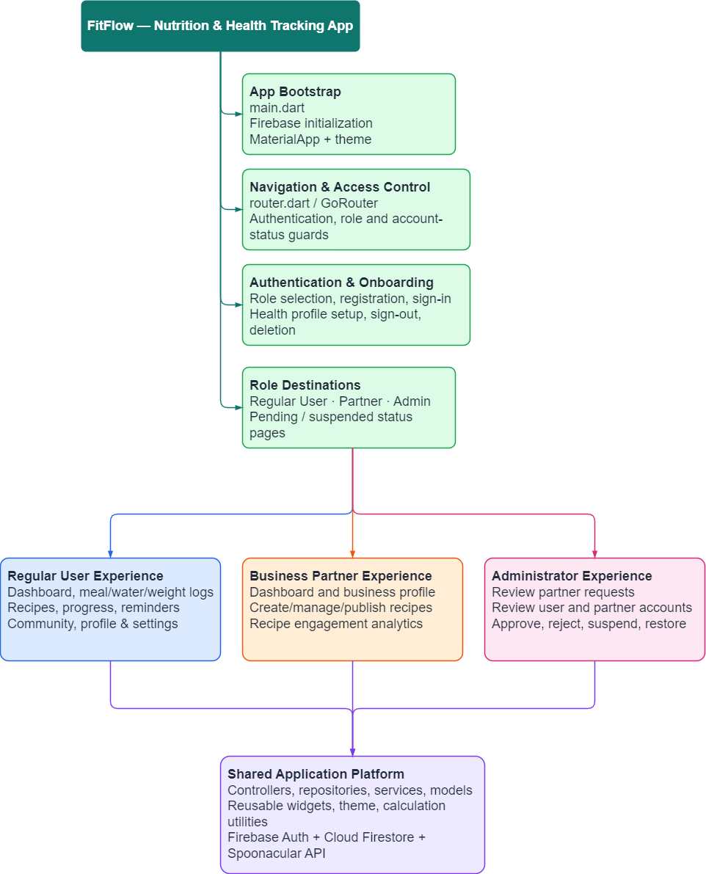
Figure 3.1 — Functional Hierarchy Diagram
Diet, allergy, and medical-condition safety matching is a pure business-logic function, implemented in meal_recommendation.dart, that cross-references a recipe's dietType/allergen/cautionTag fields against a user's profile before it is surfaced as a recommendation — it has no dedicated screen of its own.

4. User Categories
LIMOS is designed around three primary account roles, implemented from a single Flutter codebase and a single Firebase project, plus supporting external actors:
Stakeholder / Actor | Role in the System | Main Needs | Representative Responsibilities
End User | Individual seeking assistance with diet and nutrition. | Secure self-management, appropriate recommendations, simple tracking and understandable progress information. | Maintain account and body profile; set goals; record food intake; manage recipes; review reports; order eligible meals; correct AI estimates.
Business Partner | Verified dietitian, nutritionist, doctor or healthy-meal provider. | A controlled channel for publishing professional content and fulfilling healthy-meal orders. | Maintain partner profile; publish recipes and meal listings; manage orders; review ratings and feedback; comply with platform rules.
System Administrator | Operational and governance role responsible for maintaining the platform. | Secure, reliable and auditable system administration. | Approve or reject registrations; manage users, partners, content and subscriptions; oversee analytics, audit logs and AI model versions.
External Nutrition / Recipe API (Spoonacular) | Third-party data provider supporting food search and recipe recommendations. | Structured and reliable nutrition, ingredient and recipe information. | Return available calorie, nutrient and recipe data through authenticated API requests.
Image Recognition Service / ML Model | Optional advanced component for analysing uploaded food images. | A constrained food-category prediction and calorie-estimation workflow. | Return candidate food labels and confidence scores; allow model versioning and administrator deployment controls.
Dietician | Optional 1-to-1 professional support role. | A messaging/video-call channel to communicate with users and adjust their meal plans. | Provide professional advice; review and adjust a user's logged meals to match their nutritional needs.
Of the six categories above, the current implemented build covers the first four roles — Regular User, Business Partner, Administrator, and the Spoonacular API integration — as detailed in the Design Specifications. The dedicated Dietician messaging/video-call role and full production-grade ML image recognition remain proposed/prototype-stage scope (see Section 7, Major Functionalities, and the Known Limitations in Section 6).

5. Requirement Specifications
The system consists of three primary user roles — user, business partner and administrator — each with distinct responsibilities and permissions.

5.1 Functional Requirements — User
ID | Functional Requirement
U1 | The system allows users to register and log in securely.
U2 | The system allows users to create, view and update their personal profiles, including age, gender, height, weight, activity level, allergies, dietary preferences, and fitness goals.
U3 | The system calculates the user's BMI, BMR, TDEE, and recommends daily calorie intake based on the user's profile.
U4 | The system generates personalized meal recommendations based on the user's profile.
U5 | The system allows users to search and browse healthy meals and recipes.
U6 | The system allows users to save favourite recipes or meals.
U7 | The system allows users to manually add their own recipes.
U8 | The system allows users to manually log meals and beverages consumed.
U9 | The system allows users to take photos for AI-based food recognition.
U10 | The system allows users to edit AI food recognition results before saving them.
U11 | The system tracks daily calorie, macronutrient and water intake.
U12 | The system displays daily, weekly and monthly nutrition progress reports.
U13 | The system sends reminders for meal logging.
U14 | The system allows users to view their meal history.
U15 | The system allows users to filter recipes by calorie range or dietary preference.
U16 | The system allows users to log out securely.

5.2 Functional Requirements — Business Partner
ID | Functional Requirement
BP1 | The system allows business partners to register and log in securely after approval from the administrator.
BP2 | The system allows business partners to create and submit healthy recipes and meal content.
BP3 | The system allows business partners to create their profile.
BP4 | The system allows business partners to update their profile information.
BP5 | The system allows business partners to edit or delete their published content.
BP6 | The system allows business partners to post content.
BP7 | The system allows business partners to view engagement statistics on their published recipes.
BP8 | The system allows business partners to log out securely.

5.3 Functional Requirements — Administrator
ID | Functional Requirement
AD1 | The system allows administrators to log in securely.
AD2 | The system allows administrators to manage user accounts, including viewing, updating, deactivating accounts when necessary.
AD3 | The system allows administrators to approve or reject business partner requests.
AD4 | The system allows administrators to view the admin dashboard to monitor important system information.
AD5 | The system allows administrators to manage business partner accounts, including viewing, updating, deactivating accounts when necessary.

5.4 Non-Functional Requirements

Security & Data Privacy
ID | Non-Functional Requirement
SD1 | Sensitive medical history, body profiles and allergy records shall be securely encrypted when stored in the database.
SD2 | All communication between the mobile app and the backend server must be encrypted to protect data travelling over the network.
SD3 | User passwords must not be stored as plain text and must be encrypted with a secure hashing algorithm.
SD4 | Login tokens should have a short life span and be removed from the server as soon as a user logs out.
SD5 | The system must collect only necessary data and allow users to delete their accounts permanently.

Reliability & Safety
ID | Non-Functional Requirement
RD1 | All allergy-tested ingredients must be considered safe, otherwise the filter must not recommend the meal to the user.
RD2 | The app should provide users with a friendly error message if the external nutrition API fails or is unable to connect, without crashing — falling back to locally stored data.

Performance & Speed
ID | Non-Functional Requirement
PS1 | Routine operations such as logging food or searching text shall complete within 2.0 seconds under normal operation.
PS2 | The AI should analyse uploaded food images and display the calorie count within 10.0 seconds.
PS3 | The system architecture must ensure the system's response does not lag when a large number of users upload food images and request food reports simultaneously.

Usability & Layout
ID | Non-Functional Requirement
UL1 | The application interface should be consistent, smooth and clean on both Android and iOS.
UL2 | Reports including graphs, weight charts and calorie logs should be obvious and easy to understand, reflecting user progress.

6. Design Specifications

6.1 System Overview
LIMOS is a client-heavy architecture: the Flutter application talks directly to Firebase Authentication and Cloud Firestore for all account, profile and activity data, and directly to the third-party Spoonacular API for recipe search and nutrition estimation. There is no custom application server — business logic (BMI/BMR/TDEE calculation, dietary/allergy/medical-condition matching, role-based routing) lives in the client's controller layer, and access control is enforced twice: once by Firestore Security Rules server-side, and once by the app's own router guard for a responsive UI experience.

Technology Stack
Layer | Technology | Notes
Client framework | Flutter (Dart) | Single codebase targeting Android, iOS and Web
Navigation | go_router 17.x | Declarative routing with a global redirect guard
Authentication | Firebase Authentication | Email/password sign-in
Database | Cloud Firestore | NoSQL document store, 11 collections
External API | Spoonacular | Recipe search/detail and nutrition-guess endpoints, called directly from the client
Field-level security | AES-256-GCM (PointyCastle) | Encrypts medical-history profile fields at rest
Backend-as-a-service | Firebase project “fypprojecthealth” | Hosting, Firestore rules & indexes, Auth

6.2 Data Flow Diagrams

Context Diagram (Level 0)
The context diagram treats LIMOS as a single process and shows every external entity it exchanges data with: the three human roles, and the two systems it depends on (Firebase and Spoonacular).
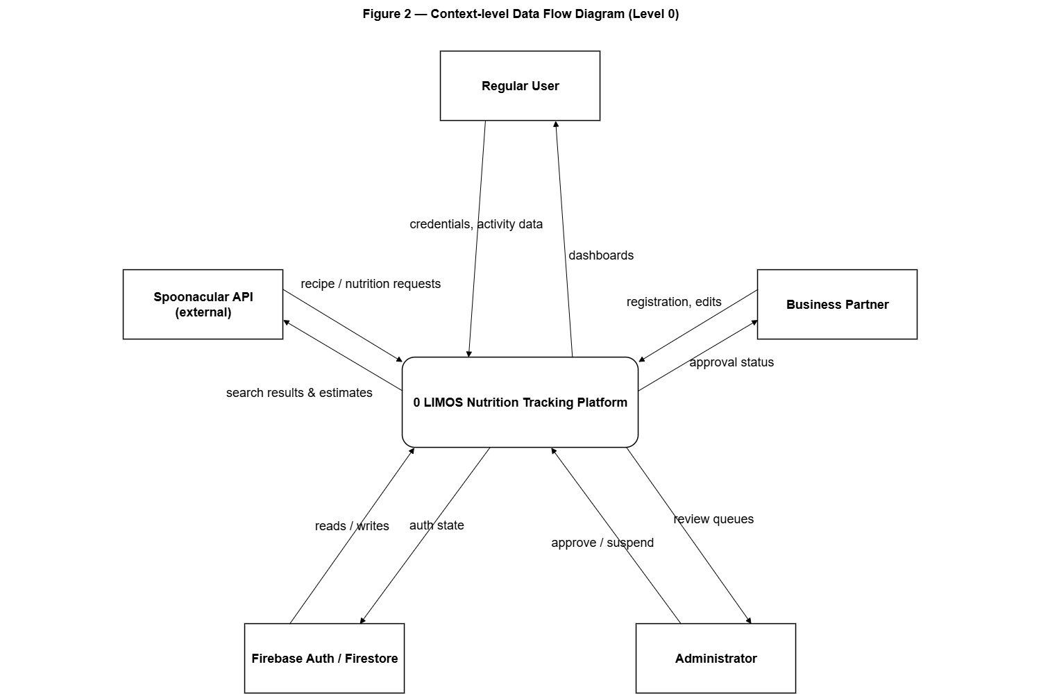
Figure 6.1 — Context-level Data Flow Diagram

Level 1 Data Flow Diagram
Decomposing process 0 into its eight major processes exposes the data stores (Firestore collections) each process reads from or writes to. Processes 1–6 serve the regular-user experience; processes 7–9 serve business-partner and administrator workflows respectively.
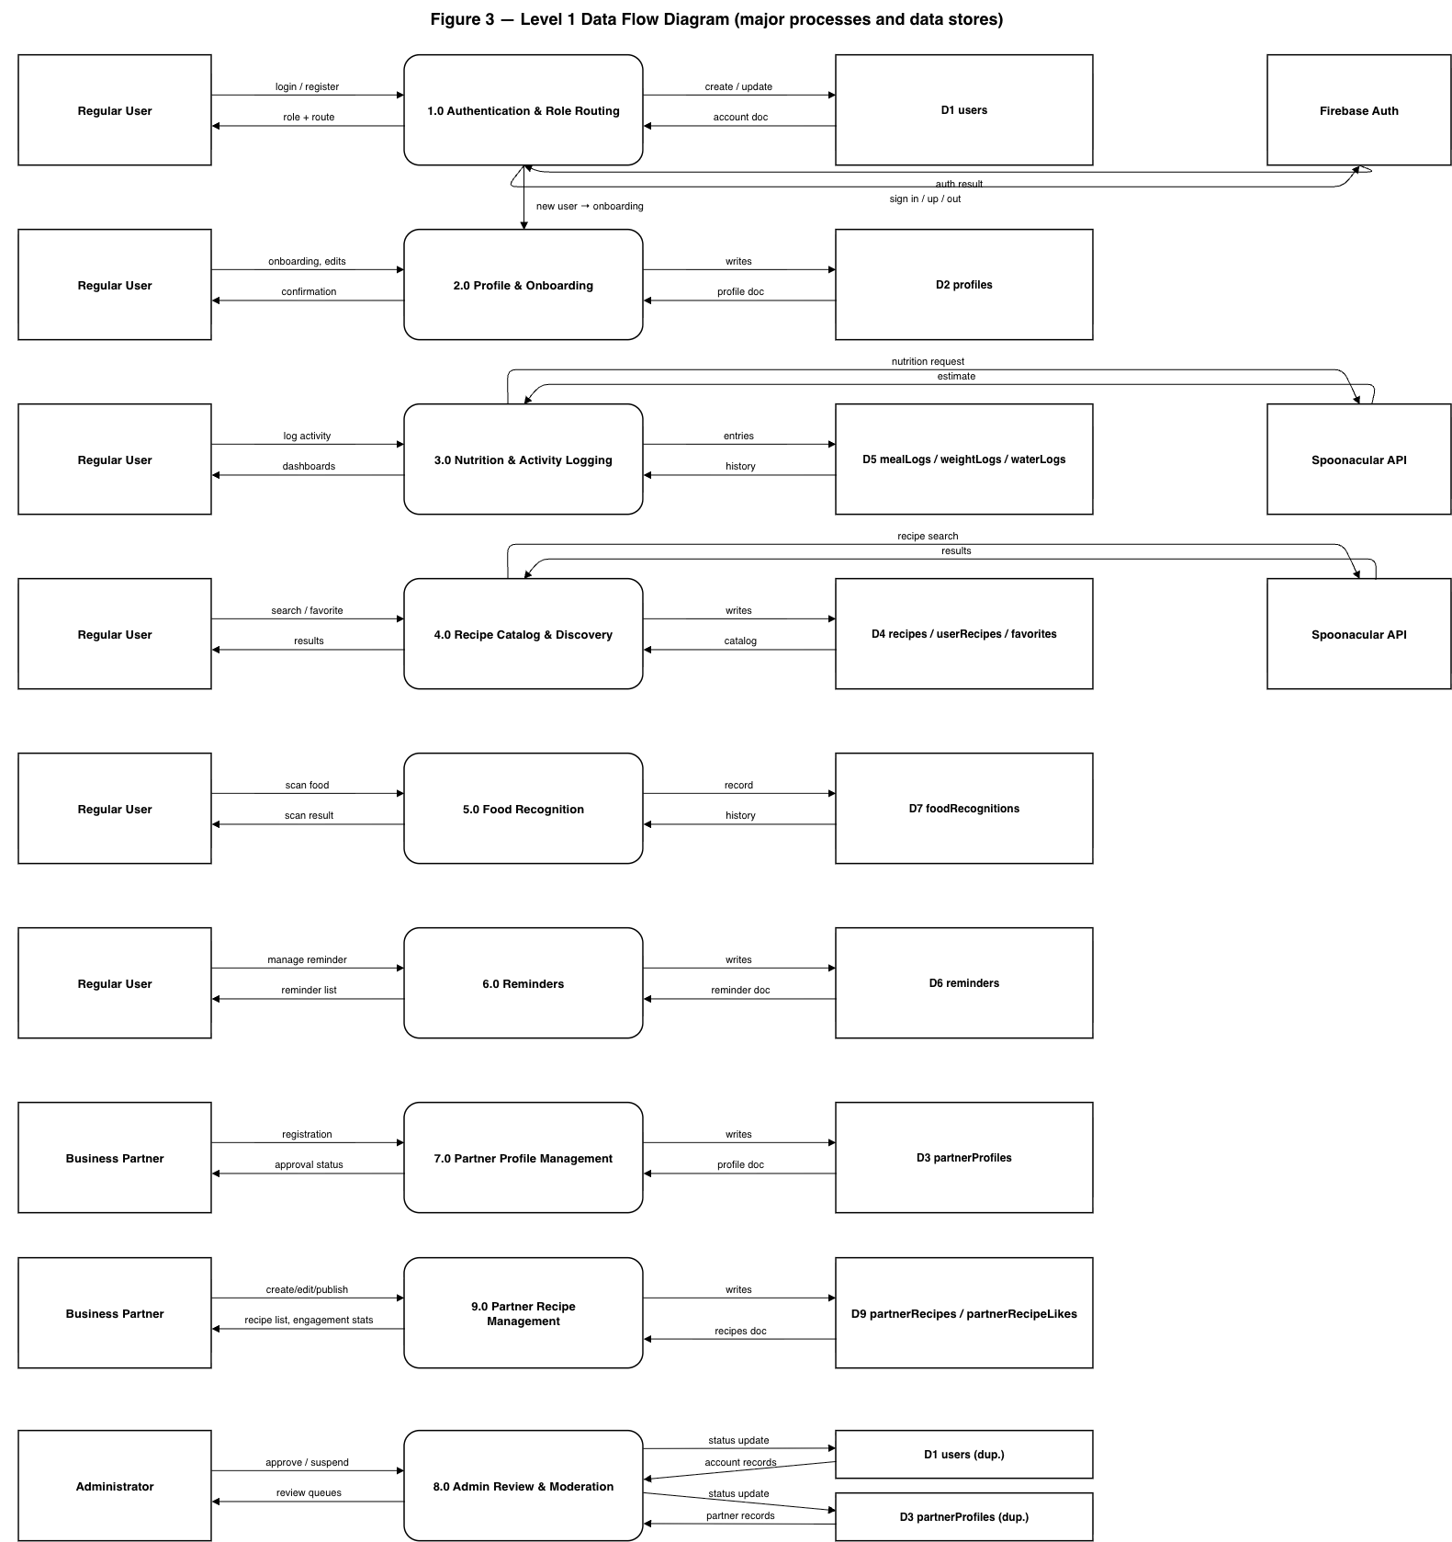
Figure 6.2 — Level 1 Data Flow Diagram

6.3 Entity Relationship Diagram
LIMOS persists data in Cloud Firestore, a document database, so the diagram below expresses “entities” as Firestore collections and “relationships” as the userId (and, for favorites, recipeId) foreign-key fields the client uses to filter queries — there is no server-enforced referential integrity, only Security-Rules-enforced ownership.
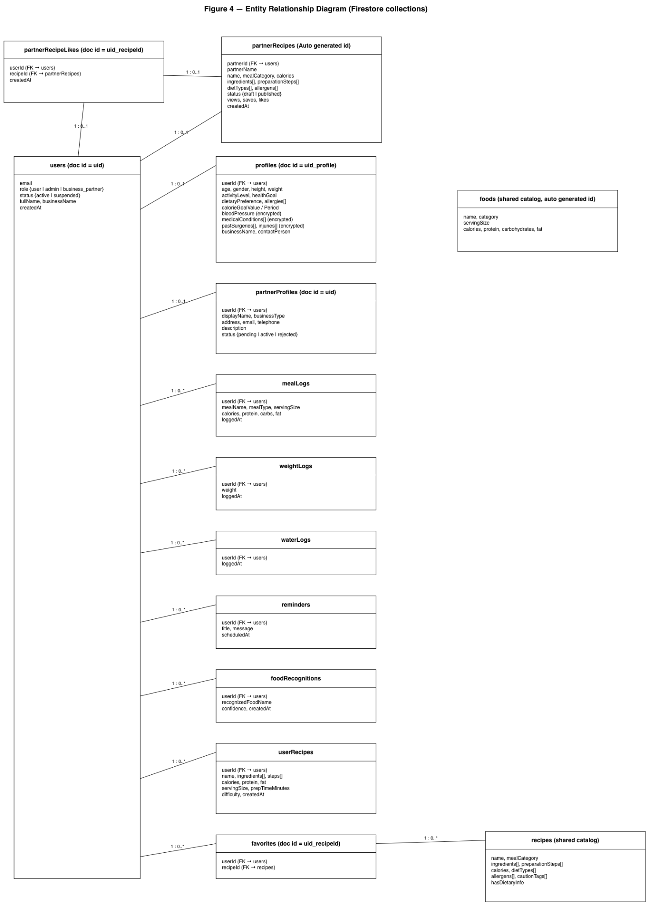
Figure 6.3 — Entity Relationship Diagram
Two documents intentionally use composite, human-readable IDs instead of auto-generated ones: profiles/{uid}_profile (a 1:1 extension of a user's account) and favorites/{uid}_{recipeId} (a many-to-many join that also guarantees a user can only favorite a given recipe once, since writing the same ID twice overwrites rather than duplicates).

6.4 Sequence Diagrams
The sequence diagrams below trace the actual Page → Controller → Repository/Service call chain used in the codebase. Each lifeline is stereotyped using the Boundary/Control/Entity (BCE) convention — Boundary for UI pages, Control for controllers/services that orchestrate logic, Entity for repositories and external systems — with the initiating human role shown as a UML actor. Genuine branch points in the underlying code (a try/catch, an if/else, a status check) are drawn as UML alt combined-fragment frames rather than flattened into a single linear path.

Register a new account
A new account writes users/{uid} and profiles/{uid}_profile in one Firestore batch; a business partner additionally gets a partnerProfiles/{uid} document seeded with status 'pending'. The alt frame reflects RegisterPage's try/catch around AuthController.register().
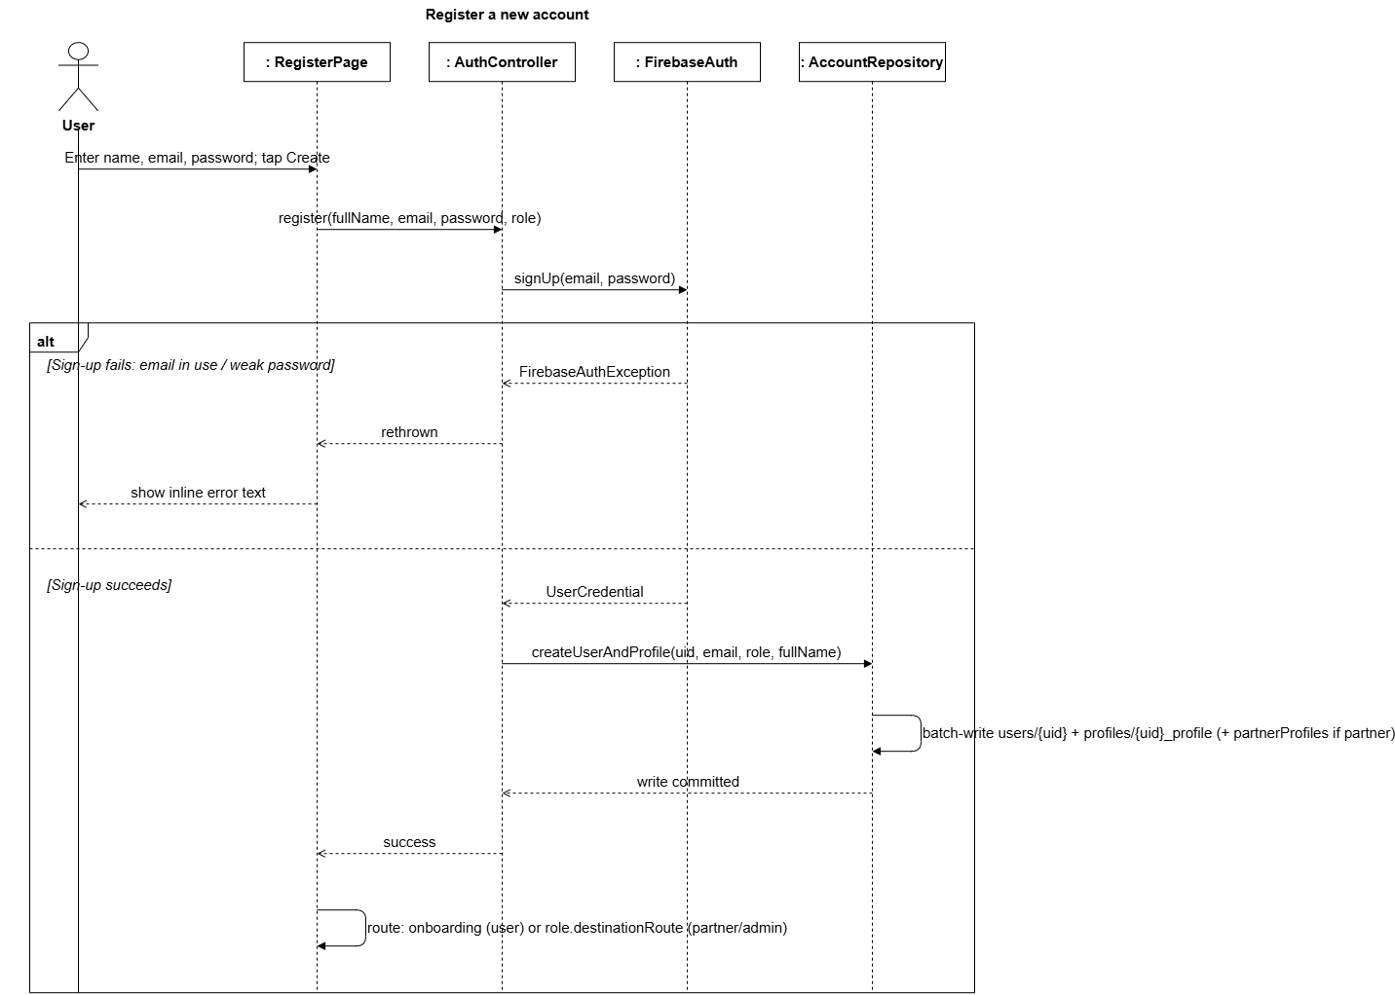
Figure 6.4 — Register a new account

Sign-in & session-aware route guard
go_router's global redirect callback re-evaluates the signed-in account's role and status on every navigation, not just at login — this is what enforces suspension and partner-approval gating throughout a session. The nested alt frames mirror router.dart's actual nested conditionals (signed-in state, then account/partner status, then role-route matching).
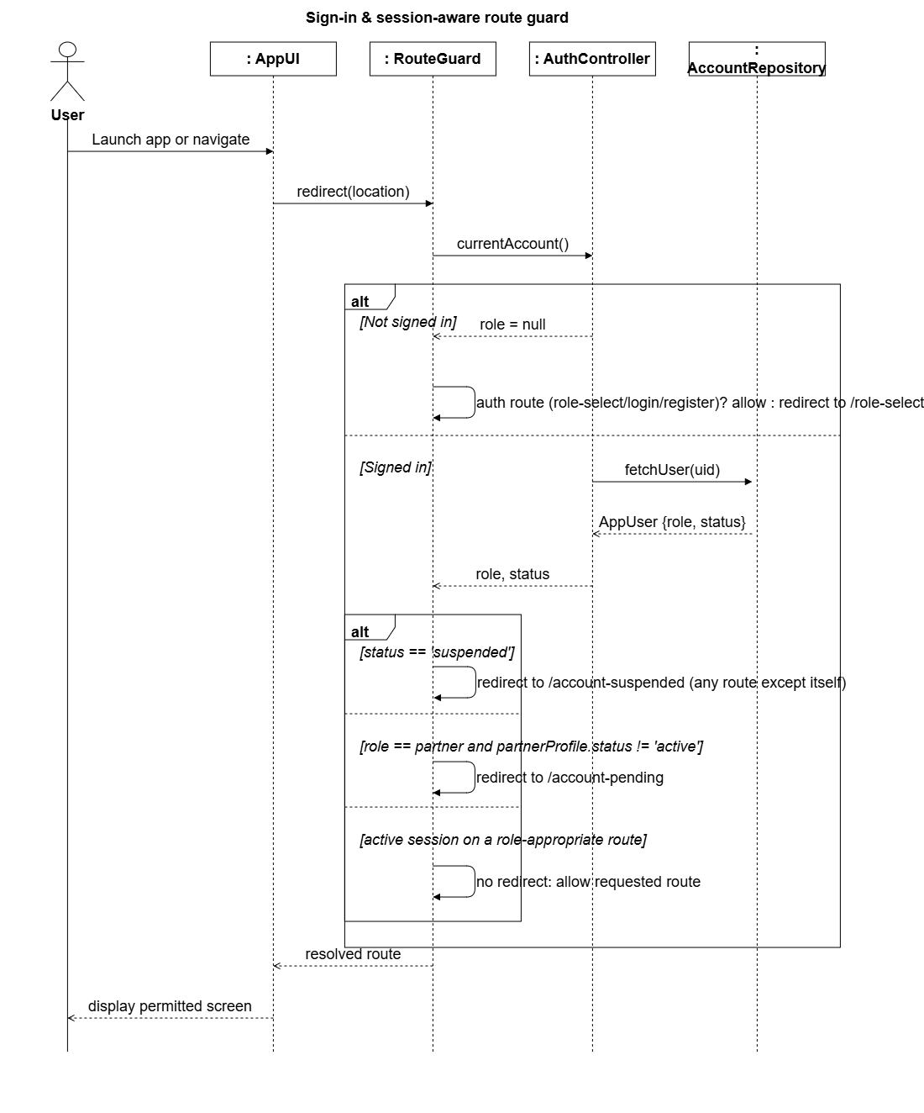
Figure 6.5 — Sign-in & session-aware route guard

Log a meal (with nutrition auto-fill)
Typing a food name triggers a live Spoonacular nutrition guess that pre-fills the calorie/macro fields, which the user can still edit before saving; the alt frame covers NutritionLookupService.lookup() returning null when Spoonacular has no estimate.
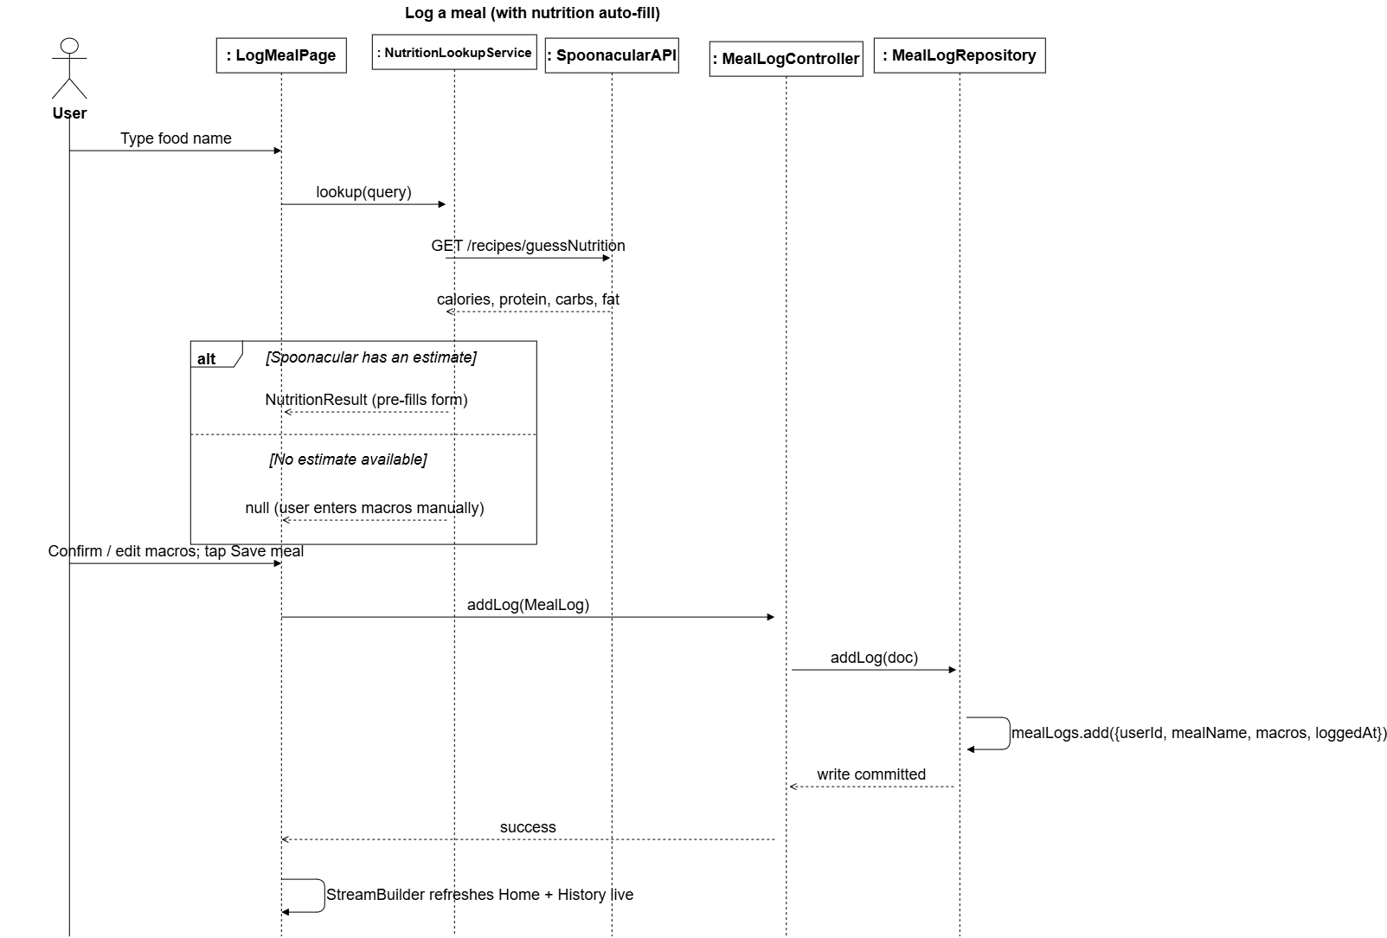
Figure 6.6 — Log a meal (with nutrition auto-fill)

Scan food (mocked recognition)
No camera or ML package is integrated; the scan screen returns a fixed mocked result ('Salad bowl', 92% confidence) but persists it through the same real repository path as any other logged data.
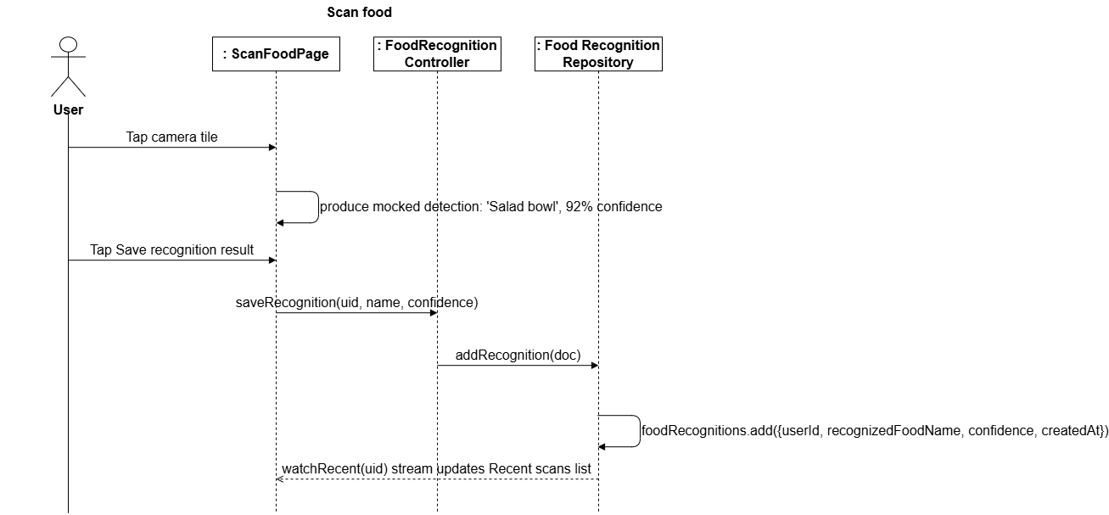
Figure 6.7 — Scan food (mocked recognition)

Discover & favourite a recipe
Discover recipes are fetched live from Spoonacular and are distinct from the app's own seeded/admin recipe catalog. The alt frame covers RecipeRepository.toggleFavorite()'s create-vs-delete branch on the favorites/{uid}_{recipeId} document.
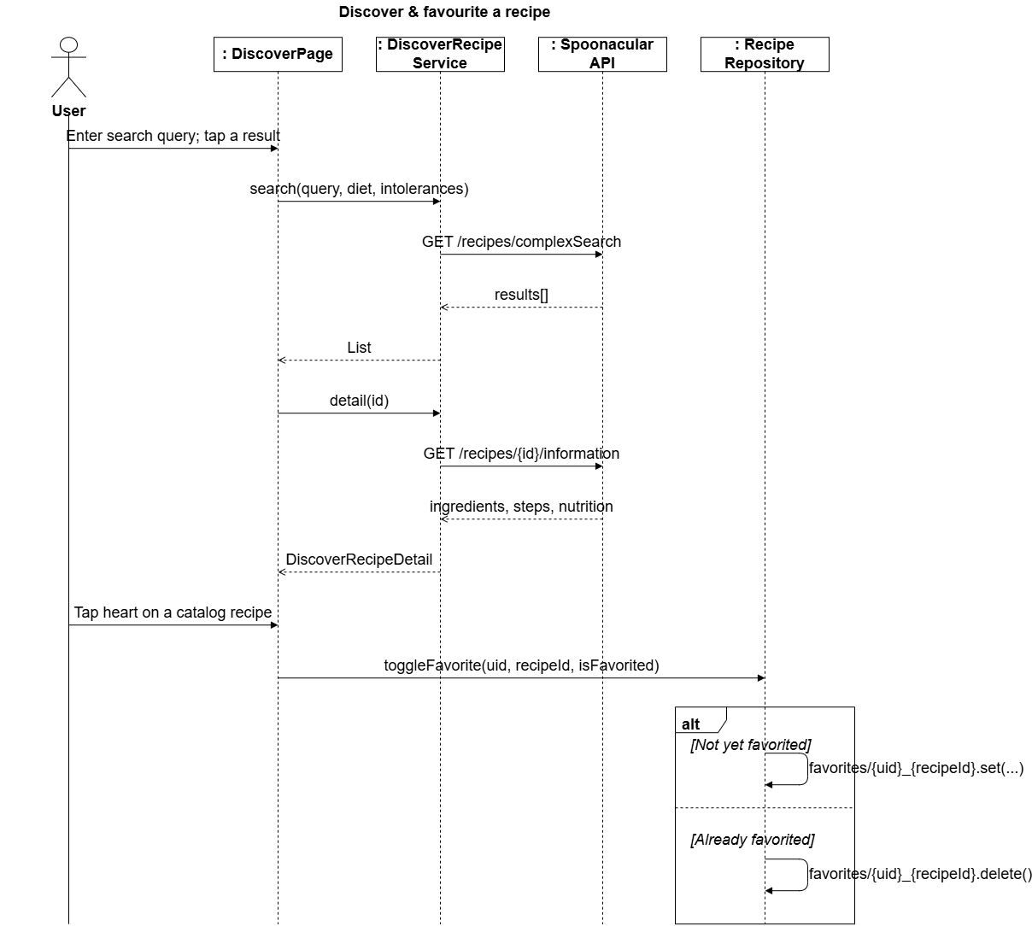
Figure 6.8 — Discover & favourite a recipe

Log weight & view progress
BMI/BMR/TDEE and calorie/macro/water targets are computed client-side in HealthMetrics from the user's profile fields, not stored pre-computed; the alt frame covers the fallback HealthMetrics.forCalorieGoal(2100) path used when a profile is too incomplete for a full BMR/TDEE calculation.
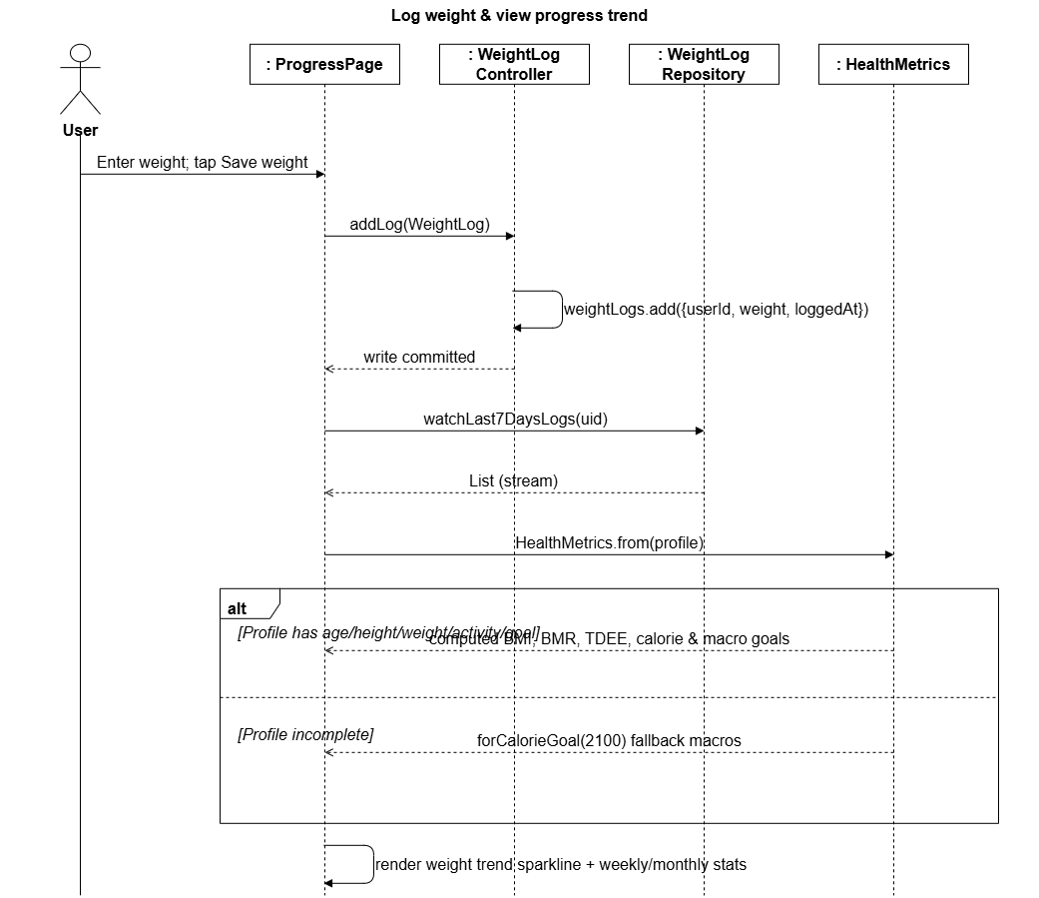
Figure 6.9 — Log weight & view progress

Business partner registration
A partner account is created active immediately (so it can sign in), but the router still blocks it at /account-pending until an admin sets partnerProfiles.status to 'active' — the alt frame is that same router guard check specialised to the partner case.
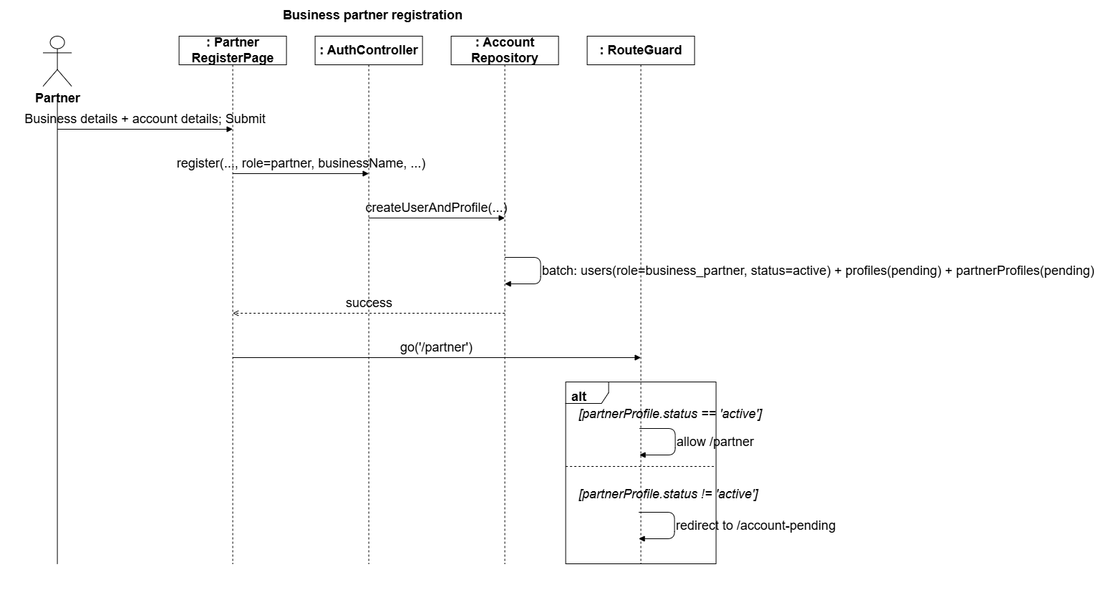
Figure 6.10 — Business partner registration

Admin reviews a partner request
The Partner requests queue streams only status == 'pending' documents; the alt frame is the admin's actual Accept/Reject choice, each branch a single field update that the partner's own router guard picks up on their next navigation.
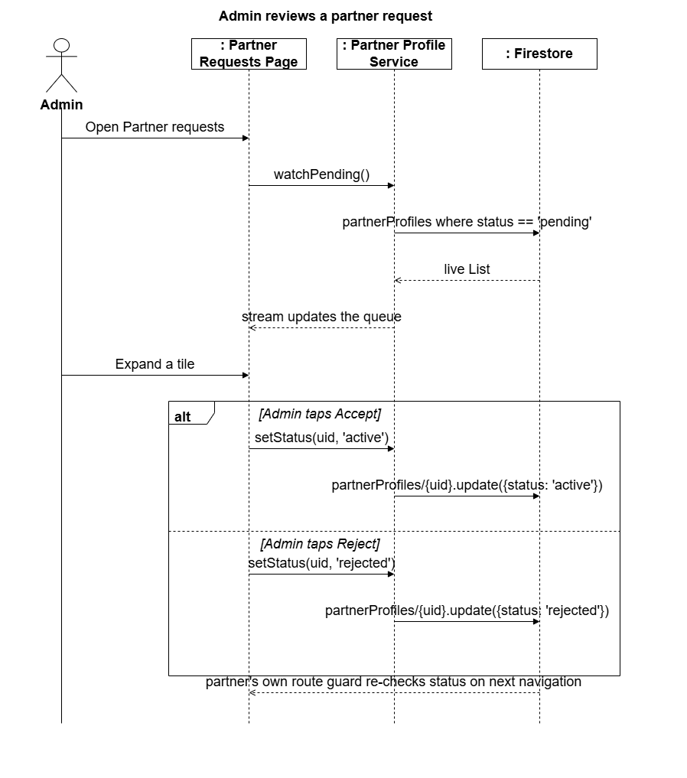
Figure 6.11 — Admin reviews a partner request

Self-service account deletion
Deletion requires a fresh re-authentication (Firebase's requires-recent-login safeguard) before anything is deleted; the alt frame covers that reauthentication succeeding versus failing on an incorrect password.
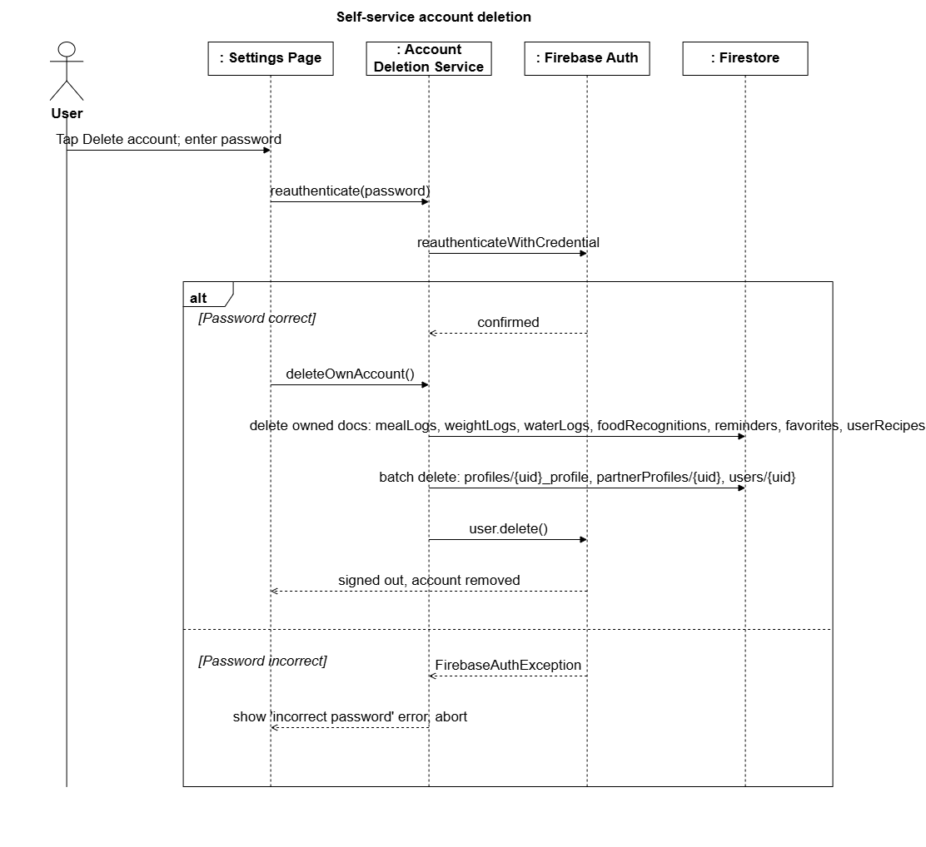
Figure 6.12 — Self-service account deletion

Business Partner Recipe: create and publish
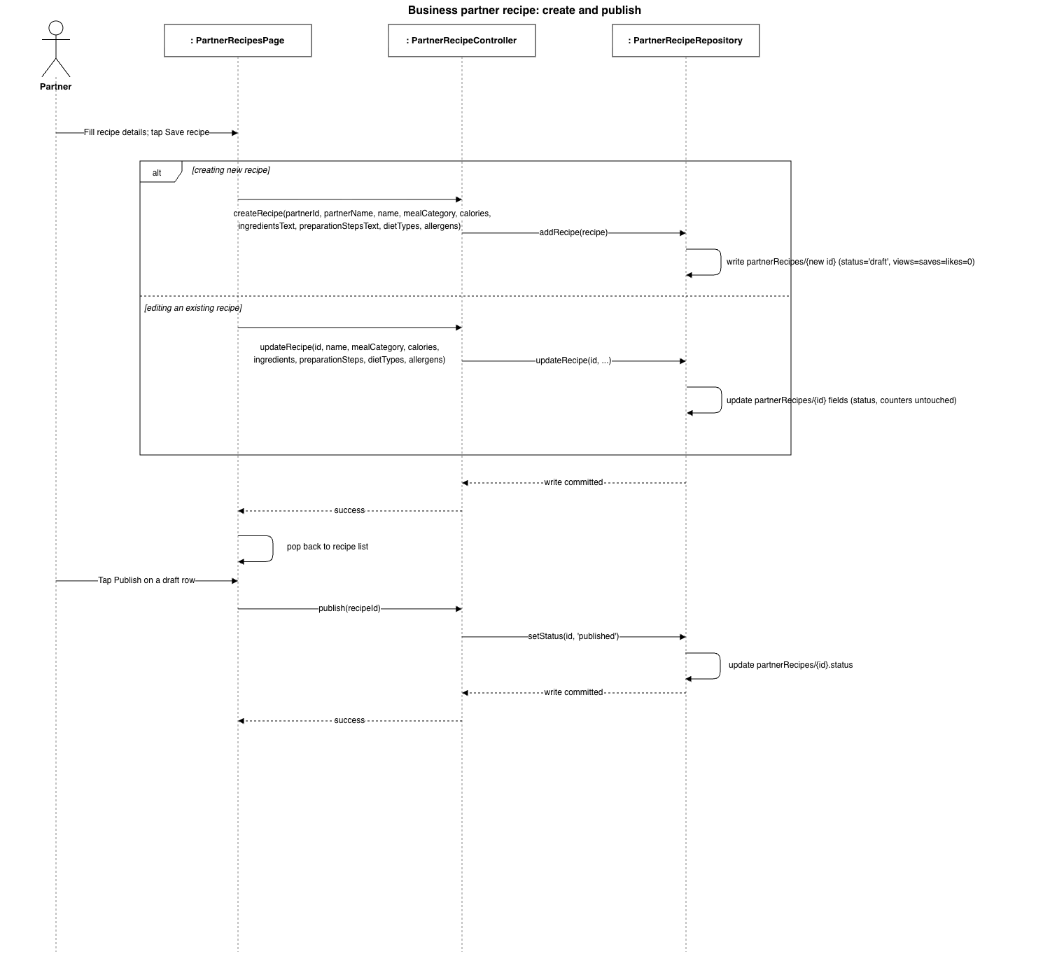
Figure 6.13 — Business Partner Recipe: create and publish

6.5 Database Design (Cloud Firestore)
LIMOS uses Cloud Firestore, a schemaless NoSQL document database organised into flat top-level collections (no sub-collections). Field types below are the Dart-level types the client reads/writes; Firestore itself stores them as string, number, boolean, array, map, or timestamp values. Fields marked “(encrypted)” are stored as an AES-256-GCM ciphertext string, not as plaintext.

users — one document per account, id = Firebase Auth uid
Field | Type | Description
email | string | Account email address
role | string enum | 'user' | 'admin' | 'business_partner'
status | string enum | 'active' | 'suspended' — admin-controlled
fullName | string? | Registering user's or partner representative's name
businessName | string? | Set only when role = business_partner
createdAt | timestamp? | Server write time

profiles — id = {uid}_profile
Field | Type | Description
userId | string | FK → users.uid
fullName, age, gender | string?/int?/string? | Basic demographic fields (regular user)
height, weight | num? | Centimetres / kilograms
activityLevel, healthGoal | string? | From onboarding wizard's fixed option lists
dietaryPreference | string? | Omnivore | Vegetarian | Vegan | Pescatarian | Keto
allergies | array<string>? | Fixed vocabulary shared with recipe tagging
targetWeight | num? | User's goal weight
address, phone | string? | Regular-user contact details
bloodPressure | string? (encrypted) | Normal | Elevated | High | Low
medicalConditions | array<string>? (encrypted) | Fixed vocabulary; drives caution-tag filtering
pastSurgeries, injuries | array<string>? (encrypted) | Free-text lines, encrypted per entry
calorieGoalValue, calorieGoalPeriod | num?/string? | User-set override of the computed calorie goal
businessName, contactPerson, category, status | string? | Business-partner profile shape (same collection, different field set)

partnerProfiles — id = uid
Field | Type | Description
userId | string | FK → users.uid
displayName, businessType | string | Public business identity
address, email, telephone | string | Public contact details
description | string | Free-text business description
status | string enum | 'pending' | 'active' | 'rejected' — admin-controlled

recipes — shared catalog, auto-generated id
Field | Type | Description
name, mealCategory | string | Display name and category
ingredients, preparationSteps | array<string> | Ordered lists
calories | int | Per serving
dietTypes | array<string> | Diets this recipe satisfies (excludes 'Omnivore')
allergens | array<string> | Tracked allergens the recipe contains
cautionTags | array<string> | e.g. 'High Sodium' — drives medical-condition filtering
hasDietaryInfo | bool | Whether the tags above were ever reviewed (false = unknown, not 'safe')

favorites — id = {uid}_{recipeId}
Field | Type | Description
userId | string | FK → users.uid
recipeId | string | FK → recipes.id

partnerRecipes — a business partner's own recipes, auto-generated id
Field | Type | Description
partnerId | string | FK → users.uid (the authoring partner)
partnerName | string | Denormalised business display name at creation time
name, mealCategory | string | Display name and category
calories | int | Per serving
ingredients, preparationSteps | array<string> | Ordered lists
dietTypes, allergens | array<string> | Same tagging vocabulary as the shared recipes catalog
status | string enum | 'draft' | 'published' — only 'published' recipes are visible to regular users
views, saves, likes | int | Engagement counters, incremented client-side
createdAt | timestamp | Client write time

partnerRecipeLikes — id = {uid}_{recipeId}
Field | Type | Description
userId | string | FK → users.uid
recipeId | string | FK → partnerRecipes.id
createdAt | timestamp | Client write time

foods — shared local nutrition catalog, auto-generated id
Field | Type | Description
name | string | Display name
category | string | e.g. 'Protein', 'Grains', 'Fruit', 'Vegetable', 'Dairy', 'Nuts & Fats', 'Legumes'
servingSize | string | Free text the macros below are measured against, e.g. '100g', '1 cup'
calories, protein, carbohydrates, fat | int | Per serving size above

userRecipes — user-authored recipes, auto-generated id
Field | Type | Description
userId | string | FK → users.uid
name, ingredients, preparationSteps | string/array<string> | As entered on Add Recipe
calories, protein, fat | int | Per serving
servingSize | string | Free text, e.g. '1 bowl'
prepTimeMinutes | int | Minutes
difficulty | string | e.g. 'easy'
createdAt | timestamp | Client write time

mealLogs — auto-generated id
Field | Type | Description
userId | string | FK → users.uid
mealName, mealType, servingSize | string | mealType e.g. Breakfast/Lunch/Dinner/Snack
calories, protein, carbohydrates, fat | int | Per logged entry
loggedAt | timestamp | When the meal was eaten/logged

weightLogs / waterLogs — auto-generated id
Field | Type | Description
userId | string | FK → users.uid
weight | num (weightLogs only) | Kilograms
loggedAt | timestamp | waterLogs has one document per glass logged

reminders — auto-generated id
Field | Type | Description
userId | string | FK → users.uid
title, message | string | Reminder content
scheduledAt | timestamp | When the reminder is due

foodRecognitions — auto-generated id
Field | Type | Description
userId | string | FK → users.uid
recognizedFoodName | string | Mocked detection result
confidence | double | 0–1 confidence score
createdAt | timestamp | Scan time

6.6 Composite Indexes
Firestore requires an explicit composite index for any query that filters on one field and orders by another. firestore.indexes.json declares the following, all scoped per-user (userId ascending) and ordered by their timestamp field:
Collection | Fields (in order)
mealLogs | userId ↑, loggedAt ↑
weightLogs | userId ↑, loggedAt ↑
waterLogs | userId ↑, loggedAt ↑
reminders | userId ↑, scheduledAt ↑
foodRecognitions | userId ↑, createdAt ↓
userRecipes | userId ↑, createdAt ↓

6.7 Security Rules Summary
Access control is enforced server-side by Firestore Security Rules (firestore.rules), independent of the client's own route guards. The general pattern is strict per-user ownership, with narrow admin overrides:
Collection | Read | Create | Update | Delete
users | Owner or admin | Owner only; role must be 'user' or 'business_partner' (never 'admin') | Admin (any field), or owner (fullName/businessName/email only) | Owner only (self-service)
profiles | Owner or admin | Owner only | Owner or admin | Owner only
partnerProfiles | Any signed-in user | Owner only, status must start 'pending' | Admin (any field), or owner (public fields only, not status) | Owner only
recipes | Any signed-in user | Denied — seeded server-side via Admin SDK | Denied | Denied
mealLogs / weightLogs / waterLogs / reminders / foodRecognitions / favorites / userRecipes | Owner only | Owner only | Owner only (n/a for favorites/foodRecognitions/waterLogs) | Owner only
Note: administrators can promote/suspend accounts and moderate partner applications, but cannot delete another user's Firestore documents or Firebase Auth identity. Account deletion is deliberately self-service only, matching the rule set above.

6.8 Non-Functional Design Considerations

Medical Data Encryption
The four confidential medical-history fields on a profile — bloodPressure, medicalConditions, pastSurgeries, injuries — are encrypted at the field level before being written to Firestore, using AES-256-GCM (via PointyCastle). The encryption key is derived per-user as SHA-256(uid : app-level pepper), so no single static key protects every user's data, and a random 12-byte nonce is generated per encryption call. This is explicitly a client-only mitigation, not equivalent to server-managed key rotation, since the project has no backend of its own to hold a server-side key.

Role-Based Access Control
Access control is layered: Firestore Security Rules are the authoritative, server-enforced boundary. The app's go_router redirect guard is a second, client-side layer that keeps the UI responsive and prevents a signed-in session from ever rendering a screen its role/status shouldn't see, re-evaluating on every navigation rather than only at login.

Third-Party Integration — Spoonacular
Recipe search/detail (Discover) and nutrition estimation (meal logging's auto-fill) both call the Spoonacular REST API directly from the Flutter client using a bundled API key, since Flutter would otherwise require a paid backend proxy tier. A production deployment would proxy these calls through a backend so the key is never shipped in the client binary.

Known Limitations
- Food recognition is mocked: Scan Food always returns a fixed result ('Salad bowl', 92% confidence) rather than performing real image capture or ML inference — planned for a later phase.
- The Spoonacular API key ships inside the client rather than behind a backend proxy.
- Firebase Authentication supports email/password only — no social sign-in or multi-factor authentication.
- Reminders are stored and listed but are not wired to a local/push notification scheduler.
- The “For You” recommendation tab filters recipes by diet, allergy and medical-condition safety, but the calorie-aware ranking function is implemented and unit-tested yet never actually called from the Recipes page.
- Medical-condition-aware filtering only covers the seeded recipes catalog — it does not extend to business-partner recipes (no cautionTags field on that model) or to Discover/Spoonacular search results.

7. Major Functionalities

7.1 Minimum Viable Product Scope
- Cross-platform mobile user interface for Android and, where feasible, iOS.
- Email/password authentication, password reset, and role-based access control.
- User profile, body profile, health constraints, allergies, dietary preferences and consent settings.
- Daily calorie goal plus optional weekly and monthly derived targets.
- Food diary with manual entry, recipe selection and online food/nutrition search.
- Recipe search, custom recipe creation, favourites and recommendation generation.
- Daily, weekly and monthly calorie summaries, trend charts and goal-compliance indicators.
- Business partner registration, verification status, recipe/menu publishing and order management.
- Administrator approval, user/partner management, content moderation, subscriptions, audit records and aggregated analytics.
- Prototype subscription state and payment-provider sandbox integration or simulated payment workflow.
- Experimental image recognition for a constrained set of food categories.

7.2 Functionality by Role (implemented routes)
The table below groups every named route declared in router.dart by the role permitted to reach it under the redirect guard, showing what each role can actually do in the current build.
Role | Route | Page / Functionality
Unauthenticated | /role-select | RoleSelectPage — choose account type before signing in
Unauthenticated | /login | LoginPage
Unauthenticated | /register | RegisterPage / PartnerRegisterPage
User (post-registration) | /onboarding | OnboardingFlowPage — one-time profile setup wizard
User | / | HomePage — dashboard (calorie ring, macros, water, weight trend)
User | /meal-log | LogMealPage — manual meal/beverage logging with nutrition auto-fill
User | /recipes | RecipesPage — shared catalog + user's own recipes, favourites
User | /recipe-detail | RecipeDetailPage
User | /discover | DiscoverRecipesPage — Spoonacular-powered search
User | /add-recipe | AddRecipePage — custom recipe creation
User | /progress | ProgressPage — weight logging, weekly/monthly trend and streaks
User | /scan-food | FoodRecognitionPage — AI food-image recognition (mocked)
User | /history | HistoryPage — last 30 days of meal logs
User | /profile | ProfilePage — computed BMI/BMR/TDEE
User | /edit-profile | EditProfilePage — including encrypted medical-history fields
User | /settings | SettingsPage
User | /reminders | RemindersPage
Business Partner (active) | /partner | PartnerHomePage — dashboard
Business Partner (active) | /partner-profile | PartnerProfilePage
Business Partner (active) | /partner-edit-profile | PartnerEditProfilePage
Administrator | /admin | AdminPage — operations dashboard
Administrator | /partner-requests | PartnerRequestsPage — approve/reject applications
Administrator | /review-users | ReviewUserAccountsPage — suspend/reinstate users
Administrator | /review-partners | ReviewPartnerAccountsPage — suspend/reinstate partners
Any suspended account | /account-suspended | AccountStatusPage
Partner awaiting approval | /account-pending | PartnerPendingStatusPage

7.3 Out of Scope
- Medical diagnosis, medication prescribing or automatic clinical treatment decisions.
- Guaranteed calorie accuracy for restaurant meals, mixed dishes or image-only estimates.
- Full hospital electronic medical record integration.
- Production-scale logistics, delivery fleet routing, refunds and tax accounting.
- Insurance, government identity or national health-record integration.
- Unrestricted autonomous learning from user images without review and model governance.
- Commercial certification as a regulated medical device.

8. Wireframes
The wireframes below are structural mockups of every screen in the current build, grouped by the role that reaches them. Labels reproduce the actual field names, button text and section headings from the Flutter source (lib/pages/*.dart) rather than placeholder text, so each wireframe can be cross-referenced directly against its screen's code.

8.1 Role Selection, Sign In, Register
Shared entry flow. Role selection determines whether Register routes to the plain regular-user form or the two-step partner form.
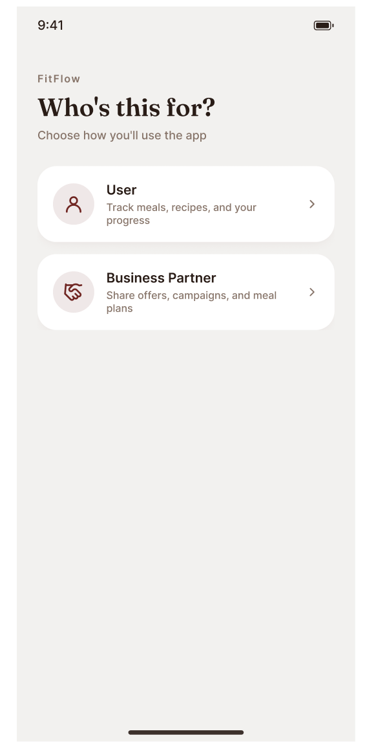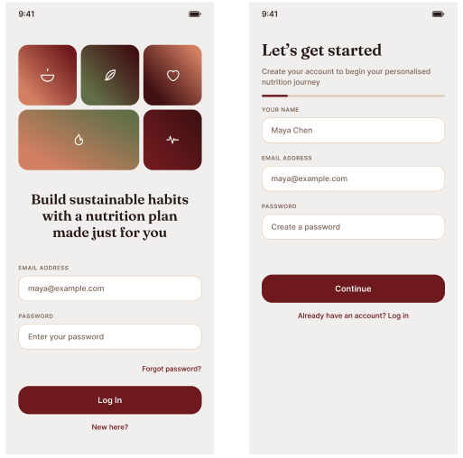
Figure 8.1 — Role Selection, Sign In, Register

8.2 Partner Registration & Account Status
The partner registration wizard (business details, then account details) and the two full-screen status interstitials a session can be redirected to at any time.
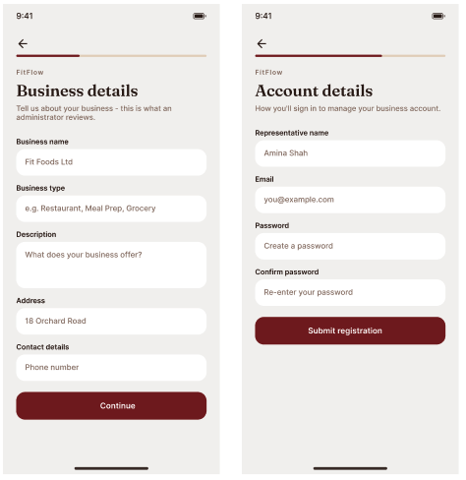
Figure 8.2 — Partner Registration & Account Status

8.3 Onboarding Wizard
Shown once, immediately after a regular user's first registration, before the Home dashboard becomes reachable.
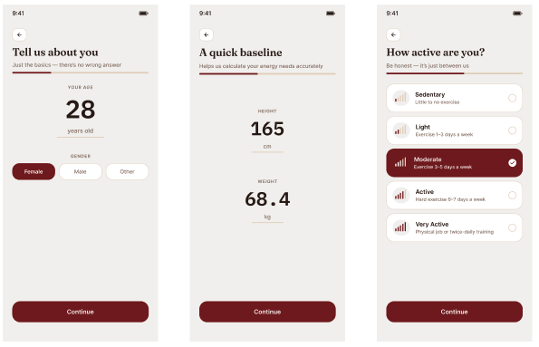
Figure 8.3a — Onboarding Wizard
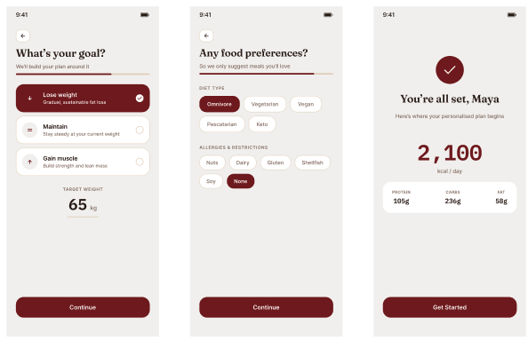
Figure 8.3b — Onboarding Wizard (continued)

8.4 Home Dashboard
The regular user's default landing screen (bottom-nav index 0): calorie ring, macro progress, water intake, weight trend, and a weekly calories chart, all live Firestore streams.
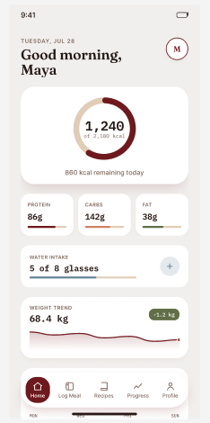
Figure 8.4 — Home Dashboard

8.5 Log Meal & Meal History
Log Meal auto-fills nutrition via Spoonacular; History lists the last 30 days grouped by day.
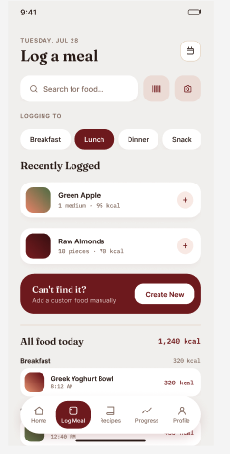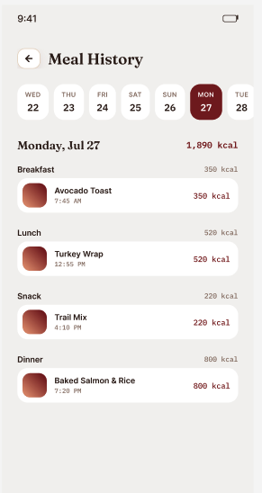
Figure 8.5 — Log Meal & Meal History

8.6 Recipe Catalog, Detail & Add Recipe
Recipes (bottom-nav index 2) filters the shared catalog and the user's own recipes together. Recipe Detail and Add Recipe are reached from it.
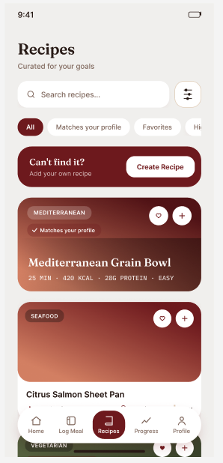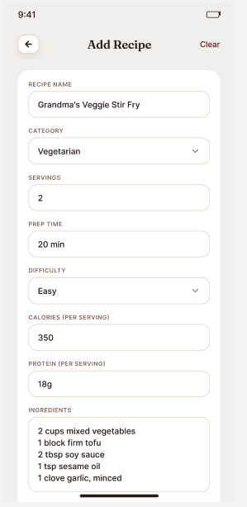
Figure 8.6 — Recipe Catalog, Detail & Add Recipe

8.7 Discover (Spoonacular) & Scan Food
Discover is a separate, search-first source from the curated catalog; Scan Food persists a mocked recognition result.
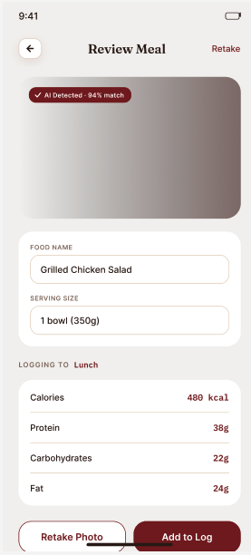
Figure 8.7 — Discover (Spoonacular) & Scan Food

8.8 Progress
Progress: weight logging, weekly/monthly toggle, and streak/average statistics.
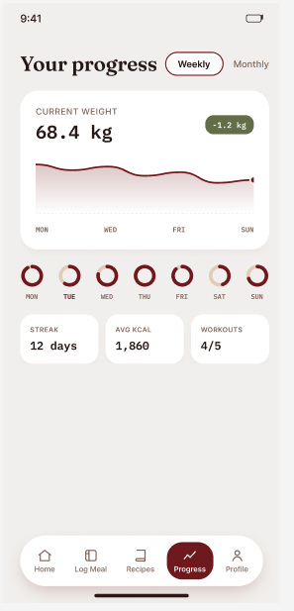
Figure 8.8 — Progress

8.9 Profile, Edit Profile, Settings & Reminders
Profile surfaces computed BMI/BMR/TDEE alongside stored fields; Edit Profile includes the encrypted medical-history fields.
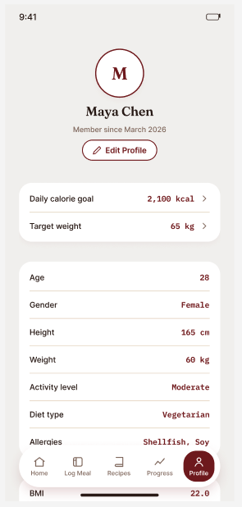
Figure 8.9 — Profile, Edit Profile, Settings & Reminders

8.10 Business Partner Dashboard & Profile
The partner's own four-item bottom nav (Home, Recipes, Analytics, Profile) reachable only once partnerProfiles.status = 'active'.
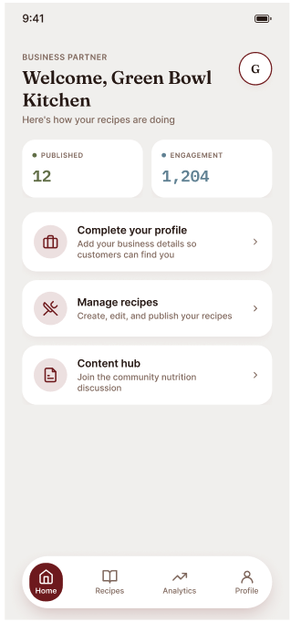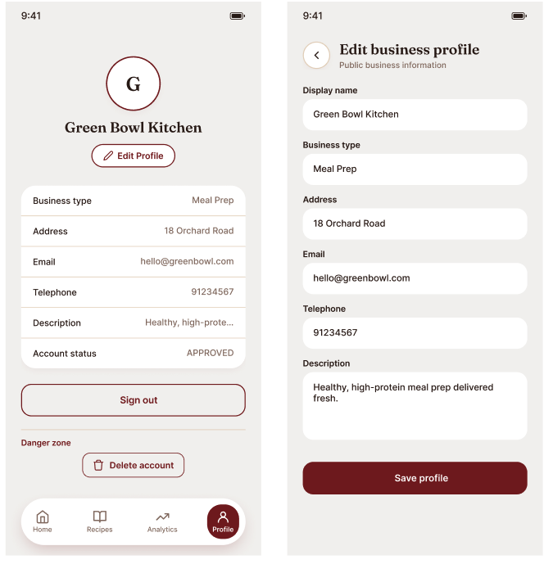
Figure 8.10 — Business Partner Dashboard & Profile

8.11 Business Partner Create & Publish Recipes
The business partner recipe form and its drafts, allowing them to edit, publish or delete the recipe.
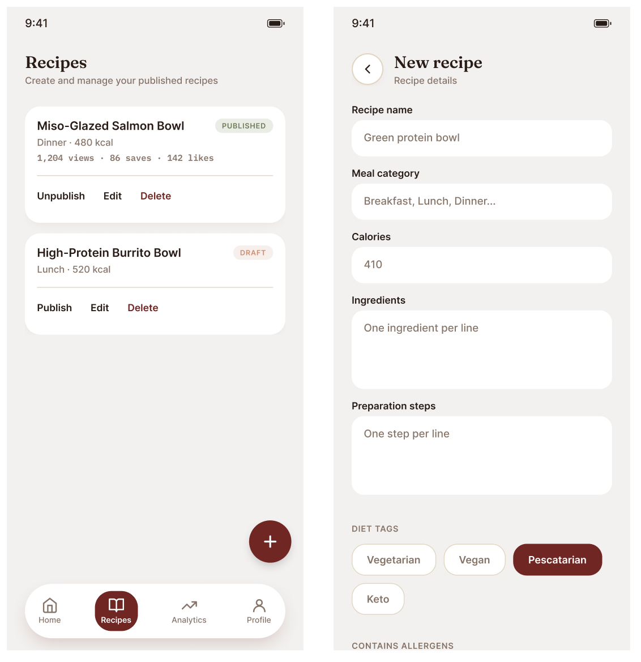
Figure 8.11 — Business Partner Create & Publish Recipes

8.12 Business Partner Analytics
Allows the business partner to see which recipes are the most popular; likes, views and saves are shown.
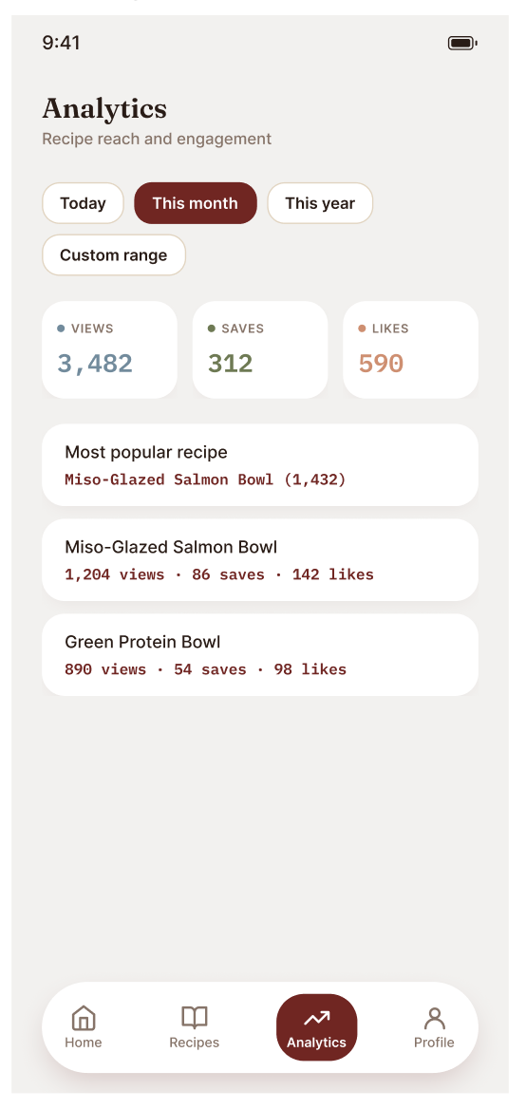
Figure 8.12 — Business Partner Analytics

8.13 Admin Dashboard & Partner Requests
The administrator's operations overview and the pending applications review queue.
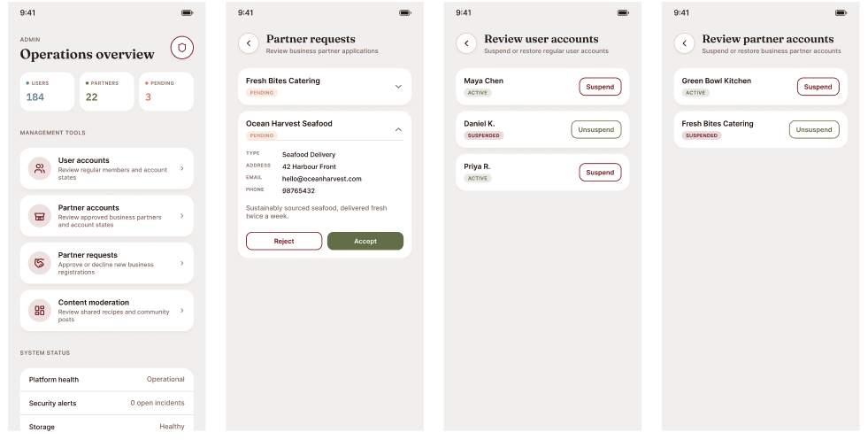
Figure 8.13 — Admin Dashboard & Partner Requests

8.14 Review User & Partner Accounts
Split suspend/unsuspend queues, kept separate per role so an admin never manages both account types in one mixed list.
Figure 8.14 — Review User & Partner Accounts

9. Development Tools

9.1 Project Management
Tool | Purpose
Taiga | Agile project management tool used to implement the Kanban workflow — product backlogs, sprint planning, task boards, user stories and progress tracking, keeping all task delegation and progress visible in one place.

9.2 Version Control
Tool | Purpose
GitHub | Version control and source code management. Enables collaborative development through Git repositories, branch management, pull requests, and commit history tracking.

9.3 Development Environment
Tool | Purpose
Visual Studio Code | Primary development environment used for writing, debugging and managing the project source code — syntax highlighting, IntelliSense, integrated terminal support and Git integration.

9.4 Frontend Technology
Tool | Purpose
Flutter | Open-source UI framework developed by Google for building cross-platform mobile applications from a single codebase, targeting Android, iOS and Web.
Dart | Primary programming language used by Flutter; implements the application's UI logic, business logic, data models, API communication and Firebase interaction.

9.5 Backend Technology
Tool | Purpose
Firebase | Backend-as-a-Service (BaaS) platform supporting authentication and cloud data storage for the application.
Cloud Firestore | Cloud-hosted NoSQL database storing user profiles, food records, health metrics and application data, with real-time synchronisation.
Firebase Authentication | Manages user registration, login and authentication state, controlling access to protected functionality.

9.6 UI/UX Design Tools
Tool | Purpose
Figma | Collaborative UI/UX design and prototyping tool used to design screen layouts and interactive prototypes before implementation in Flutter.
draw.io | Diagramming tool used to produce use case diagrams, functional hierarchy diagrams, system architecture diagrams and other project documentation.

