LIMOS
Use Case Corrective Pass
Corrected Use Case Descriptions, Use Case Diagrams, BCE Diagrams and Sequence Diagrams for all 42 user stories
Group 34 — CSIT321 Final Year Project
12/09/2026

Purpose and Method
The Project Proposal's Use Case Descriptions, Use Case Diagrams, BCE Diagrams and Sequence Diagrams for all 42 user stories were drafted before implementation began. This document supersedes those diagrams with corrected versions grounded directly in the current LIMOS Flutter/Firebase codebase: every class name, method signature and call sequence below was read from the actual controller, service and repository files (lib/controllers/*.dart, lib/services/*.dart) and the real page/route names in router.dart, not re-invented.
Corrections found fall into three categories, flagged inline against each story:
- Naming corrections — the proposal invented single-purpose controller/entity names (e.g. RegistrationController, CreateProfileController, UserAccountController) that do not exist; the real codebase uses fewer, broader domain controllers (AuthController, ProfileController, AdminController, PartnerProfileController, …).
- Flow corrections — some call sequences were restructured at implementation time (e.g. account + profile creation is one atomic Firestore batch, not two sequential entity writes).
- Scope corrections — a small number of proposed use cases (admin account registration, admin/partner account deletion) were never implemented; these are marked “NOT IMPLEMENTED” with an explanation instead of a fabricated diagram, and two pairs of stories (20/21 and 39/40) that map to the exact same single implemented action are flagged as such rather than duplicated as if they were distinct behaviours.
Diagram styling note: sequence diagrams here are simplified UML (no activation-bar lifetime tracking) so the same generator could be applied consistently across all 42 stories — what is being corrected is the technical content (class/method names, call order, branching), not diagram notation.

User Stories 1 – 11

Story 1: Register an account
Actor: User
The proposal's original BCE modelled this as two sequential writes (RegisterUser then CreateProfile on separate entities). The real implementation is a single atomic Firestore batch inside UserRepository.createUserAndProfile — corrected below.

Use Case Description
Use Case ID | #1
Use Case Name | Register an account
Description | Allow a new user to create an account by providing personal/health details, an email address and a password.
Actor | User
Trigger | User selects “New Here” / Register on the Role Selection or Welcome screen.
Precondition | - User is on the Role Selection / Register screen.  - User has chosen the “User” role.
Postconditions | - A Firebase Auth account exists for the user.  - users/{uid} and profiles/{uid}_profile documents exist in Firestore.  - The user is signed in and routed to the Home dashboard.
Main Flow | - User enters full name, email, password and onboarding profile fields.  - RegisterPage calls AuthController.register(fullName, email, password, role: user, ...).  - AuthController calls AuthService.signUp(email, password) to create the Firebase Auth account.  - AuthController calls UserRepository.createUserAndProfile(...), which writes users/{uid} and profiles/{uid}_profile in one Firestore batch.  - The app navigates to AuthController.destinationFor(role) — the Home dashboard.

Alternative Flow — signUp() throws a FirebaseAuthException (e.g. email already in use, weak password)
- AuthService surfaces the FirebaseAuthException.
- authErrorMessage(error) maps it to a user-facing message, shown on RegisterPage.

Use Case Diagram
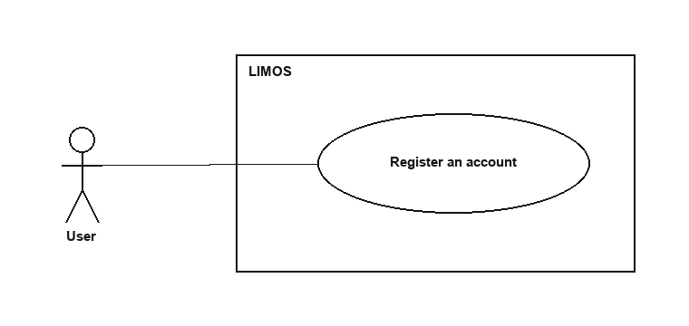
Figure 1.1 — Register an account

BCE Diagram
<<boundary>>  RegisterPage | <<control>>  AuthController | <<entity>>  AuthService | <<entity>>  UserRepository
displayError(String msg) | Future<void> register({fullName, email, password, role, ...}) | Future<UserCredential> signUp({email, password}) | Future<void> createUserAndProfile({uid, email, role, fullName, ...})
 | String destinationFor(UserRole role)

Sequence Diagram
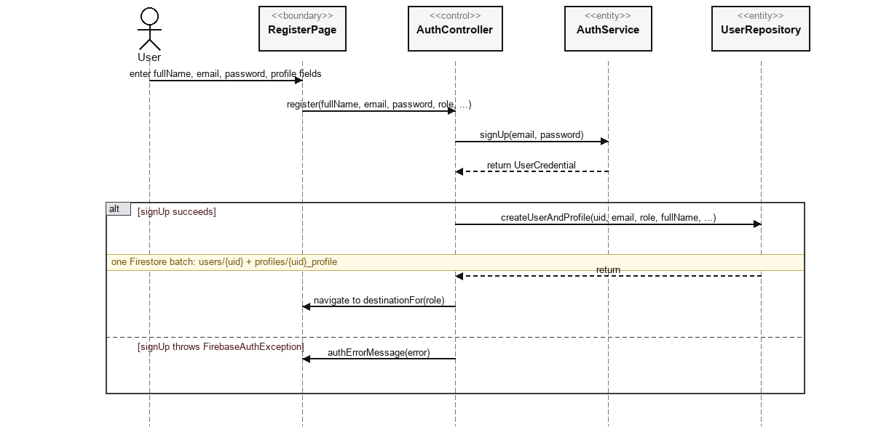
Figure 1.2 — Register an account

Story 2: View personal profile
Actor: User

Use Case Description
Use Case ID | #2
Use Case Name | View personal profile
Description | Allow a user to view their current account and profile details, plus computed BMI/BMR/TDEE.
Actor | User
Trigger | User opens the Profile tab.
Precondition | User is signed in.
Postconditions | The user's current profile details are displayed.
Main Flow | - ProfilePage subscribes to AuthController.watchUser(uid) for account fields (name, email).  - ProfilePage subscribes to ProfileController.watchProfile(uid) for profile fields (age, height, weight, allergies, etc.).  - ProfilePage computes HealthMetrics.from(profile) locally and displays BMI/BMR/TDEE alongside the stored fields.

Use Case Diagram
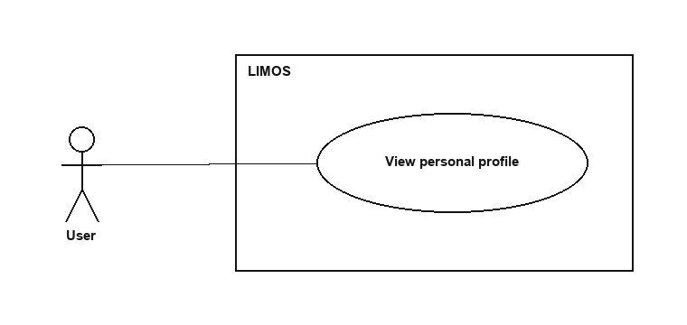
Figure 2.1 — View personal profile

BCE Diagram
<<boundary>>  ProfilePage | <<control>>  AuthController | <<control>>  ProfileController | <<entity>>  UserRepository
display(AppUser user, UserProfile profile, HealthMetrics metrics) | Stream<AppUser?> watchUser(String uid) | Stream<UserProfile?> watchProfile(String uid) | Stream<AppUser?> watchUser(String uid)
 |  |  | Stream<UserProfile?> watchProfile(String uid)

Sequence Diagram
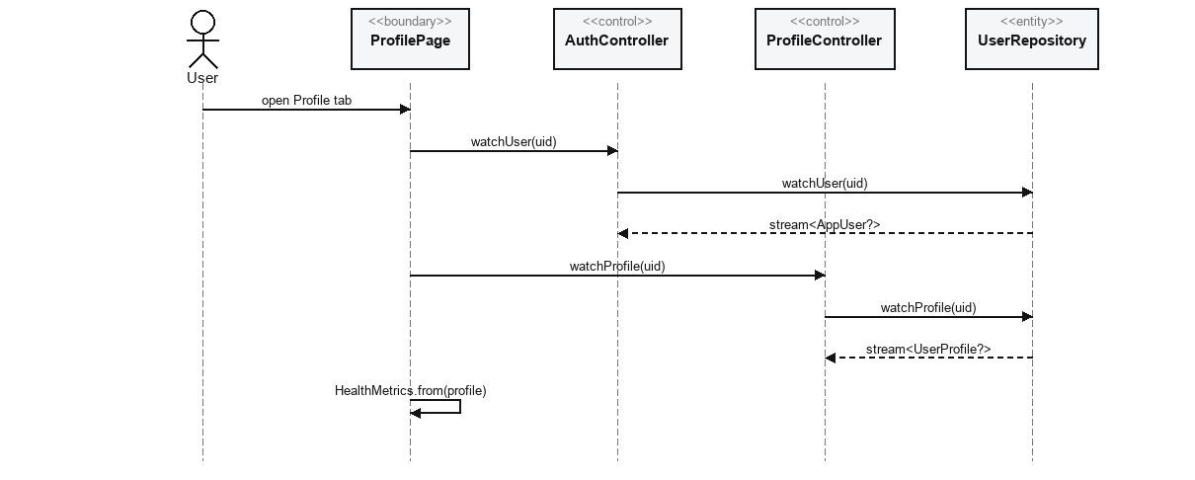
Figure 2.2 — View personal profile

Story 3: Update personal profile
Actor: User
The proposal's BCE invented a Validate_Field()/“Invalid input” branch. The real ProfileController does not validate field contents — it only omits null/empty fields before writing; there is no equivalent alt branch in the code.

Use Case Description
Use Case ID | #3
Use Case Name | Update personal profile
Description | Allow a user to edit and save their profile so the system holds accurate information.
Actor | User
Trigger | User edits fields on Edit Profile and selects Save.
Precondition | - User is signed in.  - User is on the Edit Profile screen.
Postconditions | - Only the fields the user actually changed are updated in Firestore.  - The Profile screen reflects the new values.
Main Flow | - User edits one or more fields on EditProfilePage.  - EditProfilePage calls ProfileController.updateProfile(uid, ...changed fields).  - ProfileController builds a fields map that skips null/empty values.  - ProfileController calls UserRepository.updateProfile(uid, fields).  - Firestore updates profiles/{uid}_profile with only the supplied fields.

Alternative Flow — the Firestore write fails (network/permission error)
- UserRepository's Future rejects.
- EditProfilePage shows an error message and keeps the user on the form.

Use Case Diagram
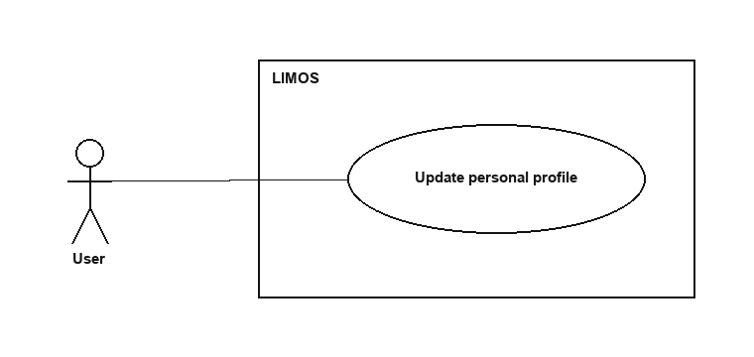
Figure 3.1 — Update personal profile

BCE Diagram
<<boundary>>  EditProfilePage | <<control>>  ProfileController | <<entity>>  UserRepository
showError(String msg) | Future<void> updateProfile({uid, age, gender, height, weight, ...}) | Future<void> updateProfile(String uid, Map<String,dynamic> fields)

Sequence Diagram
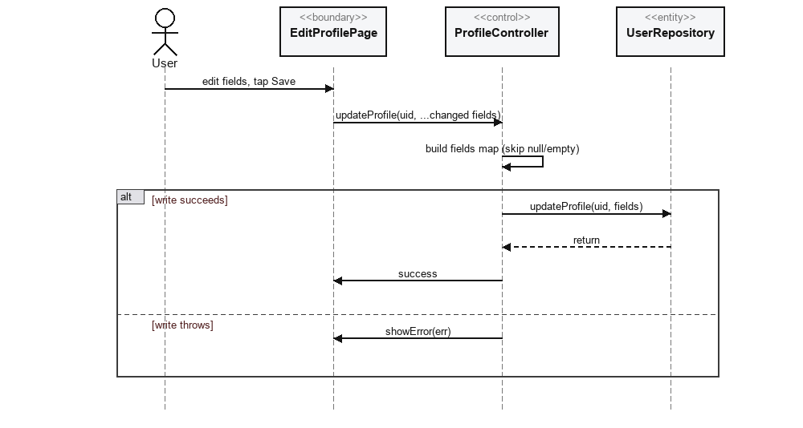
Figure 3.2 — Update personal profile

Story 4: View computed BMI/BMR/TDEE and calorie recommendation
Actor: User
This is a pure client-side calculation (lib/utils/health_metrics.dart) — there is no dedicated controller/entity round trip beyond fetching the profile that already backs story 2.

Use Case Description
Use Case ID | #4
Use Case Name | View computed BMI/BMR/TDEE and calorie recommendation
Description | Show the user their BMI, BMR, TDEE and a recommended daily calorie intake derived from their profile.
Actor | User
Trigger | ProfilePage (or Home dashboard) loads with the user's current profile.
Precondition | User is signed in and has a profile document.
Postconditions | BMI/BMR/TDEE and a calorie goal are displayed, or a reduced fallback view if the profile is incomplete.
Main Flow | - ProfileController.watchProfile(uid) emits the current UserProfile.  - The page calls HealthMetrics.from(profile).  - HealthMetrics computes BMI from height/weight, BMR from weight/height/age/gender (Mifflin-St Jeor), and TDEE = BMR × activity multiplier.  - The calorie goal, and protein/carb/fat macro targets, are derived from TDEE (or a user override, calorieGoalValue/Period).

Alternative Flow — height or weight is missing from the profile
- HealthMetrics falls back to HealthMetrics.forCalorieGoal() using only an explicit user-set calorie goal if present, or returns an empty HealthMetrics() with no numbers to show.

Use Case Diagram
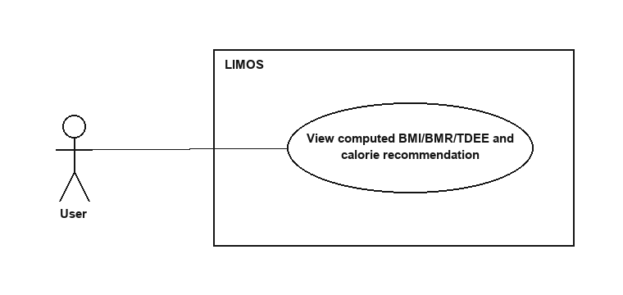
Figure 4.1 — View computed BMI/BMR/TDEE and calorie recommendation

BCE Diagram
<<boundary>>  ProfilePage | <<control>>  ProfileController | <<control>>  HealthMetrics | <<entity>>  UserRepository
display(HealthMetrics metrics) | Stream<UserProfile?> watchProfile(String uid) | static HealthMetrics from(UserProfile? profile) | Stream<UserProfile?> watchProfile(String uid)
 |  | HealthMetrics.forCalorieGoal(double goal)

Sequence Diagram
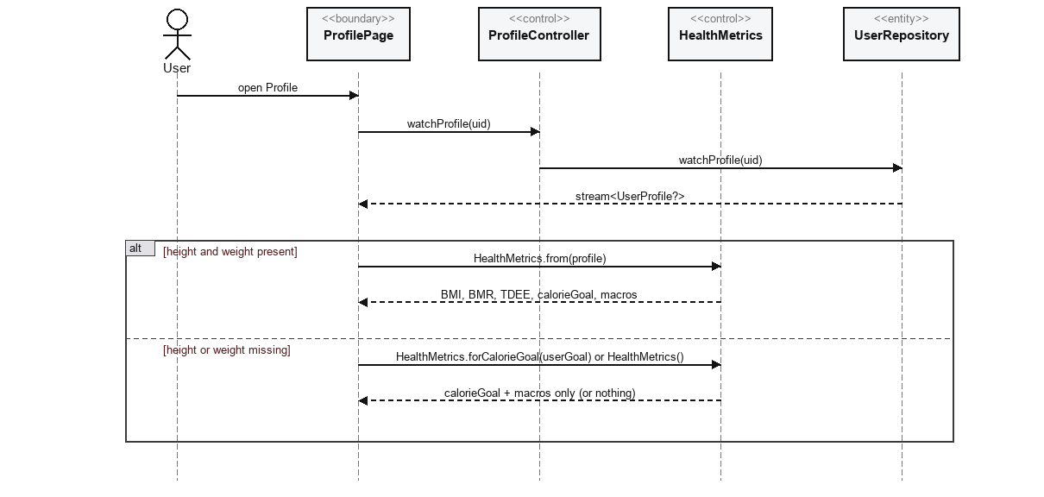
Figure 4.2 — View computed BMI/BMR/TDEE and calorie recommendation

Story 5: View personalized meal recommendations
Actor: User
Known gap (matches the TDM): meal_recommendation.dart also defines recommendedRecipes(), which additionally sorts matches by fit against the user's remaining daily calories — it is implemented and unit-tested but RecipesPage never calls it; it calls isRecommendedFor() directly, so “For You” filters by diet/allergy/medical safety only, with no calorie-goal-aware ranking despite that logic existing in the codebase.

Use Case Description
Use Case ID | #5
Use Case Name | View personalized meal recommendations
Description | Show the user recipes recommended for them under the Recipes page's “For You” filter.
Actor | User
Trigger | User opens the Recipes page and selects the “For You” tab.
Precondition | - User is signed in.  - The shared recipes catalog is loaded.
Postconditions | Only recipes matching the user's diet, allergy and medical-condition constraints are shown.
Main Flow | - RecipesPage subscribes to RecipeController.watchRecipes() for the full shared catalog.  - For each recipe, RecipesPage calls isRecommendedFor(recipe, profile) directly.  - Recipes for which isRecommendedFor returns true are shown under “For You”.

Use Case Diagram
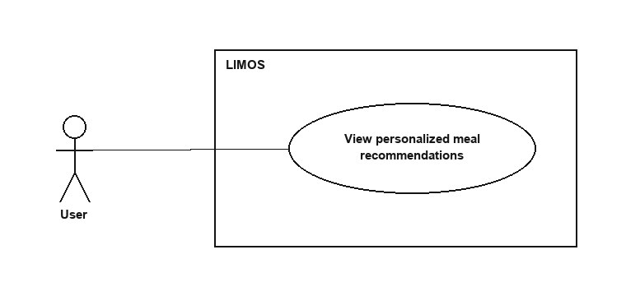
Figure 5.1 — View personalized meal recommendations

BCE Diagram
<<boundary>>  RecipesPage | <<control>>  RecipeController | <<control>>  meal_recommendation | <<entity>>  RecipeRepository
display(List<Recipe> forYou) | Stream<List<Recipe>> watchRecipes() | bool isRecommendedFor(Recipe recipe, UserProfile? profile) | Stream<List<Recipe>> watchRecipes()
 |  | List<Recipe> recommendedRecipes({recipes, profile, remainingCalories}) — unused here

Sequence Diagram
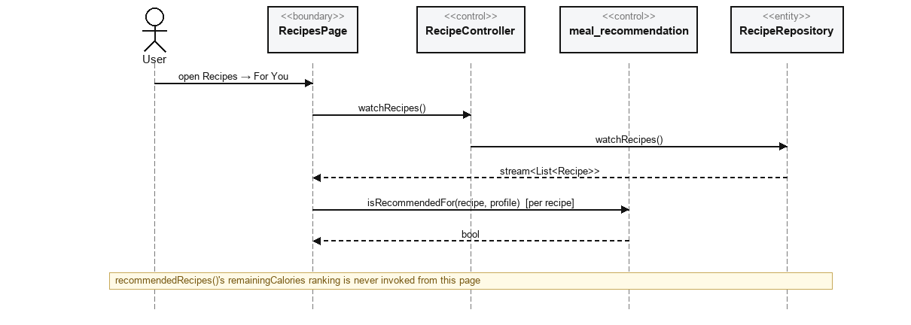
Figure 5.2 — View personalized meal recommendations

Story 6: Search and browse healthy meals and recipes
Actor: User
Corrects an inconsistency across the team's own docs: Discover is a section inside RecipesPage, not a separate '/discover' route — confirmed directly against router.dart, which declares no such route.

Use Case Description
Use Case ID | #6
Use Case Name | Search and browse healthy meals and recipes
Description | Allow the user to search the shared catalog and browse externally sourced recipes.
Actor | User
Trigger | User enters a keyword on the Recipes page, or opens the Discover section within it.
Precondition | User is signed in.
Postconditions | Matching recipes from the local catalog and/or Spoonacular are displayed.
Main Flow | - RecipesPage filters the live RecipeController.watchRecipes() stream by the typed keyword for the local/shared catalog.  - For the Discover section (same page, not a separate route), RecipesPage calls DiscoverRecipeService.search(query) directly.  - Matching results from Spoonacular are shown alongside/under the local results.

Alternative Flow — the Spoonacular API is unreachable or returns an error
- DiscoverRecipeService's request fails.
- RecipesPage shows a friendly error message and continues to show local-catalog results (per the app's offline/degraded-API fallback requirement).

Use Case Diagram
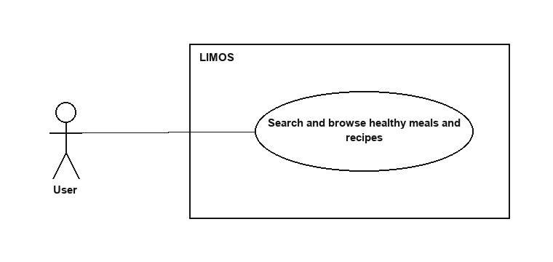
Figure 6.1 — Search and browse healthy meals and recipes

BCE Diagram
<<boundary>>  RecipesPage | <<control>>  RecipeController | <<entity>>  DiscoverRecipeService | <<entity>>  RecipeRepository
displayResults(...) | Stream<List<Recipe>> watchRecipes() | Future<List<DiscoverRecipe>> search({query, ...}) | Stream<List<Recipe>> watchRecipes()
showError(String msg)

Sequence Diagram
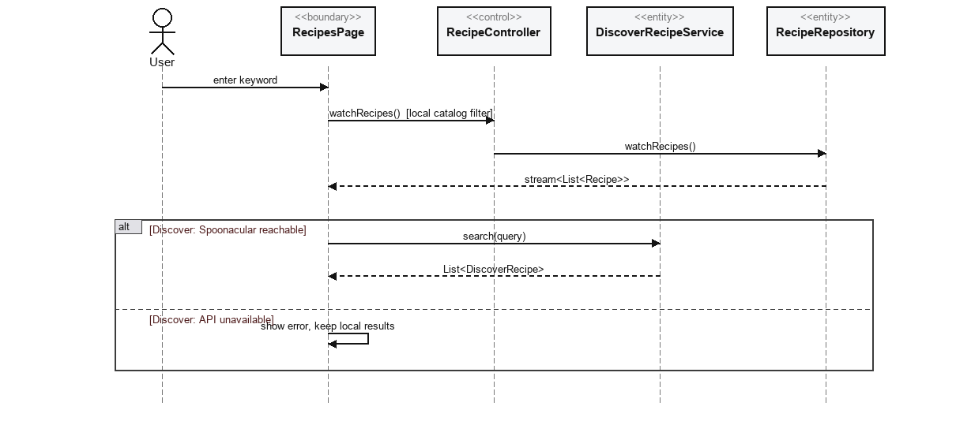
Figure 6.2 — Search and browse healthy meals and recipes

Story 7: Save recipes as favourites
Actor: User

Use Case Description
Use Case ID | #7
Use Case Name | Save recipes as favourites
Description | Allow the user to save/unsave a catalog recipe as a favourite for quick access later.
Actor | User
Trigger | User taps the favourite (heart) icon on a recipe card or detail page.
Precondition | - User is signed in.  - The recipe exists in the shared catalog.
Postconditions | A favorites/{uid}_{recipeId} document exists (saved) or has been removed (unsaved).
Main Flow | - RecipesPage/RecipeDetailPage calls RecipeController.toggleFavorite(uid, recipeId, isFavorited).  - RecipeController calls RecipeRepository.toggleFavorite(uid, recipeId, isFavorited).

Alternative Flow — isFavorited is currently false (saving)
- RecipeRepository creates favorites/{uid}_{recipeId}.
Alternative Flow — isFavorited is currently true (un-saving)
- RecipeRepository deletes favorites/{uid}_{recipeId}.

Use Case Diagram
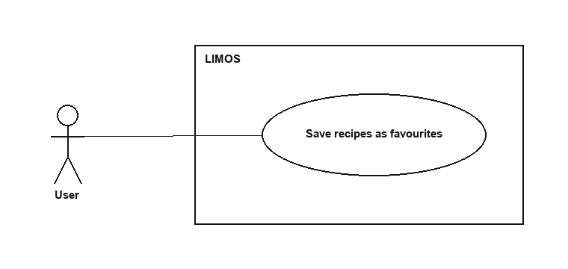
Figure 7.1 — Save recipes as favourites

BCE Diagram
<<boundary>>  RecipesPage | <<control>>  RecipeController | <<entity>>  RecipeRepository
updateHeartIcon(bool isFavorited) | Future<void> toggleFavorite({uid, recipeId, isFavorited}) | Future<void> toggleFavorite({uid, recipeId, isFavorited})

Sequence Diagram
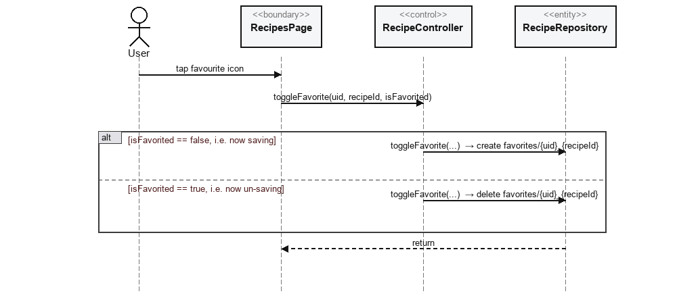
Figure 7.2 — Save recipes as favourites

Story 8: Manually add a personal recipe
Actor: User

Use Case Description
Use Case ID | #8
Use Case Name | Manually add a personal recipe
Description | Allow the user to create their own recipe not already available in the system.
Actor | User
Trigger | User fills in the Add Recipe form and selects Save.
Precondition | - User is signed in.  - User is on the Add Recipe screen.
Postconditions | A userRecipes document exists for the new recipe, owned by the user.
Main Flow | - User enters name, ingredients, preparation steps, calories, macros, serving size, prep time and difficulty.  - AddRecipePage calls UserRecipeController.createRecipe(uid, name, ingredientsText, preparationStepsText, ...).  - UserRecipeController splits the ingredients/steps text into ordered lists.  - UserRecipeController calls UserRecipeRepository.addRecipe(recipe).

Alternative Flow — the recipe name is empty
- UserRecipeController throws ArgumentError('Recipe name is required').
- AddRecipePage shows a validation message and does not save.

Use Case Diagram
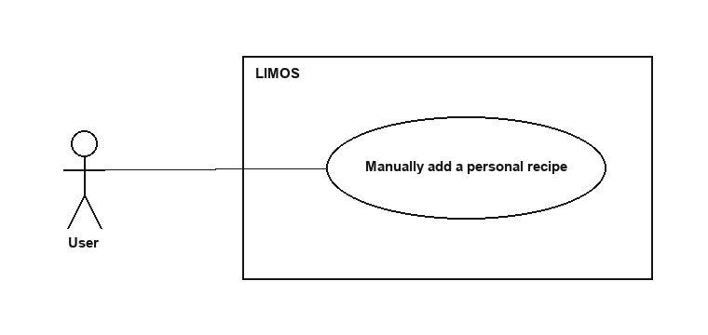
Figure 8.1 — Manually add a personal recipe

BCE Diagram
<<boundary>>  AddRecipePage | <<control>>  UserRecipeController | <<entity>>  UserRecipeRepository
showValidationError(String msg) | Future<void> createRecipe({uid, name, ingredientsText, preparationStepsText, calories, protein, fat, servingSize, prepTimeMinutes, difficulty}) | Future<void> addRecipe(UserRecipe recipe)

Sequence Diagram
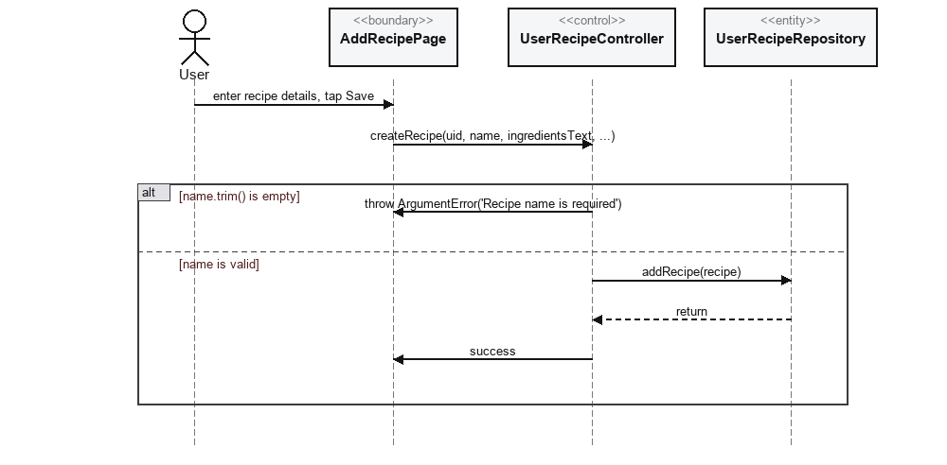
Figure 8.2 — Manually add a personal recipe

Story 9: Manually log meals and beverages
Actor: User

Use Case Description
Use Case ID | #9
Use Case Name | Manually log meals and beverages
Description | Allow the user to record a meal or beverage they consumed, with nutrition auto-fill.
Actor | User
Trigger | User selects Log Meal and enters a food name.
Precondition | - User is signed in.  - User is on the Log Meal screen.
Postconditions | - A mealLogs document exists for the entry.  - The day's calorie/macro totals include the new entry.
Main Flow | - User types a food name; LogMealPage calls NutritionLookupService.lookup(query) to auto-fill calories/macros.  - User confirms or edits the pre-filled values, then selects Save.  - LogMealPage calls MealLogController.logMeal(uid, mealName, mealType, servingSize, calories, protein, carbohydrates, fat).  - MealLogController validates the entry, then calls MealLogRepository.addLog(log).

Alternative Flow — Spoonacular has no nutrition estimate for the typed food
- NutritionLookupService.lookup() returns null.
- LogMealPage leaves the calorie/macro fields blank for manual entry.
Alternative Flow — mealName is empty or calories <= 0
- MealLogController._validate throws ArgumentError.
- LogMealPage shows a validation message and does not save.

Use Case Diagram
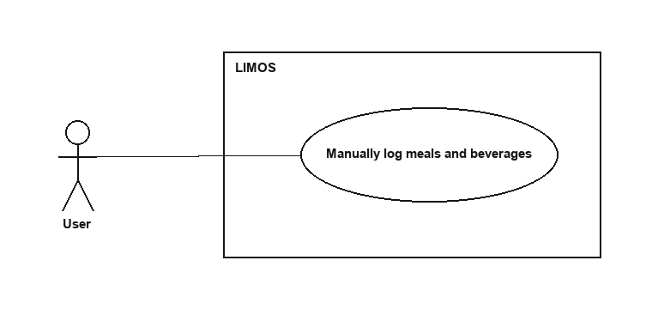
Figure 9.1 — Manually log meals and beverages

BCE Diagram
<<boundary>>  LogMealPage | <<entity>>  NutritionLookupService | <<control>>  MealLogController | <<entity>>  MealLogRepository
prefill(NutritionResult? result) | Future<NutritionResult?> lookup(String query) | Future<void> logMeal({uid, mealName, mealType, servingSize, calories, protein, carbohydrates, fat}) | Future<void> addLog(MealLog log)
showValidationError(String msg)

Sequence Diagram
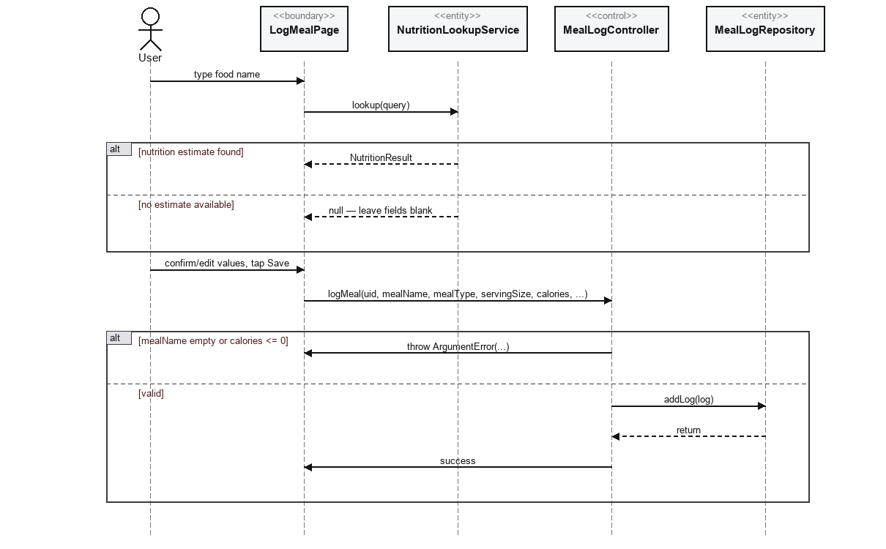
Figure 9.2 — Manually log meals and beverages

Story 10: AI-based food recognition from a photo
Actor: User
Known limitation (confirmed in code, matches the TDM): no camera or ML package is integrated. Scan Food always returns the same fixed result and persists it through the real repository path — there is no image-capture or model-inference entity to diagram, by design of the current build.

Use Case Description
Use Case ID | #10
Use Case Name | AI-based food recognition from a photo
Description | Let the user capture/select a food photo and get a suggested food name to log.
Actor | User
Trigger | User selects Scan Food.
Precondition | - User is signed in.  - User is on the Scan Food screen.
Postconditions | A foodRecognitions document exists recording the (mocked) result.
Main Flow | - User selects Scan Food.  - FoodRecognitionPage returns a fixed mocked result ('Salad bowl', 92% confidence) — no camera or ML model is invoked.  - User reviews/accepts the result; FoodRecognitionPage calls FoodRecognitionController.saveRecognition(uid, recognizedFoodName, confidence).  - FoodRecognitionController calls FoodRecognitionRepository.addRecognition(recognition).

Use Case Diagram
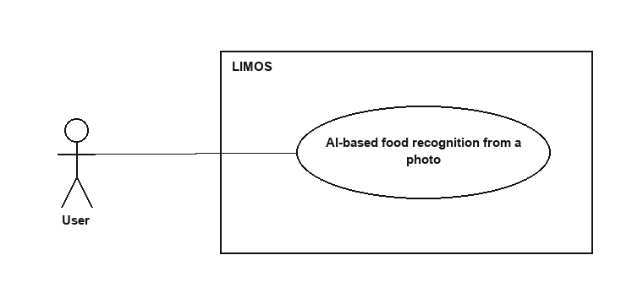
Figure 10.1 — AI-based food recognition from a photo

BCE Diagram
<<boundary>>  FoodRecognitionPage | <<control>>  FoodRecognitionController | <<entity>>  FoodRecognitionRepository
displayResult(String food, double confidence) | Future<void> saveRecognition({uid, recognizedFoodName, confidence}) | Future<void> addRecognition(FoodRecognition recognition)

Sequence Diagram
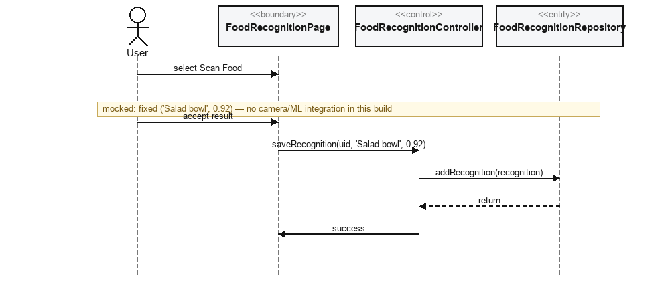
Figure 10.2 — AI-based food recognition from a photo

Story 11: Restore session role and protect role-specific routes
Actor: User

Use Case Description
Use Case ID | #11
Use Case Name | Restore session role and protect role-specific routes
Description | Restore a signed-in user's role on app launch and re-check it on every navigation so role/status-specific routes stay protected.
Actor | User
Trigger | App launches with a cached Firebase session, or the user navigates within the app.
Precondition | A Firebase Auth session may or may not already exist on-device.
Postconditions | The user lands only on routes permitted for their current role and account status.
Main Flow | - GoRouter's global redirect callback runs on every navigation, not only at launch.  - It calls AuthController.currentAccount() (which reads Firebase Auth's current user, then AuthController.currentRole()/status via UserRepository.fetchUser).  - If the account is a business partner, it also calls PartnerProfileController.fetchOnce(uid) to check partnerProfiles.status.  - Based on signed-in state, account status and role, the guard allows the navigation or redirects to /login, /account-suspended, /account-pending, or the role's home route.

Alternative Flow — no signed-in account
- redirect to /role-select or /login
Alternative Flow — account status == 'suspended'
- redirect to /account-suspended
Alternative Flow — role == business_partner and partnerProfiles.status != 'active'
- redirect to /account-pending
Alternative Flow — all checks pass
- allow navigation to the requested route

Use Case Diagram
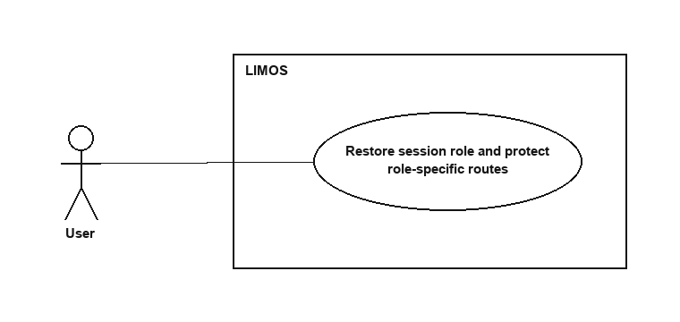
Figure 11.1 — Restore session role and protect role-specific routes

BCE Diagram
<<boundary>>  GoRouter (redirect callback) | <<control>>  AuthController | <<control>>  PartnerProfileController | <<entity>>  UserRepository
redirect(BuildContext, GoRouterState) | Future<AppUser?> currentAccount() | Future<PartnerProfile?> fetchOnce(String uid) | Future<AppUser?> fetchUser(String uid)
 | Future<UserRole?> currentRole()

Sequence Diagram
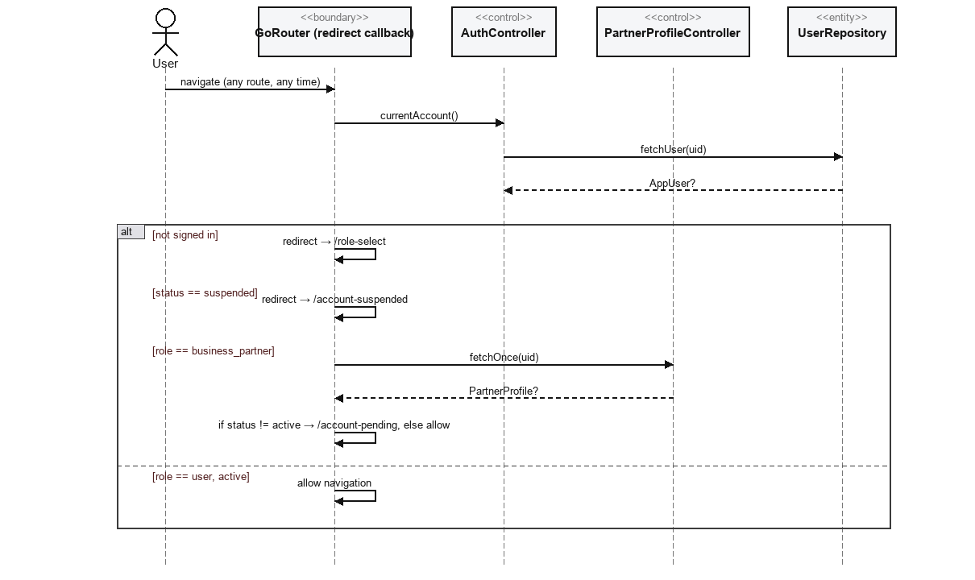
Figure 11.2 — Restore session role and protect role-specific routes

User Stories 12 – 21

Story 12: Review and correct AI food recognition results
Actor: User
There is no separate “correct after saving” endpoint — editing happens on the client before the single saveRecognition() call, since FoodRecognitionController exposes no update method, only saveRecognition and watchRecent.

Use Case Description
Use Case ID | #12
Use Case Name | Review and correct AI food recognition results
Description | Let the user review the (mocked) recognition result and adjust it before it is saved.
Actor | User
Trigger | Immediately after Scan Food returns its mocked result.
Precondition | User has just triggered Scan Food (story 10).
Postconditions | The (possibly edited) result is what gets saved to foodRecognitions.
Main Flow | - FoodRecognitionPage displays the mocked result fields as editable.  - User edits the food name/confidence locally on the page (client-side only).  - User taps Save; FoodRecognitionPage calls FoodRecognitionController.saveRecognition(uid, recognizedFoodName, confidence) with the (possibly edited) values.

Use Case Diagram
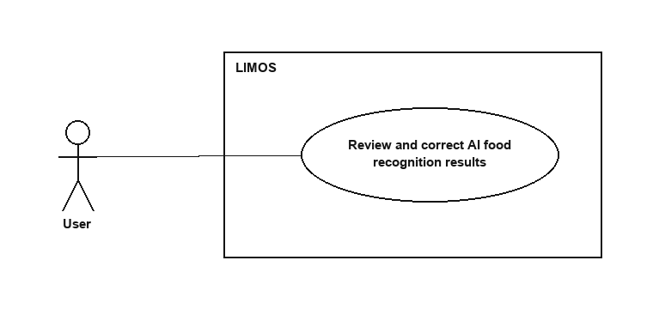
Figure 12.1 — Review and correct AI food recognition results

BCE Diagram
<<boundary>>  FoodRecognitionPage | <<control>>  FoodRecognitionController | <<entity>>  FoodRecognitionRepository
editableResult(String food, double confidence) | Future<void> saveRecognition({uid, recognizedFoodName, confidence}) | Future<void> addRecognition(FoodRecognition recognition)

Sequence Diagram
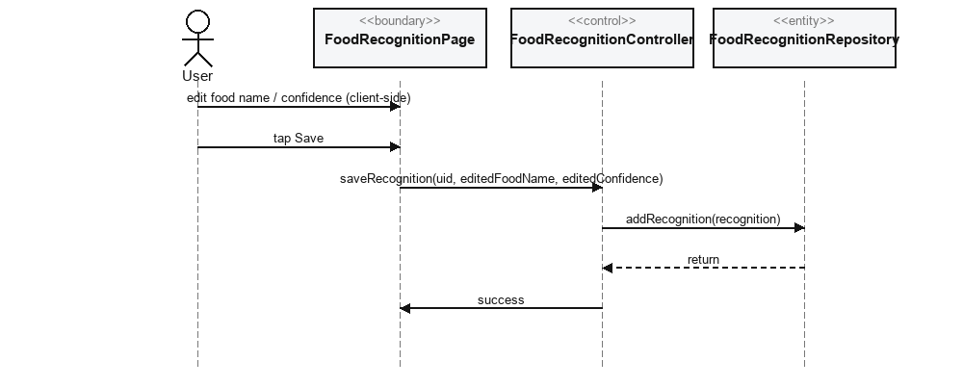
Figure 12.2 — Review and correct AI food recognition results

Story 13: Track daily calorie, macronutrient and water intake
Actor: User

Use Case Description
Use Case ID | #13
Use Case Name | Track daily calorie, macronutrient and water intake
Description | Show the user running totals of what they have logged today against their targets.
Actor | User
Trigger | User opens the Home dashboard.
Precondition | User is signed in.
Postconditions | Today's calorie/macro/water totals are displayed against the user's goals.
Main Flow | - HomePage subscribes to MealLogController.watchTodayLogs(uid) for today's meals.  - HomePage subscribes to WaterLogController.watchTodayLogs(uid) for today's water glasses.  - HomePage sums calories/protein/carbohydrates/fat from the meal logs and glasses from the water logs, and compares totals against HealthMetrics.from(profile).

Use Case Diagram
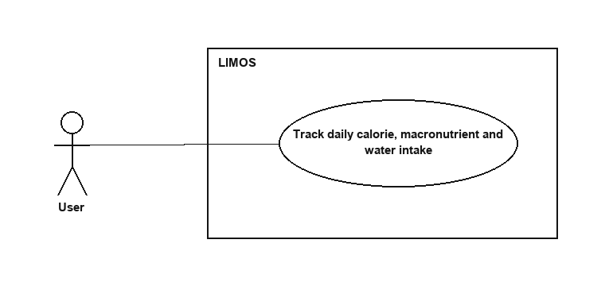
Figure 13.1 — Track daily calorie, macronutrient and water intake

BCE Diagram
<<boundary>>  HomePage | <<control>>  MealLogController | <<control>>  WaterLogController | <<entity>>  MealLogRepository | <<entity>>  WaterLogRepository
displayTotals(...) | Stream<List<MealLog>> watchTodayLogs(String uid) | Stream<List<WaterLog>> watchTodayLogs(String uid) | Stream<List<MealLog>> watchTodayLogs(String uid) | Stream<List<WaterLog>> watchTodayLogs(String uid)

Sequence Diagram
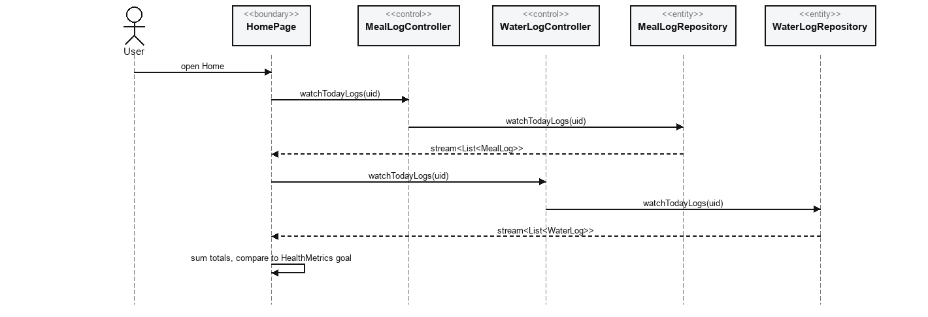
Figure 13.2 — Track daily calorie, macronutrient and water intake

Story 14: View daily, weekly and monthly progress reports
Actor: User

Use Case Description
Use Case ID | #14
Use Case Name | View daily, weekly and monthly progress reports
Description | Show the user their weight and meal-logging trends over different time windows.
Actor | User
Trigger | User opens the Progress tab and optionally toggles weekly/monthly.
Precondition | User is signed in.
Postconditions | Weight trend and streak/average statistics are displayed for the selected window.
Main Flow | - ProgressPage subscribes to WeightLogController.watchLast7DaysLogs(uid) for the weight trend chart.  - ProgressPage subscribes to MealLogController.watchLastNDaysLogs(uid, days) for logging-streak/average statistics.  - Toggling weekly/monthly re-queries with a different N and re-renders the chart/stats client-side.

Use Case Diagram
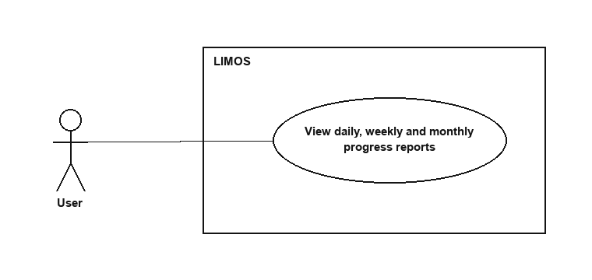
Figure 14.1 — View daily, weekly and monthly progress reports

BCE Diagram
<<boundary>>  ProgressPage | <<control>>  WeightLogController | <<control>>  MealLogController | <<entity>>  WeightLogRepository | <<entity>>  MealLogRepository
renderChart(...) | Stream<List<WeightLog>> watchLast7DaysLogs(String uid) | Stream<List<MealLog>> watchLastNDaysLogs(String uid, int days) | Stream<List<WeightLog>> watchLast7DaysLogs(String uid) | Stream<List<MealLog>> watchLastNDaysLogs(String uid, int days)
renderStats(...)

Sequence Diagram
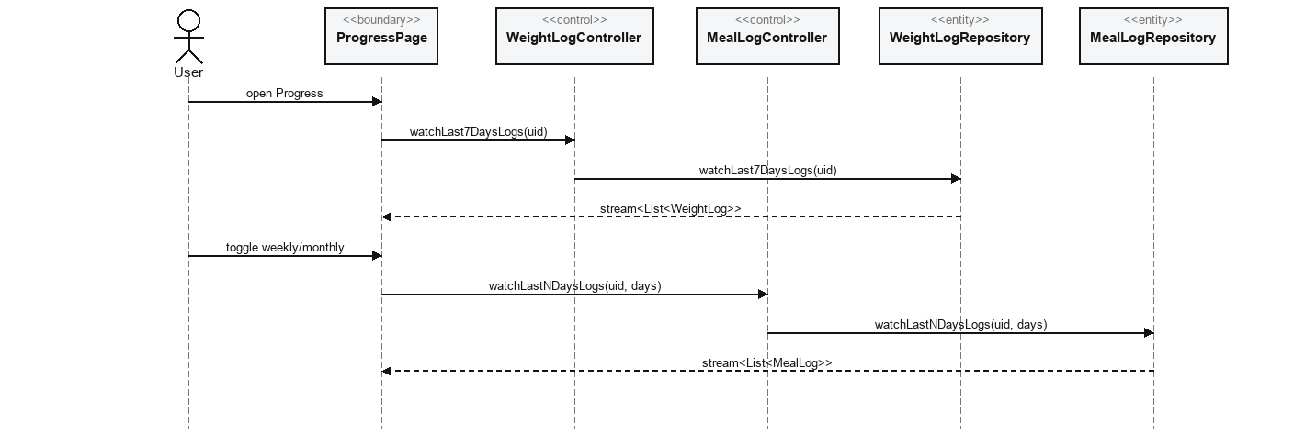
Figure 14.2 — View daily, weekly and monthly progress reports

Story 15: Receive meal-logging reminders
Actor: User
Known limitation (matches the TDM): reminders are only stored and listed (RemindersPage subscribes to ReminderController.watchReminders(uid)) — there is no local/push notification scheduler wired up, so scheduledAt does not actually trigger anything on-device yet.

Use Case Description
Use Case ID | #15
Use Case Name | Receive meal-logging reminders
Description | Let the user set up a reminder so they remember to log meals.
Actor | User
Trigger | User adds a reminder on the Reminders screen.
Precondition | - User is signed in.  - User is on the Reminders screen.
Postconditions | A reminders document exists with the chosen title/message/time.
Main Flow | - User enters a title, message and time; RemindersPage calls ReminderController.addReminder(uid, title, message, scheduledAt).  - ReminderController validates the title, then calls ReminderRepository.addReminder(reminder).

Alternative Flow — title is empty
- ReminderController throws ArgumentError('Reminder title is required').
- RemindersPage shows a validation message.

Use Case Diagram
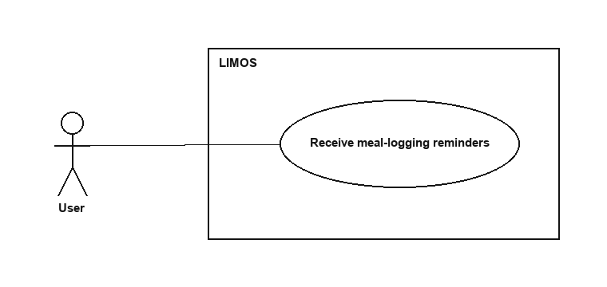
Figure 15.1 — Receive meal-logging reminders

BCE Diagram
<<boundary>>  RemindersPage | <<control>>  ReminderController | <<entity>>  ReminderRepository
showValidationError(String msg) | Future<void> addReminder({uid, title, message, scheduledAt}) | Future<void> addReminder(Reminder reminder)

Sequence Diagram
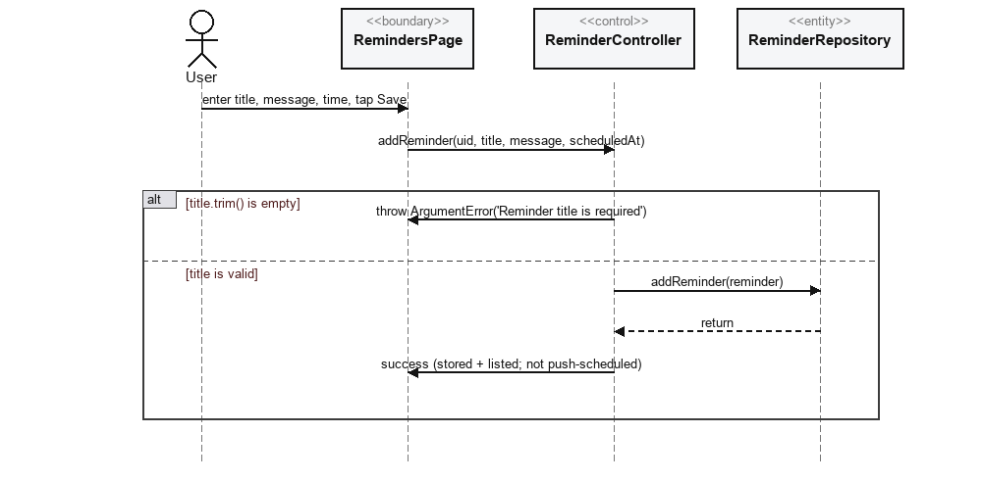
Figure 15.2 — Receive meal-logging reminders

Story 16: View meal history
Actor: User

Use Case Description
Use Case ID | #16
Use Case Name | View meal history
Description | Let the user review the meals/beverages they have previously logged.
Actor | User
Trigger | User opens the History screen.
Precondition | User is signed in.
Postconditions | The last 30 days of meal logs are displayed grouped by day.
Main Flow | - HistoryPage subscribes to MealLogController.watchLastNDaysLogs(uid, 30).  - HistoryPage groups the returned logs by day for display.

Use Case Diagram
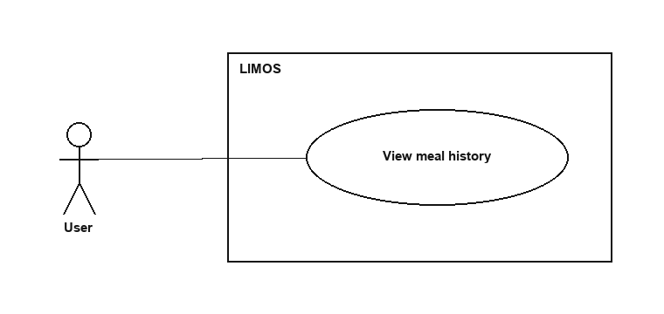
Figure 16.1 — View meal history

BCE Diagram
<<boundary>>  HistoryPage | <<control>>  MealLogController | <<entity>>  MealLogRepository
displayGroupedByDay(List<MealLog>) | Stream<List<MealLog>> watchLastNDaysLogs(String uid, int days) | Stream<List<MealLog>> watchLastNDaysLogs(String uid, int days)

Sequence Diagram
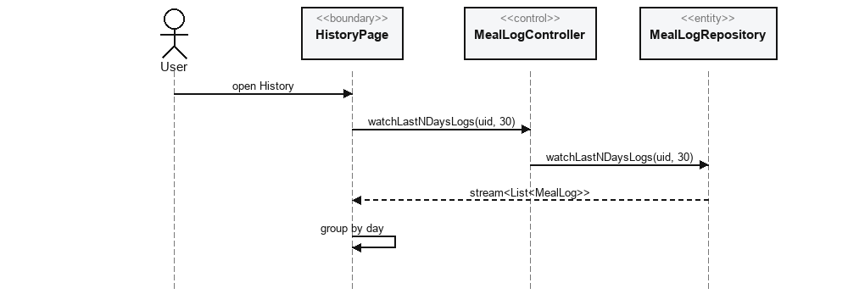
Figure 16.2 — View meal history

Story 17: Filter recipes by calorie range and dietary preference
Actor: User
There is no dedicated 'filter' controller method — filtering is a client-side list operation on the same stream story 6 already subscribes to, not a separate query.

Use Case Description
Use Case ID | #17
Use Case Name | Filter recipes by calorie range and dietary preference
Description | Let the user narrow the recipe list to ones matching a calorie range and/or dietary preference.
Actor | User
Trigger | User sets filter options on the Recipes page.
Precondition | - User is signed in.  - The recipe catalog is loaded.
Postconditions | Only recipes matching the selected filters are shown.
Main Flow | - RecipesPage already holds the live list from RecipeController.watchRecipes().  - RecipesPage applies the calorie-range and dietaryPreference filter predicates to that in-memory list, client-side.  - The filtered list re-renders as the user changes filter values.

Use Case Diagram
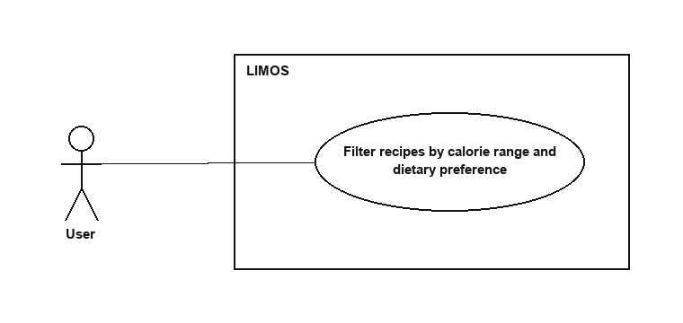
Figure 17.1 — Filter recipes by calorie range and dietary preference

BCE Diagram
<<boundary>>  RecipesPage | <<control>>  RecipeController | <<entity>>  RecipeRepository
applyFilters(calorieRange, dietaryPreference) | Stream<List<Recipe>> watchRecipes() | Stream<List<Recipe>> watchRecipes()

Sequence Diagram
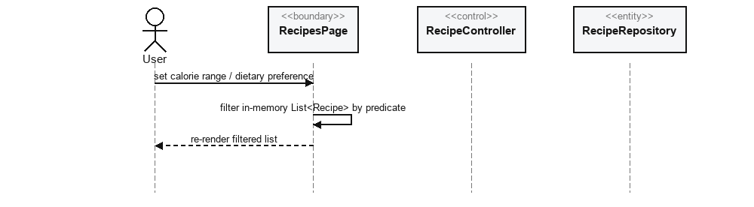
Figure 17.2 — Filter recipes by calorie range and dietary preference

Story 18: Log out securely
Actor: User

Use Case Description
Use Case ID | #18
Use Case Name | Log out securely
Description | Let the user end their session.
Actor | User
Trigger | User selects Log Out on the Settings screen.
Precondition | User is signed in.
Postconditions | - The Firebase Auth session is cleared.  - The user is routed to Role Selection / Login.
Main Flow | - SettingsPage calls AuthController.signOut().  - AuthController calls AuthService.signOut(), which signs the Firebase Auth user out.  - GoRouter's redirect guard (story 11) sees no signed-in account and routes to /role-select.

Use Case Diagram
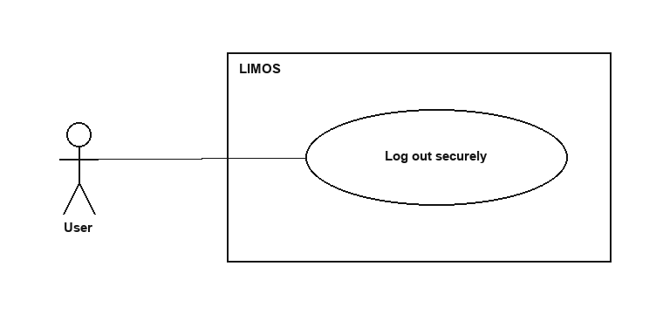
Figure 18.1 — Log out securely

BCE Diagram
<<boundary>>  SettingsPage | <<control>>  AuthController | <<entity>>  AuthService
 | Future<void> signOut() | Future<void> signOut()

Sequence Diagram
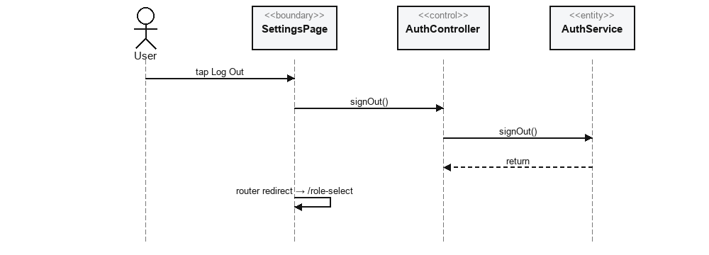
Figure 18.2 — Log out securely

Story 19: Log in securely
Actor: User

Use Case Description
Use Case ID | #19
Use Case Name | Log in securely
Description | Let a registered user sign in to access user-related features.
Actor | User
Trigger | User enters credentials on the Login screen and selects Sign In.
Precondition | User has a registered account.
Postconditions | The user is signed in and routed to the Home dashboard.
Main Flow | - LoginPage calls AuthController.signIn(email, password, fallbackRole: user).  - AuthController calls AuthService.signIn(email, password) against Firebase Auth.  - AuthController calls UserRepository.fetchUser(uid) to read the account's real role.  - AuthController returns that role (or fallbackRole if the Firestore doc can't be found); LoginPage navigates via AuthController.destinationFor(role).

Alternative Flow — signIn() throws a FirebaseAuthException (wrong password, no such account)
- authErrorMessage(error) is shown on LoginPage.

Use Case Diagram
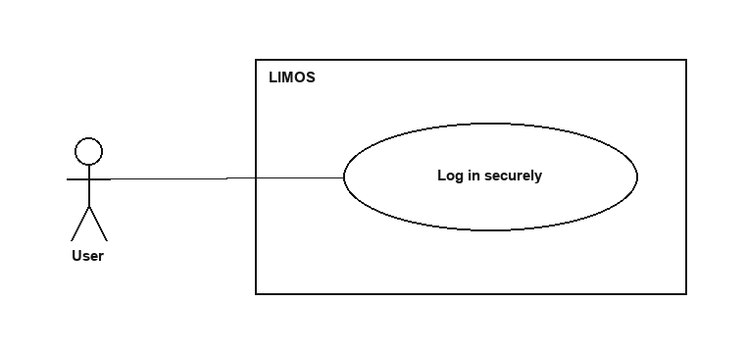
Figure 19.1 — Log in securely

BCE Diagram
<<boundary>>  LoginPage | <<control>>  AuthController | <<entity>>  AuthService | <<entity>>  UserRepository
showError(String msg) | Future<UserRole> signIn({email, password, fallbackRole}) | Future<UserCredential> signIn({email, password}) | Future<AppUser?> fetchUser(String uid)
 | String destinationFor(UserRole role)

Sequence Diagram
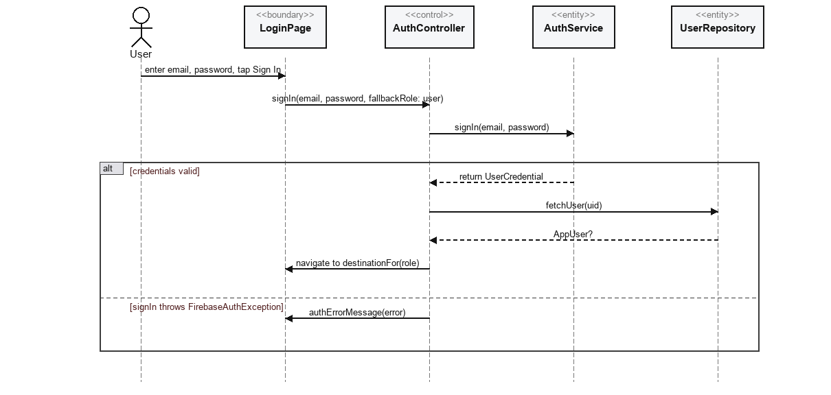
Figure 19.2 — Log in securely

Story 20: Register a business partner account
Actor: Business Partner
Stories 20 and 21 in the original proposal describe registration and “create my profile” as two separate steps. In the real code they are the same single AuthController.register() call — the registration form collects business details directly, with no separate profile-creation step afterwards.

Use Case Description
Use Case ID | #20
Use Case Name | Register a business partner account
Description | Allow a prospective business partner to register, submitting both account and business details together.
Actor | Business Partner
Trigger | User selects the Business Partner role on Role Selection, then Register.
Precondition | User is on the Register screen having chosen the Business Partner role.
Postconditions | A Firebase Auth account, users/{uid} (role=business_partner), profiles/{uid}_profile and a pending partnerProfiles/{uid} document all exist.
Main Flow | - PartnerRegisterPage collects the representative's name/email/password plus business name/type/description/address/contact in one form.  - PartnerRegisterPage calls AuthController.register(..., role: business_partner, businessName, businessType, ...).  - The same UserRepository.createUserAndProfile() batch used in story 1 additionally seeds partnerProfiles/{uid} with status: 'pending' when role == business_partner.  - The account is routed to /account-pending until an administrator approves it (story 36).

Use Case Diagram
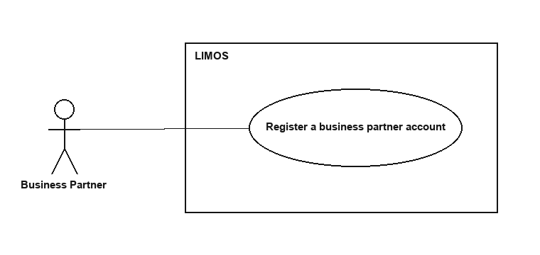
Figure 20.1 — Register a business partner account

BCE Diagram
<<boundary>>  PartnerRegisterPage | <<control>>  AuthController | <<entity>>  AuthService | <<entity>>  UserRepository
displayError(String msg) | Future<void> register({fullName, email, password, role, businessName, businessType, businessDescription, businessAddress, businessContact}) | Future<UserCredential> signUp({email, password}) | Future<void> createUserAndProfile({..., partnerProfiles seeded when role=partner})

Sequence Diagram
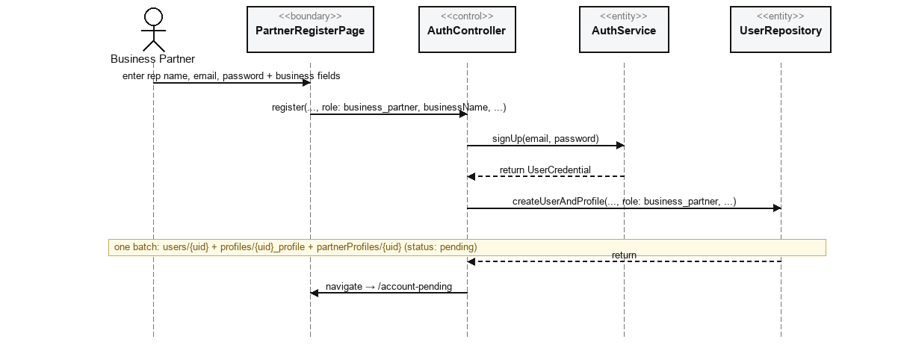
Figure 20.2 — Register a business partner account

Story 21: Provide business details during registration
Actor: Business Partner
In the real implementation, story 21 is not a distinct use case from story 20 — it describes the business-detail fields captured by the one registration call. Kept as its own entry here only because the original proposal listed it separately.

Use Case Description
Use Case ID | #21
Use Case Name | Provide business details during registration
Description | As part of registering, let the business partner provide the business details the system stores for admin review.
Actor | Business Partner
Trigger | Same registration form as story 20.
Precondition | User has chosen the Business Partner role on Register.
Postconditions | The submitted business details are stored on partnerProfiles/{uid} (status: pending).
Main Flow | - This is the same AuthController.register(...) call as story 20 — there is no separate step.  - The business fields the user enters (businessName, businessType, businessDescription, businessAddress, businessContact) are passed straight through to PartnerProfileRepository.initialDoc(...) inside the same Firestore batch.

Use Case Diagram
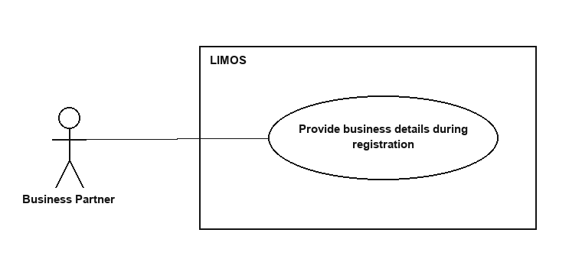
Figure 21.1 — Provide business details during registration

BCE Diagram
<<boundary>>  PartnerRegisterPage | <<control>>  AuthController | <<entity>>  UserRepository
 | Future<void> register({..., businessName, businessType, businessDescription, businessAddress, businessContact}) | Future<void> createUserAndProfile({...})

Sequence Diagram
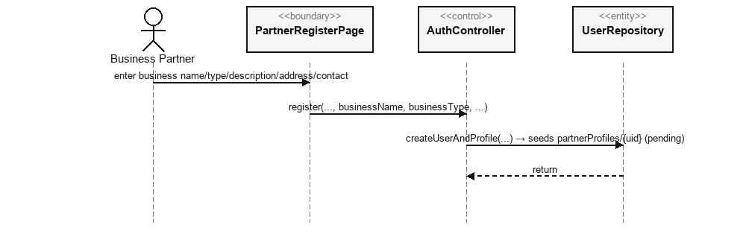
Figure 21.2 — Provide business details during registration

User Stories 22 – 32

Story 22: Create/update the business profile
Actor: Business Partner
PartnerProfileRepository.save() is a single upsert used for both the very first save after approval and every later edit — there is no functional difference between “create” and “update” here (see also story 24, which is the same call).

Use Case Description
Use Case ID | #22
Use Case Name | Create/update the business profile
Description | Let an approved business partner maintain the public business profile users see.
Actor | Business Partner
Trigger | Partner edits fields on Partner Edit Profile and selects Save.
Precondition | Partner account is active (approved).
Postconditions | partnerProfiles/{uid} reflects the submitted display name, business type, address, email, telephone and description.
Main Flow | - PartnerEditProfilePage calls PartnerProfileController.save(uid, displayName, businessType, address, email, telephone, description).  - PartnerProfileController calls PartnerProfileRepository.save(...), which writes (upserts) partnerProfiles/{uid}.

Use Case Diagram
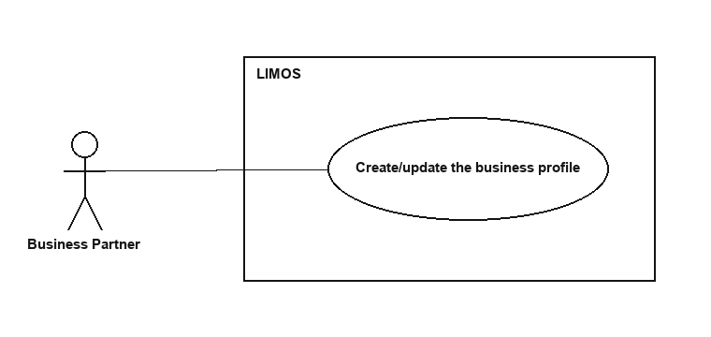
Figure 22.1 — Create/update the business profile

BCE Diagram
<<boundary>>  PartnerEditProfilePage | <<control>>  PartnerProfileController | <<entity>>  PartnerProfileRepository
 | Future<void> save({uid, displayName, businessType, address, email, telephone, description}) | Future<void> save({...})

Sequence Diagram
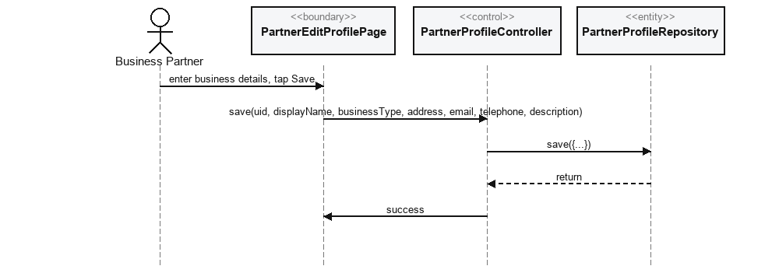
Figure 22.2 — Create/update the business profile

Story 23: View business profile
Actor: Business Partner

Use Case Description
Use Case ID | #23
Use Case Name | View business profile
Description | Let the partner see the business profile information currently shown to users.
Actor | Business Partner
Trigger | Partner opens the Partner Profile screen.
Precondition | Partner account is active.
Postconditions | Current partnerProfiles/{uid} fields are displayed.
Main Flow | - PartnerProfilePage subscribes to PartnerProfileController.watch(uid).  - PartnerProfileController subscribes to PartnerProfileRepository.watch(uid).

Use Case Diagram
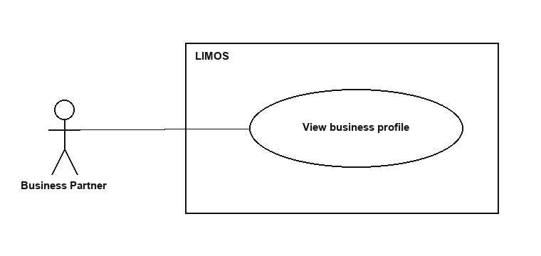
Figure 23.1 — View business profile

BCE Diagram
<<boundary>>  PartnerProfilePage | <<control>>  PartnerProfileController | <<entity>>  PartnerProfileRepository
display(PartnerProfile profile) | Stream<PartnerProfile?> watch(String uid) | Stream<PartnerProfile?> watch(String uid)

Sequence Diagram
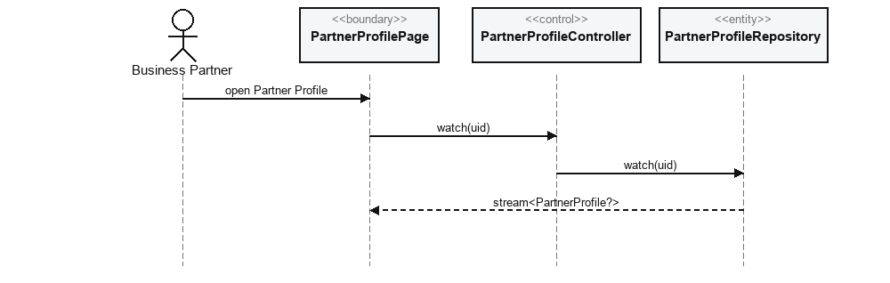
Figure 23.2 — View business profile

Story 24: Update business profile
Actor: Business Partner
Story 22 (“create”) and story 24 (“update”) are the exact same implemented action — PartnerProfileRepository.save() upserts either way.

Use Case Description
Use Case ID | #24
Use Case Name | Update business profile
Description | Let the partner correct/update the business profile so users see accurate information.
Actor | Business Partner
Trigger | Same as story 22.
Precondition | Partner account is active.
Postconditions | partnerProfiles/{uid} is updated.
Main Flow | Identical call to story 22: PartnerEditProfilePage → PartnerProfileController.save(...) → PartnerProfileRepository.save(...).

Use Case Diagram
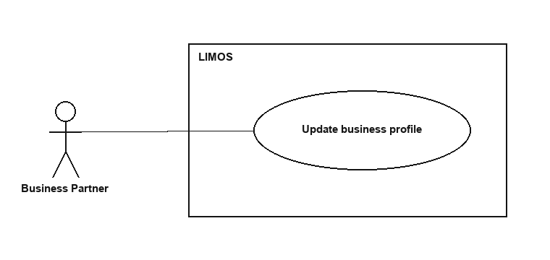
Figure 24.1 — Update business profile

BCE Diagram
<<boundary>>  PartnerEditProfilePage | <<control>>  PartnerProfileController | <<entity>>  PartnerProfileRepository
 | Future<void> save({uid, displayName, businessType, address, email, telephone, description}) | Future<void> save({...})

Sequence Diagram
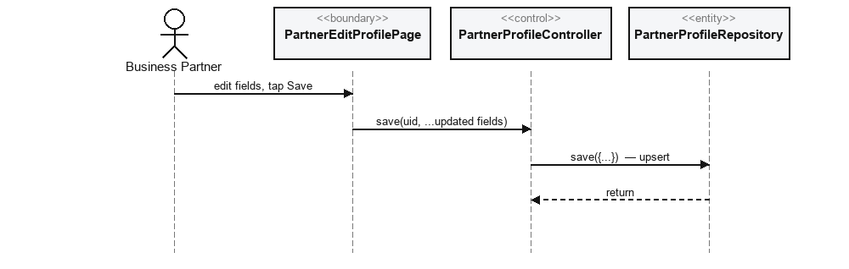
Figure 24.2 — Update business profile

Story 25: Edit published content
Actor: Business Partner

Use Case Description
Use Case ID | #25
Use Case Name | Edit published content
Description | Let the partner correct/update a recipe they have published.
Actor | Business Partner
Trigger | Partner opens one of their recipes on Partner Recipes and selects Edit.
Precondition | - Partner account is active.  - The recipe belongs to this partner.
Postconditions | The partnerRecipes document reflects the edited fields.
Main Flow | - PartnerRecipeFormPage calls PartnerRecipeController.updateRecipe(id, ...changed fields).  - PartnerRecipeController calls PartnerRecipeRepository.updateRecipe(...).

Use Case Diagram
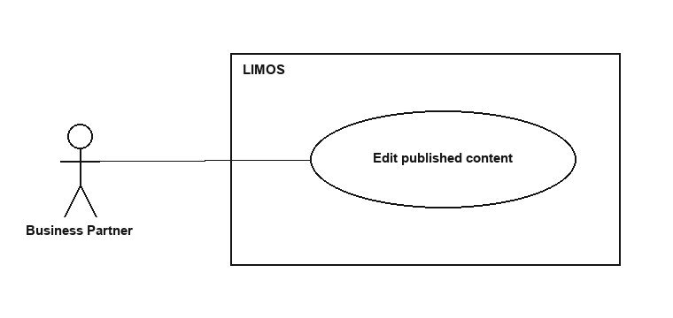
Figure 25.1 — Edit published content

BCE Diagram
<<boundary>>  PartnerRecipeFormPage | <<control>>  PartnerRecipeController | <<entity>>  PartnerRecipeRepository
 | Future<void> updateRecipe({id, name, mealCategory, calories, ingredientsText, preparationStepsText, dietTypes, allergens}) | Future<void> updateRecipe({...})

Sequence Diagram
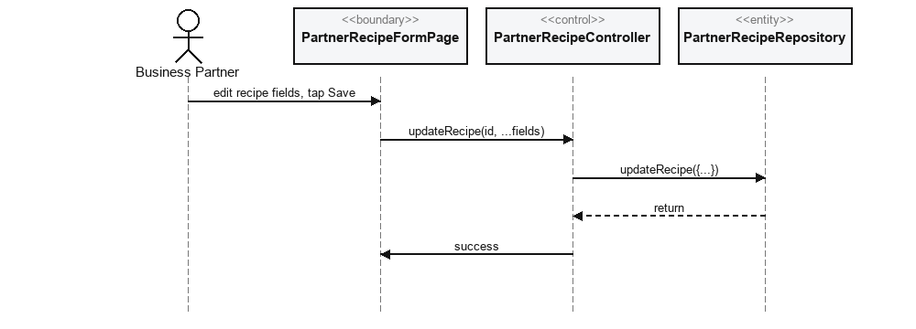
Figure 25.2 — Edit published content

Story 26: Delete published content
Actor: Business Partner

Use Case Description
Use Case ID | #26
Use Case Name | Delete published content
Description | Let the partner permanently remove a recipe they have published.
Actor | Business Partner
Trigger | Partner selects Delete on one of their recipes.
Precondition | - Partner account is active.  - The recipe belongs to this partner.
Postconditions | The partnerRecipes document no longer exists.
Main Flow | - PartnerRecipesPage calls PartnerRecipeController.deleteRecipe(id).  - PartnerRecipeController calls PartnerRecipeRepository.deleteRecipe(id).

Use Case Diagram
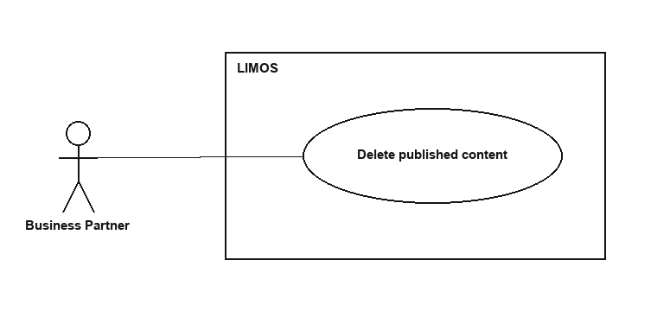
Figure 26.1 — Delete published content

BCE Diagram
<<boundary>>  PartnerRecipesPage | <<control>>  PartnerRecipeController | <<entity>>  PartnerRecipeRepository
 | Future<void> deleteRecipe(String id) | Future<void> deleteRecipe(String id)

Sequence Diagram
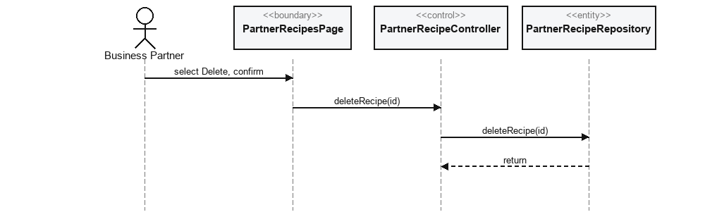
Figure 26.2 — Delete published content

Story 27: View engagement statistics for published content
Actor: Business Partner
views/saves/likes are simple counters incremented client-side by registerView()/toggleSave()/toggleLike() whenever a user interacts with a recipe — there is no separate server-side analytics aggregation pipeline behind this screen.

Use Case Description
Use Case ID | #27
Use Case Name | View engagement statistics for published content
Description | Let the partner see how users engage with their published recipes.
Actor | Business Partner
Trigger | Partner opens the Analytics screen.
Precondition | Partner account is active.
Postconditions | Views/saves/likes per recipe are displayed.
Main Flow | - PartnerAnalyticsPage subscribes to PartnerRecipeController.watchMyRecipes(partnerId).  - The page reads each recipe's views, saves and likes fields and sorts/displays them.

Use Case Diagram
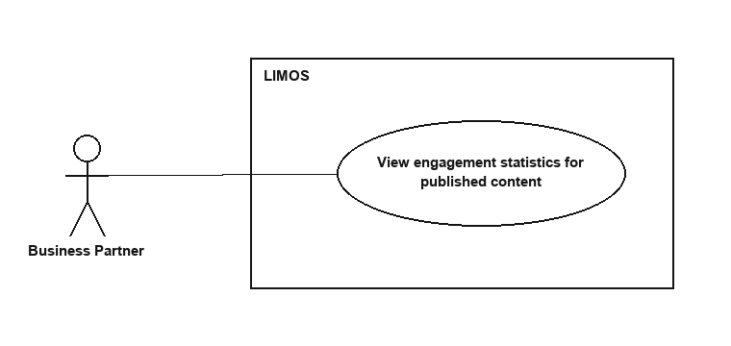
Figure 27.1 — View engagement statistics for published content

BCE Diagram
<<boundary>>  PartnerAnalyticsPage | <<control>>  PartnerRecipeController | <<entity>>  PartnerRecipeRepository
displayStats(List<PartnerRecipe> recipes) | Stream<List<PartnerRecipe>> watchMyRecipes(String partnerId) | Stream<List<PartnerRecipe>> watchMyRecipes(String partnerId)

Sequence Diagram
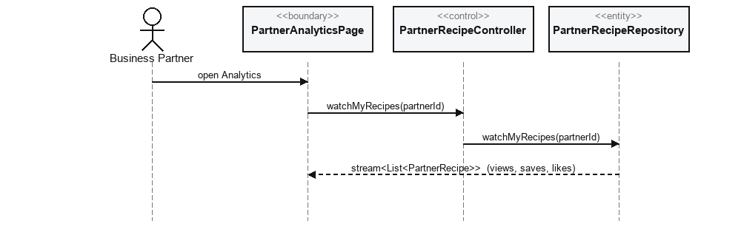
Figure 27.2 — View engagement statistics for published content

Story 28: Log out securely
Actor: Business Partner

Use Case Description
Use Case ID | #28
Use Case Name | Log out securely
Description | Let the partner end their session.
Actor | Business Partner
Trigger | Partner selects Log Out.
Precondition | Partner is signed in.
Postconditions | The Firebase Auth session is cleared.
Main Flow | Same call as story 18: AuthController.signOut() → AuthService.signOut().

Use Case Diagram
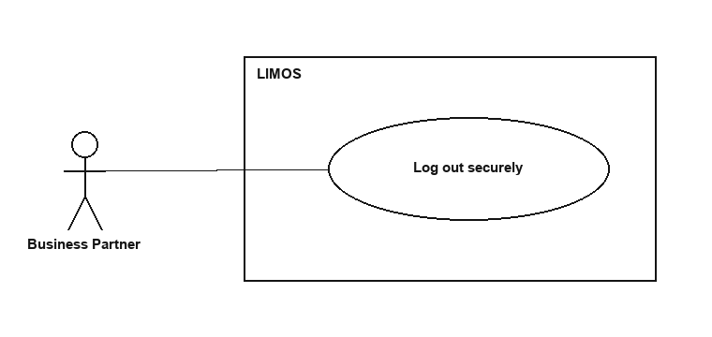
Figure 28.1 — Log out securely

BCE Diagram
<<boundary>>  PartnerProfilePage | <<control>>  AuthController | <<entity>>  AuthService
 | Future<void> signOut() | Future<void> signOut()

Sequence Diagram
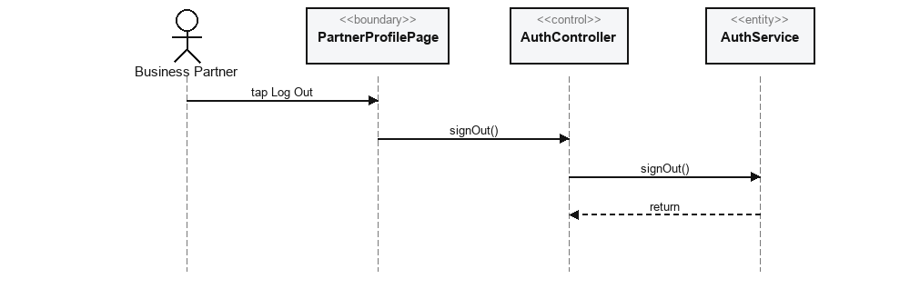
Figure 28.2 — Log out securely

Story 29: Log in securely
Actor: Business Partner

Use Case Description
Use Case ID | #29
Use Case Name | Log in securely
Description | Let a registered business partner sign in to access partner services.
Actor | Business Partner
Trigger | Partner enters credentials on Login (partner role selected).
Precondition | Partner has a registered account.
Postconditions | Partner is signed in and routed to /partner if approved, or /account-pending if not yet approved.
Main Flow | - LoginPage calls AuthController.signIn(email, password, fallbackRole: business_partner).  - As in story 11's route guard, the redirect callback additionally calls PartnerProfileController.fetchOnce(uid) to check partnerProfiles.status before allowing /partner.

Alternative Flow — partnerProfiles.status == 'active'
- allowed into /partner
Alternative Flow — partnerProfiles.status != 'active'
- redirected to /account-pending

Use Case Diagram
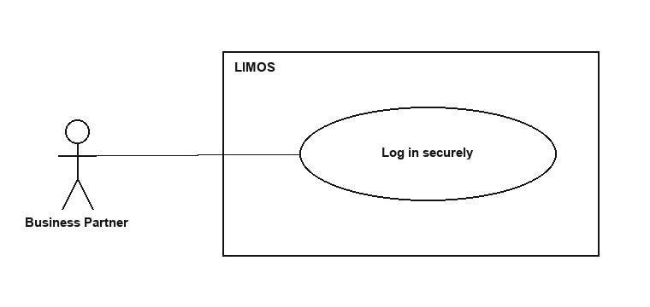
Figure 29.1 — Log in securely

BCE Diagram
<<boundary>>  LoginPage | <<control>>  AuthController | <<control>>  PartnerProfileController | <<entity>>  AuthService
 | Future<UserRole> signIn({email, password, fallbackRole}) | Future<PartnerProfile?> fetchOnce(String uid) | Future<UserCredential> signIn({email, password})

Sequence Diagram
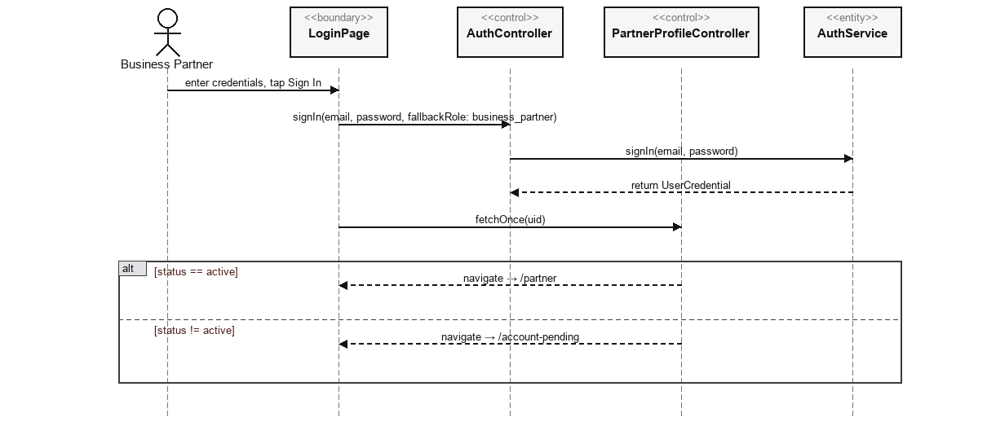
Figure 29.2 — Log in securely

Story 30: Register an administrator account
Actor: Administrator
NOT IMPLEMENTED — Not implemented as an in-app use case. firestore.rules explicitly blocks role: 'admin' from ever being set through the app's own sign-up flow. The only supported way to create an admin account is running create_admin.js (a Node script using the Firebase Admin SDK) out-of-band — there is no RegisterPage path, boundary, controller or entity call for this inside the Flutter app.

Use Case Diagram
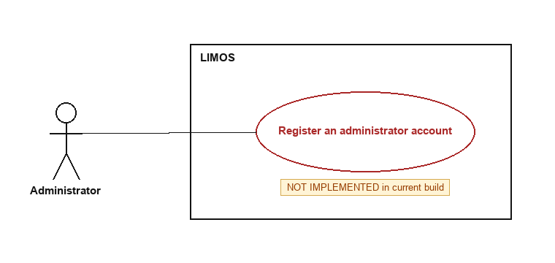
Figure 30.1 — Register an administrator account (not implemented)

What exists instead
<<boundary>>  create_admin.js (Node script, run by a developer) | <<entity>>  Firebase Admin SDK
node create_admin.js <email> <password> ["Full Name"] | auth.createUser({email,password})
 | firestore users/{uid}.set({role:'admin'})

Story 31: Log in securely
Actor: Administrator

Use Case Description
Use Case ID | #31
Use Case Name | Log in securely
Description | Let an administrator sign in to access administrative functions.
Actor | Administrator
Trigger | Admin enters credentials on Login.
Precondition | An admin account already exists (provisioned via create_admin.js).
Postconditions | Admin is signed in and routed to the Admin dashboard.
Main Flow | - Same call as story 19/29: AuthController.signIn(email, password, fallbackRole: user).  - UserRepository.fetchUser(uid) returns role: 'admin'; AuthController.destinationFor(admin) routes to /admin.

Use Case Diagram
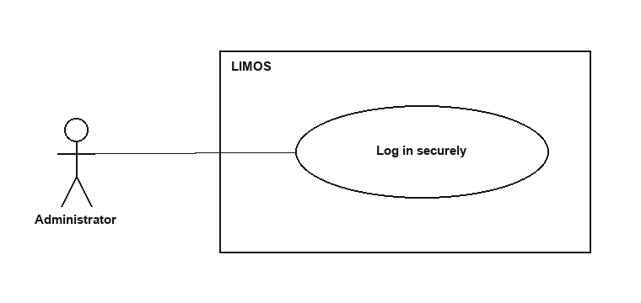
Figure 31.1 — Log in securely

BCE Diagram
<<boundary>>  LoginPage | <<control>>  AuthController | <<entity>>  AuthService | <<entity>>  UserRepository
 | Future<UserRole> signIn({email, password, fallbackRole}) | Future<UserCredential> signIn({email, password}) | Future<AppUser?> fetchUser(String uid)
 | String destinationFor(UserRole role)

Sequence Diagram
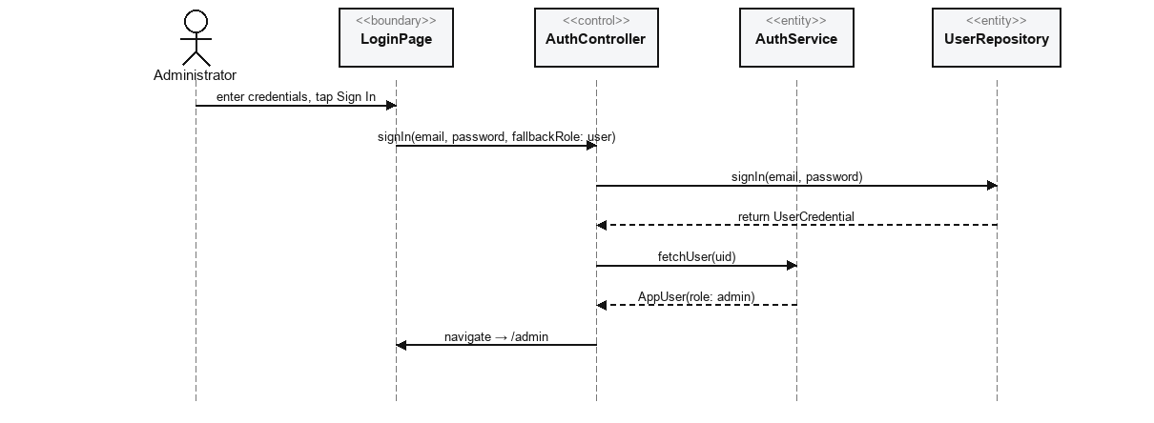
Figure 31.2 — Log in securely

Story 32: View user accounts
Actor: Administrator

Use Case Description
Use Case ID | #32
Use Case Name | View user accounts
Description | Let the admin retrieve and review stored regular-user account information.
Actor | Administrator
Trigger | Admin opens Review User Accounts.
Precondition | Admin is signed in.
Postconditions | A live list of role:'user' accounts is displayed.
Main Flow | - ReviewUserAccountsPage subscribes to AdminController.watchAccountsByRole(UserRole.user).  - AdminController subscribes to AdminRepository.watchAccountsByRole(role).

Use Case Diagram
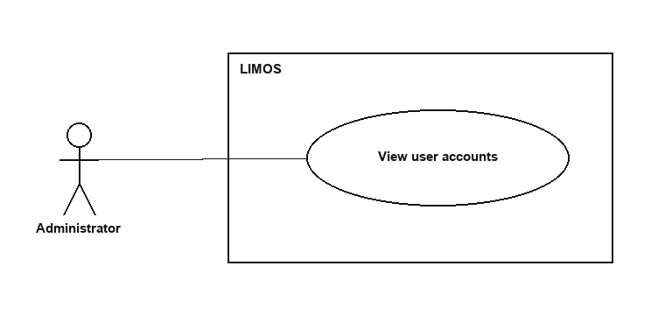
Figure 32.1 — View user accounts

BCE Diagram
<<boundary>>  ReviewUserAccountsPage | <<control>>  AdminController | <<entity>>  AdminRepository
display(List<AppUser> accounts) | Stream<List<AppUser>> watchAccountsByRole(UserRole role) | Stream<List<AppUser>> watchAccountsByRole(UserRole role)

Sequence Diagram
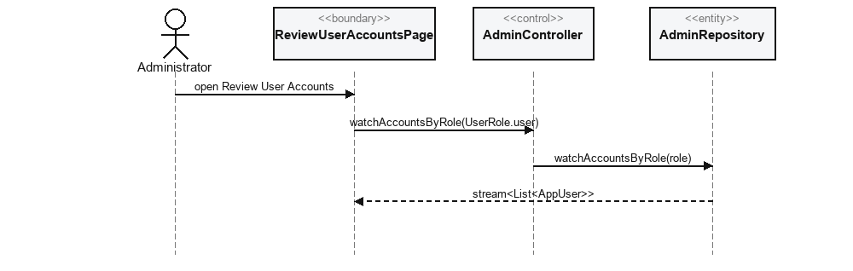
Figure 32.2 — View user accounts

User Stories 33 – 42

Story 33: Update user accounts (suspend/reactivate)
Actor: Administrator
The only “update” an admin can actually perform on a user account is flipping active/suspended — AdminController exposes no general field-edit method, so there is no form for changing a user's other account details.

Use Case Description
Use Case ID | #33
Use Case Name | Update user accounts (suspend/reactivate)
Description | Let the admin correct a user account's status when needed.
Actor | Administrator
Trigger | Admin taps Suspend/Unsuspend on a user row.
Precondition | - Admin is signed in.  - Admin is viewing Review User Accounts.
Postconditions | users/{uid}.status is 'suspended' or 'active' as chosen.
Main Flow | - ReviewUserAccountsPage calls AdminController.setStatus(uid, 'suspended' | 'active').  - AdminController calls AdminRepository.setStatus(uid, status), which updates users/{uid}.status.

Use Case Diagram
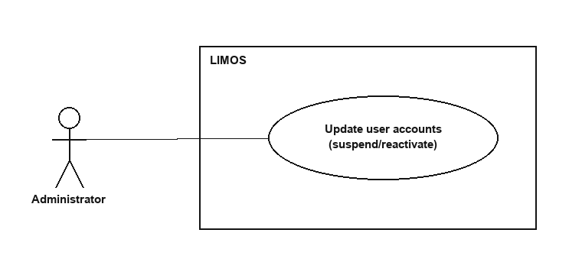
Figure 33.1 — Update user accounts (suspend/reactivate)

BCE Diagram
<<boundary>>  ReviewUserAccountsPage | <<control>>  AdminController | <<entity>>  AdminRepository
 | Future<void> setStatus(String uid, String status) | Future<void> setStatus(String uid, String status)

Sequence Diagram
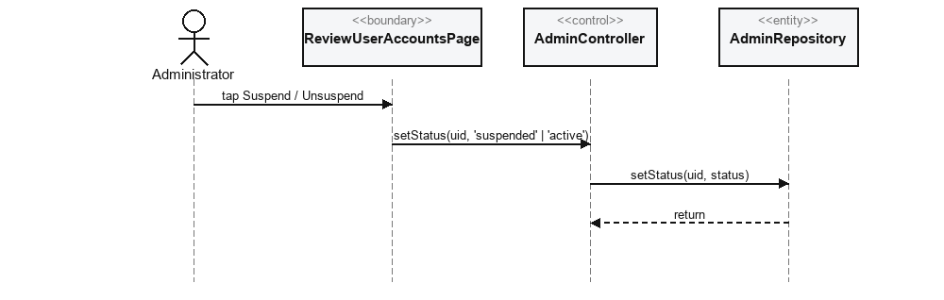
Figure 33.2 — Update user accounts (suspend/reactivate)

Story 34: Delete user accounts
Actor: Administrator
NOT IMPLEMENTED — Not implemented. AdminController/AdminRepository expose only watchAccounts, watchAccountsByRole and setStatus — no delete method. Per firestore.rules and the TDM's security-rules summary, account deletion is deliberately self-service only (AccountDeletionService, story-equivalent to the user's own “delete my account” flow): an admin can suspend a user, but cannot delete another user's Firestore documents or Firebase Auth identity.

Use Case Diagram
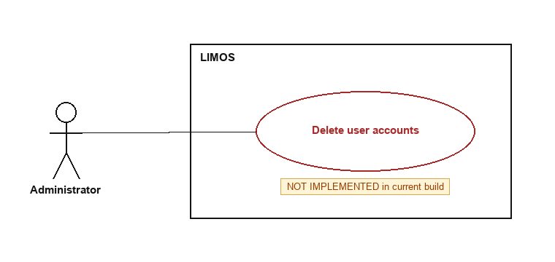
Figure 34.1 — Delete user accounts (not implemented)

What exists instead
<<boundary>>  ReviewUserAccountsPage | <<control>>  AdminController
(no delete action available) | setStatus(uid, status) only — no delete method

Story 35: View business partner registration requests
Actor: Administrator

Use Case Description
Use Case ID | #35
Use Case Name | View business partner registration requests
Description | Let the admin see pending business partner applications to assess.
Actor | Administrator
Trigger | Admin opens Partner Requests.
Precondition | Admin is signed in.
Postconditions | All partnerProfiles with status 'pending' are displayed.
Main Flow | - PartnerRequestsPage subscribes to PartnerProfileController.watchPending().  - PartnerProfileController subscribes to PartnerProfileRepository.watchPending().

Use Case Diagram
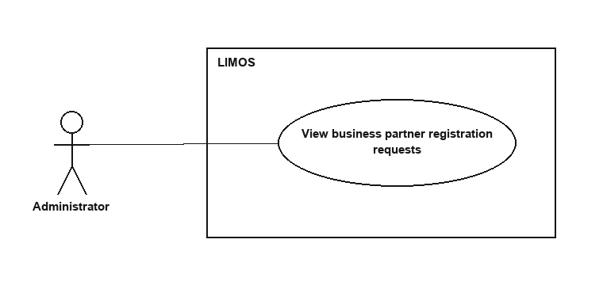
Figure 35.1 — View business partner registration requests

BCE Diagram
<<boundary>>  PartnerRequestsPage | <<control>>  PartnerProfileController | <<entity>>  PartnerProfileRepository
display(List<PartnerProfile> pending) | Stream<List<PartnerProfile>> watchPending() | Stream<List<PartnerProfile>> watchPending()

Sequence Diagram
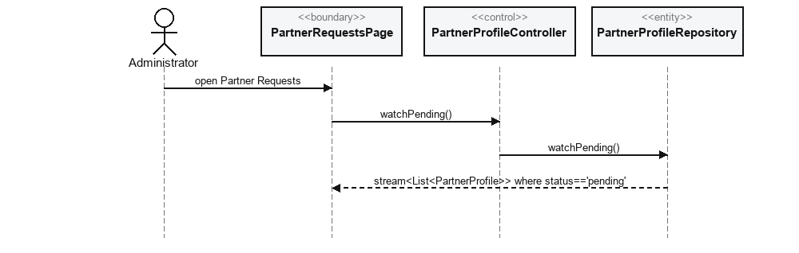
Figure 35.2 — View business partner registration requests

Story 36: Approve business partner registration requests
Actor: Administrator

Use Case Description
Use Case ID | #36
Use Case Name | Approve business partner registration requests
Description | Let the admin approve a pending partner application, granting access.
Actor | Administrator
Trigger | Admin taps Accept on a pending request.
Precondition | - Admin is viewing Partner Requests.  - The request's status is 'pending'.
Postconditions | - partnerProfiles/{uid}.status == 'active'.  - The partner's own router guard now allows /partner.
Main Flow | - PartnerRequestsPage calls PartnerProfileController.setStatus(uid, 'active').  - PartnerProfileController calls PartnerProfileRepository.setStatus(uid, 'active').

Use Case Diagram
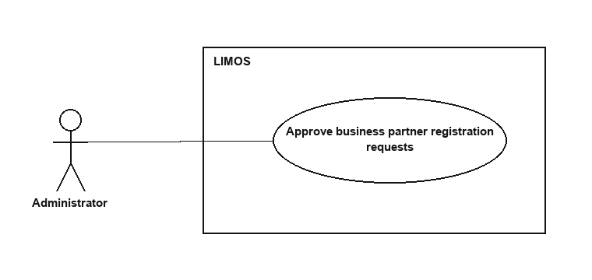
Figure 36.1 — Approve business partner registration requests

BCE Diagram
<<boundary>>  PartnerRequestsPage | <<control>>  PartnerProfileController | <<entity>>  PartnerProfileRepository
 | Future<void> setStatus(String uid, String status) | Future<void> setStatus(String uid, String status)

Sequence Diagram
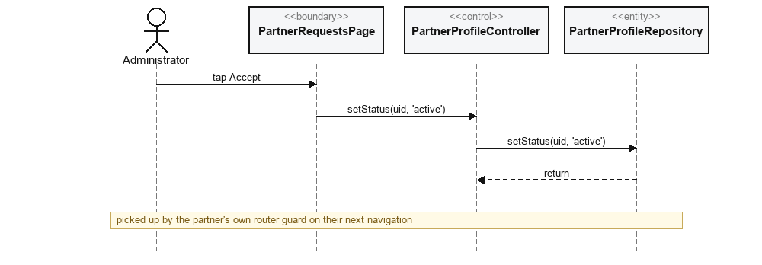
Figure 36.2 — Approve business partner registration requests

Story 37: Reject business partner registration requests
Actor: Administrator

Use Case Description
Use Case ID | #37
Use Case Name | Reject business partner registration requests
Description | Let the admin reject a pending partner application.
Actor | Administrator
Trigger | Admin taps Reject on a pending request.
Precondition | - Admin is viewing Partner Requests.  - The request's status is 'pending'.
Postconditions | partnerProfiles/{uid}.status == 'rejected'.
Main Flow | - PartnerRequestsPage calls PartnerProfileController.setStatus(uid, 'rejected').  - PartnerProfileController calls PartnerProfileRepository.setStatus(uid, 'rejected').

Use Case Diagram
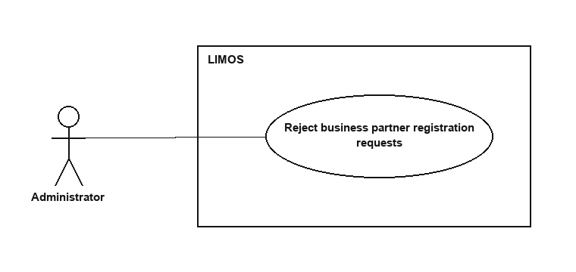
Figure 37.1 — Reject business partner registration requests

BCE Diagram
<<boundary>>  PartnerRequestsPage | <<control>>  PartnerProfileController | <<entity>>  PartnerProfileRepository
 | Future<void> setStatus(String uid, String status) | Future<void> setStatus(String uid, String status)

Sequence Diagram
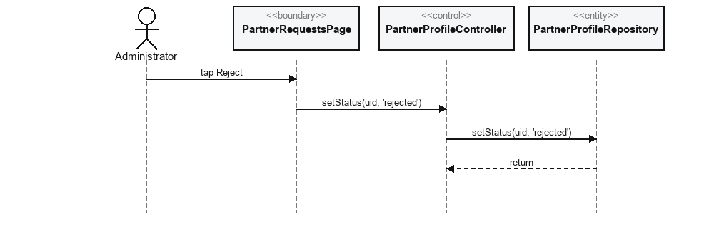
Figure 37.2 — Reject business partner registration requests

Story 38: View business partner accounts
Actor: Administrator

Use Case Description
Use Case ID | #38
Use Case Name | View business partner accounts
Description | Let the admin review approved partner accounts' information and status.
Actor | Administrator
Trigger | Admin opens Review Partner Accounts.
Precondition | Admin is signed in.
Postconditions | A live list of role:'business_partner' accounts is displayed.
Main Flow | - ReviewPartnerAccountsPage subscribes to AdminController.watchAccountsByRole(UserRole.partner).  - AdminController subscribes to AdminRepository.watchAccountsByRole(role).

Use Case Diagram
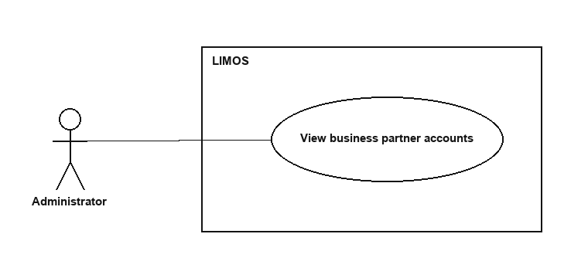
Figure 38.1 — View business partner accounts

BCE Diagram
<<boundary>>  ReviewPartnerAccountsPage | <<control>>  AdminController | <<entity>>  AdminRepository
display(List<AppUser> accounts) | Stream<List<AppUser>> watchAccountsByRole(UserRole role) | Stream<List<AppUser>> watchAccountsByRole(UserRole role)

Sequence Diagram
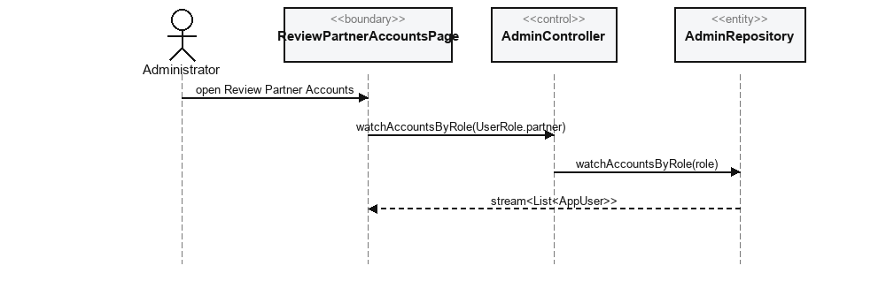
Figure 38.2 — View business partner accounts

Story 39: Update business partner accounts
Actor: Administrator
Stories 39 (“update”) and 40 (“suspend/deactivate”) describe the exact same implemented action — there is only one status-toggle call, not two distinct behaviours.

Use Case Description
Use Case ID | #39
Use Case Name | Update business partner accounts
Description | Let the admin keep partner account details/verification status accurate.
Actor | Administrator
Trigger | Admin taps Suspend/Unsuspend on a partner row.
Precondition | Admin is viewing Review Partner Accounts.
Postconditions | users/{uid}.status is 'suspended' or 'active' as chosen.
Main Flow | Identical call to story 33/40: ReviewPartnerAccountsPage → AdminController.setStatus(uid, status) → AdminRepository.setStatus(...).

Use Case Diagram
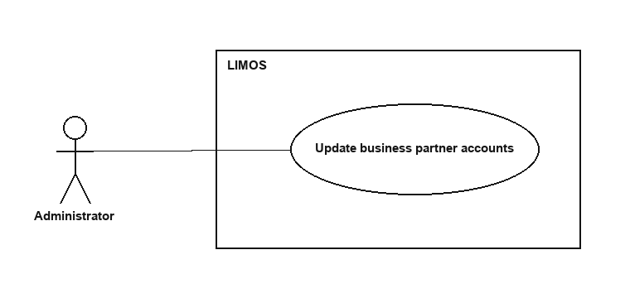
Figure 39.1 — Update business partner accounts

BCE Diagram
<<boundary>>  ReviewPartnerAccountsPage | <<control>>  AdminController | <<entity>>  AdminRepository
 | Future<void> setStatus(String uid, String status) | Future<void> setStatus(String uid, String status)

Sequence Diagram
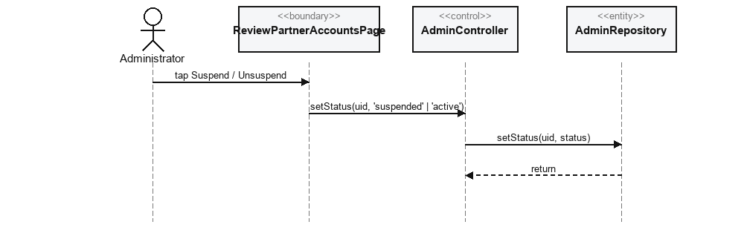
Figure 39.2 — Update business partner accounts

Story 40: Suspend or deactivate business partner profiles
Actor: Administrator
See story 39 — this is not a separate implemented behaviour.

Use Case Description
Use Case ID | #40
Use Case Name | Suspend or deactivate business partner profiles
Description | Let the admin stop a partner that breaches policy from continuing to publish content.
Actor | Administrator
Trigger | Same as story 39.
Precondition | Admin is viewing Review Partner Accounts.
Postconditions | users/{uid}.status == 'suspended'; the partner's router guard blocks /partner on their next navigation.
Main Flow | Same call as story 39: AdminController.setStatus(uid, 'suspended').

Use Case Diagram
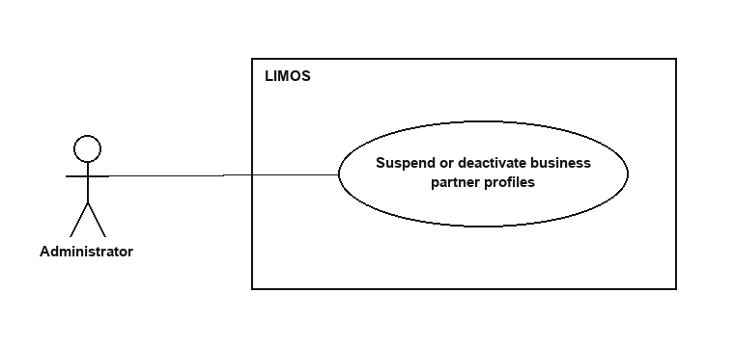
Figure 40.1 — Suspend or deactivate business partner profiles

BCE Diagram
<<boundary>>  ReviewPartnerAccountsPage | <<control>>  AdminController | <<entity>>  AdminRepository
 | Future<void> setStatus(String uid, String status) | Future<void> setStatus(String uid, String status)

Sequence Diagram
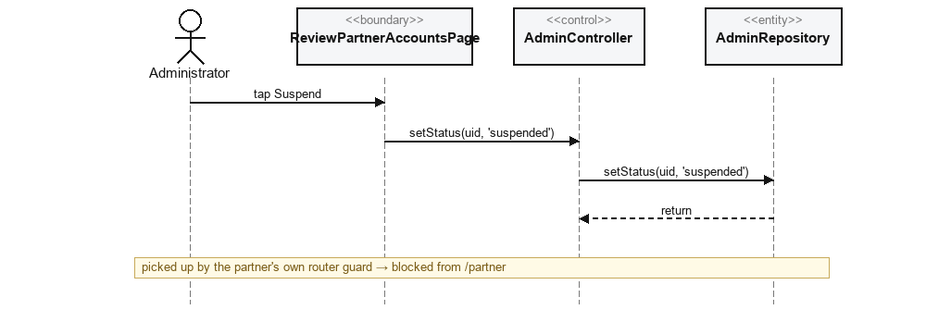
Figure 40.2 — Suspend or deactivate business partner profiles

Story 41: Delete business partner accounts
Actor: Administrator
NOT IMPLEMENTED — Not implemented, for the same reason as story 34: no delete method exists on AdminController/AdminRepository or PartnerProfileController/PartnerProfileRepository. Admins can suspend or reject a partner, but only the partner themself can permanently delete their own account (AccountDeletionService also cleans up partnerRecipes keyed by partnerId).

Use Case Diagram
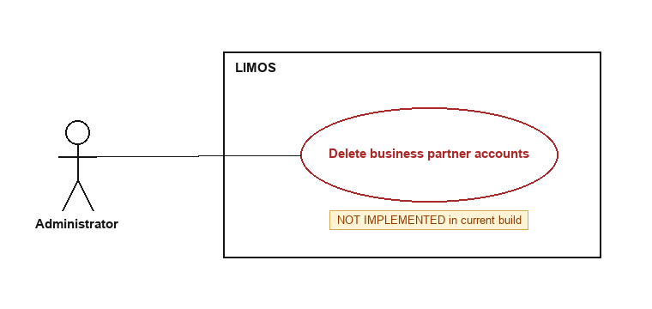
Figure 41.1 — Delete business partner accounts (not implemented)

What exists instead
<<boundary>>  ReviewPartnerAccountsPage | <<control>>  AdminController
(no delete action available) | setStatus(uid, status) only — no delete method

Story 42: Log out securely
Actor: Administrator

Use Case Description
Use Case ID | #42
Use Case Name | Log out securely
Description | Let the admin end their session.
Actor | Administrator
Trigger | Admin selects Log Out.
Precondition | Admin is signed in.
Postconditions | The Firebase Auth session is cleared.
Main Flow | Same call as story 18/28: AuthController.signOut() → AuthService.signOut().

Use Case Diagram
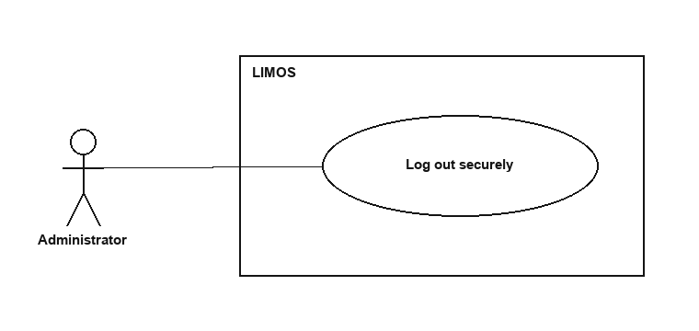
Figure 42.1 — Log out securely

BCE Diagram
<<boundary>>  AdminPage | <<control>>  AuthController | <<entity>>  AuthService
 | Future<void> signOut() | Future<void> signOut()

Sequence Diagram
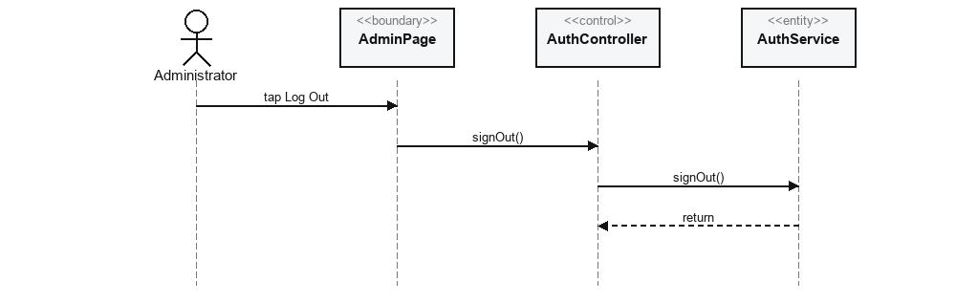
Figure 42.2 — Log out securely

