| **Supplementary Table 1. One-way ANOVA for Plant Biomass** | | | | |
| --- | --- | --- | --- | --- |
| *Conditioning phase - Insect Herbivory* | | | | |
| . | Sum Sq | Df | F value | Pr(>F) |
| Plant pathway induced | 1,318,991.72 | 2.00 | 15.28 | 0.00 |
| Residuals | 1,424,150.17 | 33.00 |  |  |
| *Note.* Signif. codes: 0 ‘***’ 0.001 ‘**’ 0.01 ‘*’ 0.05 ‘.’ 0.1 ‘ ’ 1 | | | | |

| **Supplementary Table 2. Post-hoc for Plant Biomass** | | | | | |
| --- | --- | --- | --- | --- | --- |
| *Conditioning phase - Insect Herbivory* | | | | | |
| contrast | estimate | *SE* | *df* | *t* | *p* |
| Control - JA | 452.50 | 84.81 | 33 | 5.34 | < .001*** |
| Control - SA | 332.58 | 84.81 | 33 | 3.92 | .001** |
| JA - SA | -119.92 | 84.81 | 33 | -1.41 | .345 |
| *Note.* Post-hoc: Tukey | | | | | |

| **Supplementary Table 3. One-way ANOVA for Plant Biomass** | | | | |
| --- | --- | --- | --- | --- |
| *Conditioning phase - Simulated Herbivory* | | | | |
| . | Sum Sq | Df | F value | Pr(>F) |
| Plant pathway induced | 1,192,310.39 | 2.00 | 15.70 | 0.00 |
| Residuals | 1,253,040.50 | 33.00 |  |  |
| *Note.* Signif. codes: 0 ‘***’ 0.001 ‘**’ 0.01 ‘*’ 0.05 ‘.’ 0.1 ‘ ’ 1 | | | | |

| **Supplementary Table 4. Post-hoc for Plant Biomass** | | | | | |
| --- | --- | --- | --- | --- | --- |
| *Conditioning phase - Simulated Herbivory* | | | | | |
| contrast | estimate | *SE* | *df* | *t* | *p* |
| Control - JA | 401.75 | 79.55 | 33 | 5.05 | < .001*** |
| Control - SA | 33.58 | 79.55 | 33 | 0.42 | .907 |
| JA - SA | -368.17 | 79.55 | 33 | -4.63 | < .001*** |
| *Note.* Post-hoc: Tukey | | | | | |

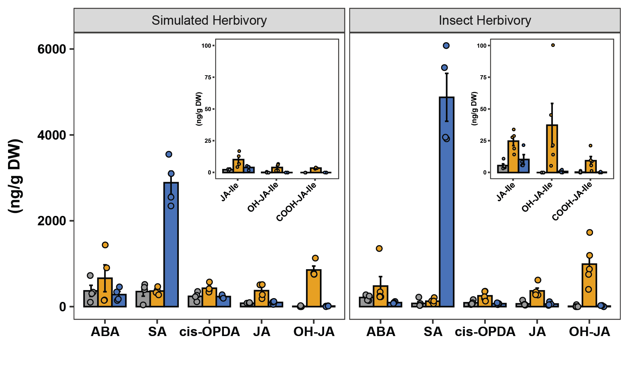

Supplementary Figure 1. Individual levels of phytohormones in both experiments.

| **Supplementary Table 5. PERMANOVA for Plant Phytohormones** | | | | | |
| --- | --- | --- | --- | --- | --- |
| *Conditioning phase* | | | | | |
| . | Df | SumOfSqs | *R*2 | *F* | Pr(>F) |
| Experiment (E) | 1.00 | 19.16 | .10 | 5.74 | 0.01 |
| Plant pathway induced (PPI) | 2.00 | 104.59 | .52 | 15.66 | 0.00 |
| E*PPI | 2.00 | 9.47 | .05 | 1.42 | 0.21 |
| Residual | 20.00 | 66.78 | .33 |  |  |
| Total | 25.00 | 200.00 | 1.0 |  |  |
| *Note.* 999 number of permutations | | | | | |

| **Supplementary Table 6. PERMANOVA for Plant Glucosinolates** | | | | | |
| --- | --- | --- | --- | --- | --- |
| *Conditioning phase* | | | | | |
| . | Df | SumOfSqs | *R*2 | *F* | Pr(>F) |
| Experiment (E) | 1.00 | 12.04 | .07 | 2.93 | 0.03 |
| Plant pathway induced (PPI) | 2.00 | 62.11 | .35 | 7.57 | 0.00 |
| E*PPI | 2.00 | 18.77 | .11 | 2.29 | 0.04 |
| Residual | 20.00 | 82.09 | .47 |  |  |
| Total | 25.00 | 175.00 | 1.0 |  |  |
| *Note.* 999 number of permutations | | | | | |

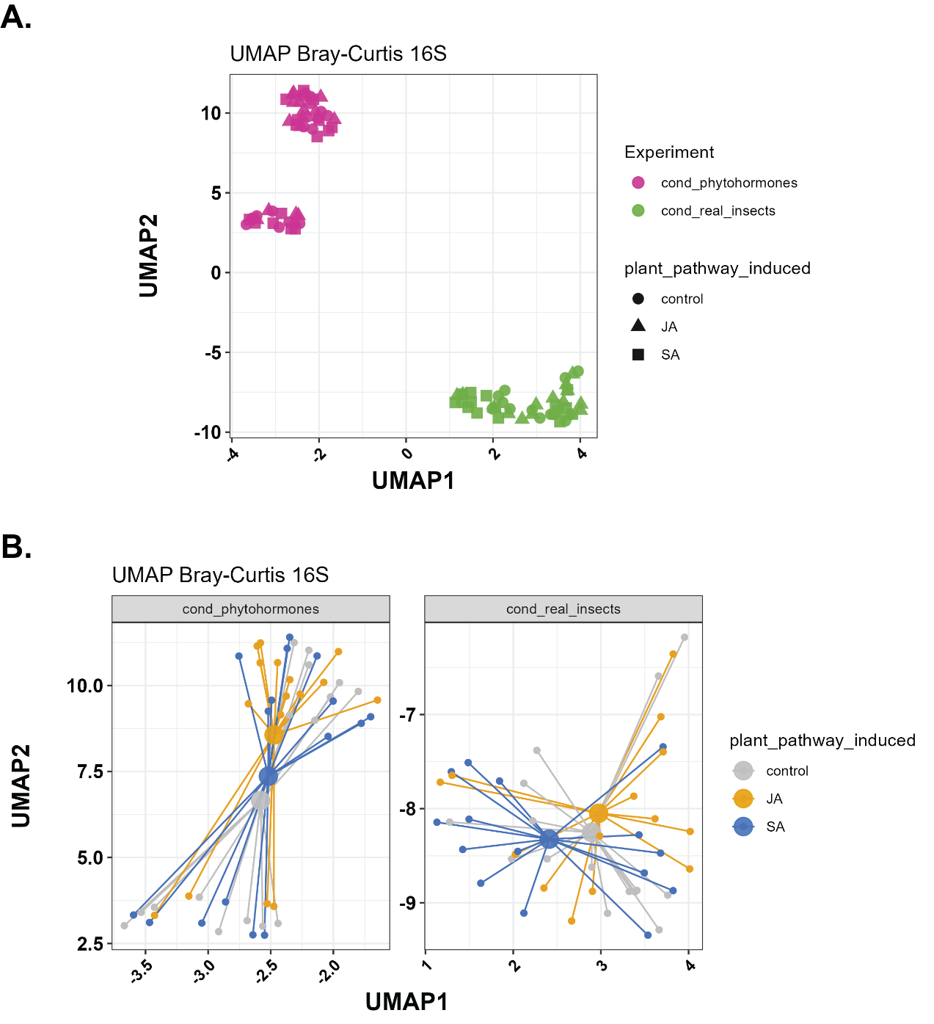

Supplementary Figure 3. UMAP for beta diversity of 16S communities with both experiments (A) and separated by experiment and stress induction (B).

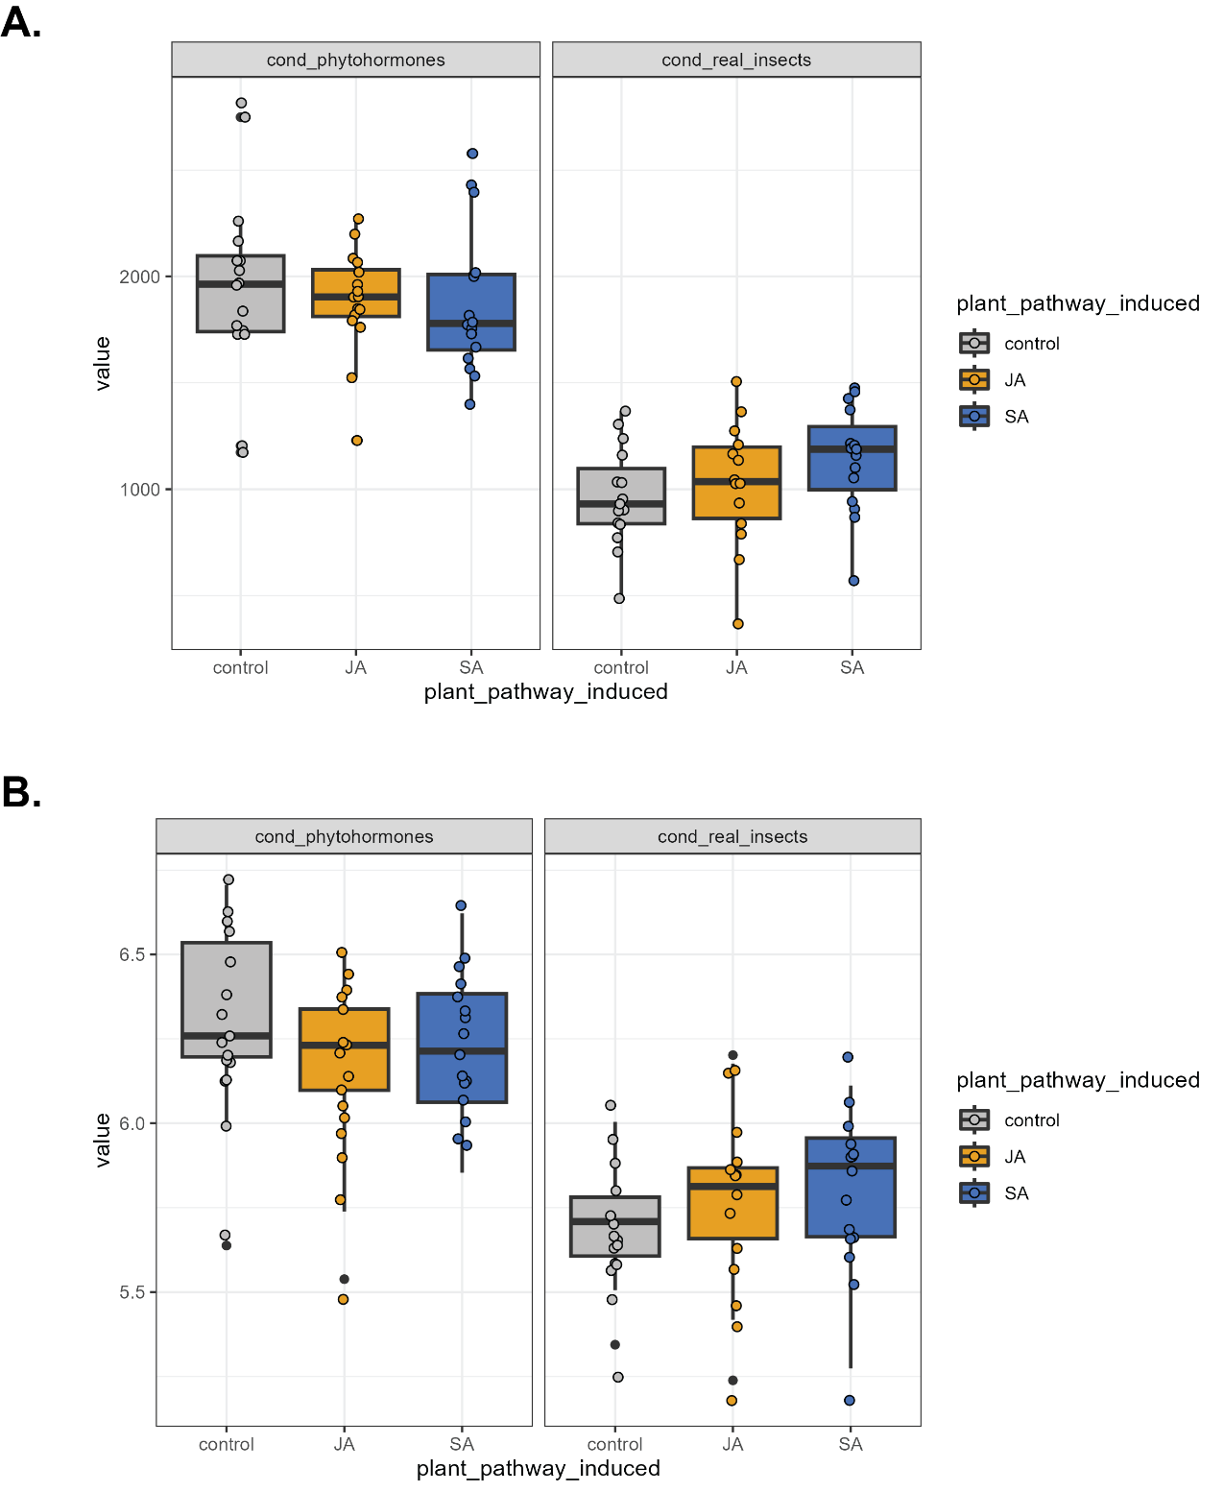

Supplementary Figure 4. Observed (up) and Shannon (down) alpha diversity.

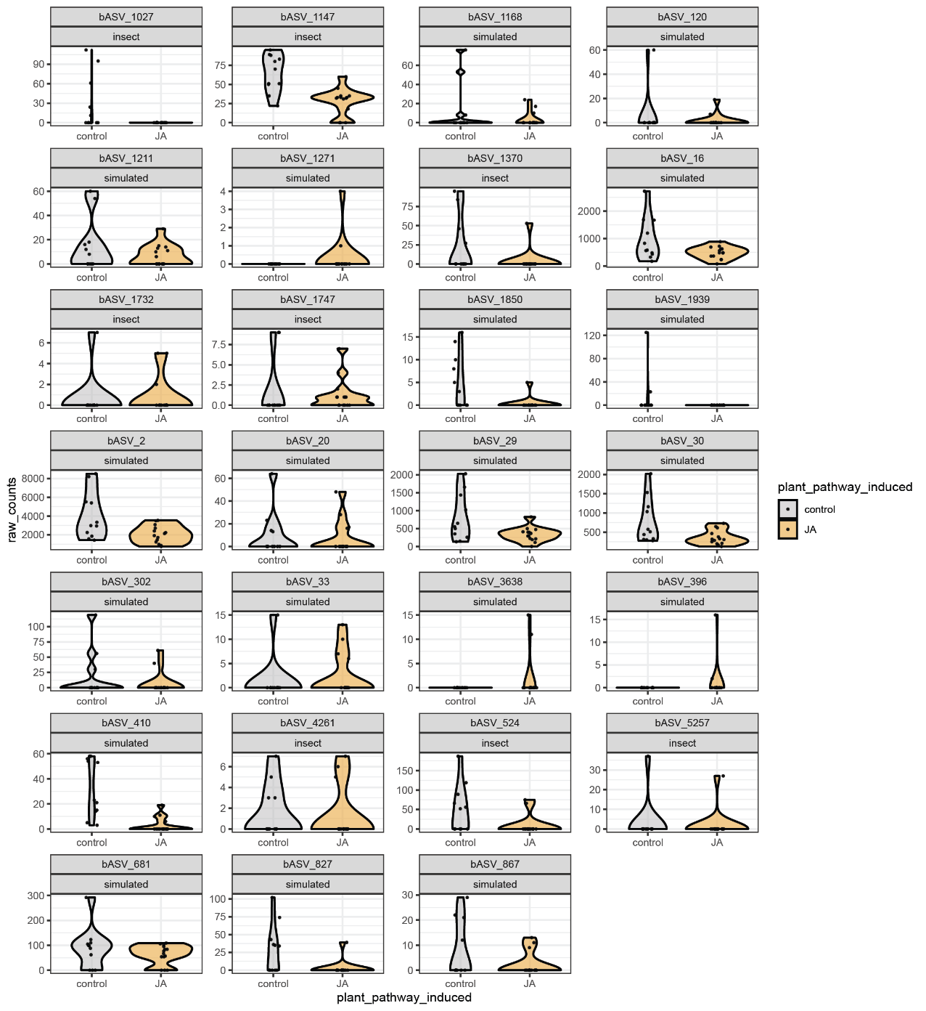

Supplementary Figure 5. Individual raw counts of differentially abundant ASVs between JA-induced plants and Controls in both experiments.

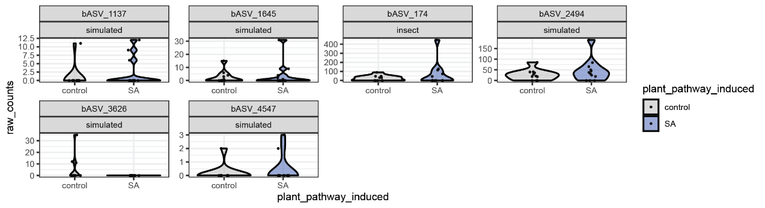

Supplementary Figure 6. Individual raw counts of differentially abundant ASVs between SA-induced plants and Controls in both experiments.

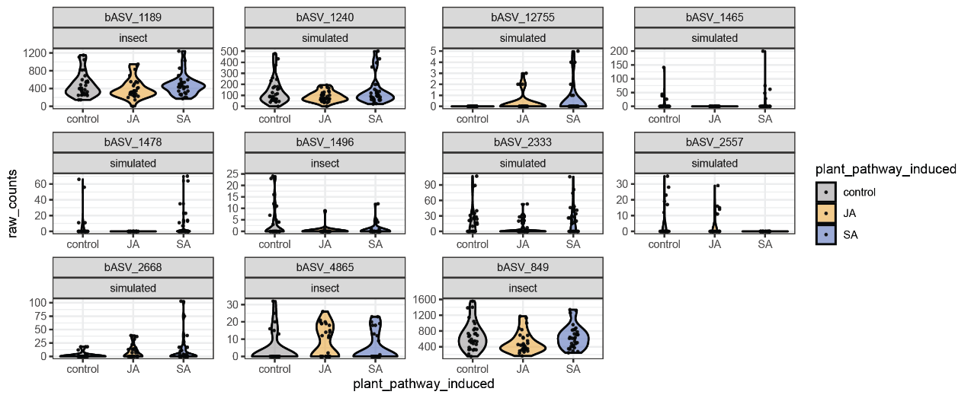

Supplementary Figure 7. Individual raw counts of differentially abundant ASVs between both JA- and SA-induced plants with Controls in both experiments.

| **Supplementary Table 7.** *Generalized Linear Model for Caterpillar Weight* | | | |
| --- | --- | --- | --- |
| . | Chisq | Df | Pr(>Chisq) |
| Soil inocula (S) | 0.49 | 2.00 | 0.78 |
| Experiment (E) | 186.61 | 1.00 | 0.00 |
| S*E | 0.64 | 2.00 | 0.73 |
| *Note.* Gamma distribution | | | |

| **Supplementary Table 8.** *Generalized Linear Model for Aphid number Full 2 time points* | | | |
| --- | --- | --- | --- |
| . | LR Chisq | Df | Pr(>Chisq) |
| Soil inocula (S) | 5.09 | 2.00 | 0.08 |
| Time point (T) | 226.55 | 1.00 | 0.00 |
| Experiment (E) | 6.06 | 1.00 | 0.01 |
| S*T | 2.96 | 2.00 | 0.23 |
| S*E | 0.02 | 2.00 | 0.99 |
| T*E | 1.56 | 1.00 | 0.21 |
| S*T*E | 0.01 | 2.00 | 0.99 |
| *Note.* Gamma distribution | | | |

| **Supplementary Table 9.** *Linear Model for plant biomass in Feedback phase* | | | | |
| --- | --- | --- | --- | --- |
| . | Sum Sq | Df | F value | Pr(>F) |
| Soil inocula (S) | 93,013.15 | 2.00 | 0.67 | 0.51 |
| Herbivory (H) | 674,009.19 | 2.00 | 4.87 | 0.01 |
| Experiment (E) | 357,324.86 | 1.00 | 5.17 | 0.02 |
| S*E | 564,465.39 | 4.00 | 2.04 | 0.09 |
| S*E | 17,319.80 | 2.00 | 0.13 | 0.88 |
| H*E | 296,914.36 | 2.00 | 2.15 | 0.12 |
| S*H*E | 219,850.61 | 4.00 | 0.80 | 0.53 |
| Residuals | 10,715,051.37 | 155.00 |  |  |
| *Note.* shoot_biomass_mg ~ soil_inocula*herbivory*Experiment | | | | |

| **Supplementary Table 10***. Post-hoc of Plant Biomass in Feedback phase Herbivory* | | | | | |
| --- | --- | --- | --- | --- | --- |
| contrast | estimate | *SE* | *df* | *t* | *p* |
| uninfested - Mamestra | 158.87 | 49.77 | 155 | 3.19 | .005** |
| uninfested - Myzus | 97.79 | 48.72 | 155 | 2.01 | .114 |
| Mamestra - Myzus | -61.08 | 49.07 | 155 | -1.24 | .429 |
| *Note.* Post-hoc: Tukey | | | | | |

| **Supplementary Table 11***.* **PERMANOVA for Plant Phytohormones** | | | | | |
| --- | --- | --- | --- | --- | --- |
| *Feedback phase* | | | | | |
| DistanceMatrix~soil_inocula*herbivory*Experiment | | | | | |
| . | Df | SumOfSqs | *R*2 | *F* | Pr(>F) |
| Soil inocula (S) | 2.00 | 20.11 | .01 | 2.26 | 0.04 |
| Herbivory (H) | 2.00 | 414.18 | .30 | 46.46 | 0.00 |
| Experiment (E) | 1.00 | 74.75 | .05 | 16.77 | 0.00 |
| S*H | 4.00 | 27.09 | .02 | 1.52 | 0.10 |
| S*E | 2.00 | 43.21 | .03 | 4.85 | 0.00 |
| H*E | 2.00 | 66.36 | .05 | 7.44 | 0.00 |
| S*H*E | 4.00 | 32.30 | .02 | 1.81 | 0.04 |
| Residual | 153.00 | 682.00 | .50 |  |  |
| Total | 170.00 | 1,360.00 | 1.0 |  |  |
| *Note.* 999 number of permutations | | | | | |

| **Supplementary Table 12***.* **PERMANOVA for Glucosinolates** | | | | | |
| --- | --- | --- | --- | --- | --- |
| *Feedback phase* | | | | | |
| DistanceMatrix~soil_inocula*herbivory*Experiment | | | | | |
| . | Df | SumOfSqs | *R*2 | *F* | Pr(>F) |
| Soil inocula (S) | 2.00 | 21.29 | .03 | 2.80 | 0.02 |
| Herbivory (H) | 2.00 | 241.10 | .34 | 31.68 | 0.00 |
| Experiment (E) | 1.00 | 62.22 | .09 | 16.35 | 0.00 |
| S*H | 4.00 | 14.05 | .02 | 0.92 | 0.50 |
| S*E | 2.00 | 42.61 | .06 | 5.60 | 0.00 |
| H*E | 2.00 | 38.80 | .05 | 5.10 | 0.00 |
| S*H*E | 4.00 | 17.96 | .03 | 1.18 | 0.28 |
| Residual | 72.00 | 273.96 | .38 |  |  |
| Total | 89.00 | 712.00 | 1.0 |  |  |
| *Note.* 999 number of permutations | | | | | |