Multimedia University of Kenya
Data Structures and Algorithms — Task One
Design of an Automated Parking System

1. Introduction
The client requires an automated parking system for Kenya that: displays available slots to drivers before entry, records vehicles on arrival, calculates the total time spent and fee owed on exit, and opens the barrier once payment is confirmed. Analysing these terms of reference yields six core modules, described below with their algorithms, supporting data structures, and a dynamic relational database.

2. Proposed Modules
Module | Responsibility
Slot Display | Shows real-time available/occupied slots before entry
Vehicle Entry/Registration | Captures vehicle details and timestamp on arrival, assigns a slot
Billing/Fee Calculation | Computes duration and amount owed on exit
Payment | Processes payment and confirms it
Barrier Control | Opens/closes the gate based on payment confirmation
Database/Records | Persists all transactions for reporting and audit

3. Algorithms per Module

3.1 Slot Display Module
LOOP continuously:
total_slots = SIZE(slot_array)
occupied = COUNT(slot_array where status = OCCUPIED)
available = total_slots - occupied
DISPLAY available, occupied on screen
IF available == 0: DISPLAY "FULL"

3.2 Vehicle Entry / Registration Module
ON vehicle_detected AT entry sensor:
IF available_slots == 0:
DENY entry, DISPLAY "Lot Full"
ELSE:
plate = CAPTURE(camera/sensor)
slot = FIND_FIRST(slot_array where status = FREE)
MARK slot as OCCUPIED
ticket = CREATE(plate, slot_id, entry_time = NOW())
STORE ticket in HashMap<ticket_id, ticket>
PRINT/ISSUE ticket to driver
OPEN entry barrier

3.3 Billing / Fee Calculation Module
ON exit_request(ticket_id):
ticket = HashMap.get(ticket_id)
exit_time = NOW()
duration = exit_time - ticket.entry_time
hours = CEIL(duration in minutes / 60) // round up part-hours
amount = hours * rate_per_hour
RETURN amount

3.4 Payment Module
ON payment_attempt(ticket_id, amount_paid):
IF amount_paid >= amount_due:
ticket.status = PAID
RECORD transaction in database
RETURN success
ELSE:
RETURN "insufficient payment"

3.5 Barrier Control Module
ON payment_success(ticket_id):
OPEN exit_barrier
WAIT until vehicle passes (sensor)
CLOSE barrier
slot = ticket.slot_id
MARK slot as FREE
UPDATE slot_array

4. Data Structures and Justification
Structure | Used for | Why
Array (fixed-size) | Parking slots (slot_array) | Fast O(1) index access for the display module; slot count is fixed physically
Hash Map / Dictionary | Active tickets (ticket_id → ticket record) | O(1) average lookup on exit — instant retrieval by ticket ID
Queue | Entry line when lot is full, or barrier processing order | FIFO order matches real-world vehicle arrival order
Stack (optional) | Undo/last-entry logging for attendant override | LIFO useful for reversing the most recent action
Linked List / Dynamic Array | Transaction history log | Grows dynamically as records accumulate; no fixed size needed
Min-Heap / Priority Queue (optional) | Assigning nearest/best available slot | Efficiently retrieves the best free slot instead of a linear scan
The core trade-off: arrays give O(1) access for the fixed slot grid used by the display module, while hash maps give O(1) average lookup for tickets — which matters because billing depends on fast entry-time retrieval at exit.

5. Dynamic Database Design
The schema below is normalised to 3NF. Tickets and Payments grow indefinitely as a transactional (OLTP) log, while Slots and Rates remain relatively static reference data — making this a dynamic database that scales with usage.

5.1 Entities
- Vehicles: vehicle_id (PK), plate_number, vehicle_type
- Slots: slot_id (PK), slot_number, status (FREE/OCCUPIED), zone
- Tickets: ticket_id (PK), vehicle_id (FK), slot_id (FK), entry_time, exit_time, amount_due, status
- Payments: payment_id (PK), ticket_id (FK), amount_paid, payment_method, timestamp
- Rates: rate_id (PK), vehicle_type, rate_per_hour, effective_date

5.2 Relationships
- One vehicle can have many tickets over time (1:M)
- One slot can have many tickets over time (1:M)
- One ticket has exactly one payment (1:1)
- Rates apply to vehicles by vehicle_type (reference relationship)

5.3 Entity-Relationship Diagram
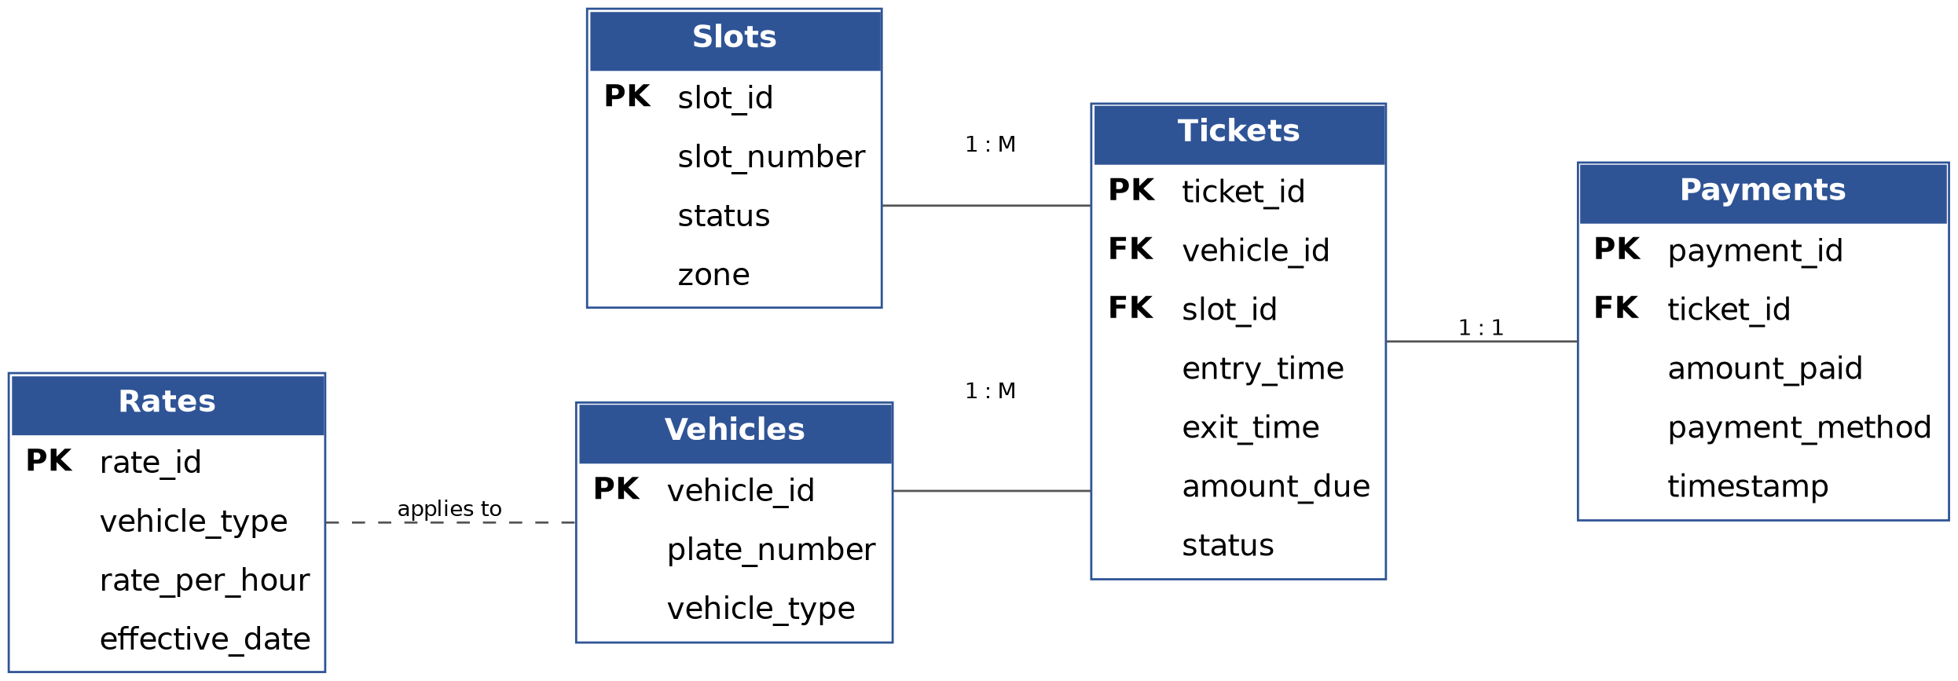

6. Conclusion
Together, the six modules and the supporting hash-map/array/queue combination give the client a responsive front-of-house display, O(1) entry and exit processing, and an auditable, dynamically growing transaction record — meeting every requirement in the terms of reference.

