AGH   
UNIVERSITY OF SCIENCE AND TECHNOLOGY CRACOW



Metals Engineering and Industrial Computer Science



**Multiscale Modelling 1st Report:**

Student: **Marcelina Bałamut**

Field of study:  **Informatyka Stosowana**

Id: **286085**

Group: **1**

Repository: **https://github.com/MarcelinaBalamut/MulticaleModeling**

Course: **Multiscale Modeling**

1. **Technologies**

This grain growth application was created using the Java programming language. The Java JavaFx library was used to graphically present grain growth simulations.

* 1. **Java**

Java is high-level programming language , defined as an object-oriented language.  The source code files are compiled into a format called bytecode which is executed by a Java interpreter.

Java is one of the simplest languages, was designed to be easy to use and is easy to write, compile, debug that is why it was chosen as the programming language of this application. One of the most significant advantages is its ability to move easily from one computer system to another, what would be useful is to show progress from class to class. Java is Object-Oriented also, which helped to implement all necessary mechanisms for the project. A very important aspect is also that Java is very well documented and commonly used, which, if necessary, allows you to quickly and easily find a solution to a problem by using documentation or an online forum.

* 1. **JavaFx**

JavaFx was used to graphically present the application. JavaFX is a Java library used to build applications which can be run consistently across multiple platforms and run on various devices such as desktop computers, mobile phones, tvs, tablets. The main advantage is the fact that it is the most developed Java graphic library and it is easy to use and commonly used.

1. **User Interface**

The main application window allows the user to enter all necessary data for the correct simulation of grain growth. Window of application is shown on Pic.1.

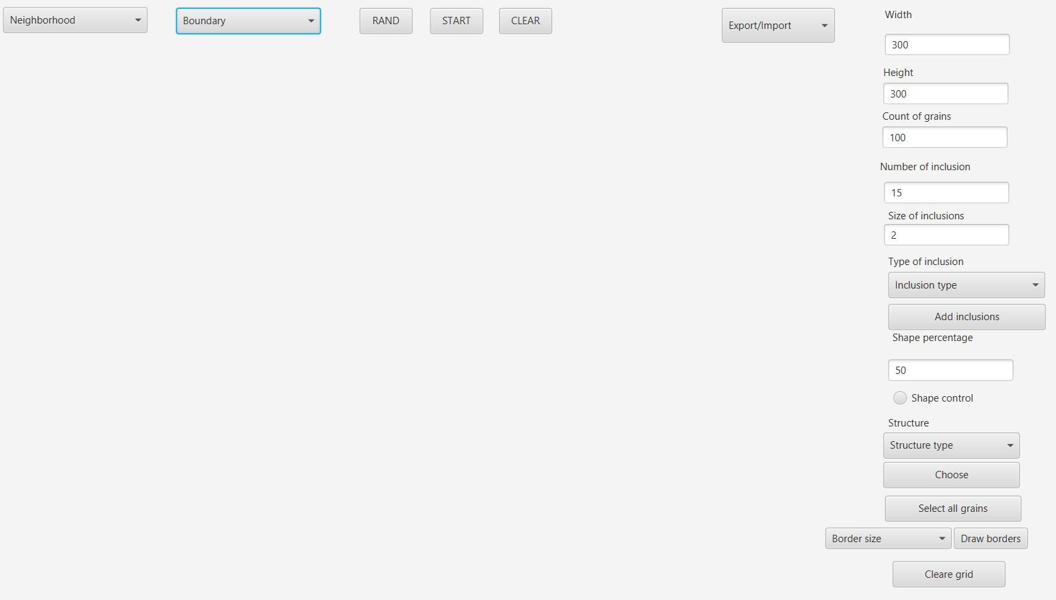

Pic.1 Main application window

1. **Functionalities**
   1. **Simple grain growth**

The first action the user should take is to set the grid size (or leave it at the default minimum size of 300x300). One of the most important things is choosing the number of random grains that will grow, which is set using the "Count of grains" texbox. The default number of grains is 100. Next, choose the type of neighborhood from the expandable combobox. For the first class, the possibility of choosing the type of neighbors was limited to only one option - von Neumann. Then select the type of boundary conditions from the combobox, the conditions are limited to periodic boundary conditions. This step can be skipped.

Next, user have to click on Rand button that place the grains on the randomly selected positions and then click on Start button to start simulation of simple grain growth. User can also repeat randomly selected grains and simulation by clicking on Clear button and then again Rand and Start button. The result of the random is shown on Pic.2 and simulation is shown on Pic.3.

 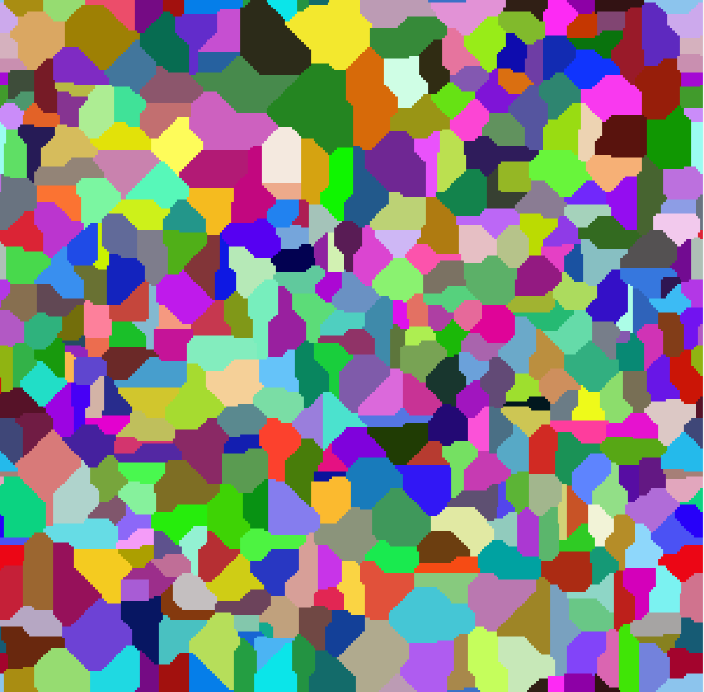

Pic.2 Selected grains. Pic.3 Microstructure for simple grain growth.

* 1. **Import and export**

This application enables the import and export of microstructure, which can be realized in two ways - as a test file and bitmap. When the microstructure is already generated, the user can choose using the combobox in which format he wants to save it and selects a specific file. Then user can also, import microstructure by selecting format and file where microstructure is saved. Window where user can import or export microstructure is shown on Pic.4.

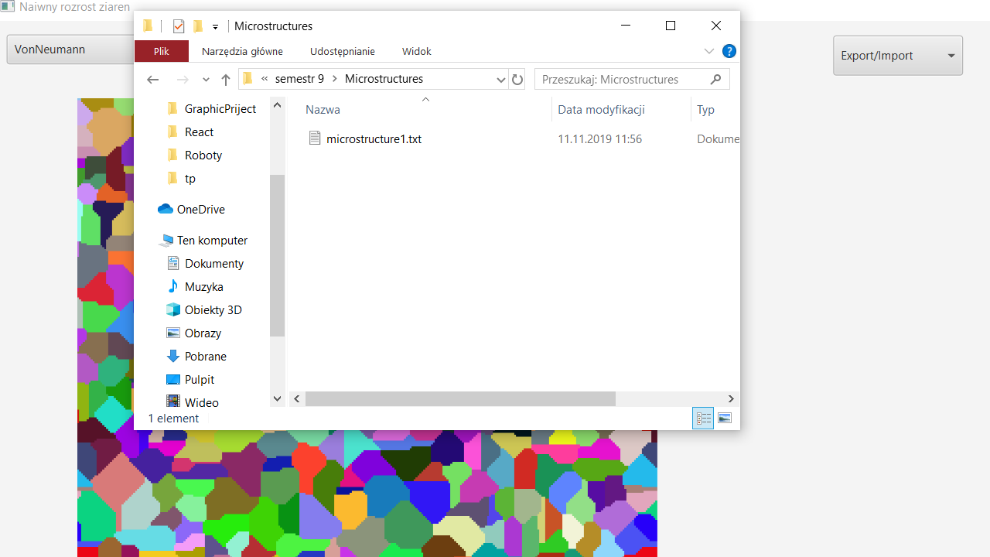

Pic.4 Window to import/export microstructure.

* 1. **Inclusions**

Another feature is the ability to add inclusions. It is possible to add inclusions to an already generated microstructure or before growth simulation. The first option adds inclusions at the grain boundary, while the second option adds inclusions randomly. The user only needs to enter the number of inclusions into the available textbox and select the type of inclusion - circle or square. It is also possible to choose the size of the inclusion by entering it in the next textbox. Circle and Square inclusions added before simulation are presented on Pic.5 and inclusions added after simulation are shown on Pic.6.

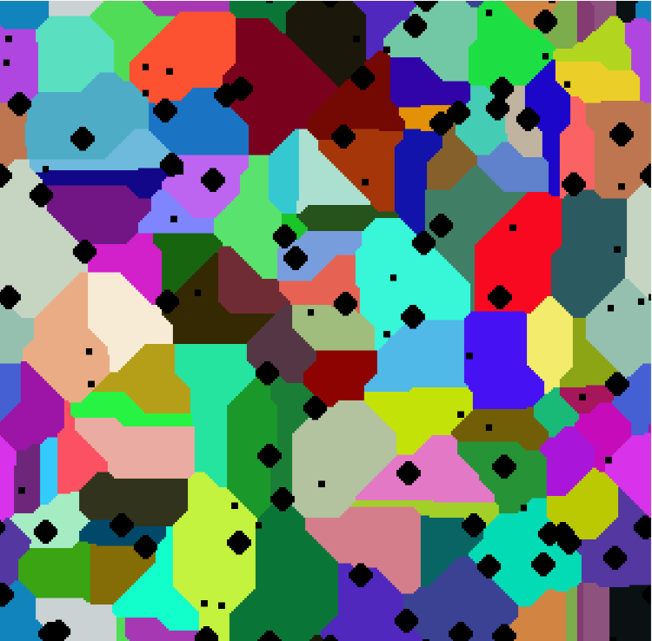 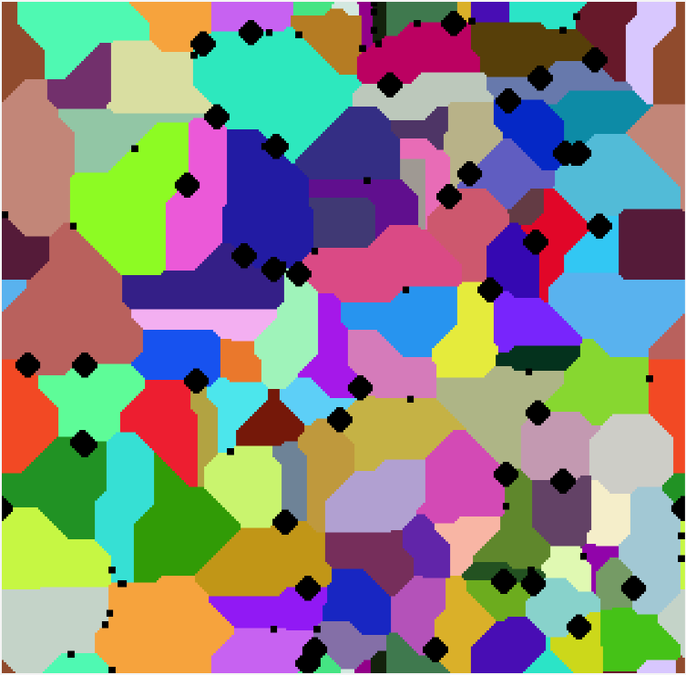

Pic.5 Inclusion before simulation . Pic.6 Inclusion after simulation.

* 1. **Control of grain boundary shape**

Another functionality that the application provides is the ability to control the shape of the borders by setting the percentage probability. User can check checkbox which is responsible or enable shape control and then set probability. Additional neighborhood has been added for this functionality - Moore neighborhood. The algorithm is based on four rules. The number of neighbors is checked for each cell, the choice of the state of the cell depends on the type of neighbor: Moore, nearest Moore, further Moore. If cell do not have any neighbors, the percentage probability rule is used. Microstructure with 1% shale control is shown on Pic.7 and Pic.8 present microstructure with 80% shape control.

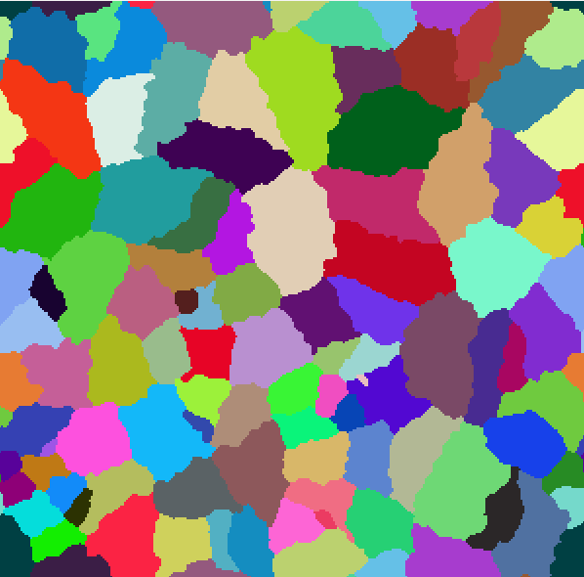 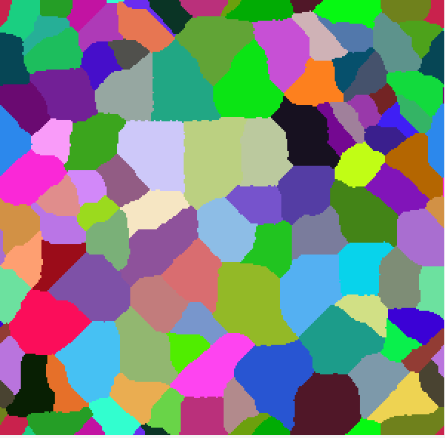

Pic.7 Microstructure for 1% shape control. Pic.8 Microstructure for 80% shape control.

* 1. **Different microstructure type**

When the microstructure is generated, the user can choose the type of structure - dual phase or substructure from combobox. Pic.9 shows microstructure prepared for substructure and Pic.10 shows microstructure prepared for dual-phase. Substructure and dual-phase differ in that when choosing grains for substructure, all grains are different - they have different colors, different ids, while for dual-phase all grains have the same color and the same id. After choosing the type of structure, the user can choose the grain by clicking on it with the mouse or by double click unselect selected grains. Then, if user click on “Choose” button rest of unselected grains are cleared as is show on Pic.11 for substructure and on Pic. 12 for dual-phase. Then, to perform simulations, the user must rand grains.

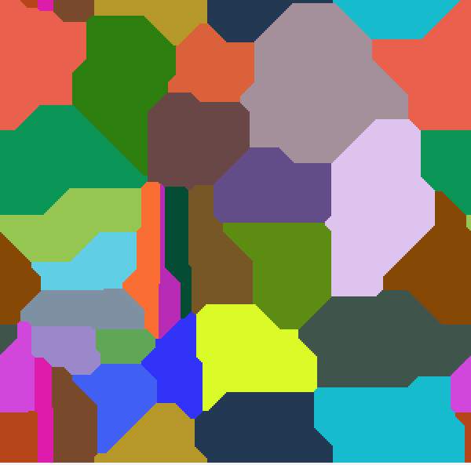 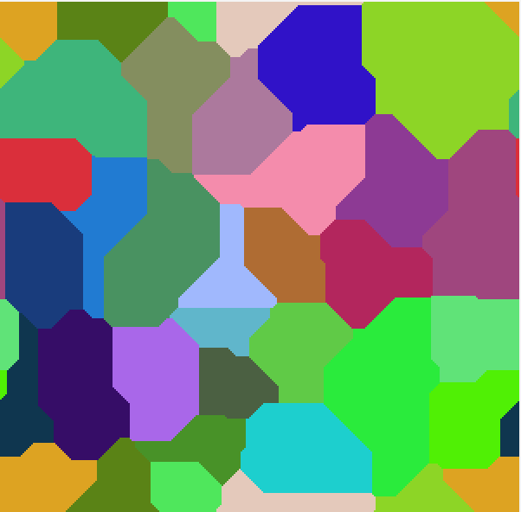

Pic.9 Microstructure prepared for substructure. Pic.10 Microstructure prepared for dual-phase.

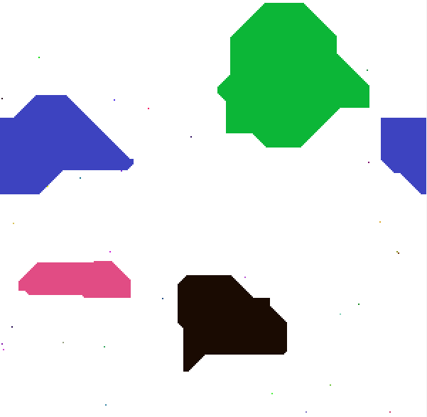 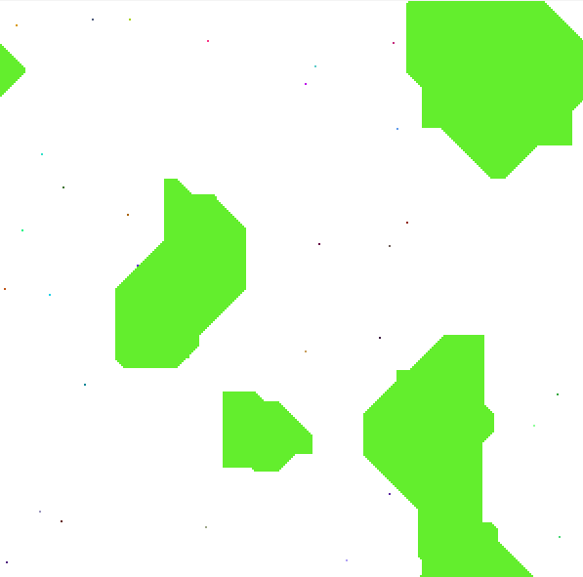

Pic.11 Selected grains for substructure. Pic.12 Selected grains for dual-phese.

Then, after clicking the Start button, the grain growth simulation begins. Microstructure after simulations in presented on Pic.13 for substructure and on Pic.14 for dual-phase.

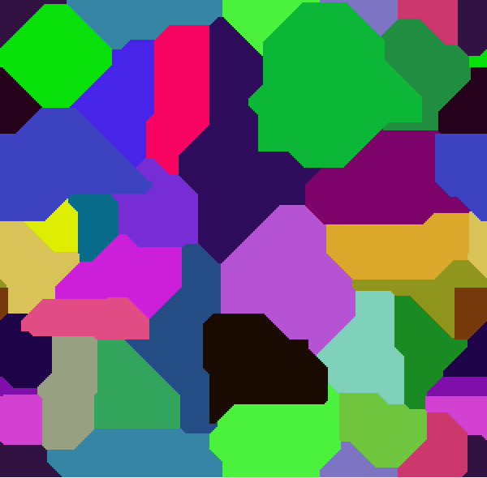 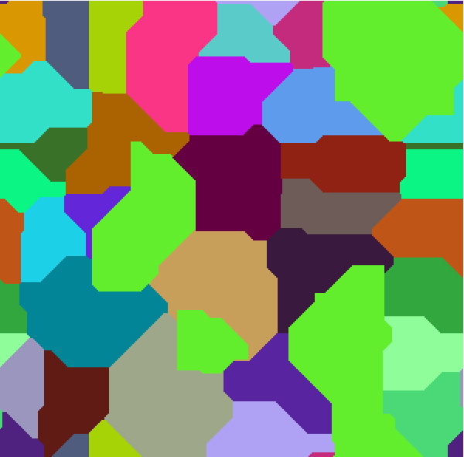

Pic.13 Microstructure for substructure. Pic.14 Microstructure for substructure.

* 1. **Grains boundaries**

Next feature which is provided by application is possibility to draw grain boundaries. After generating the microstructure, the user has the option of choosing the combobox option, which will allow to choose the grains for which the boundaries should be drawn using mouse click. Microstructure with choosen grains is presented on Pic.15. User can also choose the size of the drawn borders from 0 to 4. After selecting the grains and size, press the button Draw Borders, then for the selected grains black borders with the selected size will appear, what is shown on Pic. 16 for few selected grains and on Pic.19 for all grains. User have also possibility to choose all grains as selected by clicking on Select All button what is presented on Pic.18. Next, user can also click on Clear Grid button which cleans the entire grid, leaving only the boundaries of the selected grains, what is shown on Pic. 17 for selected grains, and on Pic.20 for all grains as selected. The application also implements a function that calculates the percentage of selected grain boundaries in relation to the entire grid. Percentage for selected grains is shown on Pic. 21, and on Pic.22 presenting percentage for all selected grains.

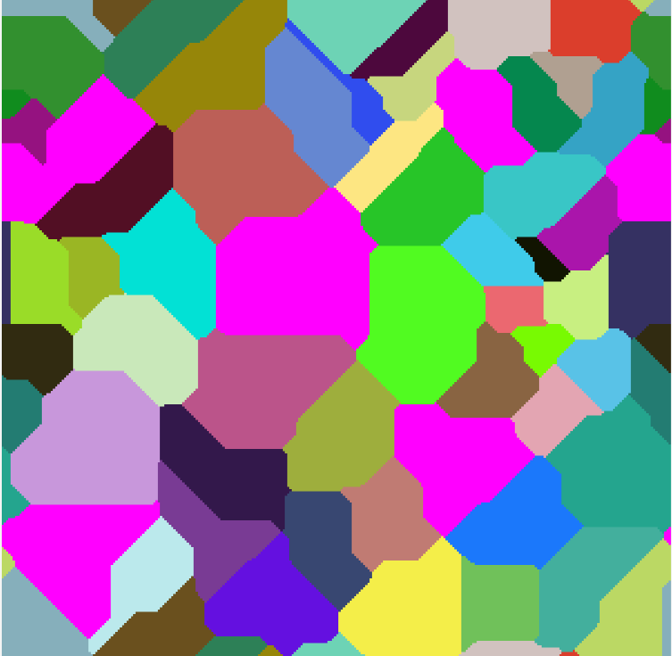 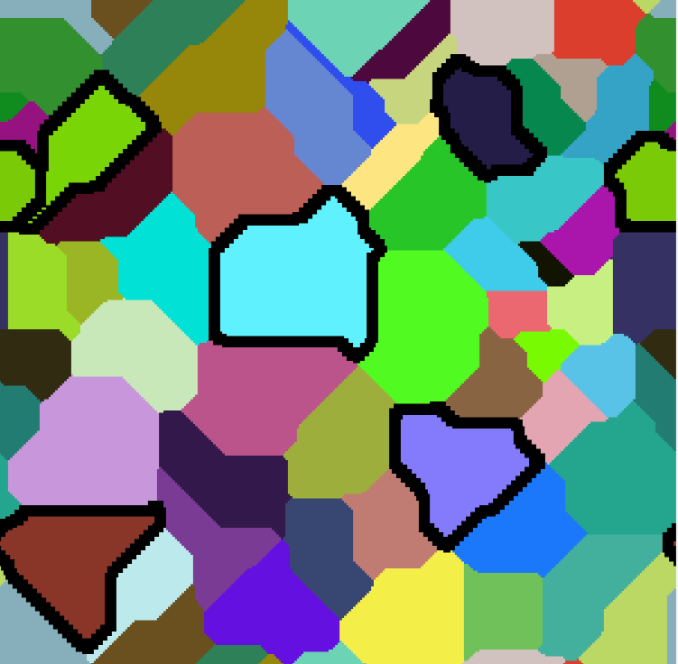

Pic.15. Selected grains. Pic.16. Drawn borders with size 2.

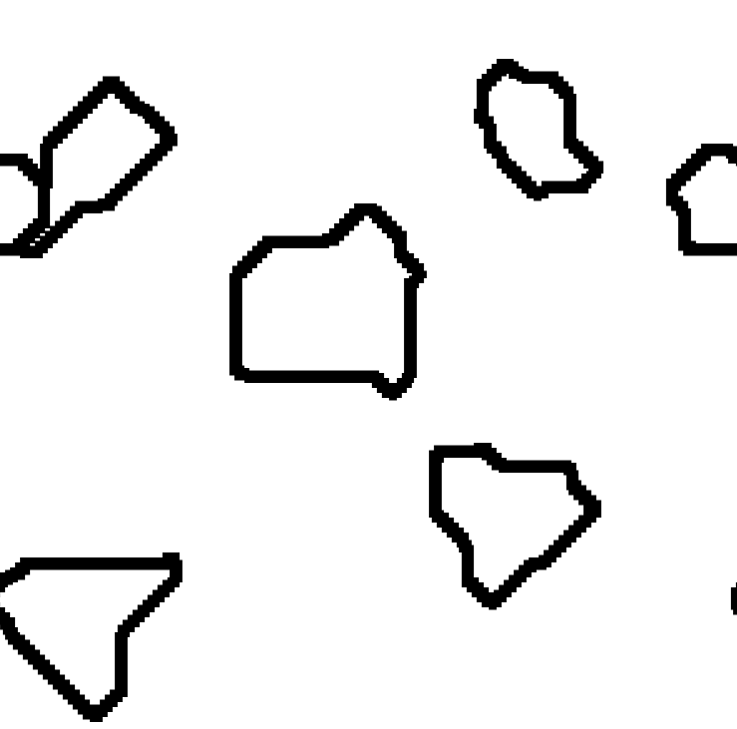 

Pic.17 Cleared space . Pic.18 All grains selected.

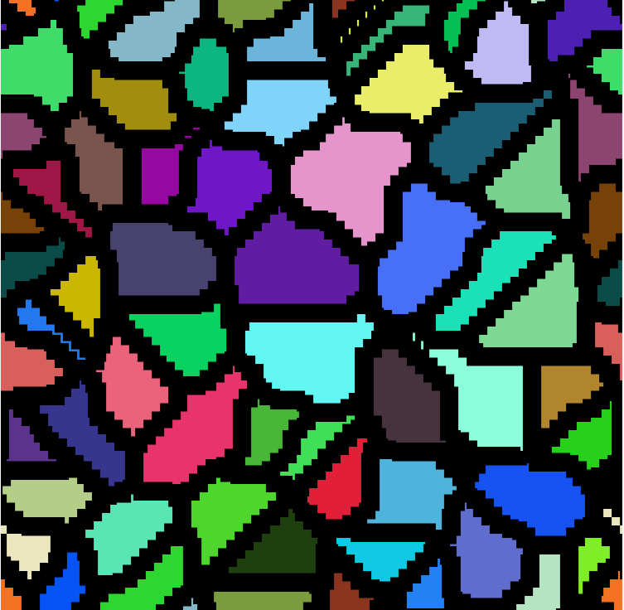 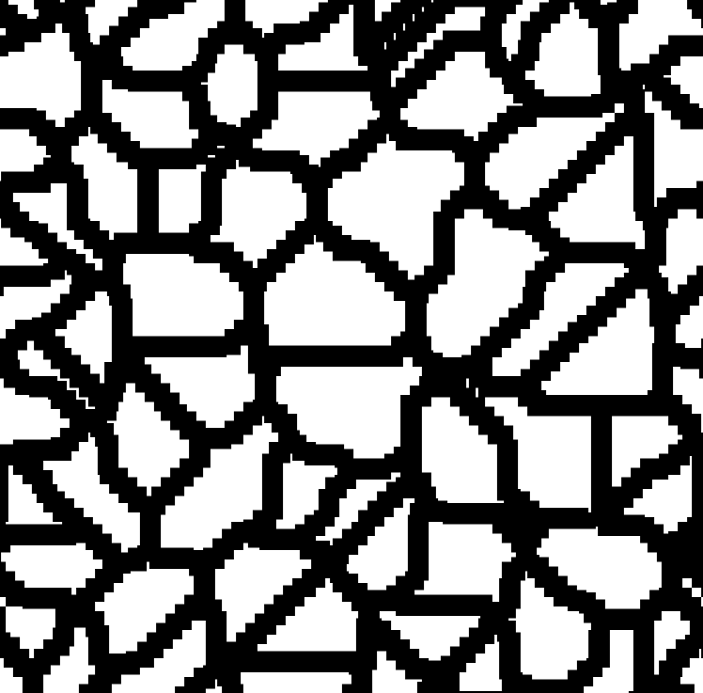

Pic.19 Drawn borders for all grains with size 4. Pic.20 Cleared space for all grains.



Pic.21 Percentage of selected grains for 6 grains.



Pic.22 Percentage of selected grains for all grains.

1. **Summary**

Microstructure analysis is now widely used. The application described in this report allows the generation of various microstructures with different parameters. The application has been created to reproduce real microstructures as faithfully as possible. Below are comparisons of real microstructure images and those generated by applications.

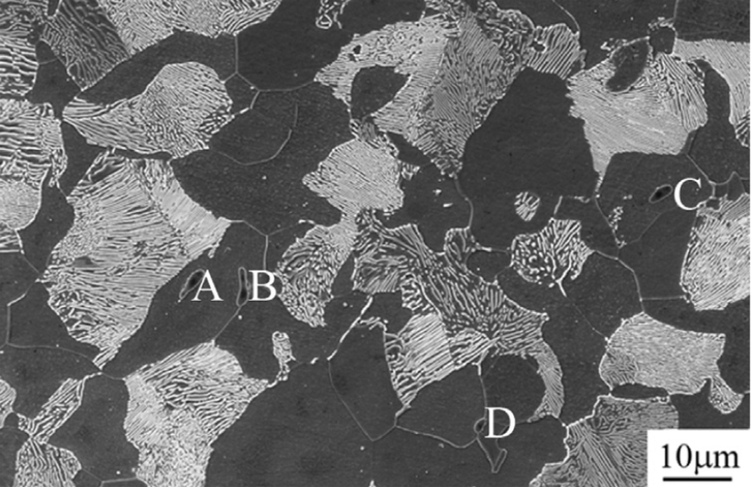 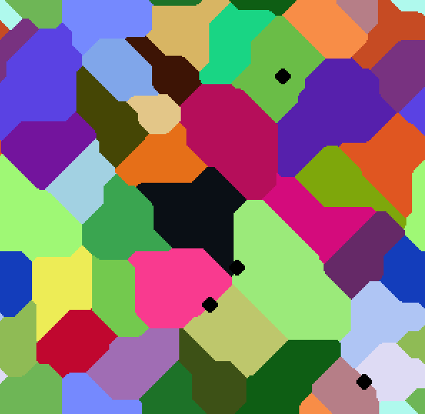

Pic.23 Microstructure of AISI 1045 Pic.24 Microstructure with four circle

Steel with 4 inclusions. inclusion before simulation.

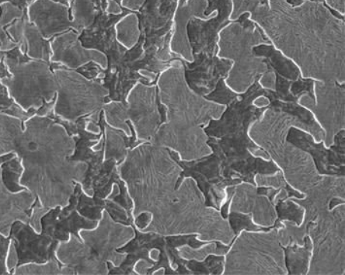 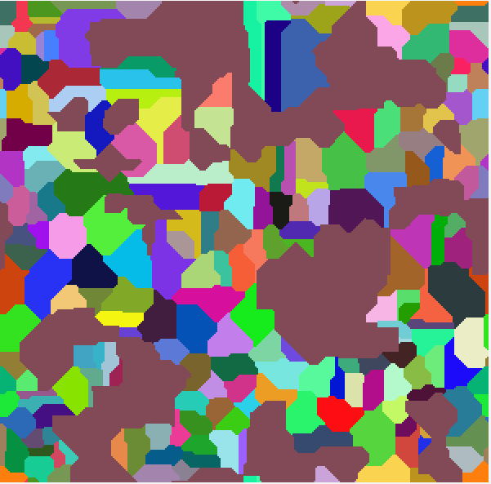

Pic.25 Microstructure of produced Pic.26 Microstructure with dual-phase structure.

dual-phase AISI 5115 steel.

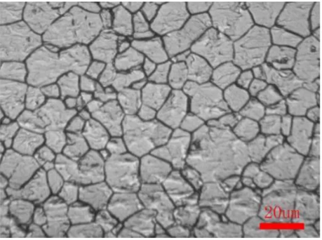 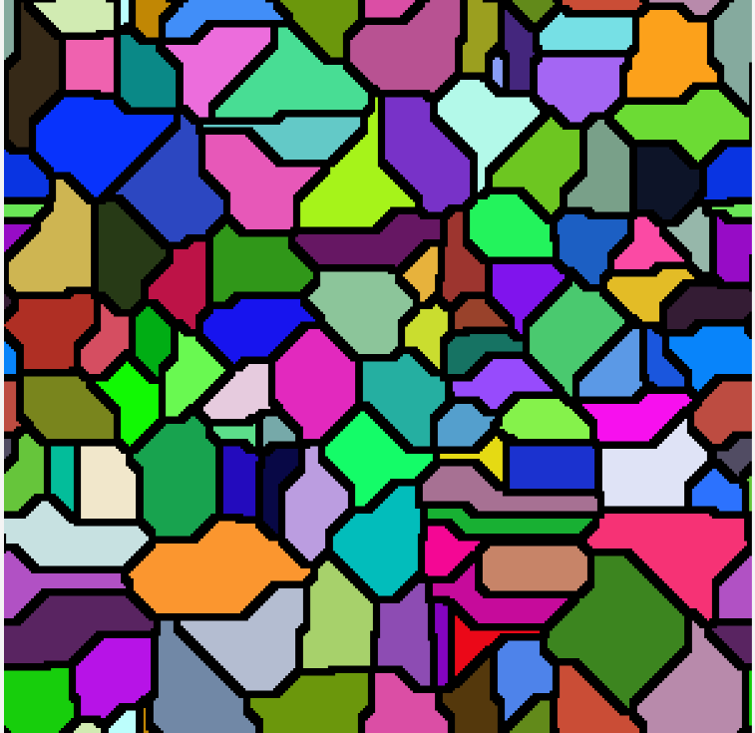

Pic.27 Microstructure during the Hot Forging of Steel 21-4N Pic.28 Microstructure with borders for all grains.

Microstructure from picture number 24 was generated using three circular-shaped inclusions. The inclusions were placed in a similar way to picture 23. Due to the inclusions added before generating the grid, the inclusions did not place only at the borders, but inside the grains also. Pictures 25 and 26 show the dual phase structure. Pictures25 shows AISI 5115 steel, while figure 28 shows the generated by application dual phase microstructure for selected grains.

Picture 27 shows microstructure during the Hot Forging of Steel 21-4N. There are clearly outlined borders. Figure 28 shows a very similar microstructure that was generated by marking the borders of each grain.

1. **References**

[1] http://home.agh.edu.pl/~msitko/multiscale-modelling/

[2] https://www.mdpi.com/2075-4701/8/6/391

[3] https://www.researchgate.net/figure/Microstructure-of-AISI-1045-steel-four-inclusions-are-indicated-by-A-B-C-and-D_fig3_312381009