Tugas Knowledge Mapping
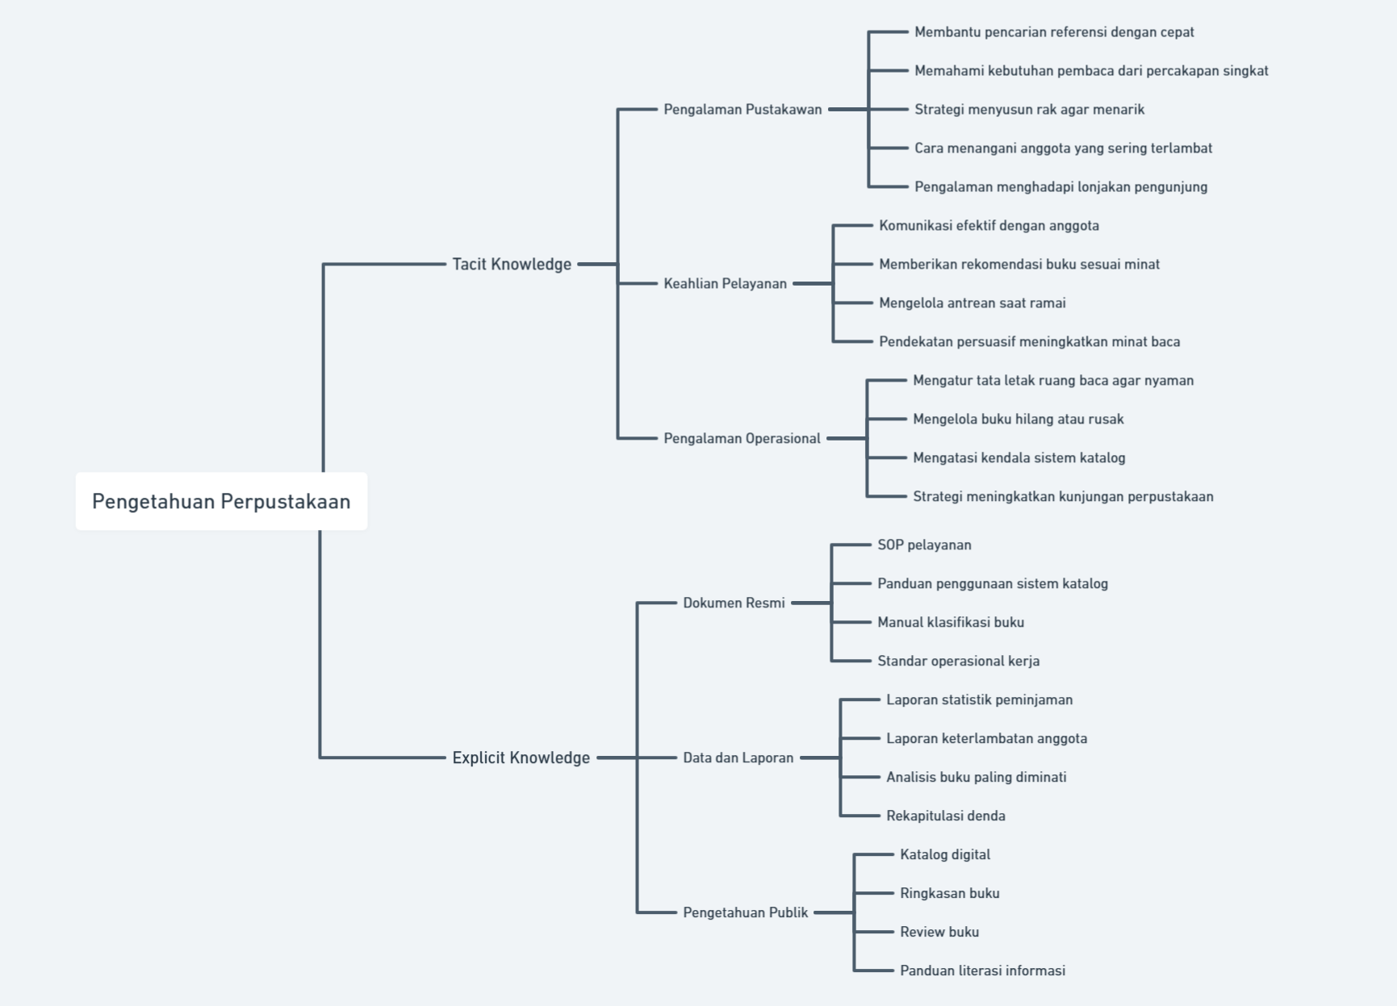
Marcell Chandra (322310015)

