# Report: Analysis of Wage Disparities in Education, Training, and Library Occupations

## Major Decisions and Data Preparation:

The analysis focused on exploring wage disparities in education, training, and library occupations, particularly looking into gender and union membership as key factors. The dataset 'morg-2014-emp.csv' was cleaned and prepared by:

* Flagging Specific Occupations: Individuals in education, training, and library occupations were identified using specific occupation codes (2200 to 2550).
* Filtering by Education Level: The dataset was filtered to include only individuals with education levels corresponding to a bachelor’s degree or higher.
* Generating New Variables: New variables were created for gender, hourly wages, and education levels to facilitate detailed analysis.

## Descriptive Analysis:

A descriptive analysis provided insights into the distribution of hourly wages and ages. Key observations included a widespread in hourly wages and a median age of 42 years.

## Regression Analysis:

* **Model 1 (Gender Wage Gap):** Focused on the wage gap between genders, indicating a significant negative impact, namely a negative 14,86% impact on wages for women.
* **Model 2 (Impact of Union Membership):** Explored the wage gap while accounting for union membership, revealing that union membership positively impacts wages, to the degree of 19,66% compared to the base case.
* **Model 3 (Education Impact):** Explored Educations impact on wages, the model showed that higher educational attainment is associated with higher wages, while indicating a wage gap for women and a positive effect of union membership. The impact was the following (all are positive impacts), bachelor’s degree 39,78%, master’s degree 59,56%, Prof. degree 78,82%, PhD degree 83,56%.
* .

## Summary:

The analysis highlights a gender-based wage gap in education, training, and library occupations and underlines an overall negative balance towards the female gender in the overall data, while highlighting the positive effect of union membership on wages. Furthermore, the effect of education level on wages reveals a general positive trend such that the higher the level of education attained by an individual, the higher their wage compared to the base case.

## Graphs and Tables List (please see pg. 2 for actual objects):

1. Stargazer based table for all models.
2. Boxplot of Hourly Wages by Gender: Showed wage distribution disparities between genders.
3. Scatter Plot of Education Level vs. Log of Hourly Wage: Illustrated the relationship between education and wages for women in these professions.

## Graphs and Tables Actual:

### Table 1

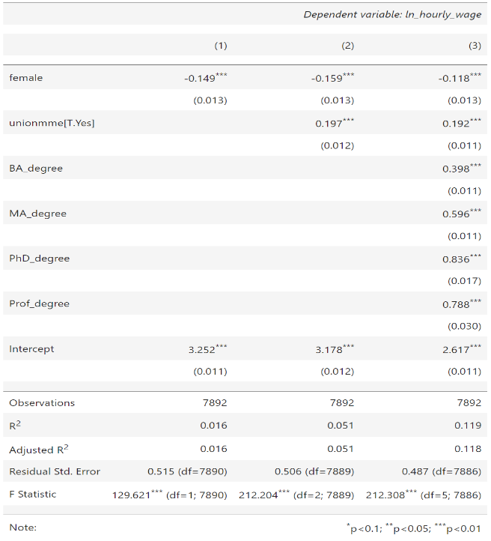

### Graph 1

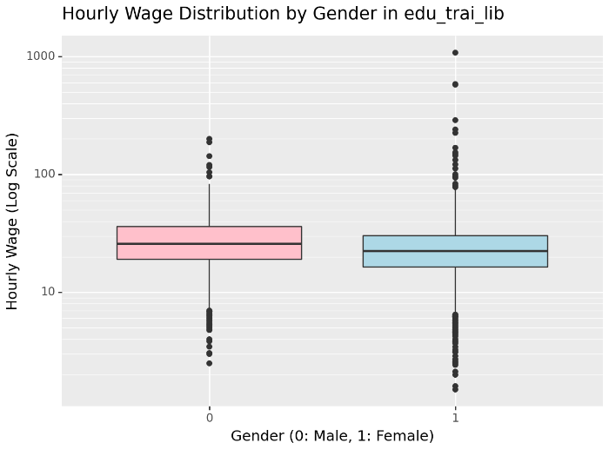

### Graph 2

