Table des matières
Material and methods 2
Image database 2
Pre-processing or extraction of ROI 2
Processing 4
Validation 5
References 6
[1] Hallau, L., Neumann, M., Klatt, B., Kleinhenz, B., Klein, T., Kuhn, C., Röhrig, M., Bauckhage, C., Kersting, K., Mahlein, A.‐K., Steiner, U. and Oerke, E.‐C. (2018), Automated identification of sugar beet diseases using smartphones. Plant Pathol, 67: 399-410. https://doi.org/10.1111/ppa.12741 6
[2]http://ultra.sdk.free.fr/docs/Image-Processing/Courses/TRAITEMENT%20NUMERIQUE%20D'IMAGES%20MEDICALES/polyTexture.pdf 6
[3]van Griethuysen, J. J. M., Fedorov, A., Parmar, C., Hosny, A., Aucoin, N., Narayan, V., Beets-Tan, R. G. H., Fillon-Robin, J. C., Pieper, S., Aerts, H. J. W. L. (2017). Computational Radiomics System to Decode the Radiographic Phenotype. Cancer Research, 77(21), e104–e107. `https://doi.org/10.1158/0008-5472.CAN-17-0339 <https://doi.org/10.1158/0008-5472.CAN-17-0339>` 6
[4]Scikit-learn: Machine Learning in Python : Fabian Pedregosa, Gaël Varoquaux, Alexandre Gramfort, Vincent Michel, Bertrand Thirion, Olivier Grisel, Mathieu Blondel, Peter Prettenhofer, Ron Weiss, Vincent Dubourg, Jake Vanderplas, Alexandre Passos, David Cournapeau, Matthieu Brucher, Matthieu Perrot, Édouard Duchesnay; 12(85):2825−2830, 2011. 6
[5]Coelho, L.P. 2013. Mahotas: Open source software for scriptable computer vision. Journal of Open Research Software 1(1):e3, DOI: http://dx.doi.org/10.5334/jors.ac 6

Material and methods

Image database
The leaf’s shooting is standardized. We made a portable stand. (add photo) It composed of a socle onto we fixed at left and right two LED light supports and at up a camera support. The LED lights are oriented to the middle of socle.
The image composition is standardized too. The background is uniform blue. At left, there is a règle. At right, there are three color mire (black, gray and white). At down, we find photo’s name and orientation leaf (recto or verso). And at the middle, we put the leaf.
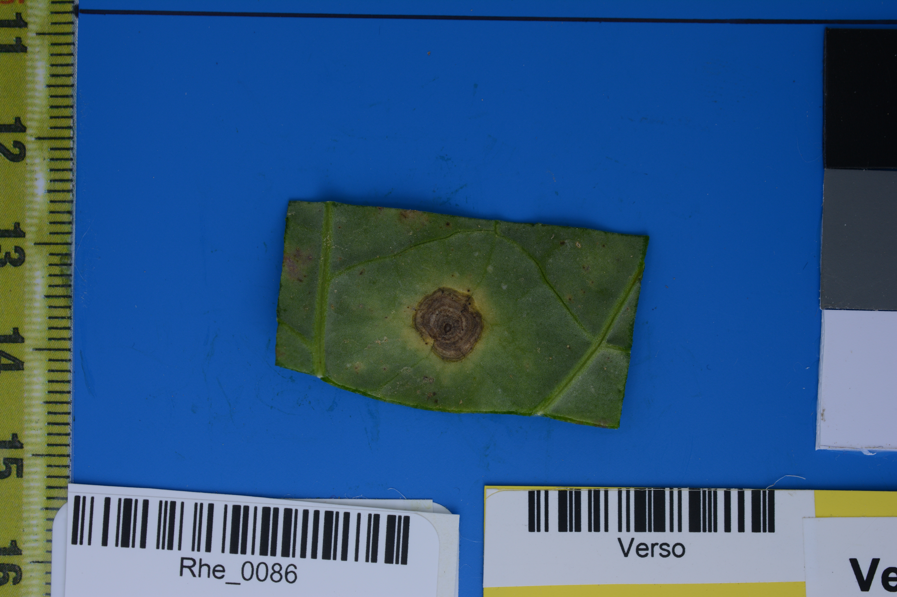
In database, for each leaf we shoot the recto and the verso. A expert identify the symptom. Here we work on six symptoms, Alternaria, Biglobosa, Maculense, Mildiou, Mycosephéréla, Pseudo and symptom-less. We have 2680 leafs (so 5360 photos), 35 Alternaria, 590 Biglobosa, 608 Maculence, 128 Mildiou, 189 Mycosephéréla, 510 Pseudo and 620 Symptom-less.

Pre-processing or extraction of ROI
The first, we make a white balance based on gray mire.
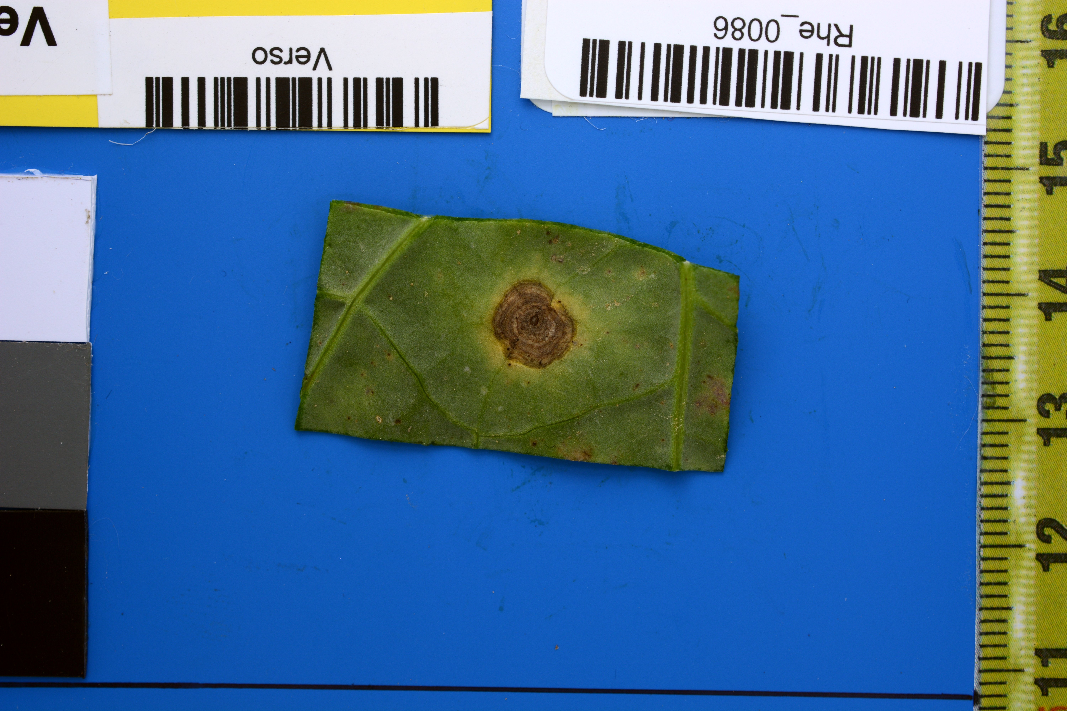
In own case, the ROI is spot product by sick on the leaf. Before we isolate the leaf.
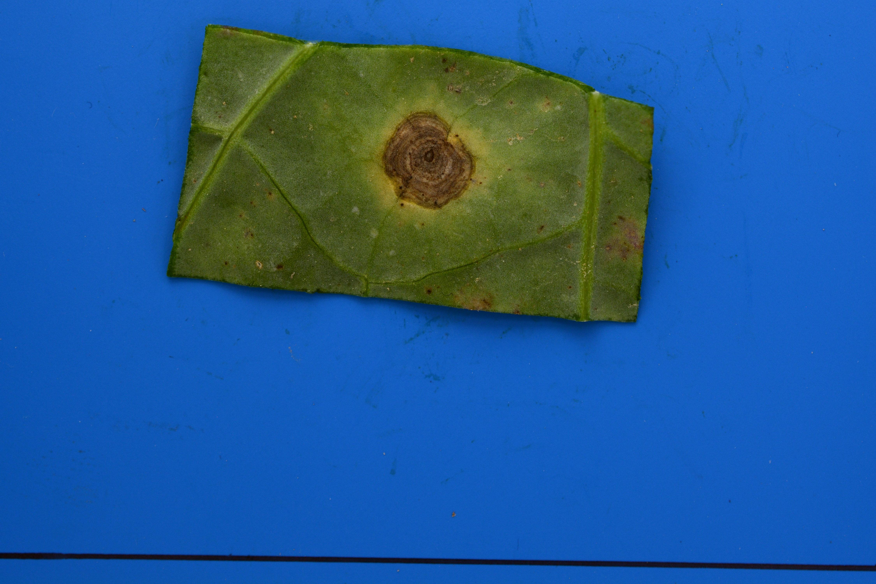
Because the image is standardized, we can delete all information around the leaf. After we use morphing to have a image more close to leaf.

To extract the ROI we keep only pixels where the red channel is bigger than green and blue channels [1].

Processing
We use linear discriminant analysis [4]like supervised classifier. We alimented this classifier with three groups of feature 1) features Haralick texture [5] on each RGB channels, 2) statistics moments on histogram for each RGB channels (mean, standard deviation, variance, minimum, maximum) and 3) Gray Level Run Length Matrix (GLRLM) features [2 3]for gray and each RBG channels. We extract these features of images recto and verso. We concatenate features of recto and verso to create one set which represent one image.

Validation
We employ Kfold [4](where one isn’t learned) to valid the process. We obtain a accuracy of 0,8545 and Kappa of 0,8188
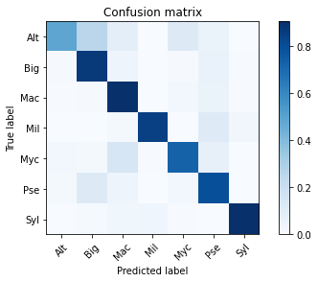

References

[1] Hallau, L., Neumann, M., Klatt, B., Kleinhenz, B., Klein, T., Kuhn, C., Röhrig, M., Bauckhage, C., Kersting, K., Mahlein, A.‐K., Steiner, U. and Oerke, E.‐C. (2018), Automated identification of sugar beet diseases using smartphones. Plant Pathol, 67: 399-410. https://doi.org/10.1111/ppa.12741

[2]http://ultra.sdk.free.fr/docs/Image-Processing/Courses/TRAITEMENT%20NUMERIQUE%20D'IMAGES%20MEDICALES/polyTexture.pdf

[3]van Griethuysen, J. J. M., Fedorov, A., Parmar, C., Hosny, A., Aucoin, N., Narayan, V., Beets-Tan, R. G. H., Fillon-Robin, J. C., Pieper, S., Aerts, H. J. W. L. (2017). Computational Radiomics System to Decode the Radiographic Phenotype. Cancer Research, 77(21), e104–e107. `https://doi.org/10.1158/0008-5472.CAN-17-0339 <https://doi.org/10.1158/0008-5472.CAN-17-0339>`

[4]Scikit-learn: Machine Learning in Python : Fabian Pedregosa, Gaël Varoquaux, Alexandre Gramfort, Vincent Michel, Bertrand Thirion, Olivier Grisel, Mathieu Blondel, Peter Prettenhofer, Ron Weiss, Vincent Dubourg, Jake Vanderplas, Alexandre Passos, David Cournapeau, Matthieu Brucher, Matthieu Perrot, Édouard Duchesnay; 12(85):2825−2830, 2011.

[5]Coelho, L.P. 2013. Mahotas: Open source software for scriptable computer vision. Journal of Open Research Software 1(1):e3, DOI: http://dx.doi.org/10.5334/jors.ac

