- Haralick
  - Avec Balance des blancs
    - Sans fond
      - LinearDiscriminantAnalysis en automatique
Acc = 0.6507462686567164
Kappa = 0.5655642920615832
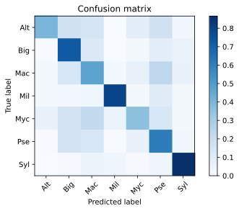

      - LinearDiscriminantAnalysis simple
Acc = 0.675
Kappa = 0.5885707598084315
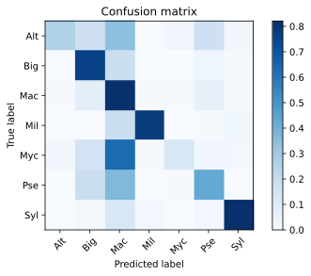

      - QuadraticDiscriminantAnalysis
Acc = 0.6511194029850746
Kappa = 0.5638023111270796
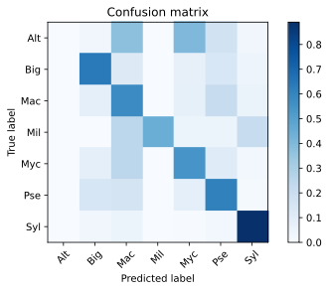

    - Avec MaxRGB
      - LinearDiscriminantAnalysis en automatique
Acc = 0.725
Kappa = 0.6542736887356964
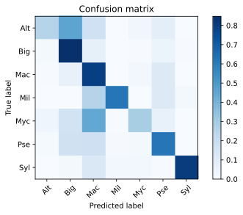

      - LinearDiscriminantAnalysis simple
Acc = 0.7973880597014925
Kappa = 0.7473822791595588
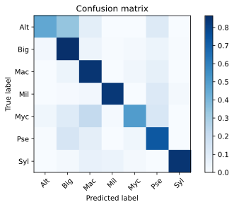

      - QuadraticDiscriminantAnalysis
Acc = 0.7440298507462687
Kappa = 0.681076797750704
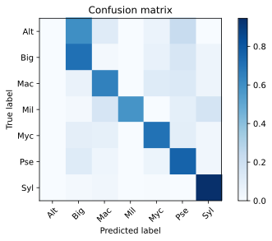

  - Sans balance des blancs
    - Sans Fond
      - LinearDiscriminantAnalysis en automatique
Acc = 0.6380597014925373
Kappa = 0.5495790515100953
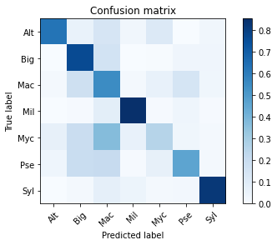

      - LinearDiscriminantAnalysis simple
Acc = 0.7111940298507463
Kappa = 0.6395901135046504
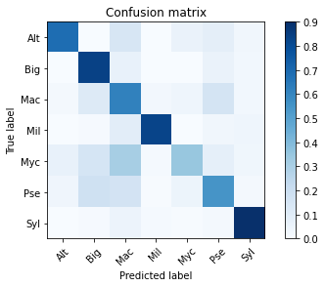

      - QuadraticDiscriminantAnalysis
Acc = 0.6720149253731343
Kappa = 0.5898923966309382
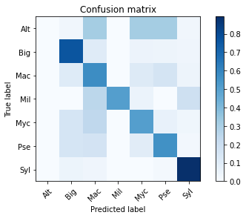

    - MaxRGB
      - LinearDiscriminantAnalysis en automatique
Acc = 0.6041044776119403
Kappa = 0.5055366030690855
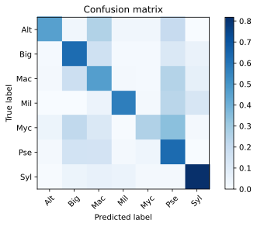

      - LinearDiscriminantAnalysis simple
Acc = 0.6477611940298508
Kappa = 0.5611530071943693
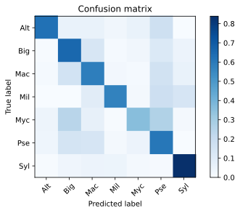

      - QuadraticDiscriminantAnalysis
Acc = 0.40932835820895525
Kappa = 0.2673136618877169
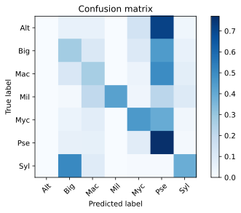

- Haralick + moments
  - Avec balance des blancs
    - Sans Fond
      - LinearDiscriminantAnalysis en automatique
Acc = 0.667910447761194
Kappa = 0.5865794668032949
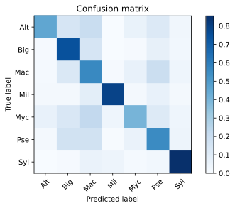

      - LinearDiscriminantAnalysis simple
Acc = 0.6369402985074627
Kappa = 0.5494845827475076
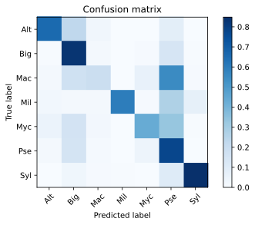

      - QuadraticDiscriminantAnalysis
Acc = 0.5384328358208955
Kappa = 0.4254309493190429
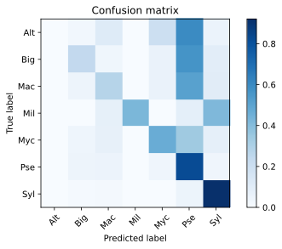

    - MaxRGB
      - LinearDiscriminantAnalysis en automatique
Acc = 0.753731343283582
Kappa = 0.6924268992221642
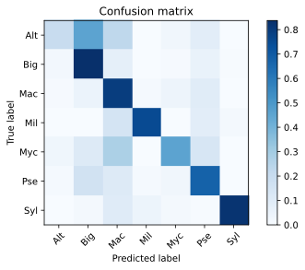

      - LinearDiscriminantAnalysis simple
Acc = 0.8104477611940298
Kappa = 0.7643217012931978
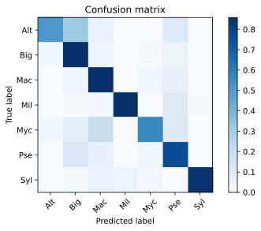

      - QuadraticDiscriminantAnalysis
Acc = 0.6843283582089552
Kappa = 0.6025503057109817
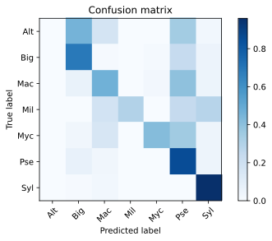

  - Sans balance des blancs
    - Sans Fond
      - LinearDiscriminantAnalysis en automatique
Acc = 0.6675373134328358
Kappa = 0.5855399637311887
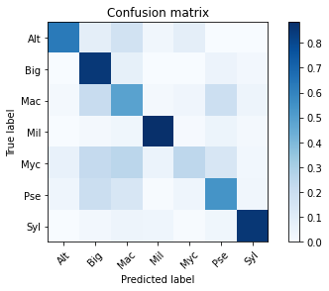

      - LinearDiscriminantAnalysis simple
Acc = 0.716044776119403
Kappa = 0.6465585171914272
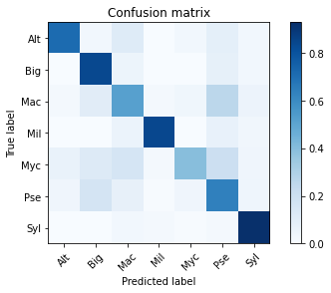

      - QuadraticDiscriminantAnalysis
Acc = 0.6720149253731343
Kappa = 0.5843820582731739
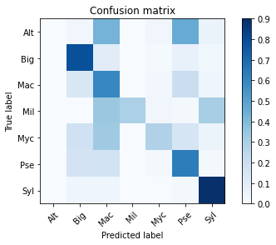

    - MaxRGB
      - LinearDiscriminantAnalysis en automatique
      - LinearDiscriminantAnalysis simple
      - QuadraticDiscriminantAnalysis

- Haralick + moments + glrlm
  - Avec balance des blancs
    - Sans Fond
      - LinearDiscriminantAnalysis en automatique
      - LinearDiscriminantAnalysis simple
      - QuadraticDiscriminantAnalysis
    - MaxRGB
      - LinearDiscriminantAnalysis en automatique
      - LinearDiscriminantAnalysis simple
      - QuadraticDiscriminantAnalysis
  - Sans balance des blancs
    - Sans Fond
      - LinearDiscriminantAnalysis en automatique
      - LinearDiscriminantAnalysis simple
      - QuadraticDiscriminantAnalysis
    - MaxRGB
      - LinearDiscriminantAnalysis en automatique
      - LinearDiscriminantAnalysis simple
      - QuadraticDiscriminantAnalysis

