Sound Engineering – Section B
Marcello Bonello 6.3A DGD

Project Overview
This document explains the backing music Ableton Live projects for the adaptive game soundtrack. The projects are organized around three main adaptive states: Forest Biome, Desert Biome, and Combat. Each state uses a different musical mood so that the soundtrack responds clearly to gameplay changes. The Forest state is calm and natural, the Desert state is mellow and Middle Eastern-inspired, and the Combat state uses a higher-energy medieval fantasy drum and bass style.
State | Genre / Feel | Main instruments | Gameplay trigger
Forest Biome | Calm forest ambient / fantasy nature ambient | MPE Airy Pad, Jazz Basic Guitar, Kalimba Big, Wood Bass, Wood Percussion / Stab Keys Birds | Triggered when the player enters or explores the forest area.
Desert Biome | Mellow Middle Eastern / Arabic-inspired ambient | Atmos Pad, Eastern Harp, Clay Flute, Indian Flute, tonal/hand percussion | Triggered when the player enters or explores the desert area.
Combat | Medieval fantasy drum and bass | Warehouse Stutter Kit, DS Drum Rack, Dark Bass, Basic Radar Pluc, Basic Silk Horns, Choir Pad Avalon, New Age String | Triggered when the player starts fighting an enemy.

Q1 – Project Structure Around Adaptive States
The Ableton backing music project is structured around the adaptive states listed in the project plan. Each state is clearly separated using named Session View scenes and/or labelled Arrangement View sections. The states are named according to their gameplay role, such as Forest Biome, Desert Biome, and Combat. Colour-coding is used to make the states visually clear: green tones are used for the forest state, yellow/orange tones for the desert state, and brighter red/pink or high-contrast colours for combat. This allows the project to be read clearly during marking and shows how the musical material maps to the game states.

Ableton organisation method | How it is used in the project
Session View scenes | Separate clips/scenes are used for different game states so that Forest, Desert, and Combat can be launched and tested independently.
Arrangement View sections / locators | The music can also be arranged horizontally to show how states connect and transition over time.
Track labels | Each instrument track is named according to its role, such as MPE Airy Pad, Eastern Harp, Dark Bass, DS Drum Rack, or Choir Pad Avalon.
Colour coding | Different colours make it easier to identify the adaptive states and related clips quickly.

Q2 – Audio Channels, MIDI Channels, and Return Tracks

Audio channel
An audio channel in Ableton is used to hold and process recorded or imported audio. This can include stems, ambience recordings, SFX, or bounced audio loops. In this project, audio channels can be used for exported ambience layers or recorded sounds such as environmental textures. Audio channels are useful when the sound already exists as a waveform and does not need to be triggered by MIDI notes.

MIDI channel
A MIDI channel contains note information that triggers an instrument. The MIDI data itself does not make sound until it is connected to an instrument such as a synth, pad, bass, drum rack, or sampled instrument. In this project, MIDI channels were used for instruments such as MPE Airy Pad, Eastern Harp, Wood Bass, Dark Bass, Basic Radar Pluc, Choir Pad Avalon, and New Age String. This allowed melodies, chords, basslines, and drum patterns to be edited and quantised accurately.

Return track
A return track is a shared effects channel. Instead of placing separate reverb or delay devices on every track, instruments can be sent to a shared return using the Send knobs. In this project, Return A is used for Reverb and Return B is used for Delay. This creates a consistent sense of space across the soundtrack and keeps the project cleaner. Pads, flutes, harps, choir, and horns receive more reverb, while bass and kick-heavy tracks receive little or none to avoid muddiness.

Q3 – Custom Drum Rack and Drum Clips

I did not create a custom drum track, I used stock drum racks that come with Ableton.

Q4 – Melodic Line
The project includes melodic lines that define the identity of each adaptive state. The Forest state uses a gentle melodic approach with instruments such as Kalimba Big and/or soft plucked guitar, creating a calm and magical exploration feeling. The Desert state uses Clay Flute, Indian Flute, and Eastern Harp to create a mellow Middle Eastern-inspired atmosphere. The Combat state uses Basic Radar Pluc as a faster rhythmic motif, helping the combat music feel tense and energetic.
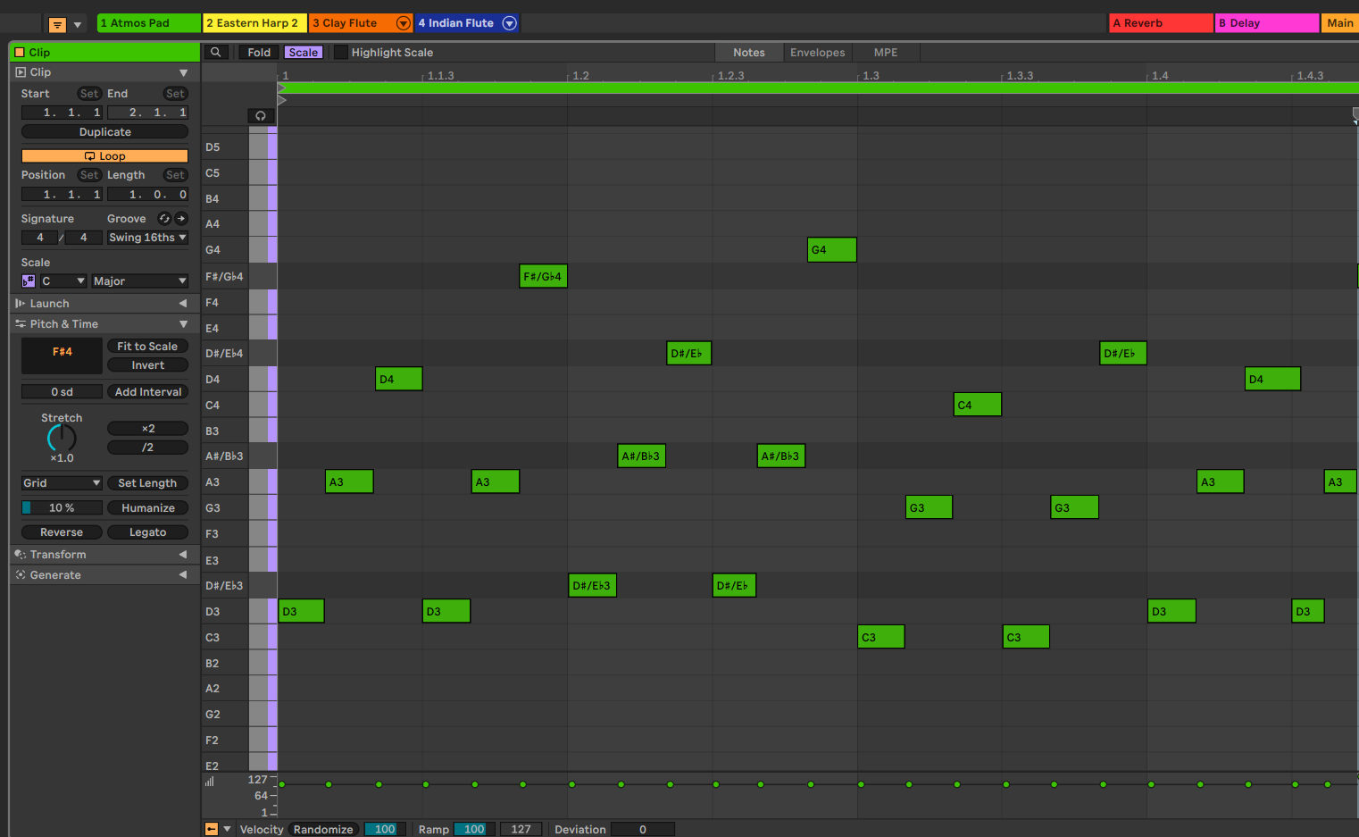
The melodic clips are quantised so that the notes align clearly with the tempo and grid. This is important because adaptive music needs to loop and transition cleanly. Quantisation also helps exported stems remain rhythmically consistent when they are later used in FMOD.

Q5 – MIDI Bass Channel
A MIDI bass channel is used to support the harmony and melody in the adaptive states. In the Forest state, Wood Bass provides a warm and natural low foundation that supports the calm ambient mood. In the Combat state, Dark Bass provides a heavier and more aggressive low end, matching the drum and bass style of the fight music. The bass parts are quantised to keep them locked to the drum patterns and to make the loop points accurate for later FMOD use.
The bass line follows the harmonic direction of the melodies rather than acting as a separate lead part. This keeps the mix organised: the bass supports the musical state, while the melodic instruments carry the main musical identity.

State | Bass approach | Reason
Forest | Longer, softer Wood Bass notes. | Supports a calm and grounded natural atmosphere.
Desert | Subtle drone or low supporting notes if used. | Keeps the desert section warm without overpowering the flutes and harp.
Combat | Shorter, stronger Dark Bass notes. | Creates energy and weight for the drum and bass combat state.

Q6 – Third-Party VST Instrument and MIDI Effects

I didn’t use any third party VST Instrument and MIDI Effects

Q7 – Chord / Filler Channel
Chord and filler channels are used to fill the musical space behind the main melody. In the Forest state, MPE Airy Pad provides a soft atmospheric bed, while Jazz Basic Guitar supports the harmony with gentle plucked movement. In the Desert state, Atmos Pad and Eastern Harp provide a warm background texture. In the Combat state, Choir Pad Avalon and New Age String add epic tension and support the medieval fantasy combat mood.
The chord/filler material is at least as long as the melody channel so that the background does not stop unexpectedly. Chord variations are introduced by changing notes, voicings, or texture over the phrase. This keeps the loop from feeling too repetitive while still allowing it to function as adaptive game music.
State | Chord/filler instrument | How it supports the state
Forest | MPE Airy Pad, Jazz Basic Guitar | Creates calm atmosphere and gentle harmonic movement.
Desert | Atmos Pad, Eastern Harp | Creates warmth, space, and a Middle Eastern-inspired texture.
Combat | Choir Pad Avalon, New Age String | Adds darker tension and a larger fantasy battle feeling.

Q8 – Synth Patch Designed from an Initialized State

I did not design a synth path from an Initialized State

Q9 – EQ Filters Inside the Drum Rack Chain
EQ filters were applied inside the Drum Rack chain to shape individual drum sounds and keep the rhythm section clean. The aim was not just to add EQ randomly, but to give each drum sound its own frequency space and prevent unnecessary frequencies from building up in the mix.

Filter type | Example drum sound | Frequency target and justification
High-pass filter | Hi-hat / shaker / small percussion | A high-pass filter removes low-frequency rumble from high percussion because these sounds do not need bass energy. This leaves more space for the kick and bass.
Low-pass filter | Low tom / kick / dark drum layer | A low-pass filter reduces excessive high-frequency click or harshness, helping the low drum sound warmer and less sharp.
Band-pass filter | Metallic hit / transition percussion / special FX hit | A band-pass filter isolates the useful mid-range character of the sound and removes unnecessary lows and highs. This makes the hit easier to place in the mix.

These EQ choices support the overall mix because the drums cover a wide frequency range. Cleaning the individual drum pads prevents low-end clutter, reduces harshness, and makes the adaptive music easier to balance before exporting stems to FMOD.

